Curriculum Vitae

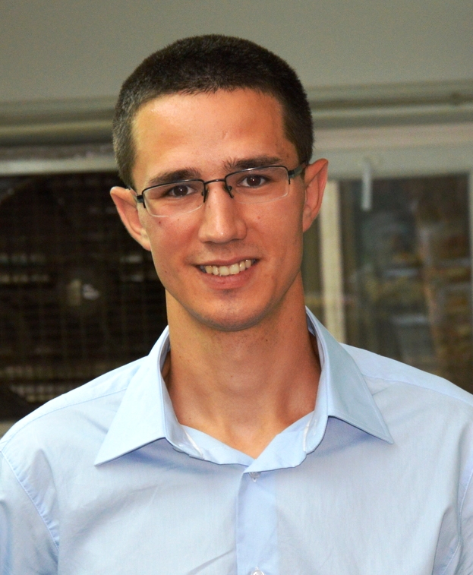
Lazar Kesić, MSc
Date of birth: 26.01.1991.
Affiliation: University of Novi Sad, Institute of Lowland Forestry and Environment
Address: Antona Cehova 13d, Novi Sad, Serbia
Phone number: +381 63 78 78 504
E-mail: kesic.lazar@uns.ac.rs

Education
- 2016-Present Department of Fruit growing, Viticulture, Horticulture and
Landscape architecture, Faculty of Agriculture,
University of Novi Sad
Ph.D student
- 2014 – 2016. Department of biology and ecology, Faculty of Sciences,
University of Novi Sad
Acquired title: Master in Biology; MODUL: Botany
Grade point average: 9.83

- 2010 – 2014. Department of biology and ecology, Faculty of Sciences,
University of Novi Sad
Acquired title: Bachelor with Honours in Biology
Grade point average: 9.05

- 2006-2010. Grammar School „Svetozar Marković“, Novi Sad

Work experience

- November 2016- present Institute of Lowland Forestry and Environment
University of Novi Sad
Junior researcher

- April 2015; 2014; 2013 Scientific-popular event, Night of biology,
Department of biology and ecology, Faculty of Sciences,
University of Novi Sad
Volunteer

- 2013 – 2014. Laboratory for Systematics of vascular plants and Phytogeography and-Herbarium BUNS,
Department of biology and ecology, Faculty of Sciences,
University of Novi Sad
Volunteer

Publications

- Matović, B., Stojanović, D., Kesić, L. & Stjepanović, S. (2017): Climate impact on growth of spruce in National Park Kopaonik. International Scientific Conference „Forestry Science in Purpose of Sustainable Development of Forestry“, 8. December 2017, Banja Luka. (announcement)
- Stojnić, S., Kovačević, B., Kebert, M., Kesić, L., Stanković, M. & Orlović, S. (2017): Investigation on the relationship between leaf water use efficiency and physio-biochemical traits of Pedunculate oak. International Scientific Conference „Forestry Science in Purpose of Sustainable Development of Forestry“, 8. December 2017, Banja Luka. (announcement)
- Kesić, L., Stojnić, S. & Stojanović, D. (2017): Correlation between climate variables and growth of Turkey oak (Quercus cerris L.). International Scientific Conference „Susainable Forestry: Fact or Fiction?“, 3. - 6. October 2017., Skopje. Book of abstracts pp. 4-5. (announcement).
- Kesić, L., Matović, B., Stojnić, S., Stjepanović, S. & Stojanović, D. (2016): Climate change as factor reducing the growth of trees in the pure Norway spruce stand (Picea abies (L.) H.Karst.) in the national park ‚‚Kopaonik''. Poplar, 197/198, 25-34.
- Stojnić, S., Orlović, S., Trudić, B., Kesić, L., Stanković, M., & Šijačić-Nikolić, M. (2016): Height and root-collar diameter growth variability of European beech provenances from southeast Europe. Poplar, 197/198, 5-14.
- Kesić, L. (2016): Variability of morphological character species Hypericum hirsutum L. 1753 and H. barbatum Jacq. 1775. [Master Thesis]. Department of biology and ecology, Faculty of Sciences, University of Novi Sad.

Projects participation

- "Biosensing Technologies and Global System for Long-Term Research and Integrated Management of Ecosystems" (III43002) financed by the Ministry of Education, Science and Technological Development of the Republic of Serbia.

Participation in Training School

- COST Action CLIMO CA15226 Training School “Dendrochronological methods in forest ecology”, Zvolen, Slovakia, September 27 – 29, 2017.
- LIFEGENMON Summer school on scientific writing and Forest genetic monitoring knowledge transfer into practice & CAPABAL 5th TRAINING SCHOOL, The Logarska Valley, Slovenia, August 7 – 11, 2017.

Prizes and Awards

- Scholarship of the Republic of Serbia, Ministry of Science, Education and Technological Development, 2014/2015
- Scholarship of the Republic of Serbia, Ministry of Science, Education and Technological Development, 2012/2013.
- Scholarship of the Republic of Serbia, Ministry of Science, Education and Technological Development, 2011/2012

Knowledge of foreign languages

• English: Understanding – B2 (independent user)good, Writing - B2 (independent user) , Speaking – B2 (independent user)

Computer skills

- Knowledge of Microsoft Office (Word, Excell, Power Point)
- Knowledge of R software for statistical analysis

Other skills

- Driver´s licence B category

