ELIMINATION OF RISKS IN THE CONTEXT OF CURRENCY FLUCTUATIONS

Ing. Sylvie Riederová, Ing. Pavlína Pinková
In today's uncertain times when the major European economics have to deal with the danger of bankruptcy, the risk management has become for financial managers a highly complicated issue, in which the crucial role plays the accepting of personal responsibility for each decision leading to the elimination of risk. Thus, it seems to be particularly important for corporate financial managers to identify the types and sources of potential risks that fundamentally affect their business activities. The historical development of risk is associated with uncertainty in a negative sense. Nevertheless, in the course of time, the authors have applied the concepts of chance or opportunity to express a positive sense of risk. The clarification of this terminological ambiguity is important for both research and practical applications. The elimination of risk can be achieved only by the proper understanding of the nature of risk. Currency risk is one of the risks that can be seen uncontrollable from the perspective of enterprises. However, one of the potential variants of financial management is to eliminate the currency risk arising from the volatility of exchange rates through the use of currency derivates. The objective of the paper is to examine the importance of individual steps within the entire process of currency hedging for export oriented companies in a small open economy, namely the Czech Republic. The purpose of the paper will be primarily achieved through the analysis of the development of the currency pair CZK/EUR in years 2000 to 2010. Time series regression analysis will be performed both for the exchange rate and for the volatility of exchange rate, and the future development will be predicted. The proposed study will use data from the Czech Statistical Office, the Czech National Bank and the Thomson Reuters database. Consequently, on the basis of a model enterprise, different exchange rate hedging strategies will be applied. Results from this approach should show whether it is beneficial to hedge in given conditions. In case of economic efficiency of hedging, it seems to be necessary to identify the financial managers' attitudes towards the exchange rate hedging, particularly the attitudes to risk in general, depending on whether the company is hedged or not, and the relation between managers' education and used hedging strategies. These primary data will be gained by the questionnaire survey realized among the industrial enterprises of the South Moravian Region. The data will be processed by standard methods of descriptive statistics and other mathematical statistical methods, such as the chi-square test. In conclusion, the recommendations for owners and financial managers concerning the comprehensive look at the currency risk elimination with the help of financial derivates will be developed. The paper summarizes the theoretical aspects necessary for the understanding of the issue and their application to the corporate sector in terms of a small open economy.

risk management, currency risk, exchange rate, hedging, currency derivatives

Introduction
The current situation in the global markets, especially the lingering financial crisis, has brought into the focus more than ever before the issue of risk management in corporate environment. According to Pulchart (2011), the risk management process definition implies that the key elements of the whole process are people, their education, skills, competencies and their perception of risks. The risk management process depends on management and its sharing across the company. CFO in export-oriented companies having costs in local currency (e.g. in CZK) and receivables in foreign currency (e.g. EUR) tries to minimize the risk of this open position, which is affected by the fluctuations of key financial market variables, especially the volatility of exchange rates, interest rates, commodity prices and other factors. The real opportunity how to manage these risks with regard to corporate cash-flow and economic result is the use of currency derivatives. The decision itself whether to hedge or not is regarded to be highly problematic. It is closely associated not only with market variables mentioned above, but also inside the company, it is related to attitudes towards risks and to education, as well as competencies, of financial managers (Hula, 2012).
The Greek word “Rhiza”, the Latin word “Riscum” or the Arabic word “Risq” emerged already in 12th century; nevertheless, their meanings have been developed since then. The concept of risk usually referred to an unfavorable event, for example the loss of the cargo during the course of the voyage (Fotr and Hnilica, 2009; Tichý 2006). In the Middle Ages, as the Pope Gregory VIIII mentions, the term risk is associated with lending money and with creditor-debtor relationship (Gregorius VIIII, 1227-1241). It can be assumed that risk is used for situations which individuals undergo voluntarily and knowingly and at the same time they take the responsibility for the final result of a transaction that is uncertain.
For a long time, the concepts of risk and uncertainty have been considered to be equivalent. However, Knight (1921) argues for a clear conceptual distinction between these two terms. The author concludes that risk is a measurable variable; whereas uncertainty cannot be measured. This finding is also supported by Merna (2007) who claims that risk is statistically predictable and uncertainty refers to unknown, generally unpredictable events. The results of transactions can be both positive and negative, since the risk is (perfectly) quantified uncertainty (Althaus, 2005). Tichý (2006) defines risk as the expected value of loss, expressed in monetary or other units, caused to recipients or risk-bearers by implementation of risk scenarios. It can be concluded that the acceptance of risks involves either positive scenario, i.e. unplanned profit, or negative scenario, i.e. unplanned loss.
Almost every business transaction between the companies of different countries is accompanied by currency exchanges. After the break-up of Bretton Woods system, the exchange rates of currencies are frequently fluctuating, which leads to the increase of currency risk of all participants. (see Henderson, 2002, Choi, 2010)
The company’s decision whether to hedge currency exposures, or not, is influenced by two main determinants. First, how significant the potential risk is regarded to be. Next, what the attitude towards risk is (Coyle, 2000). This relation to risk can be neutral, averse or risk-seeking and is dependent on decision maker's preferences, which are affected by many other factors, including past experience or environment development (Martinovičová et al., 2010). Yet, the empirical studies have shown that the company’s attitude to risk is independent of real hedging decisions (Donoso, 1995).
Likewise, the issue of currency risk management appears to be even more complex, due to difficulties with the understanding of exchange rates fluctuations. As Beltratti et al. (2004) state, the long-term trend does not enable to find the stable relations among variables. Consequently, the short-term perspective is necessary to be considered as well (Subramanian, 2011).
The proper hedging strategy enables to minimize or even eliminate the currency risk (Riederová, 2010). However, the hedging does not systematically improve the returns, the investment horizon and the currencies of choice are significant determinants of the final result (Subramanian, 2011).
The Czech companies, either exporting or importing, are closely dependent on the overall trends of the European economy. The current financial markets are extremely sensitive (see Kolb, Overdahl, 2010) and the exchange rate development has both direct and indirect impact on businesses. Consequently, in terms of hedging, the right decisions are highly important. The objective of the paper is to examine the importance of individual steps within the entire process of currency hedging for export oriented companies in a small open economy, namely the Czech Republic.

Methods and Resources
The real historical data of the currency pair CZK/EUR from 2000 to 2010, based on the daily fixing of the Czech National Bank (CNB), have been used for the purposes of our study. First, the long term trend of the CZK/EUR development has been generated with the help of linear regression analysis. Next, the whole period of ten years has been divided into one-year periods, in which the linear regression has been performed to mark differences between the long-term and short-term trends.
For the time series analysis the most common form of linear regression model has been applied. The plain linear regression is used to simulate linear dependencies between variables. According to Yan and Gang Su (2009), the equation takes following form:
y = β₀ + β₁x + ε,
where β₀ and β₁ represent the parameters of the model (β₁ is gradient), y represents depending variable, x is independent variable and ε represents the statistical error.
Based on Anderson (2010), the equation for E(y) can be written as follows:
E(y) = β₀ + β₁x,
where the graphical representation is straight line.
To test the hedging profitability, the artificial exporting company is considered. On the basis of guided interviews with the representatives of financial organisations (HSBC Bank plc, Commerzbank AG and Komerční Banka, a.s.), the average exporting company has been defined and the following assumptions have been made:
- The company’s exposure is €50 million.
- The net exposure is €24 million = €50 million - €26 million (natural hedging).
- The company enters one FX deal every month, in the amount of €1 million. The maturity date is on 20th of each month or the first following business day.
- The budgeting procedure determines the company’s net exposure to October 3 of each year.
- The company hedges 100% of open position.
For the hedging of considered artificial company, the outright forward has been used. The forward points, defined as a premium or discount added to or subtracted from the spot rate (Chisholm, 2010), are calculated on the basis of real market data, which were obtained from Thomson Reuters database. These forward points are determined according to Jílek (2005), as:
The hypothetical example of the hedging of future cash-flows (namely 1.000.000€ for the period of one year) is applied to demonstrate the comparison of various hedging instruments. The hedging prices, as well as the hedging rates, are the real market values provided by banks to creditworthy companies. Two different exchange rate predictions based on the appreciation and depreciation of Czech crown are defined to determine the advantageousness of hedging instruments. The calculations are based on the fact that the hedging, not the speculation, is considered (see Henderson, 2002) and the amount of hedged foreign currency corresponds to net foreign exchange exposure (see Homaifar, 2003).
The identification of financial managers' attitudes towards the exchange rate hedging has been done through the questionnaire method. The questionnaire survey has been realized among the industrial enterprises of the South Moravian Region in the Czech Republic in the period from September to October 2011. The sample consists of 195 companies with more than 100 employees belonging to CZ-NACE division 13. The secondary data are obtained from the Amadeus database, Albertina database, and the Czech Statistical Office and Intrastat system. The primary data are processed by standard methods of descriptive statistics and other mathematical statistical methods, such as the chi-square test.

Results and discussion
Firstly, the development of the currency pair CZK/EUR, during the monitored period of time, is to be analyzed. The long term trend is generated, and the long-term trend (marked as LR_10Y) and short-term trend (marked as LR_1Y) are compared.
Fig. 1 presents the development of CZK/EUR in the period 2000 – 2010. The particular values are based on the daily fixing rate as reported by the Czech National Bank. The blue line represents a graphical expression of the linear regression results. This long-term trend clearly identifies the appreciation slope of CZK during the examined period. Under consideration of first (35,805) and last (34,111) LR values, the appreciation rate of CZK/EUR for the last ten years is approximately 3, 7%, which is more than 20% higher, compared to the appreciation target announced by the CNB in year 2000.
Since, the trend is empowering and the appreciation rate is higher than was expected by the CNB, it seems to be apparent that the use of hedging for exporting companies in the conditions of the Czech Republic is justifiable. Nevertheless, in certain periods, the exchange rates fall dramatically.
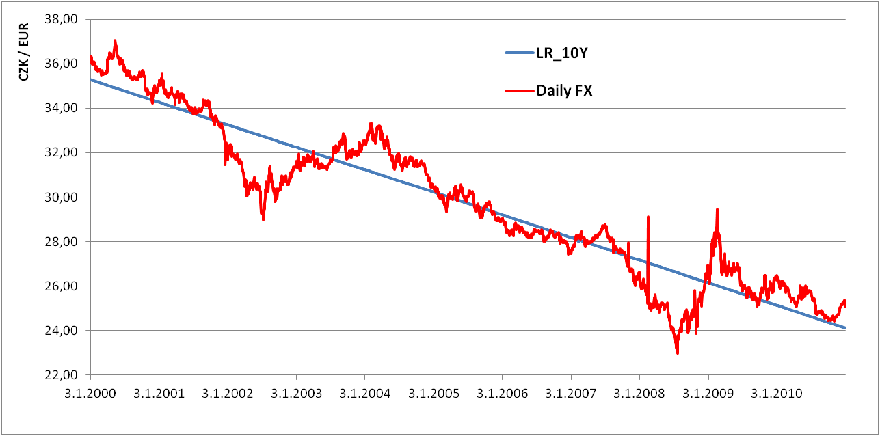
Figure 1: CZK/EUR for 2000 – 2010 (Source: Own calculations based on the CNB)
Development of year 2000
From the currency point of view, the year 2000 can be considered to be calm. Fig. 2 shows that the long-term trend is almost parallel to the short-term trend.
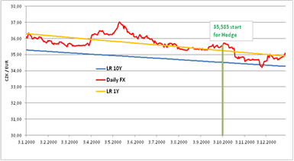
Figure 2: CZK/EUR for 2000 (Source: Own calculations based on the CNB)
The currency hedging was established in year 2000. The exchange rate of October 3, 2000 at 35,585 CZK/EUR has been used as the entry level for the hedging forwards. The interest rates quoted on October 3, 2000 are presented in Tab. 1.
Table 1: Interest rates quoted on October 3, 2000 (Source: Komerční banka, a.s.)
Interest rates for CZK |  |  | Interest rates for EUR
1M | 3M | 1Y | 1M | 3M | 1Y
5,32 | 5,37 | 5,74 | 4,78 | 4,99 | 5,16
The interest rates for corresponding periods are taken into consideration for the calculation of the forward basis points (BIBS). No difference between the bid and offer rates is considered, thus, the mid-rate is applied. The same procedure has been performed as well for the following years.
Development of year 2001
Similar development to previous year can be seen in 2001. However, in the end of the year the financial market experienced turbulences and the CZK appreciated dramatically, which is represented by the crossing of long-term and short-term trends. Tab. 2 reports that the hedging in 2001 was effective.
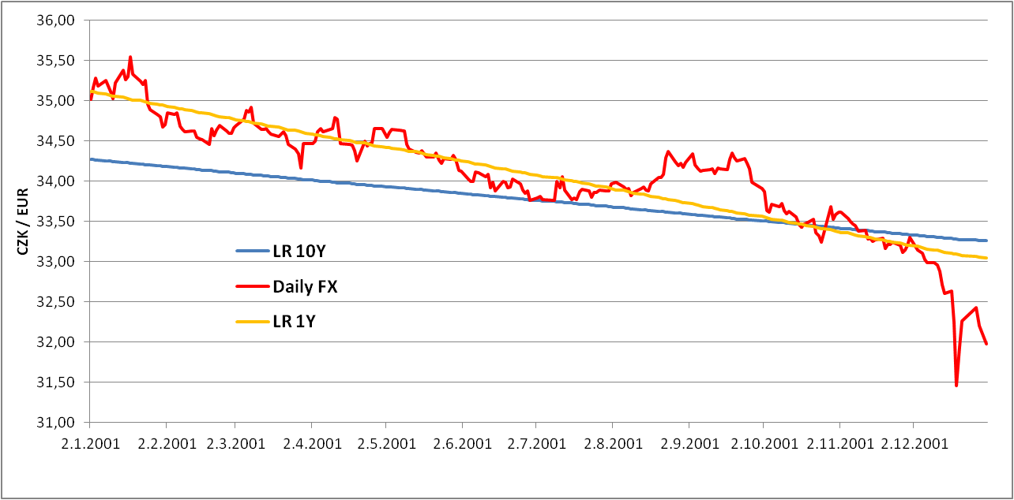
Figure 3: CZK/EUR for 2001 (Source: Own calculations based on the CNB)

Table 2: Evaluation of 2001 and 2002 (Source: Own calculations)

Development of year 2002
Year 2002 was very turbulent. In spite of the fact that the slopes of long-term and short-term trends are almost parallel, significant fluctuations occurred during this period. The short-term trend was lying under the long-term, due to a big rise in previous year 2001. This development implies the high efficiency of hedging in 2002. The potential risk for the near future is the upward trend of exchange rate in the end of the year, signalling the weakening of CZK.
As expected, the hedging for the year 2002 was successful and the company realized profit of about CZK 39.068.100, 74 CZK (see Tab. 2).
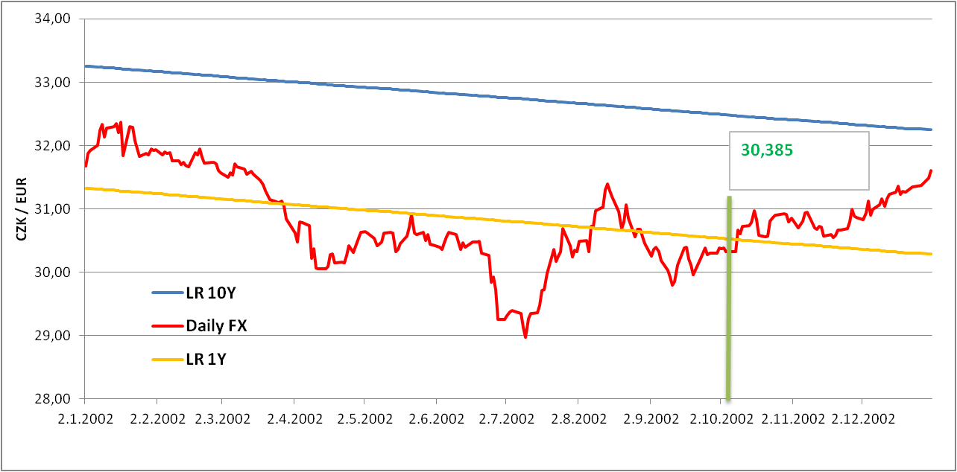
Figure 4: CZK/EUR for 2002 (Source: Own calculations based on the CNB)
Development of year 2003
The weakening of the CZK in relation to EUR was characteristic of year 2003, which is against the long-term trend. At the beginning of June 2003, the short-term curve crosses the long-term curve and the gap between them expands. In the context of this development, the hedging was not successful and the company realized losses (see Tab. 3).
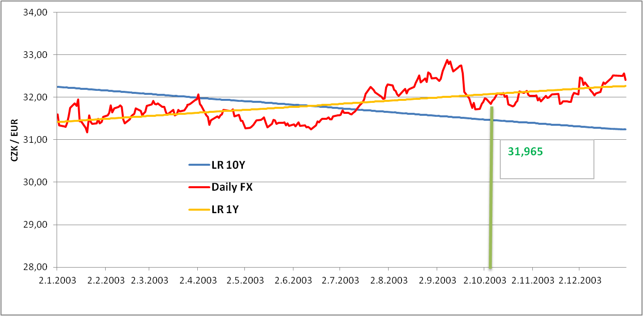
Figure 5: CZK/EUR for 2003 (Source: Own calculations based on the CNB)
Table 3: Evaluation of 2003 and 2004 (Source: Own calculations)

Development of year 2004
The year 2004 showed the clear strong appreciation trend without significant fluctuations. The rate of appreciation was higher than in the long-term trend, which led to the convergence between short and long-term trends.
As is demonstrated in Tab. 3, the year 2004 for the first time showed both positive and negative results. Nevertheless, the final result remains positive. The profit could be achieved as the consequence of more significant appreciation.
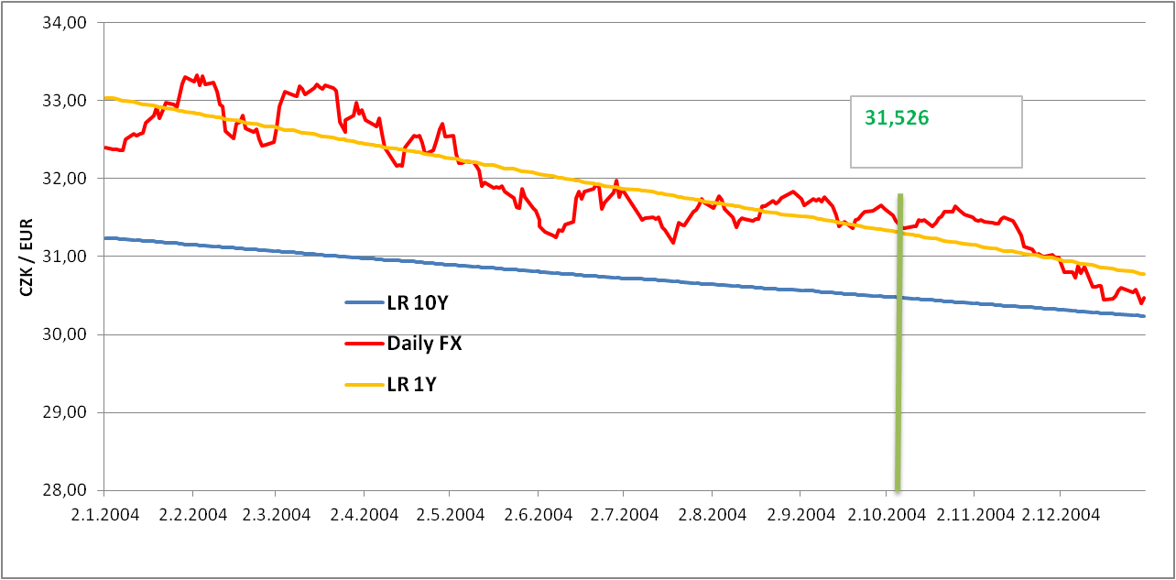
Figure 6: CZK/EUR for 2004 (Source: Own calculations based on the CNB)
Development of year 2005
Both trend lines in the year 2005 are nearly identical. The CZK was appreciating in expected way and without significant fluctuations within the whole period. The year evinces only positive results (Tab. 4).
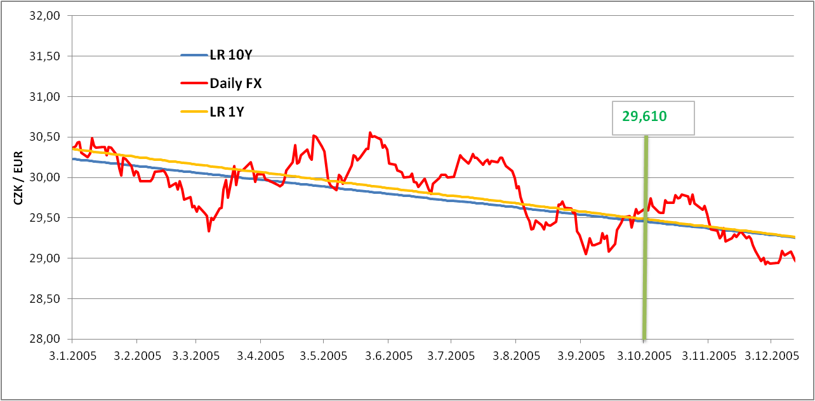
Figure 7: CZK/EUR for 2005 (Source: Own calculations based on the CNB)
Development of year 2006
The low fluctuations and slower appreciation rate have become key factors since 2006. The whole curve is under the long-term trend and therefore the slower appreciation is understandable. High entry level for forwards is the main success factor for positive result of hedging operations (see Tab. 4).

Table 4: Evaluation of 2005 and 2006 (Source: Own calculations)
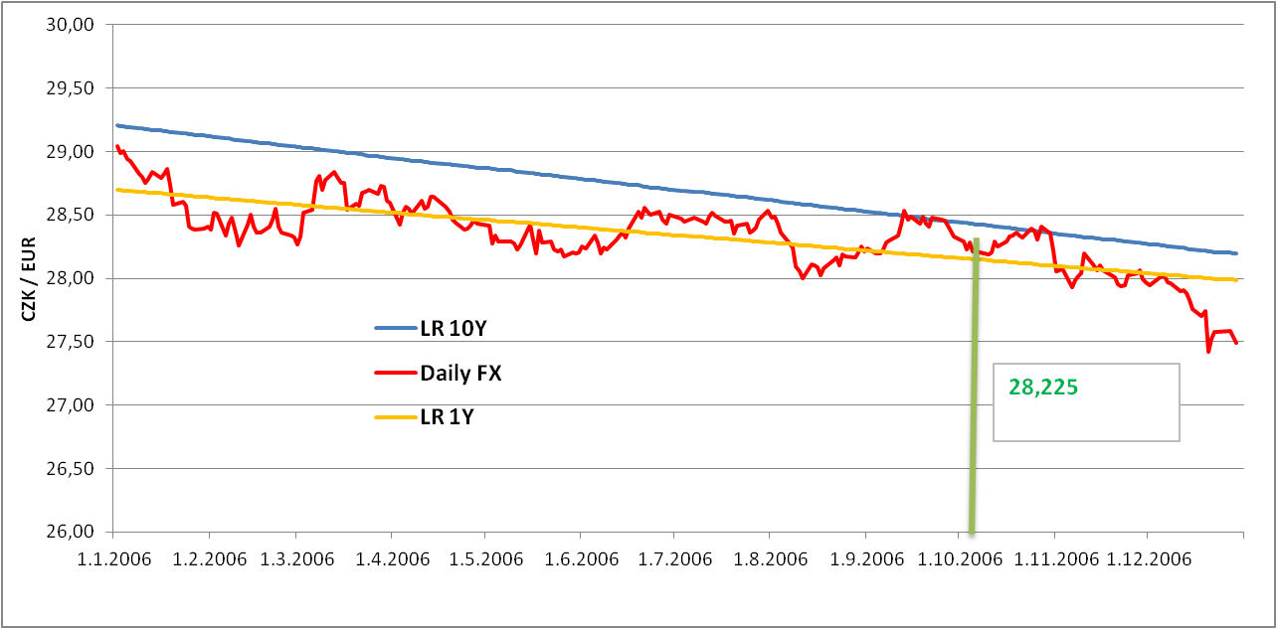
Figure 8: CZK/EUR for 2006 (Source: Own calculations based on the CNB)
Development of year 2007
There were a lot of fluctuations in 2007. After the weakening phase with the peak in July 2007, the steep appreciation followed. These high fluctuations are reflected in Tab. 5; the primary profits were transformed into three months losses and finally turned to the final profit phase.
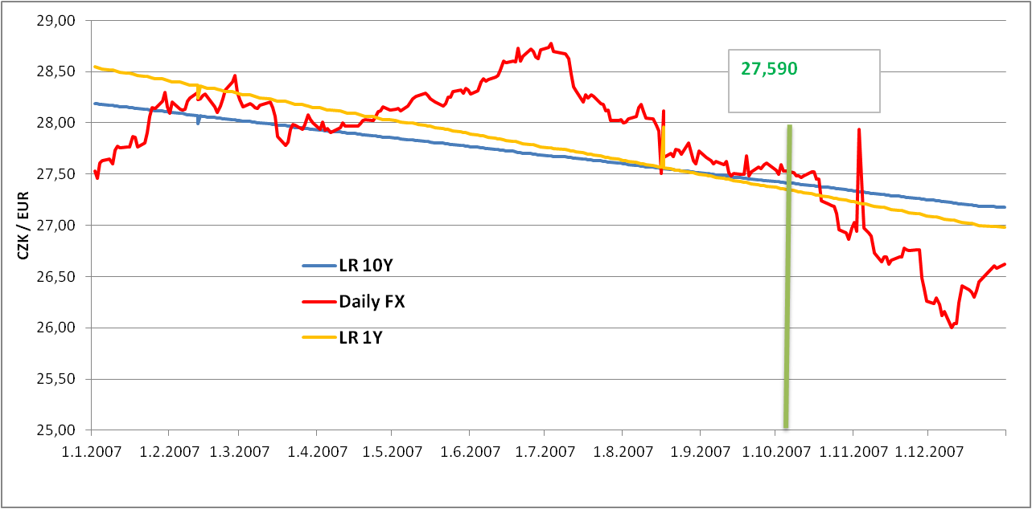
Figure 9: CZK/EUR for 2007 (Source: Own calculations based on the CNB)

Table 5: Evaluation of 2007 and 2008 (Source: Own calculations)
Development of year 2008
Year 2008 was accomplished with high fluctuations and unexpected changes. The CZK reacted swiftly on the crisis. The rapid strengthening of CZK was followed by a huge fall, related to the start of crisis. According to Tab. 5, the hedging was efficient, but it should be noted that the July result represents 15% of the total profit.
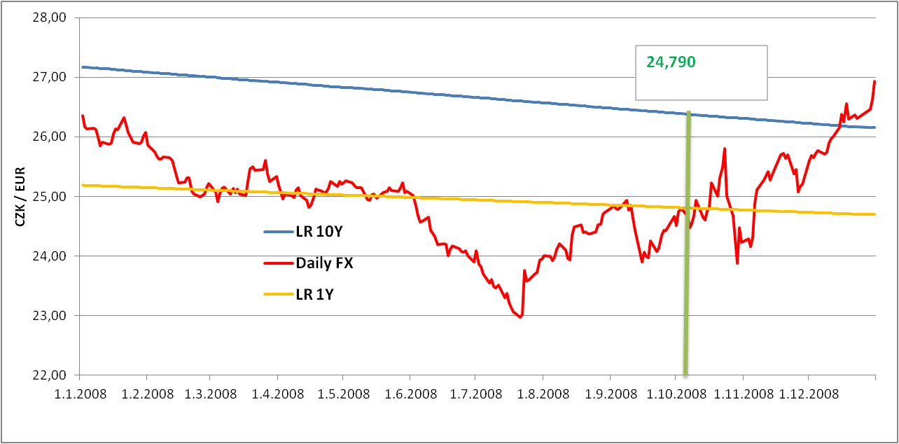
Figure 10: CZK/EUR for 2008 (Source: Own calculations based on the CNB)
Development of year 2009
The first half of 2009 was characterized by the overall crisis and high uncertainty. The weakening of CZK was the expected reaction. The following correction, in beginning of April, eliminated the dip and the CZK returned to the appreciation trend.
However, the results of hedging operations show clearly negative figures (see Tab. 6); thus, it was very unprofitable for the company to make a currency hedging in this year.
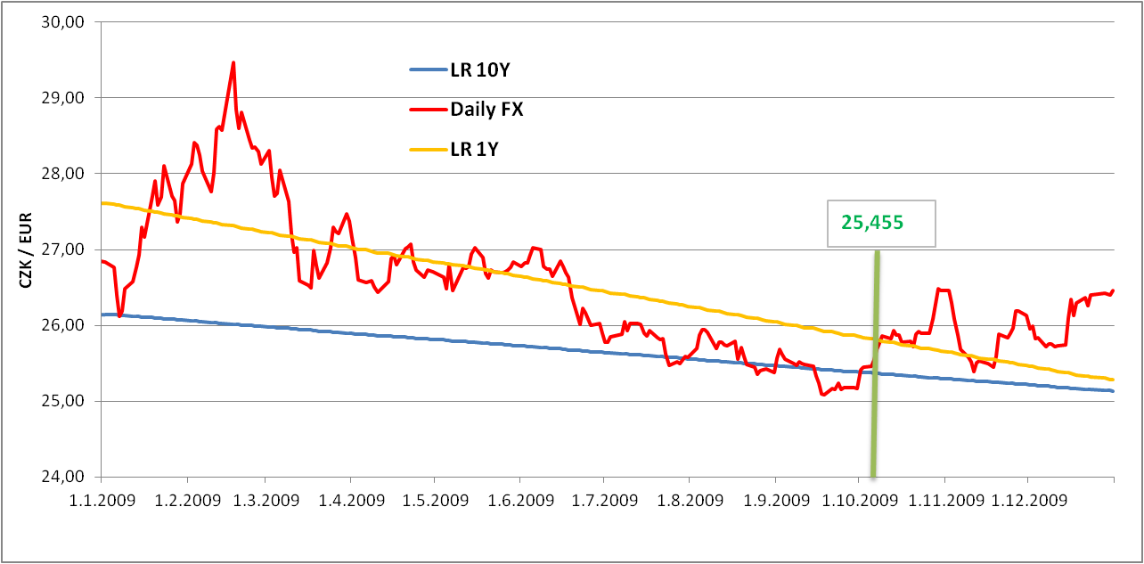
Figure 11: CZK/EUR for 2009 (Source: Own calculations based on the CNB)
Table 6: Evaluation of 2009 and 2010 (Source: Own calculations)

Development of year 2010
The short term trend line of 2010 was above the long term, but almost parallel. The appreciation was therefore very similar to the long-term expectations. After a very turbulent year of 2009, the CZK reacted immediately, even to usually weak factors. Regarding the hedging strategy, the positive forward points contributed to the final positive result (see Tab. 6).
In conclusion, the currency hedging for the artificial exporting company can be considered as successful, with the cumulated profit of CZK 95.196.015, 95.
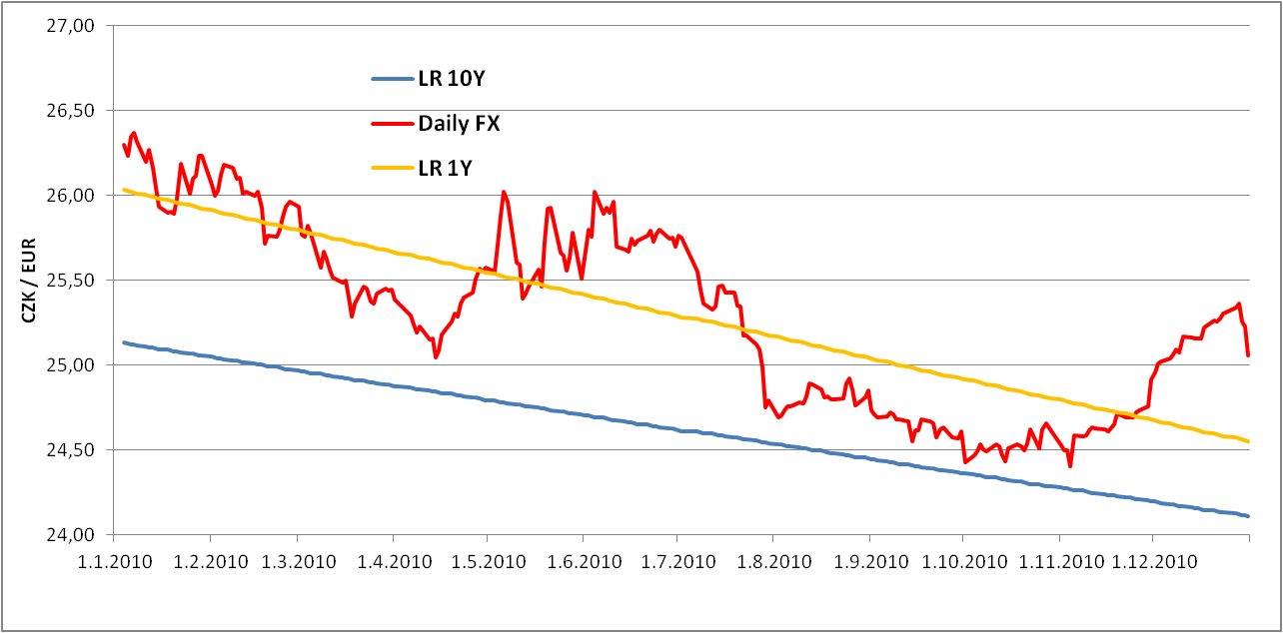
Figure 12: CZK/EUR for 2010 (Source: Own calculations based on the CNB)
Fig. 13 confirms the turbulent development of CZK/EUR. This development, i.e. weakening of CZK, caused problems to majority of the exporters hedged. Two scenarios have been used for the model example. Scenario 1 means the weakening to the level of 27,000 CZK/EUR, scenario 2 means the strengthening to the level of 25,000 CZK/EUR.
Scenario 1
Scenario 2
22,00
22,50
23,00
23,50
24,00
24,50
25,00
25,50
26,00
26,50
27,00
27,50
28,00
28,50
29,00
29,50
01.08
03.08
05.08
08.08
10.08
12.08
03.09
05.09
08.09
10.09
12.09
MONTH
CZK/EUR

CNB
40-day average
200-day average
Figure 13: CZK/EUR for 1/2008 – 2/2010 and the scenario determination (Source: Own calculations based on the CNB)

The selection of five typical hedging strategies frequently used among the exporters has been made. All data were gained from Komerční banka, a.s. Tab. 7 briefly summarizes the main features of derivatives (see Henderson, 2002, especially chapter 7, for an overview of hedging strategies). The “SPOT” column presents a reference value of CZK/EUR valid at the moment of strategies creation. The premium is the option premium paid. Columns marked with a minus sign (-Call; -Put) denote the strike prices of sold options.
Table 7: Comparison of hedging strategies for € 1.000.000 on February 23, 2011
Druh zajištění |  | SPOT | STRIKE | Premium | STRIKE  -Call | STRIKE  - Put
1 | Forward | 25,750 | 25,885 | 0€
2 | Nákup PUT EUR | 25,750 | 25,885 | 36.900€
3 | Leveraged synthetic FWD 1: 2 | 25,750 | 26,450 | 0€ | 26,450
4 | Seagull | 25,750 | 25,900 | 0€ | 26.500 | 24,800
5 | Knock In Forward (Leveraged 1:1,5), KI 26,850 | 25,750 | 26,050 | 0€ | 26,050

- Forward – The exporter is hedged at level of 25,885 CZK/EUR and is obliged to deliver € 1.000.000 to the agreed date. The premium is not paid.
- Purchase PUT EUR – The exporter is hedged at level of 25,885 CZK/EUR. It has the right, but not the obligation, to realize hedging. For this right 36.900 € is paid.
- Leveraged synthetic Forward 1:2 – The exporter is hedged at level of 26,450 CZK/EUR. For this right, however, the obligation is applied (i.e. counterparty's right) to exchange on the invitation (i.e. implementation of sold option) twice the volume, i.e. € 2.000.000 for 26,450 EUR.
- Seagull – If the exchange rate at the date of implementation is within <24,800; 25,900>, the exporter is hedged at level of 25,900 CZK/EUR. If the CZK is weaker, it can benefit up to 26,500 CZK/EUR. If the CZK is stronger, the exporter receives 1.000.000 * 1,100 (i.e. 25,900 – 24,800) = 1.100.000 CZK.
- Knock in Forward, leveraged 1:1, 5, KI 26, 850 – The exporter is hedged at level of 26,050 CZK/EUR (i.e. right). However, if 26,850 CZK/EUR is traded (activation barrier), it has the obligation to exchange on the invitation of counterparty (i.e. implementation of sold option) € 1.500.000 for 26,050 EUR.
Tab. 8 summarizes the impact of above strategies for given exchange rate predictions. The “In Total” column presents the overall results, including the paid option premium. The model is based on standard assumptions that each party uses its option right, provided it is advantageousness.
Table 8: Overall impact of derivatives at predicted rates (Source: Own calculations)
Hedging strategy |  | Scenario 1 |  |  | Scenario 2
 |  | Loss | In total | Sold | Profit | In total | Sold
1 | Forward | -1.150.000 | -1.150.000 | 1.000.000€ | 885.000 | 885.000 | 1.000.000€
2 | Purchase PUT EUR | 0 | -955.000 | 0€ | 885.000 | -70.000 | 1.000.000€
3 | Leveraged synthetic FWD 1: 2 | -1.100.000 | -1.100.000 | 2.000.000€ | 1.450.000 | 1.450.000 | 1.000.000€
4 | Seagull | -500.000 | -500.000 | 1.000.000€ | 900.000 | 900.000 | 1.000.000€
5 | Knock In Forward (Leveraged 1:1,5), KI 26,850 | -1.900.000 | -1.900.000 | 2.000.000€ | 1.050.000 | 1.050.000 | 1.000.000€

Tab. 8 shows that scenario 1 (i.e. the strengthening of CZK) leads in all case to the loss. This result is, of course, predictable, since the exporter is hedged against strengthening and not weakening of CZK. The amount of the loss can be reduced by the selection of appropriate derivative. The forward with its firm commitment to fulfill the term does not offer many opportunities. Strategy 2 means the loss of 0 CZK (non-implementation of option) and the total loss is equal to the option premium paid. This loss would be constant even under the catastrophic weakening of CZK. The leverage effect of strategy 5 has very negative impact. Due to the breakthrough of action barrier (27,000 › 26,850), the counterparty has acquired the right to purchase € 2.000.000 for a favorable rate. In case of unexpected weakness, strategy 4 seems to be most advantageous, since the wide opening of seagull that protects against weakness.
Scenario 2 leads, as expected, in all cases to exchange rate profit. When using strategies 1 and 2, the profit remains the same. Nevertheless, the option premium paid causes the overall loss. Strategy 4 offers a slightly better result than forward and due to the absence of option premium is generally interesting.
With respect to the outcomes, the most attractive are the strategies with financial leverage, namely strategies 3 and 5. Concerning strategy 3, the realized exchange rate profit is approximately 64% higher than in case of forward. As demonstrated in scenario 1, this option is associated with a high risk in case of the CZK strengthening. It confirms a fundamental law financial markets that high profits are linked with high risk.
The overall findings indicate that the final result is influenced not only by non-suggestible factors of the financial market, but also by the suitable selection of hedging method. The selection of hedging instrument is one of the key aspects of hedging effectiveness. This selection is dependent on managers, usually financial managers, on market information but also on education of managers and their attitudes towards risks.
The questionnaire survey was conducted on managers of industrial companies in South Moravian region in order to determine whether these companies monitor the risks to which they are exposed. The outcomes of the survey are presented in Fig. 14 and Fig. 15.

Figure 14: The overview of monitored risks in industrial companies (Source: Own elaboration)

Figure 15: Attitude of managers towards risks (Source: Own elaboration)

The results indicate that the most frequently monitored risks associated with the rising costs arising from changes in inputs prices. Therefore, it is likely that companies control their suppliers and monitor input markets. It has been observed that firms do not reflect financial, legal, environmental or information risks. Despite the rather financial crisis and several month long shortage of liquidity, it seems rather surprising that companies do not consider financial risks. Further research should investigate whether the companies include the potential exchange rate risks, which may be linked to the prices of their inputs (or outputs as well), into the prices of inputs. The prevailing attitude towards risk among observed firms is neutral. This finding can be viewed as a form of passivity rather than proactive negotiations aiming to take advantages of possible opportunities. It is therefore conceivable that risks that are monitored and subsequently controlled are related to this attitude.
:
Figure 16: The relation between managers' education and used hedging strategies (Source: Own elaboration)

Table 9: Results of Chi-square test between education of managers and hedging against exchange rate risk (Source: Own calculations)
Pearson Chi-square test
H₀: Variables are independent.  H₁: Variables are dependent. | Chi-square: 14.58912
H₀: Variables are independent.  H₁: Variables are dependent. | DF: 3
H₀: Variables are independent.  H₁: Variables are dependent. | P-value: 0.00220

The relation between managers' education and the company's hedging has been tested in examined industrial enterprises in the Czech Republic (see Fig. 16). The chi-square test has been performed with a significance level £= 0.05. The null hypothesis was rejected since p-value is lower than the level of significance. The test has proved that the education of the employee, who makes decisions about the hedging against exchange rate risks, influences whether the company is hedged or not. The managers' education is a significant aspect that has to be taken into consideration within the process of currency hedging.

Conclusions
According to the Henderson (2002), the management of the currency risk is to be a part of the corporate financial strategy. Nevertheless, our study substantiated that in the field of currency risk management, there exist many situations which are extremely difficult to predict. Taleb (2007) describes these situations, which led to unexpected jumps and discontinuities, as “Black Swans”,
For a serious consideration of hedging strategy as a part of financial strategy in the Czech environment, the long term and short term analysis of CZK/EUR development is to be done. Based on the long term analysis (ten years), the long term appreciation rate has been calculated for CZK/EUR. With help of the artificial company, the hedging procedure was simulated to compute the overall efficiency. After ten simulations, the conclusion is that for an exporting company, the use of currency hedging makes sense.
We can argue to add the hedging strategy to overall financial strategy. However, in times of crisis and unexpected weakening of the CZK, high losses occur. This “impact of highly improbable” (see Taleb, 2007) is one of the biggest risks of hedging and the company has to be strong enough to overcome these unexpected periods. The unpredictable situations, or their impact, have to be considered and solved as the part of hedging strategy.
The results clearly indicate that hedging against exchange rate risk is relevant. The essential prerequisite for successful hedging is the accurate knowledge of net foreign exchange exposure (see Homaifar, 2003), without which the attempt to hedge can become mere speculation. The creation and compliance of a directive for the implementation of hedging transactions should be self-evident. This is also related to the issue of managers, their education and competencies. The research shows that in the context of competitiveness the company must very carefully choose a manager and develop further education to be able to manage and eliminate currency risks.
The findings confirm that from the standpoint of economic efficiency, the easiest hedging instrument does not have to be the most advantageous one. The forward contract is well-known, widely used and easy to understand, nevertheless, the options are limited. In times of economic crises, when the predictability of future cash-flows decreases (i.e. from the point of view of the absolute amount and timing), it is appropriate to deal with more complex products that give the exporter more opportunities if the prediction fails and cash-flow develops unfavorably. In this case, the possibility of options, respectively the possibility of their non-utilization, represents the way how to mitigate the cumulative negative impact of a cash flow loss.
The manager who has developed a risk management strategy should focus on exchange rate risk and monitor regularly its potential impact. The economic crisis has brought the increased uncertainty and high volatility of currency markets into the financial planning. Yet, it does not mean that the businesses no longer deal with the issue of exchange rate hedging. By the knowledge and selection of suitable financial instruments, the company may convert the unilateral dependence on currency development into the comparative advantage.

Acknowledgement
This paper was worked out thanks to Internal Grant Agency of Faculty of Business and Economics, Mendel University in Brno project No. 33/2012.

References
- Althaus, C. E. (2005). A Disciplinary Perspective on the Epistemological Status of Risk.
Risk Analysis. 25(3), pp. 567-588
- Anderson, D. R. et al. (2010). Statistics for Business and Economics. South-Western
College Pub
- Beltratti, A., Laurent, A., Zenios, S. A. (2004). Scenario modelling of selective hedging
strategies. Journal of Economic Dynamics and Control. 28(5), pp. 955-974
- Coyle, B. (2000). Hedging Currency Exposures. Financial World Publishing
- Chisholm, A. M. (2010). Derivatives demystified: a step-by-step guide to forwards, futures, swaps and options. New York: John Wiley & Sons
- Choi, M. S. (2010). Currency risks hedging for major and minor currencies: constant hedging versus speculative hedging. Applied Economic Letters. 17, pp. 305-311
- Donoso, G. (1995). Exporting and hedging decisions with a forward currency market: the multiperiod case. The Journal of Future Markets. 15(1), pp. 1-11
- Fotr, J., Hnilica, J. (2009). Aplikovaná analýza rizika. Praha: Grada Publishing, a.s.
- Gregorius VIIII (1227-1241). Decretalium Complatio. http://www.documentacatholicaomnia. eu/01p/1227-1241,_SS_Gregorius_VIIII_Decretalium_Compilatio,_LT.pdf (accessed 1.10.2011.)
- Henderson, C. (2002). Currency strategy. New York: John Wiley & Sons
- Homaifar, G. A. (2003). Managing Global Financial and Foreign Exchange Rate Risk. New York: John Wiley & Sons
- Hula, J. (2012). Možnosti využití spotů a derivátů v podnikové praxi. Finanční management. 10(2), pp. 41-42.
- Jílek, J. (2005). Finanční a komoditní deriváty v praxi. Praha: Grada Publishing
- Knight, F. H. (1921). Risk, Uncertainty and Profit. Cambridge: The Riverside Press Houghton Mifflin
- Kolb, R. W., Overdahl, J. A. (2010). Financial derivatives – Pricing and risk management. New York: John Wiley & Sons
- Martinovičová, D., Beranová, M., Polák, J., Drdla, M. (2010). Teoretické aspekty kategorizace rizik. Acta universitatis agriculturae et silviculturae Mendelianae Brunensis. LVIII(3), pp. 131-136
- Merna, T. (2007). Risk management. Brno: Computer Press
- Pulchart, V. (2011). Lidé a jejich kompetence v managentu rizik. Finanční management. 9(2), pp. 41-42.
- Riederová, S. (2010). Currency hedging with help of derivates. Acta universitatis agriculturae et silviculturae Mendelianae Brunensis. LIX,(4), pp. 273-280
- Subramanian, R. A. (2011). The importance of currency returns and currency hedging. MSCI Barra Research Paper No. 13. http://ssrn.com/abstract=1915325 (accessed 30.05.2012.)
- Taleb, N. N. (2007). The Black Swan: The Impact of the Highly Improbable. Random House
- Tichý, M. (2006). Ovládádní rizika. Praha: C.H. Beck
- Yan, X., Gang Su, X.(2009). Linear regression analysis: Theory and computing. World Scientific Publishing Co.

Department of Business Economics, Mendel University in Brno, Zemědělská 1, 613 00 Brno, Czech Republic, xriedero@mendelu.cz
Department of Business Economics, Mendel University in Brno, Zemědělská 1, 613 00 Brno, Czech Republic, pinkova@node.mendelu.cz

