LOGO WILL BE HERE
NUMERICAL MODEL FOR THE CRITICAL STRESS DETERMINATION IN SPUR GEARS - CASE OF A DRIVEN GEAR

Daniela Ristić, Dragan Milosavljević
Summary: Tooth root form and fillet radius have a great influence on gear tooth root strength that is one of the primary subjects of this paper. Special attention is given to analysis on impact of gear tooth fillet radius at the critical cross section on stress value and distribution. Stress intensity factor and gear working life depends directly on tooth root stress. It is well known that a first initial crack appears at the gear tooth affected the most by root stress concentration. Hence, this paper’s research topic is focused on finding the optimal fillet tooth root radius to minimize the tooth root stress intensity. This paper provides results achieved by application of numerical methods - finite element method (FEM) and real working conditions simulation. The results of this analysis are presented in this paper as figures and tables of Von Mises stresses as well as charts against different values of tooth root fillet radius ρ_{F}.
Key words: finite element method-FEM, tooth root stress concentration, tooth root fillet radius.
- INTRODUCTION
It is well known that a first initial crack appears at the gear tooth affected the most by tooth root stress concentration.
Tooth root critical cross section, according to ISO recommendation, is determined by tooth fillet radius tangent that is positioned 30° against gear symmetry line, and its dimensions are in critical cross section of width s_{Fn} and face of width b.
Tooth root critical cross section is exposed to a pressure load under radial component, and under tangential component as bending and shearing. It all shows complex load state in the tooth root critical cross section. Accumulation of normal stresses gives maximal stress on pressured side of the gear tooth, while, in the same time, resulting normal stress on the tensile side is considerably less than on the pressured side of the gear. However, unwanted phenomenon as plastic deformations, crack initiation, even a gear failure appears on a tensile side of gear tooth. Plastic deformations make material strength significant and they give elasticity threshold appearance which gives cracks initialization. According to that, rectangular tooth root cross section is deformed and goes to trapeze form, which leads to changes of the position of neutral axe.
Consequently, all stress values on the tensile side of gear tooth are important for determination of applied stresses.
- CHARACTERISTICS OF ANALYZED GEAR
All analytical and numerical researches are carried out on a real construction with real condition simulation. Considered driven gear is a part of structural elements of great power planetary transmitter (big excavator of power 2x550kW) [1, 2, 5].
As a consequence of working conditions and irregular formed tooth root shapes appearance of failures is often remarked during the exploitation. Because of that, the topic of this work is determination of exact tooth root stress and optimal tooth root shape.
According to the theory, at the contact point B, double mesh follow transforms to single and reverse. In that point F_{bn} force acts in total value, while in point A, F_{bn} force acts with half of its total value. Hence, the most important loads for stress concentration appearance are the loads in contact points A and B at driven gear. Loads in other mesh contact points have no big influence on critical cross section stress concentration and they don’t cause failures and crack initiation in a tooth root. In this paper shall be represented only results for the driven gear and its A and B contact points.
These researches are deduced to stress determination for a driven gear tooth of observed planetary transmitter according to various tooth root fillet radius ρ_{F}. The tooth root fillet radius ρ_{F} has the most important influence on tooth root stress concentration, so that is the topic of this work. It is analyzed for eight different values of tooth root fillet radius ρ_{F}. The lowest value is ρ_{F} = 4.56 mm and it is incrementally increased to the value of ρ_{F}=10.94 mm. Fig. 1 shows dimensions of critical section for tooth of a driven gear.
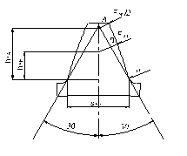
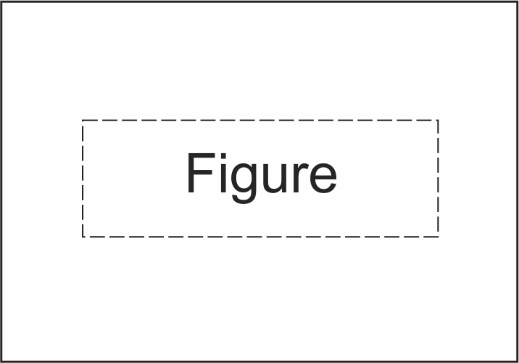
Fig. 1 Dimensions of the critical section for driven gear tooth
Tooth root fillet radius ρ_{F} is given in the form of:
where с_{p} presents gear tip clearance (с_{p} = (0.1÷0.3)m, m - module).
- ANALYSIS OF RESULTS BY FEM
Numerical analysis is deduced to determination of Von Mises stresses and normal stresses, for a driven gear of planetary transmitter, according to the tooth root fillet radius ρ_{F}. Finite element method (FEM) is used for numerical analysis here. For that purpose finite element package FEMAP v.9.3 [4] is used. On the basis of the gear data, the 3D finite element model is made [6, 7]. One driven gear tooth has 11240 elements and 12915 nodes. The mesh is refined in the tooth fillet region in order to show the best possible way the stress condition in that section. Only 50 mm width layer of tooth is analyzed according to a supposition that load is equally arranged along the instantaneous tooth side contact line. The gear tooth is loaded with the normal force F_{bn}, which is acting at the outer point of single tooth contact (B) and inner point of double contact (A).
Outer load, normal force F_{bn}, that is equally arranged along the instantaneous tooth side contact line, is changed with concentrated force at nodes along that line (21 nodes along the width b₁). It is possible to get equal force distribution along the tooth width, if it is possible, to have more layers of finite elements and that sooths influence of concentrate force in the instant contact point.
Developed FEM of stress determination in gear tooth root allows not only good picture of stress distribution but even defines exact position of maximum stress value point. In the same time, processes of stress concentration are nominated, which is very important in engineering.
The results of such numerical computations for Von Mises stresses at critical section and normal stresses are presented in Tab. 1. For results of this paper the most important are stress values in the critical section nodes of tensile side of the gear, because these stresses cause damages and failures of the gear at the end.
Table 1 Von Mises σ_{e} and normal stresses σ_{y} at critical section on the tensile side of the driven gear tooth
Fillet radius  ρ_{F} [mm] | σ_{e} [MPa] |  | σ_{y} [MPa]
Fillet radius  ρ_{F} [mm] | A | B | A | B
4.56 | 122.2709 | 161.3647 | 114.4822 | 149.1460
5.47 | 122.2340 | 159.7299 | 112.0955 | 144.1272
6.38 | 119.8831 | 157.9008 | 108.3209 | 140.1133
7.29 | 117.3293 | 153.2990 | 105.4750 | 135.1501
8.22 | 115.7455 | 151.0676 | 102.2062 | 130.4780
9.12 | 114.1146 | 148.3358 | 99.7774 | 126.6121
10.03 | 112.8445 | 142.4273 | 97.3036 | 119.4627
10.94 | 108.8632 | 140.5581 | 92.0478 | 115.6458
It may be seen from these tables that Von Mises σ_{e} and normal σ_{y} stresses become smaller as fillet radius ρ_{F} grows up and it is in agreement with analytical results [1, 2, 5]. So, there is a recommendation for higher values of fillet radius, but only in allowed boundaries.
Fig.2 shows the results of numerical computations for Von Mises and for normal stresses both for the load acting in the first two contact points (A and B).
It shows, for the analyzed gear, (a) the functional relationship between equivalent stresses and various values of fillet radius ρ_{F} and (b) relationship between normal stresses and fillet radius ρ_{F}. These graphs show again a fact that tooth root stresses become smaller as fillet radius ρ_{F} grows up.

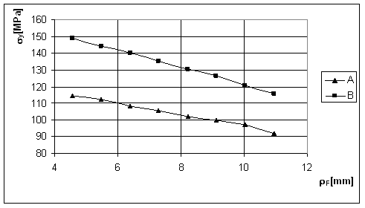
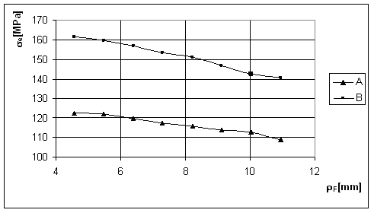
(a) (b)
Fig. 2 (a) Equivalent stress σ_{е} in function of fillet radius ρ_{F} and (b) normal stress σ_{y} in function of fillet radius ρ_{F}.
All values of equivalent stresses, in function of notch parameter s_{Fn}/2ρ_{F}, are presented by graphs in Fig.3 and values of normal stresses in Fig.8. Notch parameter becomes smaller as fillet radius grows up, and that cause, again, smaller values of tooth root stresses.
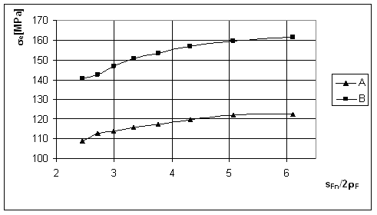
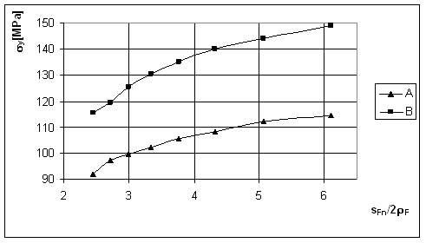
(a) (b)
Fig. 3 (a) Equivalent σ_{е} and (b) normal σ_{y} stress in function of notch parameter s_{Fn}/2ρ_{F} for a driven gear tooth.
The greatest values of normal and equivalent stresses in the tooth root appear in the moment when the contact between two meshed gears is in the outer point of single mesh. The diagrams of stresses in this paper show good agreement with that assumption.
There is a conclusion, according the analysis in this paper, that a notch parameter has great influence on tooth root load capacity. In the same time, as the notch parameter grows up the stresses grow up, and reverse. Critical section width s_{Fn} grows up as the tooth root radius grows up, and that cause smaller stresses. Therefore, critical section stresses become smaller as the fillet radius grows up.
For driven gear there is some stress values disagreement of linear distribution for fillet radius higher than ρ_{F} = 10.03 mm, but for driving gear disagreements of linear distribution are for fillet radius less than ρ_{F} = 5.47mm (not presented in this work). For that reason, these values of fillet radius should be boundary (5.47 mm < ρ_{F} < 10.03 mm).
Graphs in this research show that appropriate selection of fillet radius should reduce critical stresses for 30% and that is important information for designers.
Stress concentration factor Y_{s} may be determined on the bases of the expression:
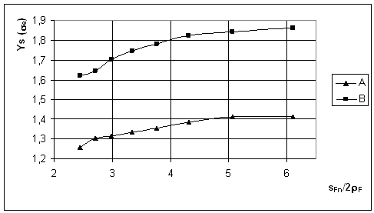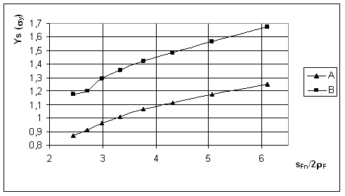
(a) (b)
Fig. 4 Graphs of stress concentration factor Y_{s} in function of notch parameter s_{Fn}/2ρ_{F} for the: (a) equivalent stresses and (b) normal stresses
In this expression σ_{max} is determined experimentally or by some numerical methods. Whereas, there is a complex strain in the tooth root, maximal stress is determined by FEM in this paper. Nominal stress σ_{Fn} may be expressed as:
Radial component of F_{bn} force is ignored for nominal stress σ_{Fn} determination, as the pressure and share stresses in tooth root are.
According to the results of research in this paper, diagrams of stress concentration factor Y_{s} in function of the notch parameter s_{Fn}/2ρ_{F}, for the both of stresses, equivalent and normal, are plotted in Fig. 4.
Stress concentration factor Y_{s} values from these graphs may be used for gear stresses determination [3].
The created model represents the basis for further development of the calculation of tooth root strength with respect to geometry, load distribution and the teeth manufacturing accuracy and for optimization of gear trains.

- CONCLUSION
The aim of this paper is forming efficient and reliable numerical model for the determination of tooth root phenomena, caused by geometrical discontinuity under static and cyclic loads. Results in this research show good agreement with data in literature and practice, and therefore this methodology may be applied in practice.
The most important are tooth root stresses caused by load in the inner contact point of mesh, because they are the greatest and the most dangerous for failure appearance.
It can be concluded, analyzing results of this research, that stresses reduce as tooth fillet radius grows up. Reduction of stress concentration acts directly on gear service life extension, because it deflects danger of initial cracks appearance and increases safety factor S_{F} in that place. Although the stresses on pressured side are higher than on the tensile side, stress concentration on the tensile side is more important for initial crack appearance. But for the better tooth root stress consideration, stresses on both tooth root sides are presented in this paper.
In this research Von Mises and normal tooth root stresses are presented. All results show that Von Mises stresses have greater values then normal stresses.
This paper shows that appropriate fillet radius selection can increase tooth root stresses in its critical section even by 30%. It was an intention of this research, because in that case it could succeed better tooth root load capacity and service life elongation.
We still don’t have acceptable data for the parameters that describe tooth root phenomena, so these analyses are actual further more. Accordingly, further researching is of great interest for science development.
REFERENCES
- Ristić D. (2009), Computation Model For The Analysis Of Gear Tooth Root Stresses, Proceedings of 2nd International Congress of Serbian Society of Mechanics, Palić (Subotica), Serbia, M2-01:1-15
- Ristić D. (2009), Numerical Stress Concentration Analysis of a Driven Gear Tooth Root With Two Fillet Radius, Scientific Technical Review, Vol. LIX, No. 3-4, pp. 69-77,
- Linke H., Stirnrad-verzahnung, Berechnung, Werkstoffe, Fertigung, Carl Hanser Verlag Münch., Wien, 2002.
- MSC/NASTRAN- Theoretical Manuals
- Nikolić V., Mechanical analysis of gear transmitters, monography (in Serbian), Kragujevac, 1999.
- Bogdanović G., Nikolić V., Milosavljević D. (1993): Analysis of dynamics behaviour of gear transmitter, Jumeh, Proceedings of XX Congress on Theoretical and Applied Mechanics, Kragujevac, pp. 184-187
- Milosavljevic D., G., Bogdanovic G., Veljovic LJ., Radakovic A., Lazic M. (2010), Failure Criteria of Fibre Reinforced Composites in Homogeneous Temperature Field, Thermal science, Vol. 14, pp. S285-S297

Phd, Daniela Ristić, Zemun-Beograd, TEHNIKUM TAURUNUM, High School Of Engineering, daniela.ristic@gmail.com
Phd, Dragan Milosavljević, Kragujevac, Faculty of Engineering, The University of Kragujevac, dmilos@kg.ac.rs

