Protection of intellectual property as a means of evaluating innovative performance

Ing. Žaneta Rylková, Ph.D., Mgr. Monika Chobotová, Ph.D.

Abstract
Intellectual property is an important tool that helps to improve the competitive position of firms in the market. Currently, companies have no motivation to protect intellectual property because they have enough experience in order to handle the entire process themselves. Commercialization of innovations into protectical use does not currently exist without the protection of intellectual property. Firms should be aware that when you interest a lot of resources into research and development, and implementation of protection of this investment is a necessary phase that should be included in the innovation process. Innovative activity is closely related to the definition of innovation process. Innovative activities can be seen as capturing the relative performance of firm in a given period. It should be stressed that it has no meaning to speak of innovation activities of firms without binding to specific competitive conditions and regardless of the specification of rivals. Distribution of innovative activities of individual companies in a given time period then reflects differences in innovative capabilities among firms. Innovation performance follows the innovative activities of the company but as innovation activity it is not the property of the company. It is again the result of the innovation process and arises from interactions among competing firms in a given market situation. Innovation performance (implementation of innovation) stands up to the very end of the innovation process. For measurement it is necessary to understand and describe the whole innovation process and to identify factors that may affect the ultimate realization of innovation. Measuring output includes for example number of newly listed products, changes in market share, growth in sales and profit growth from sales of innovative products. It is also important to know that the measurement should involved financial and nonfinancial criteria for evaluation of innovation performance. Innovation performance is generally considered as a crucial component of long-term competitiveness of countries and regions. The paper introduces innovative performance and patent activity of the Czech Republic on the basis of secondary research. From the primary research it may be inferred that measurement of innovative performance can have high impact on the speed of adaptability of companies to changes and development. The aim of the paper is to highlight that innovation and patent activity and their measurement are a prerequisite for the development of companies. This paper was supported by the project "Innovation of Educational Programs at Silesian University, School of Business Administration in Karvina" n. CZ.1.07/2.2.00/28.0017

Keywords: innovation performance, intellectual property, innovation

Introduction

Innovations today determinate the competitiveness of any organization; often they are pre-conditions of its survival. The paper introduces innovative performance and patent activity of the Czech Republic on the basis of secondary research. From the primary research it may be inferred that measurement of innovative performance can have high impact on the speed of adaptability of companies to changes and development. (Vacek, Egerová, and Plevný, 2011, p. 538)
Innovation measurement can be assessed in two basic levels. Company´s level uses to the measure research that deals with the economical results and financing, motivation of employees, or there is applied customer satisfaction. It can include revenue from the sale of a new product, the cost of research and development, the length of the life cycle of the product or how the product is perceived by consumers. The second level is the political - and deals with the competitive advantages of regions or countries in which innovation plays its unique role. In this case, the innovation can be evaluated by using the areas dealing with technology, processes, or marketing. (Pitra, 2006)
Measuring innovation should be carried out effectively, efficiently (must bring relevant information to the corporate management) and economically (must be done at a reasonable cost). Individual indicators generally meet the requirement of economy, but rarely effectiveness, as they focus on innovation from a too narrow view. (Hadraba, 2006)
Many companies began to realize the seriousness intellectual property (IP) in the last few years. This issue came to the fore of interest of entrepreneurs because it is means of ensuring competitive advantages. The importance of patent protection is becoming more important due to the rapid technological development in certain fields such as IT. On the market there are always new products, process marketing innovations that arise as a result of continuous customer needs. IP should be understood as a managerial discipline within which offers a portfolio of formal and informal means of tools, their specifics purpose is to support the business. Companies should be automatically established intellectual property protection in the innovation cycle, because in the event of the premature publication of new knowledge e.g. through publication in the journal, before he was protecting innovation, then the owner of this means high losses and losing competitive advantage. Currently IP should constitute a strategic element of any society. For this reason, businesses should create innovative strategy, which should include the patent strategy.

Innovative performance measurement and patent activity of the Czech Republic

According to the SII (Summary Innovation Index) the Czech Republic ranks third position in the group of countries known as moderates innovators with SII value slightly below the EU-27 in recent years. Moderate innovators are countries reaching 50 to 90 % of the EU-27. The average innovation performance is measured using a composite indicator that takes into account the "innovative results" of countries based on 24 indicators, zero is the worst possible result and maximal possible result is assigned by value 1. In the year 2011 the average innovation performance reflects the real innovation performance in 2009/2010 – the reason is the time delay in disclosure of relevant statistical data.
Countries belonging to the innovative leaders (innovation leaders) are reaching at least 20 % higher innovation performance than the average for the EU-27, the so-called followers of innovation (innovation followers) are those whose innovation performance is within 10 % below average to 20 % above the EU-27 average. Performance of Moderate Innovators group of countries is lower than in the EU-27, but reaches higher values than corresponds to 50 % of the EU-27. Countries with lower innovation performance belong to the group Moderate Innovators.
Czech Republic belonged according to rating dynamics of innovation performance (calculated on the basis of the development of the indicators making up the SII in the previous five years) with an average annual growth of 4.8 % among well above average among countries (average annual growth rate of the EU-27 amounted to 1.8 % ) in the year 2009. In the year 2010, the average annual growth in innovation performance of Czech Republic was lower - only 2.6 %, while the average annual growth rate of EU countries amounted only 0.85 %. Thanks to economic growth in the year 2010 (mainly due to positive developments in the manufacturing and service industries), the current average annual growth rate of the innovation performance of the Czech Republic rose to 3.2 %. While in the year 2010 the value for the EU-27 was 0.85 % in the year 2011 average growth rate dropped to 0.33 % due to the impact of the economic crisis. In both years, the resulting growth rate is positively influenced by the development of indicators in open, excellent and attractive research systems, the negative impact was observed in indicators of corporate investment, in usage of venture capital (there decreased indicator - amount of funds designated as venture capital to HDP3) and in innovators group (decrease of innovative small and medium sized enterprises).
The figure 1 shows the average annual change in the major indexes, which is calculated indicator SII. The graph shows the average annual change in the CR compared with Switzerland and EU27. Switzerland was chosen because it achieves the best position to evaluate and ranks among the leaders in innovation.

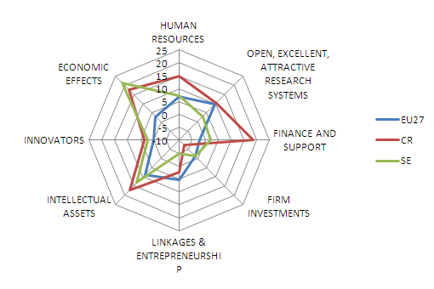

Figure 1 Annual average growth per indicator and average country growth (2011) (Source: Chobotová, 2013)

By international comparison of overall innovative performance of the Czech Republic remains below the EU-27, however, the ability to take advantage of economic benefits of innovation is deluxe. The main shortcomings of the innovative environment include low availability of financial resources for innovation (especially in venture capital) and small industrial use and legal protection. The data document "Analysis of research, development and innovation in the Czech Republic and their comparison with foreign countries in 2011" shows that competitiveness (innovative performance) CR is mainly driven by innovative activities of firms while the quality of the institutional environment is likely to be reduced (more information Innovation Union Scoreboard 2011, 2012).
The final position of the Czech Republic in the field of innovative performance is still below the European average but there is a trend of gradual convergence to the average innovative performance of the EU-27. However, the innovative performance and competitiveness of the country slows down inefficient management of public funds, excessive bureaucracy and poor political environment. This is clear from the international comparisons of WEF. Arising from the international comparison, the most evident limitation of the Czech innovative system is a relatively lower availability to financial resources and skilled workforce with the appropriate requirements for the development of innovative economic performance. Lack of innovation is also the number of entities that use legal forms of intellectual property protection. In the area of R & D the Czech Republic suffers with research activities support and ability to use venture capital to support individual firms with these activities. Compare to EU-27, the Czech Republic is also below average rate in using public resources spending on research and development. The communication and cooperation of the innovative system is also assessed as very weak. A little emphasis is placed at the return of investments and commercialization as the results of scientific research supported projects. Positive side of CR is the export of the high technology with the results achieving above-average. This is primarily due to the structure and openness of the Czech economy market. One of the tools for improving the environment in the area of science, research and innovation and which was also successfully used in many countries is so-called "Foresight". In Czech conditions, this is a completely new service provided by a state with the purpose to successfully identify technology areas of strategic importance. Foresight as an open system for the collection, evaluation and processing signals for strategic decision-making would enable The Czech republic to provide businesses with relevant information on new requirements, key technologies, changing markets, new sectors and new trends.
The results contained in the report of the international audit research and development (R & D) in the Czech Republic, among other things, reviewed, using a questionnaire survey where respondents classified (grade 1 = not at all to 5 = large extent) the use of formal and informal instruments for the protection of industrial property the following conclusions (figure 2):
- Czech companies consider the protection of intellectual property rights as an important medium.
- Patents were among the "limited" and "moderate" range of both national and international.
- Higher values ​​were recorded trademarks and utility models with grade 2.8 were considered "moderately important."
- Greater weight gave the company informal tools IP.

Protection of trade secrets was graded 3.6 ("moderate" and "large" scale), which is the highest value obtained in the survey. In second place with a 3.4 rating is considered strategies lead. Surprisingly strategy of relying on the performance of the technical solution is not so much preferred (average 2.7). (Radauer, 2011)

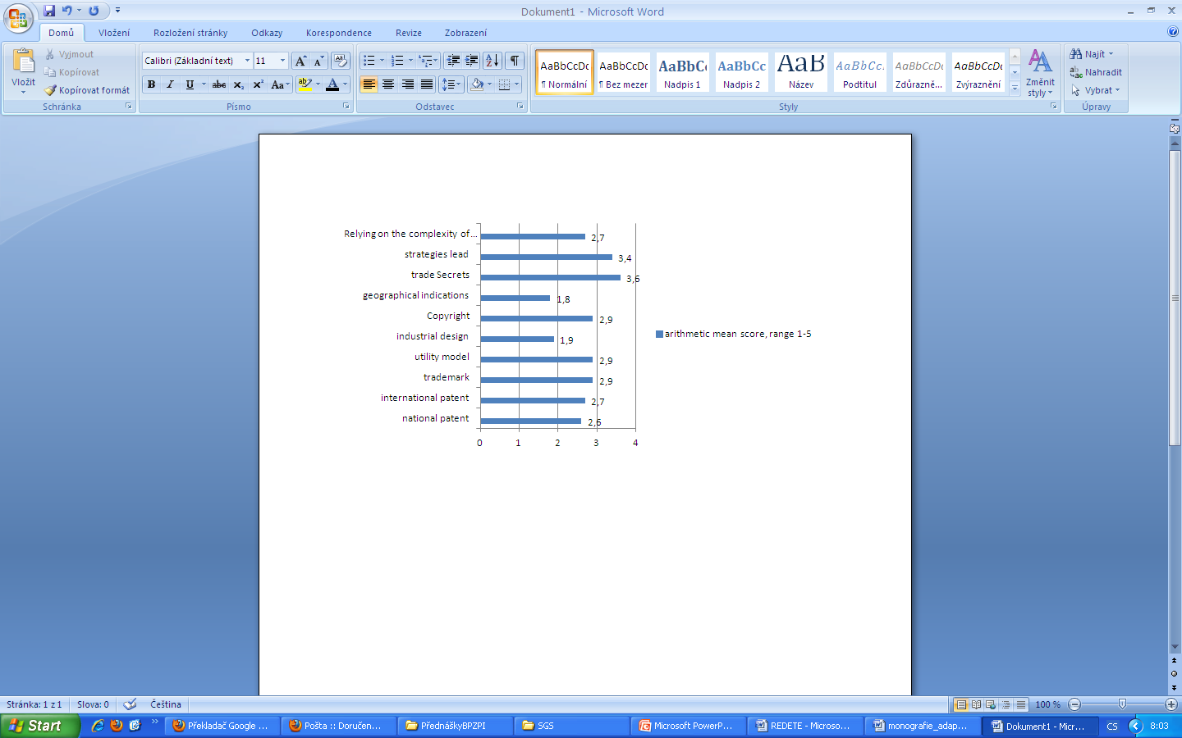

Figure 2 Relevance of different tools industrial property selected Czech companies (own according Radauer, 2011)

In this research have been identified barriers to the use of intellectual property (figure 3), respondents evaluated again grades 1 - "no obstacle" to 5 - "obstacle to large-scale". From the results shown in figure shows that the greatest obstacle to the use of IP enforcement is weak possibility (3.7) in second and third place are cost and lack of resources (time) to patenting. The problem were considered, the cost of filing and maintaining other forms of IP.
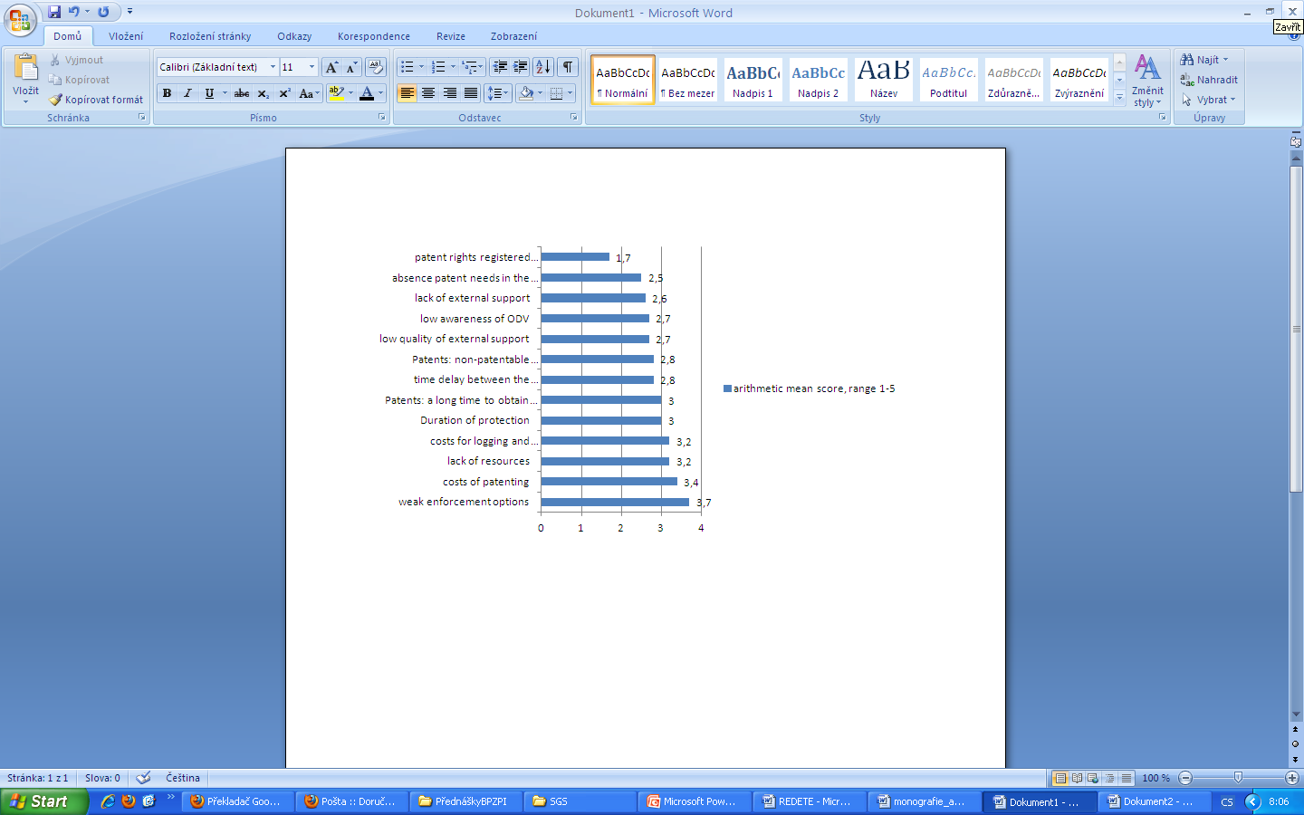

Figure 3 Barriers to the use of intellectual property, as perceived by respondents in industrial research ( own according Radauer, 2011)

The overview of the current state of research, development and industry, as well as the competitiveness of individual sectors indicate the number of patent applications, as well as the number of granted national patents and European patents for the validation of the Czech Republic. The website of the Czech Statistical Office annually publishes the data on the statistics of industrial property protection.
In terms of the breakdown field of patents granted at the end of 2012 in the Czech Republic had recording a total of 4,009 valid patents in the field of "Organic Chemistry" in 2012 were awarded the IPO (or validated) 747. This field together with the field of "Transport and storage" is including among the most important in terms of patent protection for domestic applicants. Very significant in terms of total number of patents is also necessary to mention the field of "medical, dental and hygiene products", here have been recorded 2,803 valid patents in 2012. Compared with utility models, which are considered small patent situation is somewhat different, 93.6% of the valid utility models, the owner of the Czech Republic. The most important industries are "Construction Industry" with 931 and "Handling and Storage" with total 889 utility models. From the perspective of selected areas of technology during the last 20 years in high-tech fields was granted only 7% of patents granted to applicants from the Czech Republic, representing the period 1992-2012 only 112 patents in high-tech fields of the total in 1729, and especially in micro-organism and genetic engineering. At the end of 2012, public research institutions had belonged less than half of Czech applicable patents in high-tech fields. Over the last 20 years was granted 700 patents in biotechnology (10 in 2011) and patents in the field of renewable 196 (3 in 2011) patents.
Association of Small and Medium-Sized Enterprises and Crafts of the Czech Republic (AMSP CR) conducted in the year 2012 research entitled "The position of the SME entrepreneurs to innovations and their financing" From the sample of 506 SMEs in the next 5 years there plan to devote 75 % of companies in the SME to innovation. Entrepreneurs are planning to introduce new models, mostly in the area of product innovation (52 % of companies) and the dynamics of innovation in comparison with the volume of innovations over the past five years is expected to decrease slightly according to the Association of Small and Medium Enterprises Czech Republic. 54 % of asked companies want to be focused on the patent activity development in the next five years.

Primary research and innovation performance

Department of Management and Business of School of Business Administration in Karvina, Silesian University in Opava conducted survey under the title "Adaptability of SMEs in the current economic conditions in the years 2007 – 2010 and the same research in the period 2008 - 2011. Interpreted sample characterizes the state in 206 companies in the Czech Republic. The questionnaire was completed by students on personal meetings with a manager of company. The questionnaire survey included the following categories: Identification of the company (11 questions), Strategic and Project Management (9 questions), Risk and crisis management (11 questions), Personnel Policy (7 questions), Production, services and innovative activities (9 questions), Use of grants and subsidies (8 questions), Energy savings and renewable energy (6 questions), Identification and intermediate student opinion survey (6 questions).
In order to evaluate the survey there was used SPSS 11.5 program. Outputs were achieved with using several methods, for the purposes of this study there were selected three methods: Rotated Component Matrix (factor loadings after rotation, arranged by size), Communalities (part of variability explained by variables common factors) Correlation Matrix (mutual dependence of two questions).
From the primary researches which were conducted in the periods 2007 – 2010 and 2008 – 2011 there were found out categories which can have the greatest impact on the speed of adaptability of companies to changes and development. In the primary research there was established hypothesis: Measurement of innovation has the impact on innovation activities of companies in the examined periods. From the research the most important issues with a correlation coefficient higher than 0.8 are product and service innovation, written strategy, performance measurement, cooperation and measurement in practice. The hypothesis is confirmed and supported by the research.
The perspective of innovation as adopted by an organization would delineate the ideal measures of innovation. (Jensen & Webster, 2009). Organizations require means not only to measure their innovative output but also to assess their ability and capacity to innovate. Measurement helps to better understand and evaluate the consequences of the initiatives geared towards innovation. Furthermore, like any other measurements, these will allow organizations to specify realistic targets of innovation in the future and to identify and resolve problems hindering progress towards goals, making decisions and continuously improve the abilities to innovate (Ebert & Dumke, 2007). Misra et al. (2005) proposed a goal-driven measurement framework for measuring innovation activities in an organization. According to Dibrell et al. (2008) innovations vary in complexity and can range from minor changes to existing products, processes, or services to breakthrough products, and processes or services that introduce first-time features or exceptional performance.
Most of the broad empirical studies on the relation between innovation and performance provide evidence that this relation is positive (Bierly and Chakrabarti, 1996, Brown and Eisenhard, 1995 and Caves and Ghemawat, 1992; e.g. Damanpour, 1991; e.g. Damanpour and Evan, 1984, Damanpour et al., 1989, Hansen et al., 1999, Roberts, 1999, Schulz and Jobe, 2001, Thornhill, 2006, Weerawardenaa et al., 2006 and Wheelwright and Clark, 1992). However, as Simpson et al. (2006) point out, innovation is an expensive and risky activity, with positive outcomes on firm performances but also with negative outcomes, such as increased exposure to market risk, increased costs, employee dissatisfaction or unwarranted changes. In addition, some studies arrive at conflicting conclusions. For instance, Wright et al. (2005), using a sample of small businesses, find that product innovation does not affect performance in benign environments, but has a positive effect on performance in hostile environments. (Jiménez and Sanz-Valle, 2011)
Innovation can be assessed in two basic levels. Company´s level uses to the measure research that deals with the economical results and financing, motivation of employees, or there is applied customer satisfaction. It can include revenue from the sale of a new product, the cost of research and development, the length of the life cycle of the product or how the product is perceived by consumers. The second level is the political - and deals with the competitive advantages of regions or countries in which innovation plays its unique role. In this case, the innovation can be evaluated by using the areas dealing with technology, processes, or marketing. Another way of assessing is the monitoring of expenditure on R & D as a percentage of GDP. The European Union's Lisbon Strategy has determined that the average expenditure on R & D should be 3 % of GDP. (Pitra, 2006)
Patents, serving as an important output indicator of research and development activities, are widely adopted in researches concerning relationship between patent counts and corporation performance (Bosworth and Rogers, 2001, Comanor and Scherer, 1969, Deng et al., 1999 and Scherer, 1965). However, they often fail to offer sufficient information regarding innovation output since that some enterprises may have only a few patents but with high influence, while others may have a lot of patents yet low in influence (Hirschey and Richardson, 2001 and Park and Park, 2006). This phenomenon is also known as the skewed distribution of patent value which means that patents with high value and high influence only take a small portion of total patents (Park and Park, 2006 and Schankerman and Pakes, 1986). (Chang, Chen and Huang, 2012)
Innovation performance follows the innovative activities of the company but innovation activity it is not the property of the company. It is again the result of the innovation process and arises from interactions among competing firms in a given market situation. According to Rylková (2012) innovation performance is generally considered as a crucial component of long-term competitiveness of countries and regions.
Problem of all available metrics measuring innovation performance is according to Hadraba (2006) that measuring innovation should be carried out effectively, efficiently (must bring relevant information to the corporate management) and economically (must be done at a reasonable cost). Individual indicators generally meet the requirement of economy, but rarely effectiveness, as they focus on innovation from a too narrow view. Comprehensive indicators then fight with economy and practicality sometimes because they contain subjective indicators or indicators difficult to estimate (for example percentage of time dedicated by management on innovative activities instead of resolving operational issues). Individual financial indicators (or their various combinations), which would seem to be suitable for easy traceability and fairly wide angle, they have not good informative value.
Measurement of innovation performance in a company should be connected with evaluation of these categories – realized innovation (number of implemented innovations during a period), success of innovation (number of successful projects to the total number of initiated innovative projects), time of innovation (average time implementation of innovative projects), acquired patents (number of patents for a certain period), economic indicators (return of innovation, total expenditure on innovation as a % of sales, real contribution of the project to the overall cost of the project). (Rylková, 2011)
It is possible the indicators of innovation performance summarize in table 1.

Table 1 Measurement of innovation performance. (Source: own processing)
Individual indicator | Measure
Realized innovation | Number of implemented innovations during a period
Success of innovation | Number of successful projects to the total number of initiated innovative projects
Time of innovation | Average time implementation of innovative projects
Acquired patents | Number of patents for a certain period
Economic indicators | Return on Innovation  Total expenditure on innovation as a % of sales  Real contribution of the project to the overall cost of the project

Primary research found that measurement of innovation performance is an important determinant of organizational success. The table shows that patents are an important component of the innovation performance of the organization. The above mentioned evaluation criteria (individual indicators) should be involved into the development strategy of company and integrated into a regional innovation strategies.
It is also important to know that intellectual property is nowadays one of the most important forms of intangible assets. Its protection is one of the basic elements of business relationships around the world. The globalization of markets and rapid technological development has positives for companies and new opportunities, but also poses a future threat. Where once was the protection of intellectual property merely administrative and support functions, is today one of the key managerial and organizational activities. Companies should consider the intellectual property rights for a resource that not only protects, but also checks essential intellectual property. It is one of the tools that help companies to maintain their market and increasing national and global competitiveness. For this reason, it is especially important that intellectual property rights were considered, both in terms of organization or individual person as a means of public interest.
Intellectual property rights give a certain protection which is intended to prevent illegal use. Owners of intellectual rights have the right to stop, allow, or even encourage the use of this right. Right to provide a license to use innovation allows the holders of the rights to exercise significant control over their innovations. The extent of this control depends on a number of internal and external factors that should be utilized to create a strategy for protecting intellectual property (IP). Strategic management of IP came to the attention of a lot sooner than many companies could found out, how it is importance. Currently a strategic element of any society and use of IP is one of the key strategies that businesses may rely upon to improve their competitiveness.

Conclusion

The paper introduced innovation performance and patent activity which can influence the speed of the adaptability of the company to the competitors and can influence development of company. There were introduced factors which specifically help companies to develop based on primary and secondary research. High attention must be focused on innovation activities if company has to be competitive. The innovation process is nowadays without intensive cooperation with R & D organizations, universities and other innovative parts of the region (also known as an innovative process of "higher rank") and patent activity. Cooperation and patent activity, which are still not so used in the Czech Republic, are characteristics of the knowledge economy and are source of competitiveness of firms and regions. Most of today's successful innovation is a combination of innovation, where combined products are the output of joint innovation activities carried out by individual members of networks and also innovations based on patent activity. The linear model of innovation is being replaced with an interactive model. Patent area and innovation area should be included in the development strategy, which will also include prerequisites for patent activity and innovation activity and lead to performance measurement. The performance measurement within innovation performance should include measurable results, balanced cost of capital, it should include both qualitative and quantitative criteria, it is necessary to monitor realized innovation, success of innovation, time of innovation, acquired patents and economic indicators based on the primary and secondary research.

Reference list

- Association of Small and Medium-Sized Enterprises and Crafts of the Czech Republic. (2012). http://www.amsp.cz/uploads/Pruzkumy/Vysledky_16._pruzkumu_AMSP_CR.pdf (accessed 01.05.2013)

- Czech Statistical Office. (2012). Patent statistics in the Czech Republic, 2012. http://www.czso.cz/csu/redakce.nsf/i/patentova_statistika (accessed 23.07.2013)

- Dibrell, C., Davis, P.S., Craig, J. (2008). Fueling innovation through information technology in SMEs. Journal of Small Business Management. 46(2). 203-218.

- Ebert, C., Dumke, R. (2007). Software Measurement: Establish, Extract, Evaluate, Execute. Springer-Verlag. Berlin: Heidelberg.

- European Innovation Scoreboard. (2006-2012). http://www.proinno europe.eu (accessed 12.05.2013)

- Hadraba, J. (2006). K problematice členění a hodnocení inovací. http://www.svses.cz/akce/inovace/hadraba.pdf. (accessed 21.09.2011)

- Chang, Chen, Huang, 2012 The relationships between the patent performance and corporation performance. Journal of Informetrics. http://ac.els-cdn.com/S1751157711000782/1-s2.0-S1751157711000782-main.pdf?_tid=967cf150-a917-11e3-92af-00000aacb362&acdnat=1394540632_1f918d7b45d013626d0ee3910f1ae5ec (accessed 11.03.2014)

- Chobotová, M. (2013). Comparative analysis of innovative activities in the Czech Republic according to selected innovative indices. Liberec Economic Forum 2013. Liberec: Techical Univerzity of Liberec.

- Innovation Union Scoreboard 2011, Research and Innovation Union Scoreboard, EU, (2012). http://ec.europa.eu/enterprise/policies/innovation/files/ius-2011_en.pdf (accessed 12.12.2012)

- Jensen, P.H., Webster, E. (2009). Another look at the relationship between innovation proxies. Australian Economic Papers. 48(3). pp. 252-269.

- Jiménez, D., Sanz-Valle, R. (2011). Innovation, organizational learning and performance. Journal of Business Research, 64 (4), 408-417. http://dx.doi.org/10.1016/j.jbusres.2010.09.010. (accessed 28.06. 2013.)

- Misra, S.C., Kumar, V., Kumar, U. (2005). Goal-driven measurement framework for software innovation processes. Proceedings of the 2005 International Conference on Software Engineering Research and Practice. SERP´05, 2.

- Pitra, Z. (2006). Management inovačních aktivit. 1st Edition. Praha: Professional Publishing.

- Radauer, A., J. Poledna, (2011). International Audit of R & D in the Czech Republic. Overview of IP. http://audit-vav.reformy-msmt.cz/soubory-ke-stazeni/druha-prubezna-zprava-z-auditu-vaval/ (accessed 23.06.2013)

- Rylková, Ž. (2011) Analýza a hodnocení faktorů vedoucích k efektu inovace. Karviná: SU.

- Rylková, Ž., Antonová, B. (2012) Innovative Measurement and the Czech Republic. Proceedings of The 19th International Business Information Management Association Conference - Innovation Vision 2020: Sustainable growth, Entrepreneurship, and Economic Development. pp. 1165-1174.

- Šebestová, J., Rylková, Ž., Pawliczek, A., Piszczur, R., Veselá, K., Antonová, B. (2011). Adaptabilita podnikání v reakci na turbulentní politicko-ekonomické prostředí a technologický pokrok v kontextu udržitelného rozvoje. Research Report of Department – Pilot research. Karviná: Slezská univerzita v Opavě, Obchodně podnikatelská fakulta v Karviné.

- Vacek, J., Egerová, D., Plevný, M. (2011). InnoSkills: Innovation Gride for Small and Medium-Size Enterprises. In: Liberec Economic Forum 2011. Liberec: Technical University of Liberec, pp. 538-546. http://www.lef-tul.cz/sekce/LEF_2011.pdf (accessed 09.04.2013)

Silesian University of Opava, School of Business Administration in Karviná, Univerzitni nam. 1934/3, 733 40 Karvina, Czech Republic, rylkova@opf.slu.cz
Silesian University of Opava, School of Business Administration in Karvina, Univerzitni nam. 1934/3, 733 40 Karvina, Czech Republic, chobotova@opf.slu.cz

