LOGO WILL BE HERE
Engine misfire identification by monitoring exhaust pressure and temperature pulsation in the exhaust manifolds
S. Biočanin , Ž. Bulatović , A. Milašinović, I. Mujanić, R. Božičković
Summary: This paper presents the results of a developed experimental method for misfire identification in engine cylinders. The subject of investigation was a ten-cylinder OM403 engine, licensed by the company "Mercedes-Benz", which is used as a drive unit for specialized tracked vehicles. The methods was developed under laboratory conditions and is based on monitoring pressure and mean temperature pulsations of exhaust gases for different operating conditions in the cylinders at steady state operation while monitoring the in-cylinder pressure of one engine cylinder. The in-cylinder pressure and pressure pulsations in the exhaust manifolds were measured by AVL piezo electric pressure transducers, a data acquisition module (USB 6210 National Instrument), an AVL charge amplifier and the Lab View software for synchronization and management of the measuring equipment. The aim of this paper is to give a practical contribution to studies identifying disturbances of engine working cycles by monitoring parameters of exhaust gases.
Key words: diagnostic, exhaust gas, pulsation, pressure, temperature
- INTRODUCTION
This paper analyzes the efficiency of the method of monitoring exhaust gas pressure and mean temperature changes for detecting disorders of the engine cycle in one of the cylinders. The subject of investigation was the OM403 engine. The OM403 is a four-stroke ten-cylinder naturally aspirated V-type engine, with a V-angle of 90°. This engine belongs to the "Mercedes-Benz" engine series OM400 which also includes the 6-cylinder naturally aspirated V-type engine (OM401), the 8-cylinder naturally aspirated V-type engine (OM402), the 12-cylinder V-type engine (naturally aspirated OM404 and turbocharged OM404A) as well as the naturally aspirated in-line 5-cylinder and 6-cylinder engines. Some important technical characteristics of the OM403 engine, declared by the manufacturer, are given in Table 1.
The misfire was simulated by disconnection of the fuel supply of individual engine cylinders.At the same time, the following information about operating regimes and conditions of individual working fluids were noted:
- rpm (n),
- force measured by the force transducer on the brake (F),
- time (τ) of the consumption of a certain amount of fuel (200 ml),
- mean pressure of the exhaust gases in the left exhaust manifold (p_{egL}),
- mean pressure of the exhaust gases in the right exhaust manifold (p_{egR}),
- mean temperature of the exhaust gases in the left exhaust manifold (t_{egL}),
- mean temperature of the exhaust gases in the right exhaust manifold (t_{egR}),
- engine outlet coolant temperature (t_{cool}),
- engine oil temperature (t_{oil}) and
- engine oil pressure (p_{oil}).
In addition to these values, the change of the following cycle parameters as a function of crankshaft angular position was monitored:
- in-cylinder pressure in cylinder number 1 (p_{i1}),
- pressure changes in the left exhaust manifold (p_{fegL}),
- pressure changes in the right exhaust manifold (p_{fegR}),
The main selection criteria for the working cycle parameters that are analyzed are the following:
- the method should be as simple as possible, including the adaptation of the engine,
- the costs of the measuring equipment and adaptation of the engine should be as small as possible,
- if successful, the method has to have the potential of implementation under exploitation conditions.
Table 1: Technical characteristics of the OM403 engine
Type | V10 engine
Effective power according to DIN 70200 (Pe) | 225 KW at 2500 rpm
Maximum effective torque (Me) | 1030 (Nm) at 1500 rpm
Total volume (Vu) | 15.95 dm³
- EXPERIMENTAL SETUP
A block diagram representation of the measurement installation used for the experiment is shown in Figure 1.
An opto-electronic incremental rotary encoder is directly mounted on the free end of the crankshaft and connected to a power supply unit. The encoder has a rectangular output signal in the form of 0 to +5V pulses with an angular resolution of 0,288° (or 1250 impulses) and one reference marker in a 360° revolution of the crankshaft. The signals from the encoder are transmitted to the USB 6210 device and used to manage and control the A/D conversion of measured analog values. The encoder shaft is fixed to the torsion vibration damper mounted on the free end of the crankshaft. A specially designed bracket attached to the engine was used for the fixation and centering of the encoder body relative to the crankshaft axis. This was the first major adaptation on the engine.
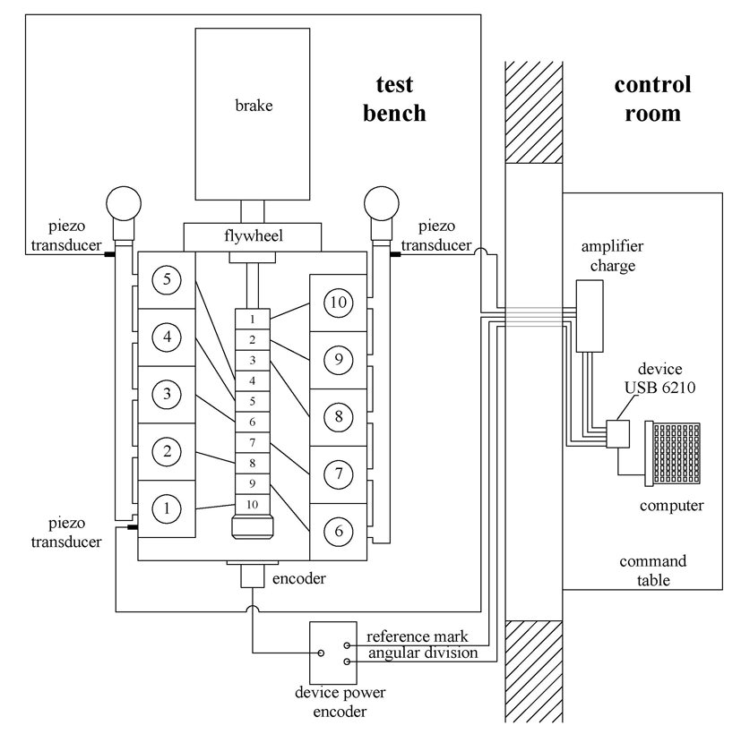
Figure 1: Block diagram of the measurement installation
During the experiment, three AVL piezoelectric pressure transducers were used. The first sensor was inserted into a specially prepared threaded hole in the cylinder head number 1. This was the second major adaptation on the engine during the experiment. The second and the third sensor were inserted into specially prepared threaded holes on the left and right exhaust manifold. After the experiment, stoppers were used to close these openings.
The output from the piezoelectric transducers was converted and amplified by the charge amplifier. The analog voltage from the amplifier was forwarded to the USB 6210 device, where the A/D conversion was performed.
The USB 6210 is a 16-bit data acquisition module, small, with exceptional flexibility and very low price. The product is from the renowned company National Instruments and is easy to use with any PC with the software package Lab View installed on. The use of the USB 6210 implied the existence of a program for the synchronization and management of the measuring equipment. For this purpose, a special adaptive Lab View application was developed. This application enabled the synchronization of measurement of any rapidly changing parameter of the engine working cycle and its subsystems in the function of the crank angle.
- MEASUREMENT DATA PROCESSING
The measurement of physical quantities implies their conversion to analog voltage values. After their amplification, the digitization of these analog signals was performed. The procedure of processing and obtaining parameter values as real physical quantities was performed in two phases.
The objective of the first phase was to convert these digitalized records to real physical values (Figure 2). The second phase included the determination of the so called "zero line" for the measured pressures, the process of „filtration“ and their connection to the working cycle in cylinder number 1, in order to enable the clearly tracking of the pressure changes during the engine working cycle.
3.1 THE FIRST PHASE OF MEASUREMENT DATA PROCESSING
The measurement was organized so that, for every analyzed stationary regime, 50 cycles with the associated data on the changes of the measured values in the function of the crank angle were recorded. After that, for each test regime, a specially developed FORTRAN program was used to create separate files with "representative" samples of averaged measured values in order to partly eliminate the present "noise" and stochastic nature of the considered parameters. The measured values from the "representative" files were then multiplied with amplification coefficients, predetermined during the calibration of the applied piezoelectric transducers. During the calibration process and experiment, the same cables and amplifiers were used. Hence, principal changes of the measured pressures were obtained, ready to be used for further processing. The term "further processing" primarily refers to the determination of the so-called "zero line" of the measured pressures, since the piezoelectric sensors do not have the ability to register the absolute pressure in the space where the pressure change is happening, but register only the difference between the initial-state pressure and the values to be measured during the experiment.
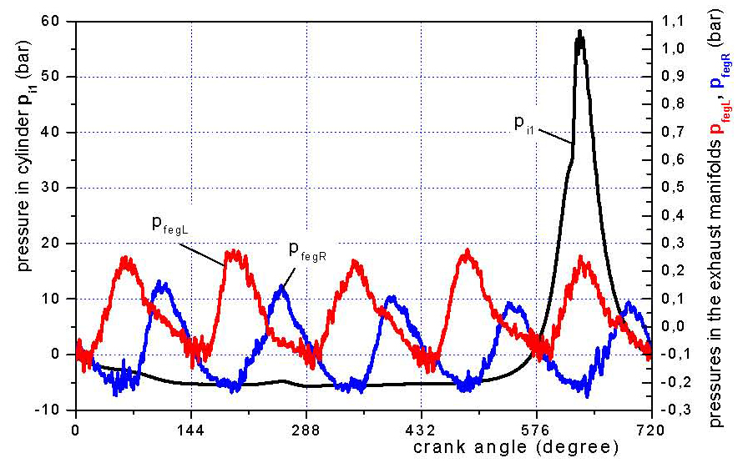
Figure 2: Measured pressures without specified "zero line" and the TDC
3.2 THE SECOND PHASE OF MEASUREMENT DATA PROCESSING
Figure 2 shows the pressure changes in the left exhaust manifold (p_{fegL}), the pressure changes in the right exhaust manifold (p_{fegR}), as well as the in-cylinder pressure change in cylinder number 1 (p_{i1}) of the OM403 engine, after the first-phase-processing of the "representative" averaged values, obtained for a certain stationary regime. It is obvious that the pressure curves were shifted in the ordinate axis direction relative to their real values. On the other hand, the position of the curves in relation to the abscissa axis is entirely arbitrary. The last anomaly comes from the fact that the start of the parameter measurement was not associated to a cycle of any engine cylinder, but is dependent on the current, completely arbitrary position of the reference marker in relation to the crankshaft.“TDC (Top Dead Center) determination” was used for shifting the parameter curves in the abscissa axis direction and their connection to a cycle of one of the engine cylinders, whereas the shifting in the ordinate axis direction is done by assessing the "zero line" for the measured values.
For the TDC determination, the pressure curve without combustion in the engine cylinder is mainly used. Numerous studies have found that the maximum of the in-cylinder pressure curve without combustion is shifted to the left of the top dead center for a specific, not great value (depending on engine type, speed regime and load, the mean value is about 1 crank angle degree).This phenomenon is called the „thermodynamic loss angle”, and it’s caused due to the existence of heat losses during the heat exchange between the combustion chamber boundaries and the working fluid, as well as the working fluid mass losses through the gaps between the piston rings and cylinder. The influence of the second factor on the observed phenomena is significantly lower (about 1/5 of the total value, provided that the clearance between the piston sealing rings and cylinder is within the prescribed limits). Although, the accuracy of TDC determination, considering the main goal of this paper, doesn’t substantially influence the final results and conclusions, it should be noted that a 1° error on TDC determination can lead to evaluation errors of about 10% on the mean in-cylinder pressure determination [1].
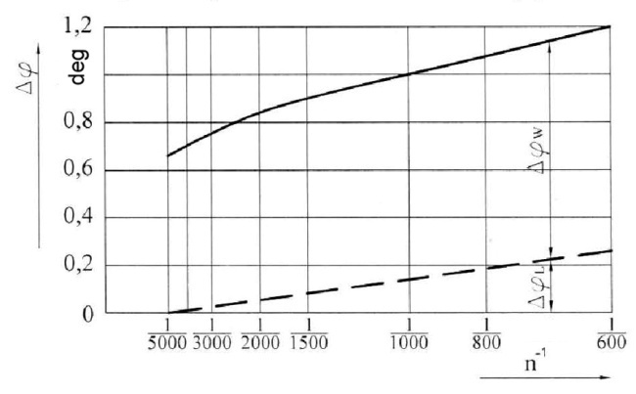 | 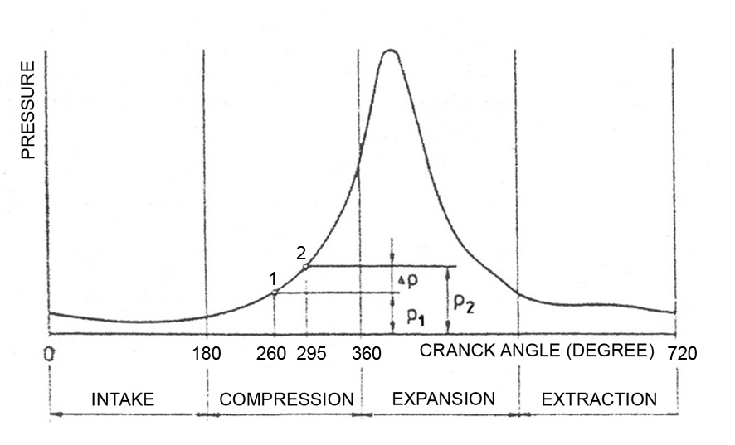
Figure 3: Recommended values of the thermodynamic loss angle depending on engine speed [2] | Figure 4: Thermodynamic principle of the "zero line" determination of the in-cylinder pressure diagram [5]
The TDC position can be accurately determined by using capacitive and inductive linear encoders for the piston stroke. If these methods are not used, methods based on the next principles can be used:
- Evaluation of the thermodynamic loss angle according to empirical data such as those given in [2] and shown in Figure 3.
- Explicit thermodynamic analysis of the engine working cycle. The variation of the compression ratio and the thermodynamic loss angle, until achieving symmetry of the T-s diagram of the engine cycle without combustion relative to the TDC appears to be a particularly effective method [3, 4].
One of the easiest methods for the determination of the "zero line" is based on the equalization of the pressure in the intake manifold and in-cylinder pressure near the Bottom Dead Centre (BDC). However, this method is not reliable due to the existence of pressure waves in the intake manifold.
The so called thermodynamic principle of referencing in two points is considered to be a significantly more accurate procedure [6], which implies a polytrophic compression with a constant polytrophic exponent during the compression stroke stage from 260 (point 1 in Figure 7) till 295crank angle degree (point 2 in Figure 4).Numerous studies have found that, without major errors, the polytrophic exponent can be assumed to be k=1,37 for the Diesel engine and k=1,32 for the Otto engine, whereby the working gas is assumed to behave like an ideal gas. The "zero line" determination procedure is carried out in the following steps:
The pressure difference between points 1 and 2 can be read from the indicator diagram:
(1)
after which, from the equation for the polytrophic change of state of the working gas, the absolute pressure in point 1 is determined:
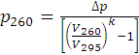 (2)
where V₂₆₀ and V₂₉₅ represent the current volumes calculated according to equation (3) with the increased α value by 180 degrees. Also, the δ value equals zero in equation (3) as there is no offset of the piston pin axis relative to the cylinder axis:
(3)
where:
V_{z} - current volume of the cylinder,
V_{c} - compression cylinder volume,
V_{h} - cylinder displacement,
λ - kinematic characteristic of the piston mechanism,
δ - offset’saxis of the piston relative to the axis of the cylinder
Thereafter all pressure points of the first left cylinder, for which the TDC is determined, were moved along the ordinate axis in order to equalize the pressure value measured in point 1 with the value obtained by this calculation, as shown in the p-α diagram (Figure 5) and the p-Vz diagram (Figure 6). Based on the diagrams, the maximum value of the indicator pressure is less than 65 bar, which ranks the OM403 engine among the mechanically and thermally less loaded diesel engines.
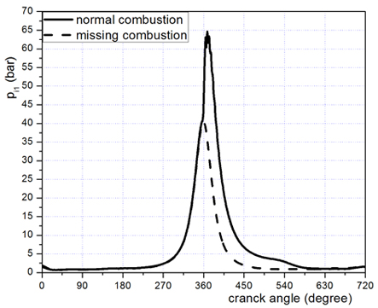 | 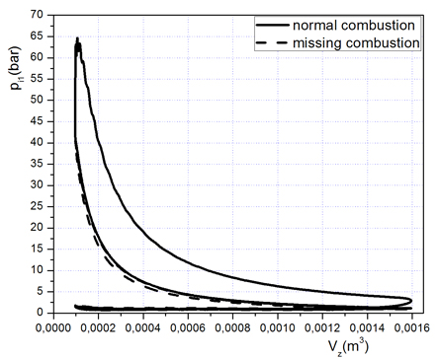
Figure 5: p-α diagram of measured pressures in the first left cylinder | Figure 6: p-Vz diagram of measured pressures in the first left cylinder
The “zero line” of the measured pressure changes in the exhaust manifolds was determined based on the measured “mean pressures”. During the experiment, the engine was operating under constant exhaust manifold vacuum since the exhaust manifolds were connected with drainage pipes that were ventilated. The “mean pressures” were obtained as the difference between the current atmospheric pressure and vacuum measured with a water-filled U-tube manometer. The Figures 7 and 8 show the “processed” diagrams of the exhaust gas pressure changes in the right and left exhaust manifold respectively, connected to the working cycle of the first left cylinder.
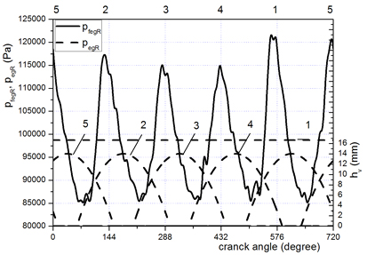 | 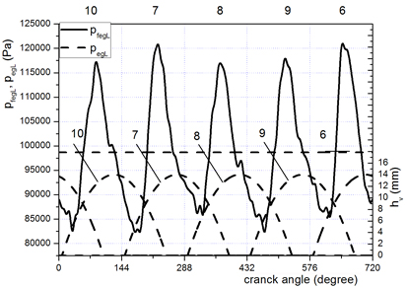
Figure 7: Pressure fluctuations in the right exhaust manifold obtained after the “zero line” determination and filtration | Figure 8: Pressure fluctuations in the left exhaust manifold obtained after the “zero line” determination and filtration
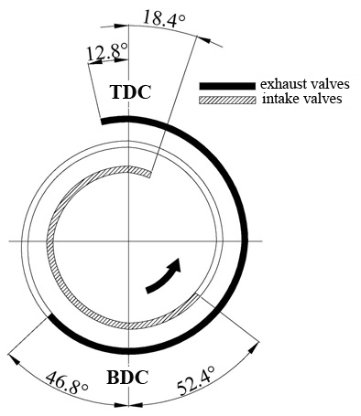 | 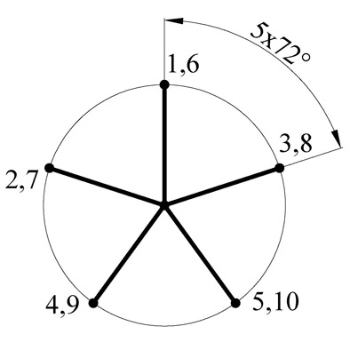
Figure 9: Valve timing diagram of the OM403 engine | Figure 10: The crank angle diagrams of the OM403 engine
In the lower parts of the diagrams (Figures 7 and 8) the curves of approximated exhaust valve strokes of individual cylinders are shown (h_{v}). The numerical designations of the curves refer to the corresponding cylinders. These diagrams were used to precisely establish the connection between exhaust gas pressure changes and working cycles of individual cylinders, i.e. their expansion and exhaust strokes. Numerical designations (from 1 to 10) above the upper frame of the diagram represent the cylinder with the most contribution to the existence of the observed peak value of pressure change in the exhaust manifold. The displayed approximated curves are in fact quadratic functions which have the same valve opening and closing times as the real curves defined by the valve timing diagram (Figure 9) and maximum valve stroke (13 mm).The firing order (1-2-4-5-3-6-7-9-10) was also required information which is in agreement with the crank angle diagrams (Figure 10).
The maximum values of exhaust gas pressure, according to the diagrams in Figures 7 and 8, do not correspond to the peak exhaust valve lift but are achieved earlier. This is explained by the fact that the effective flow cross-section of the valve, as well as the gas flow, achieve their maximum values before the peak exhaust valve lift [6].
- EXPERIMENTAL DATA DISPLAY
Figures from 11 to 13 display comparative diagrams of effective performance parameters (power, torque and specific fuel consumption), absolute pressures and temperatures of exhaust gases in the engine exhaust manifolds, at maximum load, in the case of normal operating conditions and deactivated left cylinder number 6 (with no combustion).
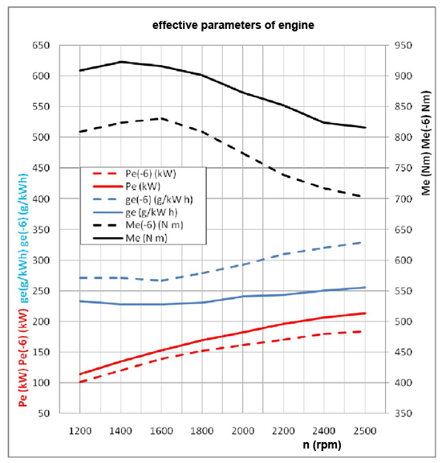
Figure 11: Comparative diagrams of effective performance parameters in the case of normal operating conditions (solid line) and
deactivated left cylinder number 6 (dashed line)
During calculation of the mentioned engine effective performance parameters a correction factor was used [7]:
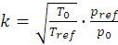 (4)
Since we had an older generation engine, the correction method indicated by DIN 70020 standards has been shown as optimal. The DIN70020 method indicates the reference atmospheric conditions of p_{ref}=101.3 bar and T_{ref}=288.152 K. Corrected values of effective power and torque were obtained by multiplying the calculated values by the correction factor, while the corrected specific fuel consumption values were obtained by dividing the calculated values by the same factor.
The decline in value of all effective performance parameters in the case of one deactivated cylinder (with no combustion) is obvious, which opens the possibility to use also the monitoring of these parameters for the identification of such condition.
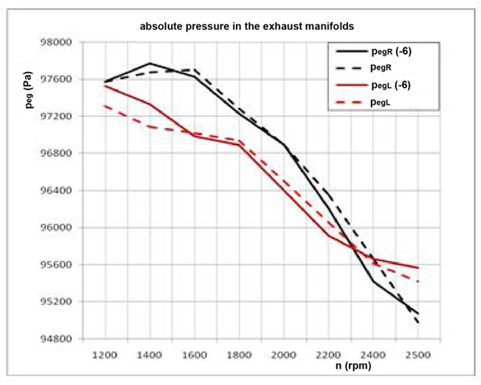 | 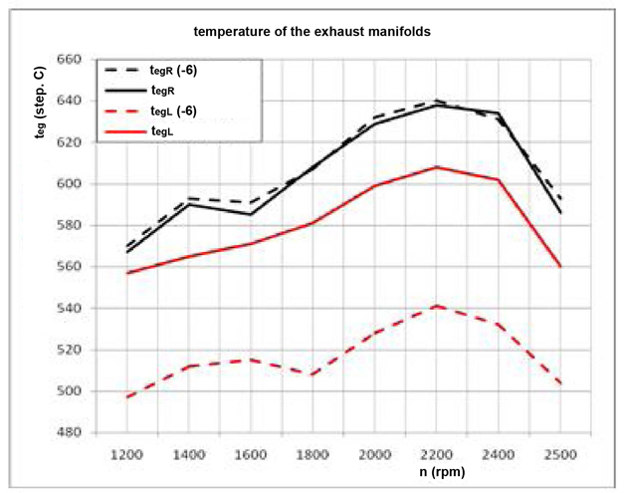
Figure 12: Mean pressure values in the exhaust manifolds at maximum load, in the case of normal operating conditions (solid line) and deactivated left cylinder number 6 (dashed line) | Figure 13: Mean exhaust gas temperatures at full load, in the case of normal operating conditions (solid line) and deactivated left cylinder number 6 (dashed line)
The change of average exhaust gas temperatures in the left exhaust manifold has also a similar tendency, on the side of the deactivated cylinder number 6 (decline by an average of about 10%), while changes in mean values of absolute pressures in the exhaust manifolds do not show the potential to be used for clear identification of irregular engine operation.
In the following section, results of measurements of pressure pulsations in the exhaust manifolds at 1700 rpm will be shown. At the same time, through interventions on the engine (by disconnecting the high pressure fuel lines from the high pressure pump) the following cases were simulated:
- normal operation in all cylinders,
- misfire in each cylinder individually,
- simultaneous misfire in two cylinders - the 3rd and 6th.
It should be reminded that all diagrams are shown as a function of the crank angle and are related to the working cycle of cylinder number 1, for which the TDC determination and parameter curve shifting was done. Numerical designations in the upper part of the diagrams represent the cylinder with the most contribution to the diagram changes (peak or absence of the expected peak).
It should be reminded that all diagrams are shown as a function of the crank angle and are related to the working cycle of cylinder number 1, for which the TDC determination and parameter curve shifting was done. Numerical designations in the upper part of the diagrams represent the cylinder with the most contribution to the diagram changes (peak or absence of the expected peak).
4.1 NORMAL OPERATION IN ALL CYLINDERS
Exhaust gas pressure changes in the right and left exhaust manifolds (Figure 14) have an expected form, reaching their peaks at crank angle values which correspond to approximately maximum values of effective flow cross-sections of the corresponding valves (Figures 7 and 8).
The differences between the peak values could be related to the different thickness of valve and valve seat deposits, different real clearances between pushrod valve and cam, stochastic of the processes, inequalities of working cycles in individual cylinders, etc.
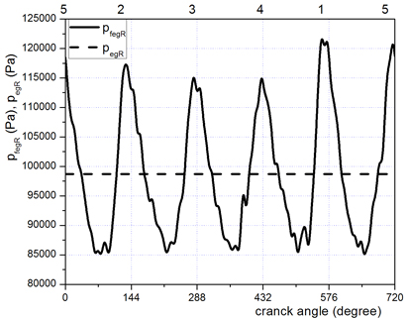 | 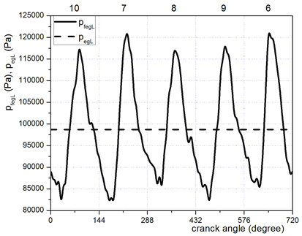
Figure 14: Diagrams of pressure changes in the right exhaust manifold (p_{fegR}) and in the left exhaust manifold (p_{fegL})
4.2 MISFIRE IN CYLINDER NUMBER 1 AND 2
Figure 15 (left) shows clearly the absence of the pressure peak in the right exhaust manifold at the cylinder position number 1, while the pressure change in the left exhaust manifold has an expected form (Figure 15 right). The recorded in-cylinder pressure in the case of misfire in cylinder 1 (Figure 5, dashed line) has a value a little over 40 bar, which is around 38.5% less than the maximum value under normal combustion (Figure 5, solid line). Misfire in cylinder number 2 are shown in Figures 16.
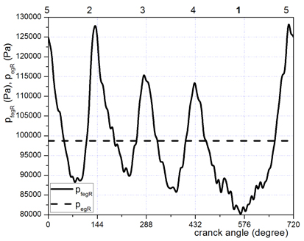 | 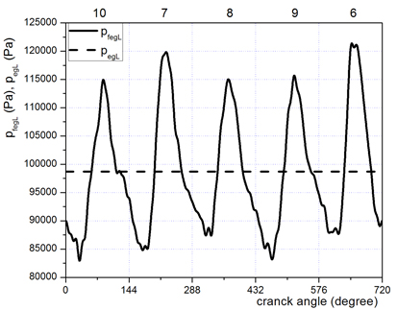
Figure 15: Diagrams of pressure changes in the right exhaust manifold (p_{fegR}) and in the left exhaust manifold (p_{fegL})
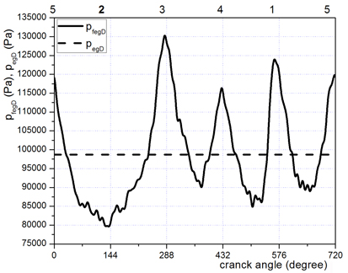 | 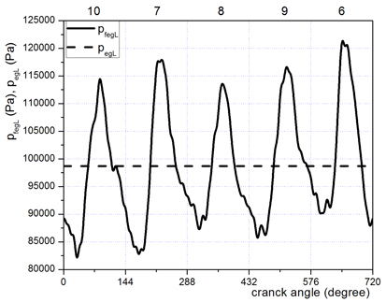
Figure 16: Diagrams of pressure changes in the right exhaust manifold (pfegR) and in the left exhaust manifold (p_{fegL})
4.3 SIMULTANEOUS MISFIRE IN TWO CYLINDERS-THE 3RD AND 6TH
Simultaneous misfire in cylinders number 3 and 6 are shown in Figures 16 and 17. The analysis leads to a conclusion that different combinations of deactivated cylinders give similar diagrams.
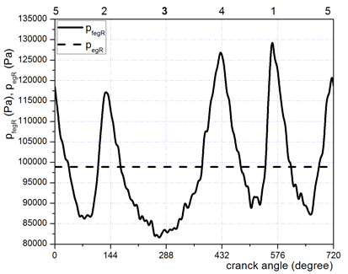 | 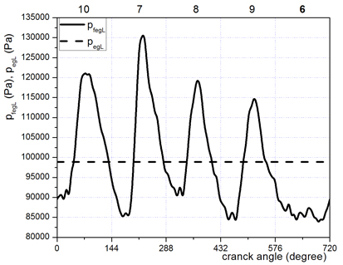
Figure 17: Diagrams of pressure changes in the right exhaust manifold (p_{fegR}) and in the left exhaust manifold (p_{fegL})
- ANALYSIS OF EXPERIMENTAL RESULTS
Monitoring exhaust gas pressure changes has proven to be a powerful and relatively simple tool for the identification of misfiring cylinders. After the exhaust valve stroke approximation, for the right side (Figure 7) and left side (Figure 8) cylinders, angular intervals on the abscissa axis, with recorded exhaust gas pressure jumps, were located. These angular intervals are unambiguously associated with the cylinders which caused these increases (peaks). Each of the recorded peaks is the result of the expelling of the spent fuel-air mixture from one of the engine cylinders, which is, in the moment of the exhaust valve opening, characterized by a high energy level, regarding temperature and pressure. The measured in-cylinder pressure, at maximum engine load, in the moment of the exhaust valve opening of a cylinder with a regular combustion process, was around 3.7bar, while the measured in-cylinder pressure of a misfiring cylinder a little over the atmospheric pressure was. A direct consequence of this is that the misfiring cylinder, with a missing pressure peak, can be clearly distinguished from the properly working cylinders with recorded peaks on the exhaust gas pressure pulsation curve. The described phenomenon is happening also at lower engine loads, which is evidenced by the diagrams in Figure 18. These diagrams represent the pressure pulsations in the right and left exhaust manifold in case of misfire in cylinders number 3 and 6, at 1200 rpm and partial load. This leads to the conclusion, that the described misfire identification process has no limitation regarding engine speed and load.
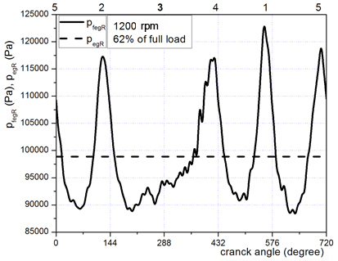 | 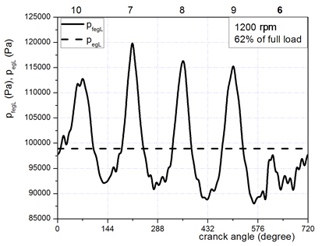
Figure 18: Pressure pulsations in the right and left exhaust manifold while simultaneous misfire in cylinders number 3 and 6 (at 1200 rpm and 62% load)
The main limitations and advantages of this procedure, especially in relation to the most effective diagnostic method, a direct cylinder indication, are:
- Amplitudes of the measured pulsations, which reached a maximum value of 0.65 bars at full engine load, decline with decreasing load due to lower values of in-cylinder pressure at the moment of the exhaust valve opening.
- The signals from the piezoelectric pressure transducers have to be amplified and converted into voltage output, and then interpreted into real physical values (Pa or bar), which implies the existence of a complex chain of electronic equipment that will perform all of these conversions.
- It is reasonable to expect a limited operating life of the embedded piezoelectric transducers in the conditions of long-term aggressive action of exhaust gases with high energy levels, regarding temperature and pressure.
- However, according to this method, the working conditions of the piezoelectric transducer are much more favorable than the conditions in the combustion chambers.
- The advantage of this method for diagnostic purposes of working cycles, in relation to the direct indication of each cylinder, is in a far smaller number of used sensors.
The above-mentioned limitations and technical problems to be solved clearly illustrate why the crankshaft speed variation analysis is the most widely studied method of improving engine diagnostics [8-15].
Finally, once again a parameter should be pointed out, which monitoring could indicate irregular engine operation, or misfire in some engine cylinder, very simple and quite effective. The mentioned parameter is the mean temperature of exhaust gases (Figure 19).
Figure 19 shows clearly the decline in mean exhaust gas temperatures in the exhaust manifold on the side of the engine that contained a defective cylinder.
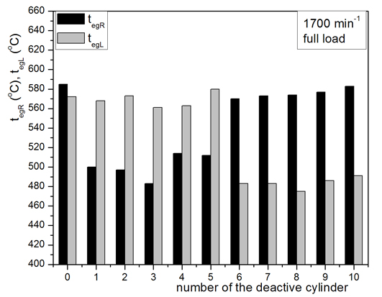
Figure 19: Mean temperatures of exhaust gases in the right exhaust manifold (t_{egR}) and left exhaust manifold (t_{egL})
- CONCLUSION
This paper presents the method of misfire detection in the cylinders of the OM403 diesel engine by exhaust gas pressure and means temperature measurement in the exhaust manifolds. Monitoring exhaust gas pressure changes has proven to be a powerful and relatively simple tool for the identification of misfiring cylinders. Study results lead to the conclusion that the described procedure has no limitation regarding engine speed and load. Mean exhaust gas temperature in the exhaust manifold on the side of the engine that contained a defective cylinder declined meanly by 10%.This means that the method based on measuring mean exhaust gas temperatures in the exhaust manifolds could be a reliable procedure for misfire determination. The advantage of this method is that the measurement of temperature is easier to implement, both in laboratory and in exploitation conditions of the engine.
Further research could go in the direction of attempting to establish a functional dependence between the change in pressure in some cylinders and pressure changes in the exhaust manifolds. If it would be proven that the slight in-cylinder pressure changes, at the end of the expansion stroke, have dominant influence on the values of the pressure peaks in the exhaust manifolds, this would mean that the level of contribution of individual cylinders to the total torque of the engine could be estimated.
REFERENCES
- Jankov R. (1984). Mathematical modeling of current-dynamic processes and operating characteristics of diesel engines, quasi-stationary models. Part I, basically. Scientific Book, Belgrade.
- Hohenberg G. (1976). Definition und Eigenschaften des thermodymischen Verlust-winkels von Kolbenmachinen. Automobil–Industrie 4/1976, pp. 15-21.
- Tazerout M., Le Corre O., and Rousseau S. (May 1999). TDC determination in IC engines based on the thermodynamic analysis of the Temperature–Entropy diagram. SAE International, Warrendale, PA, Tech. Rep. 1999–01–1489.
- Pipitone E., Beccari A. (Oct. 2010). Determination of TDC in internal combustion engines by a newly developed thermodynamic approach. Applied Thermal Engineering, Vol. 30, No. 14–15, pp. 1914–1926,.
- Hohenberg G., Killmann I. (1982). Basic findlings from mesaurement of the combustion process. XIX FISITA Congress, Melburne.
- Cvetić M. (1990.). Research of real gaso thermodynamic parameters coupling diesel engine turbo-compressor. Master's thesis, Belgrade.
- DIN 70020:1976, Tail 6–Kraftfahrzeugbau. Leistungen.
- Bulatović Ž. M., Štavljanin M. S., Tomić M. V., Knežević D. M., Biočanin S. Lj. (November 2011). Measurement and Analysis of Angular Velocity Variations of Twelve-Cylinder Diesel Engine Crankshaft. Mechanical Systems and Signal Processing, Volume 25, Issue 8, p.p. 3043 – 3061, ISSN 0888-3270, DOI: 10.1016/j.ymssp.2011.05.002.
- Taraza D. (2003). Statistical Correlation Between the Crankshaft’s Speed Variation and Engine Performance–Part I: Theoretical Model. Transaction of ASME, Journal of Engineering for Gas Turbines and Power, Vol. 125, No. 3, pp. 791-796.
- Taraza, D. (2003). Statistical Correlation Between the Crankshaft’s Speed Variation and Engine Performance–Part II: Detection of Deficient Cylinders and Mean Indicated Pressure Calculation. Transaction of ASME, Journal of Engineering for Gas Turbines and Power, Vol. 125, No. 3, pp. 796-803.
- Taraza D. (2001). Quantifying Relationships Between the Crankshaft’s Speed Variation and the Gas Pressure Torque, SAE Paper No. 2001-01-1007.
- Taraza D., Henein N.A., Bryzik W., The Frequency Analysis of the Crankshaft’s Speed Variation: A Reliable Tool for Diesel Engine Diagnosis, ASME Transactions, Journal of Engineering for Gas Turbines and Power, Vol 123, No. 2, 2001.
- Taraza D., Henein N. A., Bryzik W. (1998). Diesel Engine Diagnosis Based on Analysis of the Crankshaft’s Speed Variation, SAE Paper 982540 and SAE Transactions, Vol. 107, Journal of Engines, pp.2183-2195.
- Williams J. (1996). Evaluation of Constant Speed Assumption for Determining Cylinder Excitation Torque, SAE Paper No. 960041.
- Williams, J. (1996). An Overview of Misfiring Cylinder Engine Diagnostic Techniques Based on Crankshaft Angular Velocity Measurements, SAE Paper No. 960039.

Dr S. Biočanin, Directorate of Defense Technology, Belgrade (stojkobiocanin@gmail.com)
Dr Ž. Bulatović, Military Technical Institute, Belgrade (zetonbulat@gmail.com)
Prof dr A. Milašinović, Faculty of Mechanical Engineering in Banja Luka, (amilasinovic@gmail.com)
mr I. Mujanić, Faculty of Mechanical Engineering in Banja Luka, Banja Luka
Prof dr R. Božičković, Faculty of Mechanical Engineering in East of Sarajevo, East of Sarajevo

