LOGO WILL BE HERE
Application of similitude laws for experimental investigations of dynamic properties of tall prototype steel structure
F.Zdraveski, H. Mickoski
Summary: This paper elaborates the procedures for scaling prototype structure to scale model according to similitude laws keeping the dynamic properties of the original structure. The scaling procedures are very suitable for experiments where the purpose is not only to check the strength of the structure, but also to investigate the performance of other dynamic devices mounted on the primary structure such as dynamic absorbers. In such cases, the use of condensation methods comes to mind in order to reduce the original d.o.f. and make the model structure behave same in the first several modes as the original structure.
Key words: structural dynamics, similitude laws, prototype, scale model, condensation methods, TMD, transducers, strain gauges
- INTRODUCTION
Full scale testing of structures is accurate but it is time consuming and costly. Therefore, it is extremely useful if a full scale prototype can be replaced by scaled-down model which is much easier to work with.
One of the fundamental aspects of the vibration analysis is to obtain the natural frequencies of the studied system. This analysis becomes relevant not only for the prediction of displacements, and related deformations and tensions, but also for their control.
Tab. 1 Dynamic properties of prototype MRF
Slenderness | 1 mode [Hz] | 2 mode [Hz] | 3 mode [Hz]
30500/80730= 1:2.6 | 0.26 | 0.75 | 1.30
The purpose of this paper is to present procedure for scaling real 80 m tall structure prototype, in order to perform scale model analysis of tuned mass damper –device used to suppress vibrations caused by wind load.
The prototype structure used for this study [1] is 20 story, 80 m high MRF. In order to make this structure prone to wind load, it should meet two conditions: first one according to Eurocode 1 [2] is the criteria for slenderness of the structure –width to high ratio at least 1:4, and second condition according to ASCE 7-05 standard [3] is the classification of structure as dynamically sensitive to wind, or “flexible” if f₀ ≤ 1 Hz.
The MRF is analyzed in N-S direction which is susceptible to wind load. Tab. 1 gives the basic parameters of the unchanged structure.
The structure is calculated with 3 degrees of freedom at each joint, horizontal, vertical and rotational, which summarize 418 degrees in total. This MRF is subject to further modifications and scaling procedures.
- ADAPTATION OF THE ORIGINAL STRUCTURE
The first change in the original structure is reducing the degrees of freedom. Reduction of d.o.f. means increasing the stiffness of the MRF, and thus increasing the natural frequencies.
First approximation is done by assigning to each joint two degrees of freedom, one horizontal (or shear stiffness), and other rotational [4]. All joints at same floor have same horizontal displacement. Therefore we get total of 140 degrees of freedom. Tab. 2 shows new values for natural frequencies.
Tab. 2 Dynamic properties of prototype MRF-r1
Slenderness | 1 mode [Hz] | 2 mode [Hz] | 3 mode [Hz]
30500/80730= 1:2.6 | 0.2879 | 0.8076 | 1.3414
Next step is simplifying the frame to less than 140 degrees by making it behave as shear type multi-story structure. This consideration is true if the structure is loaded in the elastic range and maintains maximal allowed deflection ≤H/200 at the top floor. Also, the mode shapes of the structure are almost identical.
Several expressions [5] have been proposed for calculation of the equivalent shear stiffness for a story in frame. The closest results in comparison to tab. 1 are obtained from the method given by Muto (1974) shown in tab. 3.
Tab. 3 Dynamic properties of prototype MRF-r2
Slenderness | 1 mode [Hz] | 2 mode [Hz] | 3 mode [Hz]
30500/80730= 1:2.6 | 0.2860 | 0.7943 | 1.22066
As it can be seen from tab. 3, the prototype structure is not completely susceptible to wind load according to codes. The missing criterion is lower or equal slenderness ratio to 1:4. Therefore, the N-S MRF is modified by shrinking the width from 30.5 m to 20.0 m in order to achieve the ratio. The floor mass is maintained, but the inter column beams are changed.
The change of beams is made according the principle: the columns stay same and carry same dead load, new beams are shorter but the stress from the load is same as the old ones. The replacement beams are shown in tab. 4.
Tab. 4 Replacement beams in MRF-r3
Old beams | New beams
W21x50 | W14x43
W24x62 | W18x50
W27x84 | W21x68
W30x99 | W24x76
W30x108 | W24x84
The new beams affect the building by decreasing all natural frequencies, especially the first one down to 0.2265 Hz. The MRF is only considered as shear type. MRF-r3 is final version for further scaling and thus meets frequency criteria for wind susceptible structure shown on fig. 1.
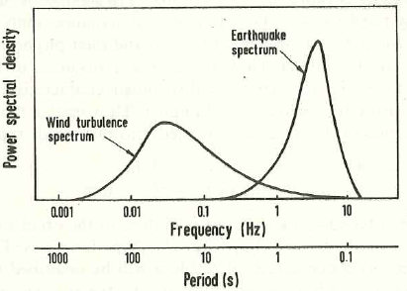
Fig. 1 Spectral densities of winds and earthquakes
- CONDENSATION OF 20 DEGREES TO LOWER 4 EQUIVALENT DEGRESS
Condensation methods [6] are usually applied to d.o.f. where mass or inertia can be neglected i.e. rotational joints. The focus of investigation is not the structure itself from strength point of view, but dynamic behavior and the purpose to serve as base to install and test the capacity of tuned mass damper.
Next simplification is reduction of 20 story masses to 4 reduced equivalent floors and columns at each level. All elements together represent structure with equivalent dynamic behavior from frequency point of view, displacement point of view and mode shape point of view. The model is condensed in a way that every fifth floor is kept and the height is the same as the 20 story frame.The comparative values of the 20 story and 4 story model are given in tab. 4.
Tab. 4 Comparative values of 20 to 4 story building
20 story MRF natural frequencies
1 mode [Hz] | 2 mode [Hz] | 3 mode [Hz]
0.2265 | 0.6340 | 1.0270
4 story condensed MRF
1 mode [Hz] | 2 mode [Hz] | 3 mode [Hz]
0.2444 | 0.6461 | 0.8937
% difference in frequencies
1 mode [Hz] | 2 mode [Hz] | 3 mode [Hz]
7.9% | 1.1% | 13%
Another comparison is given with normalized mode shape vectors (tab.5 and fig. 2).
Tab. 5 Normalized mode vectors with √Mn
20 story MRF |  |  | 4 story MRF |  |  | Error
mode |  |  | mode |  |  | [%]
1st | 2nd | 3th | 1st | 2nd | 3th
0 | 0 | 0 | 0 | 0 | 0
0.2117 | ‐0.4777 | ‐0.5338 | 0.2343 | ‐0.4897 | ‐0.4607 | modes
0.3934 | ‐0.4794 | 0.1287 | 0.4326 | ‐0.4692 | ‐0.0051 | 1 | 7-10.7
0.5395 | 0.0721 | 0.5044 | 0.5879 | 0.1217 | 0.5353 | 2 | 2-18
0.6269 | 0.7476 | ‐0.8269 | 0.6707 | 0.8835 | ‐0.8240 | 3 | 0.3-13
Parameters of the equivalent mass of floors and stiffness of the columns are given in tab. 6.
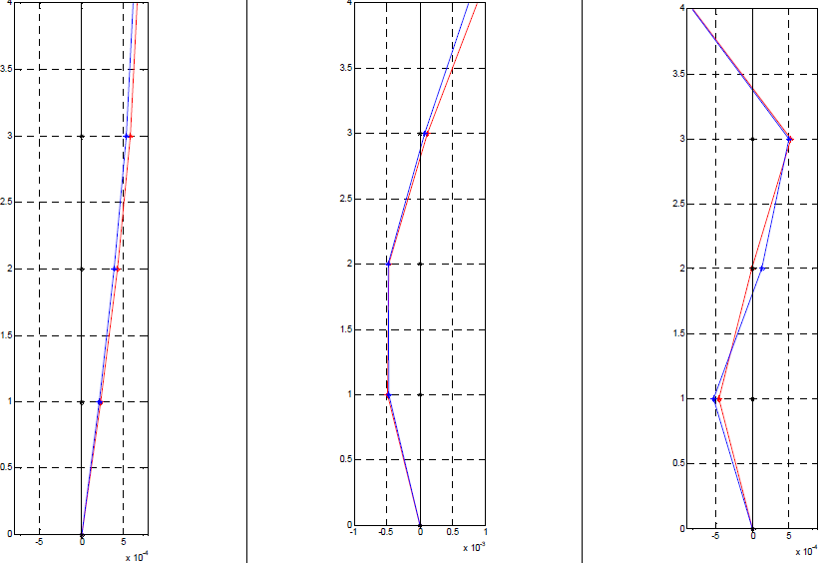
Fig. 2 Mode shapes of 20 story-blue and condensed 4 story-red structure
Based on the formula (1) for lateral stiffness of shear type story:
 | $$K=N_{c} \frac{12 E I}{h^{3}}$$ | (1)
where N_{c} is number of columns per story, can be calculated equivalent moment of inertia I_{EK}. Calculated values are also shown in tab. 7.
Tab. 6 Condensed model of 4 story MRF-r4
Story | Mass[kg]*10⁶ | Stiffness[N/m]*10⁷ | Iek [m⁴]
1 | 1.2566 | 1.9871 | 0.080349
2 | 1.2621 | 1.9974 | 0.064603
3 | 1.3418 | 1.7214 | 0.055676
4 | 0.5137 | 0.9818 | 0.03175
The condensed matrix is not diagonal, but has offset members. This is result of condensation done over members which have significant inertia, which in real case can’t be neglected. Consequently the sum of masses in tab. 6 is lower than the one of structure with 20 stories. In order to keep the sum consistent, it will be assumed that the difference in mass is equally distributed to the floors. Therefore, we get final structure with natural frequencies lower than one in tab. 4, given in tab. 7. The error introduced in the modal shape vectors with the last assumption is ≤20%.
Tab. 7 Four story condensed MRF-r5
1 mode [Hz] | 2 mode [Hz] | 3 mode [Hz]
0.2007 | 0.5026 | 0.7975
- SCALING THE CONDENSED MODEL TO RATIO OF 1:80
In structural problems, two types of similitude are most often considered [7]. One of them is Cauchy similitude, based on Cauchy number and expressed as $Cn=ρ v^{2}/E$, which should be the same on the prototype and the model [8]. This similitude is adequate for cases in which restitution forces are essentially elastic.
The other type of similitude is the Froude similitude, adequate for situations in which gravity action plays a primary role. Similitude relationships are given in tab. 8.
For scale modeling, there are two categories of modeling: with (a) artificial mass simulation or (b) gravity loads are neglected.
Tab. 8 Similitude relationships
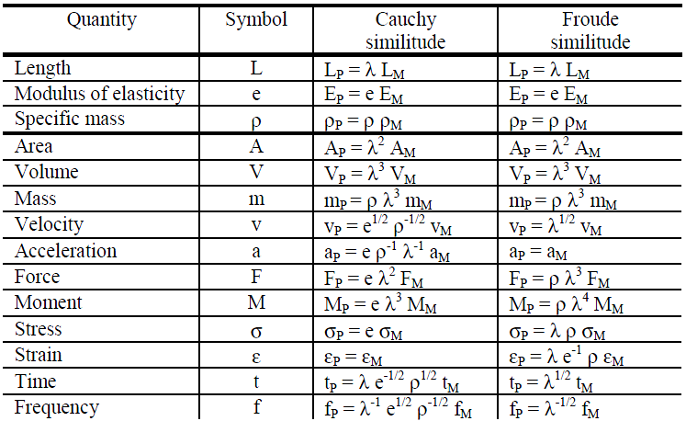
The general rule for modeling is given with expression (2):
 | $$\frac{S_{g} S_{L} S_{ρ}}{S_{E}}=1$$ | (2)
where g:gravity; L:length; ρ: density; E: stiffness. If we accept that gravity scaling factor is 1, than the expression (2) takes shape:
 | $S_{ρ}=\frac{S_{E}}{S_{L}}$$\frac{S_{g} S_{L} S_{ρ}}{S_{E}}$ | (3)
which means that we cannot scale density and stiffness in the same time. This means we need to add additional artificial masses.
Therefore, we select first two important features of our scale model: S_{L} and S_{ρ}. Then we select the third scale factor – S_{E} which determines the material for the columns. The scaling factors are given in the tab. 9.
Tab. 9 Scaling factors
S_{L} | S_{ρ} | S_{E}
80:1 | 0.75:1 | 61:1
- SELECTION OF MATERIALS AND DEFINING DIMENSIONS
Since the scale factors are defined, according to Froude similitude, next step is to select materials and geometrical properties of the model structure.
Because S_{ρ} is different from 1, it means that the model will be built from different material of the prototype and additional masses will be added.
The prototype structure is analyzed in wind susceptible direction which is N-S frame only. It means that the model should behave same as the prototype and the weak axis of columns should be normal to the oscillating plane fig. 3. Also, to make columns more susceptible to oscillate in same direction for higher modes, we select high ratio of b:d ≥ 3.
The criteria for final determination of dimensions of columns should be bucking analysis with eccentric load. Final dimensions of columns are given in tab. 10. The 4th–level column size is only different from the condition b:d ≥ 3 because of buckling.
Tab. 10 Column dimensions
Story | 1 | 2 | 3 | 4
[mm] | 6x25 | 6x23 | 6x18 | 6x12
Material selection for columns is determined by the stiffness scaling factor S_{E}. In this case, the model should have columns made out of material with approx. 61 time’s smaller modulus of elasticity than the steel. One options for large size scaling in experimental techniques is PMMA. The commercial name of this product is Plexiglas.
For this experiment two types of products were tested: extruded and cast PMMA fig. 4. The cast PMMA came to be more appropriate, and less stiff than the extruded one. The columns were made from cast PMMA and cutted with laser.
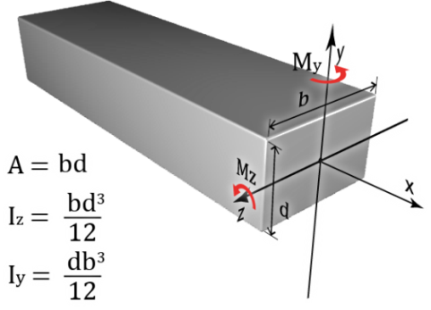 |  | 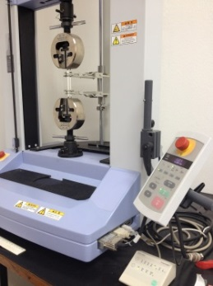 |  | 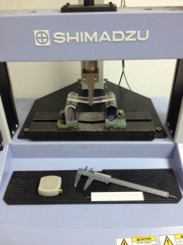
Fig. 3 Weak axis of the column Iz |  | Fig. 4 Tensile test and bending test
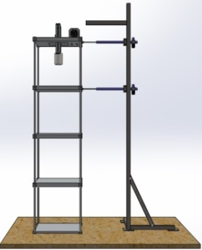 | 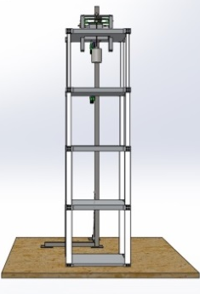 | 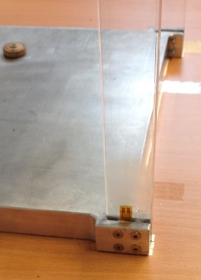 | 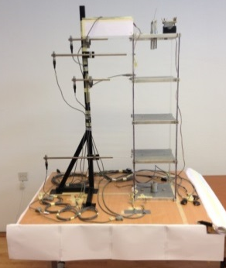
Fig. 5 CAD model |  | Fig. 6 Restrains | Fig. 7 Expe. layout
Specimens were were prepared according to ISO 3167 – multipurpose specimens from polymers , and the modulus of elasticity was confirmed by tensile and bending test [9]. It came to be min. 3000, and average 3250 MPa. Total mass of the model according to scaling density scaling factor S_{ρ} is calculated to be total of 14 kg. Average floor mass without columns included is calculated to be equal to 3.36 kg. The sum of mass of all plexiglas columns is considered to be equally distributed to each floor of the structure. Review is given in tab. 11.
Tab. 11 Review of masses
Model mass [kg] | Floor mass [kg] | Column mass [kg]
14 | 3.36 | 4x0.14
Aluminum alloy plates thick 20 mm are being used as floor weight. The shape of the plates is made with CNC machine according to CAD drawings of the model (fig.5). The external dimensions from centerline to centerline of columns are maintained in accordance with the slenderness ratio.
The connection of column to floor plate is done in order to achieve shear type of building by restraining the joint from bending. This assumption should work enough accurate for small inter-story drifts (fig.6).
- EXPERIMENTAL LAYOUT
The prototype structure is being prepared in order to investigate the capacity of the of vibration absorption device.
For researchers, it’s much easier to work around with a small scale model and control the parameters of the experiment than with large size structure.
The main parameters that needs to be measured during the experiment are: Symmetry of the model; Displacements of stories and vibration device; Accelerations of stories; Natural frequencies of the physical model; Phase difference between structure and TMD. In order to achieve the above stated targets, sensors are being used shown on fig. 7.
Inductive transducers W50 HBM are used to quantify the motion of model structure. Acceleration transducers B12 HBM are mounted on top 2 floors because at higher floors acceleration affects the comfort of living.
Strain gauges from Micro-Measurement 350.0±0.2Ω are connected in half bridge to sense only bending of columns at bottom and top connection where strain would be maximal. Also, they serve to give conclusion for the symmetry of the model, and also the range in which the structure behaves as shear type frame.
With different color of arrows, on fig. 7 is shown: red arrows-displacement transducers; blue arrows-acceleration transducers; yellow arrows-bending strain gauges; black arrow-excitation with eccentric mass.
A simple yet effective method of simulating wind induced vibrations in one direction was developed to satisfy the requirements for excitation (fig. 8).
An eccentric rotating mass, provided by a small DC motor with adequate range of rpm’s, was mounted rigidly on the top of the 4-th floor plate. By slowly increasing the voltage input, the rotational frequency varied from 0 to 4 Hz.
By observing the displacement of the structure over the duration of frequency sweep, it was possible to identify the first mode of natural frequency.
Kit of 3 eccentric masses was built in order to achieve 3 different displacement values in the elastic range of the structure with amplitude value of 3÷7 mm.
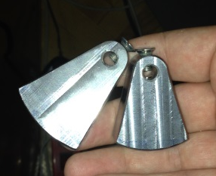 | 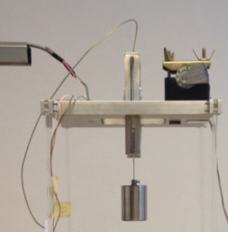 | 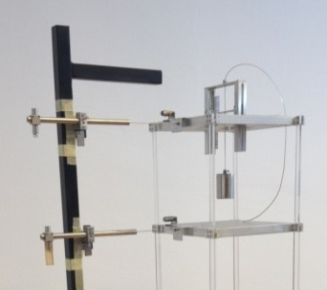  TMD  slide  rail
Fig. 8 Excitation eccentric mass |  | Fig. 9 Location of TMD
The device for vibration suppression shown on fig. 9 (whose performance is not presented in this paper) was calculated earlier according to known procedures [10].
- CONCLUSION
The main objective of conducting experiments on structures at reduced scale is to reduce the cost of experimentation. Cost is reduced due to the reduction in the loading equipment and reduction in the cost of test structure fabrication and testing.
Similitude law is generally applied to define a specimen for scale model tests. A proper similitude law should be selected for satisfying a specific test objective or method. Overall, the method of scaling is valid and justifies further research.
The modeling accuracy depends from the model material properties, fabrication accuracy, loading techniques, measurement methods and interpretation of results. Elastic models can be easily built to give high correlation with the prototype, if the model is fabricated and loaded perfectly.
This paper gives example of enough accurate, relatively easy and low cost approach for creating scaled structure that will be used as base for experimental testing of devices for vibration absorption. It also presents the experimental layout of measuring points, measuring equipment and simple system for external harmonic excitation.
REFERENCES
- B.F Spencer Jr., R.E. Christenson, S.J. Dyke, 1998, Next Generation Benchmark Control problems for Seismically Excited Buildings, Proc. of 2nd World Conf. on Structural Control,1135-1360
- Eurocode 1: Actions on structures - General actions - Part 1-4: Wind actions. prEN 1991-1-4: European Standard, 2004
- D. Boggs, J. Dragovich, 2006, The nature of wind loads and dynamic response, ACI Special Publications, 240(2), pp.15–44
- G. S. Pandit, S. P. Gupta, Structural Analysis-A Matrix Approach, 2001, 2nd ed., Tata McGraw Hill Education,pp.252-263
- A. Schutz, 1992, Approximating Lateral Stiffness of Stories in Elastic Frames, Journal of Structural Engineering, 118 (1), 243-263
- M.I. Friswell, S.D. Garvey, J.E.T. Penny, Model Reduction Using Dynamic and Iterated IRS Techniques,1995, Journal of Sound and Vibration, 186(2), 311-323
- M. Ramu, V.P. Raja, P.R. Thyla, 2013, Development of Structural Similitude and Scaling Laws for Elastic Models, Journal of Civil Engineering, 17(1), pp.139-144
- C. Ziemian, R. Ziemian, E. Barker, 2010, Shake table simulation study of small scale layered models, Rapid Prototyping Journal, vol.16, iss:1, pp.4-11
- H.G. Harris, G. Sabnis, Structural Modeling and Experimental Techniques, 1999, 2nd ed., CRC Press,Ch.3
- F. Zdraveski, I. Mickoski, D. Kozinakov, 2013, Exploring the performance of tuned mass dampers – TMD in multi storey buildings, 11-th Intern. Conf. on Accom. in Electrical and Mechanical Eng. and Inform. Technology – DEMI, Banja Luka, Bosnia and Herzegovina

MSc, Filip Zdraveski, Skopje, Faculty of mechanical engineering, filip.zdraveski@mf.edu.mk
PhD, Hristijan Mickoski, Skopje, Faculty of mechanical engineering, hristijan.mickoski@mf.edu.mk

