LOGO WILL BE HERE
Mathematical model of dynamic vibration absorber-response prediction and reduction
F. Zdraveski, E. Donceva
Summary: This paper is dealing with procedures for mathematical modeling of DVA. Usually the problems of optimization are converted to equivalent single degree of freedom (SDOF) structure at particular mode in order to optimize the damper. There are three main parameters in a DVA system: DVA mass, DVA stiffness coefficient and DVA damping ratio. Consequently, the objective is to find the optimum value of these parameters. This paper is investigating also the effect of relative speed of primary structure and its influence on response.
Key words: structural dynamics, DVA, relative speed, response, state-space model.
- INTRODUCTION
In engineering applications, many systems can be modeled as single degree-of-freedom systems [1]. For example, a machine mounted on a structure can be modeled using a mass-spring-damper system, in which the machine is considered to be rigid with mass m and the supporting structure is equivalent to a spring k and a damper c, as shown in Figure 1. The machine is subjected to a sinusoidal force $F_{0}sinΩt$, which can be an externally applied load or due to imbalance in the machine.
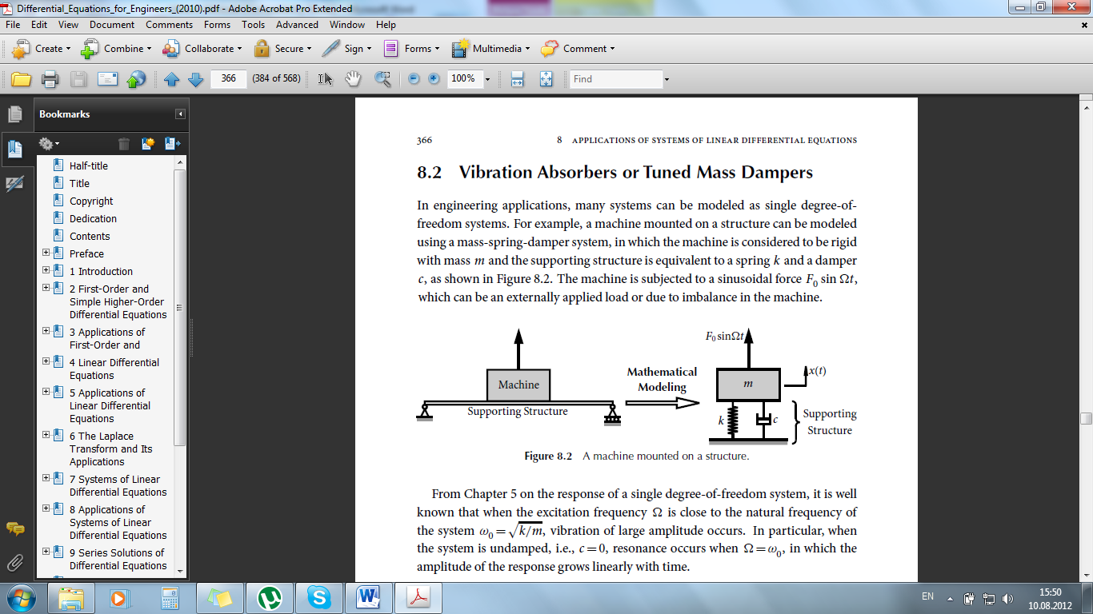 | 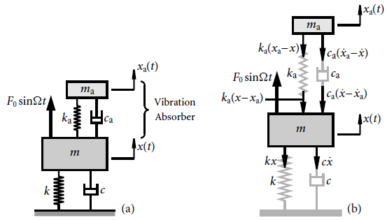
Fig. 1: A machine mounted on a structure | Fig. 2: Vibration absorber installed
It is well known that when the excitation frequency $Ω$ is close to the natural frequency of the system $ω_{0}=\sqrt{k/m}$, vibration of large amplitude occurs. In particular, when the system is undamped, i.e., $c=0$, resonance occurs when $Ω=ω_{0}$, in which the amplitude of the response grows linearly with time.
To reduce the vibration of the system, a vibration absorber (DVA) or a tuned mass damper (TMD), which is an auxiliary mass-spring-damper system, is mounted on the main system [2, 3] as shown in Figure 2. The mass, spring stiffness, and damping coefficient of the viscous damper are m_{a}, k_{a} and c_{a}, respectively, where the subscript “а” stands for “auxiliary”.
- EQUATION OF MOTION AND DMF
To derive the equation of motion of the main mass m, consider its free-body diagram as shown in Figure 2(b). Since mass m moves upward, spring k is extended and spring k_{a} is compressed. Considering Fig. 2(b) and Newton’s Second Law we get the following equitation’s:
 | $m\ddot{x}=\sum{F}$: $m\ddot{x}=-kx-c\dot{x}-k_{a}\left(x-x_{a}\right)-c_{a}\left(\dot{x}-{\dot{x}}_{a}\right)+F_{0}sinΩt$ | 1
or
 | $$m\ddot{x}+\left(c+c_{a}\right)\dot{x}+\left(k+k_{a}\right)x-c_{a}{\dot{x}}_{a}-k_{a}x_{a}=F_{0}sinΩt$$ | 2
Similarly, consider the free-body diagram of mass m_{a}. Since mass m_{a} moves upward a distance x_{a}(t), spring k_{a} is extended. The net extension of spring k_{a} is x_{a}−x. Hence, the spring k_{a} and damper c_{a} exert downward forces $k_{a}\left(x_{a}-x\right)$ and $c_{a}\left({\dot{x}}_{a}-\dot{x}\right)$, respectively. Applying Newton’s Second Law gives:
 | $m_{a}{\ddot{x}}_{a}=\sum{F}$: $m_{a}{\ddot{x}}_{a}=-k_{a}\left(x_{a}-x\right)-c_{a}\left({\dot{x}}_{a}-\dot{x}\right)$ | 3
or
 | $$m_{a}{\ddot{x}}_{a}+c_{a}{\dot{x}}_{a}+k_{a}x_{a}-c_{a}\dot{x}-k_{a}x=0$$ | 4
The Dynamic Magnification Factor (DMF) for mass m is equal to:
 | $$DMF=\frac{{\left|x_{P}\left(t\right)\right|}_{max}}{x_{static}}$$ | 5
Adopting the following notations:
 | $ω_{0}^{2}=\frac{k}{m}$, $c=2mζω_{0}$, $r=\frac{Ω}{ω_{0}}$, $μ=\frac{m_{a}}{m}$, $ω_{a}^{2}=\frac{k_{a}}{m_{a}}$, $c_{a}=2m_{a}ζ_{a}ω_{0}$, $r_{a}=\frac{ω_{a}}{ω_{0}}$ | 6
The Dynamic Magnification Factor becomes:
$$DMF=\sqrt{\left\{\frac{{\left({r_{a}}^{2}-r^{2}\right)}^{2}+{\left(2ζ_{a}r\right)}^{2}}{{\left[\left(1-r^{2}\right)\left(r_{a}^{2}-r^{2}\right)-μr_{a}^{2}r^{2}-4{ζ_{a}ζ r}^{2} \right]}^{2}+4{r^{2}\left[ζ_{a}\left(1-r^{2}-μr^{2}\right)+ζ \left(r_{a}^{2}-r^{2}\right)\right]}^{2}}\right\}}$$ | 7
For the special case when $μ=0$, $r_{a}=0$, $ζ_{a}=0$, the Dynamic Magnification Factor reduces to:
 | $$DMF=\frac{1}{\sqrt{{\left(1-r^{2}\right)}^{2}+{(2ζr)}^{2}}}$$ | 8
which recovers the DMF of a single degree-of-freedom system, i.e., the main system without the auxiliary vibration absorber or TMD.
The Dynamic Magnification Factors for an undamped main system, i.e., $ζ=0$,are shown in Figure 3.Without the vibration absorber or TMD, the single degree-of-freedom system is in resonance when $r=1$ or $Ω=ω_{0}$, where the amplitude of the response grows linearly with time or DMF approaches infinite.
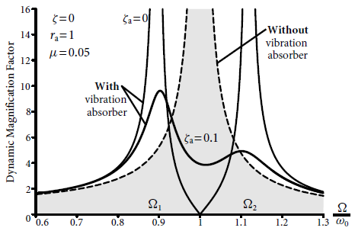 | 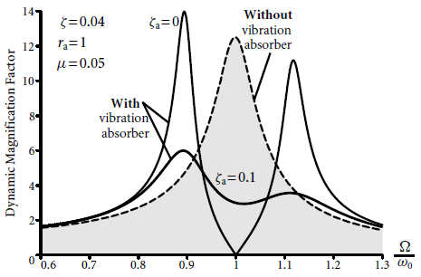
Fig. 3: DMF for $ζ=0$ | Fig. 4: DMF for $ζ=0.04$
In order to reduce the vibration of the main system at resonance, a vibration absorber or TMD is attached to the main mass m. The vibration absorber is usually tuned [4] so that $ω_{а}=ω_{0}$ or $r_{a}=1$, hence the name tuned mass damper. In practice, the mass of the vibration absorber or TMD is normally much smaller than that of the main mass, i.e., $m_{a}≪m$ or $μ≪1$; in Figure 3 and 4, μ is taken as 1/20=0.05.
If the vibration absorber or TMD is undamped, i.e., $ζ_{a}=0$, then DMF=0 when$Ω=ω_{0}$, meaning that the vibration absorber eliminates vibration of the main mass m at the resonant frequency $Ω=ω_{0}$. However, it is seen that the vibration absorber or TMD introduces two resonant frequencies $Ω_{1}$ and $Ω_{2}$, at which the amplitude of vibration of the main mass m is infinite. In practice, the excitation frequency$Ω$ must be kept away from the frequencies $Ω_{1}$ and $Ω_{2}$.
In order not to introduce extra resonant frequencies, vibration absorbers or TMD are usually damped [4]. A typical result of DMF is shown in Figure 3 for $ζ_{a}=0.1$. It is seen that the vibration of the main mass m is effectively suppressed for all excitation frequencies. By varying the value of $ζ_{a}$, an optimal vibration absorber can be designed.
When the main system is also damped, typical results of DMF are shown in Figure 4. Similar conclusions can also be drawn.
- MATHEMATICAL MODEL OF DYNAMIC VIBRATION ABSORBER WITH MATLAB&SIMULINK
Governing equitation’s of motion for the system on Fig. 2 can be written as:
 | $$m\ddot{x}+\left(c+c_{a}\right)\dot{x}+\left(k+k_{a}\right)x-c_{a}{\dot{x}}_{a}-k_{a}x_{a}=F_{0}sinΩt$$ | 9
 | $$m_{a}{\ddot{x}}_{a}+c_{a}{\dot{x}}_{a}+k_{a}x_{a}-c_{a}\dot{x}-k_{a}x=0$$ | 10
or in matrix for:
 | $$\left[\begin{matrix}m & 0 \\ 0 & m_{a}\end{matrix}\right]\left[\begin{matrix}\ddot{x} \\ {\ddot{x}}_{a}\end{matrix}\right]+\left[\begin{matrix}\left(c+c_{a}\right) & -c_{a} \\ -c_{a} & c_{a}\end{matrix}\right]\left[\begin{matrix}\dot{x} \\ {\dot{x}}_{a}\end{matrix}\right]+\left[\begin{matrix}\left(k+k_{a}\right) & -k_{a} \\ -k_{a} & k_{a}\end{matrix}\right]\left[\begin{matrix}x \\ x_{a}\end{matrix}\right]=\left[\begin{matrix}1 \\ 0\end{matrix}\right]F_{0}sinΩt$$ | 11
Hence
 | $$M\ddot{X}+C\dot{X}+KX={I∙F}_{0}sinΩt$$ | 12
In the following step equitation of motion is re-written in State Space system [5]:
 | $$\ddot{X}=\left[-M^{-1}K\right]X+\left[-M^{-1}C\right]\dot{X}+{\left[-M^{-1}I\right]∙F}_{0}sinΩt$$ | 13
 | $$\dot{X}=\left[0\right]X+\left[1\right]\dot{X}+{\left[0\right]∙F}_{0}sinΩt$$ | 14
or in matrix form:
 | $$\left\{\begin{matrix}\dot{X} \\ \ddot{X}\end{matrix}\right\}=\left[\begin{matrix}0 & \begin{matrix}1 & 0 \\ 0 & 1\end{matrix} \\ -M^{-1}K & -M^{-1}C\end{matrix}\right]\left\{\begin{matrix}X \\ \dot{X}\end{matrix}\right\}+\left[\begin{matrix}0 \\ -M^{-1}I\end{matrix}\right]{∙F}_{0}sinΩt$$ | 15
Hence
 | $$\dot{X}=A∙X+B∙u$$ | 16
Second equitation of the system is:
 | $$X=C∙X+D∙u$$ | 17
where
 | $C=\left[\begin{matrix}1 & ⋯ & 0 \\ ⋮ & ⋱ & ⋮ \\ 0 & ⋯ & 1\end{matrix}\right]$ and $D=\left[\begin{matrix}0 & ⋯ & 0 \\ ⋮ & ⋱ & ⋮ \\ 0 & ⋯ & 0\end{matrix}\right]$ | 18
Above equitation’s conclude the final State-Space form:
 | $$\dot{X}=A∙X+B∙u$$ | 19
 | $$X=C∙X+D∙u$$ | 20

which is one way for solving the system of differential equitation’s by using the command State-Space system in Matlab Simulink.
Figure 5 shows the structural scheme in Simulink. The second equitation with coefficients C and D is called equitation of output values.
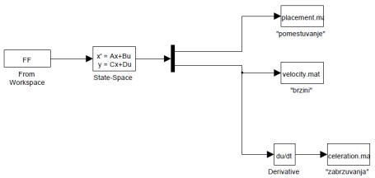
Fig. 5: State-Space model in Matlab Simulink for solving system of ODE’s
On the left side of Fig.5 are given input values as column vectors (time of sampling and external force $F_{0}sinΩt$). The initial conditions are also listed here as x and x_{a} at t=0, as well as ${\dot{x} and \dot{x}}_{a} at t=0$. For the studied case it is adopted initial values to be equal to zero.
Another way of modeling the system in Matlab Simulink is with block diagrams using function ODE45 for solving differential equitation’s. For this purpose we need to re-write the governing equitation’s:
 | $$m\ddot{x}+\left(c+c_{a}\right)\dot{x}+\left(k+k_{a}\right)x-c_{a}{\dot{x}}_{a}-k_{a}x_{a}=F_{0}sinΩt$$ | 9
 | $$m_{a}{\ddot{x}}_{a}+c_{a}{\dot{x}}_{a}+k_{a}x_{a}-c_{a}\dot{x}-k_{a}x=0$$ | 10
in the following order:
 | $$\ddot{x}=\frac{F_{0}}{m}sinΩt+\frac{c_{a}}{m}{\dot{x}}_{a}+\frac{k_{a}}{m}x_{a}-\frac{\left(c+c_{a}\right)}{m}\dot{x}-\frac{\left(k+k_{a}\right)}{m}x$$ | 21
 | $$\ddot{x}=A sinΩt+B {\dot{x}}_{a}+C x_{a}-D \dot{x}-E x$$ | 22
and
 | $${\ddot{x}}_{a}=\frac{c_{a}}{m_{a}}\dot{x}+\frac{k_{a}}{m_{a}}x-\frac{c_{a}}{m_{a}}{\dot{x}}_{a}-\frac{k_{a}}{m_{a}}x_{a}$$ | 23
 | $${\ddot{x}}_{a}=K \dot{x}+L x-M {\dot{x}}_{a}-N x_{a}$$ | 24
if adopted variables:
 | $ω_{0}^{2}=\frac{k}{m}$, $c=2mζω_{0}$, $r=\frac{Ω}{ω_{0}}$, $μ=\frac{m_{a}}{m}$, $ω_{a}^{2}=\frac{k_{a}}{m_{a}}$, $c_{a}=2m_{a}ζ_{a}ω_{0}$, $r_{a}=\frac{ω_{a}}{ω_{0}}$ | 25
the coefficients A, B, C, D, E, K, L, M, N become:
$B=2μζ_{a}ω_{0}$, $C=μω_{a}^{2}$, $D=2ω_{0}(ζ+μζ_{a})$, $E=ω_{0}^{2}+μω_{a}^{2}$, $K=M=2ζ_{a}ω_{0}$, $L=N=ω_{a}^{2}$ | 26
Following equitation’s:
 | $$\ddot{x}=A sinΩt+B {\dot{x}}_{a}+C x_{a}-D \dot{x}-E x$$ | 27
 | $${\ddot{x}}_{a}=K \dot{x}+L x-M {\dot{x}}_{a}-N x_{a}$$ | 28
we make the block scheme in Matlab Simulink shown on Figure 6.
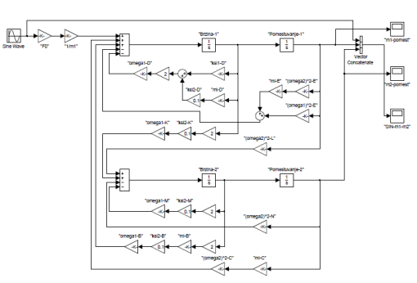
Fig. 6: Block representation in Matlab Simulink for solving ODE’s
In this type of representation, initial conditions are given by clicking on each block in the scheme. The solutions obtained with block scheme representation and State-Space system must be identical.
The analysis of the system on Fig. 2, 5 and 6 is carried out with the values of the main parameters given in Table 1:
Tab. 1: Selected values for main parameters
$$m [kg]$$ | 200 | $$ζ_{a}$$ | 0.1
$$μ$$ | 0.05 | $$c[N∙(s/m)]$$ | 502.4
$$m_{a}[kg]$$ | 10 | $$k[N/m]$$ | 197192
$$f[Hz]$$ | 5 | $$c_a [N∙(s/m)]$$ | 62.8
$$ω_{0}[rad/s]$$ | 31.4 | $$k_a [N/m]$$ | 9859.6
$$ω_a [rad/s]$$ | 31.4 | $$F_{0}[N]$$ | 5000
$$ζ$$ | 0.04 | $$Ω [rad/s]$$ | 31
With this input parameters we can calculate the governing equitation’s of motion for 10 sec. and sampling time of 0.01 s. The results of the response are shown on Fig. 7 and 8.
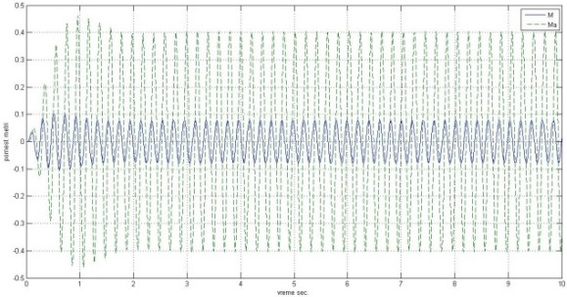 | 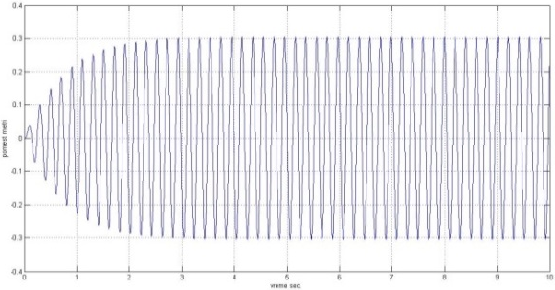
Fig. 7: Displace. of main mass with TMD | Fig. 8: Displa. of main mass without TMD
If we calculate the maximal value of the displacement at same time of the main (primary) mass for case with and without TMD it can be seen that displacements are larger in the case without the auxiliary mass. Comparison of amplitudes from Fig. 7 and 8 is given in table 2. It shows that TMD decreased the vibrations for 74% of the value without TMD.
Tab. 2: Comparison of amplitudes
Max. displace. [m] without TMD for t=5s | Max. displace. [m] with TMD for t=5s
0.3038 | 0.07892
Another important detail for review is the displacement of the auxiliary mass which can be seen on Fig. 7. It is clear that the displacement is significantly larger than the response of the primary mass. In our case, the amplitude of the auxiliary mass is 0.4 compared with 0.07892 of the main mass.
This is one of the problems with application of TMD. In order to do its function, it is necessary to be provided with large space for the auxiliary mass so it can oscillate without any obstacles. Considering that these devices are installed on top of the building roofs, this space is usually limited.
Fig. 9 represents the influence of the ratio$μ$ (auxiliary mass/main mass). It is clear that increasing the auxiliary mass$m_{a}$ is widening the area of impaired oscilations, but as it is mentioned before, this is limited with the ration of less than 15%. Usually large masses lead to big unpractical structures.
Fig. 10 illustrates the weakening effect caused by shifting frequency ratio $r_{a}={ω_{a}}/{ω_{0}}≠1$ over size of the area of impaired oscillations.
Fig. 11 shows the DMF as function of the normalized frequency $r$ and the damping ration of the auxiliary mass $ζ_{a}$. It is clear that with increasing the damping two major maximums intend to joint in one, which has much lower value. It is evident from the diagram that TMD has optimal value [6].
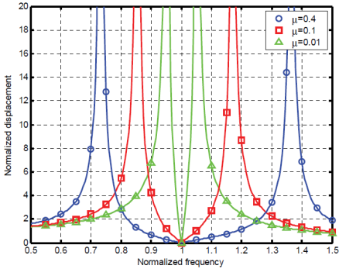 | .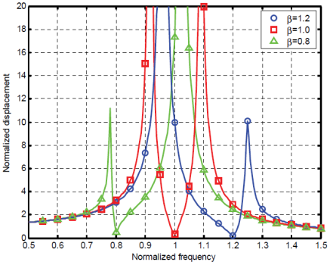
Fig. 9: Influence of the mass ratio$μ$ | Fig. 10: Influence of the ratio $r_{a}={ω_{a}}/{ω_{0}}$
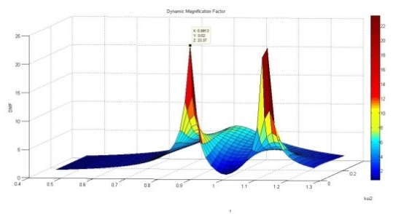 | 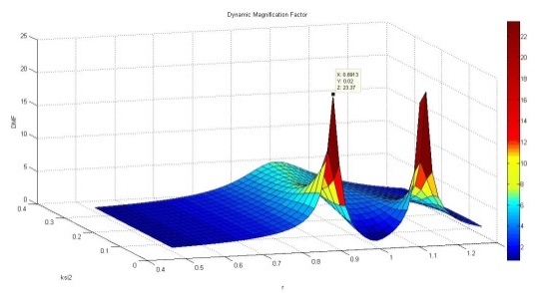
Fig. 11: DMF as function of normalized freq. $r$ and the damping ration $ζ_{a}$
- MODELING FORCE AS FUNCTION OF RELATIVE VELOCITY
Wind force is dependent on wind velocity and also type of airflow. This is described with the equitation [7, 8]:
 | $$F=C_{F}∙A∙q$$ | 29
where $C_{F}$ is coefficient of shape, $A$ is building surface and $q$ is wind pressure.
Wind pressure is equal to:
 | $q=\frac{1}{2}∙ρ∙V^{2}$ | 30
where $ρ$ is air density and $V$ is wind velocity.
The $C_{F}$ is dimensionless number which depends on Reynolds number, and for normal wind velocities can be considered as constant. Therefore the equitation for wind force can be written as:
 | $F=C_{F}∙A∙q=C_{F}∙A∙\frac{1}{2}∙ρ∙V^{2}=C_{W}∙V^{2}$ | 31
where $C_{W}$ is wind constant.
From the analysis in previous section Fig.7 and 8, we can make following statement:
 | $$F=sgn\left(V\right)∙C_{W}∙V^{2}=F_{0}sinΩt$$ | 32
Wind force is always in the direction of wind velocity and therefore:
 | $$sgn\left(V\right)=sgn(sinΩt)$$ | 33
Hence, wind velocity and force for analyzed model can be calculated as:
 | $V=sgn\left(sinΩt\right)∙\sqrt{\frac{F_{0} }{C_{W}}∙\left|sinΩt\right|}$ | 34
 | $F=sgn\left(sinΩt\right)∙C_{W}∙{\left(\sqrt{\frac{F_{0} }{C_{W}}∙\left|sinΩt\right|}\right)}^{2}$ | 35
Next analysis calculates differential equitation’s (ODE’s) with external wind force that will depend on the relative speed between wind and structure velocity [9,10]:
 | $$F=sgn\left(V-\dot{x}\right)∙C_{W}∙{\left(V-\dot{x}\right)}^{2}$$ | 36
the differential equitation’s will take shape:
 | $$\ddot{x}=\frac{A}{F_{0}} sgn\left(V-\dot{x}\right)∙C_{W}∙{\left(V-\dot{x}\right)}^{2}+B {\dot{x}}_{a}+C x_{a}-D \dot{x}-E x$$ | 37
 | $${\ddot{x}}_{a}=K \dot{x}+L x-M {\dot{x}}_{a}-N x_{a}$$ | 38
For easier calculation we will adopt $C_{W}=1$. Next, we lower the order of ODE’s:
 | $x_{1}=x$, $x_{2}=\dot{x}$, ${ x}_{3}=x_{a}$, $x_{4}={\dot{x}}_{a}$ | 39
and $A/{F_{0}=A'}$ and we have:
 | $${\dot{x}}_{1}=x_{2}$$ | 40
 | $${\dot{x}}_{2}=A' sgn\left(V-x_{2}\right)∙{\left(V-x_{2}\right)}^{2}+B{ x}_{4}+C x_{3}-D x_{2}-E x_{1}$$ | 41
 | $${\dot{x}}_{3}=x_{4}$$ | 42
 | $${\dot{x}}_{4}=K x_{2}+L x_{1}-M x_{4}-N x_{3}$$ | 43
Using ODE45 (an explicit Runge-Kutta method) in Matlab for solving non-stiff differential equations, we obtain solution for the system above. The results are presented graphically with Fig. 12.
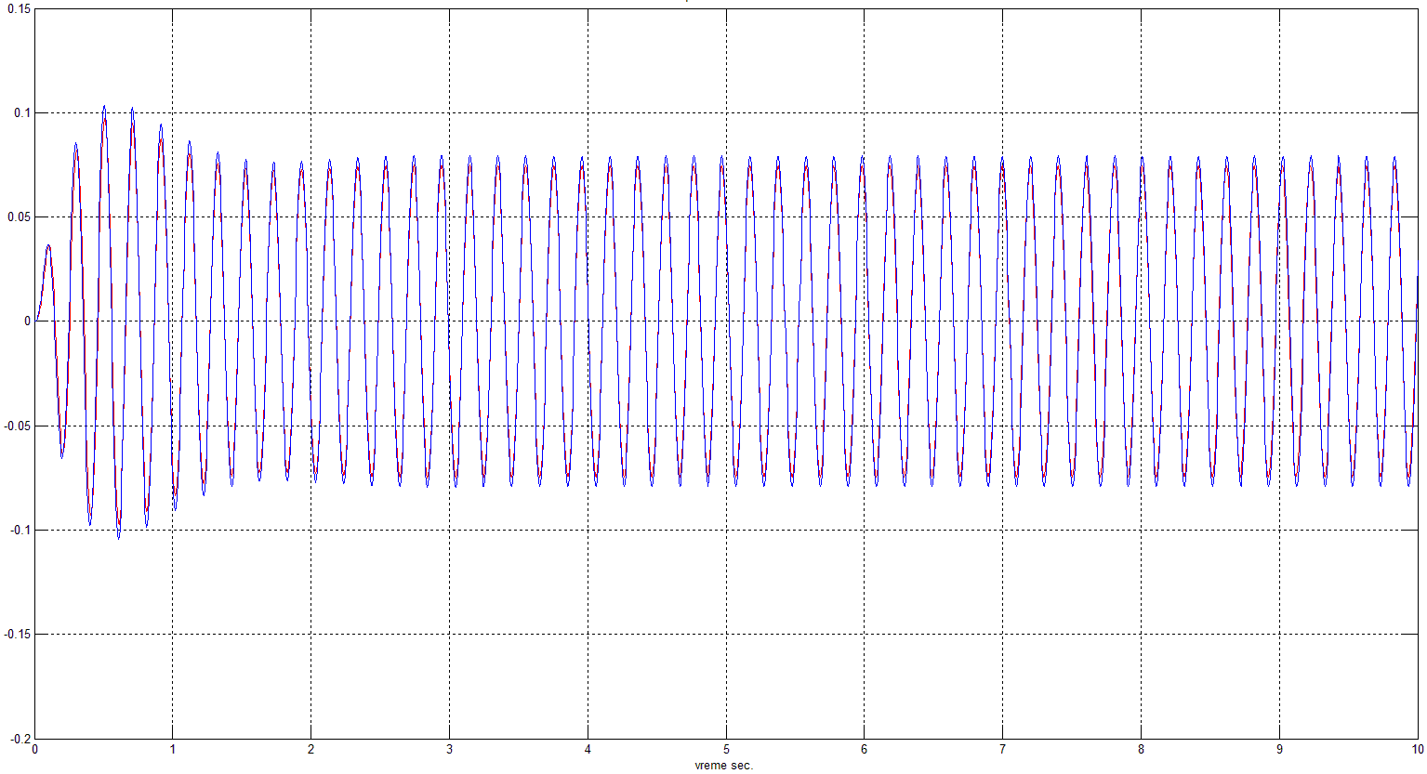 | 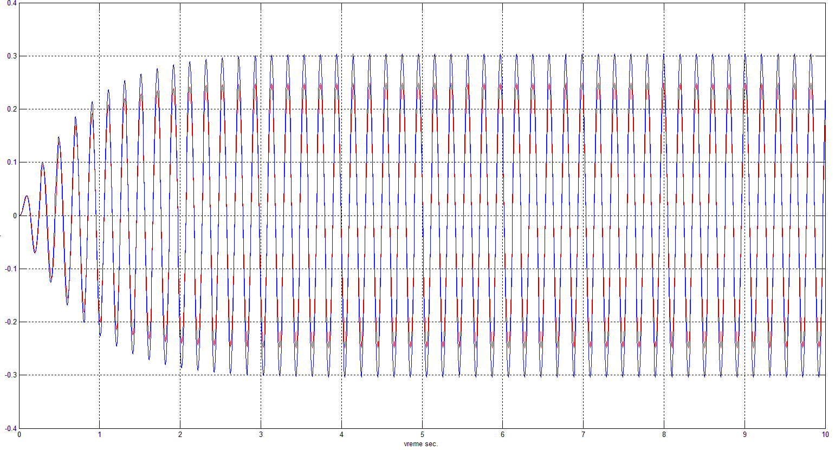
Fig. 12: Comparison between calculation with and without relative speed included
The results show general trend for smaller amplitudes of displacement of the primary and secondary mass when relative speed is included (tab. 3).
Tab. 3: Comparison of amplitudes
Amplitude of primary mass for t=5s [m]
without TMD (relative speed included) | without TMD (relative speed not included)
0.25 | 0.3038
with TMD (relative speed included) | with TMD (relative speed not included)
0.07467 | 0.07929
- CONCLUSION
This paper is analyzing the mathematical approach for modeling dynamic vibration absorber with s.d.o.f. and m.d.o.f. mass. The paper presents the technique for modeling the differential equitation’s with state-space form and block diagrams using Matlab Simulink.
Also, it shows how the relative speed affects the primary mass response under external excitation. It can be concluded that when the primary mass vibrates with frequency close to the natural frequency and it is without TMD the relative speed is causing smaller amplitudes of oscillations.
If TMD is installed, the relative speed is not affecting the response of the primary mass and the difference between the amplitudes of oscillations is insignificant.
If relative speed is included, the response of primary mass is smaller than the case without it.
REFERENCES
- Clough,W. R., J.Penzien, Dynamics of Structures, 2rd ed. McGraw-Hill, 1993. Ch. 9-12.
- Anil K. Chopra, Dynamics of Structures. 4rd ed. Prentice Hall, 2011. Ch. 1-3, 5-7
- T. K. Datta, Seismic Analysis of Structures. 1rd ed. John Wiley and Sons, 2010. Ch. 3 and 9
- I.Takewaki, Critical Excitation Methods in Earthquake Engineering, 1rd ed. Elsevier Science, 2007. Ch. 5
- Aly, A. M., Zasso, A., Resta, F. „Proposed Configuration for the Use of Smart Dampers with Bracings in Tall Buildings‟. Hindawi Publishing Corporation, Smart Materials Research.2012.Vol.2012. Article ID 251543
- Lewandowski, R., Grzymislawska, J. „Dynamic analysis of structure with multiple tuned mass dampers‟. Journal of Civil Engineering and Management. 2009. Iss.1. Vol.15. 77-86
- Eurocode 1, „Eurocode 1: Actions on structures — General actions — Part 1-4: Wind actions‟. prEN 1991-1-4: European Standard, 2004.
- Simiu, Emil, Robert H. Scanlan. Wind effects on structures, Fundamentals and Application to Design. 3rd ed.John Wiley and Sons, 1996. Ch.5
- Dyrbye, Claës, S. O. Hansen, Wind Loads on Structures, 1rd ed.John Wiley and Sons, 1997. Ch. 4 and 5
- Chen, Shu-Xun. „A More Precise Computation of Along Wind Dynamic Response Analysis for Tall Buildings Built in Urban Areas‟. Scientific Reaserch Publishing, Journal of Engineering.2010.vol. 2.no.4. 290-2

MSc, Filip Zdraveski, Skopje, Faculty of mechanical engineering, filip.zdraveski@mf.edu.mk
MSc, Elisaveta Donceva, Skopje, Faculty of mechanical engineering, elisaveta.doncheva@mf.edu.mk

