LOGO WILL BE HERE
Crankshaft angular velocity of a ten-cylinder diesel engine as a diagnostics parameter
S. Biočanin , Ž. Bulatović , A. Milašinović, I. Mujanić, R. Božičković
Summary: This paper presents methods of measurement and analysis of instantaneous angular speed at the free end of a ten-cylinder OM403 engine crankshaft regarding different operating conditions in the engine cylinders. The angular velocity was measured under laboratory conditions, by using an opto-electronic incremental rotary encoder, directly mounted on the free end of the crankshaft. Additionally, a simplified mathematical model for instantaneous angular velocity of the crankshaft has been developed which simulates the same operating conditions in the engine cylinders as during the experiment. At the end, the results of the measurement and mathematical model were analyzed and compared. The goal of this paper is to give a practical contribution to studies introducing the measured crankshaft speed as a key parameter for the detection of working cycle disturbances in particular engine cylinders.
Key words: diagnostic, angular velocity, crankshaft, diesel engine
- INTRODUCTION
Application of digital microprocessors and microcontrollers and ultrafast analog-to-digital and digital-to-analog converters, gave engines new qualities and enabled complex management of engine working processes. On the other hand, wide possibilities of adaptive operation control of almost all vital engine subsystems were opened as well as diagnostics of the quality of the working process. Simultaneously with the development of measuring equipment and application of micro-processor technology for monitoring parameters of the working process, studies have been done with the aim of using information contained in the angular speed of the crankshaft, parallel with mathematical models and direct measurement, for diagnostic purposes [1, 2, 3, 4, 8, 12, 13].
There is a wide range of theoretical and practical approaches, regarding mathematical modeling, analysis and measuring procedures [5] of the angular speed of the crankshaft, that can be found in literature. The complexity of applied mathematical models is directly influenced by the primary characteristics of the examined engine. Definitely, the most complex models include factors influencing the no uniform nature of the angular speed, like torsion vibrations. However, it is absolutely illogical to develop such models for engines for which these factors are of secondary importance.
There is a series of diesel engines, designed for vehicles for special purposes, which are expected to have high reliability during exploitation. Therefore, it is necessary to explore the possibilities of real-time monitoring of changes in operating parameters during exploitation, with the aim of preventive and timely maintenance of the engine and to increase its reliability. In order to fulfill the set goal, achievements in research on engines for specialized tracked vehicles - series V46, were used [6, 7, 9, 10, 14].
Table 1: Technical characteristics of the OM403 engine
Type | V10 engine
Effective power according to DIN 70200 (P_{e}) | 225 KW at 2500 rpm
Maximum effective torque (M_{e}) | 1030 (Nm) at 1500 rpm
Total volume (V_{u}) | 15.95 dm³
Some important technical characteristics of the observed OM403 engine, declared by the manufacturer, are given in Table 1.
The misfire was simulated by disconnection of the fuel supply for individual engine cylinders. At the same time the instantaneous angular speed (ω) was noted as a function of the crank angle. This examination was carried out simultaneously with the examination described in [15].
- MATHEMATICAL MODELING OF CRANKSHAFT ANGULAR SPEED OF AN OM403 ENGINE
The mathematical model of crankshaft's instantaneous angular speed of the OM403 engine has been built upon following assumptions:
- the mean effective pressures during operation was relatively moderate and consequently amplitudes of the excitation torque weren’t too high;
- the OM403 has a flywheel with high polar moment of inertia, a torsion vibration damper and crankshaft counterweights (since it is not naturally balanced);
- preliminary measurement results do not indicate the dominant influence of torsion oscillations on instantaneous angular speed variations.
The above facts had a crucially influence on setting the mathematical model of instantaneous angular speed variations of the crankshaft in a simplified form through the general dynamical equation of motion for a body with a variable moment of inertia (in this case - the moving parts of the piston mechanism) about a fixed axis [11]:

 | $$\frac{d}{dα}\left[\frac{1}{2}∙J(α)∙{ω(α)}^{2}\right]=M_{U}\left(α\right)-M_{OP}(α)$$  $$\frac{1}{2}∙\frac{dJ\left(α\right)}{dα}∙{ω\left(α\right)}^{2}+J\left(α\right)∙ω\left(α\right)∙\frac{dω\left(α\right)}{dα}=M_{U}\left(α\right)-M_{OP}\left(α\right)$$ | (1)
where ω(α) is instantaneous angular speed of the crankshaft, J(α) is variable moment of inertia, $M_{U}\left(α\right)$M_{U}(α) is total torque acting on the crankshaft (gas pressure torque, engine friction torque, load torque due to the auxiliary devices), M_{OP}(α) is brake torque (assumed to be constant) and α is crank angle.
The model was simplified by neglecting the variable character of the polar moment of inertia of the moving parts of the piston mechanism and assuming that J(α)=J₀= const. Also, angular speed beside the term dω(α)/dα was assumed to be constant – the mean value ω₀ was used in this case. With the above assumptions the mathematical model becomes linear. By using variable parameters J(α) or ω(α) beside the terms dω(α)/dα, the mathematical model of motion of the crankshaft becomes a nonlinear differential equation.
Consequently, equation (1) can be written as a system of equations:
 | $$M_{U}\left(α\right)=M_{OP}\left(α\right)+J_{0}∙ω_{0}∙\frac{dω\left(α\right)}{dα}$$ | (2)
 | $$M_{U}\left(α\right)=\sum_{i=1}^{10}{{M_{gi}\left(α\right)+M}_{fi}\left(α\right)}$$ | (3)
The variability of moment of inertia of engine moving parts was taken into account indirectly, through moment of inertia forces of the whole crankshaft J₀·ω₀·dω(α)/dα. In equation (3), M_{gi}(α) is the gas pressure torque component from the i-th engine cylinder, M_{fi}(α) is the friction torque component from the i-th engine cylinder. Equation (2) shows that the instantaneous value of available torque M_{U}(α) is being spent on overcoming resistance, primarily referring to:
- external resistance torque i.e. reactive resistance from a brake which is assumed to be constant,
- internal resistances that can be neglected (gravitational forces, aerodynamic drag, etc.),
- mechanical losses due to powering of some engine subsystems,
- overcoming moment of inertia generated during acceleration or deceleration of rotational masses of the engine mechanism (J₀·ω₀·dω(α)/dα).
Furthermore, it has been assumed that the total moment due to frictional forces (Σ M_{fi}(α)) is a lower-order term in comparison to the total torque from gas pressure (Σ M_{gi}(α)) and inertial forces (J₀·ω₀·dω(α)/dα) from all cylinders. Based on that, the influence of friction forces was neglected, which didn’t produce a significant error during calculation, while the model was additionally simplified. Now the differential equation of crankshaft angular speed variations in function of the crank angle was obtained:
 | $$\frac{dω\left(α\right)}{dα}=\frac{1}{J_{0}∙ω\left(α\right)}\left[M_{U}\left(α\right)-M_{OP}\left(α\right)\right]$$ | (4)
Since the instantaneous torque M_{U}(α) is directly proportional to the total instantaneous tangential force T_{U}(α):
 | $$M_{U}\left(α\right)=R∙T_{U}\left(α\right)$$ | (5)
(where R is the distance between axes of crankpin and main journal of the crankshaft) equation (4) can be written in a more convenient form for solving, where ω(α) is expressed in radians per second:
 | $$\frac{dω\left(α\right)}{dα}=\frac{1}{J_{0}∙ω\left(α\right)}\left[R∙T_{U}\left(α\right)-M_{OP}\left(α\right)\right]∙\frac{π}{180}$$ | (6)
The total instantaneous tangential force T_{U}(α) is a resultant force of gas pressure forces in all engine cylinders and inertial forces caused by reciprocating elements of the slider-crank mechanism reduced to the crankpin journal axis.
In order to apply the differential equation of crankshaft angular speed variations, it is necessary to determine the total mean value of the reduced moment of inertia of the engine mechanism - J₀ and the change of total tangential force originating from all engine cylinders - T_{U}(α). The moment of inertia - J₀ is determined on the basis of known masses and moments of inertia of elements constituting that mechanism. These values were determined on the basis of 3D models of the slider-crank mechanism elements, created by using ProEngineer (Figure 1), and are shown in Table 2.
Table 2: Mass and moment of inertia values of the OM403 engine elements
Element | Mass | Moment of inertia
Piston group | m_{kl}=3.43 kg | -
Connecting rod | m_{kp}=3.487 kg | J_{kp}=0.04618 kg·m²$J_{kp}$
Connecting rod reciprocating mass | m_{kpo}=1.003 kg | -
Connecting rod rotating mass | m_{kpr}=2.484 kg $m_{kpr}$ | -
Crankshaft assembly | - | J_{kv}=1.99446 kg·m²
The mean value of reduced moment of inertia of the engine mechanism in relation to the crankshaft’s axis of rotation (2.19320 kg·m²) is determined according to equation:
 | $$J_{0}=J_{kv}+10∙m_{kpr}∙R^{2}+\frac{10}{2}∙m_{o}∙R^{2}$$ | (7)
where m₀ is the total mass of elements of one cylinder that are assumed to be in linear oscillatory motion (piston group and part of the connecting rod mass):
 | $$m_{o}=m_{kl}+m_{kpo}$$ | (8)
The total variable tangential force - T_{U}(α) was determined as a sum of tangential forces of all cylinders:
 | $$T_{U}\left(α\right)=\sum_{i=1}^{10}{T_{i }(α)}$$ | (9)
Figure 3b shows the change of tangential force for cylinder 1 during normal operation (solid line) and during misfire (dashed line). Thereby, diagrams of measured pressure changes in cylinders, without combustion (dashed line) and with regular combustion (solid line) [15], shown in Figure 3a, were used. When it comes to tangential forces of other cylinders, during mathematical modeling it was assumed they have identical forms as the curves shown in Figure 3b, just shifted according to phase differences and the firing order (1-6-5-10-2-7-3-8-4-9). A schematic representation of phase differences according to the firing order and in relation to cylinder 1 is shown in Figure 2.
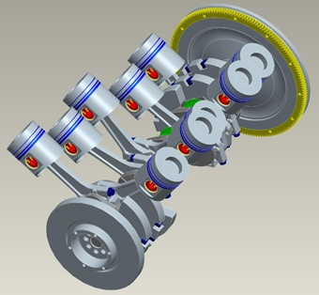 | 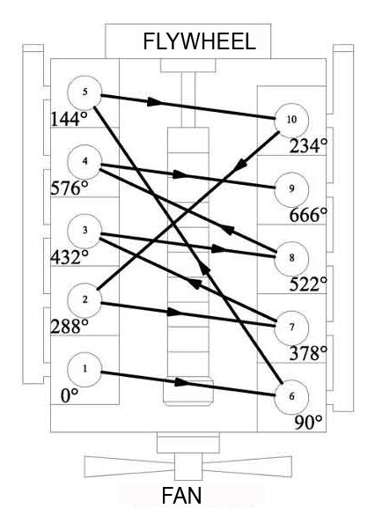
Figure 1: 3D model of the OM403 engine slider-crank mechanism | Figure 2: Schematic representation of phase differences in relation to cylinder 1
Figure 3a: Diagram of indicated pressures (p-α) in the first left engine cylinder [15] | Figure 3b: Instantaneous value of tangential force for cylinder 1 during normal operation (solid line) and during misfire (dashed line)
Figures 4 to 7 show instantaneous total tangential force and angular speed of the crankshaft for different operating conditions in individual cylinders. Numerical designations on the top of the curves refer to the cylinder in which the combustion occurs at that moment. Indicated pressure curves were used for calculation of gas pressure torque, while assuming that the operation of all cylinders is identical.
Figure 4 shows the mathematical model of total tangential force and crankshaft angular speed at 1700 rpm and full load during normal combustion in all cylinders. Both functions are periodical with 5 distinctive periods. Peaks of tangential force, which occur on segments during the working process in the right sided cylinders (1, 2, 3, 4, 5), are more emphasized than peaks which occur on segments referring to the cylinders on the left side of the engine (6, 7, 8, 9, 10). This is a consequence of an uneven phase difference of working processes in individual cylinders or the composite influence of spatial distribution of crank arms and the angle value between the left and right engine cylinders (90°).
 | 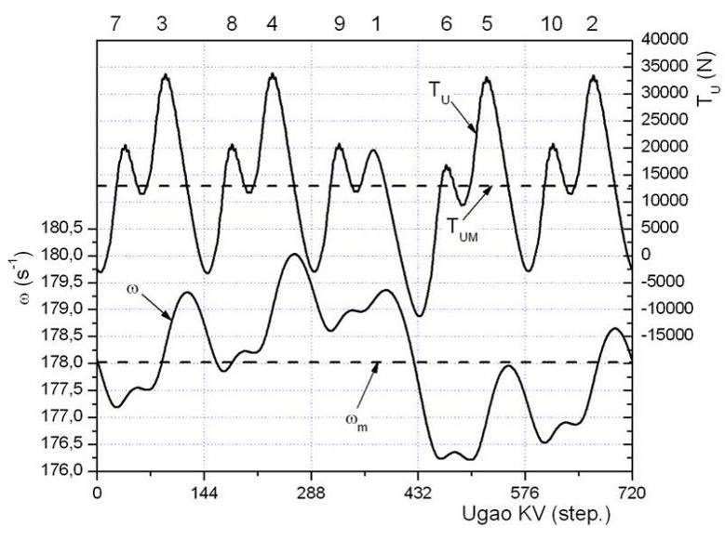
Figure 4: Diagram of total tangential force and crankshaft angular speed according to the mathematical model during normal combustion in all cylinders (at 1700 rpm and full load) | Figure 5: Diagram of total tangential force and crankshaft angular speed according to the mathematical model in case of misfire in cylinder 1 (at 1700 rpm and full load)
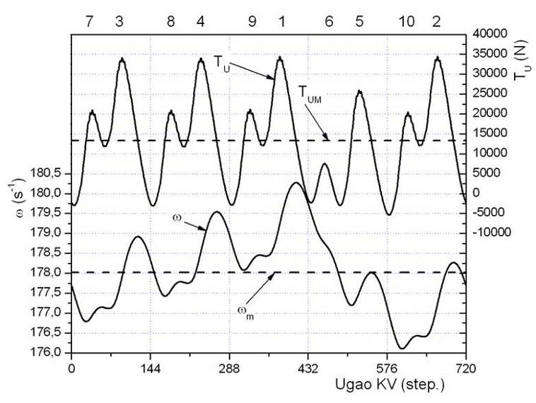 | 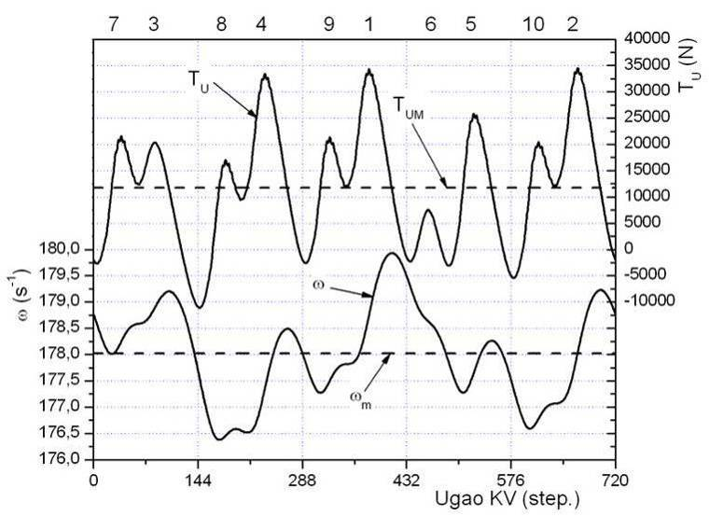
Figure 6: Diagram of total tangential force and crankshaft angular speed according to the mathematical model in case of misfire in cylinder 6 (at 1700 rpm and full load) | Figure 7: Diagram of total tangential force and crankshaft angular speed according to the mathematical model in case of misfire in cylinders 3 and 6 (at 1700 rpm and full load)
Figure 5 shows the mathematical model of total tangential force and crankshaft angular speed at 1700 rpm and full load in the case of misfire in cylinder 1. Both the total tangential force and the crankshaft angular speed have a distinctive decline on the segment referring to the working process in cylinder 1. While the total tangential force in 4 out of 5 segments kept its periodical character to some extent, the curve representing angular speed completely lost this feature.
Figure 6 shows the mathematical model of total tangential force and crankshaft angular speed at 1700 rpm and full load in the case of misfire in cylinder 6. Like before, both the total tangential force and the crankshaft angular speed have a distinctive decline on the segment referring to the working process in cylinder 6.
Figure 7 shows the mathematical model of total tangential force and crankshaft angular speed at 1700 rpm and full load in the case of misfire in cylinders 3 and 6. The total tangential force has a distinctive decline on the segments referring to the working processes in those cylinders. The same applies to the modeled angular speed of the crankshaft.
A common feature of all the curves of crankshaft angular speed shown above is that they reach their extreme values at those points where the variable tangential force - T_{U}(α) intersects the mean value of this force designated with T_{UM}. This is a direct consequence of the application of differential equation (6), i.e. the fact that a function reaches its extreme values at points in which the value of its first derivative equals zero, which confirms the correctness of the calculation.
It is very important to note that the curves of angular velocity of the crankshaft in the case of misfire in the right cylinder number 1 (Figure 5) and in the left cylinder number 6 (Figure 6) are not identical, which is logical. However, curves of crankshaft angular speed with misfire in any of the cylinders on right side can be perfectly matched by shifting along the abscissa axis according to the phase difference of working cycles in those cylinders. The same rule applies to cylinders on the left side of the engine. The above mentioned characteristic will be clearly seen in diagrams showing comparison between measured instantaneous angular speed and model results. According to this, at first glance it could be concluded that the harmonic amplitudes of Fourier's interpolation polynomial, which describe the variation of angular speed in relation to its mean value, regarding the right side of the engine will have extremely different values compared to the left sided cylinders. However, quite the opposite happened. Dominant harmonic amplitudes of the Fourier spectrum analysis of angular speed for both right- and left-sided cylinders have identical values. This can be clearly seen on diagrams labeled with c, d, e and f in Figure 8, which represent amplitudes of instantaneous angular speed gained through Fourier spectrum analysis in the case of misfire in 4 adjacent cylinders according to firing order (1, 6, 5 and 10), distributed on different sides of the engine. The mathematical interpretation of this phenomenon is that angular speed variations in case of misfire in any cylinder could be gained by superposing sinusoidal functions of almost equal amplitudes, which at the same time have different angle values of the starting phase, which finally results in gaining two very similar but phase shifted periodical functions:
- in case of misfire in one of the cylinders on the right side and
- in case of misfire in one of the cylinders on the left engine side.
Theoretically, this would mean that by analyzing amplitudes of the Fourier series of variable angular speed in case of misfire in any engine cylinder, the difference between this case and regular combustion in all cylinders can be clearly seen (diagram labeled as a in Figure 8) but the cylinder cannot be identified nor the side on which he is located.
Figure 8: The values of the amplitude Fourier interpolation polynomial modeled variation of the angular velocity of the crankshaft for different states correctness unfolding of work processes in the engine cylinders (n = 1700 rpm, full load)
The case whit two defect cylinders, number 3 and 6 (diagram labeled as b in Figure 8) clearly differs from other diagrams in the same Figure, but also does not provide the possibility of locating defect cylinders. It is quite certain that the same diagrams would have been obtained for any other combination of two defect cylinders with the same phase difference as in the case of cylinder number 3 and 6.
It is interesting that the angular velocity variations of the crankshaft in case of normal engine operation (Figure 8a) can be obtained quite accurately by superposing only three Fourier harmonics - the fifth (5), tenth (10) and fifteenth (15), while the fifth harmonic is dominant. In case of misfire in one engine cylinder (Figure 8 – c, d, e and f) the first harmonic is dominant and in the case of two defect cylinders (number 3 and 6, Figure 8b) the second harmonic is dominant.
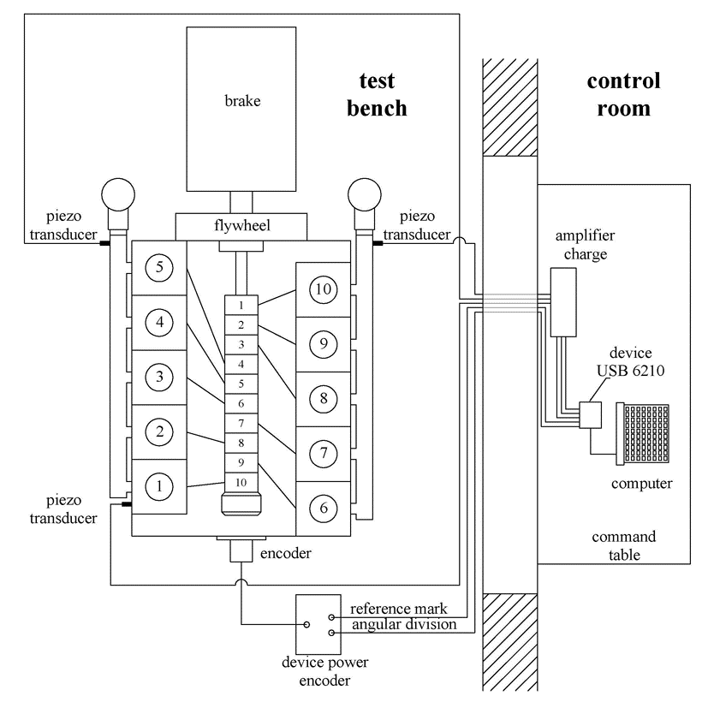
Figure 9: Block diagram of the measurement installation
A block diagram representation of the measurement installation used for the experiment, described in [15], is shown in Figure 9. An opto-electronic incremental rotary encoder is directly mounted on the free end of the crankshaft and connected to a power supply unit. A standard technique for measuring the angular speed, described in detail in reference [14], was applied. Systematic measurement errors directly affected measurement results of the interval Δτ_{i} between elementary angle units of the encoder, which is characterized by considerable "noise". This can be clearly seen in Figure 10. It is quite logical that the angular speed of the crankshaft, as a inversely proportional value to the measured time intervals Δτ_{i} (Figure 10), has a similar curve form, which is illustrated in Figure 11:
 | $$ω_{i}=\frac{dα}{dt}≈\frac{∆α}{∆τ_{i}}∙\frac{π}{180}$$ | (10)
The Fourier's trigonometric interpolation polynomial was also used in order to eliminate the systematic measurement errors and obtain smooth curves that can easily and efficiently be used for analysis and comparison with the results of mathematical modeling of the angular speed.
In the second phase during “filtration” of the signal with considerable „noise“ (the crankshaft's instantaneous angular speed as a derived value, shown in Figure 13), the starting point was the analysis of amplitudes of the first 250 harmonics of the Fourier's trigonometric interpolation polynomial, which is shown in Figure 12. Two important issues can be observed in these diagrams. First, the fifth harmonic is dominant, which corresponds to the true nature of the signal of angular speed of the crankshaft and the results of mathematical modeling, which will be discussed later. Secondly, extremely large values of amplitudes of higher harmonics accumulating somewhere around the 50th, 100th and partly around the 150th harmonic cannot be a reflection of the real physical event. These higher harmonics actually refer to superposed systematic measurement errors related to the eccentricity of the crankshaft axis and the axis of the encoder pin, so it is logical that they should be discarded during “filtration” of the signal. By keeping (synthesis) only the first 25 harmonics of the Fourier's trigonometric interpolation polynomial, a "filtered" signal of the crankshaft angular speed is obtained as a smooth curve (Figure 13), which can easily be compared with the results of mathematical modeling, as well as for other types of analysis regarding this parameter.
Figure 10: Typical changes in measured values of time intervals Δτ_{i} |  | Figure 11: Angular speed of the crankshaft as a inversely proportional value to the measured time intervals Δτ_{i}
 | Figure 12: Typical histogram of harmonic amplitudes of the Fourier's trigonometric interpolation polynomial for the crankshaft angular speed |  | Figure 13: Angular speed of the crankshaft before and after “filtering“
In this paper the Fourier's trigonometric interpolation polynomial was applied as a universal tool for analysis and “filtering“ of measured parameters of the engine working cycle.
- TEST RESULTS
Trial tests previously suggested that the optimal operating regime, which is common in practice, and at which all measured parameters of the working process are making their full contribution to the diagnosis of the engine’s proper operation, should be found at lower angular speed. The optimal operating regime was determined regarding maximum force realized on a laboratory brake for different speeds (from 2500 rpm to 1200 rpm). At the same time, the instantaneous crankshaft angular speed in case of misfire in cylinder number 6 and in the case of normal operation of all cylinders was measured. Comparative diagrams of direct measurement and mathematical modeling at the limit values of angular speed (2500 rpm and 1200 rpm) are shown in Figures 14 and 15.
a | b
Figure 14: Comparative diagrams of measured (solid line) and modeled angular speed of the crankshaft in case of normal combustion (a) and misfire in cylinder number 6 (b) at 2500 rpm and full load
The presented diagrams clearly show that the deviation of the measured data from values obtained by mathematical modeling rapidly decreases with decreasing engine speed. Therefore, operating modes for the efficient implementation of the method should be sought from 1800 rpm downwards. At lower speeds the influence of elastic deformations (torsion oscillations) of the crankshaft is lower, which can be seen from Figures 14 and 15.
Considering that the highest thermal engine load is achieved at the maximum torque (according to declaration at 1500 rpm) this operation mode is advisable to use less frequently in practice. Since operating modes at speeds lower than 1500 rpm are rarely used during exploitation, as the optimal mode to display the success of implementation of the developed method, 1700 rpm and full engine load were chosen.
The crankshaft angular speed, during simulated misfire in cylinders, was measured by disconnecting the high pressure fuel lines from the high pressure pump.
All diagrams are shown as a function of the crank angle and are related to the working cycle of cylinder number 1, where the crank angle value equals 0° when the piston of this cylinder is at the top dead center (TDC) and the start of suction process.
a |  | b
Figure 15: Comparative diagrams of measured (solid line) and modeled angular speed of the crankshaft in case of normal combustion (a) and misfire in cylinder number 6 (b) at 1200 rpm and full load
 | Figure 16: Comparative diagram of measured and modeled angular speed of the crankshaft during normal operation |  | Figure 17: Comparative diagram of amplitudes of the first 25 harmonics regarding changes of measured and modeled angular speed of the crankshaft during normal operation
During normal operation in all cylinders, the measured angular speed of the crankshaft does not match perfectly with the results of the modeling (Figure 16), but in either case five dominant peaks can be clearly identified. The main reason for deviations should be sought in the imperfections of the applied mathematical model.
The best mathematical description of this deviation can be achieved by comparing the amplitudes of the first 25 Fourier harmonics that are related to changes of measured and modeled angular velocity (Figure 17). The main reason for the similarity of the two curves in Figure 16 is the fact that the dominant harmonic, in either case, is the fifth harmonic. Anyhow, the measured curve of angular velocity, for the given regime and the normal operation in all cylinders, represents a sort of record or code which will always be repeated when the engine finds itself in identical conditions.
Figure 18: Comparative diagram of measured and modeled angular speed in case of misfire in cylinder number 1 | Figure 19: Comparative diagram of amplitudes of the first 25 harmonics regarding fluctuations of measured and modeled angular speed in case of misfire in cylinder number 1
Figure 20: Comparative diagram of measured and modeled angular speed in case of simultaneous misfire in cylinders number 3 and 6 | Figure 21: Comparative diagram of amplitudes of the first 25 harmonics regarding fluctuations of measured and modeled angular speed in case of simultaneous misfire in cylinders number 3 and 6
There is also a good match between measured and modeled angular velocity of the crankshaft in the case of misfire in cylinder number 1 (Figure 18 and 19). This feature is repeated in all cases of misfire in individual cylinders. Figure 18 shows clearly the decline of angular speed on the segment that follows the number 1 inscribed on the top of the diagram, which indicates the angular interval referring to the working cycle of cylinder number 1.
Similar analyses are valid in case of simultaneous misfire in two cylinders (Figures 20 and 21) and do not need a special comment.
In the framework of the experimental method, developed for the diagnosis of misfire in the cylinders of the OM403 engine, changes of the angular speed at the crankshaft's free end were monitored. The following cases were simulated:
- normal operation in all cylinders,
- misfire in all cylinders individually and
- simultaneous misfire in two cylinders (the 3rd and 6th).
The measured crankshaft angular speed principally follows the course of angular speed obtained by simplified a mathematical model, which confirmed the hypothesis that the main cause of crankshaft angular speed variations of the engine is variable torque. It has to be emphasized that there are deviations between the curves obtained by mathematical modeling and direct measurement that are not small and insignificant.
The simplification which primarily affected the obtained deviations was excluding torsional vibrations by the mathematical model.
In all figures, representing diagrams of instantaneous angular speed of the crankshaft, declines on segments which follow the bolded numbers inscribed on the top of the diagrams can be clearly noticed, which indicate the angular interval of misfire in the defect cylinder represented by this number.
The comparison between values of amplitudes of dominant Fourier harmonics which refer to changes of modeled and measured instantaneous angular speed in relation to their mean values is shown in Tables 3 and 4 in descending order.
Approximately similar values of amplitudes of Fourier harmonics of the angular speed curves and for the case of misfire in one cylinder on both the left and right side of the engine, means that the location differences and even the side of the engine cannot be clearly determined. Misfire in two engine cylinders (the 3rd and 6th) is, regarding the analysis of the order of amplitudes of dominant harmonics, clearly different than regular operation of the engine and misfire in only one cylinder.
Table 3: Values of amplitudes of the dominant Fourier harmonics of modeled angular speed changes of the crankshaft
Defect cylinder | Order of dominant harmonics
Defect cylinder | I | II | III | IV | V | VI | VII | VIII | IX | X
- | 5 | 10 | 15 | - | - | - | - | - | - | -
1 to 10 | 1 | 5 | 2 | 10 | 3 | 4 | 15 | 6 | 7 | 8
3 and 6 | 2 | 5 | 4 | 10 | 3 | 6 | 15 | 8 | 7 | 9
The situation is similar to the analysis of amplitudes of dominant harmonics of Fourier's trigonometric polynomials that approximate the measured instantaneous angular speed of the crankshaft. A summary comparison from the largest to the smallest for each analyzed combination of "defective" cylinders is given in Table 4. In all cases of misfire in one of the cylinders, the maximum value of the amplitudes has the fifth harmonic, after him comes the first harmonic, while the third place is "reserved" for the second or seventh harmonic. When misfire occurs in the first and later in the second cylinder, in these two cases the order of the first eight harmonic amplitudes is identical (labeled part of Table 4).
Table 4: Values of amplitudes of the dominant Fourier harmonics of measured angular speed changes of the crankshaft in relation to their mean values
Defect cylinder | Order of dominant harmonics
Defect cylinder | I | II | III | IV | V | VI | VII | VIII | IX | X
 | 5 | 7 | 8 | 2 | 10 | 18 | 3 | 11 | 15 | 23
1 | 5 | 1 | 2 | 7 | 8 | 3 | 18 | 10 | 11 | 15
2 | 5 | 1 | 2 | 7 | 8 | 3 | 18 | 10 | 4 | 15
3 | 5 | 1 | 2 | 7 | 8 | 18 | 3 | 10 | 4 | 6
4 | 5 | 1 | 7 | 3 | 8 | 2 | 18 | 10 | 6 | 15
5 | 5 | 1 | 7 | 8 | 10 | 4 | 2 | 3 | 18 | 15
6 | 5 | 1 | 7 | 2 | 8 | 3 | 18 | 10 | 15 | 4
7 | 5 | 1 | 2 | 7 | 8 | 10 | 18 | 3 | 11 | 15
8 | 5 | 1 | 7 | 3 | 8 | 18 | 10 | 4 | 15 | 2
9 | 5 | 1 | 2 | 7 | 8 | 18 | 4 | 3 | 10 | 15
10 | 5 | 1 | 7 | 2 | 8 | 3 | 10 | 18 | 4 | 15
3 and 6 | 5 | 2 | 7 | 8 | 4 | 10 | 18 | 6 | 15 | 23
- CONCLUSIONS
There are several methods for detecting occasional misfire in some of the engine cylinders by monitoring parameters of the working process. The most suitable method proved to be the method of measuring crankshaft angular speed variations, hence the angular speed is a parameter which is relatively easy to determine by measurement and which contains a large amount of information about engine operation and working processes that take place within individual cylinders.
A comparative analysis of modeled and measured angular speed was performed and the following was concluded:
- By analyzing amplitudes of Fourier harmonics which refer to changes of instantaneous angular speed in case of misfire in any cylinder individually, the difference between this case and regular combustion in all cylinders can be clearly noticed. On the other hand, the cylinder in which the misfire occurred cannot be clearly located nor can the side of the engine, to which the cylinder belongs, be identified.
- The impossibility of determining which of the cylinders is turned off is a direct consequence of the mathematical model which assumes that the crankshaft is a rigid body. The whole crankshaft is, as a matter of fact, reduced to a single mass and therefore the equivalent mass which induces a particular excitation cannot be located. Generally, this problem could be solved by a mathematical model that takes into account the elasticity of the system. To determine the contribution of individual cylinders it is necessary to precisely define the parameters of the elastic mathematical model: moment of inertia, stiffness, damping and the variable part of the braking torque.
- There are deviations between the curves obtained by mathematical modeling and direct measurement. The cause of these deviations is the simplification of the mathematical model: the crankshaft is considered to be rigid, the fluctuating form of moment of inertia is neglected, losses due to the engine friction are neglected and the torque at the flywheel is considered to be constant.
- The deviations between results obtained by the simplified mathematical model and measurement are less significant at lower speeds.
REFERENCES
[[1] T. S. Brown, W. S. Neill. (1992). Determination of Engine Cylinder Pressures from Crankshaft Speed Fluctuations, SAE Paper 920463.
[2] G. F. Mauer, R. J. Watts. (1989). On-Line Cylinder Diagnostic on Combustion Engine by Non-contact Torque and Velocity Measurements. SAEPaper 890485.
[3] Francisco V. Tinaut, Andrés Melgar, Hannes Laget, José I. Doménguez. (2007). Misfire and Compression Fault Detection Through the Energymodel. Mechanical Systems and Signal Processing 21, pp 1521–1535.
[4] M. Klenk, W. Moser - Robert Bosch GmbH, W. Meuler, W. Wimmer - Audi AG (1993). Misfire Detection by EvaluatingCrankshaft Speed–a Means to Comply with ODB II. SAE paper 930399.
[5] Yuhua Lia, Fengshou Gu, Georgina Harris, Andrew Ball, Nick Bennett, Ken Travis. (2005). The Measurement of Instantaneous Angular Speed,Mechanical Systems and Signal Processing 19, pp 786–805.
[6] R. Jankov, T. Smailagić, V. Stajić, (1987). Results of Development and Research of Ultra-Rapid Measuring System for Testing Engines andOther Dynamic Systems. Science and Motor Vehicles, Belgrade (in Serbian), 1.-3. April 1987.
[7] R. Jankov. (2000). Results of Development of CADEX System for Research and Technical Diagnosis of Engines and Other Machines. Researchin IC Engines Field, Monograph, pp. 297-314. Kragujevac 2000 (in Serbian).
[8] M. Desbazeille, R.B.Randall , F.Guillet, M.El Badaoui, C.Hoisnard. (2010). Model-Based Diagnosis of Large Diesel Engines Based on Angular Speed Variations of the Crankshaft. Mechanical Systems and Signal Processing 24,.pp 1529–1541.
[9] Ž. Bulatović. (2008). Possibilities of Engine Working Process Diagnostic Using the Analysis of Crankshaft Angular Velocity Variations. MSc Thesis, Faculty of Mech. Eng., University of Belgrade, Belgrade 2008 (in Serbian).
[10] M. Štavljanin. (2007). Research of Injection Process in Multi-Cylinder Diesel Engines at Non-Stationary Working Conditions for the Fuel Injection System. PhD Thesis, Faculty of Mech. Eng., University of Belgrade, Belgrade 2007 (in Serbian).
[11] D. Radonjić. (1977). The analysis of parameters influencing on the rotation evenness of the crankshaft of internal combustion engines used in vehicles. Motor vehicles and motors, YU ISSN 0350–1027, Novembar 1977, Kragujevac.
[12] S. Braun, , B. Seth, (1979). On the Extraction and Filtering of Signals Acquired from Rotating Machinery. J. of Sound and Vibration, 65(1), 1979, pp. 37-50.
[13] H. A. Henein, W. Brycik, C. Tayior, A. Nichols. (1993). Dynamic Parameters for Engine Diagnostics, Effect of Sampling. SAE Paper 932411.
[14] Ž. M. Bulatović, M. S. Štavljanin, M. V. Tomić, D. M. Knežević, S. Lj. Biočanin. (2011). Measurement and Analysis of Angular Velocity Variations of Twelve-Cylinder, Diesel Engine Crankshaft. Mechanical Systems and Signal Processing, Volume 25, Issue 8, November 2011, p.p. 3043 – 3061, ISSN 0888-3270, DOI: 10.1016/j.ymssp.2011.05.002.
[15] S. LJ. Biočanin, Ž. M. Bulatović, A. Milašinović, I. Mujanović, R. Božičković. (2015). Engine misfire identification by monitoring exhaust pressure and temperature pulsation in the exhaust manifolds. DEMI 2015.

Dr S. Biočanin, Directorate of Defense Technology, Belgrade (stojkobiocanin@gmail.com)
Dr Ž. Bulatović, Military Technical Institute, Belgrade (zetonbulat@gmail.com)
Prof dr A. Milašinović, Faculty of Mechanical Engineering in Banja Luka, (amilasinovic@gmail.com)
mr I. Mujanić, Faculty of Mechanical Engineering in Banja Luka, Banja Luka
Prof dr R. Božičković, Faculty of Mechanical Engineering in East of Sarajevo, East of Sarajevo

