DEVELOPMENT OF MATHEMATICAL MODEL OF OFFSET TYPE SOLAR PARABOLIC CONCENTRATING COLLECTOR
Sasa Pavlovic, Velimir Stefanovic², Marko Mancic³, Zivan Spasic⁴
Summary: In this paper will be presented the process of design, construction and optical ray tracing analysis of a low cost solar concentrator for medium temperature applications. To avoid complexity of design of an specific shaped surface a common offset parabolic antenna is used to make the reflector. This study develops and applies a new mathematical model for estimating the intercept factor of a new solar concentrator based on the geometric and optical behaviour of the concentrator in cartesian coordinates. the goal of this paper is to present mathematical model and optical design of a low-tech solar concentrator that can be used as a potentially low-cost tool for laboratory-scale research on the medium-temperature thermal processes, hot water systems, heating systems, cooling systems, polygeneration systems etc. The paper also describes the ray tracing study with a solar concentrating system consist of three offset parabolic dish reflector. The total flux on receiver and the distribution of irradiance for absorbed flux on center and periphery receiver are given. The total flux at the focal region is 2188 W
Key words: solar energy conversion, solar radiation, ray tracing simulations, optical modelling, solar offset parabolic concentrator
- INTRODUCTION REMARKS
Solar energy is one of the alternative sources of energy for meeting the energy demands. The device which is used to transform solar energy to heat is reffered to a solar collector. Among several types of solar concentrators, the multi-dish concentrator that consists of several discrete small dishes evokes extensive interest. It is convenient for manufacturing, installation and mending the discrete dishes. Moreover, the wind load imposed on the multi-dish concentrator is relatively low in comparison with other continuous surface solar concentrators. For solar concentrators, the concentrated solar flux distribution is one of the most practical performances, which plays an important role in conversion efficiency, material selection and structural design for the solar receivers/absorbers. Mid and high-temperature systems are applicable for refrigeration systems, industrial processes and polygeneration systems. Our solar concentrating system is similar to some extend to Scheffler type of solar parabolic concentrating system. Anjum Munir [1] work concerns an experimental study of transformation solar energy into thermal energy by using a parabolic solar concentrator directed by using a system of continual tracking of the sun. This model parabolic solar concentrator led to levels of temperatures ranging between 200⁰C and 350⁰C. Nadir Bellel [2] studed performance difference of two types of solar cylindrical receivers of a spherical concentrator. Delaney [3,4] developed concentrators that are capable of delivering temperatures in the range of 300⁰C and are technically suitable for medium temperature applications. Scheffler [5] showed that about half of the power of sunlight which is collected by the reflector becomes finally available in the cooking vessel. The use of solar energy for the generation of steam is now an economically attractive possibility since the pay back period of such a system lies between 1.5 and 2 years. José Ruelas et al [6] developed and applied a new mathematical model for estimating the intercept factor of a Scheffler-type solar concentrator (STSC) based on the geometric and optical behaviour of the concentrator in Cartesian coordinates. The incorporation of a thermal model of the receptor is performed using numerical simulations to determine the technical feasibility of attaching the STSC to a 3 kWe Stirling engine. A. Munir et al. [7] shows design principle and calculation of a Scheffler fixed focus concentrator of 8 m² surface area for medium temperature applications. The authors have mathematically proved that it is possible to construct a concentrator that can provide fixed focus for all the days of the year.
- MATHEMATICAL MODEL OF NEW TYPE OFFSET PARABOLIC SOLAR THERMAL CONCENTRATOR
Unlike a conventional paraboloid concentrator, the offset parabolic concentrator system fixed focus concentrator is a lateral part of a paraboloid as shown in Fig. 1. In this geometrical model, it is necessary to specify the height of the virtual parabola. In this section, the mathematical model for attaching an offset type solar concentrator to a thermal absorber is developed using the mathematical estimation of the intercept factor, which considers the optical and geometric models.
Q_{rec} = I_{d} A_{ap,ref} ρφ | (1)
In Eq. (1), all of the terms are known, except for the intercept factor of the STSC, which is necessary to consider the geometric model of the offsset parabolic concentrator. Eq. (2) corresponds to the estimation of the intercept factor, and the total energy incident on the offset reflector (denominator) is easily established by substituting the value of the direct radiation and the aperture opening area. However, to determine the amount of energy intercepted (numerator), it is necessary to develop the terms of the numerator, which involve the geometric and optical models of the offset parabolic concentrating collector.
$$\frac{\int_{-n}^{+n}{I \left(a\right)da}}{\int_{-α}^{+α}{I\left(a\right)}da}$$ | (2)
a) |  | 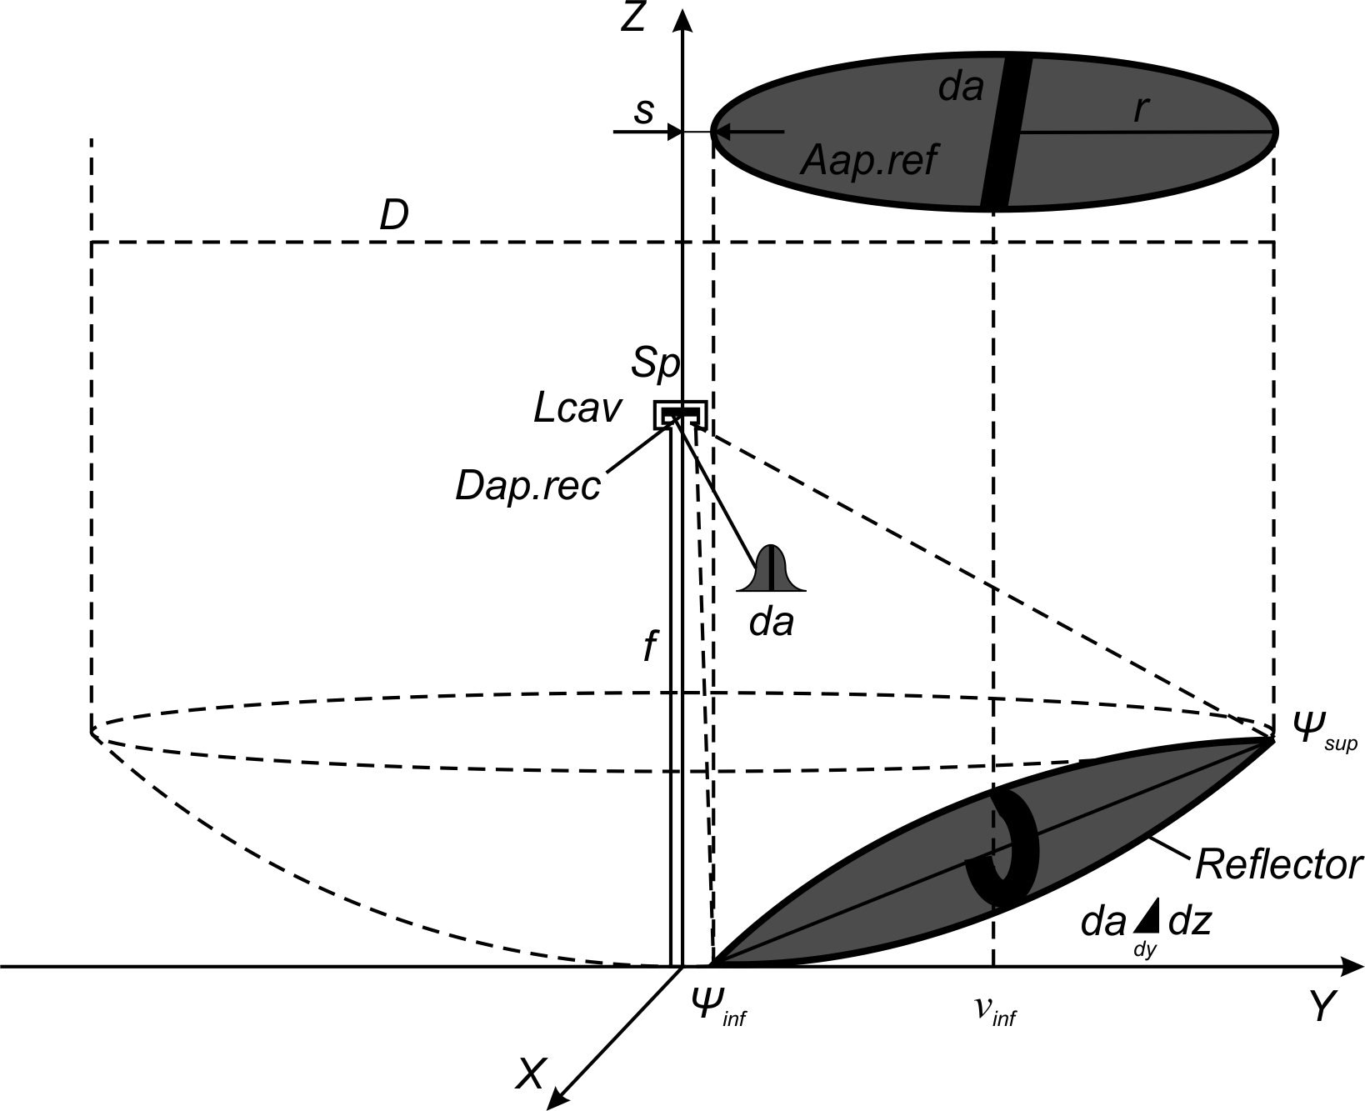  b)
Fig. 1 a)Section of the offset parabolic solar dish concentrator from baseline paraboloid; b) process of determining a offset parabolic solar dish concentrator
2.2 GEOMETRICAL AND PHYSICAL MODEL
In the 3D model on Fig.2. are shown the main elements of offset parabolic dish concentrator system in working position. The offset parabolic dish concentrator (2.85 m²), that follows the sun reflecting and concentrating its rays in the solar receiver. To develop the mathematical model, we propose the integration of the geometric model, which corresponds to the intercept of a circular area with a virtual parabola, as shown in Fig. 2. This model moves the intercept point along the y-axis, which can be applied to parabolic concentrators, shifting the intercept point to the origin. The limits of the reflector are given on the y-axis and are delimited by (y_{int} ± r).
a) |  | 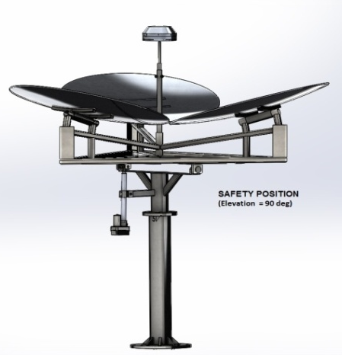b)
Fig. 2 a) Working position of offset parabolic dish solar concentrator (axonometric view); b) Safety position (elevation angle of 90⁰)
A parabolic dish solar concentrator is a surface that can be mathematically defined as:
$$Z= \left(x^{2}+y^{2}\right)/4f$$ | (3)
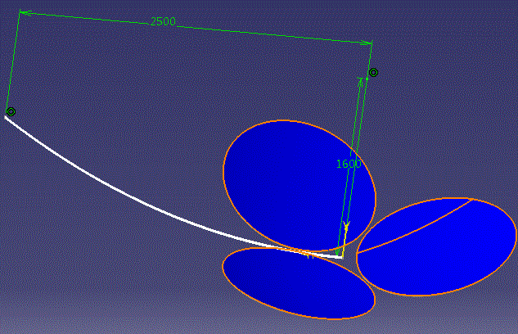  a) |  | 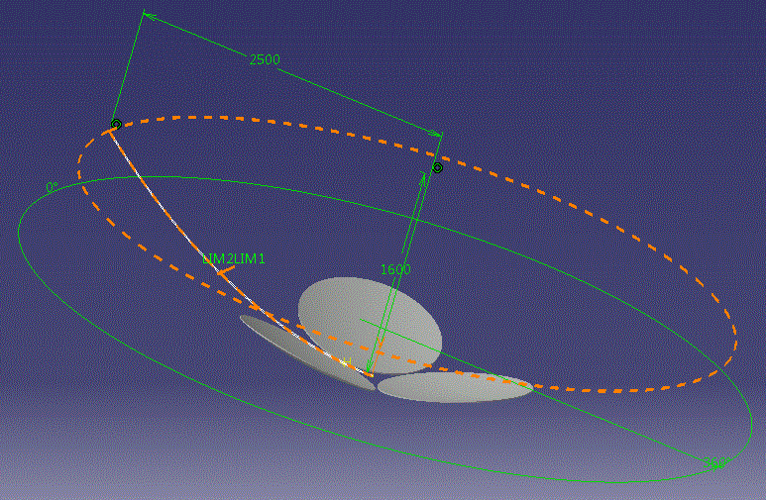  b)
Fig. 3 a) Construction of new type of solar offset parabolic concentrator; b) Geometrical model of new type of solar offset parabolic concentrator
The geometric model of offset parabolic solar concentrator is obtained by applying the surface integral for the interception of the two solids, as observed in Eq. (4).
The surface of the surface of revolution generated by rotation curve y= f(x) on the interval [a, b] around the x – axis.
$$P= 2π\int_{a}^{b}{f\left(x\right) \sqrt{1+{\left(f'(x)\right)}^{2}}dx}$$ | (4)
$$\int_{-n}^{+n}{I\left(a\right)da= \int_{n}{\int_{R}{I\left(a\right)}}}\sqrt{\left({\frac{∂z}{∂x}}^{2}\right)+{\left(\frac{∂z}{∂y}\right)}^{2}}dxdy$$ | (5)
It is also necessary to define the equation of a circular cylinder in Cartesian space; Eq. (5) is used to delimit the area intercepted.

$${(x-0)}^{2}+{(y-y_{int})}^{2}=r^{2}(y-y_{int})$$ | (6)
We can write from the basic parabola equations with its axis passing through the y-axis in the following form
$$P\left(x\right)= m_{p}x^{2}+C_{p}$$ | (7)
$$P'\left(x\right)= {2m}_{p}x$$ | (8)
where m_{p} is the slope of parabola and C_{p} is the y-intercept of the parabola.
By substituting Eq. (3) and Eq. (6) into Eq. (5), we obtain the differential area that can be assessed within the limits of the intercept of the parabola, and using the definition summation to replace the integral, we obtain the geometric model integration of the offset parabolic concentrator, Eq. (9), which can be solved using an iterative method.
Taking first derivative of Eq. (9) for the slope of the parabola:
$$\int_{-n}^{+n}{I\left(a\right)da=\sum_{yint-r}^{yint+r}{I \left(a\right)\sqrt{k_{1}}}}y+k_{2} × \sqrt{r^{2}y+2y_{int}y-y_{int}^{2}- r^{2}y_{int}-y^{2}}$$ | (9)
where $k_{1=}\frac{2y_{int+r^{2}}}{{4f}^{2}}$ and $k_{2}=\frac{{4h}^{2}-y_{int }^{2}- r^{2}}{{4f}^{2}}y_{int}$
Mathematics for whole geometrical model is done in Wolfram Mathematica v.8.0. Numerical solution of mathematical model is used for obtaining geometrical parameters such as radius of smaller and larger semi axis of ellipse, focal length, tangent slope for three offset reflectors.First step is designing rotational paraboloid with diameter D = 5000 mm and focal length f = 1600 mm. In the Fig 4 presented mathematical representation of offset parabolic reflector. Mathematical modeling of offset parabolic concentrating collectos is done by using mathematical equations of certain geometric objects which define a parabolic solar concentrator.

- RAY TRACING ANALYSIS OF OFFSET PARABOLIC SOLAR CONCENTRATOR
The ray tracing technique is implemented in a software tool that allows the modeling of the propagation of light in objects of different media. In the ray-tracing software, it is necessary to specify the properties of the reflector and the grid of the rays after the reflector and absorber are placed in the space X, Y, Z corresponding to the virtual parabola with the supporting objects
Fig. 4 a) Mathematical interpretation of offset parabolic solar reflectors and their focus point; b) 3D Graphical representation of modeling a offset parabolic solar reflectors
Table 1 Geometrical parameters of the offset parabolic concentrating collector
Design Parameter | Numerical value | Unit
Major diameter of reflector D_{ref} | 1.20 | [m]
Minor diameter of reflector D_{ref} | 1.10 | [m]
The cross section of the opening offset parabolic concentrator A_{proj} | 5.31 | [m²]
A sheltered area of the concentrator A_{shadow} | 0 | [m²]
The effective area of the offset concentrator A_{ef} | 2.85 | [m²]
Receiver diameter | 0.20 | [m]
Shape of receiver | Flat circular disc | [-]
Diameter of baseline paraboloid | 5 | [m]
Depth of the baseline parabolid | 0.98 | [m]
Depth of the offset parabolic concentrator | 0.33 | [m]
Focal lenght | 1.6 | [m]
ψ₁ - rim angle | 43.15 | [⁰]
Absorber area | 0.0314 | [m²]
Geometric concentration ratio CR_{g} = A_{ap}/A_{rec} | 96.01 | [-]
Optical (flux) concentration ratio CR₀ = I_{rec}/ I_{ap}= I_{rec} / DNI· | 87,07 | [-]

. The relationship between the relative aperture and the rim angle is given by:
$${f/D=\frac{1}{4\tan\left({\text{Ψ}}/2\right)}, }_{}$$ | (10)
$f/D=$0.48
The geometric concentration ratio can be defined as the area of the collector aperture A_{app} divided by the surface area of the receiver A_{rec} and can be calculated by Eq.11
(11)
Flux concentrating ratio can be defined as ratio of flux concentrated in a point to incident solar flux I_{bn} :
$${CR}_{flux}=\frac{I}{I_{b,n}}= \frac{1}{A_{rec}}\int{I_{rec}}dA_{rec}$$ | (12)
$Ψ=\tan^{-1}\left(\frac{y}{f-z}\right)$ is the rim angle of the solar parabolic concentrator.
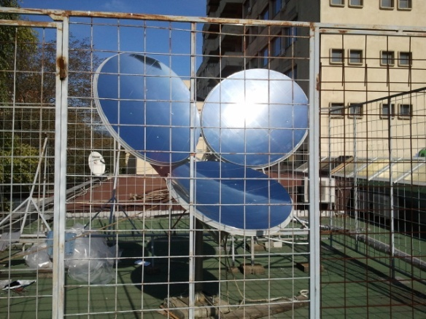 | 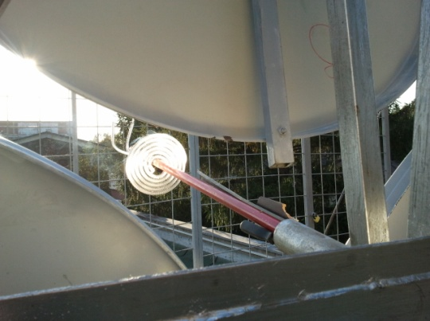
Fig. 5 a) Experimental model of a parabolic offset solar concentrator system; b) The concentration of solar radiation in a spiral absorber
Fig.5a. shows experimental model of our offset parabolic dish concentrator system installed in the Laboratory for Thermal Engineering at Faculty of Mechanical Engineering in Nis. The concentration of solar radiation in a absorber – receiver (focus surface area) was as shown on Fig. 5b.
For optical analysis of solar parabolic concentrator software TracePro version 7.4.2, Lambda Research Corporation, USA is used. Reflectance coefficient was 60%. Receiver was flat plate circular absorber with diameter 200 mm. r. After several calculations in TracePro it is found that optimal position is 1155 mm from vertex of parabolic dish. Spatial profile of generated rays was uniform and angular profile was solar radiation. Input parameter for optical analysis is solar irradiance 800 W/m². Experimential value for solar irradiation for town of Niš in Serbia is between 750 W/m² and 900 W/m².. Since the offset parabolic concentrator is always tracks the sun, incidence angle of solar rays is always θ=0⁰. For this type of solar concentrator cosine losses does not exist.

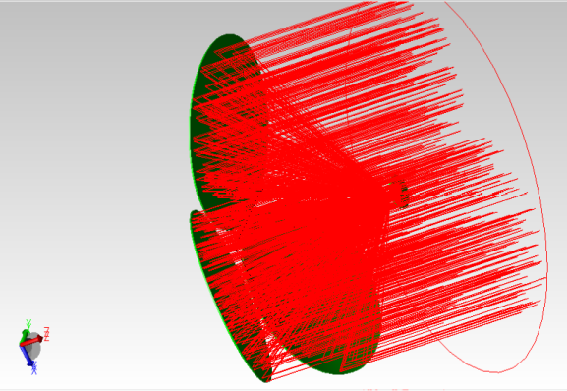  a) |  | 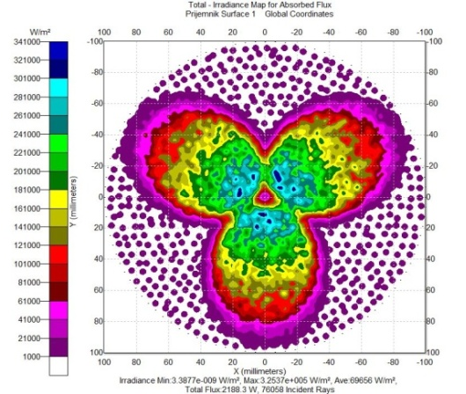  b)
Fig. 6 a) Optical system of offset parabolic solar concentrator with traced rays; b) Irradiance map for absorbed flux on circular absorber surface
Optical analysis is done by generating and calculating Monte Carlo ray trace for 119401 ray. From all emitted rays only 76058 rays reached absorber surface which is 64% rays of emitted rays are absorbed on receiver. Calculated irradiance for absorbed rays on receiver is from 3.88∙10⁹ W/m² to 3.25∙10⁵ W/m². Total calculated flux on receiver was 2188 W. On Fig. 6 is shown total irradiance map for absorbed flux on receiver.
- CONCLUSION
This paper presents geometrical modelling, design, and optical modelling of the offset parabolic dish solar concentrating collector. Developed a completely new physical, mathematical and numerical optical model of the offset parabolic dish concentrating collector. When performing a ray tracing simulation and analyses of the geometry of solar image in the receiver, we found that the more suitable geometry for the receiver has an elliptical form; however, the geometry of the receiver must be modified to improve the efficiency of the parabolic offset solar concentrator.. Total flux in focal area is good. Irradiance distribution for absorbed flux is relatively uniform for small area for absorber. As a next step various analysis and simulations of the model are planed. Among others are variation of tilt angle of each offset reflector in solar concentrating system, high reflective material of reflectors, size of absorber surface, shape of absorber surface, shape of solar cavity - receiver. In future development of thermal receiver model of solar thermal absorber as well as experimental verification of simulated results.
ACNOWLEDGEMENT: This paper is done within the research framework of research projects: III42006 – Research and development of energy and environmentally highly effective polygeneration systems based on renewable energy resources

LITERATURE
- Anjum Munir, Design, development and modeling of a solar distillation system for the processing of medicinal and aromatic plants, Dissertation zur Erlangung des akademischen Grades Doktor der Agrarwissenschaften, Faisalabad, Pakistan, 2010. Universität Kassel / Witzenhausen Fachbereich Ökologische Agrarwissenschaften Fachgebiet Agrartechnik
- Nadir Bellel, Study of two types of cylindrical absorber of a spherical concentrator, Energy Procedia 6 (2011), Laboratoire Physique Énergétique Université Mentouri-Constantine 25000. Algérie, pp. 217–227
- Bhirud, N., Tandale, M.S., 2006. Field evaluation of a fixed-focus concentrators for industrial oven. Advances in Energy Research (AER– 2006)
- Delaney, D., 2003. Scheffler’s community solar cooker. http://www.solar-bruecke.org.
- Scheffler, W., 2006. Introduction to the revolutionary design of Scheffler. In: SCIs International Solar Cooker Conference, Granada, Spain
- José Ruelas, Gabriel Pando, Baldomero Lucero and Juam Tzab, (2014). Ray Tracing Study to Determine the Characteristics of the Solar Image in the Receiver for a Scheffler-Type Solar Solar Concentrator Coupled with a Stirling Engine, 2013 ISES Solar World Congress, Energy Procedia 57 pp. 2858 – 2866
- A. Munir, O. Hensel, W. Sheffler, Design principle and calculations of a Scheffler fixed focus, Solar Energy 84 (2010), pp. 1490–1502, Department of Agricultural Engineering ,University of Kassel, Nordbahnhofstr. 1 a 37213 Witzenhausen, Germany Solar Bruecke G.v.Werdenbergstr.6 D-89344 Aislingen, Germany

M.Sc., Saša Pavlović, research assistant, Niš, Faculty of Mechanical Engineering in Niš, Serbia, E- mail: saledoca@gmail.com 2 Ph. D., Velimir Stefanoviić, Faculty of Mechanical Engineering in Niš, Serbia, E- mail: veljas@masfak.ni.ac.rs 3 M.Sc., Marko Mančić, research assistant, Niš, Faculty of Mechanical Engineering in Niš, Serbia, E- mail: markomancic@yahoo.com

