LOGO WILL BE HERE

PARAMETRIC MODELING OF GEOMETRY SHAPES OF GEAR TEETH BY USING CAD SOFTWARE
Predrag Živković
Summary: Gears in gear shafting are exposed to high intensity of stress of complex sharing. Modeling of gear geometry was preceded by analysis of work condition and analysis of geometric forms and accomplished solutions. Purpose of work was finding a form gear of minimum size necessary to transfer the given load for adequate gear ratio. Conditions between size of gear and moment of inertia were made in function of gear ratio and rotary moment.
For finding an optimal form, we started from Hertz’s pressure on flank of cogs and intensity of stress in bottom. Conditions between size of gear ratio, module, axis distance, wdith of gears and intensity of stress on cog flank and in bottom.
Parametric modeling of gear geometry using CAD software in outlines of this work should be signification for next two aspects: presents a developed method for gear and geometry shapes modeling.

Key words: Gear shafting, gear, parametric modeling
- INTRODUCTION
Fundamental parametric gear geometry modeling represents a fase in which and dimensions of models and all components that are needed to perform forecast and analisys are defined. Gear in gears shafting are the most important components, their form and geometry are specific. Because of their specific features, they represent a challenge for defining a form, size and dimensions. Therefore, in outlines of this work, parametric gear modeling of cilindric gears with straight cobs were made, as an elemets of alredy existing form or form of a mechanical part that is repeated and fundamental in gear shafting. Purpose of work was finding a form gear of minimal size and weight, necessary to transfer load for given gaer ratio – u and keeping the given axis distance – a. Conditions between moment of inertia in function of gear ratio and rotary moment. For finding an oprimal form, we started from Hertz’s pressure on flank of cogs and intensity of stress in bottom. Modeling of gear geometry was done with siftware CATIA V5P3 R11. Form of gear geometry can be shown in parametric form, so that the whole procedure of modeling can be automated. Attained form is kept in program and model mode, in outline of software. Changing the parameter or one of the parametars, can obtain a gear family based on same form, in function of one or more parametars.
Fig. 1. Preposition of algorhythm for parametric modeling of teeth form geometry
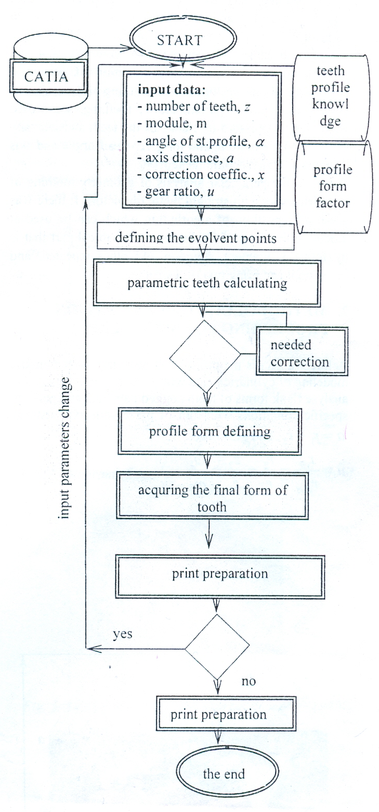

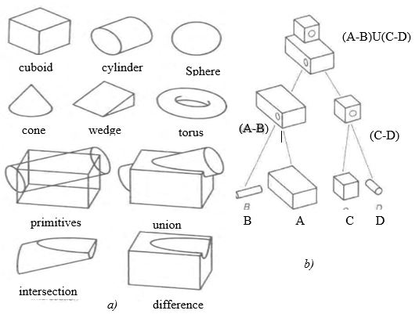
Parametar modeling results depending on initial form and type of applied modeller. Before process of modeling it self or work on the modeling program it is necessary to accomplist form analsysis by decomposing the final form to simple forms, or to decompose the final form to – primitives, covered by CAD software. After that, That is followe by their additing or subtraction ( by cutting or by driling), and binding with adding specific basic forms, in order with to get a final form. Chosen forms of teeth a wreatli gear aree modeled by decomposing the final forms to basic form – primitives, and than by applying the Bool’s operations on the them. Figure 2, a and b, shows this procedure.

Slika 2. Bsic primitives and axample of applied Bool’s operations

Algorithm suggestion for parameter modeling of mechanical parts, wich can be applied to any chosen geometric forms is elaborated in paper [1], figure 1.
For modeling geometry of teeth, it is necessary to establish intero eqendece in size depending on the selected parameter.
Talking about gears; that is the axial distance – a, module – m, transmission ratio – u, and number of teeth - z.
Interdepence in size, are dationed from linear equation system [1],[2].
$\left\{q_{i}\right\}=\left[G\right]∙\left\{p_{i}\right\}$ , where is:

$\left\{q_{i}\right\}$- vector dimension gear,
$\left[G\right]$- transformation matrix sizes for selected parameter,
$\left\{p_{i}\right\}$- selected parameters,
In this paper, anly the gears and wreath are modeled, other dimensions of body gear and hub are excluded. Models obtained by this method (in this maner) can be used for analysis of stress and strain and the model is adjusted for the preparation full SOLID – models. These model include a point in the interior volume and they required the of computers for their creation. Figure 2, a and b, as an example, presents the basic shapes, primitives, whose merger ( applying Boolean operations) forms the final shapes.
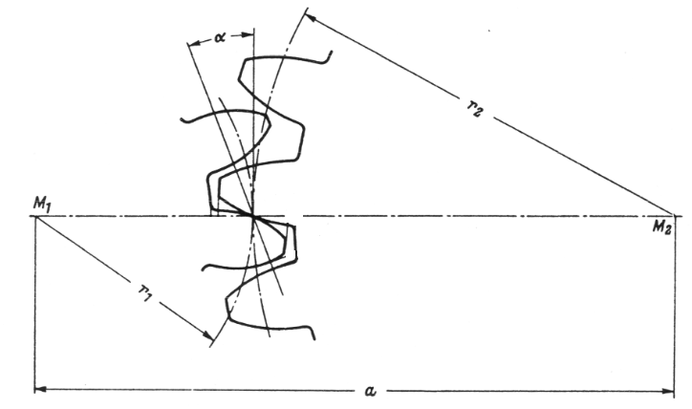
Considering that there is a large number of constructional solutions and performance of bodz gears in gear shafting. Their form depends ( full sized body of gear, body of gear where crown of gear connects with arms to hub or in form of circular panel as a bosz, of gear, weakend with openings because of weight). It is common that it is possible to make a parametric conditiona of geometric form body gear, in function of theeting parametars. For finding the optimal parametars of teething, we started from Hertz’s pressure, on flank of the teeth and intensity of stress on the bottom, and for given gear ratio u and axial distance a, which should be kept. Based on the parameter analisys of geometry teething of cilindric gears with straingh teeth, on figure 1, there was given a preposition of algorithm which can be used at modeling the form af flanks, as a mechanical part thad is by form, assignment, function and other repeated, function and other repeated, and based on it cab bring row of decisions.

Figure 3. Cilindrical teethed pair

- METHODOLOGY OF REALISATION PROCEEDING FOR SPUR GEAR
Before we acces the proces of modeling for parametric modeling of cylindric gears with straight teeth, we need to analyse flank form of teeth cogged pair fig 3 .and perform specific conditions with aim of preserving axis distance $a=r_{1}+r_{2}$, and gear ratio. $u=\frac{r_{2}}{r_{1}}=\frac{z_{2}}{z_{1}}=\frac{ω_{2}}{ω_{1}}$. Resurrecting connection for $r_{2}=a-r_{1}$ and if mobile ratio shows in form $u=\frac{a-r_{1}}{r_{2}}$, then it is needed pich radius of small gear $r_{1}=\frac{a}{a+1}$, showed with purpose of preserving the needed axis distance and demanded gear ration. Then we can define radius of pitch circle of pursuited gear. If gear mass is $M=b∙r^{2}∙π∙ρ$, where: b – width of gear, r – pitch circle radius, ρ – gear material density. Total mass of toothed pair is $M_{tot}=M_{1}+M_{2}=b∙π∙ρ∙\left(r_{1}^{2}+r_{1}^{2}\right)$. If we show pitch circle radius by gear ratio, the totall mass of toothed pair, in function of axis distance – a, width of gear – b and gear ratio - u, can be written as $M_{tot}=M_{1}+M_{2}=π∙ρ∙a^{2}∙b∙\frac{1+u^{2}}{{\left(1+u\right)}^{2}}.$
Knowing that cylindric moment of inertia $J_{cil}=M_{cil}∙\frac{r_{cil}^{2}}{2}$. Then the reducted moment of inertia for toothed pair 1 – 2 can be written as $J_{tot}=J_{1}+\frac{J_{2}}{u^{2}}=M_{1}∙\frac{r^{2}}{2}+M_{2}∙\frac{r_{2}^{2}}{2∙u}=\frac{π∙ρ}{2}∙b∙a^{4}∙\frac{1+u^{2}}{{\left(1+u\right)}^{4}}$.
For finding the particular gear size we used Hertz's pressure of teeth flanks.
$σ_{H}=Z_{E}∙Z_{H}∙Z_{ε}∙\sqrt{\frac{F_{trac}∙K_{Hα}∙K_{Hβ}∙\left(u+1\right)}{b∙d_{1}∙u}}$, (1)
If material elastic factor is written $Z_{E}=\sqrt{0,175E}$, where E, N/mm², module of gear material elastic. Factor of flank teeth form, for cylindric gears with straight teeth for β=0 has form $Z_{H}=\sqrt{\frac{2}{sin2α_{t}}}$. For factor noch of meshing $Z_{ε}=\sqrt{\frac{4-ε_{α}}{3}}$ if $ε_{α}$– notch of meshing, is shown via number of teeth - z₁, and gear ratio - u, then it's:
$$ε_{α}=\frac{z_{1}}{2∙π∙cosα}∙\left(\sqrt{\sin^{2}α+\frac{4}{z_{1}}+\frac{4}{z_{1}^{2}}}+u∙\sqrt{\sin^{2}α+\frac{4}{z_{1}∙u}+\frac{4}{z_{1}^{2}∙u^{2}}}-\left(u+1\right)∙sinα\right)$$
If we know that
$F_{t}=\frac{T∙\left(u+1\right)}{a∙u}$, $d_{1}=\frac{2∙a}{u+1}$ ,and $d_{2}=\frac{2∙a∙u}{u+1}$
and with their exchange in equation (1), we get intensity of stress on teeth flanks which can be shown with next equation: $σ_{H}^{2}=Z_{H}^{2}∙Z_{E}^{2}∙Z_{ε}^{2}∙K_{Hα}∙K_{Hβ}∙\frac{T_{rac}∙{\left(u+1\right)}^{3}}{2∙b∙a^{2}∙u^{2}}$
then it's gear axis distance:
$a^{2}b=Z_{H}^{2}∙Z_{E}^{2}∙Z_{ε}^{2}∙K_{Hα}∙K_{Hβ}∙\frac{T_{rac}∙{\left(u+1\right)}^{3}}{2∙u^{2}∙σ_{Hmax}^{2}}$ (2)
If we consider that reviewed ideal toothed pair, made without profile mistakes, without mistakes with factor of dynamic condition K_{v} = 1 and K_{A} = 1. Then the factors of load sharing on pair teeth in leash K_{Hα} = 1, and factor of load sharing along cotiguous line on flanks of teeth lacking the most precise value K_{Hβ} = 1 – 1,3.
For size of axis distance – a, and gear ratio – u, by equation (2), calculated size of maximum intensity of stress on flanks of teeth should be calculated on critical value of intensity of stress for gear material $σ_{Hlim}$.
Which is adequate to dynamic durability and number of changes N_{H1}.

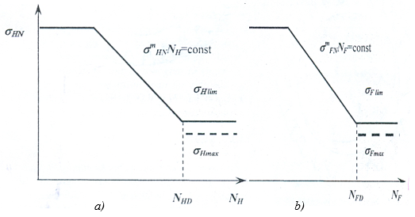
Fig. 4. a) Diagram of destruction and dynamic durability of teeth flanks,
b) Diagram of destruction and dynamic durability of teeth bending,

it can be shown on a diagram of destruction and dynamic durability of teeth flaks, os on fig. 4,a, and durability of teeth bending 4,b.
With the same procedure, connetions between geometric sizes of toothed pair and intensity of stress on bottom of the teeth where made, and size of axis distance can be expressed wit next equation:
$a^{2}b=Y_{F}∙Y_{ε}∙K_{Fα}∙K_{Fβ}∙\frac{T_{rac}∙z_{1}∙{\left(u+1\right)}^{2}}{2∙u∙σ_{Fmax}}$ (3)
Where:
$Y_{F}≈2,2+3,1∙e^{\frac{-z}{14}}$, is factor of teeth form,
$Y_{ε}=\frac{1}{ε_{α}}$, factor of meshing notch, K_{Fα} and K_{Fβ} are factor of load sharing on teeth pair in mesh and along contigious line on teeth flanks. If missing some more precise references, K_{Fα} = 1, and K_{Fβ} = K_{Hβ.} Minding that intensity of stress of surface ressure on teeth flanks are greater than intensity of stress on bottom, geometry modeling was done considering the size of axis distance that was attained with equation (2). Values of maximum intensity of stress $σ_{Hmax}$ and $σ_{Fmax}$, would have value $σ_{Hmax}=\frac{σ_{Hlim}}{S_{H}}$ and $σ_{Fmax}=\frac{σ_{Flim}}{S_{F}}$ . For size of axis distance - a, and gear ratio - u, by equation (3), calculated size of work intensity of stress on bottom of the teeth should be calculated on critical value intensity of stress for gear material $σ_{Flim}$. Which is appropriate for a dynamic durability and number of changes N_{FD}. It can be shown on a diagram of destruction and dynamic bottom of teeth, as on fig. 4,a and b.

- RESULTS OF MODELING AND TESTING RESULTS
For this kind of relationship of axis distance –a, and given value of gear ratio – u, was done a modeling of cilindrig teethet pair with straight teeth, whose parametars as example are given in table 1. Realised models are given on a figure 5,6,7.
Table 1. Testing results
 | Pinion | Gear whwel
z | 12 | 36
m (mm) | 3,5 | 3,5
a (mm) | 75
x | 0,4595 | 0,4594
α | 20º
α_{wt} | 22,942º
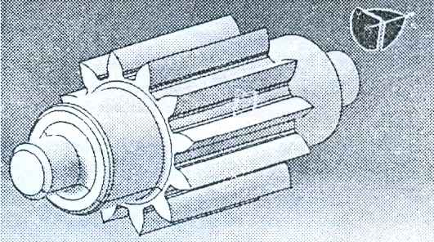

Fig. 5. Gear form for z = 12 and x = 0,4594.
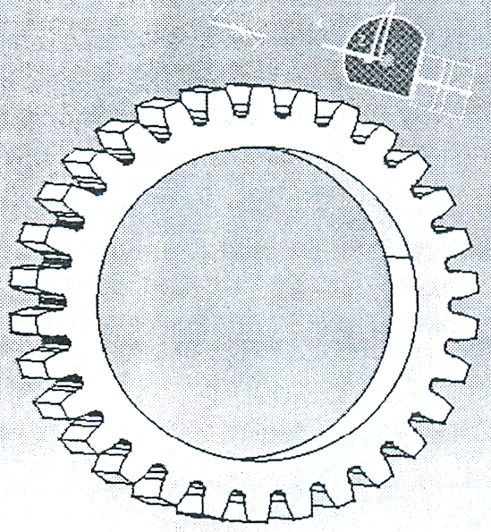
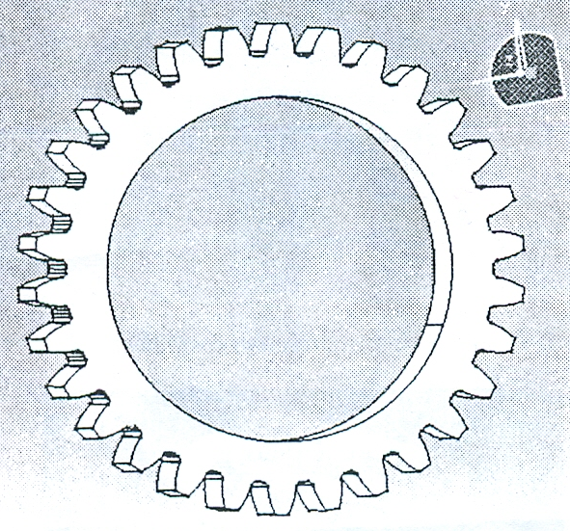

Fig. 6. Teeth form and gear size for z =30 and x = 0,

Fig. 7. Teeth form and gear size for z =30 and x = 0,4594

- CONCLUSION
It was achieved that parametric modeling of cylindric toothed pair with straight teeth, for already given limits, and so: preserving given axis distance and gear ratio if work intensity of stress was less then critical. Relations were reinstated, between gear ratio and axis distance with module, number of teeth and correction coefficient of teeth flanks, for evolvent teeth flanks and work intensity of stress, on flanks and bottom of teeth. Parametric modeling, in outlines of this work should be significant for next two aspects: presents a developed method for cylindric gear geometry modeling for gears with straight teeth and variation of size ond form gear.

- REFERENCES
[1] P. Živković: Istraživanje gubitaka energije i razaranja delova planetarnih prenosnika snage, Doktorska disertacija, Mašinski fakultet, Beograd, 2006.
[2] P. Živković: Optimiranje geometrije nosača satelita planetarnih prenosnika primenom metode konačnih elemenata, magistarski rad, Mašinski faklutet, Beograd, 1995.
[3] M. Ognjanović: Konstruisanje mašina, Mašinski fakultet, Beograd, 2000.
[4] M. Ognjanović: Mašinski elementi, Mašinski fakultet, Beograd, 2006.
[5] DIN 3990.

Predrag Živković, Faculty technical science, Kosovska Mitrovica, jomine@sbb.rs.

