LOGO WILL BE HERE
HEAT BALANCE OF LOSSES IN PLANETARY GEAR DRIVES
Predrag Živković
Summary: Planetary gear drives have extremely high specific caring capacity. Great energy is being transmitted per gear drive mass unit. A part of this energy which is by friction being transferred to thermal energy, is heating the gear drive components. With prolonged intensive work, the quantity of released heat can be more significance greater than of the emitted one in surrounding. This article treats two issues. The one is concerning producing balance between mechanical losses and released heat. The estimate outcomes of the released heat are put in balance with the mechanical energy losses. The other issues is concerning solutions that can provide heat balance at the prolonged stationary gear work.
Key words: planetary gear drives, efficiency, mechanical energy losses
1.INTRODUCTION

The energy consumed to overcome the frictional resistance at the hips pair of teeth and friction in the bearings, is converted into heat. As a result, the temperature of the oil, shafts, gears and bearings is increased. This heat, through the oil and the inner surface of the housing is transferred to the exterior surface, which increases to the temperature level of the outer surface of the housing. If the carried out heat is less than the energy converted to heat during work, there is an increase of the operating temperature rang of the gear. Calculation of the oil temperature in the planetary gears housing, is mainly based on a calculation of the oil temperature and the heat distribution in components, which are used for gear with parallel shafts. For planetary gear these models are not applicable without further corrections. Experimental determination of mechanical power losses and distribution of power losses per component of the planetary gear, procedure and method of this calculation are discussed in the paper [2]. In order to stabilize the temperature, it is necessary to achieve thermal balance, ie. that the amount of released heat through the outer surface of the housing is equal to produced.

2. STARTING POINTS OF CALCULATION

To establish the heat balance and to determine the temperature of the oil in the housing of the planetary gear, it is necessary to define the method and place, ie. components in which the mechanical energy is converted into heat and how that heat is removed from the outer surface of the housing.
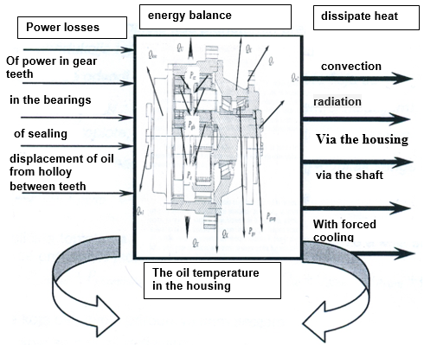
Graphical view of the venergy balance is given in figure 1.

Figure 1. Energy balance in planetary gears drive

Power losses in the components of the planetary gear unit and the resulting heat dissipation through the various components, is shown in Figure 2 [1].

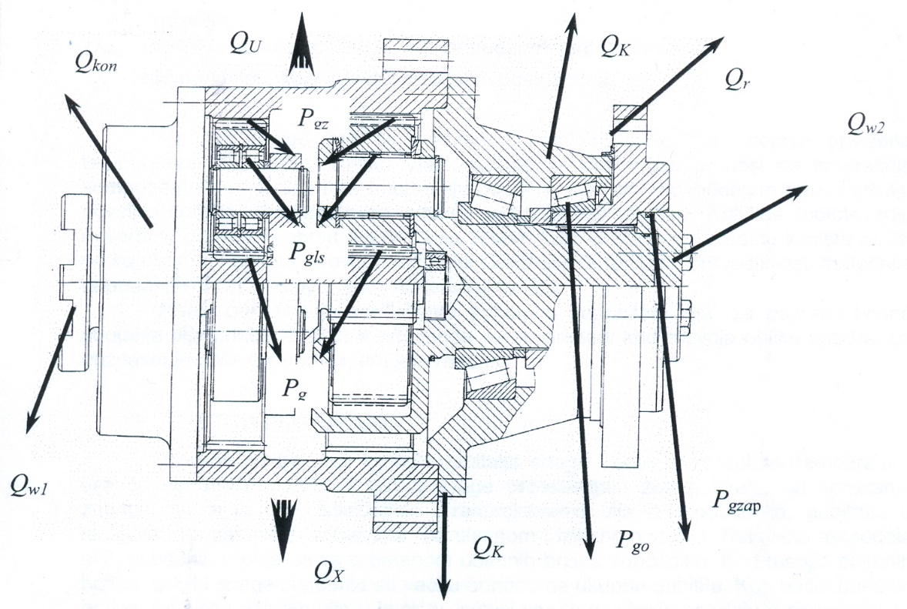

Slika 2. Power losses and heat dissipation of planetary gears
Q_{W1} and Q_{W2} - conduction of heat through the shaft, Qr - radiation of heat,
Q_{K} - heat discharged by convection, Q_{kon} - heat discharged by construction,
QU - heat discharged by circulation of oil, Qx - the remaining heat, Pgz -
power loss due to gear coupling, Pglz – power loss in satellite bearings
Pgol – power loss in the remaining bearings
Pgzap – power loss due to sealing

The required amount of heat for the establishment heat balance, which is discharged via the casing can be represented by Eq.

P_{gz}+P_{gzap}+P_{gL}+P_{graspulja}=Q_{K}+Q_{R}+Q_{W}+Q_{Kon}+Q_{Pvent}+Q_{ost}

In which is:
Q_{K} - the amount of heat which is supplied by natural convection
Q_{R} - The amount of heat that is discharged by radiation
Q_{w} - The amount of heat that is discharged through the implementation of the output shafts
Q_{kon} - the amount of heat supplied to the implementation of the design of the underframe through
Q_{Pvent -} the amount of heat which is supplied by a forced draft
Q_{ost} - the amount of heat which is carried out by other methods

The power loss that is converted into heat, leads to the occurrence of high oil temperature in the gear. The excess heat is transmitted through oil to the internal components of the gear and to the inner surface of the housing. By conducting the external surface of the housing allows the emitted into the external environment. The amount of heat absorbed by the inner swivel parts which pass through the inner surface of the housing depends on the coefficient of thermal conductivity of oil and coefficient of the thermal conductivity material internal rotating components and materials of the case.
The method for determining the coefficient of thermal capacity of oil, for known speed of oil flow inside the housing, which can be applied in the development of forms of housing, with the knowledge of flow conditions, is given in paper [1].

3. CALCULATION METHOD

Depending on the balance between power losses and derived heat, the temperature of the oil will be changed. Total power losses are the sum of the losses of the coupling teeth, mixing oil displacement and the bursting of oil from the space between teeth, losses in the bearings and sealing compounds on the input and output shaft. The relative distribution of these losses, changes with the change of extensive speed of gears. For smaller extensive speed, power losses perforation are higher, compared to the total losses. For large voluminous speed, with the higher level of oil in the housing, power losses perforation decline compared with losses of mixing, extrusion and bursting oil. For the calculation of heat that is transferred from the gear in the environment, it is necessary to define the outer surface of the housing and to determine the effects of devices for forced heat dissipation.
The distribution and dissipation losses per components, removal of heat from the housing and oil temperature of planetary gears are difficult to describe with mathematical equations. That complicates the specificity of the geometry of the components and their movement. Establishing a dependency between losses and distribution losses per component, it is possible to achieve only by experimental bench.
Two-stage planetary gear, which was the test subject, is declared with characteristics: overall gear ratio 42, 23000 Nm torque output, the input speed is 1108 min⁻¹ [1]. During tests in laboratory conditions, the ambient temperature indoors was 20º ($±$) 2º C. The testing lasted 8 hours a day. Before the start of the test table on which were placed transmissions, gear oil temperature was equal to the ambient temperature. During the tests the temperature of the housing was measured, by which it is determined that the housing temperature reached a value of 90º degrees. In order to maintain steady operating temperature during the test gear cooling is performed by forced air flow with the help of the fan. This ensures a steady state.
For practical application, a procedure for calculating the heat balance of power of planetary gears is made. Started from the known sizes and ambient temperature of 20º degrees, and the temperature of the external surface of the housing 90º degrees. Based on the known temperature of the casing and the measured power losses, the difference between the temperatures of the inner and outer surface is determined. It was used to calculate the temperature of the oil, with the knowledge of the value of the coefficient of thermal conductivity of the oil. To calculate the thermal emission from the housing, the housing surface was calculated:
Outer surface of the housing A_{SPK} = 0,665 m², inner surface A_{upk} = 0,373 m², and is equivalent to the thickness of the wall housing δ_{ek}=0,0334 m.
For calculating the thermal emission from the housing of the elaborated method the Funck's equation was applied[1,2].
$$Q_{kod}=Q_{w1}+Q_{w2}+\sum_{j}^{n}{Q_{j}=f\left(ϑ_{oil}, v_{airvelocity}\right)}$$

Q_{kod} – total discharged heat from the housing,
Q_{w1} and Q_{w2} – heat discharged through the inner and outer shaft,
$\sum_{j}^{n}{Q_{j}}$ – total heat discharged through the housing,
ϑ_{oil} – oil temperature ºC,
$v$_{airvelocity}– air velocity,

Using the calculation method of amount of heat $Q_{kod}=K∙A_{SPK}∙\left(ϑ_{oil}-ϑ_{vazolonine}\right)$ kW, which is given through the housing for different conditions of air velocity and oil temperature in the gear $ϑ_{oil}=\frac{Q_{os}}{α_{oil}∙A_{UPK}}+ϑ_{uk}$ ºC ,

where:
$α_{oil}$– coefficient of heat crossing from the oil to the interior of the housing in kW/m²K [3].
A computation of coefficients of heat crossing, with air flowing around the housing, was used $K=\frac{1}{\frac{1}{α_{oil}}+\frac{1}{γ_{mk}}+\frac{1}{α_{airvelocity}}}$, with application of the calculated difference of inner and outer surface temperatures of the housing $Δϑ=ϑ_{uk}-ϑ_{sk}$, with equation $\left(ϑ_{uk}-ϑ_{sk}, \right)=\frac{Q_{os}∙δ_{ek}}{γ_{mk}∙A_{UPK}}$ ºC,

where:
$Q_{os}$ – discharged heat,
$δ_{ek}$ – equivalent wall thickness of the housing,
$γ_{mk}$ – coefficient of heat conduction for the housing material – steel,

This has established a correlation between the mechanical transmission losses and dissolution rate of heat over the surface of the gear housing, with natural and forced air circulation environment, in order to ensure the heat balance during long-term stationary work.

4. THE CALCULATION RESULTS

Table 1 shows the power losses obtained by measuring the on test rig, screening methods and thermal budget.
By comparing the results of measurements of power loss and results of thermal calculation, a good match of results was obtained. A very good balance between power loss, heating and cooling gear was established. In models for calculating power losses based on the work of the friction force of the coupled gear teeth, a serious correction should be applied because of inaccurate and unacceptable results.

Table 1. Power loss in planetary gear

Power losses measured on the test ring kW | total power loss in planetary gear
Power losses measured on the test ring kW | 2,227
Power losses obtained by orientational calculation kW | orientational calculation |  | approximate calculation
Power losses obtained by orientational calculation kW | 6,905 |  | 5,105
Power losses obtained by thermal calculation  kW | for air velocity of 1.25 m/s | for air velociy of  3 m/s |  | for air velociy of 5 m/s
Power losses obtained by thermal calculation  kW | 1,516 | 2,122 |  | 2,454

5. CONCLUSION
Because of the high degree of compactness, in continuous operation of planetary gear, the amount of heat discharged is larger than that heat can be emitted into the environment through the housing. In this regard, a balance between power losses and heat discharge is established solutions that provide heat balance during long-term stationary work are provided. In addition, we obtained the following results:
- Developed a method and procedure of calculating the amount of heat that is released through the outer surface of the housing, and the temperature of the oil in the gear housing.
- Established a correlation between the mechanical losses and the amount of heat that is emitted into the environment. Numerical results are well matched with the test results.
6. REFERENCES
[1] Živković P.:ISTRAŽIVANJE GUBITAKA ENERGIJE I RAZARANJA DELOVA PLANETARNIH PRENOSNIKA SNAGE, doktorska disertacija, Univerzitet u Beogradu, Mašinski Fakultet, Beograd. 2006.
[2] Predki W., Jarchow F., Ketler J. : Calculation Method the Determination of the Oil Sump Temperature of industrial Planetarz gears, International Conference on Gears, Volume 1, VDI-BERICHTE NR.1665,2002, pp 507-522.
[3] Leiman, D. O.: Erhhung der Wemegrenzleistung bei Getrieben mit Luftkhlung. “Konstruktion”, 1979, Nº 11, 434-438.

Predrag Živković, Faculty technical science, Kosovska Mitrovica, jomine@sbb.rs.

