LOGO WILL BE HERE
THE IMPACT OF TOOL DESIGN ON PHARMACEUTICAL BLISTER PACKAGING
Živko Babić , Rodoljub Lekanić
Summary: Blister packaging machines are used in pharmaceutical industries for packing of medicinal preparations in tablets. It was determined that the design of tools for PVC film thermoforming and aluminum foil welding influences the process stability and the occurrence of errors and delays. This paper presents an analysis of the causes of wrought and ''struck'' tablets. The improvement of tool design prevents the occurrence of errors and delays.
Key words: tool design, thermoforming, blister packaging
- INTRODUCTION
The packaging is a process which needs to provide the necessary protection of the product from the environment during storage, transportation, and sale until it is consumed. Packaging should provide benefits for the use, safety for the user and the environment, and should provide the necessary information on the identity of the product during the product use. The choice of packaging is affected by many factors, thus the choice of packaging and ways of packaging is often a result of compromise to satisfy all requirements.
Today, a special focus is paid to the packaging of medicinal products. Without adequately marked packaging, distribution and use of drugs is not possible. When selecting and executing the package errors can be fatal, therefore the importance given to the packaging of drugs is not excessive.
In order to pack solid medicinal preparations, various materials, forms and dimensions can be used. A variety of materials such as plastic, glass, rubber, metal, and paper are used. Packaging of solid forms depends on the type of preparations (tablets, capsules, powder, granules, etc.) as well as the quantity and specificity of preparations (sensitivity to light or temperature).
This paper examines the problem of packing tablets in a plastic film subsequently welded with aluminum foil. Such a product is called a blister.
In the factory of ''Hemofarm'' d.o.o Banja Luka errors and the emergence of ''bumping'' tablets in 16 tools for blister packaging were analyzed. Design improvements of tools were made taking into account the effect of cooling of foil on the change of position of tablet seats, in the longitudinal and transverse direction.
- MATERIALS AND BLISTER PACKING PROCESS
Plastic is an important and very popular material for packaging drugs, since it largely assumed primacy in the drug market compared to any other packaging material. The most commonly used plastic materials are: Polyvinyl chloride (PVC), polystyrene (PS), polypropylene (PP), polyethylene (PE), cellophane, polyolefin, ethylene vinyl acetate, polyethylene terephthalate (PET), polycarbonate (PC) and others.
Plastics are generally referred to by code systems according to international standard ISO/DIS 11469 "Plastics - Generic Identification and Marking of Plastic Products".
Table 1 presents the general requirements in the choice of packaging for medications.
Table 1 Requirements for the primary packaging for packing drugs
Request | Function
Mechanical strength | Stability in the preparation, transportation and storage
Protection against light | Prevention of photochemical reactions
Sealing | Preventing leaks of the contents; Prevention of recontamination from the environment or parts of packaging
Permeability | Impermeability to gases and steam from the external environment; Preventing the loss of the contents of the package; Protection contamination by microorganisms
Stability | Preserving the physical, chemical and microbiological stability preparations; Preventing possible damage to the packaging
Cleanliness | Sterility or limited number of microorganisms
Design | Pack; Dosing accuracy; Suitable use for patients; The ability of the press; Review details
Thermoforming is one of the most widespread methods of shaping thermoplastics for the packaging industry. Thermoforming is a process of shaping thermoplastic sheet into a product through the application of heat and force. In most cases, the heat-softened plastic assumes the shape by being forced against the mold until it cools and sets up. Forming force may be developed by vacuum (atmospheric pressure), positive air pressure, or mating matched molds.
Thermoforming process can be successfully integrated into a combined process and procedures of serial production. Such an integrated method is applied to the line of packaging of tablets in blisters.
Tablets are compressed dosed preparations in the form of tiles of round, elliptical or any other form, flat or embossed surfaces, with sharp or with rounded edges, which consist of one or more substances, with or without auxiliary materials.
Modern production, in addition to the above requirements in regards with uniformity of the tablets, involves the application of high-capacity tableting machines.
The blister is the final form of packaging for tablets (Figure 1).
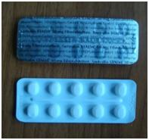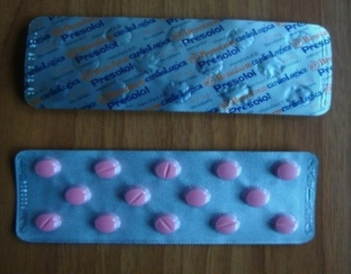
Fig. 1 Different versions of the blister pack
Procedure in brief for packaging tablets in blister packs is shown in Figure 2.
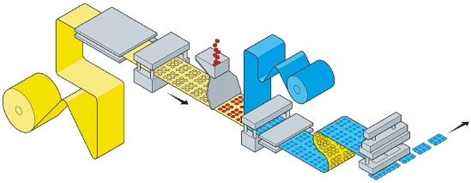
Fig. 2 Schematic presentation of the packing blisters [4]
Packaging process starts by filling the tank for tablets, wherefrom they fall into a vibratory container. PVC film is unwound from the roll, warmed by heaters and thermoforming takes the required shape under the influence of compressed air. Designed sheet is filled with tablets, while control cameras check the presence, position and integrity of the tablets. At the same time on top of the machine the aluminum foil coated with polyethylene is pulled, and welding is performed. One plate of welding tools is in the form of blisters, and the other is straight with a heater. At the end, the control number is pressed on the blister which is then cooled by aluminum plates. After that, perforation is performed as well as cutting and final packing.
- IMPROVEMENT OF TOOL DESIGN
In the company of solid forms Hemofarm Banja Luka tablets under various names are packed by using thermoforming tools and welding tools for foil of different types of materials. Packaging is carried out on the blister packaging machine (Figure 3). Because of errors and 'bumping' tablets production stoppages of the blister were analyzed.
After the experiments, the design of 16 tools for the production of medicines in tablets under various names, such as Diclofenac, Presolol, Metoten, Sertralin, drugs such as Vazotal was improved. Transparent and white PVC film of 0.25 mm thickness and aluminum foil of 0.02 mm thickness was used for packaging.
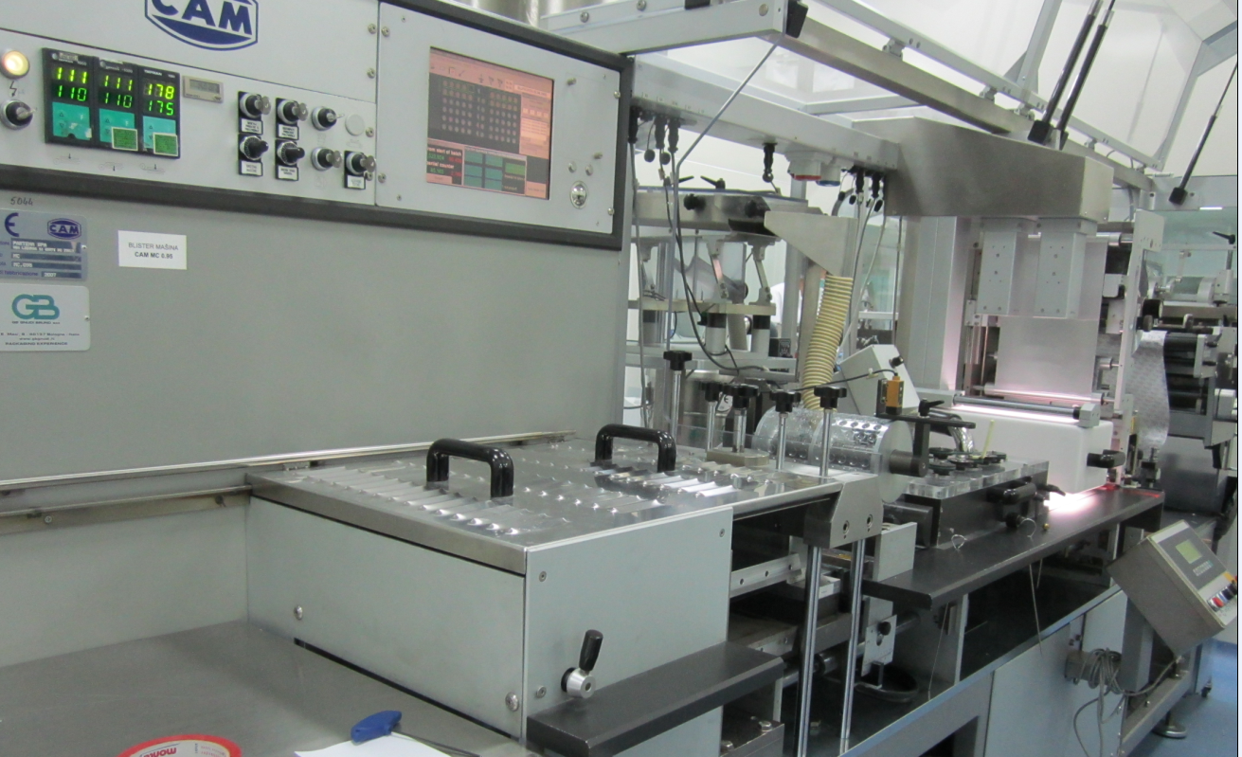
Fig. 3 The blister packaging machine (in the company Hemofarm)
The process of thermoforming is carried out at a temperature of 1050 C and the blowing pressure of 6 bars. When the formed PVC film is moved into the welding zone, this leads to a temperature change and temperature foil dilatation which can cause improper opening filling in the welding tool. The consequence of this is the occurrence of bumping and damaged tablets which leads to delays. Structural improvements led to appropriately aligned hole spacing changes for tablets made in the longitudinal and transverse direction and removed jams leading to stable packing process.
Figure 4 shows the change of distance of the longitudinal holes for the PVC foil for 50 mg Diclofenac tablets, as a consequence of temperature dilatations.
In Figure 5 thermoforming tool for 50 mg Diclofenac is shown.
Figure 6 shows a tool for PVC and aluminum foil welding with the uncorrected hole distances, and Figure 7 shows a tool for PVC and aluminum foil welding with the corrected hole distances.
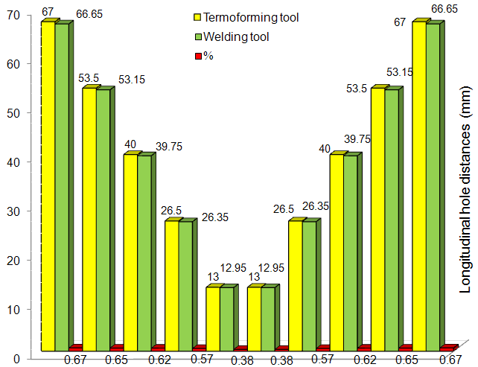
Fig. 4 Change of the longitudinal hole distances for 50 mg Diclofenac
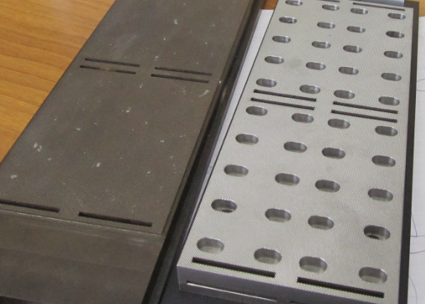
Fig. 5 Thermoforming tool for 50 mg Diclofenac foil
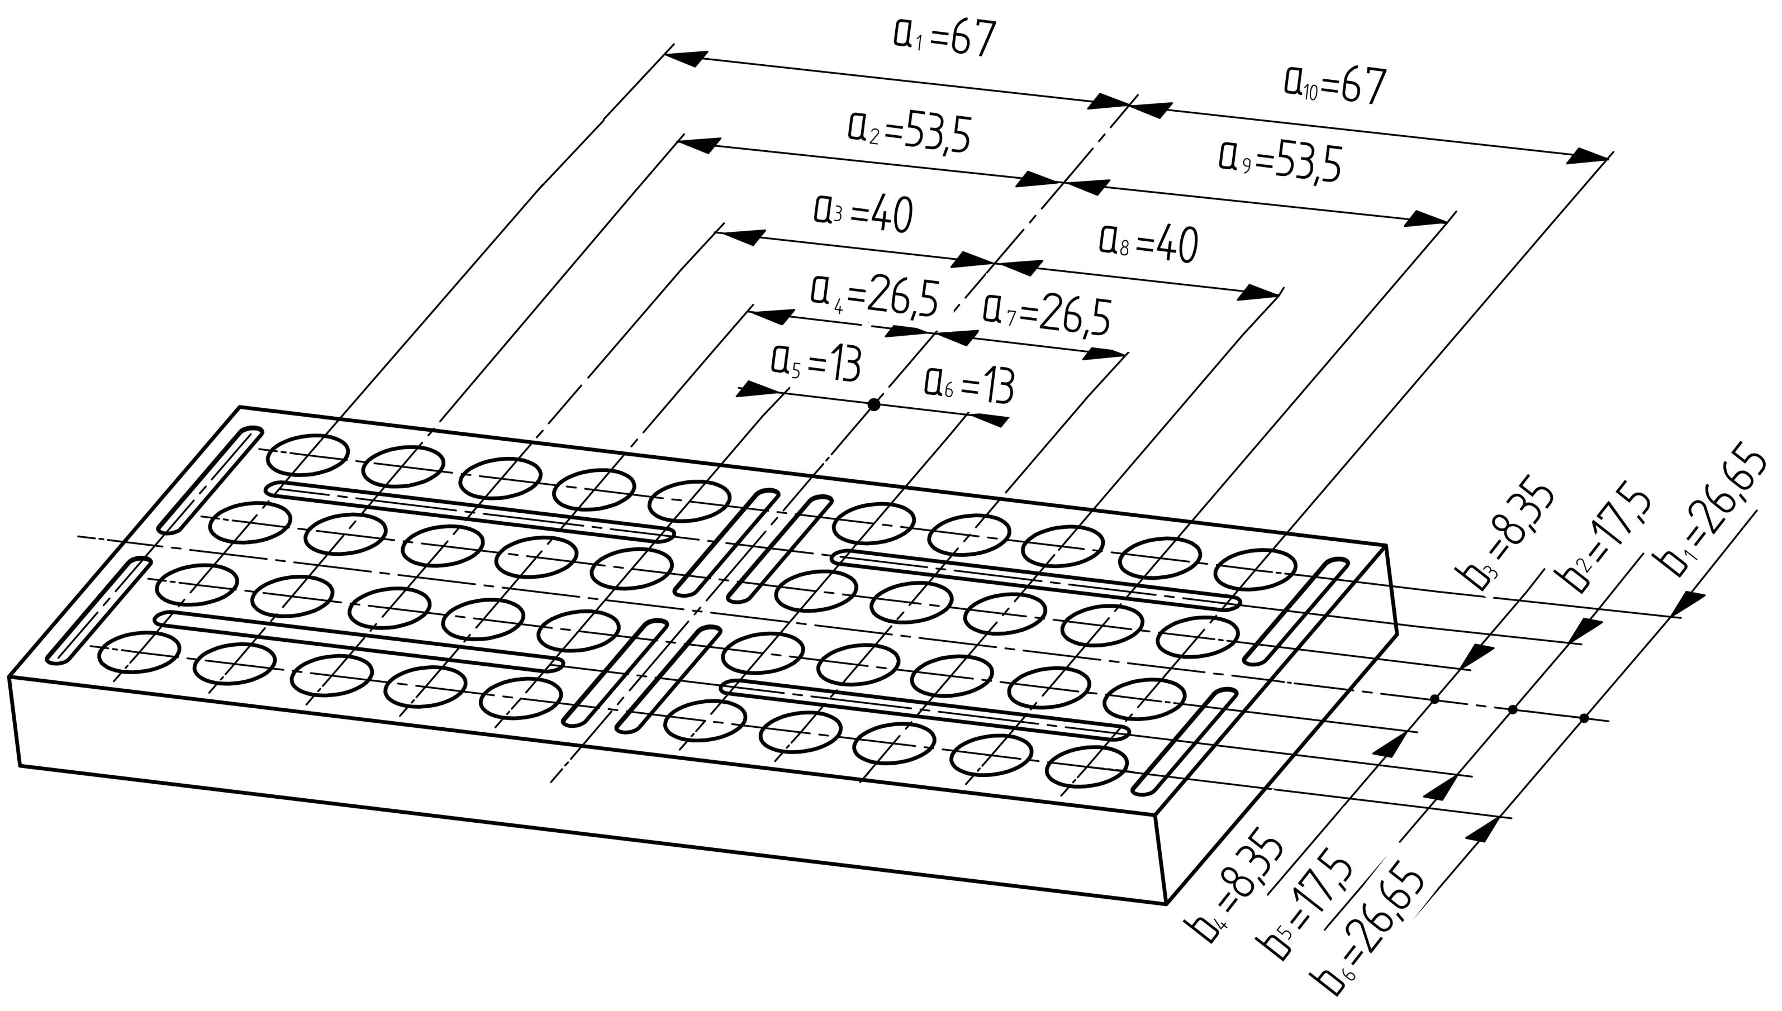
Fig. Tools for PVC and aluminum foil welding with uncorrected hole distances
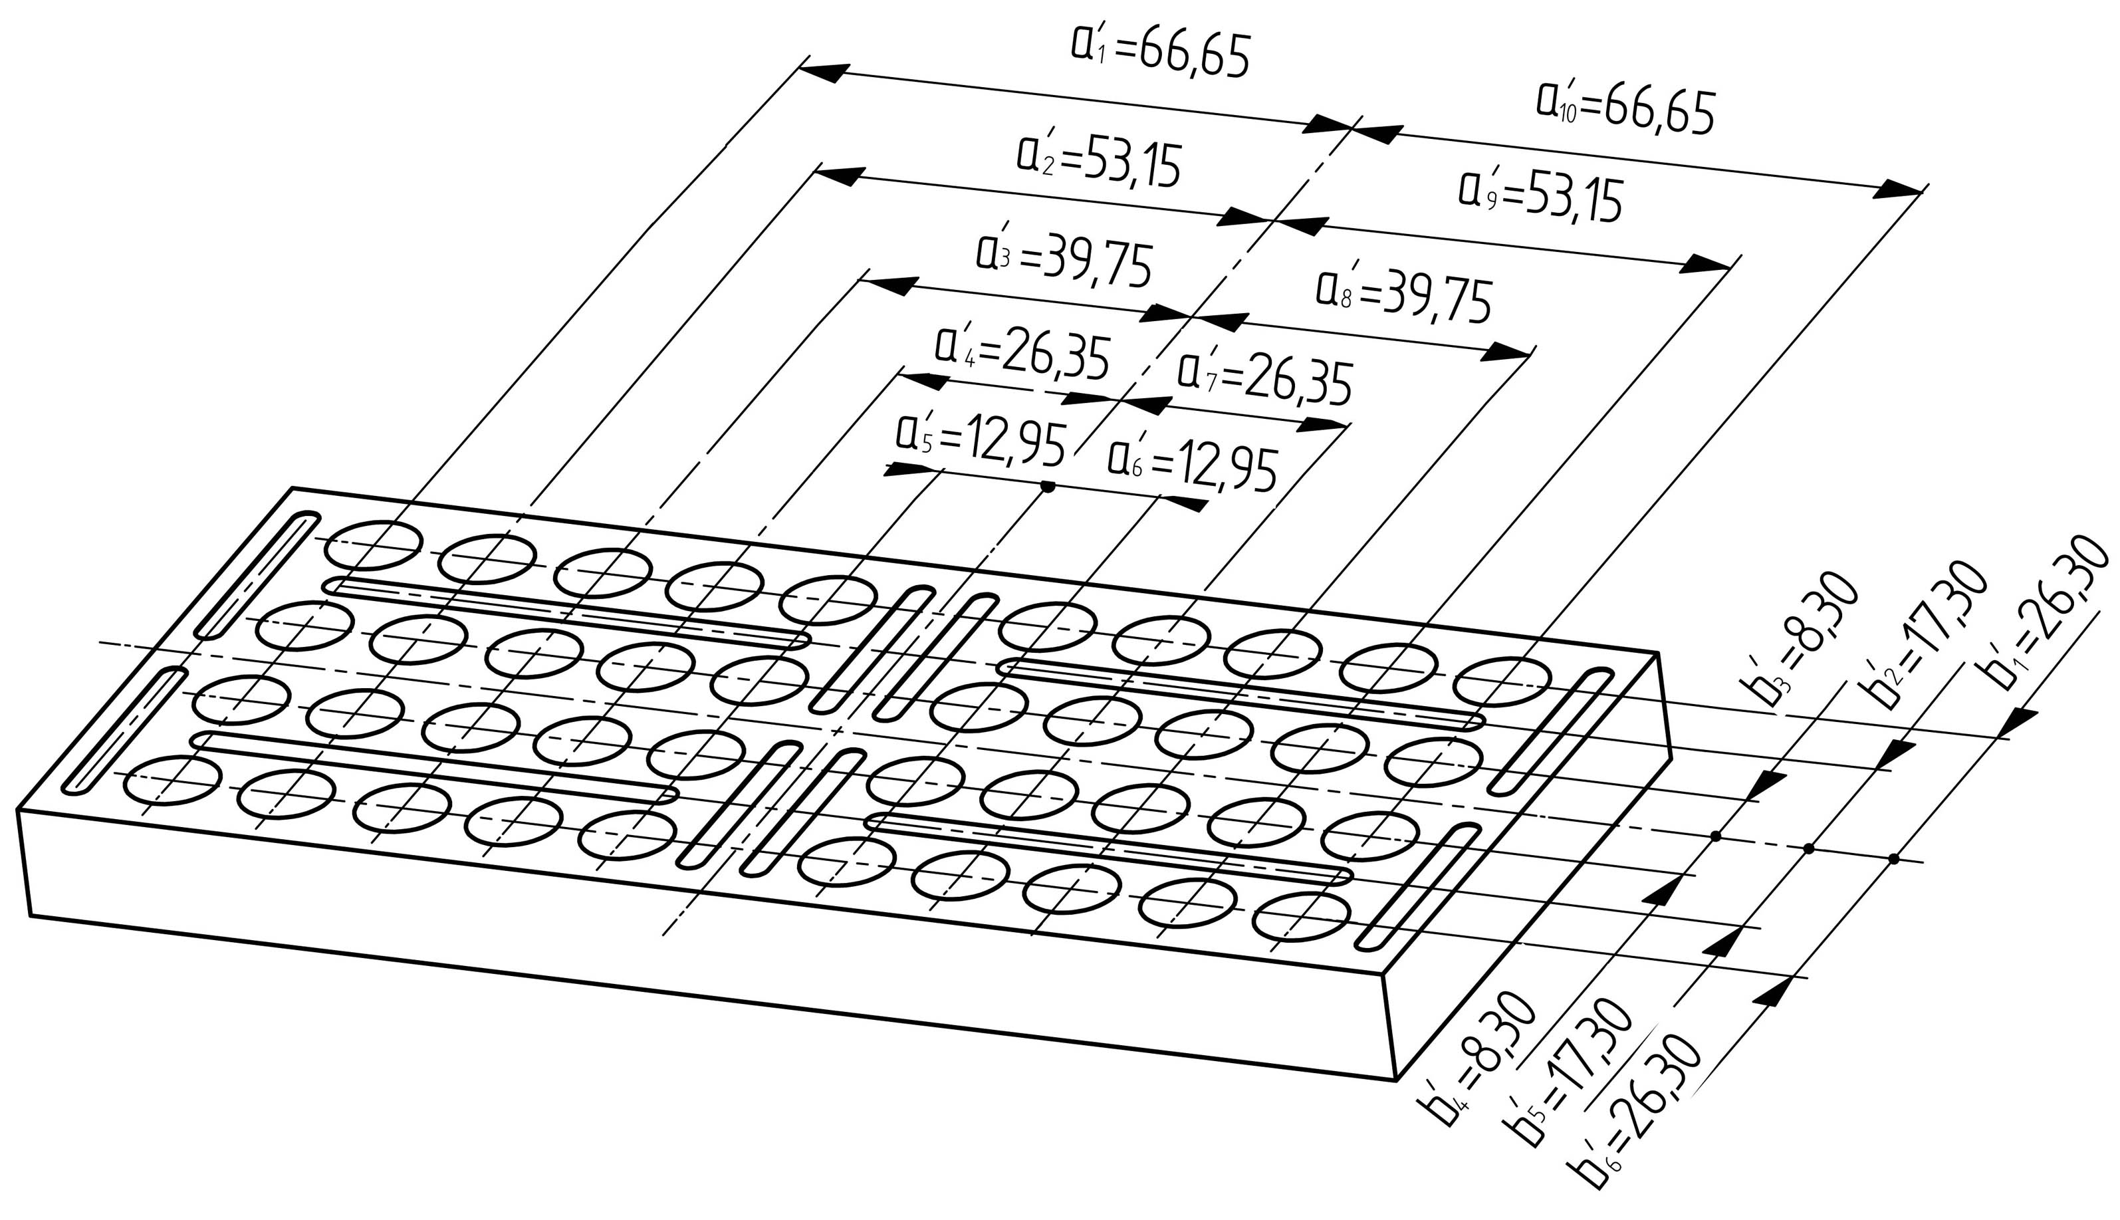
Fig. 7 Tools for PVC and aluminum foil welding with corrected hole distances
- CONCLUSION
To achieve the stability of the process of packaging tablets in blister packs and to avoid the appearance of 'bumping' tablets, the design of thermoforming tools for plastic sheeting and tools for aluminum foil welding is significant. Compliancy of hole position dimensions of the aluminum foil welding tool with the process of temperature dilatation of openings in PVC foil in the longitudinal and transverse direction eliminates potential downtime and errors.
Today, there is software (e.g. BlisterPro®) that allows finite element analysis of thermoforming process, thinning of the film and achieving quality when designing packaging tools, which reduces the need for correction, production time and costs..
REFERENCES
- B. Nedić, Tehnologija prerade plastičnih masa, Mašinski fakultet, Kragujevac, 2008.
- D. Cvetković, D. Marković, Dizajn pakovanja, Univerzitet Singidunum, Beograd, 2010.
- R. Pilchik, Pharmaceutical Blister Packaging, Part I and II: Rationale and Materials, Pharmaceutical Technology, 24 (11), 68–78 (2000).
- http://www.carmichael- eng.co.uk/Machine_Range/Blisters/nMX_Blister_ Packer/nmx_blister_packer.html, accessed on 2015-04-24
- http://www.contractpharma.com/issues/2014-03-%2001/view_features/packaging-equipment-amp-trends-/, accessed on 2015-04-24

Dr Živko Babić, University of Banja Luka, Faculty of Mechanical Engineering, (zivkobabic@unibl.rs)
Rodoljub Lekanić, Bsc, Eng., Hemofarm, d.o.o., Banja Luka, (rodoljub.lekanic@hemofarm.com)

