LOGO WILL BE HERE

The Use of Parametric Spectral Estimation for Extracting Angular Velocity Variations From the Exhaust Pressure Pulsations in IC Engines
Dobrivoje Ninković
Summary: Presented in the paper is a method for extracting the angular velocity variation of an IC engine from the exhaust pressure pulsations. The method is based on the so-called parametric (model-based) spectral estimation, and is capable of detecting a narrow-band, time-dependent frequency variation in a signal using only several signal samples at a time.
The procedure developed is demonstrated by application to data recorded on two Diesel engines, whereby the rotational speed variation was also measured. The respective angular velocity variations were extracted from the records of pressure pulsations in the exhaust systems of the two engines, and then compared with the measured ones. Very good accuracy was achieved in both cases.
The method can also be used for special spectral analyses of short signals, where the application of FFT-based spectral estimation would result in a very coarse frequency resolution.
Key words: Parametric Spectral Estimation; Exhaust Pressure Pulsations; Angular Velocity Variation.
- INTRODUCTION
Oscillatory phenomena (vibrations, pressure pulsations, etc.) observed in rotating machinery, such as e.g. IC engines and reciprocating compressors, are usually periodic in terms of shaft rotation, but not necessarily in terms of time. For example, the angular speed of IC engines running at a nominally constant speed is known to vary not only within individual cycles, but also generally due to small imprecisions of the speed governor. However, most oscillatory quantities produced by the machine's operation remain periodic with respect to the crankshaft rotation.
If such signals are recorded by sampling in the time domain, and subsequently subjected to the standard, i.e. non-parametric spectral estimation, the harmonic peaks obtained often appear as smeared, and their respective amplitudes are inaccurate. However, if the variation of the crankshaft angular velocity with time is known, i.e. by being simultaneously measured, the oscillatory signals recorded can be resampled in terms of the shaft angle, and the spectral peaks obtained by a subsequent FFT analysis will then have correct amplitude values.
There are situations when the instantaneous angular velocity of the crankshaft can not be measured with sufficient resolution, if at all. The question is then whether this information can be extracted from some other measured quantity in the same data set. One such candidate is the pulsating pressure in the exhaust manifold, provided the engine has constant valve timing within the measurement run.
The results of the study reported in the present paper show that it is indeed possible to obtain the engine speed variation over time by subjecting the exhaust pressure pulsations to a parametric (model-based) spectral analysis. As it happened, in the projects dealt with in this paper, the exhaust pressure was the very signal that was to be analyzed in the frequency domain, so it served a twofold purpose in that it was also employed as its own time base.
The need for the study arose in conjunction with an investigation carried out at ABB Turbo Systems Ltd. of the excitation forces due to pressure waves at the turbine inlets that may give rise to torsional vibrations in the turbocharger rotor assembly under operating conditions. In order to calculate the excitation forces, one needs accurate values of the pressure amplitudes in the frequency range where the natural torsional frequency of the rotor assembly happens to be located.
- OVERVIEW OF THE SPECTRAL ESTIMATION METHODS
Referring to any standard calculus textbook, a periodic function of an arbitrary argument can be represented by an infinite trigonometric series in terms of sines and cosines. Taking time as the independent argument, the series expansion of a function $f\left(t\right)$ with a period $T$ is:
$$f\left(t\right)=\sum_{k=0}^{∞}{\left[a_{k}∙cos\left(ω_{k}t\right)+b_{k}∙sin\left(ω_{k}t\right)\right]}$$ | (2-1)
where $a_{k}$ and $b_{k}$ are referred to as Fourier coefficients, $ω_{k}={2πk}/T$, $b_{0}=0$, and the series itself is known as the Fourier series.
Making use of the Euler identitiy $e^{jαt}=cos\left(αt\right)+j∙sin\left(αt\right)$, where $j=\sqrt{-1}$, the series of Eq. (2-1) above can be expressed in the complex mumber domain as:
$$f\left(t\right)=\sum_{k=-∞}^{∞}{c_{k}∙e^{jω_{k}t}}$$ | (2-2)
Without going into the derivation details, in the case of real periodic signals in continuous time, the above representation can be transformed into the form [1]:
$$f\left(t\right)=c_{0}+\sum_{k=1}^{∞}{C_{k}∙cos\left(kω_{0}t+θ_{k}\right)}$$ | (2-3)
which expresses the original signal $f\left(t\right)$ as a sum of discrete sinusoids with the respective amplitudes $C_{k}$ and phase angles $θ_{k}$. The free term $c_{0}$ is the signal mean value, and $ω_{0}$ is referred to as the fundamental frequency component, corresponding to the shortest signal period $T_{0}$ (an infinite signal periodic with $T_{0}$ is also periodic with all positive integer multiples of the latter).
The above equation constitutes the basis for the so-called harmonic signal analysis, because its typical result are the respective plots of the amplitudes and phase angles against the discrete frequencies $kω_{0}$, or harmonics. The method is also referred to as spectral analysis.
Since the exact transformations from the time into the frequency domain and v.v. with signals acquired in practice is not possible, one then speaks of spectral estimation. Note that the latter term customarily refers to the estimation of the distribution of the total signal power over frequency [2], but since the amplitude and power spectra are related by the square root operation, the term spectral estimation is used to refer to both. Note also that the power spectrum is devoid of the phase information, which may play a role in some applications.
In the contemporary measurement practice, signals are not analysed in the analogue domain any more; instead, they are discretised in terms of amplitude (quantisation) and time (sampling), producing a time-series representation of their continuous counterparts. The sampling process assumes a constant time increment between subsequent signal values, referred to as sampling time $T_{s}$, the reciprocal of which is the sampling rate, or frequency, $f_{s}=1/{T_{s}}$, also referred to as the Nyquist frequency. According to the sampling theorem [1], a continuous signal can be reconstructed from its time series representation only up to a frequency that is at most twice lower than $f_{s}$.
The above represents a crucial difference between the continuous and discrete-time signals in that the latter are limited in their frequency content to ${f_{s}}/2$. Therefore, given a periodic time series $y\left(i∙T_{s}\right), i=0,1,2,…,N-1$ with a period of $N∙T_{s}$, where $N$ is the number of samples within the period, its discrete Fourier transform reads [3]:
$$y\left(i\right)=c_{0}+\sum_{k=1}^{N-1}{c_{k}∙e^{j2πk\frac{i}{N}}}$$ | (2-4)
All the above formulae represent the so-called synthesis equations, i.e. one assumes that the coefficients $c_{k}$ are known, and reconstructs then the signal in the time domain. The task of the spectral estimation consists of determining the values of these coefficients, which can be accomplished by two methods, referred to as the nonparametric and parametric spectral estimation. Only the discrete-time spectral estimation procedures will be dealt with in the rest of the paper.
2.1 NON-PARAMETRIC SPECTRAL ESTIMATION
The non-parametric spectral estimation consists of the discrete Fourier transform of the time series at hand. The algorithm used almost exclusively for this task is the so-called Fast Fourier Transform (FFT), which achieves maximal efficiency if the number of data points in the time series is a power of two. Since this is nowadays a standard topic in any signal analysis course, there is no need to deal with its details here; however, two points of importance for the analysis will be briefly discussed.
The resolution of the analysis, i.e. the accuracy of the spectral components' frequencies is directly dependent upon the length of the available time series in the time domain, which is equal to the product of the number of samples in a data record and the sampling time $T_{s}$. For example, a signal length of 10 seconds results in the frequency resolution of 0.1 Hz. If the data record available is longer than absolutely necessary for the minimal resolution required, the amplitude accuracy of the analysis can be enhanced by dividing the record into equal length sub-records, and averaging over the individual spectra obtained. The periodicity requirement can be relaxed by multiplying the sub-records with a suitable window function [3], in which case the analysis may also proceed over overlapping data segments [4].
However, there is a strict requirement for the sampling time to be constant. For example, if the signal to be measured is stationary and periodic in the absolute time, and the sampling rate generator in the data acquisition system is unstable, the acquired signal will not be periodic in the discrete-time domain. The same happens if the sampling rate generator is stable, but the signal periodicity is variable in the time domain, which is often observed in rotating machinery.
Referring to Fig. 1 below, the left plot shows an example of engine speed variation over a time interval of 5 seconds, whereas the right one depicts the turbine entry pressure spectrum over the same time interval. The blue lines represent the pressure spectrum with constant sample rate in the time domain, and the red ones with constant crankshaft angle increment. Obviously, the latter has a much better amplitude accuracy than the former.
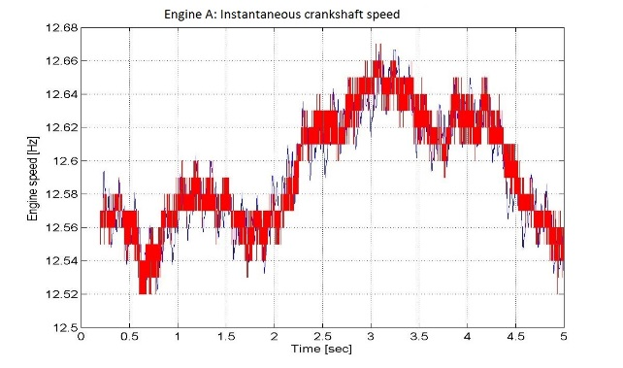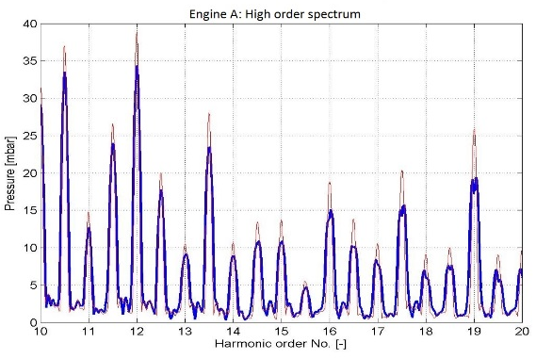
Fig. 1 Speed variation and the exhaust pressure spectrum
In the above example, the signals were sampled with a fixed sample rate in the time domain, but since the engine speed was also measured (the red line in the LHS plot), the data were resampled in the crankshaft angle domain in order to obtain the "red" spectrum in the RHS plot.
2.2 PARAMETRIC SPECTRAL ESTIMATION
Parametric, or model-based, spectral estimation does away with the assumptions and limitations inherent in its FFT-based counterpart [3]. From the practical point of view, this relates above all to the requirement for having long data records in order to achieve good frequency resolution, which in turn makes data windowing unnecessary and eliminates the spectral leakage thus caused.
In order to use the parametric spectral estimation, one must have a-priori knowledge about the process that generated the signal to be analyzed. This does not mean that in the case above a physical model of the exhaust manifold and the turbine is mandatory, but rather a data-based model that would produce the measured signal from white noise. Therefore, the measured signal is seen as the output of a linear dynamic system, i.e. a filter, and the unknowns are the model coefficients. The latter are determined by iteration until agreement is achieved between the data and the filter output, at which point the eigen-frequencies of the model correspond to the spectral components of the signal [3]. In comparison with the non-parametric spectral estimation, the parametric procedure can be interpreted as a solution of the inverse problem in that a process is sought that produces the measured signal (refer to Fig. 2 below for the block-diagram of the method).
Fig. 2 Block diagram of the parametric spectral estimation procedure
The particular discrete-time filter structure is usually chosen from within the class of rational transfer functions in terms of the backwards shift operator $z^{-1}$ [5]:
$$H\left(z^{-1}\right)=\frac{b_{0}+b_{1}z^{-1}+…+b_{m}z^{-p}}{1+a_{1}z^{-1}+…+a_{n}z^{-q}}=\frac{B\left(z^{-1}\right)}{A\left(z^{-1}\right)}$$ | (2-5)
with the corresponding difference equation:
$$x\left(n\right)=-\sum_{k=1}^{q}{a_{k}∙x\left(n-k\right)+\sum_{k=0}^{p}{b_{k}∙y\left(n-k\right)}}$$ | (2-6)
Depending upon the polynomials $A\left(z^{-1}\right)$ and $B\left(z^{-1}\right)$, different random processes can be generated by the the transfer function of Eq. (2-5). If both $p$ and $q$ are at least unity, the process is referred to as autoregressive, moving average process, and usually denoted by $ARMA\left(p,q\right)$; if $q=0$ and $b_{0}=1$, one has an autoregressive process of order $p$, or $AR\left(p\right)$; and if $A\left(z^{-1}\right)=1$, the output of the system is a moving average process, or $MA\left(q\right)$.
According to Proakis and Manolakis [3], the autoregressive process lends itself best for the representation of spectra with sharp peaks, and results in very simple equations for the calculation of the coefficient values. For these reasons, it is the one used in the present study.
- METHOD SELECTION AND VERIFICATION
Since there are several possibilities to design a filter for the above purpose, it was decided to test the candidate filters with synthetic data. Before going to the filter design procedures, it is necessary to introduce basic ideas of the angle modulation.
A sinusoidal signal with amplitude $A$ can be generated by means of the well-known formula:
$$y\left(t\right)=A∙\sin{Θ\left(t\right)}$$ | (3-1)
whereby the following relationship between the argument of the sine function above and the instantaneous angular velocity $ω_{m}\left(t\right)$ holds [1]:
$$ω_{m}\left(t\right)=\frac{dΘ\left(t\right)}{dt}$$ | (3-2)
A sinusoidal signal with constant frequency and phase is generated with the argument:
$$Θ\left(t\right)=ω_{0}t+{Θ_{0}}$$ | (3-3)
which implies a constant angular frequency $ω_{0}$. A phase-modulated sinusoidal signal is obtained when the phase varies with time and the frequency is constant:
$$Θ\left(t\right)=ω_{0}t+{{k_{p}∙Θ}_{1}\left(t\right)}$$ | (3-4)
Inserting the definition of Eq. (3-3) above into Eq. (3-2) one obtains the instantaneous angular velocity of the phase-modulated sinusoid:
$$ω_{m}\left(t\right)=\frac{dΘ\left(t\right)}{dt}=ω_{0}+{k_{p}\frac{dΘ_{1}\left(t\right)}{dt}}$$ | (3-5)
A frequency-modulated signal is obtained when the angle derivative varies linearly with the modulation function:
$$\frac{dΘ\left(t\right)}{dt}={ω_{m}\left(t\right)=ω}_{0}+{k_{p}∙Θ_{1}\left(t\right)}$$ | (3-6)
Comparing the above equations it can be seen that the phase and frequency modulations are closely related in that a frequency modulation with $Θ_{1}\left(t\right)$ equals a phase modulation with the derivative of $Θ_{1}\left(t\right)$.
The performance of the method was verified by trying to identify a sine signal with a known frequency of $f_{1}=1 Hz$ and amplitude of 0.01 from another sine signal with $f_{0}=8 Hz$ and unity amplitude, whereby the latter is phase-modulated by the former:
$$y\left(t\right)=\sin\left[2πf_{0}t+0.01\sin\left(2πf_{1}t\right)\right]$$ | (3-7)
which produces an instantaneous frequency
$$f_{m}=f_{0}+0.01\sin\left(2πf_{1}t\right)$$ | (3-8)
Referring to Fig. 3 below, the upper plot shows the instantaneous frequency of the original signal of Eq. (3.7), and the lower one the same quantity identified by the application of the so-called covariance method [6] to the discrete-time version of the former, obtained by sampling with the rate of $5 kHz$. It is seen that both the amplitude and phase of the original and identified instantaneous frequencies agree very well. The results were generated with a second-order AR model that processes five data points in a step, which means that each value of the reconstructed instantaneous frequency represents an average over a time interval of $0.8 ms$.
Three other identification methods available in the Matlab package were also tested: the modified covariance, Yule-Walker, and Burg. Only the first one was found to produce the same result as shown in Fig. 3 below. Thus, the methods after Yule-Walker and Burg were eliminated from further consideration for this study.
Newer literature lists many other methods that can potentially be used to accomplish the task at hand [2], but since the simplest one was found satisfactory, there was no need for further method evaluation.
Note that in this case one is dealing with the so-called time-frequency analysis, i.e. of estimating the frequency variation with time, which is possible due to the small number of data points needed in order to obtain the result, and which can not be performed by using the FFT-based methods.
Fig. 3 The original and identified instantaneous frequencies
- RESULTS
The verification results shown above demonstrate that parametric spectral estimation is capable of reconstructing instantaneous frequency variation in a spectrally simple time series. However, exhaust pressure fluctuations in a typical IC engine contain a large number of individual harmonics, and it is hardly possible to construct a data-based model that could encompass all of them. In principle, however, every single spectral component contains the information about the frequency variation of the entire signal. Therefore, if it would be possible to isolate a single spectral component and reconstruct its frequency variation, then the result obtained can be considered as representative for the entire time series to be analyzed.
The plot in Fig. 4 below illustrates the approach and the results. A sharp infinite impulse response (IIR) [1] filter of the band-pass type is applied to the strongest harmonic of the exhaust pressure pulsation signal measured at one of the two turbine inlets. The particular frequency chosen corresponds to three exhaust pulses per 720 degrees of crankshaft rotation of a six-cylinder, medium-speed engine, running at 685 rpm. Since pulse turbocharging [7] with two turbine inlets was implemented, each turbine inlet receives three exhaust pulses in two crankshaft revolutions, hence the frequency of approx. 17 Hz. Obviously, the filter isolates the desired pulsation harmonic with negligible artefacts from the neighbouring spectral components.
Note that filtering operations involving causal IIR filters give rise to a nonlinear phase shift in the filtered result, which is undesirable in the present application. Fortunately, the filtering is performed offline, and it is then possible to completely eliminate the phase shift by running the filtered signal through the same filter backwards, i.e. by starting with last sample (see function filtfilt in Matlab [6]). Since the phase shift thus produced is opposite to the one generated in the forward pass, the two phase shifts cancel, and the end result has zero phase shift.

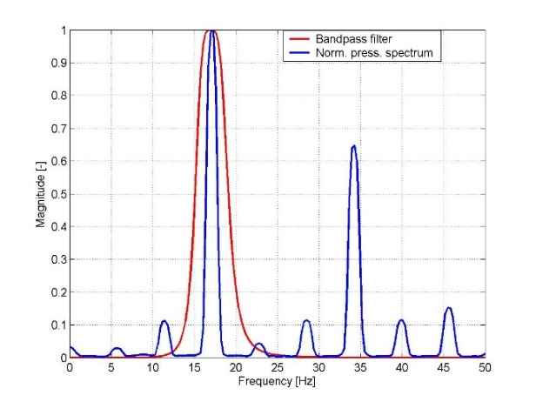
Fig. 4 Band-pass filter in the pressure pulsation spectrum
Subjecting now the pressure pulsation signal extracted by the filter to the parametric spectral estimation by the covariance method, and plotting the results obtained together with the measured engine speed, the diagram of Fig. 5 below is obtained.
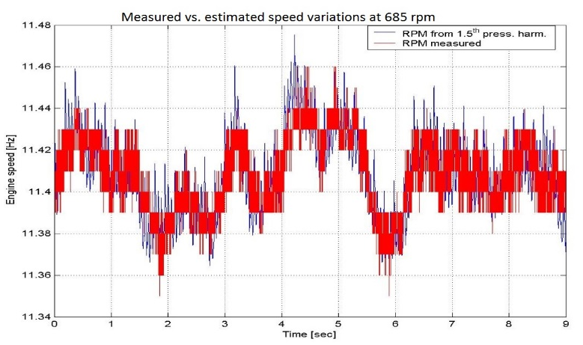
Fig. 5 Measured vs. estimated engine speed variations at 685 rpm
Apparently, the agreement between the measured (red) and estimated (blue) instantaneous engine speeds is very good; as a matter of fact, the estimated engine speed has even more dynamics than the measured one.
Using now the estimated engine speed to resample the pressure pulsation signal in terms of the crankshaft angle and comparing the spectra of the same signal in the time and crankshaft angle domains, it is seen that the latter spectral components are narrower and have higher amplitudes, which is the expected result (see Fig. 6 below). Amplitude differences of up to 25% can be observed in the plot, which are of importance in assessing the torsional excitation forces at the turbine wheel.
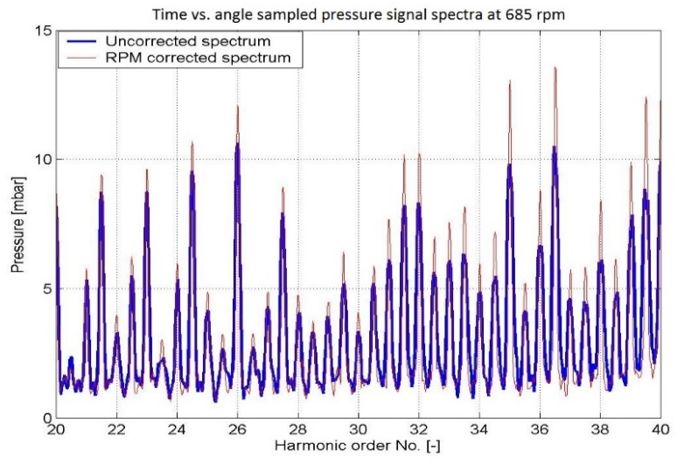
Fig. 6 Pressure spectra from time (blue) and angle (red) samplings at 685 rpm
Similar results have been obtained in several other measurement projects, but will not be presented in the paper. Generally, the effects of the domain transformation are more pronounced in the high-frequency parts of the spectra. This is to be expected, for the engine speed variations are relatively small and thus affect the results in proportion to the harmonic number.
Another interesting result of the application of the parametric spectral estimation to pressure pulsation signals is shown in Fig. 7 below. A pressure measurement in the inlet manifold of a customer's engine indicated a resonant pulsation after the inlet valve closure, but the small number of data points has not permitted an accurate FFT-based analysis. The signal was then processed by the same covariance algorithm and revealed an almost constant frequency over the engine cycle, confirming thus that the pulsation was indeed resonant. It was self-excited by the compression wave created by the air stagnated at the closed valve, which also explains the presence of high frequencies at 60°, i.e. at the moment of valve closure.
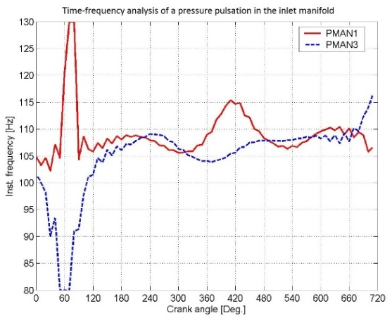
Fig. 7 Example of time-frequency analyis of a resonant pressure pulsation
- CONCLUSIONS
It has been shown in the paper that parametric spectral estimation is capable of resolving frequency variations in frequency-modulated signals with very good accuracy. Applied to IC engine exhaust pressure records acquired by sampling in the time domain, the method was successfuly used to identify the engine speed variations. In situations where the instantaneous engine speed is not available, the information as to its variation obtained in the above described way can be used to resample the signals of interest in the crankshaft angle domain, achieving thus improved amplitude accuracy in the subsequent FFT-based spectral estimation.
ACKNOWLEDGEMENTS
The author acknowledges with gratitude the permission granted by the Management of the R&D Turbocharging Solutions Dept. of ABB Turbo Systems Ltd., Baden, Switzerland, to present this paper at the Conference.
- REFERENCES
- Oppenheim, A.V., Willsky, A.S., Young, I.T. (1983). Signals and Systems. Prentice/Hall International Inc.
- Stoica, P., Moses, R. (2005). Spectral Analysis of Signals. Prentice Hall.
- Proakis, J.D., Manolakis, D.G. (1992). Digital Signal Processing: Principles, Algorithms, and Applications (2nd Edition). Macmillan, New York.
- Welch, P.D. (1967). The use of fast Fourier transforms for the estimation of power spectra: A method based on time averaging over short modified periodograms. IEEE Transactions on Audio and Electroacoustics, Vol. 15, pp. 70-73.
- Isermann, R. (1988). Identifikation dynamischer Systeme: Band 1. Springer.
- MATLAB Signal Processing Toolbox, Mathworks, Inc.
- ABB Turbocharging. Operating Turbochargers: Collection of articles by J. Schieman published in Turbo Magazine 1992-1996, also available from http://www09.abb.com/global/scot/scot208.nsf/veritydisplay/77547b9dbf02d66ec1257880005681d3/$file/ABB%20Turbocharging_Operating%20turbochargers.pdf, accessed on 02.04.2015.

Dr. Dobrivoje Ninković, ABB Turbo Systems Ltd, 5401 Baden, Switzerland, dobrivoje.ninkovic@ch.abb.com

