LOGO WILL BE HERE

QUALITY ASSURANCE INSTRUMENTS IN HIGHER EDUCATION SYSTEM OF REPUBLIKA SRPSKA
Miroslav Bobrek, Jugoslav Tepić, Duška Radmanović
Summary:
Obezbjeđenje kvaliteta kao koncept funkcionisanja organizacija operacionalizuje se primjenom odgovarajućih metoda, tehnika, alata i drugih oblika organizacionog znanja u oviru uspostavljenog Sistema kvaliteta, za koje se u ovom radu koristi termin „instrumenti obezbjeđenja kvaliteta“. U Sistemu visokog obrazovanja Republike Srpske ovi instrumenti se prepoznaju na tri nivoa: nivo visokoškolske institucije u vidu internog obezbjeđenja kvaliteta, nivo institucija i tijela visokog obrazovanja Republike Srpske u vidu eksternog obezbjeđenja kvaliteta i nivo Agencije za akreditaciju u vidu instumenata međunarodne prepoznatljivosti visokog obrazovanja Republike Srpske u okviru evropskog prostora visokog obrazovanja (EHEA). Radom se ukazuje na dosadašnja iskustva u primjeni adekvatnih instrumenata na sva tri nivoa i na moguće pravce daljnjeg razvoja.

Ključne riječi: Obezbjeđenje kvaliteta, Audit, Ocjenjivanje, Akreditacija, Evaluacija.

Key words: Quality assurance, Audit, Assesment, Acreditation, Evaluation.

- INTRODUCTION (Style: 10 PT BOLD, UPPERCASE, Spacing Before 18 pt, After 6 pt)
Quality in higher education is a complex and multidimensional apprehension strongly conected with the specific standards as well as with the concepts of excellence, fit to purpose and enhancement for improvement. Therefor, quality assurance is a continuos process of evaluating quality at higher education institutions. As a regulatory mechanism, quality assurance focuses on both accountability and improvement, providing information and judgments (not ranking) through an agreed upon and consistent process and well established criteria. When it comes to accreditation it is diffrent because it is a formal recognision of a quality at institution or a study program or both according to certain standards and criteria.
- QUALITY AND ACCREDITATION IN EHEA
European Higher Education Area (EHEA) is known as one of the main objective of the Bologna process – to create more comparable, compatible and coherent systems of Higher Education in Europe. With the creation of the EHEA, quality and accreditation are becoming important issues. Some of the core European networks and associations regarding quality and accreditation are: EUA, EURASHE, ESU, ENQA, EQAR.
EUA - European University Association was formed in 2001 with 850 members across 47 countries. EUA is the largest and most comprehensive organisation representing universities in Europe. 17 million students are enrolled at EUA member universities. As the voice of Europe’s universities EUA supports and takes forward the interests of individual institutions and the higher education sector as a whole. EUA provides unrivalled opportunities for members to share best practice by participating in projects, events and other mutual learning activities involving a wide range of universities. EUA’s website, briefings and newsletters keep members well-informed about these activities and European developments impacting their activities /1/.
EURASHE - European Association of Institutions in Higher Education is the European Association of Institutions in Higher Education that offer professionally orientated programmes and are engaged in applied and profession-related research within the Bologna cycles. Members of EURASHE are national associations of higher education institutions and individual institutions, such as universities, (university) colleges and universities of applied sciences, as well as other professional associations and stakeholder organisations active in the field of higher education. EURASHE was founded in Patras (Greece) in 1990 as an international association that promotes and emphasizes professional higher education (PHE). While EURASHE originally admitted only national organisations (such as Councils of Directors) as members, it later opened up membership to individual institutions. Nowadays its members are Colleges, Polytechnics, University Colleges, Universities of Applied Sciences and Universities with their professional trainings /2/.
ESU - European Students’ Union is the umbrella organisation of 47 national students’ unions from 39 European countries (December 2012). ESU promotes and represents the educational, social, economic and cultural interests of 11 million students to all key European decision-making bodies: the European Union, Council of Europe, UNESCO and the Bologna Follow Up Group. ESU was founded in 1982 by seven national unions of students (NSU Norway, NUS-UK, SFS Sweden, SHÍ Iceland, UNEF-ID France, DSF Denmark and ÖH Austria) and back then was called WESIB, the West European Student Information Bureau. The political changes in Eastern Europe at the end of the 1980s affected WESIB as well, as it opened up itself to national unions of students from the former east. In February 1990, WESIB dropped the “W” to become the European Student Information Bureau (ESIB). As the European Communities started to gain more influence on higher education in Europe and certainly with the start of the Bologna Process, the objective from just an information sharing organisation changed into to a political organisation that represents the views and interests of students. In May 2007 it was decided that ESIB needed to change its name as the ESIB acronym no longer represented the work of the organization and ESIB changed its name into the European Students' Union (ESU) /3/.
ENQA – European Association for Quality Assurance in Higher Education. The idea of the creation of an association originates from the European Pilot Project for Evaluating Quality in Higher Education (1994-95) which demonstrated the value of sharing and developing experience in the area of quality assurance. Following the Recommendation of the Council (98/561/EC of 24 September 1998) on European co-operation in quality assurance in higher education and the Bologna Declaration of 1999, ENQA was established in 2000 as the European Network for Quality Assurance in Higher Education to promote European co-operation in the field of quality assurance. In 2004 the Network was transformed into the European Association for Quality Assurance in Higher Education (ENQA). The mission of the European Association for Quality Assurance in Higher Education (ENQA) is to contribute significantly to the maintenance and enhancement of the quality of European higher education at a high level, and to act as a major driving force for the development of quality assurance across all the Bologna signatory countries. As the association of the European quality assurance agencies, ENQA contributes to this goal especially by promoting European co-operation in the field of quality assurance (QA) in higher education in order to develop and share good practice in QA and to foster the European dimension of QA /4/.
EQAR – European Quality Assurance Register for Higher Education formed in 2008 provides clear and reliable information on the quality assurance agencies (QAAs) operating in Europe: this is a list of agencies that substantially comply with the European Standards and Guidelines for Quality Assurance (ESG) as adopted by the European ministers of higher education in Bergen 2005. The EQAR is established by the E4 Group: ENQA, ESU, EUA and EURASHE /5/.
E4 Group with other interested associations and networks represent institutional framework of EHEA, by providing appropriate analyses and prepositions to ministerial conferences of Bologna process countries. Until now there were 8 ministerial conferences held: Bologna 1999, Prague 2001, Berlin 2003, Bergen 2005, London 2007, Leuven 2009, Budapest/Vienna 2010 and Bucharest 2012. After every conference the ministers responsible for higher education adopt communique with conclusions of the conference, progress and priorities for the next period.
Among many documents, decisions and recommendations, one of the key document relevant for quality and accreditation is Standards and Guidelines for Quality Assurance in the European Higher Education Area (ESG) /6/, adopted by ministerial conference held in Berlin 2003. ESG standards are structured in 3 main chapters regulating quality assurance methods for different levels of national Higher Education System: Part 1: European standards and guidelines for internal quality assurance within higher education institutions (7 standards), Part 2: European standards and guidelines for the external quality assurance of higher education (8 standards) and Part 3: European standards and guidelines for external quality assurance agencies (8 standards). Prepared new version of ESG standard shall be adopted at the Ministerial conference which will be held in Jerevan in May 2015. The core changes are expected in focusing to creation of study programs in higher education in accordance with National qualification frameworks (NQF) or competence – based teaching as well in student - centered learning approach in educational process /7/. There shall also be some structural changes of the mentioned 3 parts of ESG standard.
According to /8/ ACCREDITATION is defined as process by which a (non-)governmental or private body evaluates the quality of a higher education institution as a whole or of a specific educational programme in order to formally recognize it as having met certain predetermined minimal criteria or standards. The result of this process is usually the awarding of a status (a yes/no decision), of recognition, and sometimes of a license to operate within a time limited validity. The process can imply initial and periodic self-study and evaluation by external peers. The accreditation process generally involves three specific steps: (i) a self-evaluation process conducted by the faculty, the administrators, and the staff of the institution or academic programme, resulting in a report that takes a sits reference the set of standards and criteria of the accrediting body; (ii) a study visit, conducted by a team o peers, selected by the accrediting organization, which reviews the evidence, visits the premises, and interviews the academic and administrative staff, resulting in an assessment report, including a recommendation to the commission of the accrediting body; (iii) an examination by the commission of the evidence and recommendation on the basis of the given set of criteria concerning quality and resulting in a final judgment and the communication of the formal decision to the institution and other constituencies, if appropriate.
Related terms to term “accreditation” are also: Institutional Accreditation which refers to the accreditation of an entire institution, including all its programmes, sites, and methods of delivery, without any implication to the quality of the study programmes of the institution; Regional Accreditation (USA) is accreditation granted to a higher education institution by a recognized accrediting association or commission that conducts accreditation procedures in a particular geographic area (usually that of three or more states). The United States has six regional accrediting commissions; Specialized Accreditation is accreditation of individual units or programmes (e.g. professional education), by “specialized” or “programme” accrediting bodies applying specific standards for curriculum and course content; Duration of Accreditation decisions are limited in time. The duration of validity of the accreditation license is established by the accrediting body, which generally holds the right to suspend or to renew the license, upon the satisfactory resolution of any identified issues; Accreditation Status is the formal recognition benefiting an institution or specialized programme for meeting the appropriate standards of educational quality established by the accrediting body at a regional, national, or specialized level; Portfolio for Accreditation is an accumulation of evidence (record of achievement) about specific proficiencies and the characteristics of an institution in relation to a specific type of activity, especially to learning standards. This operation can be performed either by the concerned institution or by an external assessor. Accreditation Body is A (non-)governmental or private educational association of national or regional scope that develops evaluation standards and criteria and conducts peer evaluations and expert visits to assess whether or not those criteria are met. It is entitled to accord formal status and sometimes a license to operate to individual higher education institutions or programmes, following the successful examination of the application and evaluation of the respective educational unit. There are different types of accreditation bodies (e.g. agencies, councils, commissions, etc.), focused on general accreditation, specialized accreditation, professional accreditation, regional accreditation, national accreditation, distance education accreditation, etc. Also, one of the OECD UNESCO recommendations requests agencies to sustain and strengthen the existing regional and international networks.
Following all previous definitions, accreditation is understood as a process that provides public recognition to institutions or study programs that meet certain standards (as ESG). It ensures that the institution has qualified staff, adequate facilities and equipment, operates on a sound financial basis and offers an approved study program. A successful accreditation may as well be interpreted as a promise to provide the quality education being claimed by institution. Regarding the assurance and improvement of quality in Higher Education, accreditation is one of multiple methods like summative or formative evaluation, standardization, certification, audit or benchmarking. These methods are conducted by Higher Education Institutions and authorized national accreditation bodies - agencies. Through membership in European networks and associations these bodies and national Higher Education Systems become recognizable in EHEA.
And besides many standards, guidelines, good practices delivered by European projects (TEMPUS), conferences, other communication and cooperation ways, there is still certain level of “the maze of accreditation in European higher education” in EHEA /9/. Still, accreditation process could be comprised of the 4 main phases (fig. 1.): 1. Preparation conducted by Higher Education Institutions (HEI) in consultation with relevant Accreditation body and production of self-evaluation report, 2. Application by HEI and check of the application documentation conducted by accreditation body staff in order to ensure meeting eligibility criteria set by accreditation body, 3. Evaluation represents the main phase and consists of the appointment of panel of assessors by accreditation body, on site visit and panel of assessors’ report, 4. Decision by accreditation body or other authority appointed by law. Positive decisions are made public on the website of accreditation agency.

- Accreditation Bodies / Agencies in EHEA
Although there is a generally reached consensus in understanding the accreditation process within the EHEA, as well as on the international plan, there are still differences in the objectives desired to be achieved by specific national higher education systems through their overall quality assurance and accreditation activities. For those reasons there are various approaches when it comes to selecting the form and defining the accreditation process. Hence, the consequences are various approaches in forming and organization of national bodies/quality assurance agencies and accreditation in higher education.
There is a short overview of the formed agencies and their roles in specific European countries. In the most of them there is a principle represented that one state has one agency established, but there are also models where there is a number of agencies in a single country. This is a characteristic of countries with complex structure (Germany, Belgium, Spain, Russia …). After meeting certain conditions in its line of functioning, established agencies are getting associated in European networks/associations of agencies: European Association for Quality Assurance in Higher Education (ENQA) and Central and Eastern European Network of Quality Assurance Agencies in Higher Education (CEENQA), thus ensuring recognition of National Higher Education Systems within its area of operations.
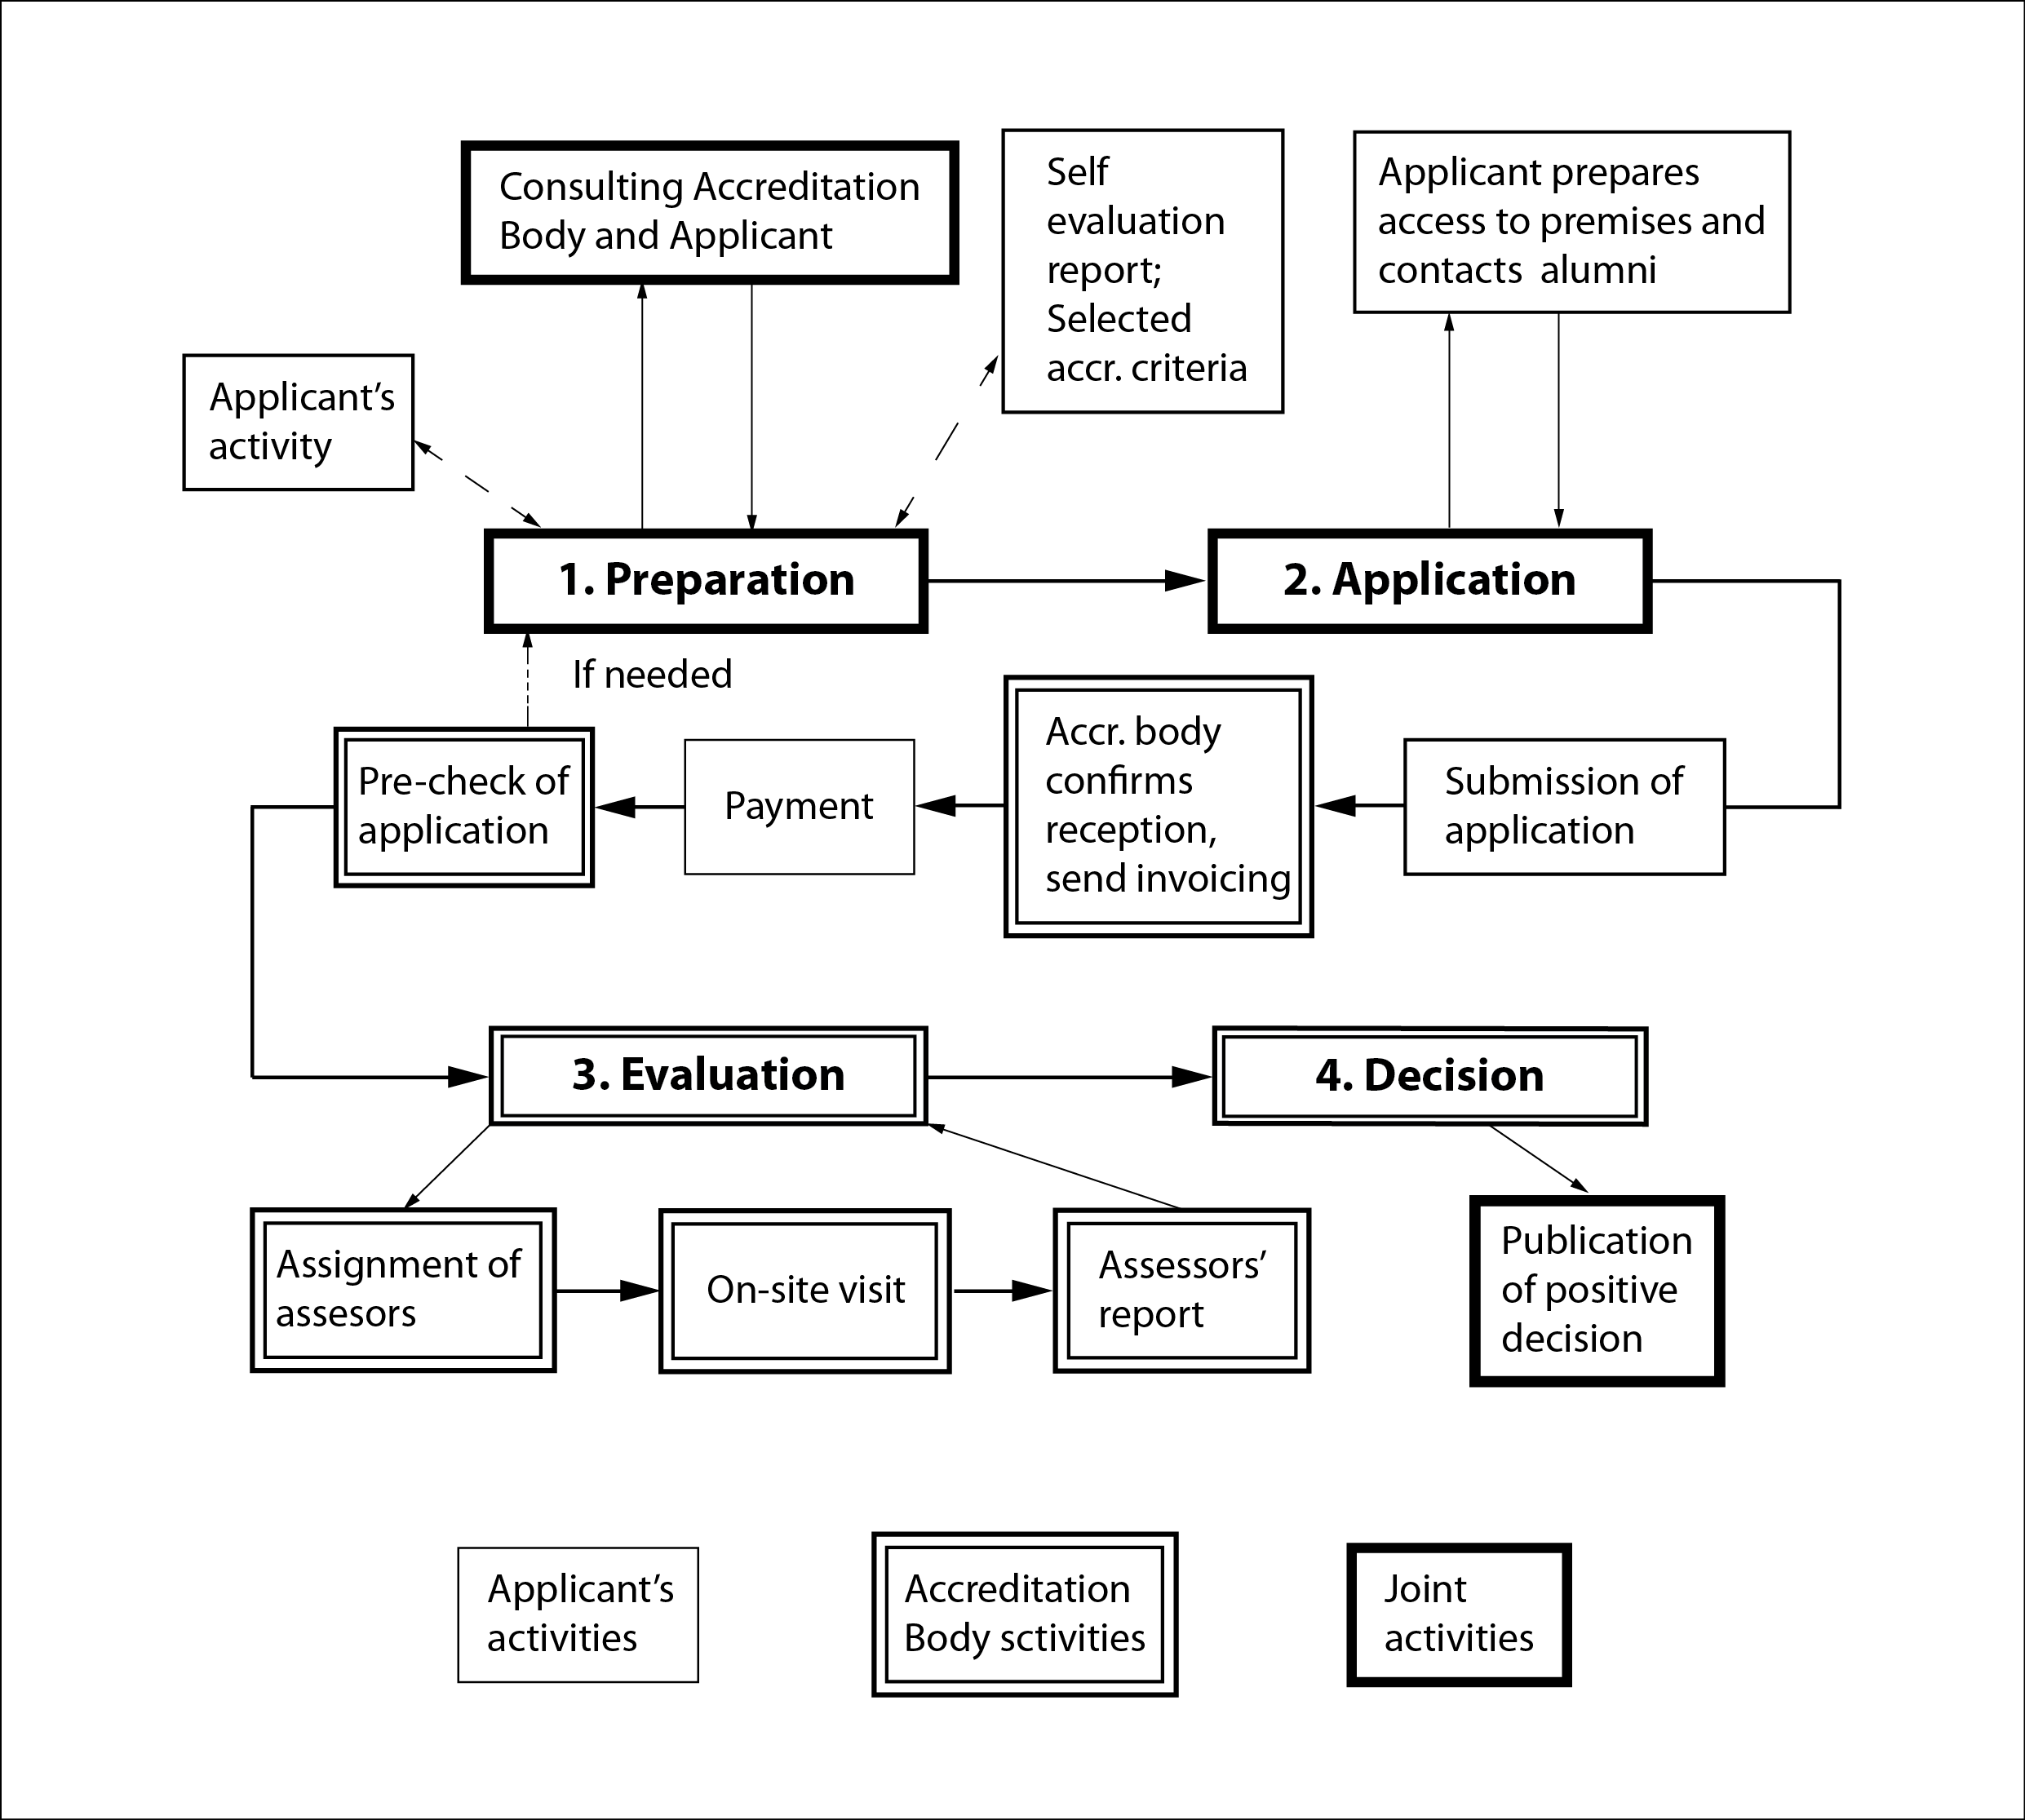
Fig. 1 Accreditation process
Members of ENQA are 46 quality assurance agencies from 26 European countries. There are eight agencies from Germany, seven from Spain, three from Russian, two from Belgium, Netherlands, Denmark, France and United Kingdom. Austria, Serbia, Slovenia, Croatia, Romania, Bulgaria, Czech Republic, Estonia, Finland, Holy See, Ireland, Kosovo, Lithuania, Norway, Poland, Portugal, Hungary and Switzerland have one agency in ENQA.
At the same time CEENQA has 27 members from 19 countries. Five agencies comes from Germany, three from Russia, two from Bosnia and Herzegovina and Poland, and by one from Albania, Austria, Bulgaria, Croatia, Czech Republic, Estonia, Hungary, Kazakhstan, Kosovo, Lithuania, North Cyprus, Romania, Slovakia, Slovenia and Turkey. As it may be assumed, some agencies are members of both ENQA and CEENQA, but there are many countries that are members of one network only.
- Accreditation in BiH – RS as country with complex structure
According to Dayton Peace Agreement, after the end of war in the 90-ies, Bosnia and Herzegovina has been established as a complex country comprised of three entities: Republika Srpska, Federation of BiH and Brcko district. Additionally, BiH Federation is structured out of 10 cantons with the high level of jurisdictions in regulating specific social sectors, including education.
As many aspects in the functioning of the administrative system of BiH, accreditation of universities in the country is a challenging and complex matter. Education, including higher education, falls within the legal competence of the ministries of education at the level of Republika Srpska, cantons and Brcko District. In accordance with different laws on Higher Education on the state level, aforementioned, there are different processes for accreditation established for Republika Srpska, each canton and Brcko district. There is an Agency for the Development of Higher Education and Quality Assurance of BiH established on BiH level with main competences for developing standards in higher education and some steps in coordinating accreditation process. There is a Higher Education Accreditation Agency of Republika Srpska formed for conducting the accreditation process of higher education institutions and study programs they perform. Ministries of education are competent for accreditation processes in the cantons of BiH Federation and Brcko district.
The purpose of this paper is to illustrate the accreditation process in the Higher Education System of Republika Srpska as an example of conducting this process in the country with complex state structure. Fig. 2. shoves accreditation process in detail which consist from for main phases illustrated in fig. 1. Competences and authorities of main actors in these process: Higher education institution (HEI), Higher accreditation agency of RS (HEAARS), nominated expert panel, and Agency for developing higher education and quality assurance on BiH level (HEA BiH), are also indicated. The main documents appearing in accreditation process are: Self-evaluation report issued by HEI, Application form with attachment by which HEI launch accreditation process, nomination panel of experts by HEAARS and HEA from common BiH list (pool), Working version of the report and final version after compliance of HEI issuing by panel of experts, and decision on accreditation by HEAARS.

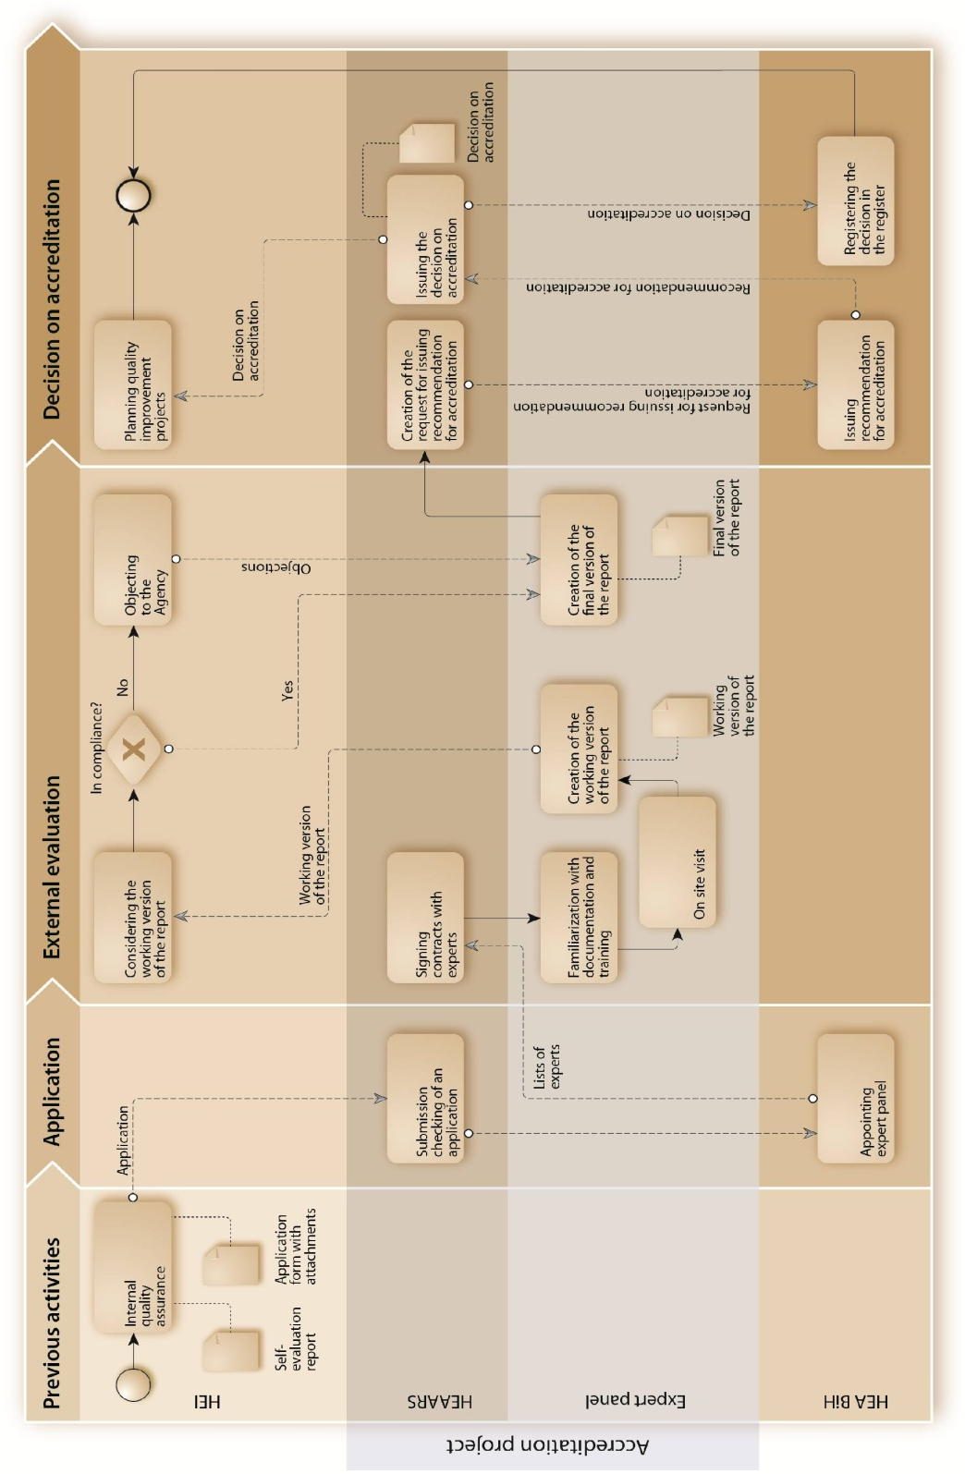

Fig. 2 Accreditation process in RS - BiH
- QUALITY ASSURANCE INSTRUMENTS IN RS

We have already mentioned that accreditation is one of the most important instruments in quality assurance in Republika Srpska and at all. Accreditation as a formal regonition of certain institution or study program usualy ends with a formal document – accreditation decision as a proof of attained demands of standards and criteria. In many cases the accreditation document is also related with a licence for work. Accreditation process understands few obligatory steps – internal quality assurance process including self-evaluation, a study visit of panel of experts appointed by the Agency with a task to assess the evidences of riched demands of standards and critera, report of experts and accreditation decision.
Assessement is a important part of accreditation process but it can be standalone process with no accreditation decision at the end. The process of the systematic gathering,quantifying, and using of information in view of judging the instructional effectiveness and the curricular adequacy of a higher education institution as a whole (institutional assessment) or of its educational programmes (programme assessment).
Audit is the process of reviewing an institution or a programme that is primarily focused on its accountability, and determining if the stated aims and objectives (in terms of curriculum, staff, infrastructure, etc.) are met.
Benchmarking is a standardized method for collecting and reporting critical operational data in a way that enables relevant comparisons among the performances of different organizations or programmes, usually with a view to establishing good practice, diagnosing problems in performance, and identifying areas of strength. Benchmarking can be internal in one institution between different organization units, external between diffrent institutions, transversal etc.
5. CONCLUSION
Accreditation of higher education in European countries it take place under European Higher Education Area (EHEA), as one of the core Bologna objective. European countries have different own social organization, and some of them are constituted from different regions, what significantly influence on establishing accreditation bodies / agencies and conducting accreditation process. Paper emphasises challenging and complex accreditation process in countries with complex structure. In Bosnia and Herzegovina this process has highlighted complexity and probably expected to be reformed to more effective structure. Therefore, it is very importnat to continuosly develop instruments of quality assurance.

REFERENCES
Books:
- Ehlers, U.D., Pawlowski, J.M. (2006). Handbook on Quality and Standardisation in E-Learning, Springer, Berlin.
- Seto, M., Wells, P.J. (2007). Quality Assurance and Accreditation: A Glossary of Basic Terms and Definitions, UNESCO.
Chapters in Books:
- Bergsmann, E., Schultes M.T., Winter, P., Schober, B., Spiel, Ch. (2015). Evaluation of competence-based teaching in higher education: From theory to practice, Elsevier – Evaluation and Program Planning. xxxxxx
WWW pages:
[1] European University Association. Xxxx from www.eua.be, accessed on xxxx.
[2] European Association of Institucions in Higher Education. Xxxx from www.eurashe.eu, accesed on xxxx.
[3] European student’s union. Xxxx form www.esu-online.org, accesed on xxxx.
[4] European Quality Assurance Register for Higher Education. xxxx from www.eqar.eu, accesed on xxxx.
[5] European Association for Quality assurance in Higher education. Xxxx from www.enqa.eu, accessed on xxxx.

