RECURRENT NEURAL NETWORK SHORT-TERM PREDICTION OF DISTRICT HEATING SYSTEM IN TRANSIENT REGIMES
Miloš Simonović, Vlastimir Nikolić, Ivan Ćirić, Emina Petrović
Summary: District heating companies have growing and significant need for improving economic and energy efficiency. Also, they have a challenge to keep the cost of produced and delivered heating energy as lower as possible. That is why it is very important to optimize production of heating energy using better prediction and control of customer needs. In this paper, the focus is on short-term prediction. Real historical data are used from city of Nis, south-eastern Serbia, heating plant Krivi vir, 128 MW installed power. This prediction is particularly important for heating in transient regimes which unlike the standard heating regime does not have continuous supply of heating energy throughout the specified heating time period. An application of neural networks is realized based on original historical data of heating source by using recurrent neural network to fulfill demands on variation in ambient temperature during a heating day and satisfied results are obtained.

Key words: district heating system, recurrent neural network, short-term prediction, energy efficiency
- INTRODUCTION
District heating companies are responsible for the delivery of heating energy produced in the central plant to the consumer through a hot water system. At the same time, they are expected to keep the cost of produced and delivered heat as low as possible. That is why we have a growing need for optimizing the production of heating energy through better prediction and management needs of consumers. Many consumers choose to be excluded from the district heating system and change it with decentralized individual heating system.
District heating systems can be characterized by a reduction in energy consumption, increasing energy efficiency and reducing the generation of pollution. This means that the optimal operation of the district heating system has significant economic potential, as discussed in [1].
Accurate prediction give possibility for increasing efficiency of heat production, decreasing fuel consumption and connected with it emission decreasing from combustion products to the atmosphere. Heat production efficiency can be optimized through the use of appropriate procedures for running heat sources alongside short-term heat demand prediction combined with preparation for adjusting heat source work parameters to the predicted heat load for a few hours hence. The artificial neural networks model delivers good forecasting results. The accuracy of the results depends on the kind of network, its architecture, the size and type of input data as well as the prediction period.
Prediction accuracy within a 3-5% margin of error is sufficient to steer heat source operations.
Prediction of heat consumption can be broadly classified as evaluation and time-dependent prediction. There is long-term, mid-term and short-term prediction. In this paper, we are dealing with short-term prediction.
Short-term prediction shows a period of several days or hours in advance to on a daily basis and manages the planned district heating system.
This prediction is particularly important for transient heating in which unlike the standard heating regime does not take place continuously throughout the time period specified heating. So it is very important to achieve quality prediction for a short period in order to reduce the consumption of thermal energy production and increased coefficient of exploitation of equipment. This gains more importance due to the fact that district heating systems in Serbia, by definition, are interrupting. Heating is not being continuously but starts in the morning and turns off in the evening.
There is various statistical prediction techniques explained in [2] that can be applied to short-term prediction. That is why there are widely used methods with supervisory learning such as support vector machine (SVM), support vector regression (SVR), artificial neural network (ANN) and partial least squares (PLS). In [3] the method of SVR, PLS and ANN used for short-term forecasting of heat consumption of district heating Korean city Suseo. In [4] artificial neural network (ANN) used to predict one hour in advance of the thermal load, including different types of days such as public holidays, Saturdays and Sundays as input variables.
In this paper we used a modelling techniques such as "black box" based on artificial neural networks (ANN) to predict the thermal energy power on the heating source Krivi vir, in the city of Nis, Serbia Southeast region. As input variables we take time, previous consumption data over power on the heat source and the outside temperature with the aim of forecasting for one week in advance.
- ARTIFICIAL NEURAL NETWORKS
Neural networks, or artificial neural networks (ANN) as they are often called, refer to a class of models inspired by biological nervous systems. The models are composed of many computing elements, usually denoted neurons, working in parallel. The elements are connected by synaptic weights, which are allowed to adapt through a
learning process. Neural networks can be interpreted as adaptive machines, which can
store knowledge through the learning process. Artificial neural networks are a collection of mathematical models that simulate some of the observed properties of biological nervous system and withdrawing similarities with biological adaptive learning. They made up of a large number of interconnected neurons which, like biological neurons, are associated with their relationships, which include bandwidth (weight) coefficients, which are similar to the role of synapses.
Most neural networks have some kind of rules for "training", which are the coefficients of connections between neurons are adjusted based on the input data. In other words, neural networks "learn" over the case (such as children learn to recognize a specific subject, object, process or development through appropriate examples) and have the ability for generalization of training data.
Great potential of neural network is ability to do parallel data processing, during the calculation components that are independent of each other. Neural networks are systems composed of a number of simple elements (neurons) that process information in parallel. Functions that are neural networks able to handle the specific structure of the network, the strength of connection and data processing are performed in neurons.
The application of artificial neural networks to short-term prediction yields encouraging results; a discussion can be found in [5]. The ANN approach does not require explicit adoption of a functional relationship between past load or weather variables and forecasted load. Instead, the functional relationship between system inputs and outputs is learned by the network through a training process. A minimum-distance based identification of the appropriate historical patterns of load and temperature used for the training of the ANN has been proposed in [6], while both linear and non-linear terms were adopted by the ANN structure.
2.1 RECURRENT NEURAL NETWORKS
Recurrent ANNs, due to feed-back connections, have the ability to model time series in a very efficient way [7] and have shown more robustness with respect to variations in structure than feed-forward models.
Recurrent neural networks (RNNs) are dynamical systems that are specifically designed for temporal problems, as they have both feed-back and feed-forward connections. More specifically, a form of memory is incorporated in RNNs, with the states of the neurons from previous iteration steps being stored and used to influence the prediction of future iterations. RNNs have been shown to out perform feed-forward neural networks on timeseries tasks and have been empirically shown to be successful on time series data sets. The overall structure of a RNN consists of synaptic connections between the input, hidden and output layers of neurons. Knowledge is represented in a network by the values of these synaptic connections.
In this paper, Elman recurrent neural networks are used. Elman neural networks are also known as partial recurrent networks or simple recurrent networks. These are multilayer perceptrons augmented with one or more additional context layers which store output values of one of the layers delayed by one step. These layers are used to activate this or some other layer in the next time step. (Fig.1)
An Elman neural network has been implemented in order to forecast thermal power from heating source for short-term period of 1, 3 and 7 days.
The feedback from the hidden to the context layer allows Elman networks to learn, recognize and generate temporal patterns, as well as spatial patterns. Every hidden neuron is connected to only one neuron of the context layer through a constant weight equal to +1. Hence, the context layer constitutes a kind of copy of the state of the hidden layer, one instant before.
The number of context neurons is consequently the same as the number of hidden neurons. According to the method presented by Sarle [8], the whole data set was subdivided into a training set and a validation set. The whole training phase was stopped when the lowest error on the validation set was reached.
Fig. 1 An Elman recurrent neural network
The proposed Elman recurrent neural network has one hidden layer, no bias and hyperbolic tangent sigmoid has been the first transfer function and as the second linear transfer function has been used. As the network training function the algorithm of gradient descent with momentum and adaptive learning rate backpropagation has been used.
Heating day started at 5 in the morning and finished at 9 every evening. Also, the most important parameter for heat load prediction, an ambient temperature is one of the inputs.Input vector for prediction consist of data for 5 previous days for power from heating source, an ambient temperature for previous 3 days and an ambient temperature for predicted day and time by hours. So, in total we have 10 input neurons.
Hidden layer after many iterations defined with 20 neurons and output layer has predicted power on the heating source as the output.
- NEURAL NETWORK APPLICATION
In the present paper, for the purpose of improving the accuracy of heat load prediction, we add a new input data for heat load prediction and adopt an Elman recurrent neural network as the prediction network to capture the dynamical variation of heat load by reconsidering characteristics of heat load data.
In order to realize neural network and perform certain conclusions to predict the power on the heat source in interrupt and transient regimes, it is first necessary to perform rearrangement of inputs or input vectors as it is defined in the previous section. A set of data for training is taken from heating source Krivi vir, Nis, Serbia installed power 128 MW for the period October 15.2012 - March 16. 2013 and prediction period is for the period 22 March – 28. March 2013.
The objective of optimization of heating is to manage to reach lower thermal power on the heating source with lower temperature of input water. On that way, fuel consumption would be lower and most important objective would be fulfilled – satisfaction of consumers with appropriate temperature in their premises.
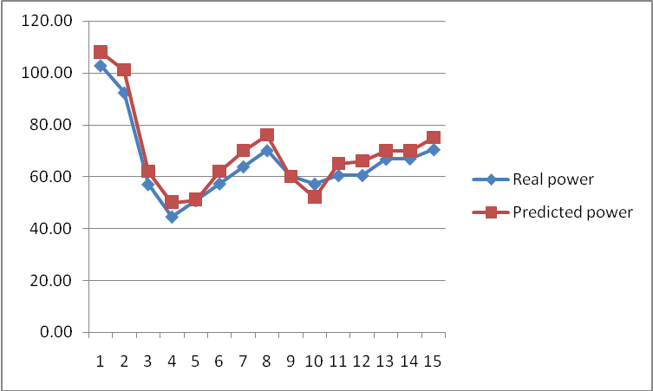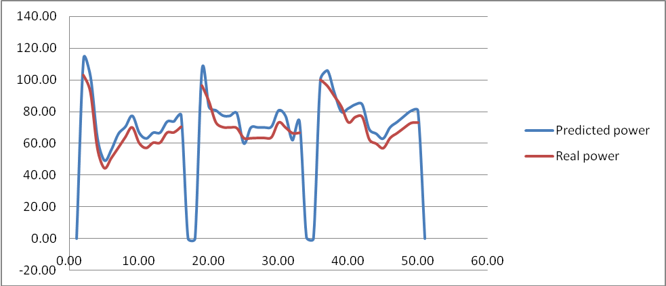
Fig. 2 Real and predicted power for 24.March and 24-26. March 2013, respectively, using Elman recurrent neural network
The important fact is that just for period February – March 2013 during 12 days, there were 92 hours without heating energy delivering and where thermal power on the heating source was zero, because of high ambient temperature. These facts make worse preconditions for good optimization.
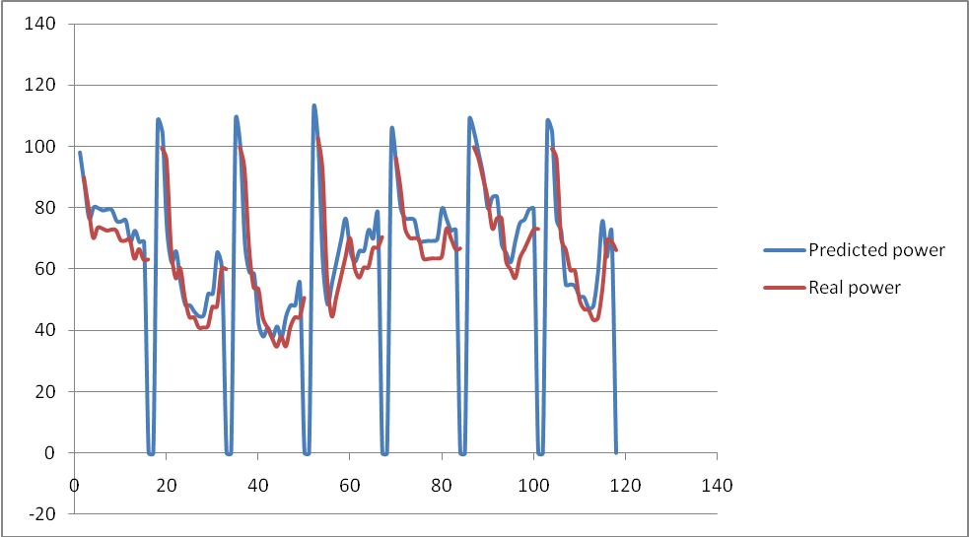
Fig. 3 Real and predicted power for 7 day period 22. March-28.March 2013, using Elman recurrent neural network
Figures 2 and 3 respectively show the recurrent neural network that realizes the prediction of 1, 3 and 7 days in advance. The obtained results are satisfactory. The mean square error is obtained by minimization and a small learning rate is relatively high. By comparing the results obtained with real data shows that with great certainty can be used to correctly and accurately predict. Better results were obtained for shorter prediction, which can be corrected by modifying selected neural network or by selecting another type of neural network that will realize the simulation with a smaller percentage of average error, or a larger set of data.
It is important to point out that despite the fact that the average error is smallest for the shortest prediction, it can be concluded that the error is relatively uniform for all three periods of prediction. It was 3.5% for the prediction of 1 day in advance, 4.5% for the prediction of 3 days in advance and 5.2% for the prediction of 7 days in advance.
Chosen prediction period is a period where no stopping of delivery heating energy was and good results were obtained. But, for choosing other week for prediction where we have periods of days with zero power on the heating source than we will get higher average error. It shows that we need modifications of used recurrent neural network and introducing new inputs in network. This topic will be subject of further research.
- CONCLUSION
Short-term prediction of power on the heat source is realized using real measured data for the period from 15 October 2012 until 31.03.2013, from the heat source Krivi vir, the city of Nis, Serbia South-East region, with installed power of 128 MW. Prediction is performed using an Elman recurrent neural network. The period of 22-28. March 2013 was taken as a period for prediction.
The results obtained by simulating neural network prediction are compared with real power on the heat source and satisfactory results were obtained with an acceptable average error. The obtained satisfactory results are especially important because it is an interrupt regime of operation of district heating system where the heating period is from 5 in the morning to 21 in the evening but also high ambient temperatures leads to the turning off heating in certain daily intervals. You must take into account the fact that as an external factor taken just outside temperature, and further research should be taken into account other conditions.
REFERENCES
- Karatasou, S., M. Santamouris, V. Geros. (2006). Modelling and predicting building’s energy use with artificial neural networks: Methods and results, Energy and Building 38.
- Rafiq M.Y., G. Bugmann, D. J. Easterbrook. (2001). Neural network design for engineering applications, Computers and Structures, 79 str. 1541–1552
- Park, T. C., U. S. Kim, L. H. Kim, B.W. Jo, Y.K. Yeo. (2010). Heat consumption forecasting using partial least squares, artificial neural network and support vector regression techniques in district heating systems, Korean J. Chem. Eng., 27(4), str. 1063-1071.
- Al-Shareef, A. J., E. A. Mohamed, E. Al-Judaibi. (2006). One-hour ahead load forecasting using artificial neural network for the western area of Saudi Arabia, International J. Electr. Systems Sci. Eng.
- D. Niebur et al.(1995). Artificial neural networks for Power Systems, CIGRE TF38.06.06 Report, ELECTRA, pp. 77-101.
- Elman, J L. (1991). Distributed representations, simple recurrent networks, and grammatical structure, Mach Leurn , 7, (2-3), pp 95-126
- Sarle WS. (1995) Stopped training and other remedies for overfitting. In: Proceedings of the 27th Symposium on the Interface of Computing Science and Statistics. Convention Center and Vista Hotel, Pittsburgh, PA; vol. 27, p. 352-360

M.Sc., Miloš Simonović, Niš, Faculty of Mechanical Engineering, (misa.simonovic@gmail.com)
PhD, Vlastimir Nikolić, Niš, Faculty of Mechanical Engineering, (vnikolic@masfak.ni.ac.rs)
M.Sc, Ivan Ćirić, Niš, Faculty of Mechanical Engineering, (ciric.ivan@gmail.com)
B.Sc, Emina Petrović, Niš, Faculty of Mechanical Engineering, (emilli85@gmail.com)

