LOGO WILL BE HERE
DEVELOPING PROFILES FROM WOOD-PLASTIC COMPOSITES
Milan Šljivić ¹, Nenad Grujović ², Ana Pavlović ³, Cristiano Fragassa ⁴, Jovica Ilić⁵, Mirko Topić ⁶

Summary: Due to the possibility of application of wood-plastic composites (WPC) as an optimal outdoor material stable to weather conditions, influencing factors were studied in order to improve the technological process. The properties of basic materials used for the production of WPC are discussed. A brief overview of production technologies used in making WPC profiles with a special emphasis on technology of creating a profile by extrusion is also presented. In addition, prototyping of optimized profiles using the Additive Manufacturing Technologies is given. Profiles are designed in the CAD program as well as simulation of load and bearing capacity of WPC profiles and optimization of starting profiles according to functional requirements.

Key words: wood-plastic composite, Additive Manufacturing Technology, profile, simulation, optimization

- INTRODUCTION

Plastic and wood waste that arise as a consequence of modern life pose a big problem and pollutant of the environment. Due to the large amounts of everyday plastic waste that industry and consumers produce, bio-persistence and short product life cycle of plastic, plastic is the biggest problem. Waste from the wood industry and irrational use of wood as a raw material, although to a lesser extent, also adversely affects the environment. However, it is important to point out that today there is a wide-spread awareness that this waste is a source of valuable raw materials from which new products can be made using subsequent recycling operations. Methods for utilization of this type of waste have been developed and there is increased need for alternative materials in comparison to basic raw materials. One of the efficient technological processes is certainly the production of WPC. In the last ten years numerous surveys concerning the WPC have been carried out throughout the world, and researchers were especially drawn to durability, easy maintenance, sufficient strength and rigidity, lower price as compared to other competing materials and the fact that the WPC is a natural resource [2]. The development of WPC materials, therefore, aims to obtain composites with different properties, with its end goal to obtain products with the desired characteristics. For this reason, the present research is focused on continuous improvement and accurate definition of the influential parameters so the end product could have the desired properties and meet functional requirements.

- RAW MATERIALS FOR THE PRODUCTION OF WPC
To ensure that the WPC meet requirements related to the mechanical properties and durability as well as the end-users’ requirements, a great deal of attention must be paid when selecting and preparing raw materials for making composites. The material that will be used to produce WPC is not strictly defined and depends on several factors such as the availability of materials, economic factors, mechanical properties of the base material, market position, etc. For example, polymer may be polyethylene or polypropylene. The wood raw material may be in the form of flour (Fig. 1) or fibers (Fig.2) and can be from different types of wood. Wood products available in the form of sawdust, wood flour, and wood fibers are the basic components of wood-plastic composites.
Wood that is mostly used in the production of wood flour is pine, maple and oak, but other types of wood may be used. The advantages of wood dust compared to fibers and other natural fibers are in relatively high volume densities, "liquid" characteristic of wood flour as well as the availability and low price, which especially attracts producers of WPC. When choosing wood for the production of wood flour, species with less accessory substances, especially tannins (e.g. fir, birch, maple, etc.) are mainly used[4]. The reason for this is a great susceptibility to thermal degradation of accessory substances and their degradation leads to the formation of micro-cavities that affect the physical and mechanical properties of composite materials. Wood flour is available in particles sizes of 180-840 microns with a moisture content of less than 8% [9]. Manufacturers of wood-plastic composites purchase wood flour from different sources, such as wood flour which is formed as a byproduct of companies dealing with wood processing, production of furniture, windows, doors, etc., or they buy wood flour from manufacturers who specialize in the production of wood flour.
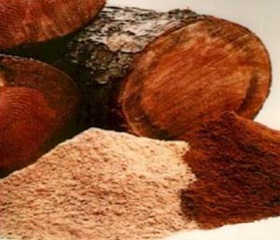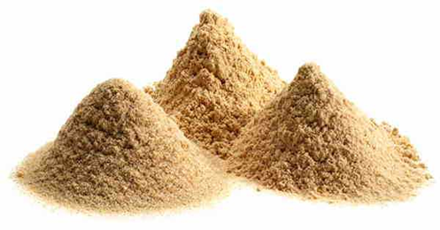
Fig. 1 Wood flour
To improve mechanical properties and obtain a wood-plastic composite with high performance, wood fibers or fillers with a larger length/ thickness ratio are used. The length of wood fibers varies depending on the type of wood, in deciduous trees it is around 1 to 1.5 mm and in coniferous trees about 3 to 3.5 mm. Adding fibers instead of wood flour significantly improves mechanical properties such as tensile strength and toughness. However, difficult deployment of fiber in a polymer matrix and reduced flowability of fiber-filled polymeric material in further processing pose a problem in the production of wood-plastic composites using wood fibers as fillers. Wood fibers are usually obtained with some of the methods of mechanical or chemical separation of wood.

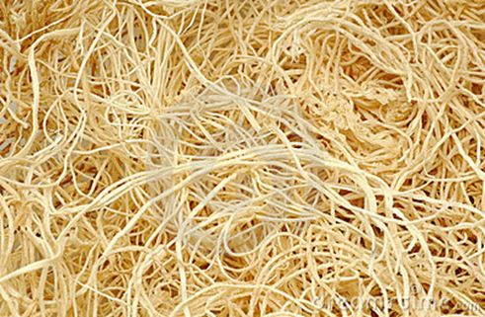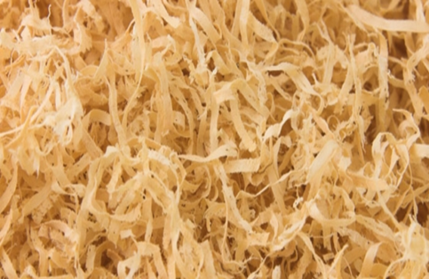

Fig. 2 Wood fiber

The plastic material mostly used in the production of wood-plastic composites is thermoplastics, with processing temperatures up to 200°C, and within this group polyethylene and polypropylene are mainly used. The most used duroplastics include polyester, epoxy and phenolic resins, etc. [5].

- PRODUCTION OF WPC

In the production of wood-plastic composites the following production operations are applied: extrusion, injection molding, calendering, hot plastic deformation, and pultrusion. Extrusion is mostly used. There are different types of extruders for production operations, e.g. extruders with one screw or extruders with two screws, with parallel axes of the screw or with angle axes, etc.
In order to allow efficient mixing with the polymer and the effective exit velocity of the extruder, wood flour and fibers should be dry and with less than 1% moisture. Removing moisture from wood flour can be done in several ways, including the use of a heater before entering the extruder, while more often rotary kilns are used and it is potentially the most responsible part of the operation of extrusion [10].
The production process of wood plastic composite is shown schematically in Fig.3.

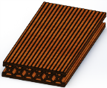
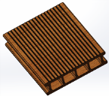
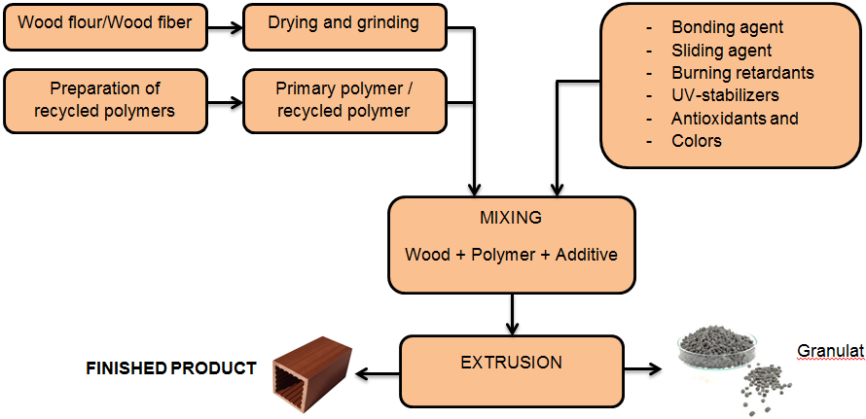 Fig.3 A WPC production process
An extruder with one screw conveyor as the simplest system is often used for extrusion of WPC profiles. A typical single-screw extruder has a length of tube with a ratio length/ diameter l/d = 34. Melting and dosing of material as well as the flow and drainage of evaporation caused in processing take place inside the extruder. The material most often used for this type of extruder is a pellet composed of wood fibers and polymers which have been previously dried in an oven.
It is usually due to gravity that material comes from the material container. Advantages of the extruder with one screw conveyor are in the proven technology and the low cost. Disadvantages include high cost of raw materials, lower productivity, the need for a drying system, the possibility of thermal degradation of wood fibers as they melt together with the polymer, the possibility of overheating the screw due to the high number of revolutions, difficulty to keep low melting temperature and high pressure in the extruder head [10]. A schematic presentation of the extruder with one screw is presented in Fig.4.
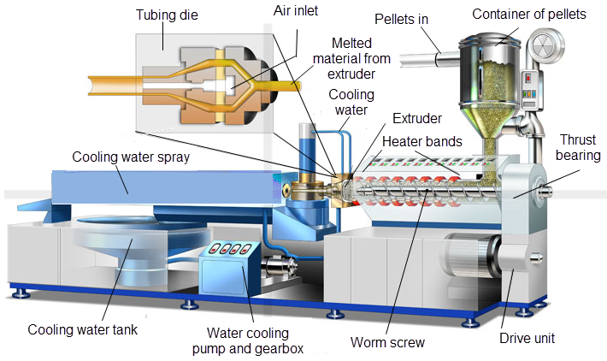
Fig.4 An extruder with one screw conveyor [8]
4. FABRICATION AND TESTING OF PROFILE PROTOTYPES MADE FROM WOOD-PLASTIC COMPOSITES

In laboratory for technology of plasticity and processing systems at the Faculty Mechanical Engineering in Banja Luka, under the IPA AdriaHUB project, we worked on developing and designing of WPC profiles as well as producing a profile prototype with additive manufacturing technology. The procedure that has to be performed to obtain a WPC profile is:
- Product design in some of the CAD software packages,
- Conversion of CAD models in STL format that recognizes a 3D printer,
- Transfer of STL files to the computer that controls the three-dimensional printer,
- Processing of STL files within the CatalystEX program in which all the parameters are set and adjusted according to the required model,
- Creating a three-dimensional model using additive technology and
- Further processing of created prototypes.
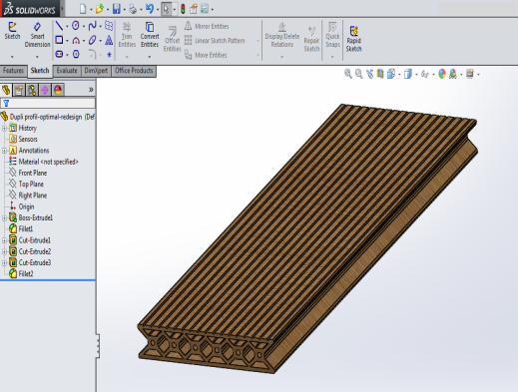
The layout of WPC profiles designed in SolidWorks software package is shown in Fig. 5 and parameter adjustment within the CatalystEX, where the selection of the orientation of models, processing of layers and layout of models on a base on which printing on a "Dimension Elite" 3D printer will be performed, is shown in Fig. 6.
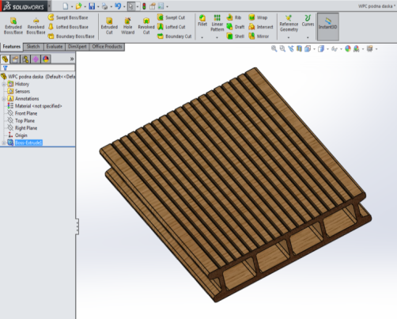
Fig. 5 Models of WPC profiles in the SolidWorks software package
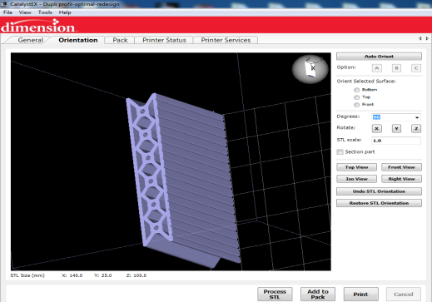
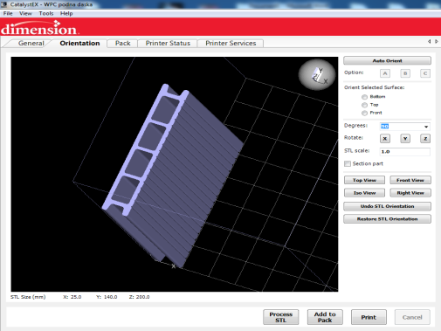

Fig. 6 Orientation and processing of models in CatalystEX

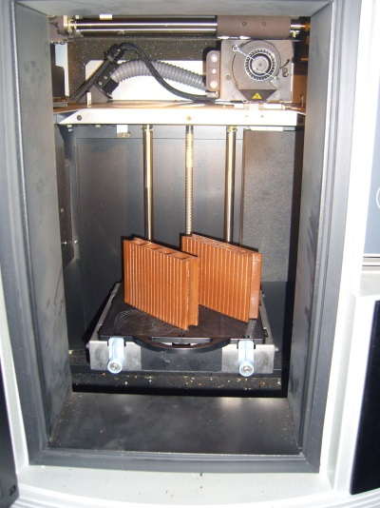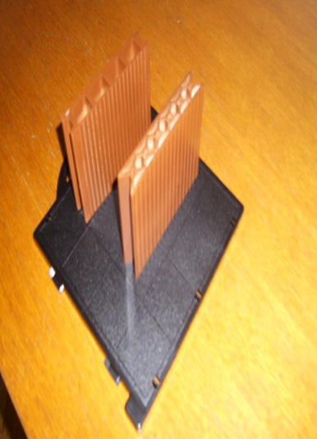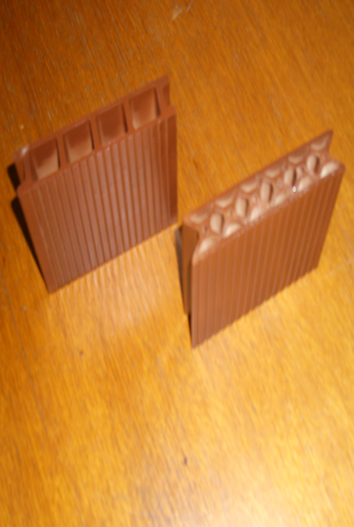

Fig. 7 Profiles produced on a 3D printer

4.1 TESTING OF WPC PROFILES

WPC profiles shown in Fig. 8. were selected for testing

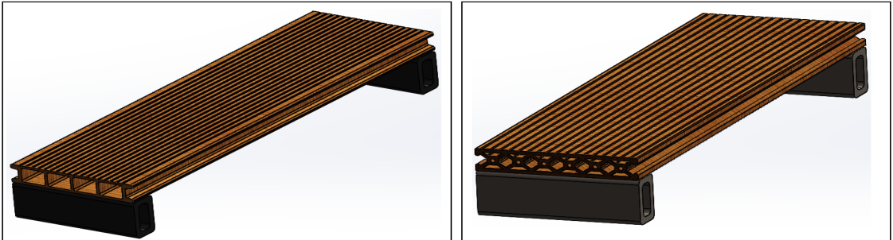
“B” Profile
”A” Profile :

a) b)

Fig. 8 WPC profiles : a) “A” Profile, b) “B” Profile

Dimensions and weight of profiles are shown in Table 1 and the fixed seatings on which profiles are fastened are at a distance of 470 mm from each other, and the dimensions of the fixed seatings are 50x30 mm.

Part | Length [mm] | Width [mm] | Height [mm] | Mass [kg]
“A” Profile: | 500 | 140 | 25 | 0.796
“B” Profile: | 500 | 140 | 25 | 1.046

Table 1 Dimensions of WPC profiles

The material used during the tests is wood-plastic composite with 40% of wood fibers whose characteristics are given in Table 2.
Material | Specific density ρ_{c}[kg/m³] | Tensile strength σ_{c}[MPa] | Modulus elasticity E_{c}[Mpa] | Poisson Ratio  P_{R} | Shear modulus  G_{T} [Mpa]
WPC | 1094 | 23,4 | 2830 | 0,38 | 920
Table 2 Characteristics of the material used in simulation [2]

The simulation was performed in the SolidWorks software package with SimulationXpress tool under the load, i.e. 20 000 N/m²pressure. Fig. 9 presents simulation of critical points and the place on profiles where deformation might occur. According to the results of simulation, "red zones" appear in both profiles, i.e. critical points at the supports in the central structure of the profile.
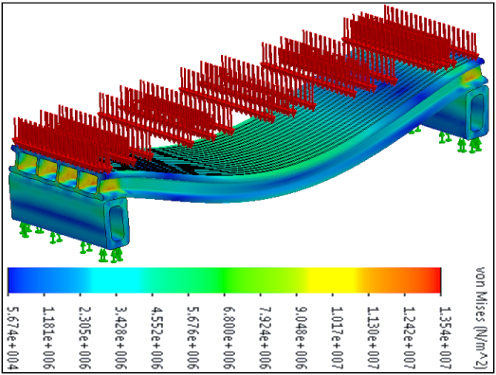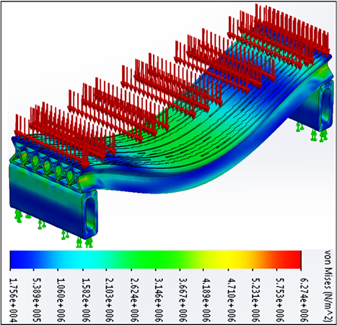
“B“ Profile
“A“ Profile
- b)
Fig. 9 Behavior of WPC profiles under load: a) WPC "A" profile, b) WPC
"B" profile

Bending of the profile is highest at the center of the profile, between the supports, with the proviso that the size of the bending of both profiles is very low, almost negligible, as shown in Fig.10.
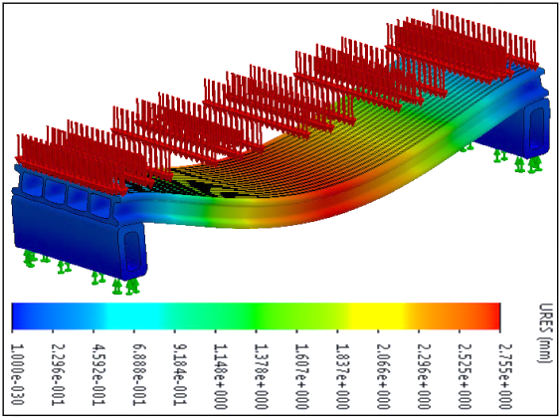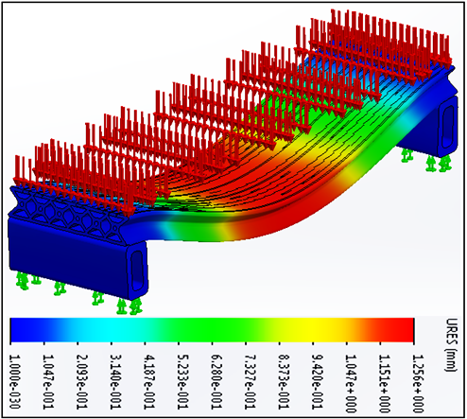
“B” Profile
“A“ Profile
- b)
Fig. 10 Size of profile deflection in the direction of load impact: a) WPC "A" profile,
b) WPC "B" profile
Considering that critical points occur under the influence of load in both profiles according to the simulation results, the models are not satisfactory. In order for them to meet the requirements, they were redesigned, i.e. the thickness of the internal structure was increased while reducing the thickness of the outer walls of the profile, with overall dimensions remaining the same. Hence, this led to the reduction of material consumption at “A” profile, while at “B” profile there was an increase.
Part | Length [mm] | Width [mm] | Height [mm] | Mass [kg]
Profil “A”: | 500 | 140 | 25 | 0.764
Profil “B”: | 500 | 140 | 25 | 1.167

Table 3 Dimensions of the newly chosen WPC profiles

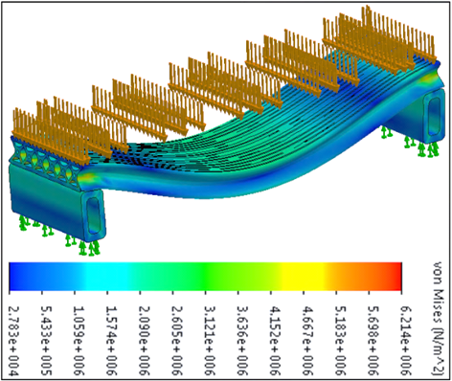
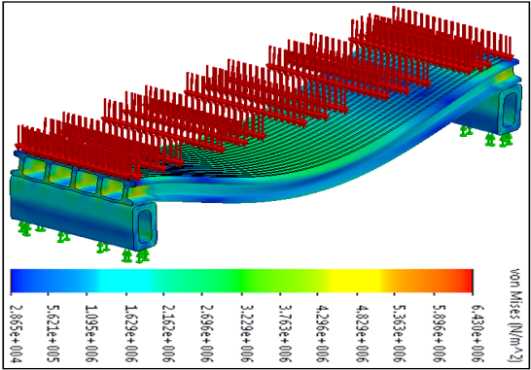
Simulation results of newly chosen profiles (Table 3), under the pressure of 20 000 N/m², are shown in Fig.11 and Fig.12.
Profil „ B “ :
Profil „ A “ :

- b)
Fig. 11 Behavior of newly chosen WPC profiles under load

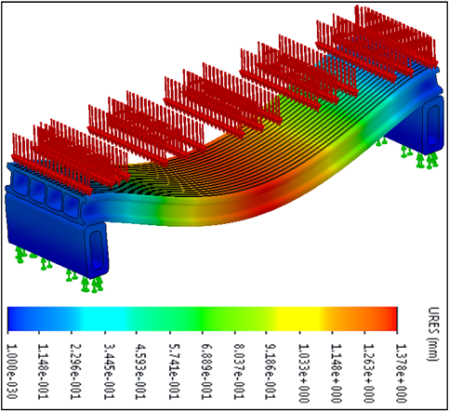
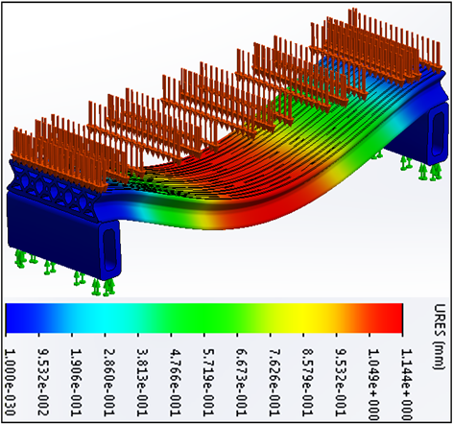
Data shows that in the case of the "A" profile there are no more red criticial points at supports Fig. 11 a), with rather little deflection, Fig. 12 a).

a) b)

Fig. 12 Size of profile deflection in the direction of load impact: a) WPC "A" profile,
b) WPC "B" profile
According to Fig 11. b) and 12 b), the “B” profile does not have any critical points so this model meets the requirements previously set.
Both newly chosen profiles shown in Fig. 11 a), b) have a very small negligible size of bending, so this requirement is met. Summing up the results of simulation for the set pressure of 20 000 N /m2, it can be concluded that in newly chosen “A” profile (0.764 kg mass) and "B" profile (1.167 kg mass), no deformation will occur and no significant deflection, thus it can be recommended for serial production.
The "A" profile (0,764 kg mass) meets the bending requirements with significantly lower use of materials so this profile had an advantage when entering the serial production.

4. CONCLUSION

This paper dealt with the research and knowledge in this particular field as well as our own virtual testing of behavior of WPC profiles under load. The result of the research is that the WPC shows very good characteristics in different conditions of use. Moreover, with almost limitless sources of raw material base, it is certainly a kind of material that should be taken into serious consideration and for which further improvement and adaptation should work. The conclusion of this study is that the characteristics and load capacity of WPC profiles designed and presented in this paper depend a lot on the profile design. This certainly deserves a lot of attention because this is where the biggest savings in materials and production technology can be achieved, along with meeting the set requirements. Due to the almost unlimited source of basic raw materials and relatively low cost of materials and processing technology, it certainly needs more research and improvements in this area in order to obtain the material that will be able to have the widest possible application and whose characteristics could be easily modified using influential parameters of the research.

ACKNOWLEDGMENTS

This paper has been done within the IPA-AdriaHUB project “Bridge technical differences and social suspicions contributing to transform the Adriatic area in a stable hub for a sustainable technological development”. Project code: 2º ord./0127/1.
The project is co-funded by the European Union, Instrument for Pre-Acession Assistance (IPA).

REFERENCES

[1] M. Šljivić, M. Stanojević, C. Fragassa, A. Pavlović: Osnove proizvodnih tehnologija, III dopunjeno izdanje, Mašinski fakultet, Univerzitet u Banjoj Luci, ISBN 978-99938-39-48-4, Banja Luka 2014
[2] S. Migneault, A. Koubaa, F. Erchiqui, A. Chaala, K. Englund, M. Wolcott : Application of micromechanical models to tensile properties of wood–plastic composites, Wood Sci Technol, DOI 10.1007/s00226-010-0351-5, Springer- Verlag 2010.
[3] A.Ashori, A. Nourbakhsh: Characteristics of wood–fiber plastic composites made of recycled materials, Waste Management 29 (2009) 1291–1295 , Elsevier 2009.
[4] A. Ashori: Wood–plastic composites as promising green-composites for automotive industries, Bioresource Technology 99 (2008) 4661–4667, Elsevier 2007.
[5] K. Segerholm: Characteristics of wood plastic composites based on modified wood, Doctoral Thesis, KTH Building Materials Technology, Stockholm,Sweden 2012
[6] Maschinen und Anlagenbau Schulz GmbH – MAS: Extrusion for wood plastic composites, Direct extrusion and compounding
[7] http://www.gpse.de
[8] http://www.infographic-illustrations.com
[9] M. Hietala: Extrusion processing of wood raw materials for use in wood- polymer composites, Lulea University of Technology, Department of Engineering Sciences and Mathematics, Division of Wood and Bionanocomposites, SE-97187 Lulea, Sweden 2011.
[10] D. Gardner, D. Murdock: Extrusion of Wood Plastic Composites, University of Maine, Advanced Engineered Wood Composites Center, Orono, Maine 04469 and Fiber Composites, 5775 Cells Mill Drive, Dublin, Ohio 43017

