DIABETIC MACULAR EDEMA - UP-to-DATE ON TREATMENT APPROACH

Prof.Vesna Dimovska
University Eye Clinic,Skopje, Macedonia

Apstract
In spite of all the efforts to find favorable therapeutic approaches and solutions for resolving diabetic retinopathy and its sight threatening complications, in the 21st century it still remains one of the leading causes of legal blindness worldwide. The estimated global number of patients with diabetic disease until 2025 is 350 millions. 12% of annual blindness is due to diabetic retinopathy and its complications.
The natural history of diabetic retinopathy is correlated with the disturbances of metabolic control in patients suffering both types of diabetes mellitus.
High levels of blood glucose are initiating the process of damaged capillary perfusion, provoking loss of pericytes and endothelial cell proliferation, leading towards increased capillary permeability, non perfusion and ultimate vessel occlusion at the end. The breakdown of blood-retinal barrier is representing as early and crucial phenomenon in the development of diabetic retinopathy, and the apoptosis of retinal capillary cells precedes the recognition of histopathological changes as features of diabetic retinopathy.
The future worsening of diabetic retinopathy, besides the metabolic control, is markedly emphasized and dependent on the occurrence of ischemic retinal areas, provoking liberation of angiogenetic (vasoproliferative) factors, leading to neovascular vessels growth. Today Vascular Endothelial Growth Factor (VEGF) is proven to be the one to blame for neovascular vessel proliferation.
Never less the stage of the disease, diabetic macular edema (DME) is one of the major causes for severe visual loss.
In the last few decades, lot of therapeutically means have been tried and examined in order to establish efficient way for prevention of severe visual loss due to DME.
Number of randomized clinical trials and studies have explored different therapeutically strategies for treatment of diabetic retinopathy, in order to find the most beneficial one, but so far, the results are still inconclusive and unsatisfactory.
Up-to date protocol for the treatment of diabetic retinopathy, e.g. diabetic macular edema, still recommends retinal laser photocoagulation for non-center involvement cases, combined with intravitreal injections of anti-VEGF substances. Those medications are blocking the VEGF receptors, enabling inhibition of further VEGF liberation and neovascular vessel growth.
In the paper would be explained the mechanisms and factors involved in the pathogenesis of diabetic retinopathy, as well as the recent therapeutic approaches, including the role and effects of different anti-VEGF treatments.
Keywords : diabetic retinopathy, macular edema, laser photocoagulation, neovascularization, anti-VEGF treatment

Introduction
Conventional definition of diabetic macular edema (DME) explains the disease as “retinal thickening caused by accumulation of intraretinal fluid primarily in the inner and outer plexiform layers”.
Most prominent features of DME include :
- multifactorial etiology
- it occurs as a consequence of retinal blood vessel hyperpermeability
- chronic course of the disease
- association with any stage of diabetic retinopathy
- major cause of significant vision loss in diabetic patients
Referring to recent data, there are approximately 93 million people with diabetic retinopathy (DR), of which 17 million with proliferative diabetic retinopathy (PDR), 21 million with DME and 28 million with vitreo-tractional diabetic retinopathy (VTDR).
The overall prevalence of DME is estimated on 6,81% of people with diabetes worldwide, accounting for 12% of new cases of blindness annually.⁽¹⁾
In patients with type 1 diabetes, DME occurs within 5 years of diagnosing, with prevalence rising up to 40% within 30 years of the disease.
Meta-analysis of 35 population-based studies conducted in USA, Europe, Asia and Australia found that in diabetic individuals the prevalence of any type of DR was 35%,with DME present in 7,5% and PDR present in 7,2% of individuals.⁽²⁾
Risk factors for development of DR and DME embrace systemic risk factors, as: elevated blood glucose (Hb₁C),blood pressure, dyslipidemia (high cholesterol levels), as well as duration of the disease. Besides those factors, great impact on the occurrence of vascular complications have multiple additional factors and processes involved, as: oxidative stress, presence of hypoxia /ischemia, accumulation of free radicals and AGE products, inflammation mediators and elevated Vascular Endothelial Growth Factor concentrations (VEGF).
Pathophysiology of Diabetic Macular Edema (DME)
The pathogenesis of DME has not been fully elucidated, since there is involvement of complex pathological processes with many contributing factors.
Crucial phenomenon and early event in pathophysiology of DME is the breakdown and dysfunction of blood-retinal barrier (BRB).The mechanism of development is multifactorial and secondary to changes in tight junctions, pericyite and endothelial cell loss, retinal vessel leucostasis, up-regulation of vascular transport and increased permeability of surface membranes of retinal vessels and retinal pigment epithelium cells.⁽³⁾
The disruption of BRB leads to abnormal inflow of fluid into the neurosensory retina that exceed the outflow and cause residual accumulation of fluid in the intraretinal layers of the macula.
The pathogenesis also includes persistence of chronic hyperglycemia, along with the accumulation of free radicals.
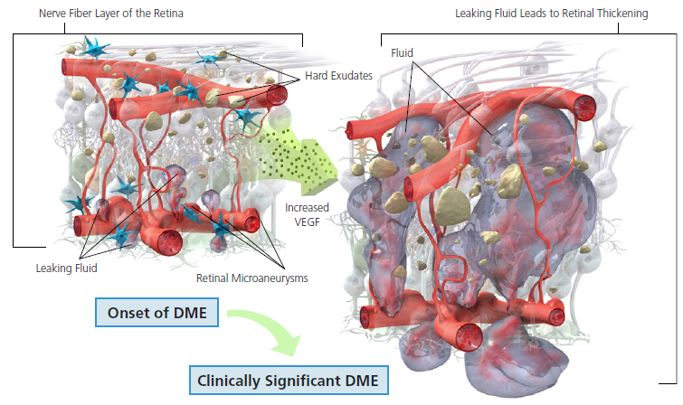
Fig.1. Development of DME (Published in “The Angiogenesis Foundation, 2014”)
A large number of studies have confirmed the significant role of vitreous that brings substantial risk in the pathogenesis of DME. It was found that the expression of PEDF in vitreous of individuals with DME was significantly increased, suggesting that vitreous inflammation plays an important role in the pathogenesis of DME.
Such a statement is supported by the fact that the incidence of DME is found to be much lower in diabetic patients with posterior vitreous detachment (PVD), compared with those subjects without PVD (20% vs 55%), suggesting a strong protective effect of PVD.⁽¹⁾This is due to the mechanical tractional effect of the epiretinal membrane.
Diagnosing of DME
All available methods for diagnosing DME have certain limitations. Retinal thickening could be, more or less successfully assessed by :
• Fundus biomicroscopy - which is less accurate; it is subjective and dependent on the observer’s experience. Besides, the results do not provide a reproducible measurement of the change in volume.
• Color stereo fundus photographs - that are useful in a way of documenting presence, size and location of the hard exudates, but the retinal thickness, cysts and the amount of sub-retinal fluid could not be objectively measured.
• Fluorescein angiography has partially lost it’s significance due to the expansion and advantages of OCT. The only relevant clinical indication is the identification of lesions and retinal areas that require treatment, after this decision has already been made.
• Optical coherence tomography (OCT) is currently considered the most effective method not only for diagnosing, but also for monitoring the evolution of DME.OCT can be also particularly beneficial in identifying vitreo-macular traction, that can induce cystic changes and macular thickening unrelated to leaking vessels.⁽⁴⁾
As most important parameters to be identified in DME are considered :
- Localization of retinal thickening in relation to fovea
- Presence and localization of hard exudates
- Presence and amount of cystoid macular edema (CME)
Classification of DME
Diabetic macular edema is characterized by microaneurysm formation and diffuse leakage from the retinal capillaries, or even arterioles.
The Early Treatment Diabetic Retinopathy Study Group (ETDRSG) defined the criteria for clinically significant macular edema, as having any of following features:
- Thickening of the retina at/or within 500 microns of the center of the macula
- Hard exudates at/or within 500 microns of the center of the macula if associated with thickening of the adjacent retina (excluding retinal hard exudates remaining after disappearance of retinal thickening)
- Retinal thickening at one disc area or larger, at any part of which is within one disc diameter of the center of the macula
Clinical classification of DME recognizes two types of edema :
- focal
- diffuse
It is based on the leakage pattern seen on Fluorescein angiography.
Based on the OCT- presentation, there are established 4 categories of DME⁽¹⁾
- Diffuse DME (DRT) - with retinal thickening, weakening of the light reflection and irregular low reflex zone ;
- Cystoid macular edema (CME) - a cystoid dark cavity could be visualized;
- Serous sensory detachment DME (SRD), which is characterized by neuronal sensory. or even pigment epithelium detachment which can be present on OCT;
- Vitreo-macular traction (VMTA) - incomplete or complete posterior vitreous detachment, and epiretinal membrane formation, or vitreo-retinal traction, or both conditions

Recent clinical trials have classified clinically significant macular edema in two subgroups: center-involving (ci-CSME) and non-center-involving (nci-CSME).
Taking into account the widespread superiority of OCT in diagnosing, recognition and monitoring of DME, it’s advantages could be summarized in:
• Establishing as additional modality to help identify and evaluate macular pathology
• Providing quantitative measurement of macular thickness and subjective analysis of the foveal architecture
• Potential to demonstrate moderate correlation between retinal thickening and best corrected visual acuity
• Capacity for identifying 3 basic structural changes of the retina with DME:
- retinal swelling
- cystoid edema
- serous retinal detachment
Treatment of DME
The goal of the local treatment for DME should be pointed towards reducing the edema, control of the disease progression and vision improvement.
The available treatment options are:
- Laser photocoagulation
- Intraocular (intravitreal) pharmacotherapy
- Surgery (vitrectomy)
The first two treatment options would be further elaborated in the paper.
√ Laser photocoagulation
Laser photocoagulation still remains “gold standard” for non-center involved DME.
ETDRS (1991) has reported efficacy of focal/greed laser in reducing the risk of moderate-severe visual loss from DME for 50% within 3 years.
Regarding the side effects of conventional laser treatment, as well as the advent of ant-VEGF therapy, there is increasing use of modified ETDRS treatment approach (DRCR net, 2009).It includes less intense laser treatment, grater spacing, targeting microaneurysms, and avoiding foveal vasculature within at least 500μm of the center of the fovea.
Most often side effects occur as laser scar expansion, reduced peripheral visual field, paracentral scotomas ,secondary choroidal neovascularization and subretinal fibrosis.
Improvement of laser technology in order to avoid side effects, has resulted in the invention of Subthreshold Micropulse Diode Laser Photocoagulation (SMDLP), that was designed to target the retinal pigment epithelium with minimizing the negative thermal effects on the neural retina and deeper structures. It is shown to be as effective as conventional laser photocoagulation in reducing DME, potentially allowing more frequent re-dosing if necessary (Jain et al,2010).
√ Intraocular (Intravitreal) pharmacotherapy
In the last decade closely was monitored and evaluated the efficacy of two prominent groups of drugs, applied mostly as intravitreal drug injections.
- Steroids
- Anti-VEGF agents
Systemic or ocular glucocorticoid treatment of eye diseases, including DME, has been known for over 50 years. The inhibition effect of inflammatory mediators and decreased vascular permeability has been confirmed in animal and human studies.
Triamcinolone acetonide (Kenalog) is used as intravitreal injection in patients with DME, as well as in patients with wet AMD.
Steroids offer the potential advantage of longer action duration. The invention of sustained-delivery devices has undergone development and testing for treatment of macular edema. This is referring on Dexamethasone injectable implant (Ozurdex, Allergan) and non-bioerodible injectable Fluocinolone polymer (Iluvien, Alimera Sciences)⁽⁵⁾.
Studies evaluating the efficacy of corticosteroids in reducing DME have reported mixed results (DRCR.net) There is high rate of cataract and secondary glaucoma. On the other hand, this treatment option allows longer action duration than laser, and is considered favorable as monotherapy in pseudophakic patients with DME .Also, it could be beneficial in non-responders to anti-VEGF.agents. (Protocol I Study)
Anti-VEGF treatment options
Anti-VEGF treatment is nowadays considered as initial treatment of choice substituting laser photocoagulation in center-involved DME. It could be applied as monotherapy, or combined with laser or steroids. Anti-VEGF treatment has been confirmed by many clinical trials for the treatment of wet AMD, DME and macular edema secondary to CRVO.
VEGF is proven anti-inflammatory mediator with ability to induce vascular leakage, and this feature especially refers to VEGF- A. It belongs to VEGF family that includes placental growth factor, VEGF-B, VEGF-C, VEGF-D and VEGF-E.
VEGF-A member is mostly investigated so far and strongly associated with development of diabetic retinopathy and DME. It is well known that patients with diabetic retinopathy have higher vitreous concentration of VEGF.
Human VEGF comprises 5 different isoforms : VEGF 110,121,165,189 and 206. VEGF₁₆₅₆ has been regarded as an endogenous inhibitor of VEGF- A.
Pegaptanib (Macugen) was first anti-VEGF agent, with FDA approval for wet AMD in December 2004.It is synthetic anti-VEGF aptamer, highly selective for VEGF ₁₆₅ subtypes. Following the invention of other anti-VEGF drugs, it has significantly increased usage.
Bevacizumab (Avastin) was the first applied drug listed for the inhibition of tumor angiogenesis. It’s primary indication is colo-rectal cancer and it is used “off label” as anti-VEGF drug in wet AMD and DME. BOLT Study (Bevacizumab or Laser treatment) have shown favorable outcomes for Bevacizumab use over macular laser treatment in eyes with ci-DME.⁽⁴⁾
Ranibizumab (Lucentis) has got FDA approval for wet AMD since 2006. It has affinity for binding VEGF-A isoforms and blocking of VEGF-R₁/R₂ receptors.
It has FDA approval as intravitreal injections for DME with NICE Guidance in 2012.
Aflibercept (Eylea) is the latest generation of anti-VEGF agents. It is fusion protein that binds with all isoforms of VEGF-A, VEGF-B and placental growth factor. It has greater binding affinity compared with Ranibizumab, and is applied as intravitreal monthly injections with dosage of 2,0 mg. It has FDA approval for wet AMD with NICE Guidance 2013, recommended for macular edema secondary to CRVO and approval for DME in Europe since august 2014. DA VINCI Study demonstrated better outcomes of Aflibercept over laser treatment for ci-DME.
The main goal of anti-VEGF treatment is reducing retinal thickness that provides better visual acuity compared with laser. The effects regarding the visual acuity are correlated with the baseline visual acuity.
In general, anti-VEGF treatment is associated with uncommon, but serious and severe adverse effects, such as endophthalmitis, cataract formation, retinal detachment and elevated IOP.
Yet, despite of proven advantages of anti-VEGF treatment, it has certain limitations (high medication costs, multiple physician visits, potential serious side effects) that provoked seeking for treatment that would overcome those limitations.
Combination therapy with both, anti-VEGF and laser treatment, or intravitreal steroids with laser, is under assessment if it would offer less injections with maintaining visual acuity gain.
The laser treatment could be applied as prompt laser, within one week after injections, or as deferred laser, at least 6 months following anti-VEGF injections.
Adding laser to anti-VEGF does not provide better visual outcome, but the goal is to decrease the total injections amount. (Protocol I Study).
On the following figures we are presenting two cases of patients with DME treated with combination therapy of anti-VEGF injections and laser treatment and the outcomes documented on OCT had shown visual acuity improvement and regression of macular edema. At the patient that had received Bevacizumab as initial treatment, the laser was applied as deferred treatment, after 6 months.
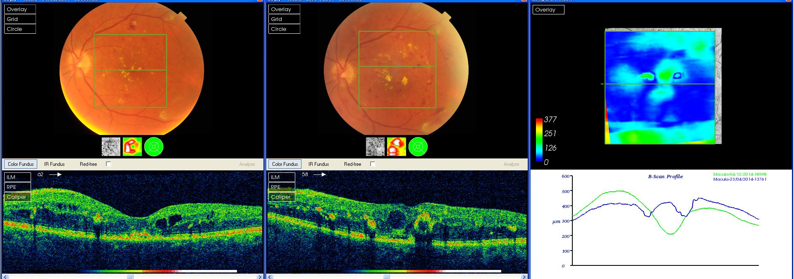
Fig.2. Patient treated with combination therapy – Bevacizumab + Laser treatment
Right - OCT before treatment; Left - OCT after combination treatment
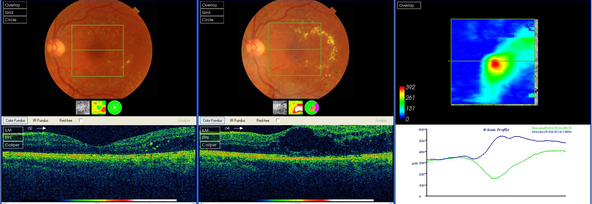
Fig.3. Patient treated with combination therapy - Laser + Bevacizumab
Right - OCT before adding Bevacizumab ; Left - OCT after combination treatment

At the moment, there is still missing consensus regarding best injection regimen and protocol.
Current Clinical Guidelines on the treatment of DME are evolving from different associations and workshops, like :
- Royal College of Ophthalmologists (Diabetic Retinopathy Guidelines,2012)
- International Council of Ophthalmology (Guidelines for Diabetic Eye Care,2013)
- American Diabetes Association (Standards of Medical care in Diabetes,2014)
- Diabetic Macular Edema Treatment Guideline Working Group (Management Paradigms for DME 2013)

Summary
• The up-to-date efficient and comprehensive treatment of diabetic retinopathy and diabetic macular edema embraces obligatory treatment of systemic risk factors (blood glucose level, hypertension, dyslipidemia)
• Laser treatment still represents “gold standard” for non-center involving DME
• Intravitreal pharmacotherapy is aimed towards prevention of blood-retinal barrier breakdown
• Anti-VEGF treatment has brought new perspectives into resolving of diabetic retinopathy and diabetic macular edema
• Anti-VEGF therapy has become treatment of choice substituting macular laser photocoagulation in cases with center involved DME, due to :
- reducing of retinal thickness
- improvement of visual outcome
• Number of available performed clinical trials is recommending combination therapy (anti-VEGF + laser/steroids)
- this assessment needs support of further clinical studies involving more participants and institutions
• Further clinical trials need to result establishing mostly accepted best treatment protocol
• Achieving best results regarding anatomical and visual outcome needs combined interdisciplinary approach of endocrinology specialist, ophthalmologist and general practitioner, that should enable individually modified treatment protocol for patients with diabetic retinopathy and diabetic macular edema.

Abreviations
DME - Diabetic Macular Edema
BRB - Blood retinal barrier
PEDF - Pigment Epithelium Derivative Factor
VEGF - Vascular Endothelial Growth Factor
PDR - Proliferative diabetic retinopathy
VTDR- Vitreo-tractional diabetic retinopathy
PVD - Posterior vitreal detachment
CSME - Clinically significant macular edema
CME - Cystoid macular edema
VMTA - Vitreo-macular traction
OCT - Optical coherence tomography

References:
1.Zhang X, Zhang H, Bao S et al. Diabetic macular edema: new concepts in pathophysiology and treatment. Cell and Bioscience 2014; 4:227
2.Jain A, Varshnev N and Smith C.:The Evolving Treatment Options for Diabetic Macular Edema. International Journal of Inflammation 2013; Vol.2013
3.Romero-Aroca P.: Targeting the pathophysiology of diabetic macular edema.Diabetes Care 2010; 33(11): 2484-2485
4. Diabetic Retinopathy : AAO Retina/Vitreous Preferred Practice Pattern Panel, Hoskins Center for Quality Eye Care. Retina/Vitreous, Oct 2014
5.Ford JA, Lois N, Royle P, Clar C, Shyangdan D and Waugh N: Current treatments in diabetic macular oedema: systematic review and meta-analysis. BMJ Open 2013
6.Ciulla TA: Corticosteroids for diabetic macular edema. Review of Ophthalmology 2015
7.Ascaso E, Huerva V and Grzybowski A.: The role of inflammation in pathogenesis of macular edema secondary to retinal vascular diseases. Mediators of Inflammation, Vol.2014
8.Bandello F, Cunha-Vaz J, Chong NV e al: New approaches for the treatment of diabetic macular oedema: recommendations by an expert panel. Eye 2012; 26:485-493
9.Advocating for improved treatment and outcomes for diabetic macular edema. A report based on an International Expert Summit , Paris, June 2014
The Angiogenesis Foundation

