LOGO WILL BE HERE
COST - OPTIMAL METHODOLOGY
Marko Serafimov, Sevde Stavreva, Igor Shesho
Summary: On European level, the requirements regarding the energy features of the buildings are given in the Energy Performance of Buildings Directives (EPBD). The EPBD has set up a common framework according to which the respective countries which are EU members, are supposed to work out or adjust their respective national regulations aiming to improve the energy performance of buildings. In compliance with EPBD, the member countries must establish the minimum requirements regarding the energy sustainability of the building and building elements to the purpose of achieving cost-optimal levels. EPBD proposes a Comparative Methodology Framework, to be used by the member countries when elaborating the comparisons between the minimum energy requirements and the calculated cost-optimal levels. This paper gives a survey of EPBD proposals within the Comparative Methodology Framework.
Key words: building sector, cost-optimal levels, Comparative Methodology, energy efficiency
- INTRODUCTION
In Europe building sector is the largest sector in energy consumption and associated of it also is largest greenhouse gas (CO₂) emissions. The need for energy in the building sector in the 27 member states of the EU average is 40% of the total energy and emission of 36% CO2.
Energy efficiency is the most cost-effective way of reducing energy consumption and CO₂ emissions, by improve the energy performance of buildings. On the European level, the principles for the requirements for the energy performance of buildings are set by Energy Performance of Buildings Directives. The EPBD 2002/91/EC has set a common framework from which the individual Member States in the EU develop or adapted their individual national regulations. The EPBD demands improvement in the overall energy efficiency of all new buildings. It also incorporates a requirement for the renovation of large existing buildings (with a floor area of over 1,000 square meters). In the recast EPBD, the threshold of 1,000 m² has been removed for new end existing buildings.
The EPBD 2010/31/EU, recast now requests that Member States ensure that minimum energy performance requirements for buildings are set “with a view to achieving cost-optimal levels”. The cost-optimal level shall be calculated in accordance with a comparative methodology. The EPBD recast defines ambition levels in two areas:
- The methodology for cost-optimal levels for energy performance requirements (for new and existing buildings)
- The requirements for nearly zero-energy buildings (nZEB) to be realized as from 2019 (only new public buildings) or 2021 (for all new buildings).
Fig. 1 Timeline for cost-optimality and nZEB requirements of recast EPBD
- COST-OPTIMAL LEVELS
2.1 DEFINITION OF COST-OPTIMAL LEVEL
The EPBD/2002/91 set out a general framework to assess the energy performance of buildings and require Member States to define maximum values for. energy delivered to meet the energy demand with standardized use of the building. However it did not contain requirements or guidance of such requirements, as a consequence building regulations in the various Member States have been developed by the use of different approaches and resulted in different ambition levels.
According to EPBD recast, Member States must set minimum energy performance requirements for building and building elements with a view to achieving cost-optimal levels. The cost-optimal level is defined as “the energy performance level which leads to the lowest cost during the estimated economic lifecycle”. Member States will determine this level by taking account a range of costs including investments, maintenance, operating costs and energy savings. The economic lifecycle is defined by each Member State. Figure 2 present ambition of energy performance (e.g. thickness of insulation and/or efficiency of heating system/air-conditioning/lighting etc.).
The EPBD recast requires Member States to report on the comparison between the minimum energy performance requirements and calculated cost optimal levels using the comparative Methodology Framework provided by the Commission (EPBD recast, Art. 5 and Annex III). The relevant legal document is the Commission Delegated Regulation (EU) No. 244/2012 (hereafter “The Regulation”).

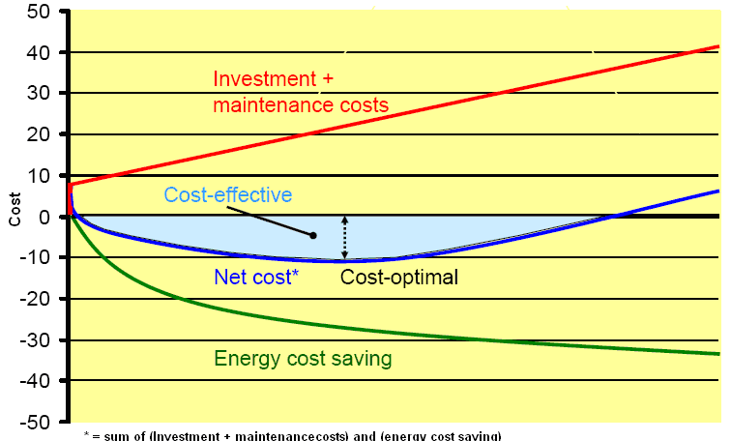
Fig. 2. Relationship between cost-optimality and cost-effectiveness
2.2 THE COMPARATIVE METHODOLOGY FRAMEWOR
The comparative methodology framework is not meant to harmonize the minimum energy performance requirements, but to ensure that the level of Member State in its given context is similar. The EPBD recast obliges Member States to report on the comparison between the minimum energy performance requirements and calculated cost-optimal levels using Comparative Methodology Framework. The report should also provide all input data and assumptions made. The comparative methodology framework requires Member States to:
- Define reference buildings that characterized by and representative of their functionality and climate conditions;
- Define energy efficiency measures that are assessed for the reference buildings;
- Assess the final and primary energy need of the reference buildings by calculating different packages of measures, and
- Calculate the costs of energy efficiency measures into account investment costs, maintenance and operating costs, as well as earnings from produced energy.
2.2.1 Reference buildings
Article 5 of the EPBD recast requires Member States to establish the comparative methodology framework in accordance with Annex III and to differentiate between different categories of buildings. Member States must define reference buildings that are characterized by and representative of their functionality and geographic location, including indoor and outdoor climate conditions. For the purpose of the energy performance calculation, the Member States should define a minimum of 9 reference (both new and existing ones), as are presented bellow. For define of reference buildings should be one for new and two for existing buildings: single-family houses of different types; blocks flats; offices; educational buildings; hospitals; hotels and restaurants; sports facilities; wholesale and retail trade services buildings and other types of energy-consuming buildings. It is recommended that reference buildings be established in one of two following ways:
- Selection of a real example representing the most typical building in a specific category (age of buildings, type of use with reference occupancy pattern, floor area, compactness of the building, building envelope structure, technical services systems and energy carriers)
- Selection of a real example representing the most typical building in a specific category (age of buildings, type of use with reference occupancy pattern, floor area, compactness of the building, building envelope structure, technical services systems and energy carriers).
The performance of buildings depends on a number of factors such as the performance of the installed heating system, building envelope, climatic conditions and social conditions. Member States are free to use and adjust already existing catalogues and databases of reference buildings for the purpose of the cost-optimal calculations. Moreover, work carried out under the Intelligent Energy Europe programme can be used as input in particular:
- TABULA – Typology approach for building stock energy assessment
- ASIEPI Project – A set of reference buildings for energy performance calculation studies
- TABULA/EPISCOPE Project – Inclusion of New Buildings in Residential Building Typology
2.2.2 Identification of energy efficiency measures
In accordance with Annex III to EPBD recast and Annex I(2) to the Regulation, Member States, must define energy efficiency measures to be applied to the established reference buildings. Measures that are submitted will have to cover the technologies such as decentralized supply, cogeneration, district heating and cooling and heat pumps. In accordance to the Regulation, Member States must also include measures based on renewable energy sources.
The determination of the finally selected packages/variants will probably be an iterative process in which a first calculation of selected packages/variants reveals the need to add further packages to allow finding out where exactly sudden “jumps” in global costs occur and why this occur. The list of the measures is divided in two different groups as follow:
- Building structure and
- Systems
Measures should be implemented in the heating systems, ventilation systems, cooling system, lighting systems and building automation and controls.
Applying several variants (measures/variants) to several reference buildings can quickly result in thousands of calculations. However, test runs performed for the Commission that the number of calculated variants should certainly not be lower than ten plus reference case. As a first step, packages of measures need to be assessed on the ambition level that comply with the minimum performance requirements in force.
Stochastic methods for energy performance calculation can be used effectively, presenting the effects of particular measures and their combination. From that, a limited number of combinations of the most promising measures can be derived. The number of full cost-optimum calculations can then be reduced to the most promising packages. Choosing selected packages from promising combinations may prove to be more efficient.
3. COST-OPTIMALITY IMPLEMENTATION PROCESS
3.1 COST EFFICIENCY vs. COST OPTIMALITY
The concepts of cost-efficiency and cost-optimality are related but different. Cost-optimality is a special case of cost-effectiveness. A measure or package of measures is cost-effective when cost of implementation is lower than the value of the benefits that result, taken over the expected life of the measure. Both are based on comparing the costs and (priced) savings of a potential action – in this case of introducing a particular level of minimum energy performance requirements for buildings. Future costs and saving are discounted, with the final result being a “net present value”. If this is positive, the action is “cost-effective” (for particular set of assumptions used in the calculation). The cost-optimal result is that action or combination of actions that maximizes the net present value.
Cost optimality is relatively easy to determine for single measures operating in well-defined conditions – for example, the optimal insulation thickness for pipework operating at a constant temperature in a constant-temperature environment. It is considerably more difficult process for complete buildings, and even more so for combinations of buildings such as a national building stock.
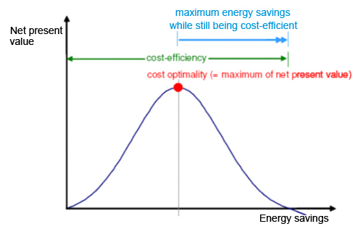
Fig. 3.Scheme presenting cost-optimality and cost-efficiency
Figure 3 illustrates the principles of cost-optimality and cost effectiveness. In reality the distribution may not be uni-modal (it may have several local optima). Typically the optimal level is less clear cut than in the illustration and may be sensitive to data uncertainties. Also for one building type there is a cloud of curves dependent on the real building and the cost-optimal measure combination for detached single house “a” might be at least slightly different than detached single family house “b”, let alone be different than those curves for row houses, etc. In order to be sure that the optimal point/zone has been identified as a minimum requirement, at least 10 variants per reference building should be used. However, to optain a clear curve, more variants (20 -30) are used.
An example of the results for different packages applied to chosen reference building is show in Figure 4. From the variety of specific results for assessed packages, a specific cost curve can be developed (see Figure 5). The combination of packages with the lowest cost will provide the minimum level of requirement at the optimal cost. Actually, the cost-optimum is rarely found as a single package of measures to a reference building, but rather as a set of more or less equality valid or cost optimal solutions that can be considered a expanding a “cost optimal range”.
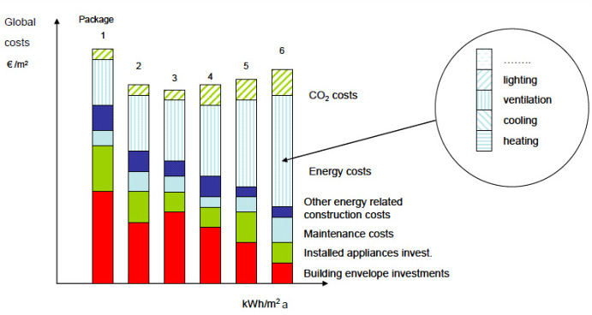

Fig. 4. Cost calculations for different packages (example only)

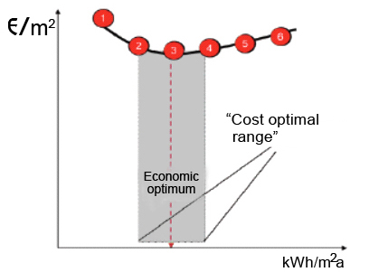
Fig. 5. Different variants on the cost-optimal curve of the cost optimal range (example only
When discussing cost-optimal levels and the effort achieve energy savings, only the lower boundary of the cloud is interesting to identify the cost-optimsl level. In case of s flat cost-curve, it was suggested to set the requirements in the lower (left) part of the calculated cost-optimal points. This will ensure that the most energy-efficient solution sets are selected. On the other hand, one should also try to avoid going too far on the left of the curve, as cost-curves often show a tendency of a steep increase in costs when moving to the far left.
- CONCLUSION
The comlete process to assess and report on cost optimal levels for energy performance requirements of buildings begin with steps that define reference buildings and packages of measures that are applied to these buildings. After combining reference buildings with different packages of measures, the calculation splits into two: the calculation of the energy performance and the calculation of the financial performance of the different combinations of reference buildings and packages.
The energy performance calculations have to be performed based on national methodologies, which should consider the European standards developed to support the implementation of the EPBD recast – more guidance is available in CEN/TR 15615: 2008. Framework conditions for the calculations have to be defined in terms of climate data, performance of energy systems, etc.
To assess the financial performance of the chosen combinations of packages, the global cost calculation method from European Standards EN 15459 (Energy performance of buildings – economic evaluation procedure for energy systems in buildings) can be used. This method results in a discounted value of all costs for defined calculation. The calculation of energy costs is thereby fed by the results of the energy performance calculations. Input data for the calculations are investment, running and disposal costs, discount rates, energy prices and scenarios, lifetime of materials and equipment. A cost curve shows the assessed combinations of energy and financial performance. Thus, an economic optimum can be derived.
The comparison with future environmental targets could feed into a new loop, represented by the dotted line. This loop enables the effect of improved framework conditions (e.g. the introduction of soft loans) to be assessed, shifting the economic optimum towards medium or long-term targets. Although not part of the EPBD recast, this loop be used as a national steering tool.
REFERENCES:
Journal Papers:
[1] Kurnitski, J. (2011). How to calculate cost optimal nZEB energy performance. REHVA Journal, vol. 48, no 5, p. 36-41.
[2] Kurnitski, J., Saari, A. and all. (2011). Cost optimal Nearly Zero-Energy Buildings (nZEB) energy performance for residential buildings with REHVA definition for nZEB national implementation. Journal Energy Build, vol. 43, no. 11, p. 3279-3288.
[3] Wittchen, K.B., Thomsen, K.E. (2012). Introducing cost-optimal levels for energy requirements. REHVA Journal, vol. 49, no. 2, p. 25-29.
[4] Atanasiu, B., Kouloumpi, I. (2013). Implementing the cost-optimal methodology in EU countries. REHVA Journal, vol. 50, no. 3, p. 16-17.
[5] Becchio, C., Corgnat, iP.S., Enrizio, E., Monetti, V. (2013). The cost optimal methodology applied to an existing office in Italy. REHVA Journal, vol.50, no.5,p.18-22.

Chapters in Books: [6] Kurnitski J. (2012). Cost-optimal and nearly zero-energy buildings (nZEB), editor Kurnitski J., Cost-optimal energy performance. Springer-Verlag, London 2013, p. 47-56
[7] Thomsen, K.E., Wittchen, K.B. Cost-optimal methodology. Implementing the Energy Performance of Bildings Directive (EPBD), ADENE 2013, p. 37-46
Proceedings Papers:
[8] Wittchen, K.B., Thomsen, K.E., editor. Cost-optimal levels for energy performance requirements. Meeting of the Concerted Action’s input to the Framework Methodology. Luxembourg, 2011. Pages 75.
Standards:
[9] ISO EN 13790:2008. Energy performance of buildings – Calculation of energy use for space heating and cooling.International Organization for Standardization (ISO). Switzerland. [10] EN 15459:2008. Energy performance of buildings – econ evaluation procedure for energy systems in buildings. European Committee for Stanrdization. Brussels. [11] CEN/TR 15615:2008. Umbrella document. European Committee for Stanrdization. Brussels.
www pages: [12] Thomas, B., Kjell, B. (2011). Cost optimal building performance requirements. Report in European council for an energy efficient economy, www.eceee.
[13] Pearce, C. (2012). Harmonized cost optimal Methodologies for the Energy performance in buildings directive, www.eeb.org. [14] BPIE (2010). Cost optimality, Discussing methodology and challenges within the recast Energy Performance of Buildings Directive, www.bpie.org. [15] BPIE (2013). Project implementing the cost-optimal methodology in EU countries, www.bpie.org. [16] TABULA Project. Typology approach stock assessment, www.building.typology.eu . [17] ASEIPI Project. A set of reference buildings for energy performance calculations studies, www.aseipi.eu. [18] TABULA/EPISCOPE Project.Inclusion of new buildings in residential building typology, www.episcope.eu.
Regulative: [19] Energy Performance of Buildings Directive (EPBD 2002/91/EC). [20] Energy Performance of Buildings Directive (EPBD 2010/31/EU) – Recast of the Directive 2002/91/EC. [21] Energy Efficiency Directive 2012/27/EU [22] COMMISSION DELEGATED REGULATION (EU) No. 244/2012 [23] Guidelines accompanying Commission Delegated Regulation (EU) No. 244/2012

PhD Full Prof. Marko Serafimov, Skopje, Faculty of Mech. Engineering, Macedonia, (m.serafimov@ukim.edu.mk)
PhD Ass. Prof. Sevde Stavreva, Bitola, Faculty of Tech. Sciences, Macedonia, (sevde.stavreva@uklo.edu.mk) MSc. Ass. Igor Shesho, Skopje, Faculty of Mech. Engineering, Macedonia,(igor.seso@mf.edu.mk)

