DEVELOPMENT AND IMPLEMENTATION OF RENEWABLE ENERGY SOURCES
IN THE WORLD AND EUROPEAN UNION

Isak Karabegović¹-Vlatko Doleček²

¹University of Bihać, Faculty of Technical Engineering, dr. Irfana Ljubijankića bb., Bihać
²Academy of Sciences and Arts of B&H, Bistrik 7, Sarajevo
isak1910@hotmail.com,vldolecek@gmail.com
----------------------------------------------------------------------------------------------------------------------------------------------
ABSTRACT:
Energy stability and security have become one of the most important issues in recent years on the planet Earth. Nowadays, worldwide economic, industrial and social development is related to the energy and energy-system that provided great benefits to a society, but the society is paying a high price because of the production and release of carbon dioxide and other greenhouse gases into the atmosphere. There are numerous climate changes, which pose a threat to each continent, disorder in agriculture, disorder in food production, floods and fires, as well as changes in the ecosystem. Energy stability and security have become one of the most important issues in recent years. Energy is essential for development of any country, notably when it comes to its industry and economy. Without adequate policy operations of the energy sector, it is not possible to achieve industrial and economic progress. Nevertheless, no matter how important energy was for development, it is only a mechanism for achieving the ultimate goals– a sustainable economy, a clean environment, high living standard, prosperity and health of the population. This paper elaborates and outlines a strategy for energy development of renewable energy sources in the world, as well as in the European Union. It presents in great details the application of new technologies that have led to the development of renewable energy sources: wind-power, solar energy, small hydro power plants, biomass, and their increase in the overall participation of energy production and reduction of fossil fuels in energy production. Investing in new technologies which use renewable energy sources have led to the increase in employment in the world, so that about 6.5 million people in the world was employed until today. This paper outlines the trend of increasing energy production from RES (renewable energy sources) by investing in any of the abovementioned energy sources, as well as employment for each energy source in the world and the EU-28. Also, the development of renewable energy sources in the future has been presented.

Key words: renewable energy sources, hydropower, wind energy, solar energy, biomass energy.

----------------------------------------------------------------------------------------------------------------------------------------------------------------

1. Introduction

Natural sources of energy that are still known are the following: wood for heating, wind energy used for the motion of water mills and ships, water power for starting mills, solar energy used for heating in buildings, as well as geothermal energy used for heating. The use of fossil fuels has caused global climate changes which humanity faced in recent decades, due to an increase in carbon dioxide and other greenhouse gases. However, what we know is that the effects of climate changes are already noticeable, so that we can see that the glaciers are melting, polar ice is breaking, permafrost is melting, sea level is rising, and eco systems are changing. These consequences are the consequences of the fossil fuels use, so that all humanity, i. e. the governments of almost all countries have been forced to seriously consider and make policies of development and replacement of fossil fuels with renewable energy sources [1, 2, 3, 4, 5, 6, 15, 20, 23, 28, 29]. It also turned out that nuclear energy is an uncertain energy source, because recently there have been major nuclear accidents such as: Fukushima in Japan (March of 2011) and Chernobyl in the former Soviet Union. The nuclear disaster in Japan has caused an increase in the share of renewable energy sources in energy production and greater attention was paid to energy efficiency in the whole world. The growth of global greenhouse gases emission would have to fall by 40-70% between 2010–2050, in order to improve the odds for achieving UN goals in curbing global warming. Intergovernmental Panel on Climate Change (IPCC). The IPCC's report from 2007 shows that the world does too little to achieve the agreed goals and limit warming to less than 2°C compared to the pre-industrial era, which means that most countries in the world will have to turn their investment in technologies of "Carbon dioxide removal"(CDR) from the air, and which range from collecting and burying emissions of coal-fired plants to planting forests that use carbon dioxide for growth. Renewable energy sources play ever increasing role in the energy system. Energy evolution is the most ambitious, because it introduces the production of energy from renewable energy sources, as well as the rigorous energy efficiency measures, so that we have the largest share of renewable energy sources in energy production by 2050. Energy sources can be classified into two main categories: traditional renewable energy sources, such as biomass and large hydropower plants, and the so-called "new renewables" such as: biomass (bio-fuel, bio-gas), small hydropower solar photovoltaic energy, solar thermal energy, wind power, geothermal energy [6, 7, 21, 43, 45], sea energy (flood and ebb tides, waves and ocean currents). Renewable energy sources are considered to be the energy of the future, i. e. clean energy that will replace fossil fuels and their harmful impact on the environment.

2. Strategy for energy development of renewable energy sources in the world and Europe

The energy system has provided a society with great benefits. Currently, the world meets its energy needs mainly through non-renewable energy sources, mostly fossil fuels – coal, oil and natural gas. Given that this type of energy production leads to large-scale climate changes, as well as damage to human health due to release large amounts of carbon dioxide (CO₂) and other greenhouse gases in the atmosphere. While the world is in search of energy safety, the use of fossil fuels leads to increased greenhouse gas emissions and extreme climate conditions. There is also an increase in fossil fuel prices, which performs pressure on the global economy in the world. In order to address these problems in the world, as well as the EU-28, many scenarios of replacing fossil fuels with renewable energy sources have been made, as shown in Figure 1 and Figure 2.[1, 2, 7, 8, 9, 10, 11, 12, 45].

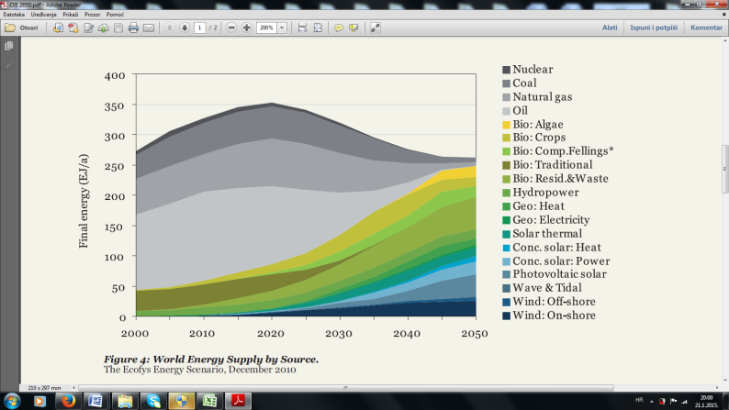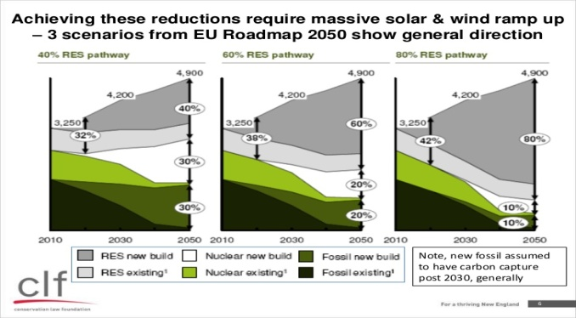
^{I - 40% OIE}
^{I - 60% OIE}
^{I - 80% OIE}
^{Fossil fuels}
^{Nuclear}
^{OIE}

a-world b-European Union-28

Figure 1. The world energy scenario to 2050. and three scenarios of the EU-28 energy strategy by 2050.

Figure 1 a) shows the development strategy of renewable energy sources in the world until 2050. The analysis of the strategy proposed by [45] offers a conclusion that the participation of renewable energy sources increases every year in the energy production in the world at the expense of fossil fuels, so that fossil fuels have a very small percentage of participation in the production of energy in 2050., and nearly 95% of energy production in the world is from renewable energy sources.

2004 2030
1950
1970
1990
2050
2010
2030
2070
2090
1930
20.000
15.000
10.000
5.000
Total primary energy supply [Mtoe]
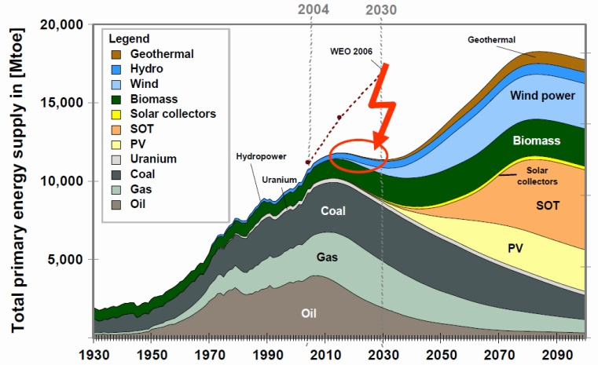

Figure 2. The overall world energy scenario of renewable energy sources implementation
for the period from 1930.-2100. [45]

Based on the scenario that appeared in [45] (World Energy Outlook 2006), we have two extremes in total primary energy supply in the world, one that occurs in the period 2004 to 2030 and the other in the period 2070. - 2090. In the first energy production extreme, fossil fuels come first with greater involvement in the energy production (coal, oil and gas), while at the other energy production extreme, the primacy is given to renewable energy sources (geothermal, wind, solar and biomass). On the basis of all energy production scenarios in the world and EU-228 that are shown here, as well as in [1, 2, 7, 8, 9, 10, 45, 46], the participation in the energy production goes in favour of renewable energy sources. Thus the share of fossil fuels in energy production is reduced to minimum over the period of 80 years. In this way, all the negative consequences of the fossil fuels use in energy production will be eliminated. Thus climate issues and problems of eco-system will vanish both in the world and in the EU-28, and we will receive energy from renewable sources, i. e. clean energy.

3. Renewable energy sources and their participation in energy production

3.1. Wind energy

From the proposed scenarios of energy production from renewable energy sources in the future, we see that wind as a renewable energy source is in second place after solar energy. Wind power plants are the fastest growing of all renewable energy sources at the beginning of the 21st century. Their capacity has more than quadrupled from 2000. to 2006. 81% of installed capacity belongs to the United States and the European Union-28. Estimates are that the power of wind turbines will increase for 21% per year. A long-term technical potential of wind as a renewable energy source is increasing, but it is followed by solving structural problems of wind turbines, because these are nowadays produced up to 150 meters in height and power 75 MW. In the future, they will reach height to 300 meters and up to 20 MW thanks to the development of new technology. Wind power plants installation will take place over large areas and high altitudes, as well as in the oceans where wind resources are high. Constructive solutions of a wind turbine will be such that they are mobile, that can be moved in an area where there is wind. A bright example is Denmark, which produces about one fifth of the electricity by wind turbines, which makes it the country with the largest share of wind turbines in its own production. Both the user and manufacturer of wind turbines are important. Germany is a leading manufacturer of wind power plants in the EU-28, accounting for 28% of world production in 2006. [6, 7, 8, 9, 10, 11, 12, 13, 48].

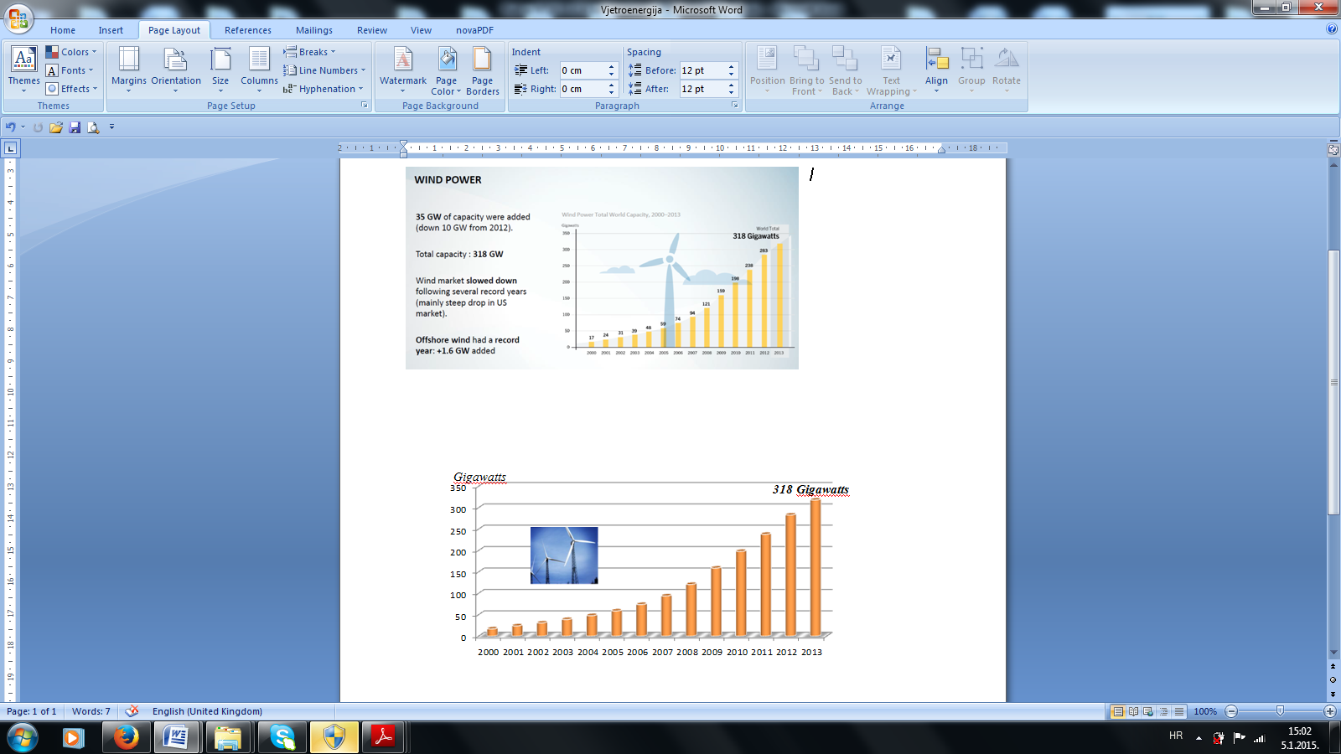
Gigawatts
118 Gigawatts

world EU-28
Figure 3. World production of energy and the EU-28 with a wind-power plants from 2000.-2013.

Based on Figure 3, we conclude that the energy production from wind-power plants every year in the world and in the EU-28 is continuously increasing, and that it reached a production of 318 gigawatts in the world in 2013., while it reached a production of 118 gigawatts in the EU-28.
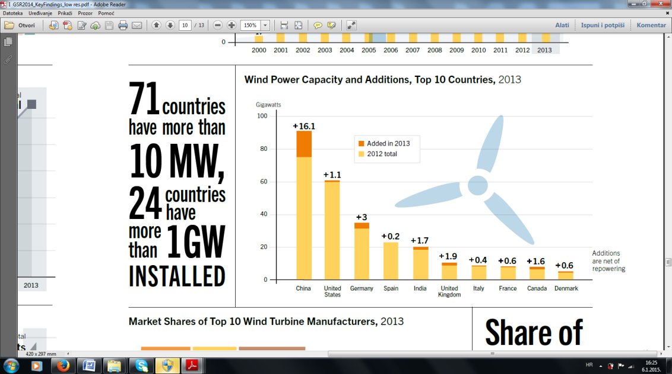
Gigawatts
Added in 2013
2012 Total
31,3
22,7
8,1
2,3
4,5
3,7

world EU-28
Figure 4. The produced wind energy in the top ten countries in the world from 2012-2013,
as well as in the EU in 2013

Ten countries listed in Figure 10 took over the leading role in world production of wind energy in 2012.-2013. When it comes to the wind energy production, the leading place in the world belongs to China, which produced 86.1 gigawatts in 2012.-2013. China is followed by the USA with 61.1 gigawatts, and the third is Germany, followed by; Spain, India, the UK, Italy, France, Canada and Denmark. If we analyze energy production by wind energy plants in the EU-28. Germany comes first with 31.3 gigawatts produced. Spain is second with 22.7 GW, and it is followed by: the UK, Italy, France, Portugal, Denmark, Sweden, Poland, and Netherlands. The production of EU-28 energy by wind power plants manages to cover 8% of energy consumption in the EU-28 for a period of one year [7, 8, 9]. Let’s conduct an analysis of investment in wind energy production in the world and the EU-28. Figure 5 shows the investments in this part of the energy in the last six years.

Bilion US $
Bilion US $

world EU-20
Figure 5. Investing in renewable energy source–the wind– in the world and the EU-28 from 2008.-2013. [6]

Investments in wind energy development in the world are shown in Figure 5, where we see they range in average about 80 billion US$ in the last six years. Maximum investment of 94.8 billion UD$ took place in 2010. When it comes to the European Union-28, the investments in the development and implementation of wind energy range about 15 billion US$ in the last six years. The investment in renewable wind energy has resulted in energy production increase, as shown in Figure 3., as well as in increase of employment both in the world and the EU-28, as shown in the following Figure 6.
40.000 Empl.
40.000 Empl.
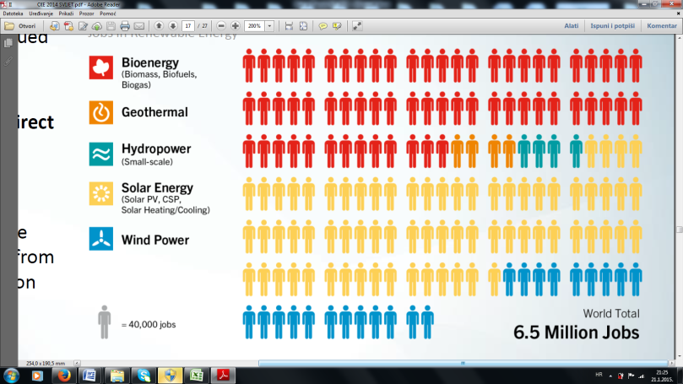
world EU-28

Figure 6. Employees in the development and implementation of renewable wind in the world and the EU-28

We conclude that about 840 000 workers have been employed in the implementation of renewable wind in the world so far through investment shown in Figure 5, while approximately 320 000 workers have been employed in the EU-28. In addition to increasing employment and opening new work posts, a part of the investment relates to the development of new technologies in this field so that the limits of wind turbines are moved towards greater energy production, as shown in Figure 7.

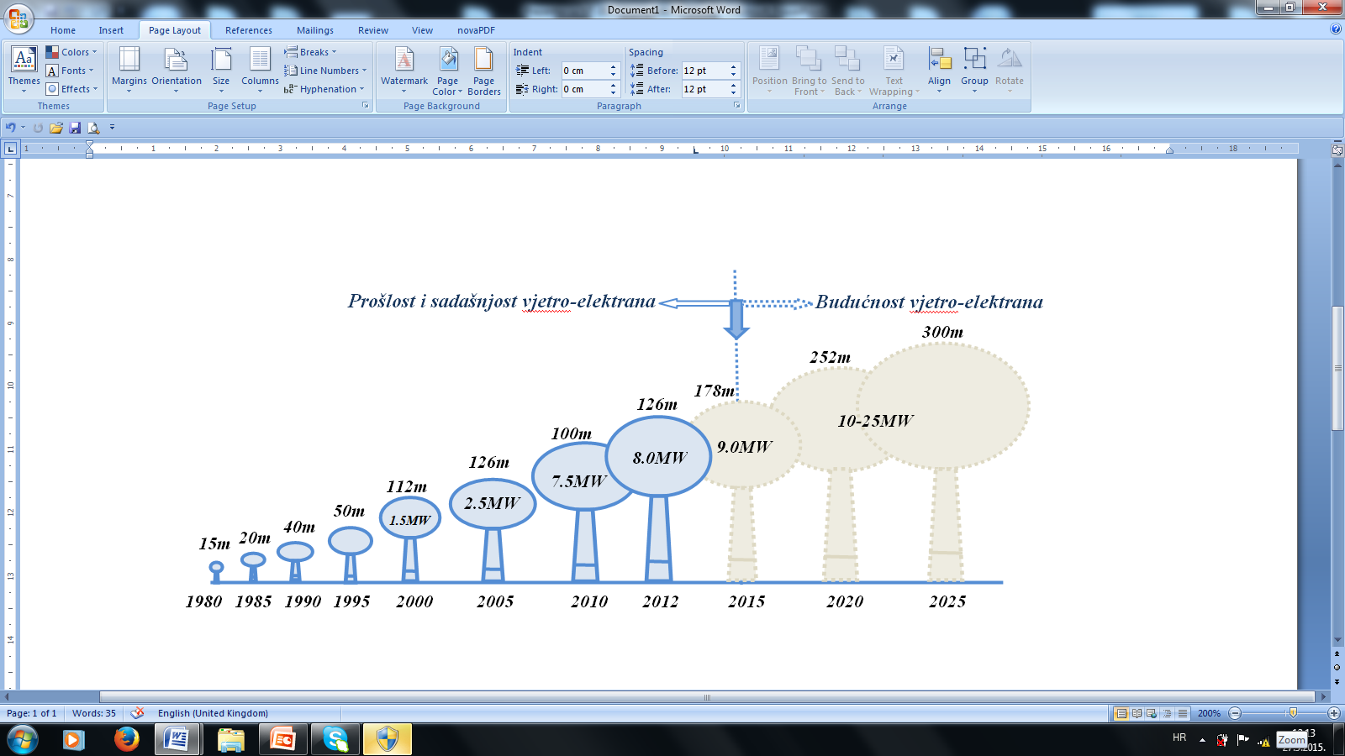
Past and present of wind power plants
Future of wind power plants
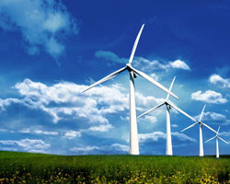

Wind power

Figure 7. Historical development of wind power plants size and the future development scenario

Based on the scenario of the future development of wind power plants, we come to the conclusion that the wind energy production is about to increase in the future, because the construction of 300 meters high wind power plant with the 10-20 MW volume is estimated.

3.2. Solar energy
Solar energy in the form of light and heat spreads into space, so that a small part comes to Earth. Although solar energy is the cause of most energy sources, about 1 kW/m² can be obtained at the Earth surface under optimal conditions, and the actual value depends on the location, season, time of day, weather conditions, etc. The main problems in the exploitation of this energy are small energy flow, huge oscillations of radiation intensity, and large investment costs. Most of the individual countries in the world are subsidizing instalment of elements which are transforming solar energy into a usable form of energy, while the EU-28 is not a very suitable area for exploitation, but despite that, the direct use of solar energy in the EU-28 increases at a rapid rate. Basic principles of direct solar energy utilization are: solar collectors – preparing hot water and space heating, photovoltaic cells – the direct conversion of solar energy into electricity, as well as focusing the sun's energy – the use in large power plants. The production of energy by utilization of solar energy in the world and EU-28 is shown in Figure 8.
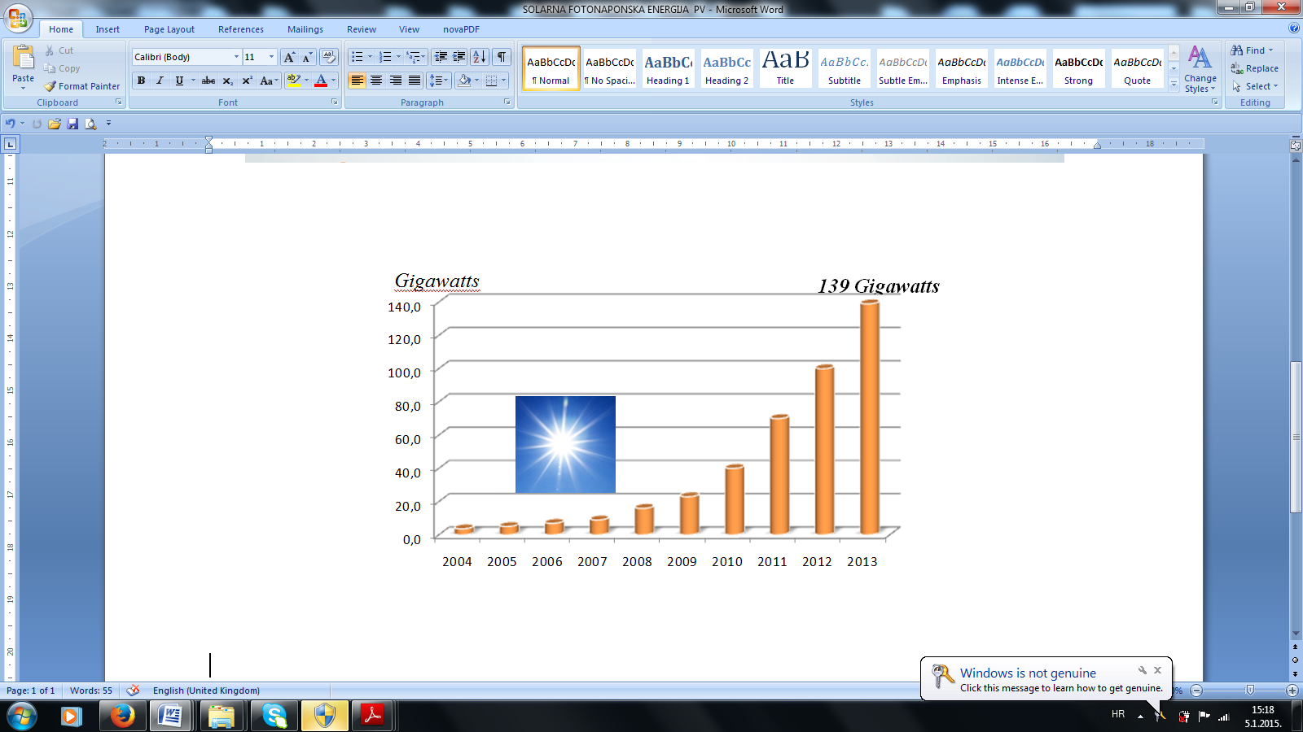
Gigawatts
81,4 Gigawatts

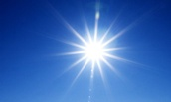

world EU-28

Figure 8. Production of energy in the world and the EU-28 (solar photovoltaic energy PV) from 2004. – 2013. [5]

Utilization of solar energy is increasing from year to year, as shown in Figure 8. When it comes to the renewable source— the sun — energy production in the world in the last ten years has the tendency of exponential growth, so that it reached the value of 139 gigawatts in 2013. The production of solar energy in the EU-28 reached a value of 81.4 gigawatts in 2013. Analysis of energy production from renewable energy sources – the sun – in the individual countries in the world in 2013. is shown in Figure 9.
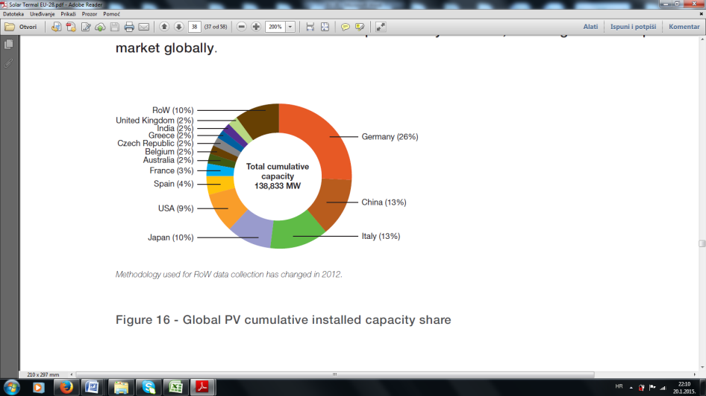

Figure 9. Energy production using renewable source, the sun (using photovoltaic cells PV),
in certain countries in the world in 2013.

Based on the Figure 9, we conclude that Germany produced 25% of the total energy produced by photovoltaic cells in 2013. It is followed by China with 13%, and then: Italy 13%, Japan 10%, the USA 9%, Spain 4%, France 3%, and other countries by 2%. Energy production using photovoltaic cells has a growing trend from year to year, both in the world and in the EU-28, for which we hope to be held. Which countries and how much energy they produce in this way in the world and the EU-28 is shown in Figure 10.
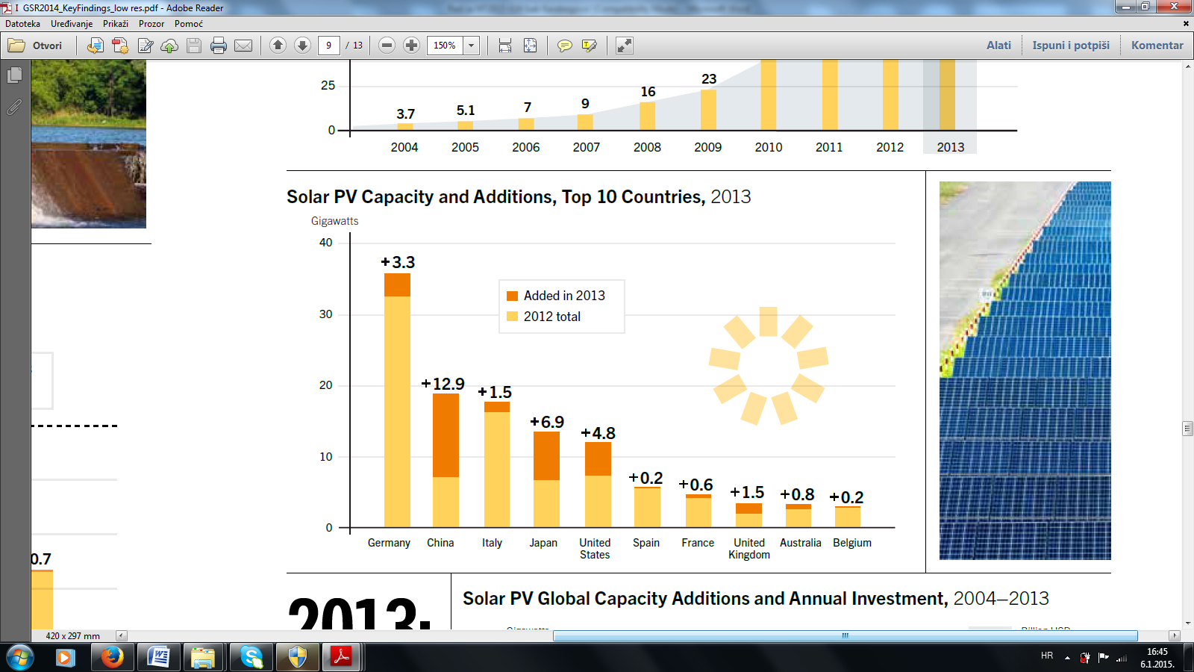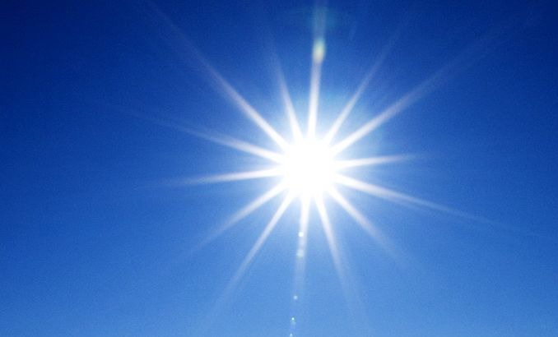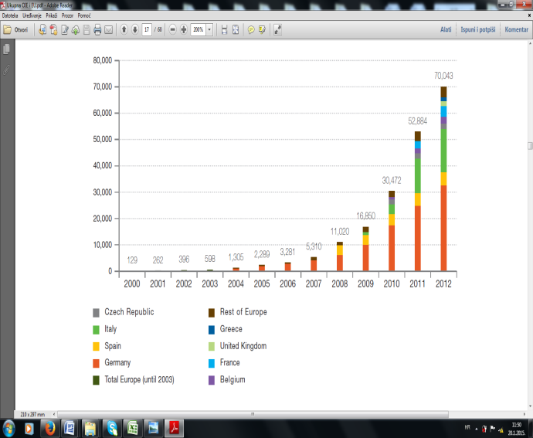
Gigawatts
Added in 2013
2012 Total
Gigawatts
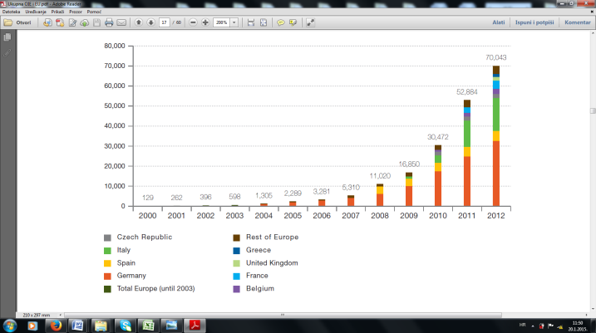

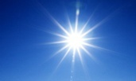

world EU-28
Figure 10. The produced solar photovoltaic energy in the ten top countries in the world from 2012.-2013. [4]

When it comes to the production of solar photovoltaic energy in 2012.-2013. – and based on the above chart – we can see that Germany occupies the first place with 37.3 gigawatts produced, the second in 2012.-2013. being China with 18.9 gigawatts, and third Italy with 17.5 gigawatts. These three countries are followed by Japan, the USA, Spain, UK, Australia and Belgium for the production of photovoltaic energy. Let’s now analyse the production of solar energy for water heating in the world. The following four countries in the EU-28 are prominent because of the production of this energy: Germany, Italy, Spain and France. From year to year, they increase the production of energy in this way. Analysis of the manner of sun energy utilisation using a collector, wherein hot water is produced for heating and industry, is shown in Figure 11.
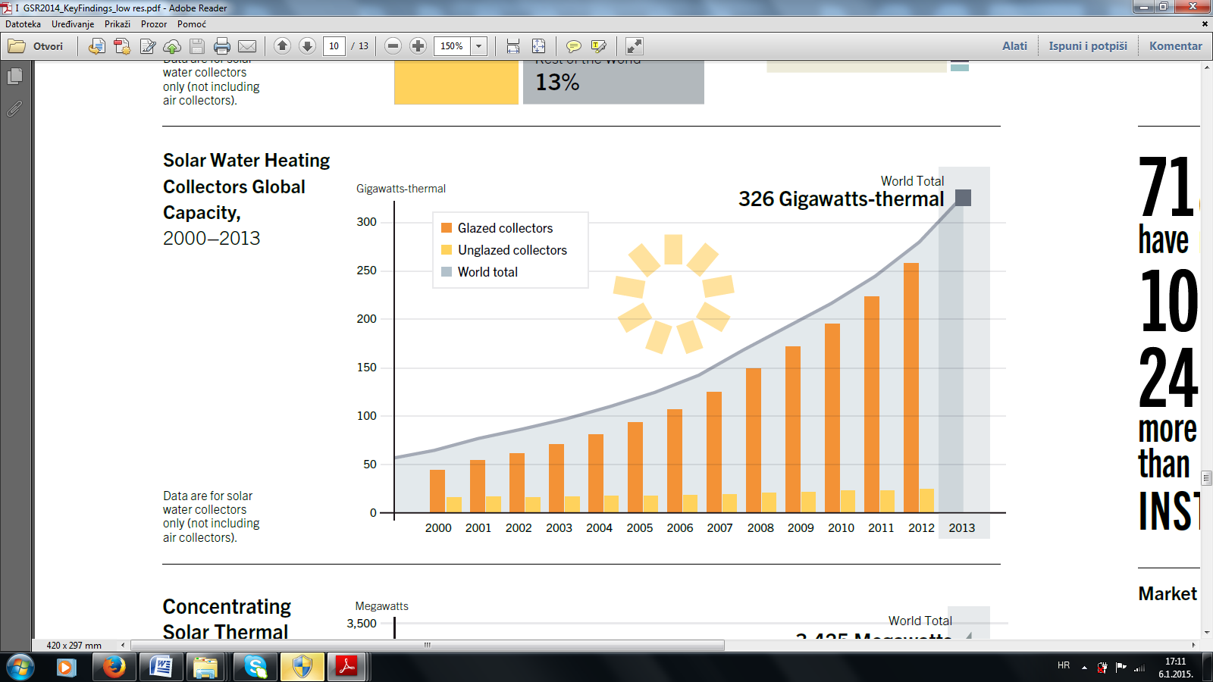
World Total
263 Gigawatts-termal
Gigawatts-thermal
Glazed collectors
Unglazed collectors
World Total

Gigawatts-thermal
29,6 Gigawatts-thermal

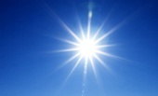

world EU-28
Figure 11. The energy produced by using solar collectors (hot water) in the world and the EU-28
during 2000.-2012. [6-16]

By producing energy in this manner, we also have an increase on a yearly basis. We concluded that 263 gigawatts was produced in the world in 2013., while 29.6 gigawatts was produced in the EU-28 at the same year. The trend of producing energy in this way is growing both in the world and in the EU-28.
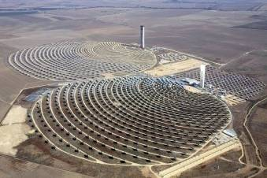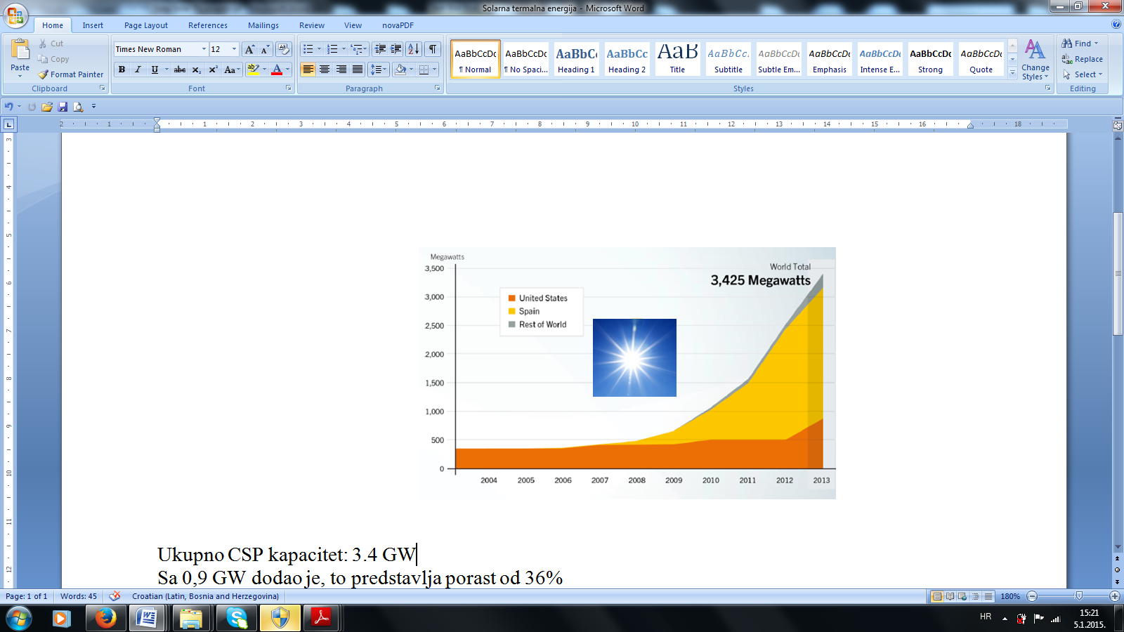
One of the largest solar power plants

Megawatts
United States
Spain
Rest World

World Total
3,425 Megawatts

Figure 12. Energy production in the world (solar thermal energy ST) from 2004. – 2013.

The production capacity of solar thermal energy increases each year from 2004. to 2013., and it reached a record production of 3,425 megawatts in 2013. The world's largest thermal power plants are: 392MW Ivanpah (California), Perovo 100MW (Ukraine), 92 MW Sarnia (Canada), Montalto di Castro 84 MW (Italy), Finsterwalde 83 MW (Germany), Ohotnikovo 80 MW (Ukraine), Senftengerg 78 MW (Germany), Lieberose 71 MW (Germany), Ravingo 70 MW (Italy), Olmedilla de Alarcon 60 MW (Spain), and Boulder City 56 MW (the USA). Many energy experts believe that solar energy is the only renewable energy source that has the potential to replace fossil fuels as the dominant source of energy in the years to come. A larger number of countries is seriously thinking about solar energy and invest large amounts of money in various projects, mainly solar plants for electricity production. Investments in this form of energy are shown in Figure 13.
Bilion US $
Bilion US $
world
EU-28
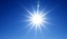

Figure 13. Investment in renewable solar energy in the world and the EU-28 from 2008.-2013. [47]

Investments in renewable sun energy amount to about 10,5 billion US$ in the world in the last six years, while the maximum investment, about 157.8 billion US$, is accounted for in 2011. After that, there is a reduction in investment so that it amounted to 113.7 billion US$ in 2013. When it comes to the European Union-28, the investment in the last six years is about 10.5 billion US$, while the same maximum investment was 14.9 billion US$ in 2011. Afterwards, there is a reduction in investment, so that it amounted to 6,4 billion US$ in 2013. The largest renewable energy investments are the ones related to solar energy, which resulted in a larger number of new jobs, which is shown in Figure 14.
40.000 Empl.
40.000 Empl.

Figure 14. Employees of renewable energy sources – solar energy – in the world and the EU-28 [6-16]

By investing in renewable energy sources in the world, 2.800.000 workers have been employed, which represents the largest number of employees when it comes to the renewable energy sources. On the other hand, 800.000 workers have been employed in the EU-28. It is estimated that the number of employees will increase when ti comes to solar energy.

3.3. Small hydropower plants

Small hydropower plants do not have any harmful effect on the environment or at least it is considered so, as opposed to large ones, whose harmfulness is described through the major changes of ecosystems (building large dams), impacts on soil, flooding, impacts on freshwater wildlife, increased methane emissions, as well as the presence of harmful emissions throughout the life cycle of hydroelectric power. For example, production of materials and the transport while a hydropower plant is being built. In small hydroelectric power plants, large amounts of water in the pipes of drinking water suggest themselves as a potential energy source. The concept of small hydro power plants can be seen from different points of view and it differs from country to country, depending on its standard, hydrological, meteorological, topographical and morphological characteristics of the location, as well as the degree of technological development and economic standard of a country. A small hydropower plant in Europe implies up to 10 MW, while it ranges to 25 MW in the world, as for example in China.

Megawatts
359,59
286,72
224,56
29.63
23,26
Gigawata
990
945
915
1000
970
885
world continents
Figure 15. Total small hydropower plant capacity in the world for the period from 2008-2013
and the capacity across the continents and the EU-28 in 2013. [46]

Considering small hydropower plants in the world currently, small hydropower plants with 10 MW capacity exist in 148 countries and territories worldwide. More than half the world's known hydro potential is located in Asia, and about one-third can be found in Europe and America. Figure 15. shows the capacity of energy production using small hydroelectric power plants in the world for the period 2008-2013. As we can see, there is a increasing trend from 2008., where 885 GW was produced, while 1.000 GW was produced in 2013.
When it comes to energy production in 2013 using small hydropower plants distributed via continents, we can se that Asia has the highest production of 359.59 MW, and is followed by America 286.72 MW, then Europe with 224.56 MW, the European Union countries 29,63 MW, and Africa being last with 23.26 MW. An overview of energy production in 2013. using small hydropower plants by countries at different continents is shown in Figure 16.

Megawatts
12,29
18,5
16,2
29,9
46,87
Megawatts
10,04
75
11,54
87,2
82,45
Europe America
Megawatts
5,5
16,88
27,57
33,60
213,4
Asia

Figure 16. Display of small hydropower energy production capacity ˃ 10 GW
in the countries of the continents in 2013. [46]

On the European continent, Russia has the highest energy production using small hydropower plants with 46.87 MW in 2013., and is followed by Norway with 29.9 MW, France with 21.3 MW, and then: Spain, Italy, Sweden, Austria and Switzerland, which produce over 10 MW. In America, Brazil has the primacy of energy production by small hydropower plants, the United States being second and Canada third. When it comes to Asia, China is at the forefront with 213.4 MW.

Gigawatts
Gigawatts
269
22,9
17,3
86,5
43.8
44,7
90
90

Figure 17. The total energy produced using small power plants
in six top countries in the world in 2013. [5]

Based on Figure 17., we can conclude that China, which produced about 269 gigawatts in 2013., comes first in the production of hydropower in the world. The second place is occupied by Brazil with 86.5 gigawatts, and then: Russia, India, Turkey and Vietnam. China is number one in the world when it comes to the production of renewable energy sources, water - small hydro power. It must be noted here that China's small hydropower plants include those that produce up to 25 MW, which is not the case in Europe, where small hydropower plants include only those that produce up to 10 MW of energy. The investment in the development and implementation of small hydropower plants in the world and the EU-28 is shown in Figure 18.

Bilion US $
Bilion US $
world EU-28

Figure18. Investing in a renewable source of small hydropower plants
in the world and the EU-28 during 2008.-2013.

Figure 18 indicates that the investment in small hydropower plants in the world is in average about 6 billion US$, and the biggest investment of 7.2 billion US$ was in 2008. In the last three years, the investment in small hydropower plants has a slight decline from 6.8 to 5.1 billion US$ in 2013. When it comes to the investment in this form of renewable energy in the EU-28, their average in their last six years is around 2.2 billion US$. Also, the investment has dropped from 2.79 to 1.15 trillion US$ in the last three years. The investments in this form of renewable energy are far less than in renewable wind and solar energy, as we have seen. This part of the investment in the world and the EU-28 made possible the employment and opening of new working places, as shown in Figure 19.

40.000 Empl.
40.000 Empl.

world Europe
Figure 19. Employees in renewable energy sources of small hydropower plants
in the world and the EU-28

As it can be seen from the Figure 19., employment is far less when compared to renewable wind and solar energy, but is still 160.000 workers is employed in the world, while 60.000 workers is employed in the EU-28. This is to be expected because small hydropower plants are fully automated, and it is not available as an energy source in all countries in the world.

3.4. Biomass

The definition of biomass is introduced in the Directive 2009/28/EK, which states that biomass is „a biodegradable part of products, wastes and residues of biological origin from agriculture (both plant and animal), forestry and related sectors, such as fisheries and aquaculture, as well as a biodegradable part of industrial and communal waste.“ This means that newly obtained biomass can be converted to natural gas as well as liquid and solid fossil fuels with appropriate industrial processing. Using different transformation processes such as combustion, gasification and pyrolysis, biomass can be transformed into „bio-fuels” for transportation, „bio-heat” or „bio-electricity.” The biomass is usually used directly in the final consumption of energy for heating, cooking and hot water, but can also be used to produce electricity and heat, and is recently increasingly used for the production of bio-fuel. It can also be used in industry for the production of fibers and chemicals. Biomass is a renewable energy source and can generally be divided into wood, non-woody and animal waste, within which we differentiate: wood biomass, agricultural waste and scrap, animal waste and scrap, as well as biomass from waste.
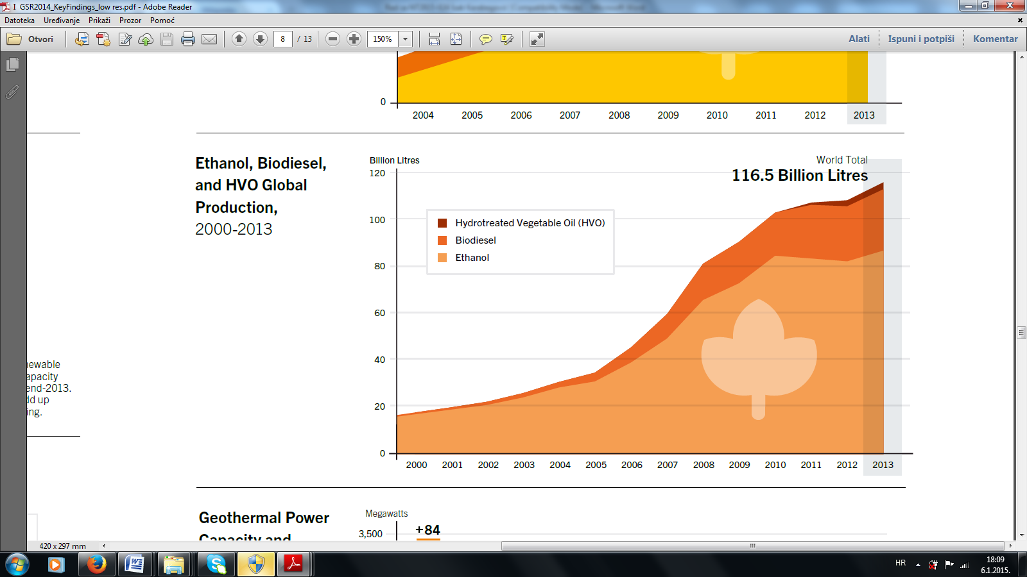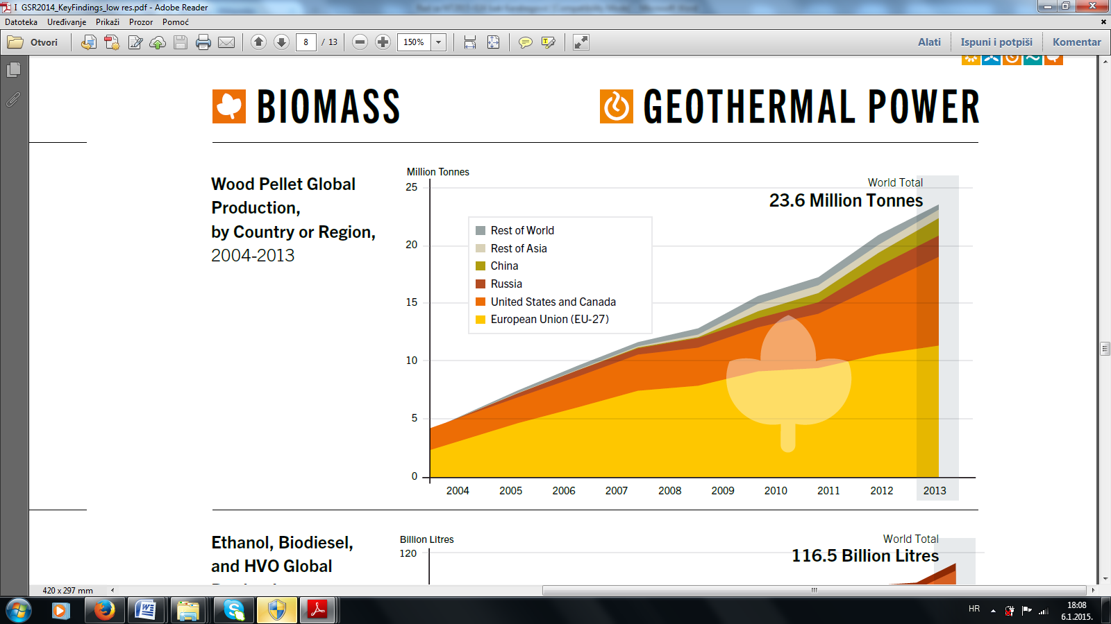
Million Tonnes
Billion Litres
World Total
23,6 Million Tonnes
World Total
116,5 Billion Litres

a – pellet production from wood mass b-production of oil from fruits, biodiesel and ethanol
Figure 20. World pellet production from wood mass and biodiesel, die and oils from fruits
during 2004.-2013. [6-16]
As it is known, biomass is mainly used for energy for heating, and this is a tradition as well. The development of new technologies leads to maximum utilization of the thermal power of biomass, so that the wood mass is produced from
a pellet, which serves as the output of raw materials for heating energy. Figure 20 shows that the trend is increasing continuously, and the world production reached 23.6 million tons in 2013, the number one in production being the EU, the second the USA and Canada, which are followed by Russia, China and the rest of the world. The development of new technologies has led to the following products to be produced from a biomass: bio-diesel, ethanol and oil from the fruit. If we look at the trend of their output in Figure 20 b), a record production is 116.5 billion litres in 2013, so that the ethanol holds the first position, bio-diesel the second and the oil third.

Kilotons
120.000
90.000
30.000
60.000
2000
2020
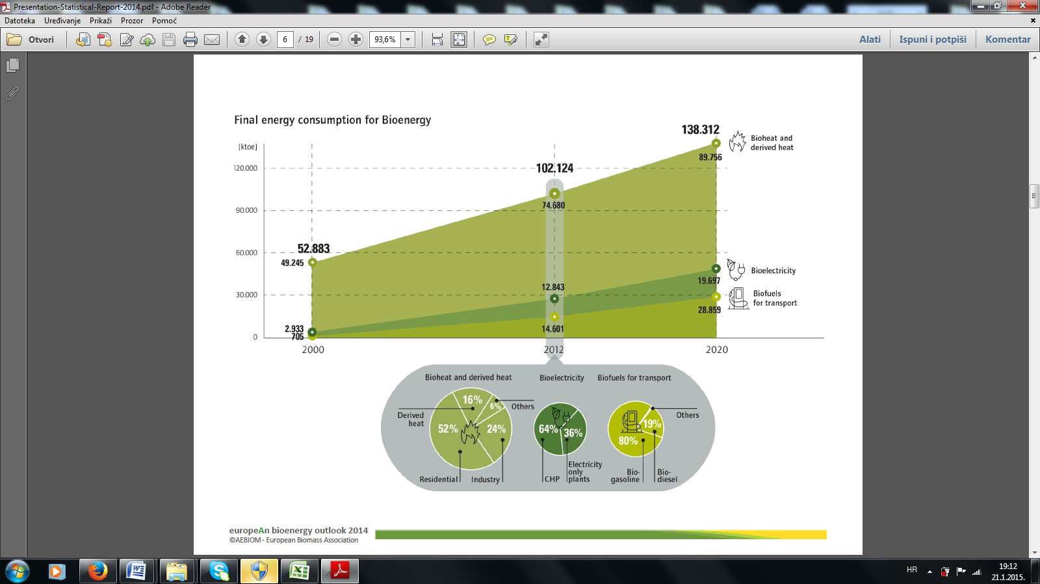

Figure 21 Production of final energy from biomass in the period from 2000.-2020. in the EU-28 [47,48]

When it comes to the utilization of a renewable energy source – biomass, the EU-28 has developed a strategy for the period 2000.-2020., which is shown in Figure 21. In 2000, the EU produced a total of 52.883 Kt of biomass for renewable energy production, of which 705 Kt bio-fuels transport, 2.933 Kt of bio-electricity, and 49.245 Kt of bio-heat energy. From 2000-2012, we have a growing trend of biomass utilization, so that it reached a value of 102.124 Kt in 2012., of which 14.601 Kt of bio-fuels, 12.843 Kt of bio-electricity, and a maximum 74.680 Kt of bio-thermal energy. A detailed ratio of each energy in 2012 is shown in the chart below. When it comes to biomass in 2020., the projection is to produce a total of 138.312 Kt of energy. Biomass is very acceptable fuel with regard to environmental impact, since it contains very little or none of the various harmful substances – sulphur, heavy metals, etc. It is estimated that the loading of the atmosphere with CO2 while using biomass as fuel is negligible, since the amount of CO2 emitted during the combustion is equal to the CO2 absorbed during plants growth. Pellet as a raw material for thermal energy production of is very interesting, thus Figure 22. presents pellet production as a renewable energy source in the world and the EU-28 in 2013.

Svjetska proizvodnja peleta
[Miliona Tona]
Evropska proizvodnja peleta
[u Tonama]
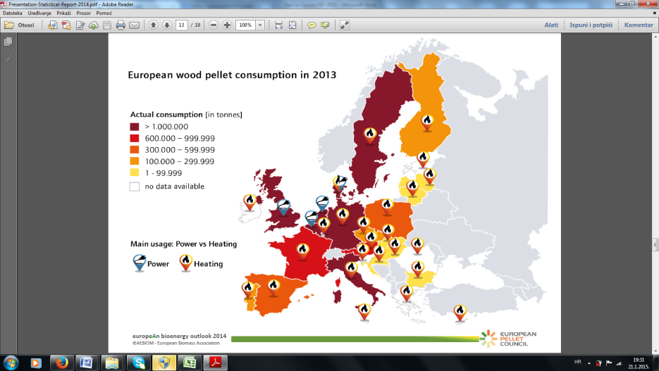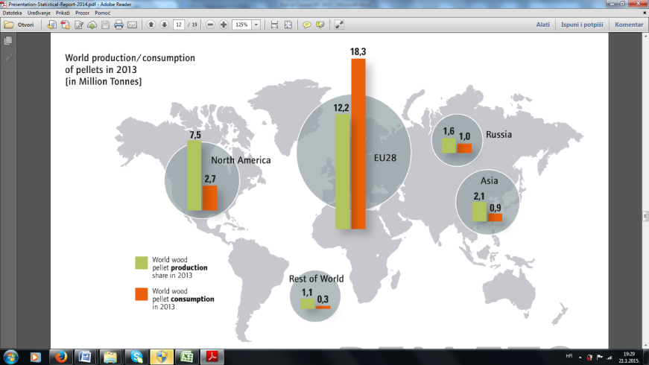

world Europe

Figure 22. Production of renewable energy source – pellet in the world and Europe in 2013. [48]

Figure 23. shows world production and consumption of pellets (left). It can be concluded that the EU-28 had a production of 12.2 million tonnes in 2013., while consumption was 18.2 million tonnes, which is far bigger than production. This is not the case in North America, Russia, Asia and the rest of the world. This fact leads to the correctness of the strategy of development of renewable energy sources – biomass in the EU-28 as shown in Figure 23.

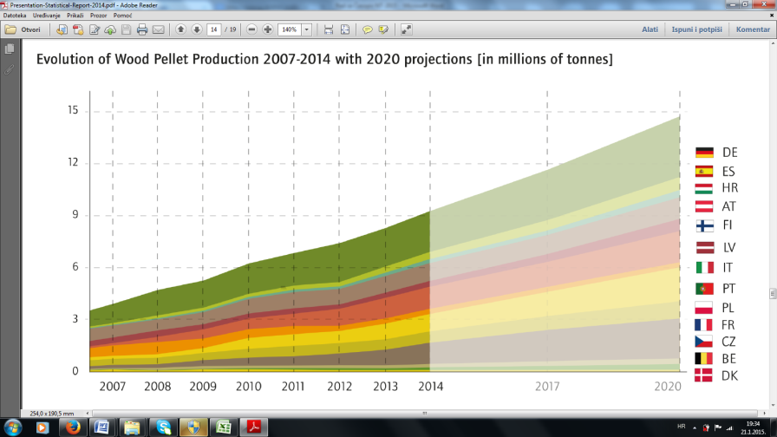

Figure 23. Projection of the development strategy of the OIE pellets from biomass
for the period from 2007.-2020. in the EU-28 [48]

Based on the strategy for the development and production of pellets from biomass (wood waste), we see that it increases every year until 2020., reaching a value of almost 15 million tons, which is justified due to the needs of the European Union. It is interesting to have an overview of countries exporting and importing pellets, as shown in Figure 24.

Miliona tona
Miliona tona
Pellet export countries Pellet import countries

Figure 24. The EU-28 countries exporting and importing renewable energy source – pellets in 2013. [47]

It can be concluded that Portugal and Latvia are the largest exporters of renewable energy source – pellet – in 2013 with 1.05 million tons and 0.77 million tons respectively, while Denmark is the smallest exporter with 0.25 million tons. When it comes to the import of pellets, it can be seen that the UK is the number one with 3.45 million tons, and the last is Austria with 0.38 million tons.

Bilona US $
Bilona US $

Figure 25. Investment in renewable source of bio-energy in the world and the EU-28
in the period from 2008.-2013. [6-16]

Investing in renewable energy source in the world in the last six years is on average about 22.65 billion US$, while the investment in the EU-28 is on average about 7.87 billion US$. Apart from the renewable energy source – sun, this part of the renewable energy source (biomass) is in second place in the world by employing 2.52 million workers, while about 0.6 million workers is employed in the European Union, as shown in Figure 26.

40.000 Empl.
40.000 Empl.

world EU-28

Figure 26. Employees in renewable bio-energy sources in the world and the EU-28

By investing in renewable bio-energy source will result in development of new technologies that will increase the utilization of bio energy, and therefore there will be an increase in employment and number of job posts in this part of renewable energy.

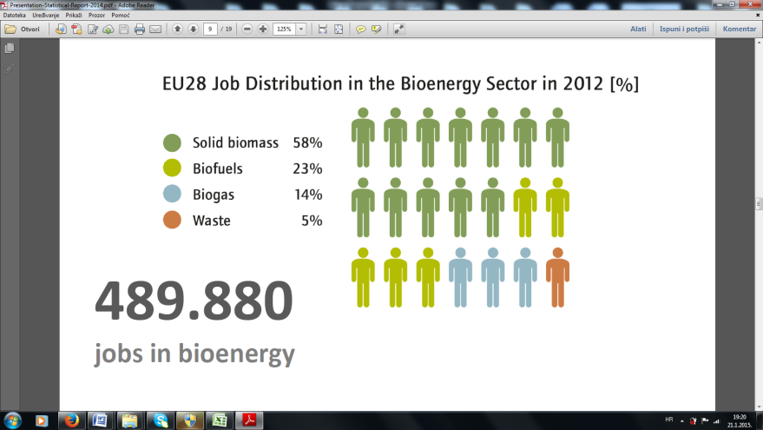

Figure 27. Percentage of employment in renewable energy sources in the EU-28

Figure 27. shows the ratio of employment in different aspects of bio-energy, so that 58% is employed in bio-thermal energy, 23% in bio-fuel, 14% in bio-gas, and 5% the rest.

3.5. Geothermal energy

Geothermal renewable energy sources are hot water reservoirs that can be found at different temperatures and depths under the Earth's surface. As it is known, the intensity of thermal energy increases with depth. The global average for the Earth's geothermal gradient is about 30°C/km. A-kilometre-deep or even deeper boreholes can be drilled in underground reservoirs, in order to use the steam and very hot water that can be brought to the surface for use in various applications, including electricity generation, as well as direct use for heating and cooling. Geothermal energy is renewable if the reservoir is properly used. Energy efficiency has to be in accordance with the natural temperature change of reservoirs. The temperature of the Earth's interior increases with depth. At a depth of 80-100 km, rock temperature is between 600 and 1.200°C. The heat is continuously flowing from the source in the Earth's interior to the surface.

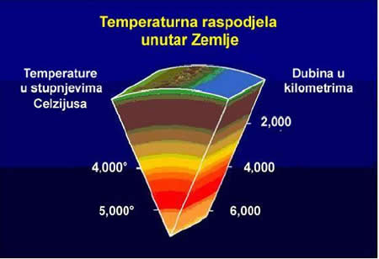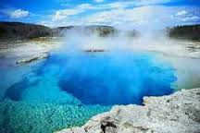

Temperature
ºC

Depth
km

Figure 28. Distribution of the temperature field in the Earth's interior depending on the depth [49]

Although there are limited data available on the recent growth in the direct use of geothermal energy, output is known to be increased annually by an average of 10% from 2005. to 2010. Much of this growth is attributed to a ground-source heat pump, which has experienced an average annual growth of 20%. With the assumption that these growth rates remained in the past two years, the global geothermal heat capacity is to an estimated 66 GWth in 2012. Geothermal energy, i. e. the use of heat (almost half), the largest share refers to bathing and swimming applications, with lesser amounts for heating (primarily district heating), industrial uses, aquaculture, pond heating, agricultural drying, melting snow, etc. At least 78 countries use direct geothermal heating. The United States, China, Sweden, Germany and Japan have the highest amount of geothermal heating capacity. Geothermal energy production in the world and the EU-28 (in the ten countries that produce the most geothermal energy and the rest of the world in 2013.) is shown in Figure 29.
Megawatts

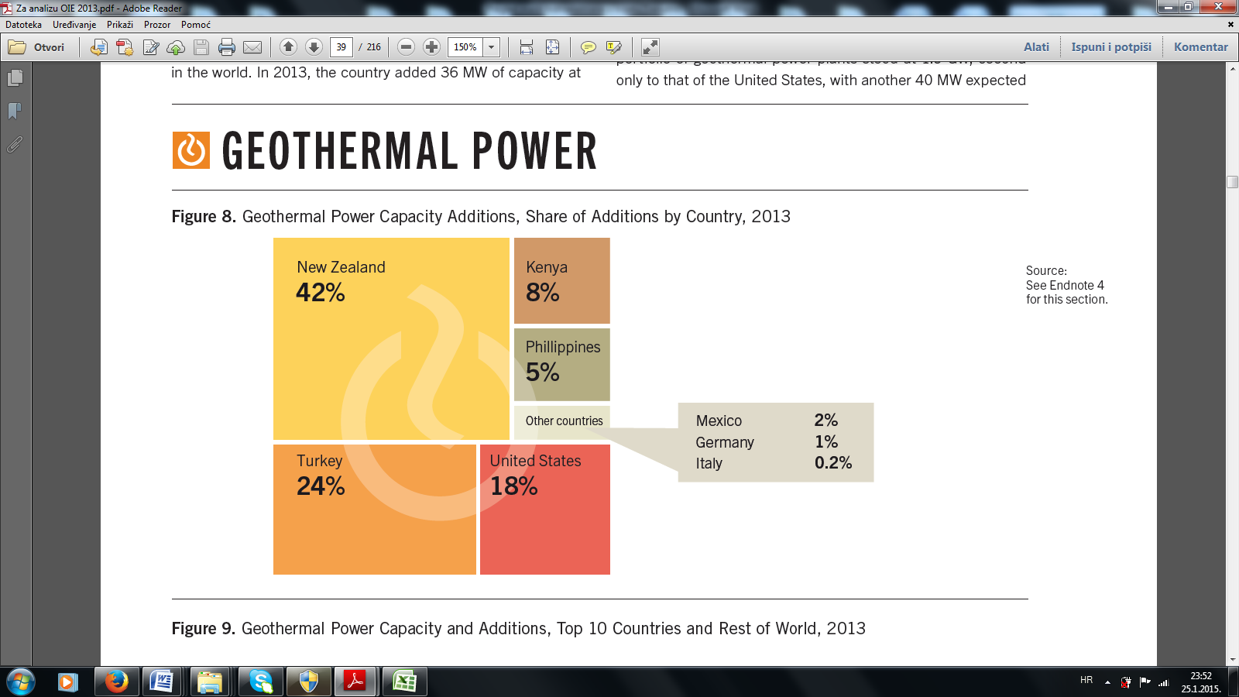

Figure 29. The capacity of geothermal energy in the top ten countries in the world and the rest of the world in 2013.

The largest producer of geothermal energy in 2013. in the world is the USA with 3.884 MW, the second place belongs to the Philippines with 1.920 MW, and the third is Indonesia with 1.380 MW. When it comes to the EU-28, Italy, which produces about 901 MW of geothermal energy, is number one in 2013. When it comes to the production of electricity from geothermal sources in 2013., the overview is given in Figure 30.

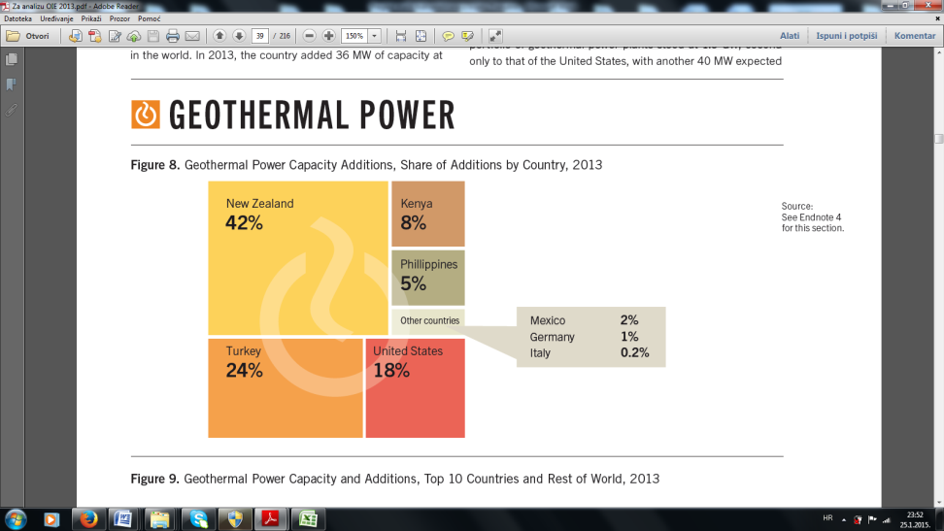
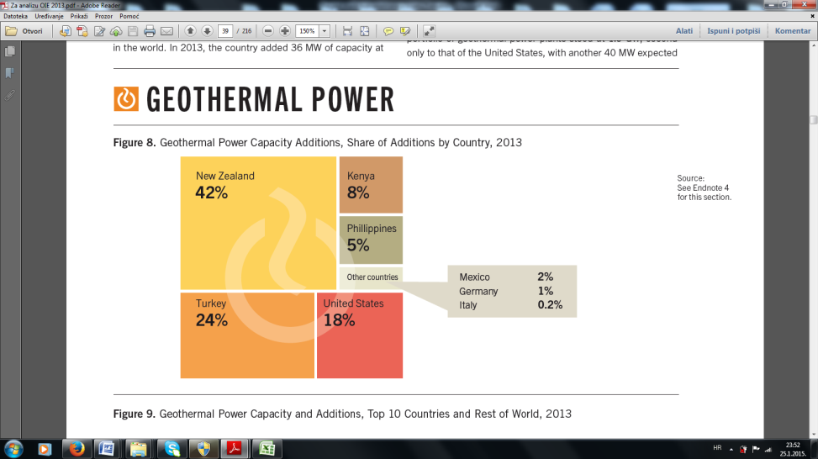

Figure 30. Production of electricity from geothermal renewable energy sources [7]

When it comes to the production of electricity from a geothermal renewable source in 2013., in the first place belongs to the New Zealand with 42%, which is followed by Turkey with 24%, and then the USA with 18%. Usage of geothermal energy can be justified as an integrated program that includes industrial production of electricity, tourism and agriculture. Cost-efficiency depends on the characteristics of a borehole and support mechanisms – the risk can be huge. The share of geothermal energy in electricity production is not large, but there is a potential to increase. Environmentally friendly is a geothermal energy source with due care.

4. Investment in renewable energy sources in the World and the EU

Many conclusions and strategies that aim to invest and develop renewable energy sources have been adopted, in order to solve the climate changes that threaten every continent and bring disorder in agriculture and food production, because there are many floods and fires, as well as changes in ecosystems in the world. Energy stability and security have become one of the most important issues in recent years, so that the world invests in the renewable energy sources as shown in Figure 31.

world European Union

Figure 31. Investment in renewable energy sources
in the world and the EU in the period from 2004.-2013. [6,7]

Investing in renewable energy sources in the world and the European Union has had a growing trend in the period from 2004.-2011., so that it reached the amount of 279 billion US$ in the world in 2011, and the amount of 114.8 billion US$ in the EU-28. After 2011 until 2013, we have a slight decline in investment in renewable energy sources, so that investment in the world amounted to 214 billion US$ in 2013., and 48.4 billion US$ in the EU-28.With such investments in the world and the EU -28, the amount of energy shown in Figure 32. has been produced.

Gigawatts
Gigawatts
560
235
162
118
78
32
31
27
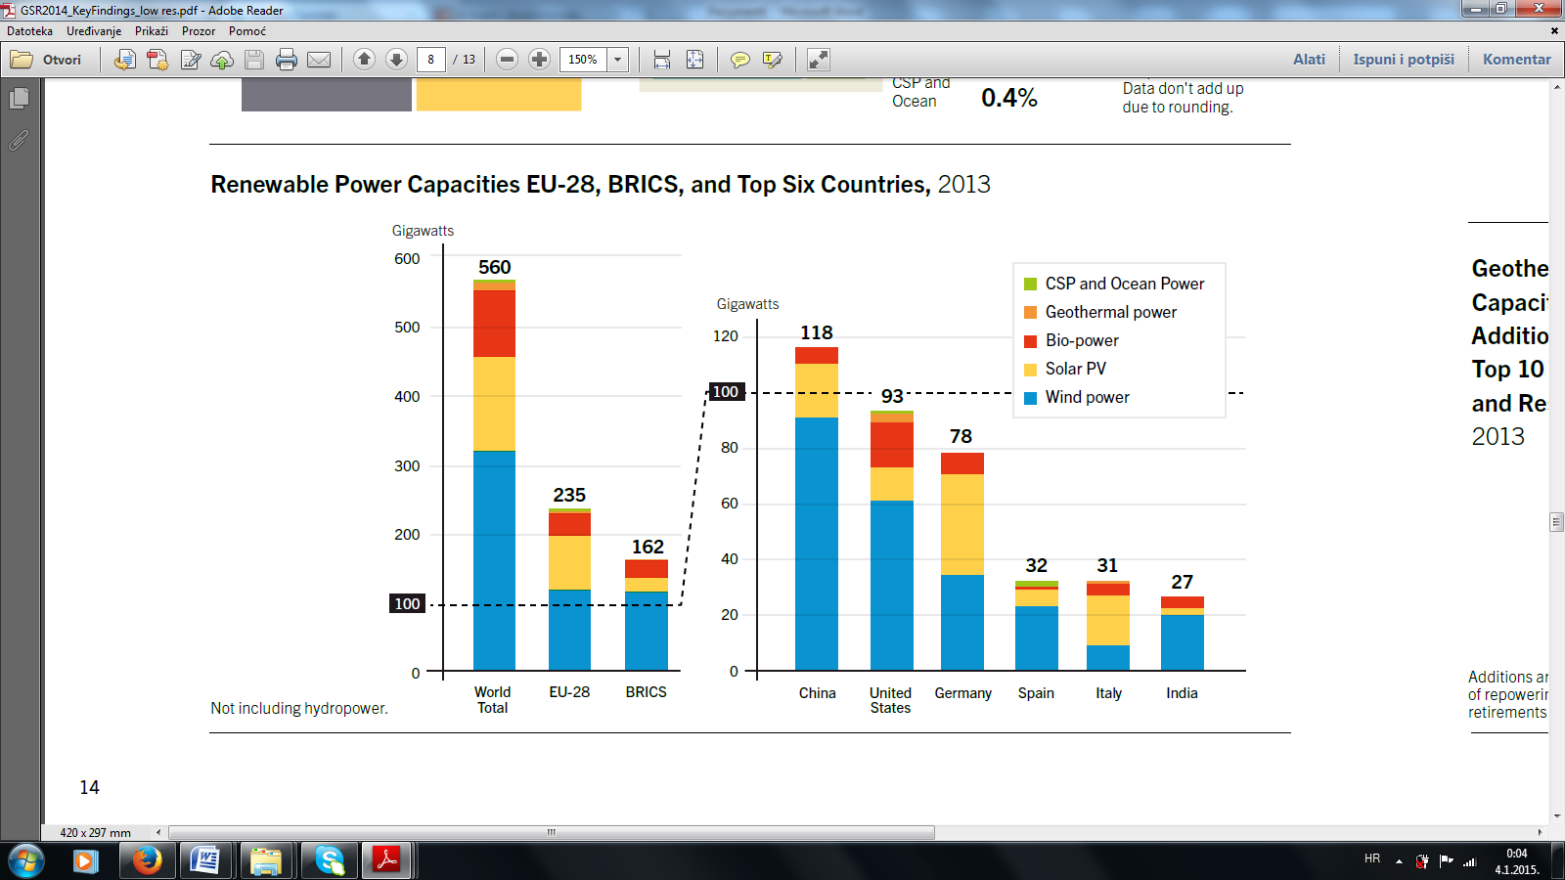

Figure 32. The energy produced from renewable energy sources in the world, the EU 28 and BRICS in 2013

The capacity of renewable energy sources in the world in 2013. amounted to 560 gigawatts, the number one being a renewable source of wind power plants with a capacity of over 300 gigawatts, which is followed by solar energy (solar PV) with about 120 gigawatts, and then biomass with the energy of about 100 gigawatts. The European Union 28 produced 235 gigawatts of energy from renewable sources in 2013., the number one also being the wind, and solar energy being second. Of the six top countries in the world for the production of energy from renewable sources, China occupies the first place with 118 gigawatts, and the USA second with 93 gigawatts. Germany is the third country in the world with 78 gigawatts of energy produced in 2013. from renewable energy sources, and is followed by Spain, Italy and India. Investment in renewable energy sources has led to the formation of new job posts, thus employment figures for renewables are presented in Figure 33.
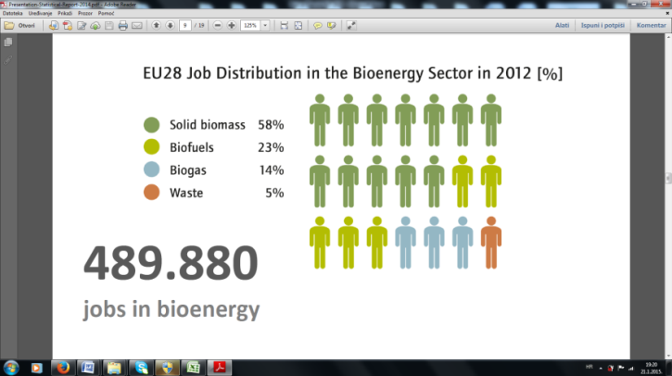

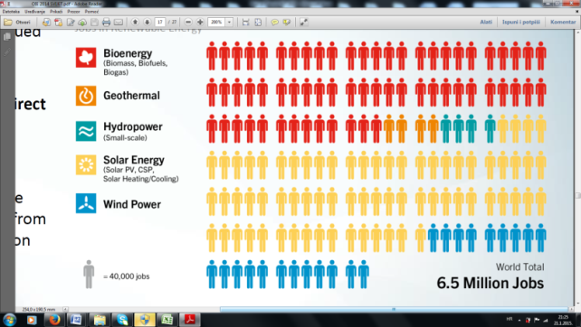

Figure 33. Employees in renewable energy sources in the world [6-16]

We come to the conclusion that the largest number of jobs was recorded in bio-energy, which is followed by solar and then wind energy, as a renewable energy source. In total, around 6.5 million job posts have been realised. When it comes to employment in bio-energy, the number one is a fundamental choice of bio-energy (production of pellets and briquettes) with about 58%.

5. Conclusion

The use of fossil fuels in energy production has already caused global climate changes, which humanity faces in recent decades. Climate changes are such that there has been an increase in carbon dioxide and other greenhouse gases in the atmosphere. However, what we know is that the effects of climate changes are already noticeable in the World. Thus, we can notice and see that the glaciers are melting, polar ice is breaking, permafrost is melting, sea level is rising, and eco systems are changing. These consequences are the consequences of the fossil fuels use, so that all humanity, i. e. the governments of almost all countries have been forced to seriously consider and make policies of development and replacement of fossil fuels with renewable energy sources. Various strategies have been proposed in the World and the EU, so that it can be concluded that the participation of renewable energy sources increases every year in the energy production in the world at the expense of fossil fuels, so that fossil fuels have a very small percentage of participation in the production of energy in 2050, and nearly 95% of energy production in the world is from renewable energy sources. When it comes to the use of renewable wind energy, we can conclude on the basis of Figure 3 that the energy production from wind-power plants in the world and the EU-28 is continuously increasing, and that the World reached a production of 318 gigawatts in 2013, while the EU-28 reached a production of 118 Gigawatts. A renewable energy source– sun– is trendy, so that the solar power increases from year to year, as shown in Figure 8. In the last ten years, energy production in the world has the tendency of exponential growth, so that it reached the value of 139 gigawatts in 2013. The production of solar energy in the EU-28 in 2013 reached a value of 81.4 gigawatts. The biggest producers of a renewable solar energy are Germany and China. By producing energy in this manner, we also have an increase on a yearly basis. We concluded that 263 gigawatts were produced in the world in 2013, while 29.6 gigawatts were produced in the EU-28 at the same year. The trend of producing energy in this way is growing both in the world and in the EU-28. By investing in renewable energy sources in the world, 2.800.000 workers have been employed, which represents the largest number of employees when it comes to the renewable energy sources. On the other hand, 800.000 workers have been employed in the EU-28. When it comes to energy production in 2013 using small hydropower plants distributed via continents, we can see that Asia has the highest production of 359.59 MW, and is followed by America 286.72 MW, then Europe with 224.56 MW, the European Union countries 29.63 MW, and Africa being last with 23.26 MW. On the European continent, Russia has the highest energy production using small hydropower plants with 46.87 MW in 2013, and is followed by Norway with 29.9 MW, France with 21.3 MW, and then: Spain, Italy, Sweden, Austria and Switzerland, which produce over 10 MW. In America, Brazil has the primacy of energy production by small hydropower plants, the United States being second and Canada third. When it comes to Asia, China is at the forefront with 213.4 MW. As a renewable source, biomass is mainly used for energy for heating, and this is a tradition as well. The development of new technologies leads to maximum utilization of the thermal power of biomass, so that the wood mass is produced from a pellet, which serves as the output of raw materials for heating energy. Figure 20 shows that the trend is increasing continuously, and the world production reached 23.6 million tons in 2013, the number one in production being the EU, the second the USA and Canada, which are followed by Russia, China and the rest of the world. The development of new technologies has led to the following products to be produced from a biomass: bio-diesel, ethanol and oil from the fruit. If we look at the trend of their output in Figure 20 b), a record production is 116.5 billion litres in 2013, so that the ethanol holds the first position, bio-diesel the second and the oil third. The largest producer of geothermal energy in 2013 in the world is the USA with 3.884 MW, the second place belongs to the Philippines with 1.920 MW, and the third is Indonesia with 1.380 MW. When it comes to the EU-28, Italy, which produces about 901 MW of geothermal energy, is number one in 2013. The capacity of renewable energy sources in the world in 2013 amounted to 560 gigawatts, the number one being a renewable source of wind power plants with a capacity of over 300 gigawatts, which is followed by solar energy (solar PV) with about 120 gigawatts, and then biomass with the energy of about 100 gigawatts. The European Union 28 produced 235 gigawatts of energy from renewable sources in 2013, the number one also being the wind, and solar energy being second. The investment in renewable energy sources has been continuous, so that the World invested 214 billion US$ in 2013, while the European Union invested 48.4 billion US$, which results in the formation of new job posts. Thus, about 6.5 million people have been employed to work in the renewable energy sources, and the trend is increasing from year to year.

6. Literature

[1] Isak Karabegović, V.Doleček, (2013), Current state and prospects for renewable energy sources with a special emphasis onpotential of solar energy in the world, europe and bosnia and herzegovina, Contemporary Materials (Renewable Energy Sources), Vol. IV. No. 2. 2013,Banjaluka, Bosnia and Hercegovina,
ISSN 1986-8677: pp. 171-179.
[2] Vlatko Doleček, Isak Karabegović,Renewable energy sources in Bosnia and Herzegovina: situation and perspectives ,Contemporary Materials (Renewable Energy Sources), Vol. IV. No. 2., Banjaluka, Bosnia and Hercegovina, ISSN 1986-8677: pp. 152 - 163.
[3] Agrafiotis, C. (2005). "Solar water splitting for hydrogen production with monolithic reactors". Solar Energy 79 (4): 409–421
[4] Anderson, Lorraine (1994). Cooking with Sunshine (The Complete Guide to Solar Cuisine with 150 Easy Sun-Cooked Recipes), Marlowe & Company. ISBN 156924300X
[5] Richards, B.S. ; Schäfer, A.I. (2009) Renewable Energy Powered Water Treatment Systems,
Chapter in: Escobar, I.C. ; Schäfer, A.I. (Eds.) (2009) Sustainable Water for the Future – Waterversus Desalination, Sustainability Science and Engineering: Defining Principles, Series Editor Abraham M.A., Elsevier, pp.353-374.
[6] Global Trends in Renewable Energy Investment 2014, Frankfurt School-UNEP Centre/BNEF. 2014.
[7] Renewable 2014 Global Status Report, New York, 2014.
[8] Renewable 2013 Global Status Report, Paris: REN21 Secretariat, 2013.
[9] Renewable 2012 Global Status Report, Paris: REN21 Secretariat, 2012.
[10] Renewable 2011 Global Status Report, Paris: REN21 Secretariat , 2011.
[11] Renewable 2010 Global Status Report, Paris: REN21 Secretariat, 2010.
[12] Renewable 2009 Global Status Report, Paris: REN21 Secretariat, 2009.
[13] Renewable 2008 Global Status Report, Paris: REN21 Secretariat, 2008.
[14] Renewable 2005 Global Status Report, DC:Worldwatch Institute. Washington, 2005.
[15] Global Trends in Renewable Energy Investment 2014, Frankfurt School-UNEP Centre/BNEF. 2014.
[16] Vanek F., Albright L., Angenent L. (2012) Energy Systems Engineering: Evaluation and Implementation, Conveo Publisher Service, New York.
[17] Daniels, Farrington (1964). Direct Use of the Sun's Energy, Ballantine Books. ISBN 0345259386
[18] Halacy, Daniel (1973). The Coming Age of Solar Energy, Harper and Row. ISBN 0380002337
[19] Hunt, V. Daniel (1979). Energy Dictionary, Van Nostrand Reinhold Company. ISBN 0442273959
[20] Karan, Kaul (2001). "Row Orientation Affects Fruit Yield in Field-Grown Okra". Journal of Sustainable Agriculture 17 (2/3): pp.169–174.
[21] Leon, M. (2007). "Mathematical modeling and thermal performance analysis of unglazed transpired solar collectors". Solar Energy 81 (1):pp. 62–75.
[22] Lieth, Helmut; Whittaker, Robert (1975). Primary Productivity of the Biosphere, Springer-Verlag1. ISBN 0387070834
[23] Meier, Anton (2005). "Solar chemical reactor technology for industrial production of lime".
Solar Energy 80 (10): pp.1355–1362.
[24] Mills, David (2004). "Advances in solar thermal electricity technology". Solar Energy 76 (1-3):pp. 19–31.
[25] Müller, Reto (2007). "Band-approximated radiative heat transfer analysis of a solar chemical reactor for the thermal dissociation of zinc oxide". Solar Energy 81 (10): pp.1285–1294.
[26] Vlatko Doleček,Isak Karabegović,(2013),Renewable Energy Sources of Bosnia and Hercegovina:State and Perspektives,8th International Conference on Renewable Energy and Energy Efficiency, Montenegrin Academy of Sciences and Arts,7.Oktober 2013,Podgorica,Montenegro,2013.
[27] Igor Raguzin,(2011),Model analize troškova i doboti uporabe biomase u proizvodnji električne energije,Magistarski rad, Strojarski fakultet Slavonski Brod.
[28] Šljivac,D. Šimić Z. (2009)Obnovljivi izvori energije, AWERES, FER, Zagreb.
[29] Miloš Banjac,(2012) Obnovljivi izvori energije u Srbiji, SREM,Ruma.
[30] Union of Concerned Scientists (1999) Benefits of Renewable Energy Use.
[31] Granić G., Željko M., (2008) Studija energetskog sektora u BiH. Modul 1, 2, 3, 4, 5, 6, 7, 8, 9, 10, Sarajevo.
[32] Armstrong J., Hamrin J. (2013) What are “Renewable Resources”?, Chapter 1: Renewable Energy Overview, Cost-Effectiveness of Renewable Energy, Organization of American States.
[33] Hondge B.K. (2010) Alternative Energy Systems and Applications, Mississippi State University.
[34] Buhrke T., Wengenmayr R. (2012) Erneuerbare Energie: Kozepte fur die Energiewende, Wiley-VCH Verlag GmbH, Weinheim.
[35] Ministero dello Sviluppo Economico (2012) Izvještaj o analizi stanja okolišnih tehnologija i obnovljivih izvora energije u BiH, Sarajevo.
[36] Đonlagić M. (2010) Obnovljivi izvori energije, Centar za ekologiju i energiju, Tuzla.
[37] Jenkis N., Allan R., Crossley P., Strbac G. (2000) Embeddded generation, The Institution of Electrical Engineerings, London.
[38] European commission, Directorate-General for Energy and Transport: (2001) COM 2001/77/EC Direktive on Electricity production from Reoewable Energy Sources.
[39] Đereg N., Kolmar Z. i dr. (2008) Obnovljivi izvori energije u Srbiji, Subotica.
[40] Knežiček Ž. (2011) Strateški pravci energetske efikasnosti TK, Tuzla.
[41] Dobrilović I. (2013) „Energetski sektor Bosne i Hercegovine“, INFOKOM, god. 6, br. 55, str. 24-27, Sarajevo.
[42] IPCC,Intergovernmental Panel on Climate Change: Fourth Assessment Report, Synthesisreport,2007. pp.52.
[43] Stjepan Car, Obnovljivi izvori energije, FER, Zagreb,2009.
[44] WWF The Energy Report 2010.pp:24
[45] International Energy Agency (IEA), Head of Publications Service, 9 rue de la Fédération, 75739 Paris Cedex 15, France.( www.worldenergyoutlook.org/media/weowebsite/2008.../WEO2006)
[46] World Small Hydropower Development Report 2013, Published in 2013 by United Nations Industrial Development Organization and International Center on Small Hydro Power,2013.
[47] AEBIOM,EuropeAn Bioenergx Outlook,2014.
[48] AEBIOM, Annual Report,2013.
[49] http://en.wikipedia.org/wiki/Renewable_energy (4.10.2014.)
[50] http://www.obnovljivi.com/geotermalna-energija/67-iskoristavanje-geotermalne-energije-u-energetici;(4.10.2014.)
[51] http://www.wbdg.org (5. 10. 2014)
[52] http://www.inhabitat.com (18. 11. 2014)
[53] http://www.q-solar.com (22. 11. 2014)
[54] http://www.klubmamut-wordpress.com (12. 12. 2013)
[55] http://www.bpz.hr (05. 01. 2015)
[56] http://www.intrade.co.ba (07. 01. 2015)

