VIII Међународни научни скуп Савремени материјали 2015 – Бања Лука, 6-7 септембар 2015.
VIII International Scientific Conference Contemporary Materials 2015 – Banja Luka, 6-7 September 2015

ПОБОЉШАЊЕ ПЕРФОРМАНСИ И ПРИМЕНЉИВОСТИ ЗЕЛЕНИХ КОМПОЗИТНИХ МАТЕРИЈАЛА ХИБРИДИЗАЦИЈОМ

IMPROVING PERFORMANCE AND APPLICABILITY OF GREEN COMPOSITE MATERIALS BY HYBRIDIZATION

Cristiano Fragassa,1 Carlo Santulli,2 Ana Pavlovic,3 Milan Sljivic,4
1 Department of Industrial Engineering, University of Bologna, e-mail: cristiano.fragassa@unibo.it,
2 School of Architecture and Design, University of Camerino, e-mail: carlo.santulli@unicam.it
3 Department of Industrial Engineering, University of Bologna, e-mail: ana.pavlovic@unibo.it
4Mechanical Engineering, University of Banja Luka, e-mail: milan.sljivic@unibl.rs

Abstract: The growing concern over environmental issues and the common interest to find a viable alternative to the use of glass or carbon composites reinforced has led to an increased attention about ecologically sustainable polymer composites. These “green” materials are made by natural fibers as reinforce, filled with natural-organic fillers, hence derived from renewable or biodegradable sources. At the same time, this relatively new class of materials faces several limits in comparison to traditional composites especially regarding the proprieties of resistance. This paper investigates the advantages on use a combination of natural fibers for improving the mechanical proprieties of “green” composite materials. At the moment, the common opinion is that green composites are not usable in structural applications, and, as consequence, have to be relegated to unworthy applications (as fillers). On the contrary, there are several evidences that mixing different natural fibers (in a practice usually called as “hybridization”) leads to increase these material proprieties. Even if usually quite limited in term of percentage, from time to time these improvements permit a net enlargement in the fields of applications for green composites. Following a large State of Arts on green composites, including potential benefits and limits of these materials, the paper proposes several examples of hybridization showing its effect on mechanical proprieties.

Key words: ecosustainability, mechanical proprieties, Polymer–matrix composites, flax, basalt, vinylester

Сажетак: Раст забринутости због еколошких питања и заједнички интерес да се пронађе одржива алтернатива употреби стакла или угљеничним ојачанјима композита је довело до повећане пажње о еколошким одрживим композитним полимерима. Ови "зелени" материјала су направљени од природних влакана, као појачања, напуњених природним органским смолама, дакле био-деградабилним или изведене из обновљивих извора. Истовремено, ова нова класа материјала релативно се суочава са неколико ограничења у односу на традиционалне композите, посебно у погледу својстава саме отпорности. Овај рад истражује предности коришћења комбинацијом природних влакана за побољшање механичких особина "зеленог" композитних материјала. У овом тренутку, опште мишљење је да зелени композити нису употребљиви у структурним апликацијама, и као последица тога, потиснути су ка неприкладним апликацијама (као пунила). Напротив, постоји неколико доказа да мешање различитих природних влакана (у пракси обично познато као "хибридизација") доводи до побољшања механичких особина. Чак и ако обично ограничена у процентима, с времена на време ова побољшања дозвољавају проширење у области апликација за зелене композите.

Након праћења светских трендова и знања о зеленим композитима, укључујући и потенцијалне користи и ограничења ових материјала, овај рад предлаже неколико примера укрштања влакана показујући њихов утицај на механичке особине.

Кључне ријечи: еко одрживост, механичка својства, полимер-матрица композита, лан,
базалт, винил естар

INTRODUCTION
Hybrid composite materials are obtained by combining two or more different types of fibers in a common matrix. They offer a wider range of properties than it is the case for conventional composite materials, where a single kind of reinforcement is present [1-2]. Hybridization would ideally allow designers tailoring the composite properties to the exact needs of the structure under consideration. This can be achieved provided the properties of the hybrid composite are predictable within a reasonable range of incertitude from those of the originating composites. This is often not the case, especially when using as one of the reinforcement vegetable fibres, such as e.g., hemp or flax [3-4]. A number of reasons can be accounted for this difficulty, which include the presence of internal voids, or lumens, which are therefore limiting homogeneity of vegetable fibres, and the irregular diameter of these fibres, and leads to possible problems in terms e.g., of water absorption [5]. It is also worth reminding that vegetable fibres are composed of sections of variable geometry with an alternation of stronger and weaker parts, which is the consequence of the increasing number of defects with length, which tends to discourage the adoption of very long stretches of aligned fibres, whose entanglement can even be detrimental in the case serious damage is applied to the material [6]. This can be partially compensated by the use of woven structures, such as tissues, mats, etc., though it needs to be clarified in this case that technical fibres obtained from plants are in reality threads composed via the application of a torque by filaments often only loosely kept together [7]. All these difficulties resulted in the limited adoption of modelling features for composites and hybrids including vegetable fibres, because the principal laws for predicting the behaviour of composite materials, such as the rule-of-mixtures, need to be adapted to the particular conditions, exposed above, due to the presence of vegetable fibres, as was the case of recent studies [8].
In practical terms, the production of hybrid composites has been adopted as
an intermediate step for reducing the environmental impact of fiberglass through the partial replacement of glass fibres with vegetable fibres, such as jute, hemp, flax, sisal, kenaf, etc. [9-11]. The limits of this substitution especially arise whenever the service performance is simulated, through dynamical testing, such as impact and fatigue [12-13]. In this case, the residual performance obtained from these materials is also important, as the presence of vegetable fibres can lead to ineffective damage absorption and especially to complex degradation modes as far as a significant energy is applied to the material [14].
In recent years, basalt fibres have been considered as an alternative to glass, with some significant advantages: these include in environmental terms the absence

of requirement for fibre sizing, since basalt is extracted directly from the molten rock, and the improved resistance of basalt to acid environments, which is particularly desirable e.g., in the automotive sector [15-16]. As a result, basalt has also been applied in hybrid composites with vegetable fibres and with glass [17-
18]. These are far from being optimised though, especially with respect to the possible effect of different stacking sequences on their properties [19]. This is of crucial importance whenever the introduction in other application sectors is proposed, such as e.g., the nautical field, where it is going to be coupled with the use of more sustainable thermosetting matrices, not exclusively oil-based.
All these considerations suggest the interest of the present work on hybrid composite materials, a promising approach to extend the use of natural fibres (Fig.
1, 2) to modern applications.

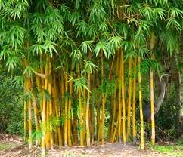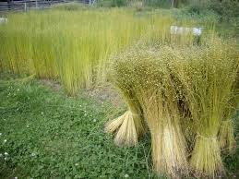
Fig. 1. Field of flax Fig. 2. Bamboo plantation

STATE OF ART ON GREEN COMPOSITES
Currently, as already stated, numerous research groups are dedicated to minimising the environmental impact of polymer composite production, where the polymer matrices are derived from renewable resources such as polylactide (PLA), thermoplastic starch (TPS) or thermoset matrices. Their high renewable content derives from vegetable oils and, combined with natural reinforced fibers (NF) to form environment-friendly and fully degradable composite laminates, they represent a potential substitute for petroleum based resins.

Natural matrices
“Green” matrix are partially or totally obtained by renewable sources and/or made by biodegradable polymers The availability of bio-based polymer matrices is nowadays relatively poor (Fig. 3), but it rapidly grows as more studies are done and more information are given.
Three different bio based polymer matrices commonly used:
- Thermoset matrices: polyols are compounds with multiple hydroxyl functional groups available for organic reactions, and they react with a large

number of chemical species, called curatives or hardeners, to produce cross-linked thermoset matrices. The most important oil used in polyols production is soy bean oil, but also cashew nut oil could give the same results. In order to decrease the impact of its activity on global warming, polyols can be also combined with petroleum based chemicals.
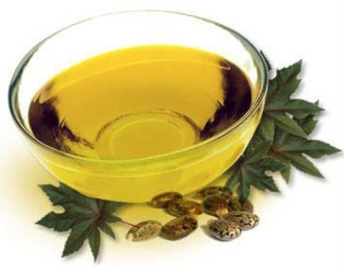- Thermoplastic matrices: the most commercially available plastic matrix is the cellulose one, which is properly toughened thus it is considered a 100% bio- based matrix. Starch based polymers and Poly lactic acid (PLA) are both available: the employment of the first ones depends on the ability to reduce their moisture absorption, while the second one has similar properties to polystyrene. In summary, the employment of these bio-based polymers depends on the possibility to modify their properties in order to obtain an easier processing and improve toughness in the final biocomposite.

Fig. 3. An example of bio-based resin

Green resins offer several advantages as:
− Low VOCs (Volatile Organic Compounds)
− Low emission of styrene
− No bisphenol or epichlorohydrin (toxic)
− Based on vegetable oil (by around 30-40%)
− No toxic exhalation
− No formaldeids
− Ipoallergenic
But event relevant disavantages as
− Low processability
− Higher costs

Natural Fibers
Natural fibers (Fig. 4) are compounds combining cellulose, hemicellulose and lignin; they can be derived from leaf (e.g. sisal), bast (e.g. flax, hemp), seed (e.g. cotton) and fruit (e.g. coir). Cellulose is a linear polymer obtained by poly- condensation glucose monomer (C6H12O6).

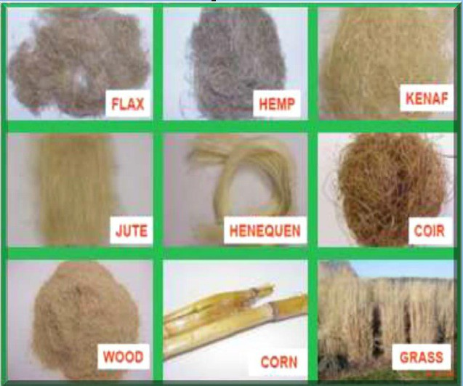
Fig. 4. The most common natural fibers used as reinforce

The most important advantages of use of natural fibers are, of course, related to the respect of environmental issues: they are biodegradable and carbon positive since they absorb more carbon dioxide than they produce. In addition, they are non-irritating and tend to be non-abrasive, with the latter property resulting in reduced wear on tooling and manufacturing equipment. Other important advantages are shown in term of specific material properties: using natural fibers in substitution of synthetic ones, it is possible to reduce the weight of an artefact by up to 40% and it is also possible to improve flexural strength, stiffness and ductility. In synthesis, natural fibers as reinforcement in composites permit:
− low density, typically 1.2-1.5 g/cm3 against 2.5 for glass and 1.7 for carbon
− good thermal and acoustic isolation
− low level of abrasion for process equipment
− low costs for materials
− easy to find and abundance of material with yearly renewable resources
− sustainable cultivation comparing to other chemical processes
− biodegradability
− low toxicity for workers

On the contrary, several disadvantages characterize the use of natural fibers as:
− variability in mechanical proprieties, related to physiological variability (e.g. age harvest, techniques for harvest and processing, environmental and climate factors);
− not excellent mechanical proprieties, in particular, for fatigue and creep resistance;
− low detectability in morphology, with high difficulty in controlling aspects as fibre porosity and thickness.

− biodegradability
Natural fibers have lower density values and they fit perfectly for non structural uses. In these terms, natural fibers can replace synthetic ones obtaining even more efficient results. In terms of overall strengths, for instance, even if mechanical proprieties are, sometimes, comparable, as in the case of fiberglass, synthetic fibres usually perform better than natural ones (Tab. 1).

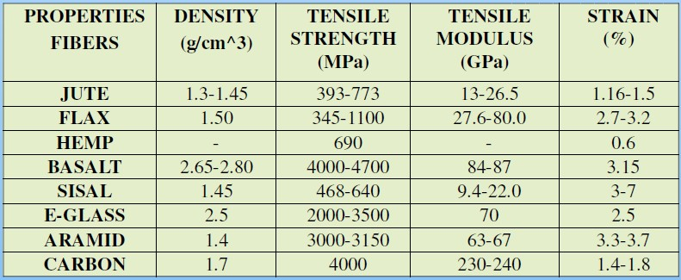
Tab. 1. Physical and mechanical properties in natural and synthetic fibers

Processing and processability
Regarding processes, literature data on green composites show a clear prevalence of wood end natural fibers in combination with polyolefins: this influences the information available on processing and processability. Typical processing techniques include extrusion followed by injection or compression molding. During the processing, temperature must not exceed 200°C and the retention time of the material exposed to high temperatures should not be too long in order to avoid fibers' degradation. Very common technologies for composite materials are resin transfer molding, vacuum injection molding, structural reacting injection molding, injection molding and compression molding. In specific applications, as prototypes, resin infusion and hand-up molding is also used.

MATERIALS AND METHODS
The potential relevance of hybridization in improving the mechanical proprieties of natural composites and, as consequence, in extending the field of application for this class of material can be investigated by specific experimental sessions as performed by authors in previous studies[17, 20, 21, 22].
In particular, during an investigation focused on sustainable materials for
sailing applications [23], five types of laminates were produced by resin infusion and hand-up molding. Three of them were composed by two natural fibers, flax or basalt (Fig. 5) combined with ecofriendly matrices (epoxy or vinylester). The other two were hybrids, obtained combining fibers (natural or not), mixed up with a

green thermoset resin: the first one is compound with both synthetic and natural fibers (carbon and flax), and the last one is compound with two different natural fibers (basalt and flax) (Fig. 6).
Finally, as term of comparison, two “traditional” glass fiber-reinforced
composites were manufactured, one obtained combining fibers with polyester resin and the other using glass fiber fabrics with epoxy as impregnant.

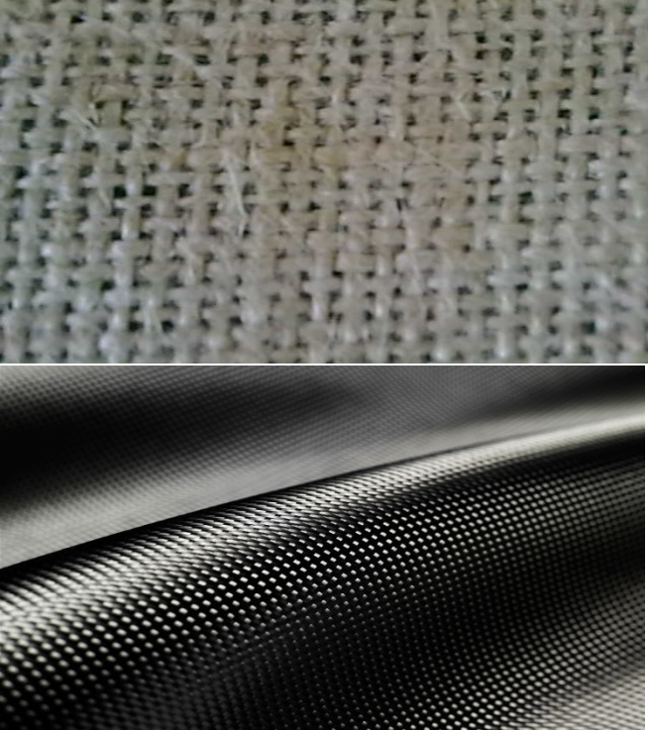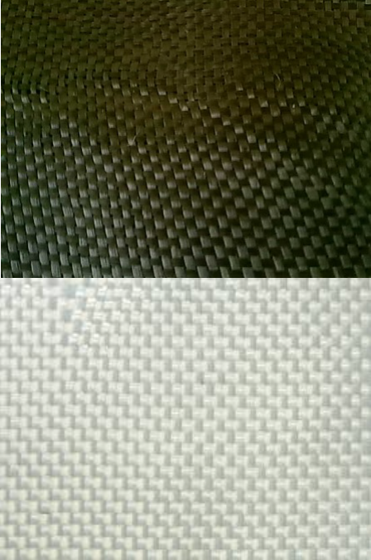Fig. 5. Natural and technological fibers used as reinforce during experiments: flax, basalt, carbon and glass

Flax fibers are commonly used for natural reinforced composites. They are considered to be complementary to glass ones. In terms of comparison, flax fibers tensile modulus is very close to glass fibers one, while their lower density makes them lighter. They can also be matched to the most important thermoset resins.
Basalt fibers is quite similar to carbon and glass fibers. They are cheaper than the first ones and have better mechanical properties than the second ones. At the same time, basalt fibers are ecologically clean and non-toxic for the end user.
Epoxy is, probably, the most common choice of resin for matrix in the production of composite materials. Its chemical formulation can largely be changed offering to the materials radically different proprieties. In the case of “green epoxy”, an high percentage of carbon biomass is included, in which 56% of the molecule is bio-renewable because of its plant origin.

Vinylester matrices have been patented as a revolutionary resin technology with extremely low content and emission of styrene. This low-VOC and low-HAP resin formulation minimizes emissions thereby reducing workplace exposure and environmental impact.

Composition of the laminates used during the tests is shown in Tab. 2.

SPECIMEN | FIBER | MATRIX | ECO
I. | FLAX | EPOXY (green) | Green
II. | FLAX | VINYLESTER (low styrene) | Green
III. | BASALT | VINYLESTER (low styrene) | Green
IV. | FLAX-CARBON | EPOXY (green) | Hybrid
V. | FLAX-BASALT | VINYLESTER (low styrene) | Hybrid
VI. | GLASS | POLYESTER | Synthetic
VII. | GLASS | EPOXY | Synthetic

Tab. 2. Details of composition for laminates

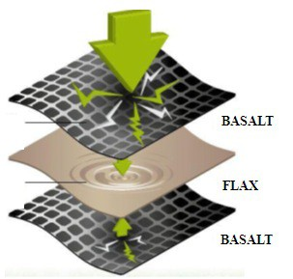
Fig. 6. Example of stratification of layers in a hybrid material

In order to determine all mechanical properties of green materials and hybrid laminates, four tests have been realized according to relevant standards (Fig. 7):
- Tensile test is performed according to ASTM D 3039 standard: a thin flat strip of material having a constant rectangular cross section is mounted in the grips of a mechanical testing machine and monotonically loaded in tension while recording load. The ultimate strength of the material can be determined from the maximum load carried before failure.

- Flexural test is performed according to ASTM D 790 standard: a bar of rectangular cross section rests on two supports and is loaded by means of a loading nose midway between the supports.
- The drop-weight impact test is performed, according to ASTM D 7136
standard, using a balanced, symmetric laminated plate. Damage is imparted through out-of-plane, concentrated impact (perpendicular to the plane of the laminated plate) using a falling weight with a hemispherical striker tip. The damage resistance is quantified in terms of the resulting size and type of damage in the specimen.
- Accelerated aging test uses aggravated conditions of heat and saline solution to speed up the normal aging processes of materials. It is used to determine the long term effects of expected levels of stress within a shorter time, usually in a laboratory by controlled standard test methods.

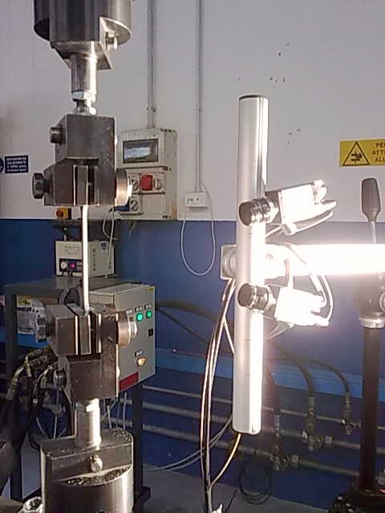

Fig. 7. Performing experimental (tensile) tests

A full description regarding the experimental sessions and measures are available in [23, 24, 25]. A brief synthesis is here reported.

EXPERIMENTAL EVIDENCES
Elastic modulus and yield/ultimate stress from experimental sessions are reported in Tab. 3. Stress-strain diagrams in the case of synthetic, natural and hybrid fibers for tensional and flexural tests are reported, respectively, in Fig 8-9.
Since these earliest results, it is already evident that green composites (e.g.
basalt fiber and vinylester matrix) can perform like other most common materials
(e.g. fiberglass), but adding the important propriety of ecosustainability.

In particular, basalt is a mineral fibre with several important proprieties as total reuse, high mechanical propriety (stress resistance and elastic modulus 15-
20% higher than glass fibre). It is evident how basalt represents a valid alternative to fiberglass (with the exception of the price) and can challenge with carbon in a significant range of advanced applications.

N. | FIBERS | MATRIX | Tensile |  |  |  |  | Flexural
N. | FIBERS | MATRIX | σ  MPa | ε  % | E  MPa | G  MPa | ν  - | σ  MPa | ε  % | E  MPa
I. | FLAX | EPOXY | - | - | - | - | - | 115.0 | 1.66 | 6930
II. | FLAX | VINYLESTER | 47.5 | 0.93 | 4854 | 2001 | 0.21 | - | - | -
III. | BASALT | VINYLESTER | 165 | 1.47 | 11042 | 5368 | 0.03 | 266.7 | 1.84 | 14481
IV. | FLAX- CARBON | EPOXY | - | - | - | - | - | - | - | -
V. | FLAX- BASALT | VINYLESTER | 86.5 | 1.12 | 8151 | 3879 | 0.13 | 139.5 | 1.69 | 8275
VI. | GLASS | POLYESTER | 67.05 | 0.89 | 8808 | 3755 | 0.17 | 127.5 | 2.16 | 5898
VII. | GLASS | VINYLESTER | 92.4 | - | - | - | - | 168.8 | 2.74 | 6157
Tab. 3. Mechanical proprieties of laminates

The stress-strain diagrams clearly show how changes in the composition (as fibers and matrices), permitted by hybridization, not only effect the mechanical resistances, but also the material behaviour as a whole. For instance, mixing flax fibers with basalt fibers, reduces the mechanical (flexural and tensile) resistance, but, on the other side, transforms a brittle composite in a ductile material.

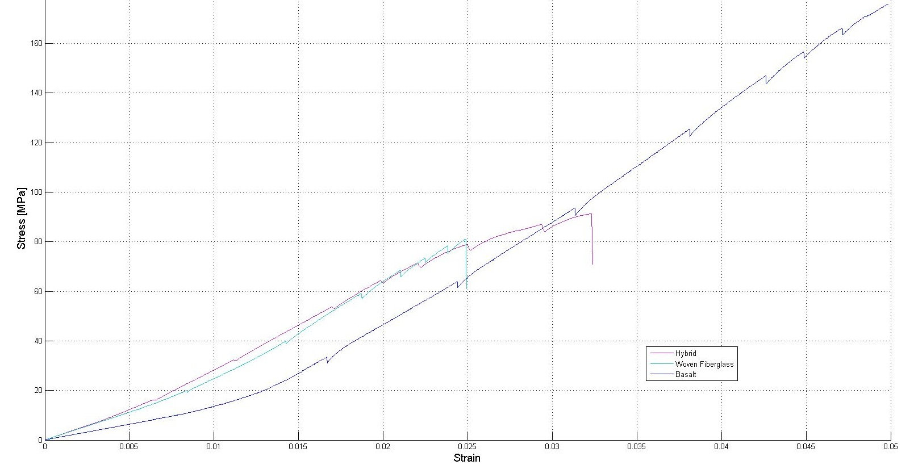Fig. 8. Tensional stress–strain diagram in the case of synthetic, natural and hybrid fibers.

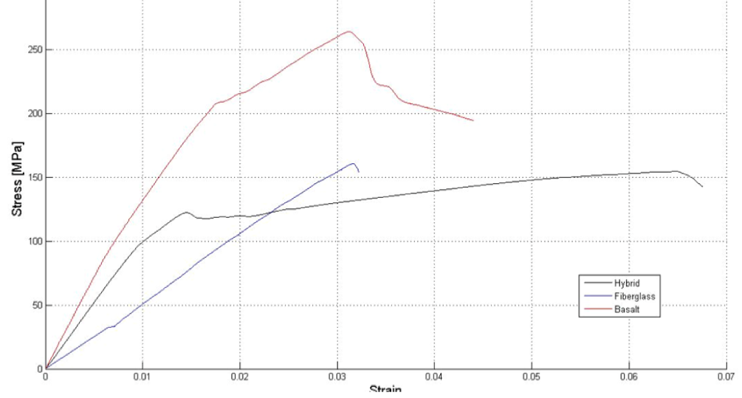

Fig. 9. Flexural stress–strain diagram in the case of synthetic, natural and hybrid fibers.

CONCLUSION
New environmental regulations and changing governmental attitudes are stimulating the research of new products and processes environmental friendly. Green composites seem to represent an emerging ecosustainable alternative to composites produced by traditional synthetic fibres and matrixes. The use of natural fibres within composite materials is predicted to be a growth market. Natural fiber reinforced biodegradable polymer composites appear to have a bright future for a wide range of applications. These biocomposites, characterised by various interesting technical properties, may soon be competitive with the existing fossil plastic materials. However, the present low level of production of natural fibers and resins, and, as a consequence, their higher cost on the market are reducing their applicability in industrial applications. Using hybrid systems for improving materials or structural performances of composites is a well-known concept in engineering design. All investigations have shown that the properties of hybrid natural/glass composites have been found to be an effective way to improve composite's mechanical properties and dimensional stability (moisture, temperature, etc.). The stiffness of biocomposites can thus be overcome by structural configurations that place material in specific locations for higher structural performances.

Acknowledgment
This investigation on application of advanced technologies for sustainable materials has been realized as part of AdriaHub implementation, a project co-funded by the European Union inside the Adriatic IPA Cross Border Cooperation program.

REFERENCES

1. R.A. Clark, M.P. Ansell, Jute and glass fibre hybrid laminates, J Mater Sci, 21 (1986), pp. 269–276.
2. M. Ramesh, K. Palanikumar, K. Hemachandra Reddy, Mechanical property evaluation of sisal–jute–glass fiber reinforced polyester composites, Composites Part B: Engineering 48 (2013), pp. 1–9.
3. S. Öztürk, The effect of fibre content on the mechanical properties of hemp and basalt fibre reinforced phenol formaldehyde composites, J Mater Sci, 40 (2005), pp. 4585–4592.
4. I.M. De Rosa, C. Santulli, F. Sarasini, M. Valente, Effect of loading-unloading
cycles on impact-damaged jute/glass hybrid laminates, Polym Compos, 30 (12) (2009), pp. 1879–1887.
5. L. Devi, S. Bhagawan, K. Nair, S. Thomas, Water absorption behavior of
PALF/GF hybrid polyester composites, Polym Compos, 32 (2011), pp. 335–346.
6. O.I. Benevolenski, J. Karger-Kocsis, K.P. Mieck, T. Reubmann, Instrumented perforation impact response of polypropylene composites with hybrid reinforcement flax/glass and flax/cellulose fibers, J Thermoplast Compos Mater, 13 (2000), pp. 481–496.
7. H.M. Akil, I.M. De Rosa, C. Santulli, F. Sarasini, Flexural behaviour of pultruded jute/glass and kenaf/glass hybrid composites monitored using acoustic emission, Mater Sci Eng, A, 527 (2010), pp. 2942–2950.
8. J. Summerscales, A. Virk, W. Hall, Review of bast fibres and their composites: Part 3 – Modelling, Composites Part A 44 (2013) pp. 132-139.
9. P. Wambua, J. Ivens, I. Verpoest, Natural fibres: can they replace glass in fibre reinforced plastics?, Compos Sci Technol, 63 (9) (2003), pp. 1259–1264.
10. C. Santulli, M. Janssen, G. Jeronimidis, Partial replacement of E-glass fibres with flax fibres in composites and effect on falling weight impact performance, J Mater Sci, 40 (2005), pp. 3581–3585.
11. J.H.S. Almeida Júnior, H.L. Ornaghi Júnior, S.C. Amico, F.D.R. Amado, Study of hybrid intralaminate curaua/glass composites, Mater Des, 42 (2012), pp. 111–
117.
12. C. Santulli, Review. Impact properties of glass/plant fibre hybrid laminates, J Mater Sci, 42 (2007), pp. 3699–3707.
13. I.M. De Rosa, C. Santulli, F. Sarasini, M. Valente, Post-impact damage characterization of hybrid configurations of jute/glass polyester laminates using acoustic emission and IR thermography, Compos Sci Technol, 69 (2009), pp.
1142–1150.
14. G. Cicala, G. Cristaldi, G. Recca, G. Ziegmann, A. El-Sabbagh, M. Dickert, Properties and performances of various hybrid glass/natural fibre composites for curved pipes, Mater. Des. 30 (2009), pp. 2538–2542.
15. M.T. Majid Tehrani Dehkordi, H. Nosraty, M.M. Shokrieh, G. Minak, D. Ghelli, The influence of hybridization on impact damage behavior and residual

compression strength of intraply basalt/nylon hybrid composites, Mater Des, 43 (2013), pp. 283–290.
16. M.T. Dehkordi, H. Nosraty, M.M. Shokrieh, G. Minak, D. Ghelli, Low velocity impact properties of intraply hybrid composites based on basalt and nylon, woven fabrics, Mater Des, 31 (2010), pp. 3835–3844.
17. R. Petrucci, C. Santulli, D. Puglia, F. Sarasini, L. Torre, J.M. Kenny, Mechanical characterisation of hybrid composite laminates based on basalt fibres in combination with flax, hemp and glass fibres manufactured by vacuum infusion, Mater. Des. 49 (2013) pp. 728-735.
18. H.N. Dhakal, F. Sarasini, C. Santulli, J. Tirillò, Z. Zhang, V. Arumugam, Effect of basalt fibre hybridisation on post-impact mechanical behaviour of hemp fibre reinforced composites, Composites Part A 75 (2015) pp. 54-67.
19. P. Amuthakkannan, V. Manikandan, J.T.W. Jappes, M. Uthayakumar, Influence of stacking sequence on mechanical properties of basalt–jute fiber- reinforced polymer hybrid composites, J Polym Eng, 32 (2012), pp. 547–554
20. C. Santulli, F. Sarasini, J. Tirillò, M. Valente, T. Valente, A.P. Caruso, M. Infantino, E. Nisini, G. Minak, Mechanical behavior of jute cloth/wool felts hybrid laminates, published online, Materials and Design, (2013), DOI:
10.1016/j.matdes.2013.02.014.
21. J. Sahari, S.M. Sapuan, Natural fiber reinforced biodegradable polymer composites, , Rev.Adv.Mater.Sci. 30 (2011) pp.166-174.
22. G. Bogoeva-Gaceva, M. Avella, et alt., Natural Fiber Eco-Composites, Polym. Compos., 28 (2007): pp. 98–107.
23. S. De Paola, C. Fragassa, G. Minak, A. Pavlovic, Green Composites: a review of state of art; Proceedings of 30th Danubia Adria Symposium, Sept. 2013.
24. A. Pavlovic, S. De Paola, C. Fragassa, G. Minak, Mechanical characterization of green composites: earliest experimental evidences by flexural tests, Proceedings of 21th Composite/Nano Engineering (ICEE), Aug. 2013.
25. A. Hyseni, S. De Paola, G. Minak, C. Fragassa, Mechanical characterization of ecocomposites, Proceedings of 30th Danubia Adria Symposium, Sept. 2013.

