TREATMENT OF LEACHATE BY ELECTROCOAGULATION USING IRON ELECTRODE

Borislav N. Malinovic^{1*}, Tijana Djuricic¹, Drazenko Bjelic², Dragana Neskovic Markic², Nikola Djukic¹, Danijela Djukic¹

¹University of Banja Luka, Faculty of Technology, Stepe Stepanovica 73, 78000 Banja Luka, B&H,
²JP Dep-ot, Bulevar Zivojina Misica 23, 78000 Banja Luka, B&H
borislav.malinovic@unibl.rs

Apstract. In this study has treated leachate with a high load organic and inorganic substances, using a electrocoagulation (EC) process with iron electrode. The treatment was preformed in a batch electrochemical reactor of 0,25 liter capacity with distance between electrodes 1,5 cm. The sample of leachate was supplied from regional sanitary landfill “Ramici”, Banja Luka. Effects of process parameters such as current density, supporting electrolyte and electrolysis duration are investigated on removal efficiencies of total disolved substances (TDS) and turbidity. The maximum TDS removal efficiency is achieved in 90 minutes of treatment (34,58%), and for turbidity (96,86%) for 60 minutes of treatment, at the current density j=25 mA/cm² and the concentration of supporting electrolyte γ_{NaCl}=1 g/L.

Key words: electrochemical treatment, landfill, total disolved substances, turbidity

INTRODUCTION

In addition to the municipal and industrial wastewater generated in various technological processes, landfill leachate require special attention and treatment because of the enormous impact on the quality of the environment. Leachate is formed when rainwater penetrates through the waste in a landfill and carries some forms of pollutants. The sanitary landfill is the most common method of disposal of urban solid waste [1]. In areas that have enough available land, sanitary landfills used for the disposal of municipal solid waste. However, even with numerous economic benefits, the sanitary landfill methods poses a number of environmental shortcomings, such as the generation of landfill leachate [2]. Leachate from landfills are one of the most toxic type of wastewaters, as well as in terms of the selection of appropriate techniques for their purification. Leachate composition depends on different factors, such as the kind of waste, site hydrology, age, type, and landfill operation [3].
For the treatment of landfill leachate there are a variety of technical and technological solutions. The treatment strategy generally depends on the characteristics of the leachate. Young landfill leachates are generally easier to treat compared with old ones [4]. Leachate from the old landfills contain less organic biodegradable matter and more toxic components, so the purification of the water should be used a combination of several different processes. Many studies have investigated different physical-chemical methods to treat landfill leachate and wastewater [5-8]. Biological treatment, including anaerobic and aerobic process is very efficient for leachate at an early stage with a high BPK₅/HPK relations. However it is not effective in the leachate with a fairly low BPK₅/HPK relations, or in high concentrations of toxic metals. Therefore, the physical-chemical processes commonly used for pre-treatment or treatment of these landfill water. Adsorption and membrane filtration are major physical leachate treatment methods [9-11]. Coagulation-flocculation, chemical precipitation, chemical and electrochemical oxidation methods are the most common chemical methods used for landfill leachate treatment [12-15].
In addition to the electrochemical oxidation, for treatment or pre-treatment of leachate is increasingly being used electrocoagulation methods. The electrocoagulation process involves the in situ generation of coagulants through the electro-dissolution of a sacrificial anode, which is usually made of iron or aluminium. The main electrochemical reactions are the oxidation of the metallic anode (Fe or Al) and the reduction of water. In the case of iron electrodes, iron (II) is rapidly oxidised to iron (III), and the system consequently behaves as if the iron (III) species were the dosed reagent [16]. The electrochemical reactions that occur in this process, including the formation of bubbles of gas (H₂ and O₂) to the electrodes. The bubbles of gas assist flotation, and thus promote the process itself. Compared to conventional chemical coagulation, electrocoagulation basic advantages are a smaller amount needed coagulate ions, the greater pollutants removal efficiency, there is no use of chemicals thus reducing the possibility of secondary pollution and reduces the quantity of sludge, less reaction time and consequently less, simple and easy handling equipment [17].
Ilhan et al. used electrocoagulation treatment of landfill leachate for reducing the COD values by using Fe and Al electrodes. They concluded that electrocoagulation is better method than chemical coagulation because electrocoagulation achieves greater efficiency to reduce COD and the reduction of sulphate [18]. Similar research of landfill leachate treatment by electrocoagulation conducted Kabuki et al. They found that the optimum operating conditions for the reduction of COD and removal of suspended solids and organic carbon are at the current density j=20 mA/cm², electrolysis duration t=60 min and pH=8. The optimum operating conditions for the removal of Kjeldahl nitrogen and NH₃-N are at the current density j=30 mA/cm², electrolysis time t=60 min and pH=8 [19]. The process of electrocoagulation also use Mussa et al. for purification and decolorization landfill leachate. They achieve the color removal, removal of NH₃-N and total phosporus removal in the amount of 70%, 37% and 62%, respectively, with the working conditions: electrolysis time of 120 minutes, the concentration of supporting electrolyte Cl⁻ 5,75 g/L, carbon electrodes [20]. Integrated electrocoagulation process and anodic oxidation for treatment of landfill leachate used Norma et al. They concluded that the best results are achieved with combined treatment using the highest current density and that in electrocoagulation best removal of dissolved organic carbon is achieved at conditions: initial pH=4 and pH=8,6, without stirring [21]. Meunier et al. carried out the removal of heavy metals from acidic leachate from saline land by electrochemical coagulation and chemical deposition. They concluded that by electrocoagulation can be achieved removal efficiency of heavy metals and up to 99% at pH=8,5, except for the removal of Cd. Also, they concluded the electrocoagulation is cheaper method than chemical deposition [22].
In this study will be treated landfill leachate by electrocoagulation method, which is increasingly used because of its efficiency, simplicity and economy.

MATERIAL AND METHODS

The experimental part of the research consists in the application of electrocoagulation treatment for purification of landfill leachate. Sample of landfill leachate was taken from the regional sanitary landfill - "JP Regional Landfill DEP-OT," Ramici, Banja Luka. Leachate water drainage into pipes leading into the tank (Figure 1), and then in the reverse osmosis plant for treatment of landfill leachate.

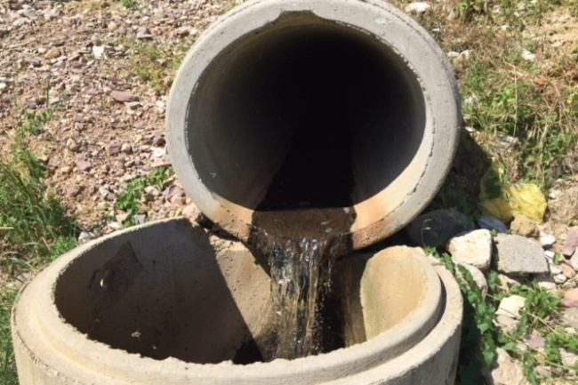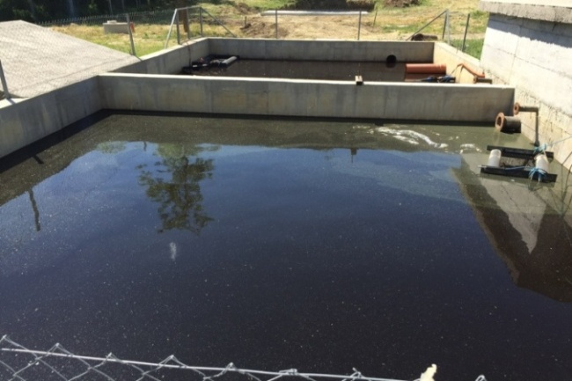

Figure 1. Drainage pipe and landfill leachate tanks (regional sanitary landfill Ramici)

Experimental setup is shown on the Figure 2. The batch electrochemical reactor of 250 cm³ capacity made from polypropylene with constant mixing (400 rpm) was used, combined with two electrodes of the same area surface. The dimensions of the electrodes are 40x40x1 mm. The total effective area of one electrode is 37,3 cm², and the distance between 2 cm. Electrodes were connected to digital power source (Atten, APS3005SI; 30V, 5A) with the potentiostatic and galvanostatic operating options.
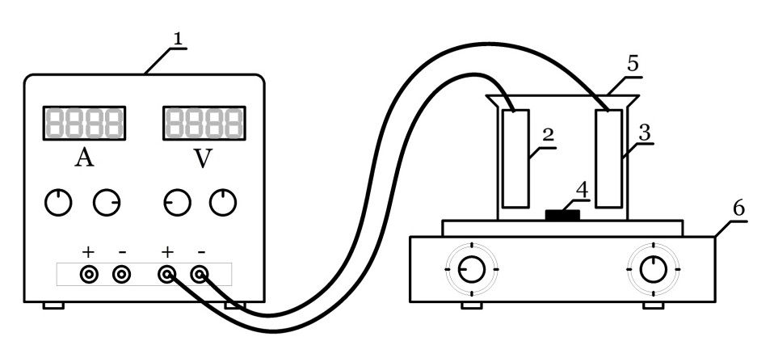
Figure 2. Schematic view of electrochemical reactor
1 – source of electric power; 2 – anode; 3 – cathode; 4 – magnetic stir bar; 5 – electrochemical cell;
6 – magnetic stirrer)

All the experiments were performed at an ambient temperature, with the wastewater volume of 200 cm³. Before each treatment electrodes were cleaned and degreased and the current density was set to a certain value. As an electrode material was used steel (EN 10130-91; max. 0,08% C, max. 0,12% Cr, max. 0,45% Mn, max. 0,60% Si), which meet the required standards. All the used chemicals are of p.a. purity. For the purpose of experiment were used the following commercially available chemicals: 99,5% sodium chloride (Lachner, Czech Republic), 97% sodium hydroxide (Zorka Sabac, Serbia), 36% hydrochloric acid (Lachner, Czech Republic), Acetone (Lachner, Czech Republic).
The values of parameters before treatment are given in the following table.

Table 1. The results of analysis of sample landfill leachate
Rb. | Parameter | Measuring unit | Result
1. | pH | - | 7,98
2. | TDS | g/L | 12,5
3. | Conductivity | mS/cm | 19,5
4. | Electrolyte resistivity | Ωcm | 51
5. | Salinity | SAL | 13,2
6. | Turbidity | NTU | 104

Treated landfill leachate after each treatment was adjusted pH=11 (using NaOH), and the formed precipitate was filtered through filter paper, Filtres Fioroni, France (Ref.:0015A00007; size: 125 mm, qty.: 1000). The samples of landfill leachate before and after treatment were analyzed on the following parameters: turbidity, total dissolved substances, pH, electrolyte resistivity (ρ), conductivity (κ) and salinity (SAL). TDS, ρ, κ and SAL are determined on the multimeter (Consort C861), and a turbidity on the turbidimeter (LP 2000, HANNA instruments).

RESULTS AND DISCUSION

Results of the electrochemical treatment of landfill leachate are shown through removal efficiency of TDS and removal efficiency of turbidity, Eu (%), whose ratio could be described by following equation:
(1)
where are γ_{i} and γ_{f} the initial and the final value of parameter which efficiency is determined.

Examined the influence of current density on the efficiency of removing total dissolved solids and turbidity. According to literature the optimal current density was j=10–60 mA/cm² [21]. In this experiment was used current densities of 10, 25 i 50 mA/cm². Figure 3 shows that the higher removal of TDS is achieved at a current density of j=25 mA/cm² (25,28%). The highest turbidity removal efficiency is at j=50 mA/cm² and amounts 98,13%, and at j=25 mA/cm² amounts 76,16% (Figure 4). Although the difference in the achieved efficiency at high current density is not negligible, for further experiments used the current density j=25 mA/cm², considering that lower density reduces investment costs.

Figure 3. TDS removal efficiency at different current densities (t=30 min, stirring 400 rpm)

Slika 4. Turbidity removal efficiency at different current densities (t=30 min, stirring 400 rpm)

Figures 5 and 6 shows the impact of concentration of supporting electrolyte on TDS and turbidity removal efficiency. The highest TDS removal efficiency is at concentration of supporting electrolyte of γ_{NaCl}=2,0 g/L and amounts 19,8% (Figure 5). Further, the highest turbidity removal efficiency is at γ_{NaCl}=1,0 g/L and amounts 66,56% (Figure 6). Due to the small differences in the achieved removal efficiencies of TDS at γ_{NaCl}=1,0 g/L and γ_{NaCl}=2,0 g/L, and for the reasons stated in the previous experiment, in next research using the concentration of supporting electrolyte γ_{NaCl}=1,0 g/L.

Figure 5. TDS removal efficiency in dependence of the concentration of NaCl
(j=25 mA/cm², t=30 min, stirring 400 rpm)

Figure 6.Turbidity removal efficiency in dependence of the concentration of NaCl
(j=25 mA/cm², t=30 min, stirring 400 rpm)

Figures 7 and 8 shows the impact of electrolysis duration (15; 30; 60; 90 and 120 min) on the TDS and turbidity removal efficiency. The highest removal efficiency of TDS is achieved at the electrolysis duration of 90 minutes and amounts 34,58% (Figure 7), and the highest removal efficiency of turbidity is at 60 minutes of electrolysis and amounts 96,86% (Figure 8).

Figure 7. The impact of electrolysis duration on the removal of TDS
(j=25 mA/cm², c_{NaCl}=1g/L, stirring 400 rpm)

Figure 8. The impact of electrolysis duration on the removal of turbidity
(j=25 mA/cm², c_{NaCl}=1g/L, stirring 400 rpm)

CONCLUSION

Based on the presented results it can be conclude that the electrocoagulation process is an alternative to other methods of treatment of landfill leachate wastewater. By increasing the duration of electrocoagulation increases the removal efficiency of total dissolved solids and turbidity.

IZVOD

U ovom istraživanju tretirane su procjedne vode visoko opterećene organskim i neorganskim materijama, elektrokoagulacijom sa željeznim elektrodama. Ispitivanje je provedeno u laboratorijskom šaržnom elektrohemijskom reaktoru kapaciteta 0,25 L, sa razmakom između elektroda 1,5 cm. Uzorak procjednih voda je uzet iz regionalne sanitarne deponije “Ramići”, Banja Luka. Ispitan je uticaj procesnih parametara kao što su gustina struje, pomoćni elektrolit i vrijeme trajanja elektrolize na efikasnost uklanjanja ukupno rastvorenih čvrstih supstanci (total dissolved solids - TDS) i efikasnost uklanjanja mutnoće. Maksimalna efikasnost uklanjanja TDS-a postignuta je za 90 minuta tretmana (34,98%), a maksimalna efikasnost uklanjanja mutnoće za 60 minuta tretmana (96,86%) pri gustini struje j=25 mA/cm² i koncentraciji pomoćnog elektrolita γ_{NaCl}=1 g/L.

Ključne riječi: elektrohemijski tretman, procjedne vode, efikasnost uklanjanja

REFERENCES

[1] Mojiri, A., Aziz, H., Zaman, N., Aziz, S., & Zahed, M. Powdered ZELIAC augmented sequencing batch reactors (SBR) process for co-treatment of landfill leachate and domestic wastewater. Journal of Environmental Management, 139 (2014), 1-14.
[2] Aziz, S. Q., Aziz, H. A., Mojiri, A., Bashir, M., Salem, S., Amr, A. Landfil Leachate Treatment Using Sequencing Batch Reactor (SBR) Process: Limitation of Operational Parameterts and Performance. International Journal of Scientific Research in Knowlwdge, 1(3) (2013), 34-43.
[3] Foul, A.A., Aziz, H.A., Isa, M.H., Hung, Y.T. Primary treatment of anaerobic landfill leachate using activated carbon and limestone: batch and columnstudies. Inter. J. Environ. Waste Management, 4 (2009), 282-290.
[4] Kargi, F. & Pamukoglu, M. Adsorbent supplemented biological treatment of pre-treated landfill leachate by fed-batch operation. Bioresource Technology, 94(3) (2004), 285-291.
[5] Mojiri, A. Review on Membrane Bioreactor, Ion Exchange and adsorption Methods for Landfill Leachate Treatment. Australian Journal of Basic and Applied Sciences 5, 5(12) (2011), 1365-1370.
[6] Bashir, M., Aziz, H., Yusoff, M., Aziz, S., Mohajeri, S. Stabilized Sanitary Landfill Leachate Treatment Using Anionic Resin: Treatment optimization by Response Surface Methodology. Journal of Hazardous Materials, 182(1-3) (2010), 115-122.
[7] Foo, H. & Hameed, B. An overview of landfill leachate treatment via activated carbon adsorption process. Journal of Hazardous Materials, 171(1-3) (2009), 54-60.
[8] Dhas, J. Removal of COD and Colour from Textile Wastewater Using Limestone and Activated Carbon. MSc thesis. University Sains Malaysia, Cagliary, Italy: IWWG- International waste working group, 2008.
[9] Kiliç, M., Kestioglu, K., Yonar, T. Landfill Leachate treatment by the combination of physicochemical methods with adsorption process. Journal of Biodiversity and Environmental Sciences, 1(1) (2007), 37-43.
[10] Bohdziewicz, J., Bodzek, M., Gorska, J. Aplication of pressure-driven membrane techniques to biological treatment of landfill leachate. Process Biochemistry, 36(7) (2001), 641-646.
[11] Trebouet, D., Schlumpf, J., Jaounen, P., Quemeneuer, F. Stabilized landfill leachate treatment by combined physicochemical-nanofiltation process. Water Research, 35(12) (2001), 2935-2942.
[12] Ahn, D., Yun-Chul, C., Won-Seok, C. Use of coagulation and zeolite to enhance the biological treatment efficiency of high ammonia leachate. Journal of Environmental Science and Health, 37(2) (2002), 163-173.
[13] Marttinen, S., Kettunen, R., Somunen, K., Soimasuo, R., Rintala, J. Screening of physical-chemical methods for removal of organic material, nitrogen and toxicity from low strength landfill leachates. Chemosphere, 46(6) (2002), 851-858.
[14] Chiang, L. & Chang, C. Electrochemical oxidation combined with physical-chemical pretreatment processes for the treatment of refractory landfill leachate. Environmental Engineering Science, 18(6) (2001), 369-378.
[15] Lin, S. & Chang, C. Treatment of landfill leachate by combinde electro-fenton oxidation and sequencing batch reactor method. Water Research, 34(17) (2000), 4243-4249.
[16] Lacasa, E., Canizares, P., Saez, C., Fernandez, F. J., Rodrigo, M. A. Electrochemical phosphates removal using iron and aluminium electrodes. Chemical Engineering Journal, 172(1) (2011), 137-143.
[17] Malinovic, B.N., Malinovic, T., Bunic, S.: Treatment of cyanides in a flow electrochemical reactor, XXIV International Conference “Ecological Truth”, Eco-Ist’16, Vrnjacka Banja, 12-15 june 2016, 398-407
[18] Ilhan, F., Kurt, U., Apaydin, O., Talha Gonullu, M. Treatment of leachate by electrocoagulation using aluminum and iron electrodes. Journal of Hazardous Materials, 154(1-3) (2008), 381-389.
[19] Kabuk, H. A., Ilhan, F., Avsar, Y., Kurt, U., Gonullu, M. T. Investigation of Leachate treatment with Electrocoagulation and Optimization by Response Surface Methodology. Clean-Soil, Air, Water, 41 (2013), 1-7.
[20] Mussa, Z. H., Othman, M. R., Abdullah, M. P.: Electrocoagulation and Decolorization of Landfill Leachate. Bangi, Selangor: School of Chemical Science and Food Technology, Faculty od Science and Technology, University Kebangsaan, Malaysia, 2013.
[21] Norma, D., Fernandes, A., Pacheco, M., Ciríaco, L., Lopes, A. Electrocoagulation and Anodic Oxidation Intergrated Process to Treat Leachate from a Portuguese Sanitary Landfill. Portugaliae Electrochimica Acta, 30(3) (2012), 221-234.
[22] Meunier, N., Drogui, P., Montané, C., Hausler, R., Blais, J.-F., Mercier, G. Heavy Metals Removal from Acidic and Saline Soil Leachate Using Either Electrochemical Coagulation or Chemical Precipitation. Journal of Environmental Engineering, 132(5) (2006), 545-554.

