DIFFERENTIAL SCANNING CALORIMETRY ANALYSIS OF
FROZEN PORK MEAT

Danica Savanović^{1*}, Radoslav Grujić², Sladjana Rakita³, Vesna Gojković², Dragan Vujadinović²

¹Faculty of Technology, University of Banja Luka
²Faculty of Technology, University of East Sarajevo
³Institute of Food Technology, University of Novi Sad

*The corresponding author: Danica Savanović, email: danicasavanovic@yahoo.com

Abstract

Differential scanning calorimetry (DSC) is a thermal analysis technique used to study the thermal behaviors of different food systems. The aim of this work was to determine the freezing points (T_{c}on, T_{c}, T_{c}end), the melting points (T_{m}on, T_{m}, T_{m}end), enthalphy of crystallization (ΔH_{c}) and enthalphy of melting (ΔH_{m}) of pork meat, using the differential scanning calorimetry (DSC) method. Samples of pork meat were scanned at five rates (2, 5, 10, 15, 20 °C/min). The percent of freezable water (FW) was calculated using the area of the integrated endothermic peak at the range of 0 °C. It was observed that the crystallization peaks increased with an increasing scanning rate. The cooling rate affected the onset (T_{c}on), peak (T_{c}) and end temperatures (T_{c}end) of crystallization process of pork meat (p<0.05). However, the enthalpy of crystallization (ΔH_{c}) did not change with a changing cooling rate (p>0.05). The influence of the heating rate on the enthalpy of melting (ΔH_{m}), onset (T_{m}on), peak (T_{m}) and end temperatures (T_{m}end) of melting process was reported, as well as the contents of freezable and unfreezable water in pork meat, depending on the scanning rates. The width of the melting peaks decreased with a decreasing heating rate, which resulted in a significant (p<0.05) change of the melting enthalpy (ΔH_{m}), from 213.60 J/g for the rate of 20 °C/min to 193.23 J/g for the rate of 2 °C/min. Analogously to the enthalpy of melting, the significant (p<0.05) increase in freezable water content was recorded in frozen pork meat, from 57.94% for the rate of 2 °C/min to 64.05% for the rate of 20 °C/min.

Key words: DSC, pork meat, crystallization, melting

INTRODUCTION

Differential scanning calorimetry (DSC) is a thermal analysis technique, which can be used for determining thermal transitions of different food systems [1-6]. In this method, the sample and a reference are cooled or heated at a constant rate, and endo- or exothermic reactions occurring in the sample are registered as differences in heat flow to sample and reference [7]. During analysis the signal from a sample cell is compared with a reference cell in an identical environment. As the temperature of the cells is changed, the temperature differences between the reference and sample cells are continuously measured and calibrated to power units. This data channel is referred to as the differential power or the DP signal between the reference and sample cells. The DP signal is converted to heat capacity, and the heat capacity is continuously recorded as a function of temperature [8].

In a generated DSC thermogram the rate of heat transfer is plotted versus temperature for a small amount of sample. That provides information on the energy released or absorbed in the form of latent heat during phase transition of that sample [3, 9, 10]. Differential Scanning Calorimetry (DSC) has been used by many researchers to measure the enthalpy of fusion, apparent specific heat and temperatures of phase transitions of food materials [4, 11, 12]. Crystallization of water during freezing and melting of ice during thawing of food are the most commonly occurring phase transitions in food [4, 13-15]. Physico-chemical and sensory characteristics of foods may be altered after freezing and thawing and these processes are extremely important for food quality [16-19].

The freezing process is widely used in the food industry, becoming the leading process for long shelf life preservation of foods. Especially, large quantities of meats are frozen before use [17, 20, 21]. The freezing process depends on the heat transfer phenomenon occurring in the food matrix, and heat transfer is a function of temperature difference and thermophysical properties of food products [22]. Knowledge of thermodynamic properties (such as initial freezing point, fraction of frozen water, specific heat and enthalpy) at refrigeration and freezing temperatures is essential for the efficient design and selection of processes and equipments, estimation of freezing and thawing time, and control of operating costs [12]. Freezing point (T_{f}) is one of the most important properties of food. It is the lowest temperature at which a product can be refrigerated and stored unfrozen. This property is used in prediction models of thermal properties, freezing and thawing times in order to optimize the process and the product quality [23].

Differential scanning calorimetry (DSC) offers the possibility to measure the freezing and melting properties of food, including the freezing and melting temperatures. DSC analysis can be performed with different scanning rates; however, there are little studies in the literature which compare DSC thermograms in case of different cooling and heating rate of food. The aim of this work was to determine the freezing points (T_{c}on, T_{c}, T_{c}end), the melting points (T_{m}on, T_{m}, T_{m}end), enthalphy of crystallization (ΔH_{c}) and enthalphy of melting (ΔH_{m}) of pork meat, using the differential scanning calorimetry (DSC) method, with various cooling/heating rate.

MATERIALS AND METHODS

Standard procedure

In this study pork meat (M. Longissimus dorsi) is investigated. It was used fresh post-rigor meat, purchased at the slaughter house.

Differential scanning calorimetry thermograms were obtained using a differential scanning calorimeter DSC (204 F1 Phoenix, Netszch). Samples (14±2 mg) were weighed into 25 µl capacity aluminium pans. After that pans were hermetically sealed. An identical empty pan was used as a reference sample during the experiments. The calibration of the cell was made following the DSC manufacturers' recommendation. Flow rate of purge nitrogen atmosphere was 20 ml/min.

The temperature of onset crystallization (T_{c}on), peak crystallization (T_{c}), end crystallization (T_{c}end) and enthalpy of crystallization ΔH_{c} (J/g) were measured from the cooling curves and analyzed for the crystallization process. The following temperatures were analyzed for the melting process: temperature of onset melting (T_{m}on), peak melting (T_{m}) and end melting (T_{m}end). The melting temperature interval was computed as width of melting peak (ΔT_{m}=T_{m}end-T_{m}on) and the crystallization temperature interval was computed as width of crystallization peak (ΔT_{c}=T_{c}on -T_{c}end). Enthalpy of melting ΔH_{m} (J/g) was determined as the area limited by the melting curve and base line. The Proteus software was used to analyze the DSC thermograms and evaluate the thermo-physical properties of meat.

Influence of scanning rate on thermo-physical properties of pork meat

Samples of pork meat were cooled and heated at five rates (2, 5, 10, 15, 20 °C/min). In each scan the sample was equilibrated at 20 °C for 5 min and then cooled to -40 °C at a preset rate; after an isothermal holding stage (-40 °C) of 5 min, the sample was heated at same rate to 20 °C. All the measurements were performed in triplicate.

Determination of the freezable water

The percent of freezable water (FW) was calculated using the area of the integrated endothermic peak at the range of 0 °C. The endothermic peak arises from the phase transition of ice into water. Eq. (1) was used in order for the freezable water of the meat to be estimated [21].
FW(%) = (1)
Where, FW is the percent of freezable water, Q is the enthalpy of melting (J/g), H_{f} represents the heat of fusion ice–water equal to 333.50 J/g of ice/water and m_{s} is the mass of the sample. The percent of unfreezable water (UFW) was calculated by subtracting the percent of freezable water from the percent of total water [24]. The total water content of meat was determined by the method of drying at 105±2 °C to constant mass [25]

Statistical analysis

The results of this study are presented as the mean values accompanied with their standard deviations of three measurements. One factor analysis of variance (ANOVA) was performed using the IBM SPSS 22 software. Where significant differences (p<0.05) were detected, Tukey’s multiple comparison was used to compare treatment means and create statistically homogeneous groups.

RESULTS AND DISCUSSION

The effect of the scanning rate on the crystallization and melting processes in pork meat

Differential scanning calorimetry (DSC) is a suitable method to characterize different phase transitions in food, such as crystallization and melting [2, 10].

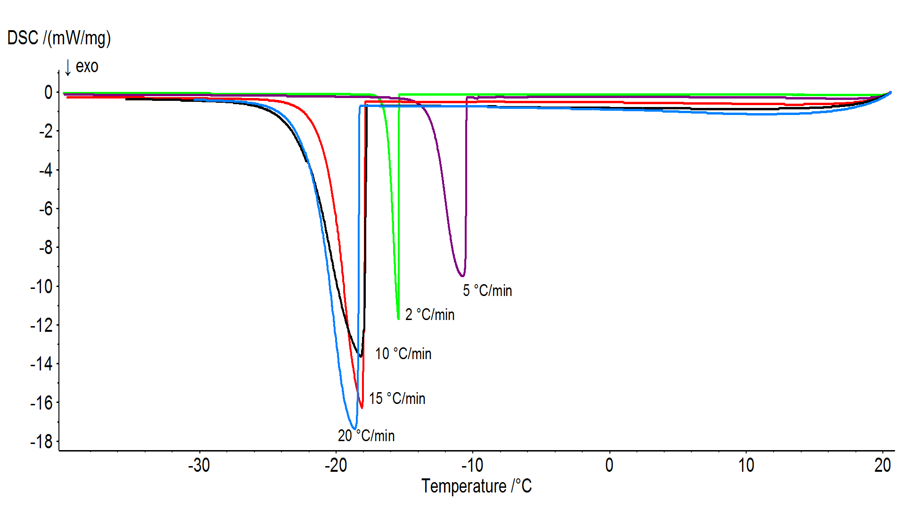
Figure 1 presents crystallization curves of pork meat obtained using different cooling rates (2, 5, 10, 15 and 20 °C/min). As seen in the Figure 1, the crystallization peaks increased with an increasing scanning rate. However, the enthalpy of crystallization (ΔH_{c}) did not change with a
changing cooling rate (p>0.05) (Table 1).

Figure 1. DSC crystallization curves of pork meat at different cooling rates (2, 5, 10, 15 and 20 °C/min)

Different transition temperatures of crystallization for pork meat were recorded with various cooling rates (2, 5, 10, 15 and 20 °C/min). The temperature at which begins the process of crystallization (T_{c}on) and temperature of peak crystallization (T_{c}) in pork meat, for the rate 5 °C/min were -10.53 °C and -10.83 °C, respectively, being significantly different (p<0.05) from the other rates. In this study significant (p>0.05) differences were not found between the values of onset crystallization temperature (T_{c}on) as well as temperature of peak crystallization (T_{c}) for the cooling rates 2, 10, 15 and 20 °C/min (Table 1).

However, the mean values of end crystallization temperature (T_{c}end) for pork meat significantly (p<0.05) changed with the increase in the cooling rate from 2 to 10 °C/min (Table 1). The mean values of T_{c}end of pork meat were: -16.80; -13.10 and -20.20 °C for the rate of 2, 5 and 10 °C/min, respectively. In this study significant differences between the values of end crystallization temperature (T_{c}end) were not found (p>0.05) in the range of cooling rates from 10 to 20 °C/min. Moreover, it was observed that the cooling rate had significant (p<0.05) effect on the crystallization temperature interval (ΔT_{c}), which increased with increasing cooling rate (Table 1). Similarly, Tomaszewska-Gras [10] reported that the shape of the curve as well as heights of crystallization peaks of milk fat change depending on cooling rate. A food material is a complex biochemical system where multiple interactions occur during any type of process [26], while the different situation is with pure substances. According to the physics, the onset values for pure substances should be always the same, despite the scanning rates. For the tested meat samples, various cooling rates caused different courses of crystallization, which was manifested in different shapes of peaks, their sizes, as well as different temperatures [10].

Table 1. Temperatures and enthalpy of crystallization for pork meat in relation to different cooling rate
Cooling  rate  (°C/min) | Crystallization
Cooling  rate  (°C/min) | Temperature (°C) |  |  |  | Entalphy  ΔH_{c} (J/g)
Cooling  rate  (°C/min) | T_{c}on | T_{c} | T_{c}end | ΔT_{c} | Entalphy  ΔH_{c} (J/g)
2 | -16.00ª ± 0.60 | -16.00ª ± 0.60 | -16.80ª ± 0.50 | 0.80ª ± 0.10 | -197.47ª ± 8.45
5 | -10.53^{b} ± 0.06 | -10.83^{b} ± 0.06 | -13.10^{b} ± 0.10 | 2.57^{b} ± 0.06 | -195.47ª ± 9.91
10 | -16.87ª ± 1.97 | -17.23ª ± 1.86 | -20.20^{c} ± 1.95 | 3.33^{bc} ± 0.31 | -190.70ª ± 1.30
15 | -16.03ª ± 1.75 | -16.70ª ± 1.50 | -21.10^{c} ± 1.40 | 5.07^{d} ± 0.35 | -187.37ª ± 5.89
20 | -18.17ª ± 1.01 | -18.60ª ± 0.95 | -22.37^{c} ± 0.55 | 4.20^{cd} ± 0.70 | -199.10ª ± 1.56
Data are expressed as mean ± standard deviation.
^{a,b}Mean values in the same colon followed by different online letters indicate significant difference (p< 0.05).
T_{c}on - temperature of onset crystallization; T_{c} - temperature of peak crystallization; T_{c}end - temperature of end crystallization; ΔT_{c} - width of crystallization peak; ΔH_{c} - enthalpy of crystallization.

This study was also conducted on the process of melting at different scanning rates. Figure 2 presents the melting curves of pork meat obtained at different heating rates (2, 5, 10, 15 and 20 °C/min), following cooling of samples with the same rates to final temperature of -40 °C. As it is presented in Figure 2, different heating rates (from 2 to 20 °C/min) influenced changes in the melting process (of ice) in pork meat. The shape of the curves, as well as width of melting peaks changed depending on the heating rate.

Comparing the curves of crystallization and melting it can be seen that the crystallization curves exhibited narrower peaks than the curves of melting. This indicated that during thawing, phase change occurred over a wider temperature range and more gradually when compared to freezing, as was previously observed in the literature [3]. Analogously to the process of crystallization, a reduction of the heating rate caused significant (p<0.05) decrease in the width of the melting peak (ΔT_{m}) for pork meat, and the width of melting peak (ΔT_{m}), in which the melting process of water in meat takes place, increased with increasing heating rate.

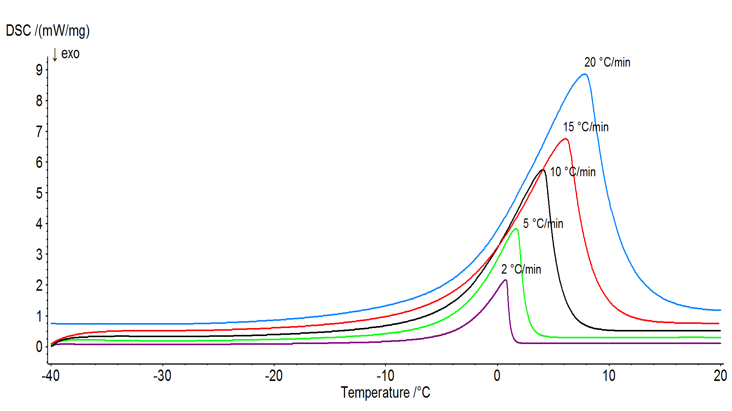
Figure 2. DSC melting curves of pork meat at different heating rates (2, 5, 10, 15 and 20 °C/min)

In this study significant (p<0.05) differences between the values of onset melting temperature (T_{m}on) were found in the range of heating rates from 5 to 20 °C/min (Table 2). Significant (p<0.05) differences between mean values of peak melting (T_{m}) and end melting temperature (T_{m}end) of pork meat were observed for all heating rates. The mean values of peak melting temperature (T_{m}) was increased from 0.70 °C to 7.60 °C in the range of the heating rates from 2 to 20 °C/min. Similarly, end melting temperature (T_{m}end) was increased from 1.17 °C to 10.87 °C, with increasing heating rate from 2 to 20 °C/min (Table 2).

Table 2. Temperatures and enthalpy of melting for pork meat, in relation to different heating rate
Heating  rate  (°C/min) | Melting
Heating  rate  (°C/min) | Temperature (°C) |  |  |  | Entalphy  ΔH_{m} (J/g)
Heating  rate  (°C/min) | T_{m}on | T_{m} | T_{m}end | ΔT_{m} | Entalphy  ΔH_{m} (J/g)
2 | -2.93^{abc} ± 0.06 | 0.70ª ± 0.10 | 1.17ª ± 0.06 | 4.10ª ± 0.00 | 193.23ª ± 3.95
5 | -3.33ª ± 0.06 | 1.70^{b} ± 0.10 | 2.67^{b} ± 0.06 | 6.00^{b} ± 0.10 | 195.73ª ± 8.70
10 | -3.07^{ab} ± 0.35 | 4.27^{c} ± 0.55 | 5.90^{c} ± 0.72 | 8.97^{c} ± 0.38 | 196.83ª ± 0.06
15 | -2.67^{bc} ± 0.15 | 6.07^{d} ± 0.25 | 8.47^{d} ± 0.25 | 11.13^{d} ± 0.23 | 197.40ª ± 6.31
20 | -2.43^{c} ± 0.31 | 7.60e ± 0.53 | 10.87e ± 0.49 | 13.30e ± 0.30 | 213.60^{b} ± 1.13
Data are expressed as mean ± standard deviation.
^{a,b}Mean values in the same colon followed by different online letters indicate significant difference (p< 0.05).
T_{m}on - temperature of onset melting; T_{m} - temperature of peak melting; T_{m}end - temperature of end melting; ΔT_{m} - width of melting peak;ΔH_{m} - enthalpy of melting.

For calculating the total heat to be removed and to determine the rate removal during refrigeration and freezing of food products the values of enthalpy of melting were used [27]. Peak area represents the melting latent heat of ice in the tested frozen meat sample. In this study the values of enthalpy of melting did not differ (p˃0.05) for the heating rates from 2 to 15 °C/min, while significantly (p<0.05) different values were recorded for the heating rates of 2 and 20 °C/min (Table 2). It was determined that for faster thawing procedures enthalpy of melting increased during the melting of meat samples. For the heating rate 2 °C/min the values of enthalpy of melting was 193.23 J/g, and 213.60 J/g for the heating rate 20 °C/min. Similary, Tomaszewska-Gras [10] recorded significantly different values of milk fat melting enthalpy for the heating rates 1 and 20 °C/ min, while the values of enthalpy did not differ for the heating rates from 2 to 10 °C/min.

As it can be seen in the next figures, linear relationships between heating rate and temperature of peak melting (T_{m}) (Figure 3), temperature of end melting (T_{m}end) (Figure 4) and the melting temperature interval (ΔT_{m}) (Figure 5) for pork meat were found. In the first case it can be described by relation y=0.394x-0.035 (R²=0.991), in the second case y=0.547x+0.122 (R²=0.997) while in the third case y=0.508x+3.409 (R²=0.992).

Figure 3. Relationship between heating rate (2, 5, 10, 15 and 20 °C/min) and T_{m} (°C)

Figure 4. Relationship between heating rate (2, 5, 10, 15 and 20 °C/min) and T_{m}end (°C)

Figure 5. Relationship between heating rate (2, 5, 10, 15 and 20 °C/min) and ΔT_{m} (°C)

The effect of the scanning rate on the content of freezable and unfreezable water in pork meat

During freezing water can be present in different states in food. Different types of food have different water content that may undergo the phase transition. Water present in food can be classified into two categories according to its reaction to freezing process: freezable and unfreezable water. During freezing, only freezable water crystallizes into ice [28]. It is abitrarily chosen that 100% of the freezable water will freeze at a temperature of -40 °C. Therefore, the amount of unfrozen water at this temperature will be named ‘‘unfreezable water’’ [4, 11, 27]. Unfreezable water is bound water, whereas freezable water fraction reflects the fraction of free water of the total water in a product. In this paper, analogously to the enthalpy of melting, the mean values of freezable water contents and unfreezable water contents did not differ (p>0.05) for the heating rates from 2 to 15 °C/min. However, the significant (p<0.05) increase in freezable water content was recorded in frozen pork meat, from 57.94% for the rate of 2 °C/min to 64.05% for the rate of 20 °C/min, and the significant (p<0.05) decrease in unfreezable water content from 15.64% for the rate 2 °C/min to 9.53% for the rate 20 °C/min The content of freezable and unfreezable water in pork meat, in relation to different heating rate, are presented in Figure 6 and Figure 7.

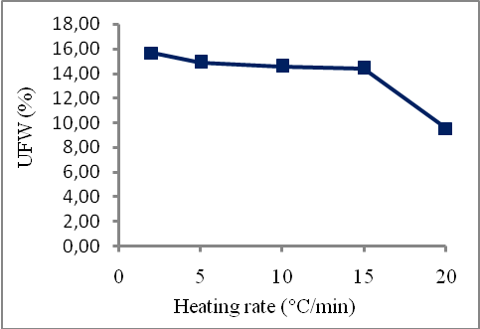
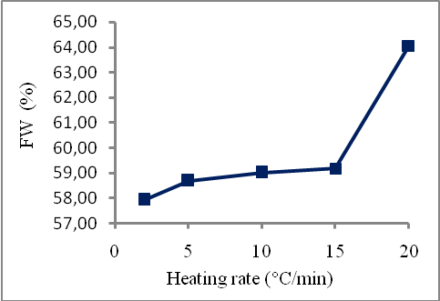

Figure 6. Content of freezable water in pork meat in relation to different heating rate | Figure 7. Content of unfreezable water in pork meat in relation to different heating rate

CONCLUSIONS

Differential scanning calorimetry (DSC) promises to offer a sensitive, rapid and reproducible method for determination of thermal behaviors of pork meat. The shape of the DSC cooling and heating curves of pork meat depended on the scanning rate. It was observed that the cooling rate affected the onset (T_{c}on), peak (T_{c}) and end temperatures (T_{c}end) of crystallization process of pork meat (p<0.05). However, the enthalpy of crystallization (ΔH_{c}) did not change with a changing cooling rate (p>0.05). In this study significant (p<0.05) differences between the values of onset melting temperature (T_{m}on), peak melting (T_{m}) and end melting temperature were found in the range of heating rates from 2 to 20 °C/min. The values of the enthalpy of melting, as well as freezable water content in frozen pork meat did not differ (p˃0.05) for the heating rates from 2 to 15 °C/min, while significantly (p<0.05) different values were recorded for the heating rates of 2 and 20 °C/min. The information presented in this study can be applied to comparability and characterization studies as well as to evaluate stability of pork meat.

REFERENCES

- Zhou, Y.-G., Li, D., Wang, L.-J., Li Y., Yang, B.-N., Bhandari, B., Chen, X. D., Mao, Z.-H. Effect of water content on thermal behaviors of common buckwheat flour and starch. Journal of Food Engineering, 93(2) (2009), 242–248.
- Dahimi, O., Rahim, A.A., Abdulkarim, S.M., Hassan, M.S., ZamHashari, S.B.T., Mashitoh, A.S., Saadi S. Multivariate statistical analysis treatment of DSC thermal properties for animal fat adulteration. Food Chemistry, 158 (2014), 132–138.
- Karthikeyan, J.S., Desai, K.M., Salvi, D., Bruins, R., Karwe, M.V. Effect of temperature abuse on frozen army rations. Part 1: Developing a heat transfer numerical model based on thermo-physical properties of food. Food Research International, 76(3) (2015), 595–604.
- Tolstorebrov, I., Eikevik, T.M., Bantle, M. A DSC study of phase transition in muscle and oil of themain commercial fish species from the North-Atlantic. Food Research International, 55 (2014), 303–310.
- Zaidul, I. S. M., Absar, N., Kim, S.-J., Suzuki, T., Karim, A. A., Yamauchi, H., Noda, T. DSC study of mixtures of wheat flour and potato, sweet potato, cassava, and yam starches. Journal of Food Engineering, 86(1) (2008), 68–73.
- Fini, A., Cavallari, C., Ospitali, F. Diclofenac Salts. V. Examples of Polymorphism among Diclofenac Salts with Alkyl-hydroxy Amines Studied by DSC and HSM. Pharmaceutics, 2(2) (2010), 136–158.
- Zielbauer, B. I., Franz, J., Viezens, B., Vilgis, T. A. Physical Aspects of Meat Cooking: Time Dependent Thermal Protein Denaturation and Water Loss. Food Biophysics, 11(1) (2016), 34-42.
- Wen, J., Arthur, K., Chemmalil, L., Muzammil, S., Gabrielson, J., Jiang, Y. Applications of Differential Scanning Calorimetry for Thermal Stability Analysis of Proteins: Qualification of DSC. Journal of Pharmaceutical Sciences, 101(3) (2012), 955-964.
- Reading, M., Hourston, D. Modulated-temperature differential scanning calorimetry, Springer, Dordrecht, The Netherlands, (2006), 38-49.
- Tomaszewska-Gras, J., Melting and crystallization DSC profiles of milk fat depending on selected factors. Journal of Thermal Analysis and Calorimetry, 113(1) (2013), 199–208.
- Hamdami, N., Monteau, J.-Y., Bail, A.L. Thermophysical properties evolution of French partly baked bread during freezing. Food Research International, 37(7) (2004), 703–713.
- Matuda, T.G., Pessôa Filho, P.A., Tadini, C.C. Experimental data and modeling of the thermodynamic properties of bread dough at refrigeration and freezing temperatures. Journal of Cereal Science, 53(1) (2011), 126-132.
- Grujić, R., Petrović, Lj., Pikula, B., Amidžić, Lj. Definition of the optimum freezing rate: 1. Investigation of structure and ultrastructure of beef M. longissimus dorsi frozen at different freezing rates. Meat Science, 33(3) (1993), 301-318.
- Kiani, H., Sun, D.-W. Water crystallization and its importance to freezing of foods: A review. Trends in Food Science & Technology, 22(8) (2011), 407-426.
- Pitschmann, V., Kobliha, Z., Tušarová, I., Bártová, L., Vetchý, D., Filipović, P.V., Lević, L., Ćurčić, B., Nićetin, M., Pezo, L., Mišljenović, N. Optimisation of mass transfer kinetics during osmotic dehydration of pork meat cubes in complex osmotic solution Chemical Industry & Chemical Engineering Quarterly, 20(3) (2014), 305-314.
- Petrović, Lj., Grujić, R., Petrović, M. Definition of the optimal freezing rate – 2. Investigation of the physico-chemical properties of beef M. longissimus dorsi frozen at different freezing rates. Meat Science, 33(3) (1993), 319-331.
- Bueno, M., Resconi, V. C., Mar Campo, M., Cacho, J., Ferreira, V., Escudero, A. Effect of freezing method and frozen storage duration on odor-active compounds and sensory perception of lamb. Food Research International, 54(1) (2013), 772–780.
- Meziani, S., Kaci, M., Jacquot, M., Jasniewski, J., Ribotta, P., Muller, J.-M., Ghoul, M. Desobry, S. Effect of freezing treatments and yeast amount on sensory and physical properties of sweet bakery products. Journal of Food Engineering 111(2) (2012), 336–342.
- Holzwarth, M., Korhummel, S., Carle, R., Kammerer, D. R. Evaluation of the effects of different freezing and thawing methods on color, polyphenol and ascorbic acid retention in strawberries (Fragaria×ananassa Duch.). Food Research International, 48(1) (2012), 241–248.
- Soyer, A., Ozalp, B., Dalmıs, U., Bilgin, V. Effects of freezing temperature and duration of frozen storage on lipid and protein oxidation in chicken meat. Food Chemistry, 120(4) (2010), 1025–1030.
- Xanthakis, E., Havet M., Chevallier S., Abadie J., Le-Bail A. Effect of static electric field on ice crystal size reduction during freezing of pork meat. Innovative Food Science and Emerging Technologies, 20 (2013), 115–120.
- Xu, H.-N., Huang, W., Wang, Z., Rayas-Duarte, P. Effect of ice structuring proteins from winter wheat on thermophysical properties of dough during freezing. Journal of Cereal Science, 50(3) (2009), 410–413.
- Bainy, E. M., Corazza, M. L., Lenzi, M. K. Measurement of freezing point of tilapia fish burger using differential scanning calorimetry (DSC) and cooling curve method. Journal of Food Engineering, 161 (2015), 82–86.
- Simmons A. L., Smith K. B., Vodovotz Y., Soy ingredients stabilize bread dough during frozen storage. Journal of Cereal Science, 56(2) (2012), 232-238.
- AOAC (2006) Official Method, 950.46.

Zhu, S., Le Bail, A., Ramaswamy, H.S. High-pressure differential scanning calorimetry: Comparison of pressure-dependent phase transition in food materials. Journal of Food Engineering, 75(2) (2006), 215–222.
- Fasina, O. Thermophysical Properties of Channel Catfish at Freezing Temperatures. Journal of Agricultural Science and Technology. B2(2012), 1287-1292.
- Ding, X., Zhang, H., Wang, L., Qian, H., Qi, X., Xiao. Effect of barley antifreeze protein on thermal properties and water state of dough during freezing and freeze-thaw cycles. Food Hydrocolloids, 47 (2015), 32-40.

