CURRENT EFFICIENCY AND ENERGY CONSUMPTION DURING ELECTROCOAGULATION OF CYANIDE WASTEWATER

Apstract. The research consisted in the application electrocoagulation process to remove cyanide from the simulated wastewater in a pilot plant, which is based on electrochemical flow reactor made of polyester in which has raised eight parallel electrodes. Results of electrochemical degradation of cyanide expressed through cyanide removal efficiency (Eu), current efficiency (η) and specific consumption of energy (W_{SP}). At higher cyanide removal efficiency (Eu=47,43%), current efficiency is lower and amount 25,96% (j=10 mA/cm², γ_{(NaCl)}=2 g/L, t=30 min), or 29,36% (Eu=27,09%, j=5 mA/cm², γ_{(NaCl)}=2 g/L, t=30 min), respectively. On the other hand, specific energy consumption increases with an increase in removal efficiency. For removal efficiency Eu=27,09%, it requires W_{sp}=35,50 kWh/kg_{CN} energy (j=5 mA/cm², γ_{(NaCl)}=2 g/L). Also, specific energy consumption is higher at higher current density (j=10 mA/cm²) and at the same concentration of supporting electrolyte γ_{(NaCl)=}2 g/L was achieved E_{u}=47,43% with a specific energy consumption W_{sp}=110,52 kWh/kg. Electrochemical removal of cyanide can be successfully performed using electrochemical coagulation processes, and further research may focus on increasing the current efficiency and reducing energy consumption, which would further enhance this treatment.

Key words: electrochemical treatment, electrochemical flow reactor, cyanide.

INTRODUCTION

Due to the use of cyanides in numerous industries, methods and processes of cyanide degradation are of great importance. The largest amounts of cyanide are found in industrial effluents such as metal, mining, electronics, automotive and pharmaceutical [1]. The total quantity of cyanide wastewater that is discharged during the year is estimated at more than 14 milion kg/year [2]. Since cyanide is very reactive, it readily binds metals such strong ligand and form complexes of different stability and toxicity [1].
Increasingly stringent environmental standards and requirement of a minimum concentration of cyanide and other toxic substances that can be discharged, many treatments can not meet these requirements. For this reason, the regulations on maximum permitted concentrations for discharge into water recipients, in addition to economic feasibility, represent one of the most important factors when choosing a treatment.
In Republic of Srpska cyanides levels are monitored in wastewater under the relevant regulations, depending on whether it is a discharge of wastewater into surface waters [3] or sanitary sewer system [4]. The limit values according to these regulations are 0,1 g/m³ for wastewater discharged into surface water, and 1 g/m³ for wastewater discharged into the sanitary sewer system.
There are several possible methods for treating wastewater containing cyanides. The most commonly used treatment is alkaline chlorination, and lately degradation with hydrogen peroxide, ozone, SO₂/air (INCO process), photocatalytic oxidation, cyanide biodegradation, reverse osmosis and electrochemical treatment [1]. Electrochemical technology of wastewater treatment use electricity through appropriate electrodes in the electrochemical reactor and presents an alternative to traditional chemical oxidation. For removing free cyanide was successfully used several different electrode materials (Pt, Ti/Pt, PbO2, Fe, Al, stainless steel) [5]. Some of these materials manifest tendency to electrolytic oxidation of cyanide. The specific problems occur when handling cyanide complexes such as iron, copper or zinc, due to the high chemical stability of these complexes.
Electrocoagulation is more present wastewater treatment in which there is a charge neutralization of pollutants under the influence of an external source of electricity. Electrochemical technology also offer an alternative the use of metal salts, polymers and polyelectrolytes in the destruction of stable suspensions and emulsions [6]. The basic parameters of electrochemical treatment are: electrode material, electrochemical reactor design, current density, pH value of wastewater, electrolyte conductivity, temperature [7,8].
Compared to conventional chemical coagulation, electrocoagulation basic advantages are a smaller amount needed coagulate ions, the greater pollutants removal efficiency, there is no use of chemicals thus reducing the possibility of secondary pollution and reduces the quantity of sludge, less reaction time and consequently less, simple and easy handling equipment. In addition, the hydrogen generated at the cathode, causing stirring the suspension in a reactor which promotes flocculation, and hence the overall efficiency of the process [5].
Literature concerning cyanide removal by electrocoagulation process is rare and limited to the wor undertaken by Moussavi et al., Koby et al., Hassani et al., Senturk and Malinovic et al. [5, 9-12].
Of these studies, only Moussavi et al. in addition to batch, carry out research on flow electrochemical reactor. In flow electrochemical reactor with different hydraulic retention times (HRT) increase cyanide removal efficiency of 57% (HRT=15 min) to complete efficiency (HRT=140 min) [5]. Kobya et al. have conducted research in the purification of rinse galvanic wastewater containing cadmium cyanide and nickel cyanide at a batch electrochemical reactor with iron electrodes. Removal efficiency and operational costs at optimal conditions (30 A/m², 30 min and pH=8-10 for cadmium; 60 A/m², 80 min and pH=8-10 for nickel) amounted to 99,4% and 1,05 €/m³ for cadmium and 99,1% and 2,45 €/m³ for nickel and >99,7% for cyanides, respectively [9]. The effect of voltage, initial concentration of cyanide and reaction time in reactor with iron electrodes are presented in the work Hassani et al. wherein was achieve a cyanide removal efficiency of 97% [10]. Senturk studied the influence of the electrode material, current density, reaction time, initial pH and electrode arrangement, and occurs optimal parameters, 20 A/m², 60 min. Applied current density was in the range of 2,5 – 40 A/m², and specific energy consuption was 0,09 – 7,327 kWh/m³ [11]. In the study of Malinovic et al. researched the influence of current density, supporting electrolyte and reaction times to cyanide removal (γ_{CN}⁻=200 mg/L) at a hydraulic retention time, HRT=2,67 min. In the presence of 1 g/L NaCl for 60 minutes of treatment, the removal efficiency was achieved, E_{u}=98,30 % [12].
The aim of this paper is to research the specific energy consumption and current efficiency during removing of cyanides from simulated wastewater by electrocoagulation process with iron electrodes.
Cost analysis electrochemical treatment of wastewater shows that the main costs are the investment costs and the costs of energy for electrolysis. To these costs were lower as compared to the designed capacity, it is necessary to achieve such conditions by which to achieve maximum removal of pollutants per unit time and per unit volume of the reactor, with minimal energy consumption.

MATERIALS AND METHODS

Experimental part of the research is contained by the application of electrocoagulation proces for removing of cyanides from simulated wastewater in a pilot plant. For the experiments was used a pilot plant (Figure 1) whose base is electrochemical flow reactor made of polyester in which is placed parallel eight electrodes (four anodes and four cathodes). Dimensions of reactor are 156x66 mm. Used flow reactor is handmade for the purposes of research, of rectangular shape with the entrance to the reactor, which is set at a height of 0,8 cm and an exit to a height of 8 cm. The flow of wastewater is provided via a peristaltic pump with the possibility of changing the flow rate. Flow velocity of wastewater through the reactor was 294 mL/min, respectively, the hydraulic retention time (HRT) was 2,67 minutes.

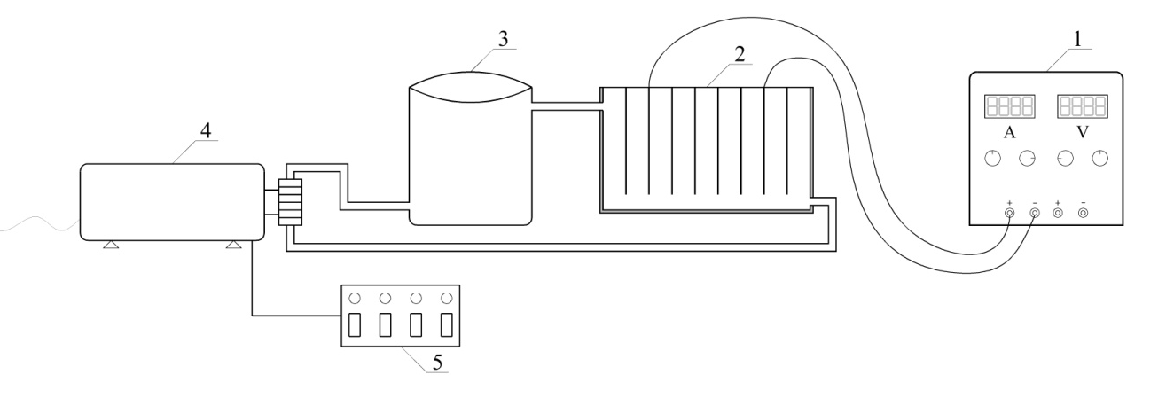
Figure 1. Shematic wiew of pilot plant (1-electrical source, 2-reactor, 3-vasel, 4-pump, 5-control unit

Iron electrodes (EN 1.4301 / AISI 304) are made to enable uniform flow of the electrolyte with each electrode. Distance between the electrodes is 1 cm, and the total area of the anode is 356 cm². Electrodes were connected to digital power source (Atten, APS3005SI; 30V, 5A) with the potentiostatic and galvanostatic operating options. Prior research, attention was paid to the choice of appropriate relations electrode surface area and volume of the reactor. Mousavi et al. researched removal of cyanide using ratio of electrode surface area and the volume of the reactor (16 m²/m³) and therefore used volume of wastewater adapted this proportion and it was V=0,786 dm³ [5].
For prepairing synthetic wastewater cyanide concentration γ_{CN}⁻=200 mg/L was used 0,01 M sodium hydroxide (NaOH), Lachner, Czech and 95% sodium cyanide (NaCN), Acros Organics, Belgium. As a supporting electrolyte was used 99.5% sodium chloride (NaCl). All the used chemicals are of p.a. purity.
All the experiments were performed at an ambient temperature of sample. Before each treatment electrodes were cleaned and degreased. The current density was set to a certain value. Prepared sample synthetic wastewater before and after treatment analyzed the content of free cyanide in accordance with standard methods [13].

RESULTS AND DISCUSSION

Results of the electrochemical removal are shown through cyanide removal efficiency, Eu (%), whose ratio could be described by following equation:

(1)
where is $γ_{i}$γ_{i} and $γ_{f}$$γ_{i}$γ_{f} initial and final cyanide concentration (mg/L).
The energy consumed to remove pollutants unit is one of the most important technological performance indicators of electrochemical reactor, because it affects the overall cost of treatment. Specific energy consumption (W_{sp}) is calculated by the following equation:

(2)

The current efficiency is the basic characteristic of any electrochemical process and a complex size which affects to the degree of conversion of the reactant and the removal efficiency of pollutants. Current efficiency is calculated according to the following equation:

(3)

where is: c₀ i c - cyanide concentration in the wastewater before and after treatment, F-Faraday constant, V- the volume of wastewater, n- the number of electrons, I- amperage, t- electrolysis duration.
Current efficiency depending on the cyanide removal efficiency for different current densities (j=5-10 mA/cm²) is shown in Figures 2 and 3. The measurements were made at a concentration of supporting electrolyte γ_{(NaCl)}=2 g/L and the initial concentration of the synthetic wastewater γ_{CN}=200 mg/L. Figure 2 shows the cyanide removal efficiency depending on the current efficiency at a current density of j=10 mA/cm² and γ_{(NaCl)}=2 g/L, which clearly shows that for the higher efficiency in removing cyanide (Eu=47,43%, t=30 min) is lower the value of current efficiency (η=25,96%). Also, at lower current density (j=5 mA/cm²) with the increase of cyanide removal efficiency (Eu=27,09%, t=30 min) decreases current efficiency (η=29,35%) (Figure 3).

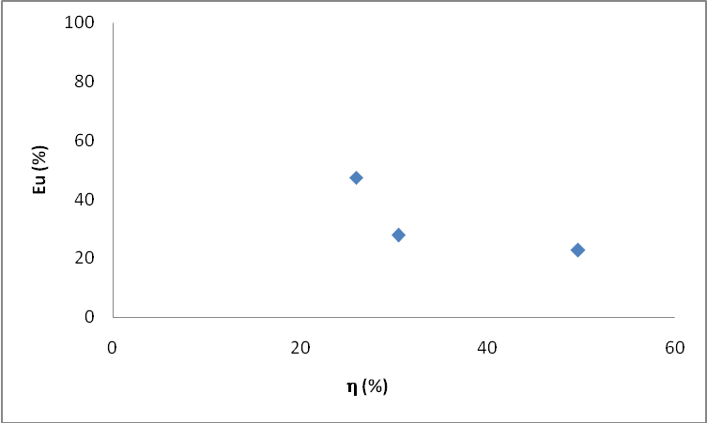

Figure 2. Cyanide removal efficiency in depend of current efficiency (j=10 mA/cm², γ_{(NaCl)}=2 g/L)

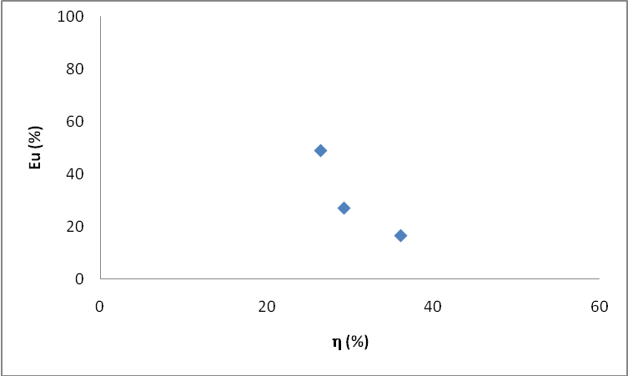

Figure 3. Cyanide removal efficiency in depend of current efficiency (j=5 mA/cm², γ_{(NaCl)}=2 g/L )

Higher current density caused high electrical energy conusumption which increased operating costs for the treatment [9]. Specific energy consumption depending on the cyanide removal efficiency for different current densities (j=5-10 mA/cm²) and a concentration of NaCl γ_{(NaCl)}=2 g/L are shown in Figures 4 and 5. Figure 4 shows the cyanide removal efficiency in depending of the specific energy consumption at a current density j=5 mA/cm², which shows that the specific energy consumption increases with an increase in removal efficiency. To achieve the removal efficiency of E_{u}=27,09%, it requires W_{sp}=35,50 kWh/kg_{CN} energy for 30 minutes of treatment.

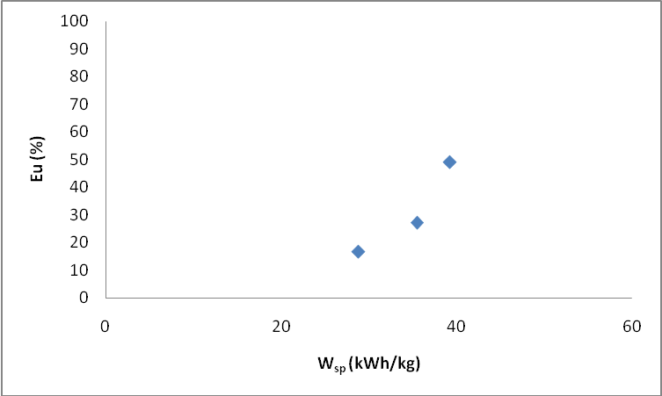

Figure 4. Cyanide removal efficiency in depend of specific energy consumption (j=5 mA/cm², γ_{(NaCl)}=2 g/L)

Since the potential applied between the electrodes increased with the increasing current density, the energy consumption of the system increased [11]. As can be seen the specific energy consumption is higher at higher current density (j=10 mA/cm²) and at the same concentration γ_{(NaCl)}=2 g/L (Figure 5). Removal efficiency of E_{u}=47,43% was achieved with a specific energy consumption of W_{sp}=110,52 kWh/kg_{CN}, for 30 minutes of treatment.

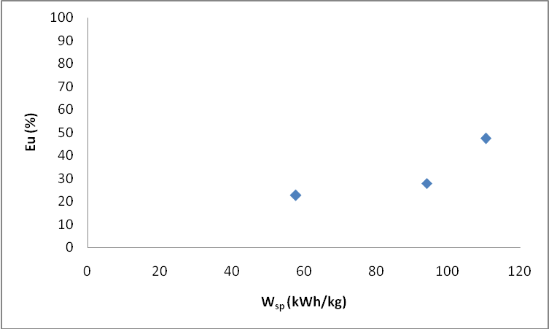

Figure 5. Cyanide removal efficiency in depend of specific energy consumption (j=10 mA/cm², γ_{(NaCl)}=2 g/L)

CONCLUSION

This process provides an alternative to the traditional process of chemical oxidation of cyanide wastewater. The process requires simple equipments, which also leads to easier process control and flexibility of industrial operating conditions (flow or batch). Application of higher current densities increases the removal efficiency, but increases specific energy consumption. Further studies may focus on increasing the current efficiency and reducing consumption of energy, which would further enhance this treatment.

IZVOD

Istraživanje se sastoji u primjeni procesa elektrokoagulacije za uklanjanje cijanida iz sintetske otpadne vode na pilot postrojenju, koje se sastoji od protočnog elektrohemijskog reaktora izrađenog od poliestera u kojem je paralelno postavljeno osam elektroda. Rezultati elektrohemisjke razgradne cijanida izraženi su preko efikasnosti uklanjanja (Eu), iskorišćenja struje (η) i specifičnog utroška električne energije (W_{SP}). Za veću efikasnost uklanjanja cijanida (Eu=47,43%), iskoršćenje struje je manje i iznosi 25,96% (j=10 mA/cm², γ_{(NaCl)}=2 g/L, t=30 min), odnosno 29,36% (Eu=27,09%, j=5 mA/cm², γ_{(NaCl)}=2 g/L, t=30 min). U drugu ruku, specifični utrošak električne enrgije raste sa porastom efikasnosti uklanjanja. Za efikasnost uklanjanja od Eu=27,09% potrebno je W_{sp}=35,50 kWh/kg_{CN} energije (j=5 mA/cm², γ_{(NaCl)}=2 g/L). Takođe, specifični utrošak električne enrgije je veći pri većoj gustini struje (j=10 mA/cm²) i istoj koncentraciji pomoćnog elektrolita γ_{(NaCl)=}2 g/L i iznosi W_{sp}=110,52 kWh/kg (E_{u}=47,43%). Elektrohemijsko uklanjanje cijanida može biti uspješno izvedeno primjenom procesa elektrokoagulacije, a buduća istraživanja mogu se fokusirati na porast iskorišćenja struje i smanjenje potrošnje energije, što bi unaprijedilo tretman.

Ključne riječi: elektrohemijski tretman, protočni reaktor, cijanidi.

REFERENCES

[1] Malinović, B.N., Pavlović, M., Gorgi, N. Uticaj hloridnih jona na elektrohemijsku oksidaciju cijanida u otpadnim vodama. Zaštita materijala, 55(4) (2014), 171-179.
[2] Ebbs, S. Biological degradation of cyanide compounds. Current opinion in Biotechnology, 15(3) (2004), 231-236.
[3] Službeni Glasnik Republike Srpske, Pravilnik o uslovima ispuštanja otpadnih voda u površinske vode, Sl. Gl. RS 44/01, Banja Luka: Službeni Glasnik republike Srpske, 2001.
[4] Službeni Glasnik Republike Srpske, Pravilnik o uslovima ispuštanja otpadnih voda u javnu kanalizaciju, Sl. Gl. RS 44/01, Banja Luka: Službeni Glasnik republike Srpske, 2001.
[5] Moussavi, G., Majidi, F., Farzadkia, M. The influence of operational parameters on elimination of cyanide from wastewater using the electrocoagulation process, Desalination, 280(1-3) (2011), 127-133.
[6] Malinović B.N, Mandić, J., Pavlović, M. G., Tomić, M. Smanjenje HPK-vrijednosti otpadnih voda anodnom oksidacijom u industriji poludisperzija i disperzija, Zaštita materijala, 53(1) (2013), 31-36.
[7] Malinović, B.N., Pavlović, M.G., Gorgi, N., Uticaj gustine struje na elektrolitičku degradaciju cijanidnih otpadnih voda, Yucorr XV, Tara, Srbija, 17-20.9.2013.
[8] Malinović, B.N., Pavlović, M.G. Uticaj različitih anjona i njihove koncentracije na elektrolitičku degradaciju cijanidnih otpadnih voda, Yucorr XV, Tara, Srbija, 17-20.9.2013.
[9] Kobya, M., Demirbas, E., Parlak, N.U., Yigit, S. Treatment of cadmium and nickel electroplating rinse water by electrocoagulation, Environmental Technology, 31 (2010), 1471–1481,.
[10] Hassani, G., Nasseri, S., Gharibi, H., Removal of Cyanide by Electrocoagulation Process. Analitical and Bioanalitical Electrochemistry, 3(6) (2011), 625-634.
[11] Senturk, E. Removal of zinc-cyanide from rinse water by electrocoagulation, Water Science & Technology, 10(68) (2013), 2220-2227.
[12] Malinovic, B.N., Malinovic, T., Bunic, S.: Treatment of cyanides in a flow electrochemical reactor, XXIV International Conference “Ecological Truth”, Eco-Ist’16, Vrnjacka Banja, 12-15 june 2016, 398-407
[13] Standard Methods for the Examination of Water and Wastewater. APHA, EPA, American public health association, New York, 1999.

