READABILITY OF SCREEN PRINTED QR CODES DEPENDING ON
THEIR DIMENSION, ENCODED CONTENT AND TYPE OF PRINTING SUBSTRATE USING SCREEN PRINTING TECHNIQUE

QR (Quick Response) code is a two-dimensional code consisting of white and black squares as information carriers. The main advantages of a two-dimensional or matrix code is the possibility of various and extensive content in the given area, wherein the amount of encoded data is limited to about 7000 numbers and about 1800 symbols. The above-mentioned codes have become an inevitable part of any industrial product. The aim of this experiment was to test readability of different QR codes printed with screen printing with different mesh tread densities (140 threads/cm and 180 threads/cm). The QR codes were prepared in six different dimensions (1 cm², 1.3 cm², 1.6 cm², 1.9 cm², 2.2 cm² and 2.5 cm²) with three different types of content (textual message-SMS with 160 characters, short URL and long URL) on seven different substrates (paper, self adhesive paper, PVC foil, white and yellow cotton cloth/fabric, aluminium sheet and glass plate). During the experiment D65 light source was used as a simulation of daylight. We have used Neo Reader software for QR code reading on HTC Desire phone, using the 5-megapixel camera and possibility of autofocus.
The results show improved readability with QR codes printed with screen mesh of 140 threads/cm and with the reduction of carried information, i.e. the number of characters that QR codes consist of. Also, the problem with readability decreases when using substrates such as aluminium sheet or glass plate.

Key words: QR code, screen printing, ink, substrate

- INTRODUCTION

Quick Response Code, (QR code®), is a two-dimensional matrix encoding consisting of black and white squares, called modules. These modules forming a machine-readable barcode to tag information onto products. It was originally designed by a Japanese company Denso Wave in 1994 for the automotive industry. In accordance with the intent of developers it could be used by as many people as possible. Under this circumstance, QR Code can grow into “public code” used by individuals and enterprises without the cost and do not worry about the potential problem. QR is the abbreviation of quick response, expressing the development notion of QR code, which means emphasizing on the high-speed reading. QR code has quickly been adapted as a fast and effective way to embed digital content and is extensively used in diverse fields including manufacturing, marketing, etc.[1,2,3]
At present, QR Code is becoming an increasingly standard way when communicating with potential customers via print media in most countries. QR Code is being located on e.g. stickers, booths, business cards and advertisement vehicle. The reason why use QR Code is that QR Code is new and unique. QR Code can immediately connect people to thevirtual environment of information and entertainment. In addition, convenient and fast features of QR code also attract people to use it. Besides, QR code can send information to the mobile phone instantly, regardless of someone's physical location [4].

1.1. QR Code Architecture

Each QR Code symbol shall be constructed of nominally square modules set out in a regular square array and shall consist of an encoding region and function patterns: finder, separator, timing patterns, and alignment patterns. Function patterns shall not be used for the encoding of data.The symbol shall be surrounded on all four sides by a quiet zone border. This zone is the spacing provided to distinguish between QR code and its surrounding. It is important for the scanning program [5].
Three common structures on the three corners of QR code symbol are called finder patterns. Finder pattern is used for deciding the correct orientation of the symbol. Timing patterns are used by the decoder software to find the side of the pattern. Alignment patterns are used in the case of image distortion to correctly decode the symbol by decoder software. The rest of the region i.e. other than function pattern is the encoded region where data code words and error-correcting code words are stored (Fig. 1)[6].

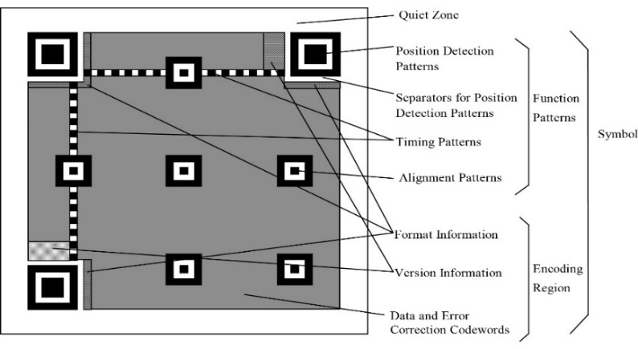

Figure 1. QR code structure (ISO/IEC18004)

- MATERIAL AND METHODS

As a first step, before generating and printing QR codes, an Adobe Illustrator SC5 program have been used to simulate the actual size of the future QR code. Simulation of screen printing mesh with the drawn lines has been done with the aim to predict possible problems which can occur in the printing process. Similar screen mesh has been drawn that simulates an actual size of the screen printing mesh, width, and thickness of the threads. An example is presented in Fig. 2. where the actual size of the mesht count, with 120 threads/cm, is unsuitable for printing in this experiment.

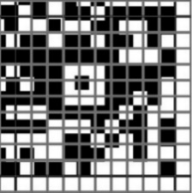

Figure 2. Simulationof QR code for screen printing with mesh count of 120 threads/cm

The simulation showed that the loss of QR code elements with lower thread density could be greater, and QR code might be completely unreadable after the printing process. Thus, screen meshes with a larger mash count – higher thread density (140 threads/cm and 180 threads/cm) have been used in the experiment.
For generating QR codes we have used an on-line generator – Kerem Erkan[7]. This program is written in PHP language and it is capable of generating two-dimensional codes. Generation of QR code for this experiment was done with three different contents of QR codes:

- textual message -SMS (160 characters, maximum for text message (Fig. 3a),
- long URL address (http://flashzourtattoo.com/blog/wpcontent/uploads/2010/05/da vidbollt.jpg) (Fig. 3b) and
- short URL address (http://www.grid.uns.ac.rs/) (Fig. 3c)

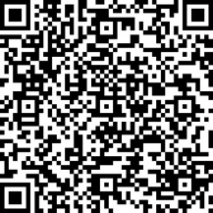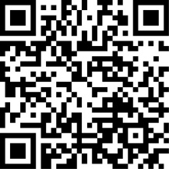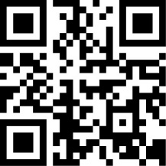
- b) c)

Figure 3. Generated QR codes with:
a) textual message -SMS, b) long URL address, c) short URL address

In order to determine the minimum dimensions that can be printed with screen printing and thereby to remain readable, these three QR codes were generated in six different dimensions: 1cm², 1.3cm², 1.6cm², 1.9cm², 2.2cm² and 2.5cm².
Seven different printing substrates have been used: paper, self-adhesive paper, PVC foil, white and yellow cotton fabric, aluminium sheet and glass plates..
Depending on the substrate, two different types of black screen printing inks have been used: Sericol Trichromatic Plastijet TG004 and SericolTexopaque Classic OP004. Plastijet ink is designed for high-speed printing of self-adhesive vinyls, rigid PVC, and polystyrenes, while Texopaque Classic is designed for printing on textile. The semiautomatic screen printing machine S550 TSH Print Swiss was used for the printing process. Each substrate was printed five times what gave on summary ten QR codes on each substrate.
For simulation of daylight conditions, Agile Radiant Controlled Light 5 box has been used with a light emission of D65 (colour temperature of 6500 K) that represents the average spectral power distribution of daylight.
Reading of printed QR codes has been done with Neo Reader software using HTC Desire mobile phone with a 5-megapixel camera and possibility of autofocus.
Before the measuring procedure, printed samples of QR codes were fixed at the wall of the background of a light box. For the scanning procedure, a model with an aperture of 25 mm x 25 mm has been made, in order to provide an easier selection of QR code that has to be scanned.
The scanning procedure has been done as follows: The phone has been placed at a distance of 15 cm from printed QR code sample, scanning time was limited to maximum 5 seconds, in order to simulate everyday use.
The test results were given as average values for every analyzed printed sample.

- RESULTS AND DISCUSSION

3.1 QR codes printed on paper

The first substrate that has been analyzed was paper printed with a screen mesh count of 140 threads/cm and 180 threads/cm.
One can see (Fig. 4 a) that readability of codes with text content, for samples printed with lower mesh count, was successful starting from QR code size 1,6 cm² and for the samples with higher screen mesh count, (Fig 4b) from the size 1,9 cm². Smaller sizes of QR codes were unreadable and the possible reason could be an extensive number of the details in the code, which cannot be readable on the smaller sizes of the QR codes

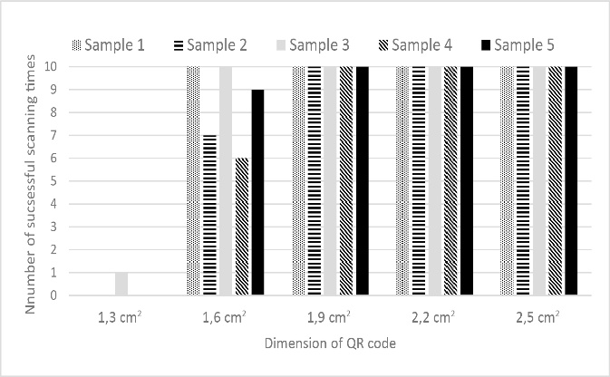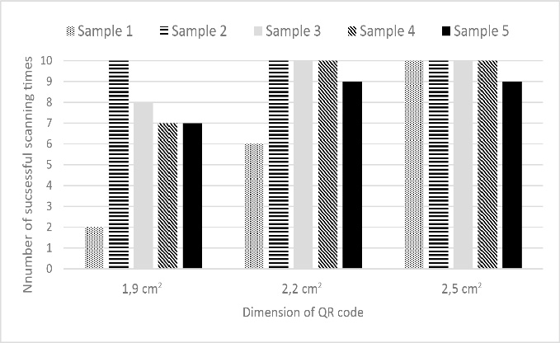
a) b)

Figure 4. Number of successful readings of QR codes with text content,
Substrate: paper a) 140 threads/cm and b) 180 threads/cm

Readability of QR codes with long URL address (Fig 5a, b) printed on paper was very similar for both resolutions of the screen threads (140 and 180 threads/cm). Very small number of QR codes could not be read on sample 4 due to a great number of small details and minor damages of the QR codes content caused by the printing process.

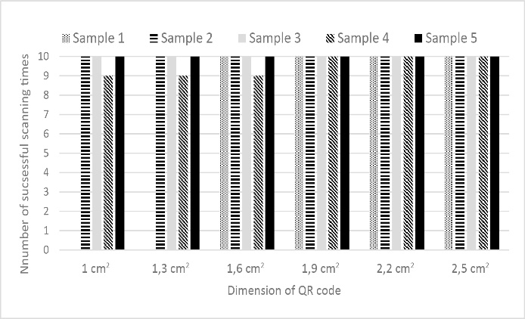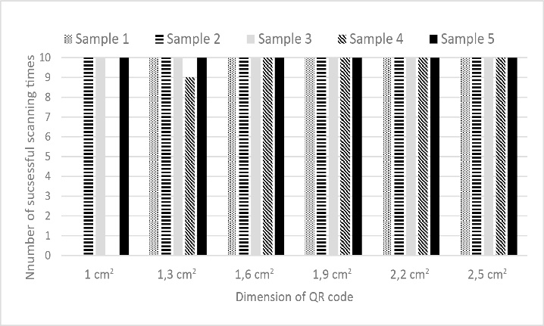
a) b)

Figure 5. Number of successful reading of QR codes with long URL address,
Substrate: paper 170g/m², a) 140 threads/cm b) 180 threads/cm

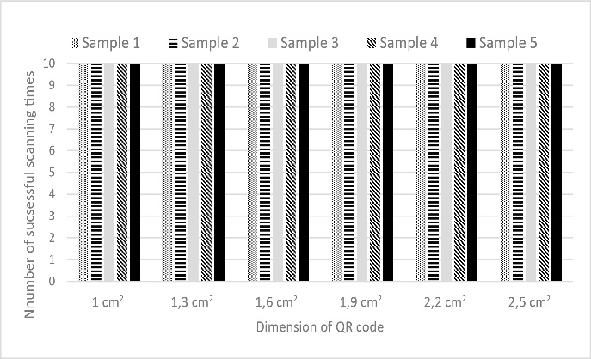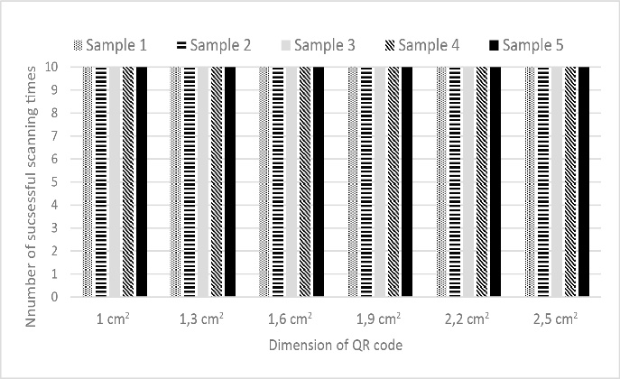
a) b)

Figure 6. Number of successful reading QR codes with short URL address,
Substrate: paper 170g/m²a) 140 threads/cm b) 180 threads/cm

Best results, as it was expected, were obtained in scanning process of QR codes with short URL address. Analyzed QR codes gave the identical values of 100% readability of printed samples (Fig. 6) on paper printed with both mashes, 140 and 180 threads/cm.

3.2 QR codes printed on self adhesive paper

From the Figure 7a, it can be seen that the readability of QR codes with text content, printed on self-adhesive paper using screen with140 threads/cm, was successful starting with the size of 1,6 cm² and 1,9 cm² with minor readability problems on sample 4 and 5.

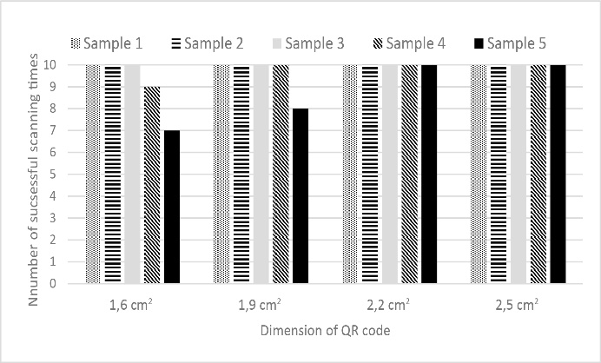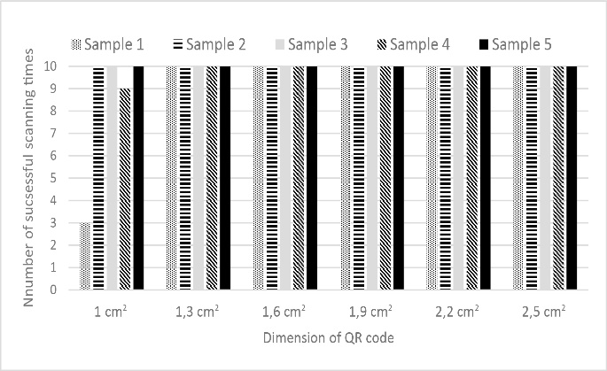
a) b)

Figure 7. Number of successful reading of QR codes with text content,
Substrate: self-adhesive paper a) 140 threads/cm b) 180 threads/cm

Similar situation with readability was with QR codes printed using the screen of 180 threads/cm. In this case, the possibility of QR reading starts with the size of 1,9 cm² and small problems are also viewed on sample 1, 3 and 4 within the same size of QR codes. With the size of 2,2 cm² readability gets better with minor problems on samples 2, 3 and 5. The reason for this results could be rough matte surface of the self-adhesive paper, larger resolution of screen fabric and a number of small details, as it was the case in the previously analyzed samples printed on paper (Fig 4 a, b).

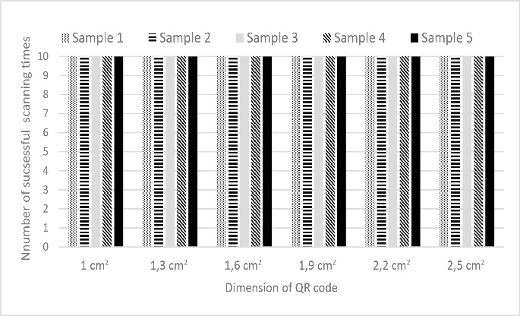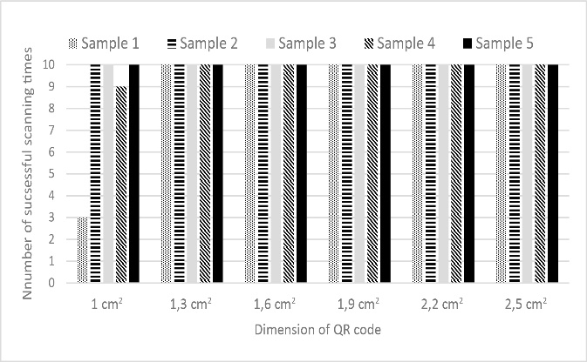
a) b)

Figure 8. Number of successful reading of QR codes with long URL address
Substrate: self-adhesive paper a) 140 threads/cm b) 180 threads/cm

Scanned samples of QR codes with long URL address (Fig. 8), printed on self-adhesive paper with both screen thread resolution gave almost identical results of complete readability of all size of printed QR codes.
The same results were obtained from the scanned QR codes with short URL address. The readability was 100% successfully for all size of QR codes with both screen thread resolution.

3.3 QR codes printed on PVC FOIL

From the Figure 9a. one can see that readability of QR codes with text content, printed on PVC substrate, begins with the size of 2,2 cm², for a screen resolution of 140 threads/cm. Readability of these QR codes has been problematic on PVC (Fig. 9 a), especially in sample 2 and 5 for the size of 2,2 cm².

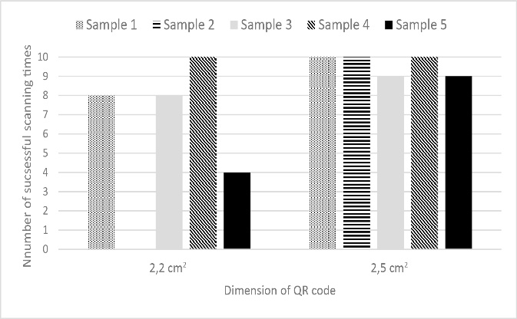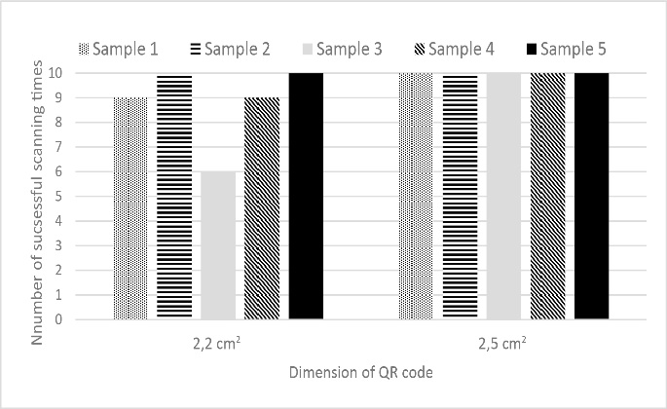
a) b)

Figure 9. Number of successful reading of QR codes with text content
Substrate: PVC a) 140 threads/cm b) 180 threads/cm

Comparing these results with the results of readability of printed samples with a screen of 180 threads/cm (Fig. 9b), it can be noticed similarity connected to the size of readable QR code. The cause of these results could be the different surface of the PVC samples as well as a large number of details of text QR codes.
Results gained from a reading of QR codes with long and short URL address are identical, for both screen threads. For all size of the printed QR codes, they are readable 100%.

3.4 QR codes printed on Cotton FaBRIC (WHITE AND yellow)

Results of QR codes printed on white cotton samples using 140 thread/cm (Fig. 10 a) shows that QR code readability starts from the printed size of 1,9 cm² and for the 180 thread/cm screen mesh readability was possible only for QR codes size of 2,5 cm² (Fig. 10b).

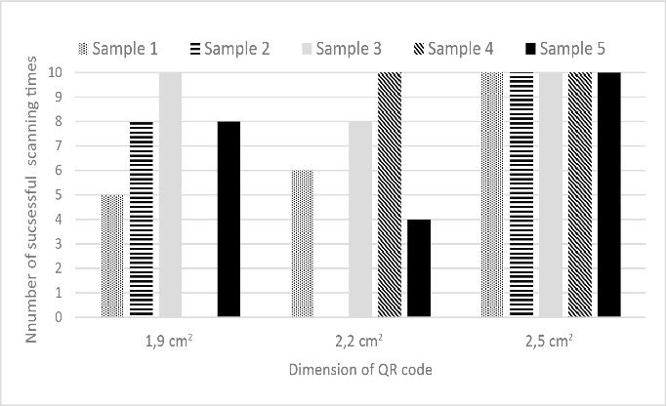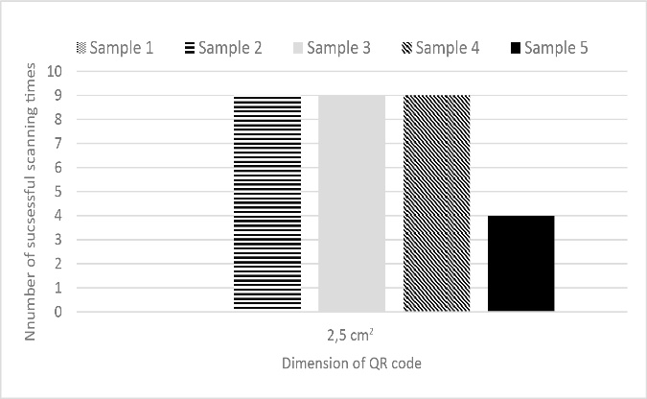
a) b)

Figure 10. Number of successful reading of QR codes with text content
Substrate: white cotton a) 140 threads/cm b) 180 threads/cm

Results of printed QR codes with text content on yellow cotton shows that readability, for both resolutions (140 and 180) were not possible and therefore result were not presented.The reason for these result could be the different texture of the textile material and lower contrast of the printed substrate as well as greater screen mesh resolution of 180 threads/cm (yellow cotton).
Readability of QR codes with long URL address printed on white cotton was almost perfect for both screen resolutions. Minor problems with reading were observed with the smallest codes (1cm²), but they were 90% successful for 140 threads/cm (Fig. 11a) and 80 % for 180 threads/cm (Fig. 11b).

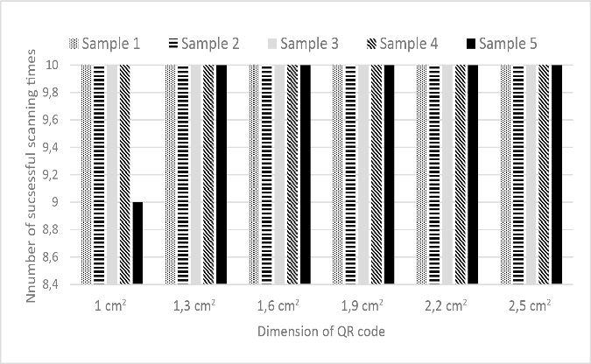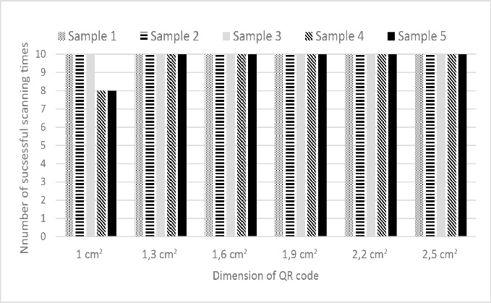
a) b)

Figure 11. Number of successful reading of QR codes with long URL address
Substrate: white cotton a) 140 threads/cm b) 180 threads/cm

The results for yellow cotton for the same QR codes with long URL address exibit differently comparing with the ones printed on the white cotton substrate (Fig. 12). For the screen resolution of 140 threads/cm, readability of samples starts from size 1, 6 cm². The sample 3 was unreadable for all sizes of QR codes with the exception of the size of 2.2cm² with a 20% of readability. Sample 5 also was problematic for reading for the QR code size of 2,2 cm² (readability of 10%). For other sizes readability was more than 60% (Fig. 12 a).

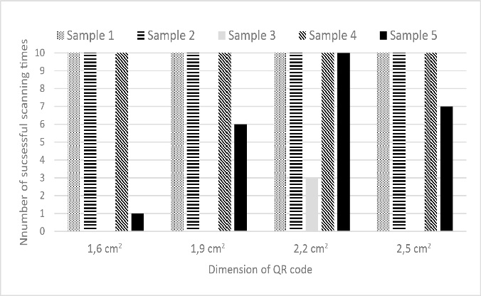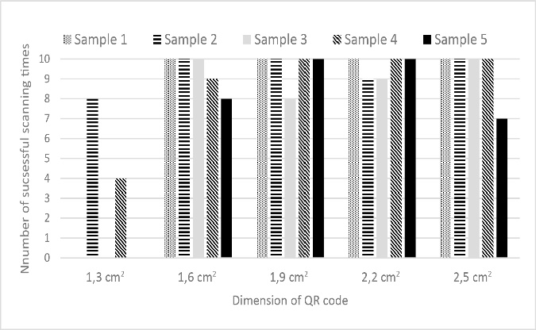
a) b)

Figure 12. Number of successful reading of QR codes with long URL address
Substrate: yellow cotton a) 140 threads/cm b) 180 threads/cm

Printed samples with screen mesh with 180 threads/cm became readable from the size of 1,3 cm² on certain samples, such as sample 2 (readability of 80%) and 4 (readability of 40%). For greater QR codes sizes, readability was successful for all samples (Fig. 12 b).
QR codes with short URL address printed on white and yellow cotton were 100 % readable.

3.5 QR codes printed on ALUMINIUM

All the QR codes, printed on aluminium, with the screen resolution of 140 threads/cm were 100% unreadable, regardless the encoded content. Results of readability of QR codes with text content for the screen resolution 180 threads/cm are shown in Figure 13. For most of the samples, successful readability starts with the QR codes size of 1,6 cm² except for the sample 3, which was unreadable until the size of 1,9cm².

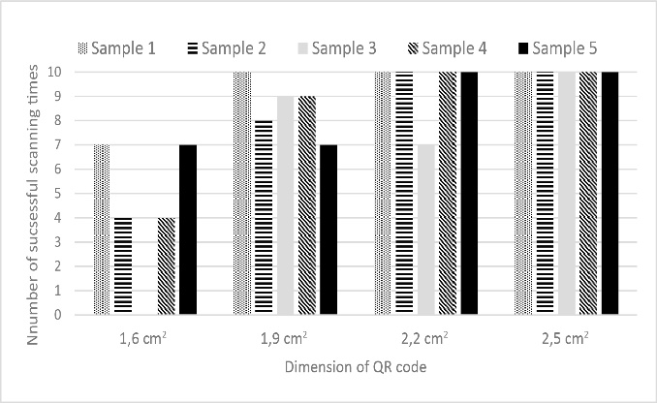

Figure 13. Number of successful reading of QR codes with text content
Substrate: aluminium, screen resolution 180 threads/cm

From the Figure 14 (a, b) one can see that readability of QR codes with longer URL printed on aluminium, for both screen resolutions, is almost identical.

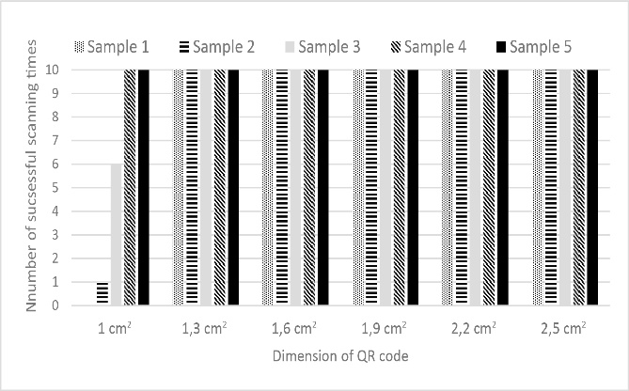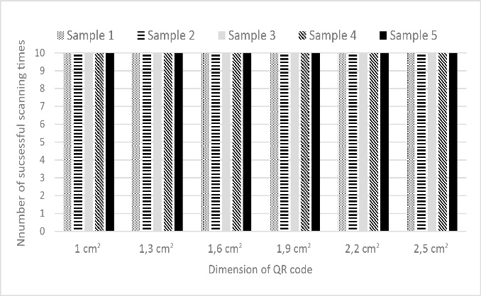

Figure 14. Number of successful reading of QR with long URL address
Substrate: aluminium, a) 140 threads/cm b) 180 threads/cm

Results obtained from the scanning process on QR codes with short URL address, printed with ascreen resolution of 180 threads/cm on analuminium substrate, were 100% readable, for all sizes and therefore were not presented.

3.5 QR codes printed on glass

Scanning process on QR codes with long and short URL, printed with a screen resolution of
140 and 180 threads/cm on a glass substrate, were 100% successful, for all sizes and therefore were not presented.
From the Figure 15, it can be seen that readability of QR codes with text content, printed on glass, using a screen with140 threads/cm, starts with the QR codes size of 1.9 cm². For sample 4, it starts with the size of 2.2 cm².

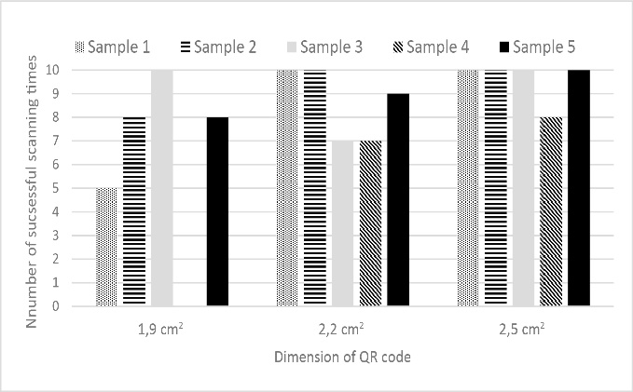

Figure 15. Number of successful reading of QR codes with text content
Substrate: glass, screen resolution 140 threads/cm

CONCLUSIONS

Printed QR codes with a text content, and thus with the largest number of information - squares, were the most problematic for reading. For most of the substrates, excluding aluminum and glass, readability starts from the size of 1.6 cm²with the screen resolution of 140 threads/cm. With the higher screen resolution (180 threads/cm), readability of printed QR codes with a text content was variable in dependence of used substrate. For aluminium, readability starts from the QR code size of 1.6cm². For the paper, self-adhesive paper and glass, readability starts from QR code size of 1.9 cm². For PVC readability can be expected from size of 2.2 cm² and for the white and yellow cotton readability was possible only on the size of 2.5 cm².
QR codes with a long URL address in the most of the cases, (for both screen resolutions and for all substrates), were readable with almost 100% of success. Only yellow cotton showed a lower readability success for this type of QR codes content.
All materials show perfect readability results for QR codes with less details containing short URL address.
Based on the results it can be concluded that different QR code size, the complexity of information coded, screen mesh tread count, surface and texture of substrate have a significant impact on the readability results. Usage of a compatible printing inks and materials is recommended in order to achieve good quality print and readability of QR codes.

LITERATURE

[1] History of QR code, Available on: http://www.qrcode.com/en/history/(12. 07. 2016.)
[2] Li L., Jinxia Q., Jianfeng L., Chin-Chen C. An aesthetic QR code solution based on error correction mechanism, The Journal of Systems and Software, 116 (2016) 85–94.
[3]Hung-Kuo C., Chia-Sheng C., Ruen-Rone L., Niloy J. M., Halftone QR Codes, ACM Transactions on Graphics (Proc. of SIGGRAPH Asia 2013), Available on:http://cgv.cs.nthu.edu.tw/Projects/Recreational_Graphics/Halftone_QRCodes/ (12. 07. 2016.)
[4] Winter, Mick 2010. Scan me-everybody‟s guide to the magical world of QR Codes. The United States: Westsong Publishing.Available on:https://books.google.com.hk/books?id=s5ZxqwwYKk8C&printsec=frontcover&dq=What+is+QR+code&hl=zh-CN&sa=X&ei=4HoyVKGrJcq7ygPR7oGoCQ&ved=0CCsQ6AEwAQ#v=onepage&q=What%20is%20QR%20code&f=false(12. 07. 2016.)
[5]ISO/IEC18004 - Information technology — Automatic identification and data capture techniques — Bar code symbology — QR Code,
[6]Sangeeta S., QR Code Analysis,International Journal of Advanced Research in Computer Science and Software Engineering, 6(5), (2016), 89 – 92.

[7] Kerem Erkan, Available on:http://keremerkan.net/ (20. 05. 2016.)

Čitjivost SITO ŠTAMPANIH qr KODOVA U ZAVISNOSTI OD NJIHOVIH DIMENZIJA, KODIRANOG SADRŽAJA I VRSTE ŠTAMPARSKE PODLOGE

QR (Quick Response) kod je dvo-dimenzionalni kod koji se sastoji od crno belih kvadrata kao nosioca informacija. Glavna prednost dvo-dimenzionalnog ili matričnog koda je mogućnost različitog i opsežnog sadržaja na određenom području, gde je količina kodiranih podataka ograničena na oko 7000 brojeva i oko 1800 znakova. Pomenuti kodovi su postali neizostavan deo svakog industrijskog proizvoda. Cilj ovog istraživanja bio je ispitati čitljivost različitih QR kodova štampanih sito štampom različitom gustinom tkanja niti sita (140 niti/cm i 180 niti/cm). QR kodovi su pripremljeni u šest različitih dimenzija (1 cm², 1.3 cm², 1.6 cm², 1.9 cm², 2.2 cm² i 2.5 cm²) sa tri različita tipa sadraja (tekstualna poruka-SMS sa 160 znakova, kratki URL i dugački URL) na sedam različitih štamparskih podloga (papir, samolepljivi papir, PVC folija, bela i žuta pamučna odeća/tkanina, aluminijumska folija i staklena ploča). Tokom eksperimenta D65 svetlosni izvor je korišten kao simulacija dnevne svetlosti. Za očitavanje QR kodova korišten je Neo Reader program na HTC Desire telefonu, koristeći 5 megapikselnu kameru sa mogućnošću autofokusa.
Rezultati pokazuju povećanu čitljivost QR kodova štampanih linijaturom tkanja mreže sita od 140 niti/cm i sa smanjenjem nosećih informacija, tj. broja znakova od kojih se sastoji QR kod. Takođe, problem čitljivosti se smanjuje u slučaju korištenja podloga kao što su aluminijumska folija ili staklena ploča.

Ključne reči: QR kod, sito štampa, boja, podloga

