MEASUREMENT AND ANALYSIS OF
NATURAL UV LIGHT

Vesna Petrović*, Borislav Simendić,

Visoka tehnička škola strukovnih studija u Novom Sadu, Novi Sad Školska 1, Srbija
petrovic.v@vtsns.edu.rs,simendic@vtsns.edu.rs,

Summary:
Adverse effects of UV light on living organisms, although known since the nineteenth century, only with the discovery of the reduction in thickness of the ozone layer over the Antarctic and the emergence of the ozone hole in the 80-ies of the last century, drew worldwide attention to UV light as an environmental problem.
The paper presents the results of measurements of all three types of natural UV light (UV-A, UV-B and UV-C) in the village of Stanisic, Sombor municipality. The measurement lasted three times in seven days, at 10h, 14h and 18h each lasting three minutes and was conducted on both the concrete and grass surfaces. The results point to several important conclusions: UV-C component was not present in any measurement, the intensity of UV-B component was an order of magnitude less than the intensity of UV-A component and it has been shown that the surface has no significant impact on the intensity of UV light.

Keywords: UV light, ozone hole, UV components.

INTRODUCTION

Ultraviolet (UV) light is part of the spectrum of electromagnetic light in the wavelength range of 100 to 400 nm. The sun emits UV light and it is essential in the formation and evolution of the living world, due to its role in various biochemical processes in the cells of living beings. Wildlife throughout evolution adjust levels and spectra of solar UV light in their life habitat - climate [1-3].
Although the harmful effects of UV light on living organisms known in the 19th century, UV light is caused general media attention only 80s of last century, the discovery of a reduced thickness of the ozone layer over Antarctica and the emergence of "ozone holes". Ozone (O3) is an unstable gas, which in the higher layers of the atmosphere acts as a light absorber is particularly important his role in the absorption of UV-C light. The intensity of solar light that reaches the Earth's surface in the bands UV, visible and infrared light directly depends on the thickness of the ozone layer. Any change in these light has consequences for the global climate, the biosphere and biota, and consequently to human health. [1,2].
With the development of science and technology comes to the development of artificial light sources based on gas discharge and to their wider application in daily life or for special purposes. In artificial sources of UV light include: incandescent lamps, fluorescent lamps, UV LED lamps, halogen lamps and UV lasers. The basic material of the low-pressure UV lamps is alive, but for the specific purpose lamp reaches gallium, indium, iron and combinations. This affects the exact composition of the spectrum lamp [5,6]. In the industry, special UV lamps, which are used primarily UV-A and UV-B light, are used in the press for making printed circuit boards and for printing on CDs. Short-wave UV-C light is used to sterilize water and air. Sources of UV-B light, sun lamps and fluorescent tubes UV-B region, are widely used in biology, medicine, and cosmetics. Powerful halogen lamps, which are also a source of intense UV light, are used in cosmetic and dermatological purposes. In recent decades, like fashion or as a preparation for the summer holidays, more and more people resort to artificial tanning in the beauty salon - solarium. Many studies point to the adverse effects of artificial UV light, especially for people with sensitive skin, and exposure to this artificial sources of UV light for cosmetic purposes is not recommended [3,4].
Unfortunately, the adverse effects that occur as a result of excessive exposure to UV light are not immediate and visible immediately, but accumulate in the body and ispoljavju years later, when already existing damage. As the UV light is invisible to the human eye and imperceptible to other human senses, man is not itself able to assess their level of exposure to UV light. Therefore, it is necessary to increase awareness and educate the population about the harmful effects of UV light and the measures of protection [1,4].

TYPES OF ULTRAVIOLET LIGHT AND THEIR EFFECTS

The effects of solar light on the human, but also to every other living organism, depend on the wavelength, intensity and exposure time, the fact of light, as well as the ability of each organism to defend itself from the harmful effects.

The basic division of UV light
The division of UV is performed via multiple depending on the facts and effects manifest. There are four divisions [1-4] :
- As defined by the CIE (Commission Internationale de l'Eclairage) UV light is divided into three areas, namely
  - UV-C light (λ=100 – 280 nm),
  - UV-B light (λ=280 – 315 nm),
  - UV-A light (λ=315 – 400 nm).
- According to the chemical action of the parts:
  - Light that participates in the synthesis of ozone (λ=175 – 220 nm),
  - Light which has a germicidal action (λ=220 – 300 nm),
  - Light with has a erythema action (λ=280 – 320 nm).
- According spectroscopy UV light is divided into:
  - Away or vacuum UV light (λ=200 – 300 nm),
  - Near UV light (λ=300 – 400 nm).
- According to the biological effects of UV, UV light is divided into three main areas:
  - UV-C light (100-290 nm) light has the shortest wavelength, or the largest energy and absorb it all cell components, including nucleic acids, and it acts directly on the genetic material and can cause cell death. However, the sun's UV-C light is completely absorbed by the ozone layer because it participates in the synthesis reaction fotohemijskoj ozone, so it can not threaten the living world on Earth. Photochemical reaction is carried out in two phases:
- In the first stage under the influence of light comes to breaking oxygen molecules into atoms:
О₂+Е₁(5,13 eV)→О+О
- of the second stage is then formed ozone molecules when one of the separated oxygen atom combined with an oxygen molecule
О₂+О→О₃
Part of the spectrum of UV-C light wavelengths from 260-290nm has a bactericidal effect and is used for sterilization of air and water.
- UV-B light (290-320 nm) is mainly absorbed by the atmosphere and therefore there is little represented in the solar light that reaches the Earth's surface (only 2%). However, this part of the UV light in a living organism is responsible for the largest number of changes - burns, mutations, formation of free radicals, premature aging, carcinogenesis, and represents a significant factor in the development of cataracts of the eye.
- UV-A light (320-400 nm) penetrates deeper into the skin than UV-B light, its effect is cumulative and is expressed much later after exposure to the sun. It is primarily responsible for the synthesis of vitamin D from its provitamin, but also for the formation of free radicals at high intensities of light. The effect of UV-A light is in no way can not perceive and therefore a long time believed to be harmless to the organism. This opinion is refuted trials were carried out in the last twenty years.

Side effects caused by UV light

The energy of natural UV light of wavelengths below 315 nm is sufficient to decompose the chemical bonds in molecules of the skin and eyes, thus causing serious biological damage. Diseases that are directly related to exposure to UV light are [1-4]:
Burns (erythema) are the most common reactions and the first response of the skin to the effects of UV light due to excessive exposure. Formed after a series of photochemical reactions caused by the absorption of a photon manifested by redness of the skin caused by inflammatory processes. The effect of UV light on the appearance of erythema is the largest in the field of UV-B spectrum at λ = 297 nm and decreases towards the border with UV-A light. UV-A light causes substantially less erythema.
Photodermatosis (sun allergies) are diseases of the skin due to the effects of UV light. This term does not include changes in skin cancer caused by UV light. Causes of Photodermatosis can be: disorders of metabolic processes, drugs or chemicals, idiopathic diseases and illnesses worsened existing UV light.
Photosensitivity are unusual reaction of the organism to the effect of solar light in the presence of certain substances. Basically these are the photochemical reaction in which energy is transmitted from the molecule which has absorbed light to another molecule. Causes of photosensitivity can be exogenous (drugs, food, perfumes and cosmetics) or endogenous (abnormal metabolites as well as the normal ingredients) substances, exposed to the look harmless UV-A light. Fotosenzibilacija skin is manifested by the appearance of itching, blistering, swelling, increased pigmentation and unexpectedly severe burns.
Aging is a natural process, to which is subject to each individual from birth. Aging skin can be naturally or prematurely. Natural aging is genetic prerequisites and the premature aging of the result of continued adverse effects of external factors. Skin is the most aggressive precisely UV light, which is why the changes caused by it are referred to as photoaging. It is believed that administration of UV-A light begins oxidant and results in the formation of free radicals that cause, among other things, and aging.
Damage to the immune system - UV-B light causes preventing the ejection of substances that naturally been launched and so block the cellular immunity. Eliminiaciju prevents microorganisms from lymph tissue and prevents the rejection of the modified cells of the epidermal cells of the tumor.
Effects on the eyes - although about its position is protected from the direct solar light, reflected light can lead to significant exposure. The largest part of UV-B light absorbing lens of the eye, causing damage in these parts of the eye. UV-A irlight has a greater penetrability and causes damage in the bottom of the eye. Overall, UV light leads to fotokeratitisa and fotokonjuktivitisa as acute diseases, which last up to several days. However, the cumulative effect is reflected in the development of cataracts and malignant lesions of the skin around the eyes.

ACTIVE SPECTRUM UV LIGHT

UV spectrum which shows the dependence of the biological effects of the wavelength of the spectrum is called the active spectrum of UV light, and in Figure 1 is represented by curve В(λ). It is obvious that its value is 1 for all wavelengths below 298 nm, which means that the light of these wavelengths have harmful biological effects, respectively the will certainly cause some consequences. In addition, for wavelengths above 325 nm and its value is very close to zero, which means that the light of these wavelengths has no harmful effect. Taking into account that only part of the UV light reaches the Earth's surface, the curve F(λ) in Figure 1, you can get a realistic range of biologically activs spectrum - ВА(λ). It is calculated as the product of the active spectrum and the spectrum of solar UV light that reaches the Earth [1,7]:
ВА(λ)=В (λ)·F(λ) (1)
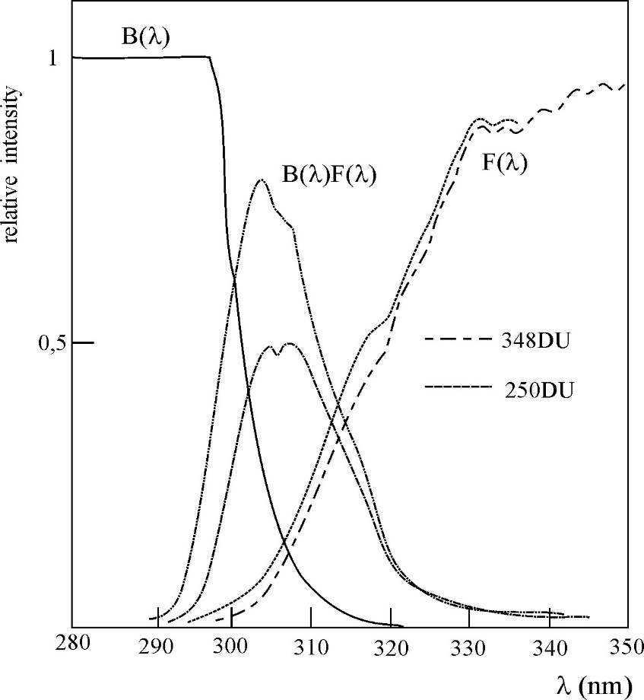
Figure 1 Active spectrum of UV light

Here is important to emphasize that the spectrum of solar UV light that reaches the earth depends on the thickness of the ozone layer and Figure 1 shows two spectra of a thickness of 250 and 350 DU (DU is a unit expressing the thickness of the ozone layer).
Precisely because of the above, the maximum range of the biologically active is in the range of 300-305 nm, or in the field of UV-B light. Where exactly will contain the maximum depends on the thickness of the ozone layer, as a lesser thickness corresponds to a higher intensity of UV light which causes a shift of the maximum to smaller wavelengths. So that BA(λ) represents a range of range of difficult because in addition to a spectrum of light sources to account for the biological effects of this light [1,7].
In practice, the happiness more units to express the intensity of light. The physical unit for the intensity of light in the range of wavelengths (λ, λ + dλ) expressed in W/m² and is obtained by integrating equation 1 at wavelengths in the range of 280-400 nm, ie an area under the curve BA(λ):
(2)
Unit UV light, which is known to the general public are called. UV indices. This unit is formed taking into account the range of biological effects and match her values from 1 to 10. Thus, the light intensity of 25 mW/m² UV index corresponds to the value of 1, while the light intensity of 250 mW/m² corresponds to the value of the UV Index 10th. In Table 1, the data division of UV light on the scale and intensity.

Table 1 Classification of UV light on the scale and intensity of UV light
UV INDEX | Level of light
0-2 | Low level
3-5 | Middle level
6-7 | High level
8-10 | Very high level
>10 | Extremely high level

MEASUREMENT RESULTS AND DISCUSSION

The measurement of solar UV light was carried out in the schoolyard of the village Stanisic, Sombor municipality, for seven days (07.09.- 13.09.2015. years) three times a day (at 10⁰⁰, 14⁰⁰ and 18⁰⁰). All measurements were carried out on the grass and concrete, in order to assess the possible effect of the substrate, a measurement lasted all of 3 minutes for each component individually UV light (UV-A, UV-B, UV-C). The exception was Thursday, when it was rainy and cloudy, and the measurement is performed in a time span of 1 minute. The results of measurements are given in Tables 2 and 3.

The instrument used for this measurement is UV meter VLX-3W, Wilber Lourmant manufacturers from France, which has three sensors for measuring each component individually. The sensors tops of the sensitivity is at 365 nm, 312 nm and 254 nm, respectively.
Analyzing the results of measurements of UV light, the first thing he faces is that no single measurement is not registered UV-C light, regardless of whether it is measured on grass or concrete. This is an indication that the ozone layer in this part undamaged and that this part of the UV light is absorbed in the ozone. In addition a learning intensity UV-A component, in all the measurements, an order of magnitude higher than the UV-B component, wherein the UV-B component has not been registered in a number of measurement at 18h. The lowest measurement values of all components registered on Thursday when, as noted, was cloudy and rainy weather.
Following the method of calculating the appropriate UV indices [8] are obtained from the value 8 (for the intensity of light of 0.2 mW / cm2) to just above 0 (for the intensities of the light of 0.001 mW / cm2). The values obtained are completely in line with the values that the Hydrometeorological Institute published the usual for this geographical area and weather conditions.

Table 2 UV light intensities measured on a concrete base
 | Интензитет зрачења [mW/cm²]
 | 10h |  |  | 14h |  |  | 18h
 | УВ-А | УВ-Б | УВ-Ц | УВ-А | УВ-Б | УВ-Ц | УВ-А | УВ-Б | УВ-Ц
Monday | 0,202 | 0,016 | / | 0,099 | 0,015 | / | 0,033 | 0,001 | /
Tuesday | 0,164 | 0,009 | / | 0,172 | 0,018 | / | 0,027 | 0,001 | /
Wednesday | 0,160 | 0,013 | / | 0,256 | 0,021 | / | 0,025 | 0,001 | /
Thursday | 0,007 | 0,001 | / | 0,007 | 0,001 | / | 0,003 | / | /
Friday | 0,020 | 0,002 | / | 0,034 | 0,004 | / | 0,001 | / | /
Saturday | 0,155 | 0,017 | / | 0,095 | 0,013 | / | 0,011 | / | /
Sunday | 0,176 | 0,016 | / | 0,178 | 0,019 | / | 0,021 | / | /

Table 3 UV light intensities measured on grass
 | Интензитет зрачења [mW/cm²]
 | 10h |  |  | 14h |  |  | 18h
 | УВ-А | УВ-Б | УВ-Ц | УВ-А | УВ-Б | УВ-Ц | УВ-А | УВ-Б | УВ-Ц
Monday | 0,201 | 0,001 | / | 0,153 | 0,015 | / | 0,014 | 0,001 | /
Tuesday | 0,139 | 0,012 | / | 0,228 | 0,016 | / | 0,031 | / | /
Wednesday | 0,184 | 0,014 | / | 0,222 | 0,019 | / | 0,013 | / | /
Thursday | 0,007 | / | / | 0,006 | / | / | 0,002 | / | /
Friday | 0,019 | / | / | 0,031 | 0,004 | / | 0,001 | / | /
Saturday | 0,150 | 0,013 | / | 0,092 | 0,013 | / | 0,084 | / | /
Sunday | 0,154 | 0,014 | / | 0,167 | 0,019 | / | 0,018 | / | /

CONCLUSION

Ultraviolet light causes particular attention to the general and scientific public last few decades. The reason for this is the discovery of reduction in thickness of the ozone layer over the Arctic, and in particular the emergence of "ozone holes" .So that in modern life has become a practice that measures the thickness of the ozone layer and the intensity of UV light that reaches the Earth's surface.
Provera intensity of solar UV light was carried out in the schoolyard of the village Stanišić Sombor municipality from 07.09.- 13.09.2015. years. The measurement is carried out three times a day, in 1000, 1400 and 18 hours. The measurement results indicate several important facts:
- UV-C light is not registered, which means that the thickness of the ozone layer above the thick enough that it completely absorbs
- The component UV-A light is an order of magnitude greater than the component UV-B light
- In a number of measurements in the afternoon is not registered is not UV-B component, and when it registered its intensity was very low
- Significant deviations intensity UV light are not registered by measuring the concrete and grass courts

REFERENCES

[1] Mijatović Z., Čonkić Lj., Miljković S., UV-zračenje, izvori, osobine, efekti, zaštita, Prirodno-matematički fakultet, Novi Sad, 2002.
[2] ICNIRP: “On guidelines on limits of exposure to ultraviolet light of wavelenght between 100 nm and 400 nm (incoherent optical light)“, Health Physics 87 (2) 171-186, 2004
[3] *** “Light Protection Standard - Occupational Exposure to Ultraviolet Light”, ARPANSA
[4] E. Fernández-García: “Skin protection against UV light by dietary antioxidants”, Food Funct. 2014 Sep; 5(9).
[5] http://www.lamptech.de/en-lamps/uv-lamps (28.12.2014.).
[6] http://www.uv-groebel.com/products/uv-light-sources (28.12.2014.)
[7] Madronich, S. and Flocke, S. (1997). Theoretical estimation of biological effective UV light at earth’s surface, in solar ultraviolet Light, edited by Zerefos, C.S. and Bais, A.F SpringerVerlag Berlin.
[8] http://meteo.lcd.lu/uvi_calculator/02-UVI-Calculations-2-7.PDF (17.08.2016.)

One Dobson unit is defined as the number of molecules of ozone that is required to form a layer around the earth pure ozone thickness of 0.01 mm, at a temperature of ⁰C and normal atmospheric pressure.

