THE APPLICATION OF THE DENSE COMPOSITE POLYMER MEMBRANES FOR CARBON DIOXIDE CAPTURE

Dragutin Nedeljkovic^{1*}, Lana Putic¹, Slavisa Putic², Aleksandar Grujić¹, Jasna Stajic-Trosic¹

¹University of Belgrade, Institute of Chemistry, Technology and Metallurgy, Serbia
²University of Belgrade, Faculty of Technology and Metallurgy, Serbia
*corresponding author, e-mail:dragutin@tmg.bg.ac.rs

Abstract: The main task of the work is to construct the polymeric membrane that is suitable for the waste gases treatment. Membrane that can be used for this purpose must have high permeability for the carbon dioxide and low permeability of the other gases commonly present in waste gases (hydrogen, oxygen, nitrogen and methane). The constructed membranes were of a dense type, based on a solubility/diffusivity mechanism. In this paper, feasibility of the application of poly(ethyleneoxid)-copoly(phtalamide) was tested. In order to enchase the permeability of carbon dioxide, four different zeolites were added, and in order to improve mechanical stability two different additives were tested. The zeolites that were tested were ZSM5; Mordenite and Zeolite Y As an additive, n-tetradecyldimethylamonium bromide – n-C14TMABr. The aim of a dergent additive was to provide good wetting of a highly electrically charged zeolite particle by the hydrophobic polymer chains. The obtained permeability of carbon dioxide was 110 Barrer, and the carbon dioxide/hydrogen selectivity was 8.5.
Keywords: Carbon dioxide capture; Dense membrane; Composite membrane; Gas separation

1. introduction

High emission of the carbon dioxide and other waste gases in the past decades has faced mankind with the great concerns in the environmental engineering. Increased concentration of carbon dioxide in atmosphere is responsible for both greenhouse effect, and the acid rains. Carbon dioxide emission mainly comes from the combustion processes at the industrial as well as the communal scale (heating plants, power plants, different procedures in chemical industry, automobile engines)[1-4]. As demand for the energy increase every day, and the fossil fuels have no feasible alternative on the world-scale, importance of carbon dioxide removal from the waste gases has become one of the emergencies of the present-day environmental engineering[5,6].

Possible approach to carbon dioxide capture is the implementation of membrane that would separate carbon dioxide from rest of the gases. Suitable membrane should exhibit high permeability for the carbon dioxide, and the lowest possible permeability for the other gases. [7-8] Standard (porous) membranes are not suitable for this purpose as the separation should be done at the molecular level. Standard membranes use the difference in the eluent particle size, which is not applicable in this case, as the diameter of carbon-dioxide molecule is significantly larger than the hydrogen or oxygen molecule. Therefore, so-called dense, non-porous membranes based on the solution-diffusion mechanism must be employed. [9-11] Mechanism of separation for those membranes is that the effluent is adsorbed on the surface on the membrane, and then is dissolved in the matrix of the membrane, and then diffuses through the thickness of the membrane layer. [12-15]

As the first approximation, theoretical comparison of molecular properties of carbon dioxide versus other gasses (especially hydrogen) shows that carbon dioxide molecule is significantly bigger. Therefore, the hydrogen diffuses much faster as its molecule is small and non-polar and, hence, has higher diffusivity coefficient. [16-19] Therefore, the solubility of the carbon dioxide must be increased in order to obtain good selectivity for the carbon dioxide versus hydrogen. Analogous situation is in the case of nitrogen and oxygen molecules, but the difference in diffusivity is not so high as their molecules are bigger than hydrogen’s, and thus, the diffusion coefficients are lower. However, the solubility of oxygen and nitrogen should be kept as low as possible. [20-22]

In order to prepare proper film for the casting of the membrane, the zeolites have to be dispersed in the same solvent as the polymer. Crucial step in this procedure is to provide good wetting of the zeolite particles by the polymer chain. This task can be extremely tedious as the inorganic zeolite particles are highly polar and hydrophile, and show very bad affinity to the highly hydrophobe polymer chains. in addition, proper film must be free of any pin holes, with the homogenous distribution of zeolite particles in the polymer matrix To fulfill this task, different additives can be added. The aim of the additive addition to the matrix is to act as a compatibilizer between the zeolite particles and polymer matrix.

2. materials and methods

For the research in this paper, possibility of application of polyether-b-amide with 60% of PEG was investigated. This polymer has shown good mechanical and diffusion properties for this purpose. This polymer is available under the commercial name PEBAX 1657 from the supplier Arkema. The structure of this polymer is presented on Fig. 1.

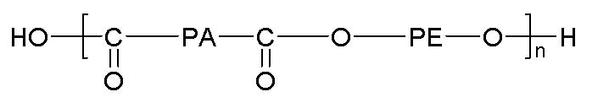
Fig. 1: Structure of the PEBAX 1657 used as a matrix

Inorganic nanopowder (zeolyte) was dispersed in the polymer matrix in order to enhance the solubility of carbon dioxide. The properties of the zeolite can be described at the macro and microlevel. At the macrolevel, the properties of the powder are determined by the specific surface of the particles. Particles used for the experiments presented in this paper have the specific surface of 500-900 m2/g. On the microlevel, properties of the zeolite are determined by the directions of the pores and the maximum sphere diameter that can diffuse along it. For this experiment, four different zeolyte types with three different pores geometries were used.

The zeolite of CFI pore type is composed solely from silicon and oxygen (Si₃₂O₆₄), and posses 1-dimensional pores with 73 pm as the maximal diameter of sphere that can diffuse along it. The zeolyte of OWE type is 2-dimensional zeolyte with max. diffusion diameter of 59 pm. IWS and ITR are both 3-dimensional zeolytes with maximal diffusion diameter of 121 and 119 pm respectively. All of the mentioned structures are selected due their relatively high diffusion diameters that should enhance the diffusion of large carbon dioxide molecule. Properties of the zeolyte powders are compiled in Table 1.

Table 1: Properties of the zeolites used in experiment
Type | Channel system | Pore size, pm | Max. diff. diam., pm
CFI | 1d | 75 | 73
OWE | 2d | 58 | 38
IWS | 3d | 82 | 67
ITR | 3d | 64 | 57

Those crystal lattices act as sieves at the molecular level. The molecular schemes of the zeolytes are presented on Figures 2-5.

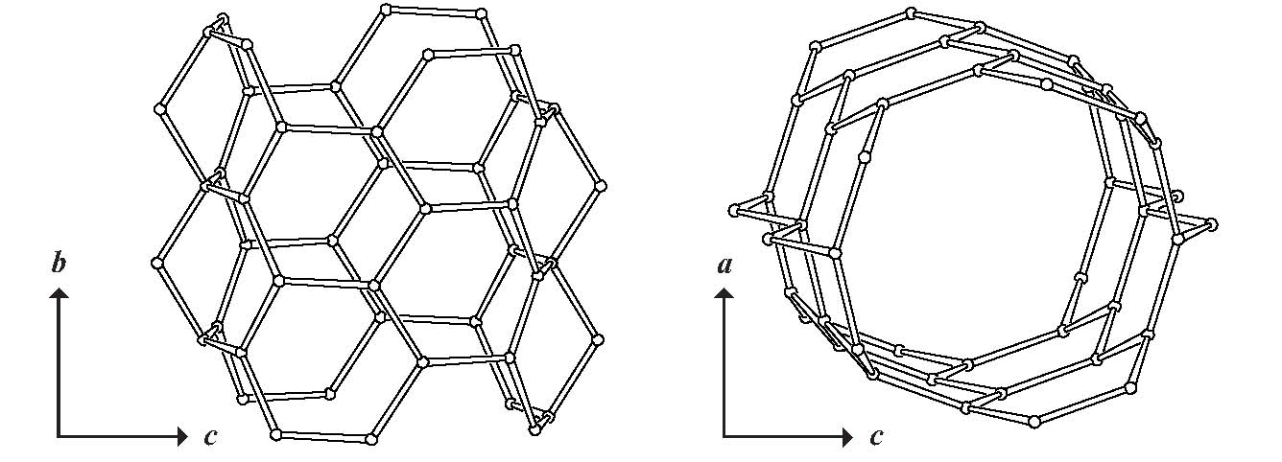
Fig 2: Structure of the CFI zeolite

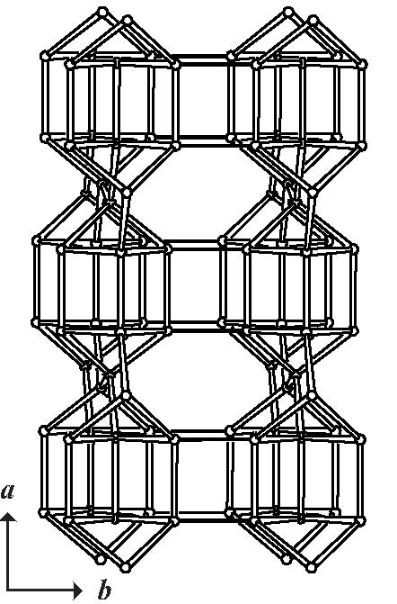

Fig 3: Structure of the OWE zeolite

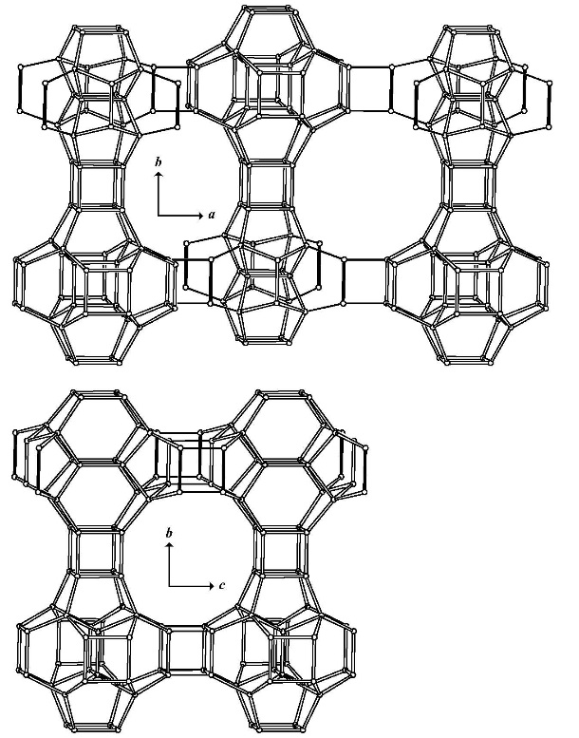
Fig 4: Structure of the IWS zeolite

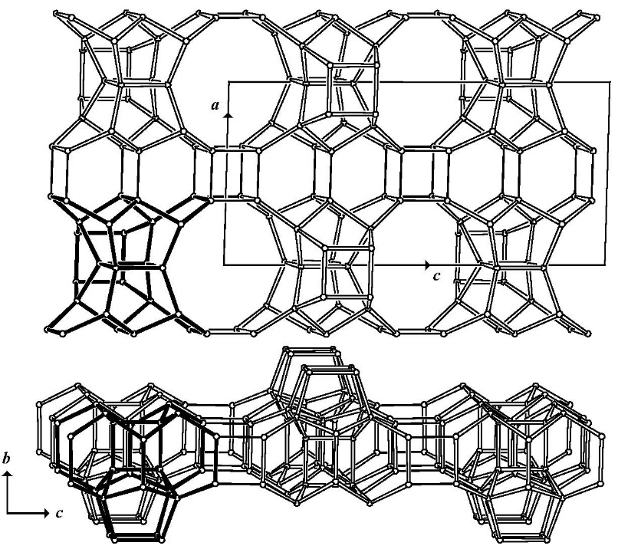

Fig 5: Structure of the ITR zeolite

The zeolite powders were supplied by the company NanoScape, and characterization was done by the supplier.

As the additive, n-tetradecane trimethyl ammonium bromide (n-C14-TMABr) was tested. The aim of this additive is to provide good contact between zeolyte nanoparticles and polymer matrix. The supposed mechanism is that the polar nitrogen – bromine bond would “attach” to the surface of the zeolite particle, and the long, normal, hydrocarbon tale would act as an “anchor” to the polymer matrix. It was supposed that the compactibility between the zeolite and polymer would be achieved by this mechanism

The procedure for the construction of the membrane was as following: The PEBAX 1657 was dissolved in the water/ethanol mixture (30/70 vol. % respectively). The dissolution was done at the 800C under reflux for 15 minutes. The zeolite was dispersed in the small amount of the same mixture, and (eventually) additive was added. The amount of zeolyte dissolved was calculated versus amount of polymer. Ultrasound mixer was used as it provides good and homogenous dispersion. The titanium head was positioned in the solution, and the mixing was done by the application of full power for three minutes. The mixing time was relatively short because if the full power is applied for the longer time, nano particles of titanium are detached from the ultrasound head, and released in the solution causing the contamination. This dispersion was mixed with the solution of polymer and stirred overnight at the 80°C under reflux. Viscous solution that came as a result was casted on the Teflon surface with the Teflon ring used as a border. This solution was covered with non-woven textile, and left overnight for drying at the ambient pressure and the room temperature. The drying process had not to be faster, as air bubbles might be formed in the volume of the membrane, and membrane cannot be used for the gas separation. At this level it, is extremely important to obtain the polymer solution with the optimal viscosity. If the viscosity is too high, the surface tension dominates trough the casting of the membrane, and the result is the membrane with the uneven thickness, which negatively affects the overall permeation properties of the membrane. On the contrary, too low value for the viscosity causes the sedimentation of the zeolite particles, and the zeolite is concentrated on the one side of the membrane. If the latter is the case, the membrane self-rolls, and its application is negatively affected.

After the drying at the ambient pressure and temperature, membrane was placed in the apparatus for the permeability measurements, and put at the high vacuum in order to remove any residual of the solvent.

The gas permeability measurements were carried out by the time lag method. The solubility (S), diffusivity (D), permeability (P) and selectivity (α) were determined by the equations [23, 24]:

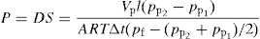

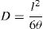

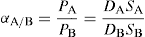

In those equations, Vp stands for the constant permeate volume, l for the thickness of the membrane, A for the area of the membrane, R for the universal gas constant, Δt for the time that permeate pressure needs to increase from value pp1 to value pp2, pf for the feed pressure, and θ for the time lag. The solution-diffusion model was used for the analysis of the gas transport properties of the membranes [25]. The selectivity of the membrane for the gas A versus gas B was defined as the ratio of their permeability. Analyzing the equations 1-3, it is obvious that both solubility and diffusivity of the gases must be taken into account in order to define properties of the suitable membrane.

The permeability measurements were done by the application of the gas at the one side of the membrane, with the high vacuum applied at the opposite side at the start of the measurement. This difference in pressure acted as a driving force for the gas diffusion. Gases were measured one at the time and in order to remove any residual gas that was solved in the membrane, high vacuum was applied between the measurements of the different gases. The permeabilities of hydrogen, oxygen, nitrogen, methane and carbon dioxide were measured, and all the selectivities were calculated versus carbon dioxide. The permeability of helium was also measured for the determination weather membrane contain pin hole or not.

3. RESULTS AND DISCUSSION

The compositions and physical appearances of the constructed membranes are compiled in Table 2. All the presented percent were mass percent versus polymer.

Table 2: The composition and optical appearances of the constructed membranes
Membrane number | Porous Filler | Filler, % | Additive | Additive % | Appearance
1 | - | - | - | - | transparent
2 | - | - | n-C14-TMABr | - | transparent
3 | CFI | 22.3 | - | - | white
4 | CFI | 22 | n-C14-TMABr | 8.6 | opaque
5 | OWE | 22.3 |  |  | white spots
6 | OWE | 21.9 | n-C14-TMABr | 8.5 | opaque
7 | IWS | 22 | - | - | white
8 | IWS | 21.8 | n-C14-TMABr | 8.5 | transparent
9 | ITR | 22 | - | - | opaque
10 | ITR | 22.5 | n-C14-TMABr | 8.3 | transparent

The permeabilities of the membranes that contained white spots or white were not measured. As it is stated in the introduction, white spots indicates aggregations of the zeolite particles, and thus implies non-uniformous distribution of particles, and thus, bad permeation properties. Membranes that appeared white were not measured as well, as white color indicates bad contact between the surface of the zeolite and the surface of the polymer. The first two samples were made in order to check the possibility and feasibility of making the membrane of the pure polymer as well as the behavior of the additive dispersed in the pure polymer. As the gained results were successful in the matter of thickness and the appearance of the membrane, this system was used for the construction of the membranes with polymers.

Analyzing the appearance of the various membranes, it can be seen that addition of the n-C14-TMABr rapidly improves the appearance of the membrane. In the ideal case, the membrane should appear transparent, smooth, without any visible spots or zones of the different color. This appearance implies that the inorganic particles are evenly distributed trough the membrane, and that contact between the polymer and inorganic particles is good. The white color of the membrane implies the bad contact between the zeolyte particles and polymer chains. If the air gap is present, the light refraction occurs in the gap, and the membrane appears white. Opaque membranes might have those gaps as well. However, their opacity implies that most of the particles are in good contact with the polymers, and that “air gapping” appears only at the small fraction of the particles. In the previous experiments with the similar polymer – zeolyte systems, no statistical relation between the opacity and the permeability of the membranes were observed. Presence of the white spots implies that the particles of zeolyte agglomerated, and thus, their distribution trough the volume of the membrane is uneven. Uneven distribution of the inorganic particles negatively affects both mechanical and separation properties of the membrane. The agglomeration further implies that most of the zeolyte particles were not covered with the additive and that the adhesive forces between the zeolyte particles prevail in the system. Therefore, only opaque and transparent membranes were used for the permeability measurements.

The results of the permeability and selectivity measurements are presented in table 3

Table 3: Permeability and selectivity of the constructed membranes
Membrane number | Thickness, μm | P CO2, Barrer | α (CO2/H2) | α (CO2/O2) | α (CO2/N2)
4 | 192 | 110 | 8.5 | 20.9 | 62.2
6 | 241 | 122 | 7.9 | 21.0 | 54.9
8 | 185 | 125 | 8.9 | 20.8 | 62.8
9 | 192 | 121 | 9.1 | 20.7 | 60.5
10 | 221 | 125 | 8.8 | 20.6 | 60.0

As it can be observed from the Table 3, all of the membranes with good appearance have shown good permeability and selectivity. The permeability of the carbon dioxide was in around 120 Barrer which is lower but comparable with other similar systems. Selectivity of the carbon dioxide versus hydrogen was just under 9 while the values for oxygen and nitrogen were over 20 and 60 respectively. Comparing the values for the permeability of the membrane made of the zeolyte with different pore systems it can also be observed that 3-dimensional systems (membranes 9 and 10) have shown slightly better result in comparison with 1- or 2- dimensional systems. Possible explanation might be that in 1-dimensional system (and partly in 2-dimensional) orientation of the pores plays significant role in the diffusion of the gas molecules trough the membrane. If the pore of the 1-dimensional zeolyte system is the perpendicular do the direction of the diffusion, the possible path of the diffusing molecule is longer, and therefore diffusion is slower. The control of the orientation of the pores is possible, however, that would made the membrane preparation procedure longer and more demanding. The slight decrease in the selectivity between the membranes 9 and 10 might be attributed to the presence of the additive, which enhances diffusivity of both carbon dioxide and hydrogen.

4. CONCLUSION

In this paper, the possibility of the construction of the mixed matrix membrane based on the polymer matrix and surface treated inorganic powder was tested. The constructed membranes are dense, mixed-matrix membranes. The membranes were constructed with polyether-b-amide with 60% of PEG as a matrix and one of the four different zeolyte particles as the dispersed inorganic phase. As an additive, the n-tetradecane trimethyl ammonium bromide (n-C14-TMABr) was tested. By the observation of the membranes after their construction, it was concluded that the presence of the C14-TMABr significantly improves appearance of the membrane, thus improving its permeability. The membrane with the acceptable quality could not be achieved without the addition of the C14-TMABr. The obtained permeability of the carbon dioxide, and the membranes’ selectivity of carbon dioxide versus hydrogen (as the main research interest of the experiments) were 120 Barrer and approximately 9, respectively. Those values are slightly lower in comparison with other systems. The permeability of the membranes constructed with 3-dimensionals zeolyte pores are slightly higher in comparison with analogous 1- and 2-dimensional systems. By this observation, it was concluded that the orientation of the pores play significant role in the permeability of the membrane.

Based on this experiment and the results, it can be concluded that polyether-b-amide with 3-dimensional pores zeolyte and C14-TMABr as an additive are promising starting point for the further research. The main task of the future research efforts is to reduce the thickness of the membrane. In order to test membranes in the conditions that are as similar as the real exploitation, the other direction for the research would be testing of the performance of the membrane at the wet conditions and with several gases simultaneously.

5. ACKNOWLEDGEMENT

The authors would like to acknowledge the financial support of the Ministry of Science of Serbia (Research projects TR 34011 and III 45019).

6. REFERENCES

[1] A.B. Rao and E.S. Rubin, A technical, economic, and environmental assessment of amine-based CO₂ capture technology for power plant greenhouse gas control. Environ. Sci. Technol., 36, (2002), 4467–4475

[2] U. Desideri and R. Corbelli, CO₂ capture in small size cogeneration plants: technical and economical considerations. Energy Convers. Manage., 39, (1998), 857–867

[3] A. Meisen and S. Xiaoshan, Research and development issues in CO₂ capture. Energy Convers. Manage., 38, (1997), 37–42

[4] The United Nations Framework Convention on Climate Change, Kyoto, 1997

[5] W.J. Koros and G.K. Fleming, Membrane-based gas separation. J. Membr. Sci., 83, (1993), 1–80

[6] S.P. Nunes, K.-V. Peinemann, Editors , Membrane Technology in the Chemical Industry, (second revised and extended edition), Wiley-VCH Verlag GmbH, Germany, (2006), 53–150

[7] K. Ghosal and B.D. Freeman, Gas separation using polymer membranes: an overview. Polym. Adv. Technol., 5, (1994), 673–697

[8] R.W. Baker, Membrane Technology and Applications, McGraw-Hill, New York, (2000), 301–392

[9] R.W. Baker, Future directions of membrane gas separation technology. Ind. Eng. Chem. Res., 41 (2002), 1393–1411

[10] P. Yu, Yampol'skii, I. Pinnau and B.D. Freeman, Materials Science of membranes, John Wiley& Sons, England, (2006), 1–47

[11] H. Lin and B.D. Freeman, Materials selection guidelines for membranes that remove CO₂ from gas mixtures. J. Mol. Struct., 739, (2005), 57–74

[12] H. Lin and B.D. Freeman, Gas solubility diffusivity permeability in poly(ethylene oxide). J. Membr. Sci., 239, (2004), 105–117

[13] L.A. Utracki, History of commercial polymer alloys and blends, . Polym. Eng. Sci., 35, (1995), 2–17

[14] G. Deleens, N.R. Legge, G. Holder, H.E. Schroeder, Editors , Thermoplastic Elastomers: A Comprehensive Review, Hanser Publishers, New York, (1987), 215–230

[15] V.I. Bondar, B.D. Freeman and I. Pinnau, Gas transport properties of poly(ether-b-amide) segment block copolymers. J. Polym. Sci. Part B Polym. Phys., 38, (2000), 2051–2062

[16] M. Yoshino, K. Ito, H. Kita and K.-I. Okamoto, Effect of hard-segment polymers on CO₂/N₂ gas separation properties of poly(ethylene oxide)-segmented copolymers. J. Polym. Sci. Part B Polym. Phys., 38, (2000), 1707–1715

[17] V. Bondar, B.D. Freeman, I. Pinnau and Gas Sorption, Characterization of poly(ether-b-amide) segmented block copolymers. J. Polym. Sci. Part B Polym. Phys., 37, (1999), 2463–2475

[18] J.H. Kim, S.Y. Ha and Y.M. Lee, Gas permeation of poly(amide-6-b-ethylene oxide) copolymer. J. Membr. Sci., 190, (2001), 179–193

[19] I. Blume, I. Pinnau, Composite membrane, method of preparation and use, U.S. Patent 4,963,165 (1990)

[20] J.C. Chen, X. Feng and A. Penlidis, Gas permeation through poly(ether-b-amide) (Pebax 2533) block copolymer membranes, Separation Sci. and Tech., 39, (2005), 149-164

[21] A. Car, C. Stropnik, W. Yave, K.-V. Peinemann, PEG modified poly(amide-b-ethylene oxide) membranes for CO₂ separation, Journal of Membrane Science, 307 (1), 88-95 (2008)

[22] A. Car, C. Stropnik, W. Yave, K.-V. Peinemann, Tailor-made Polymeric Membranes based on Segmented Block Copolymers for CO2 Separation, Advanced Functional Materials, 18 (18), (2008), 2815–2823

[23] A.M. Shishatskii, Y.P. Yampolski and K.-V. Peinemann, Effects of film thickness on density and gas permeation parameters of glassy polymers. J. Membr. Sci., 112, (1996), 275–285

[24] J. Qiu, J.-M. Zheng and K.-V. Peinemann, Gas transport properties of poly(trimethylsilylpropyne) and ethylcellulose filled with different molecular weight trimethylsilylsaccharides: impact on fractional free volume and chain mobility. Macromolecules, 40 (2007), 3213–3222

[25] .G. Wijmans and R.W. Baker, The solution–diffusion model: a review. J. Membr. Sci., 107, (1995), 1–21

