THE PROPERTIES OF COMPOSITES BASED ON NR/CSM RUBBER BLEND AND WASTE RUBBER POWDER

Gordana Marković ¹, Milena Marinović-Cincović², Vojislav Jovanović³, Dejan Kojić⁴,
Nevena Vukic⁵, Suzana Samaržija-Jovanović³, Jaroslava Budinski-Simendić⁵

¹Tigar, Pirot, Serbia, gordana1markovic@gmail.com
²University of Belgrade, Institute of Nuclear Science Vinča, Serbia, milena@vinca.rs
³Faculty of Natural Science and Mathematics, University of Priština, Kosovska Mitrovica, Serbia, jovanovicvojislav62@gmail.com
⁴ Faculty of Engineering, University of Business Engineering and Management, Banja Luka, B&H, kojic.d@hotmail.com
⁵Faculty of Technology, University of Novi Sad, Serbia, nevena.vukic@gmail.com, jarkamer@gmail.com

The use of reclaiming scrap waste rubber is of great ecological interest due to its significant influence to the environment. Powdered waste rubber (WRP) can be used as a filler in mixtures with rubbers, thermoplastics, and as modifiers for asphalt. In this work the composites based on natural rubber (NR) and chlorosufonated polyethylene (CSM) filled with different content of WRP were prepared on a laboratory-size two-roll mixing mill. The curing by sulfur was done at 160ºC. The mechanical properties, namely tensile strength, tensile modulus at 100% elongation, elongation at break and hardness have been followed up as a function of irradiation dose (100; 200; 300; 400 kGy) as well as waste rubber powder content (0; 20; 40; 60; 80; 100 phr). It was assessed that the addition of 20 phr waste rubber has improved the properties of obtained elastomeric materials. The improvement of composites mechanical properties is in correlation with homogeneous WRP distribution which has been assigned by scanning electron microscopy (SEM).

Key words: composites, elastomer, waste rubber powder, gamma irradiation.

INTRODUCTION

Technological development of reclaiming scrap waste rubber process is of great interest due to its significant influence to the environment. A normal disposal method of waste rubber such as incineration or landfilled is not desirable approach as it caused environmental problems such as air and water pollution. The recyclization of waste rubber by mechanical or chemical methods is the ultimate approach to solve the problems [1]. Transforming bulk rubber to powders using mechanical process is the most preferable procedure of reclaiming rubber and it is more economical compared to chemical process. Powdered waste rubber (WRP) can be used as a filler for elastomeric materials, thermoplastics, and as modifiers for asphalt. It is studied the effect of WRP addition (a waste product from mechanical process of rubber ball and artificial eggs) on the properties of natural rubber (NR) compounds [2]. Blending of two or more types of rubber is a useful technique for preparing and developing elastomeric material with properties superior to those of individual constituents. Moreover, each kind of rubber in the blend has its own advantages and specific application due to its chemical configuration and composition. Hence, it is economically easier to blend more than one type of rubber having the desired properties rather than chemically creating of a new elastomer. Elastomer based on two or more rubbers are used for many reasons such as lowering the compound cost, for ease of fabrication and to improve the performance of the industrial rubber. [3] Natural rubber (NR) was blended for a long time for these reasons. Figure 1 shows the chemical structure of cis-polyisoprene, which is the main constituent of NR. Sinthetic cis-polyisopren and natural cis-polyisopren are derived from different precursors (isopentenyl pyrophosphate and isoprene). NR is an elastic hydrocarbon polymer that naturally occurs as a milky colloidal suspension, or latex, in the sap of some plants. Natural rubber is categorized as a radiation crosslinking type of polymer as it contains a double bond in its basic cis-1,4-polyisoprene units.

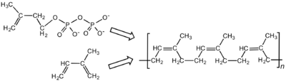
Figure 1. Chemical structure of cis-polyisoprene, the main constituent of natural rubber.
Synthetic cis-polyisoprene and natural cis-polyisoprene are derived from different precursors.

Due to these properties, it would be expected that NR attains higher tensile strength than other elastomers like chlorosulphonated polyethylene rubber (CSM). The introduction of chlorine and sulfur dioxide onto the polyethylene linking via condenzation or substitution reactions molecule destroys the crystallinity, thereby changing the thermoplastic material into an amorphous polymer chlorosulphonated polyethylene, which contains 25–43% by weight of chlorine and 1–1.5% by weight of sulfur as SO₂Cl units. The high reactivity of this rubber is due to the SO₂Cl groups. Elastomeric materials based on CSM are superior to other rubbers in its resistance to the effects of ozone and inorganic acids, such as chromic, nitric, sulfuric, and phosphoric acids, as well as to the effects of concentrated alkalies, chlorine dioxide, and hydrogen peroxide [4]. Elastomers based on CSM are used for cable jacketing materials and have excellent radiation resistance needed in nuclear power stations. The temperature region for its most efficient use is from –60° to 180°C. Rubber waste is usually generated during the manufacturing process of product of these industries and by disposal of post-consumer (retired) products mainly including scrap tires [5]. High-energy radiation is a well-known technique for modification of polymers. Radiochemical studies on crosslinking or degradation of polymers are important for designing new materials [6]. The focus of the present work was to study the gamma irradiation resistance of composites based on two network precursor nonpolar natural rubber and polar CSM and different content of WRP.

MATERIALS AND METHODS OF WORK

Natural rubber was supplied by Dow chemical, USA. Its cis-1,4 content was 97%. Mooney viscosity, ML 1+4 was 48. Chlorosufonated polyethylene (CSM, Hypalon 40S) with sulphur content 1 mol% was obtained from DuPont. The rubbers were used as delivered. The recycled rubber waste powder was supplied by Watas holding Sdn. Bhd, Penang Malaysia (250–500 mm particle size). The network precursor ratio in all samples was 50:50 (w/w). The content of waste rubber powder was varied (0; 20; 40; 60; 80; 100 phr). Other ingredients were: tetramethyl thiuramdisulfide, TMTD (1 phr); N-cyclohexyl-2-benzothiazolesulfonamide, CBS (1 phr); magnesium oxide (4 phr); sulfur (1.5 phr); zinc oxide 5 phr; stearic acid (2 phr); naphthenic oil (10 phr). The rubbers were separately pre-masticated for about 1 min each, keeping a tight nip gap. The mixing of the rubbers and fillers was per formed on a two roll mill. The gear friction of the mill is 1:1.4. The hollow rolls were cooled by using flushing water in order to regulate the temperature not exceeding at 40°C C during the different stages of mixing according to ASTM D-15-627. The rubber mixes obtained were sheeted and left for a period of at least 6 h before testing. The addition of ingredients during mixing was carried following the same order and conditions of mixing. The applied hydraulic force during crosslinking attained 6.7 MPa. The vulcanization characteristics of compounds were carried out using an oscillating disc reometer (Monsanto 100). The scorch time (t_{s2}), the optimum cure time (t_{c90}), the curing rate index (CRI), and maximum torque (M_{h}) were determined from the obtained curves. The cross-linking was carried out at 160°C in an electrically heated hydraulic press. Tensile tests were performed on dumbbell samples that were cut from sheets (2 mm thick). The tensile strength and the elongation at break were determined at room temperature using a universal tensile testing machine (Zwick 1425). Samples with flat surface were cut for hardness test (Durometer Model 306L Type A). Gamma irradiation was performed in air in the Co 60 radiation sterilization unit with the dose rate of 10 kGyh^{–1} and total absorbed dose of 100, 200, 300 and 400 kGy. Radiation dose of 400 kGy can be considered as the relatively high dose. The scanning electron microscopy images of the rubber blends fractured surfaces were taken by a JEOL JSM-5400 model of the microscope. The samples were sputter coated with gold for 3 min under high vacuum with image magnifications of 7500X.

RESULTS AND DISCUSSION

NR/CSM rubber blend were found to be compatible, hence the partial compatibility might be due to the interaction of nonpolar phase of NR and polar phase of CSM phase occurs with the strain induced crystallization of NR rubber. The curing characteristics of the rubber blend filled with WRP are summarized in Table 1. It can be seen that the values for Ml and Mh increases with the WRP content in the rubber compounds. The addition of WRP reduces the flow of rubber blend compounds, which resulted in an increase of minimum torque.

Table 1. The curing data for NR/CSM rubber blend compounds with different content of waste rubber powder
WRP content  (phr) | Curing characteristics
WRP content  (phr) | M_{l},  dNm | M_{h,}  dNm | ΔM,  dNm | t_{s2,}min | t_{c90,}min | CRI
0 | 4 | 40 | 36 | 6 | 15 | 11.0
20 | 5 | 42 | 37 | 8 | 16 | 12.5
40 | 5 | 45 | 40 | 9 | 16 | 14.3
60 | 7 | 46 | 39 | 9 | 17 | 12.5
80 | 7 | 47 | 40 | 10 | 17 | 14.3
100 | 7 | 47 | 40 | 10 | 17 | 14.3

It can be seen that the curing time, t_{c90} increases with increasing WRP content. Various researchers who studied the curing of the rubber compounds containing recycled rubber powder reported that sulfur migrates from rubber matrix into the rubber powder. The increased scorch time, indicating higher scorch safety of the rubber blend.
In the Figure 2. is given the effect of waster rubber powder on tensile strength for the prepared composites irradiated with different doses. It is obvious that the tensile strength increases with increasing irradiation dose reaching its maximum value at 200 kGy. Due to the strain induced crystallization behavior of both network precursor in elastomeric material [8] the rubbers reinforced each other when subjected to extension [9]. Gamma irradiation is a powerful means for crosslink elastomers, however, exposure to higher dosage of it degrades the polymer. It is well known that during irradiation several detrimental processes take place, such as main chain scission, crosslink formation and crosslink breakage [10,11,12]. The extent of crosslinking and chain scission depends on network precursor structural characteristics and the presence of initiators. Based on its chemical structure, the tertiary substituted carbon atom on the main rubber chain represents the most susceptible carbon atoms and during irradiation breakage of this bond takes place favorably leading to the formation of the hydrogen atoms and chloride radical. When it happened that such radicals stand favorably to each other then they may react with each other with the result of formation of a covalent bond, i.e., crosslink between two adjacent macromolecules.

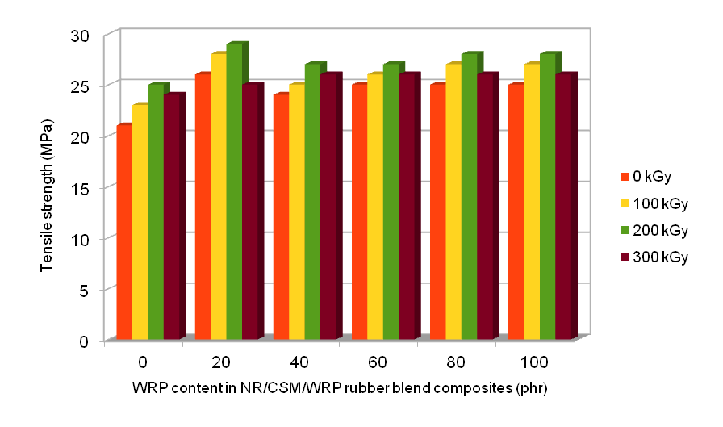
Figure2. The effect of waste rubber powder content on tensile strength for the NR/CSM/WRP composites irradiated with different doses.

The influence of WRP content on tensile modulus at 100% elongation (M100) for the composites irradiated with different doses is shown in Figure 3. It can be seen that the M100 of all samples increases with increasing the irradiation dose, whereby NR/CSM/WRP rubber blends composites has attained higher value than pure NR/CSM rubber blend. The M100 value increase with content of WRP rubber increase up to 20 phr and it decreases after 20 phr of WRP content in blends. The influence of WRP content on elongation for the rubber blend composites irradiated with different doses is shown in Figure 4. And, the influence of WRP on hardness for prepared composites irradiated with different doses is shown in Figure 5. The hardness of the rubber blends increases with irradiation dose. A higher amount WRP would result in an increased hardness of the vulcanizates. The SEM micrograph of composites with 20 phr WRP is shown in Figure 6. The mechanical properties improvement of prepared composites is in correlation with homogenous WRP distribution which has been assigned by SEM.
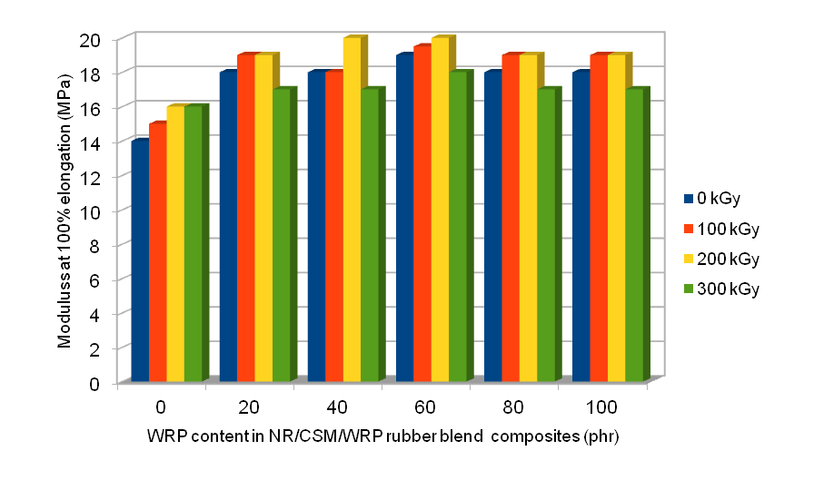
Figure 3. The effect of waste rubber powder content on tensile modulus at 100% elongation (M100) for the NR/CSM/WRP composites irradiated with different doses.

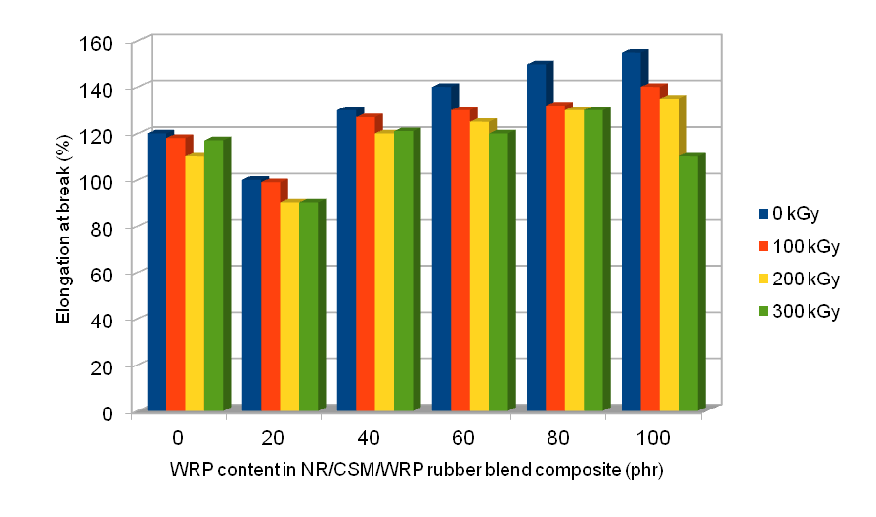
Figure 4. The effect of waste rubber powder content on elongation at break (Eb%) for the NR/CSM/WRP composites gamma irradiated with different doses.

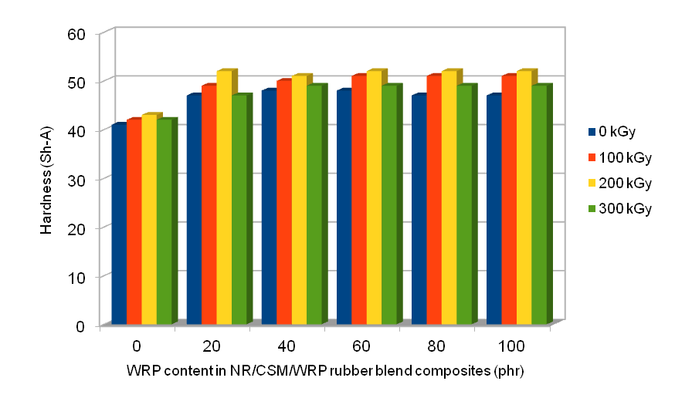
Figure 5. The effect of waste rubber powder content on hardness values for composites gamma irradiated with different doses.
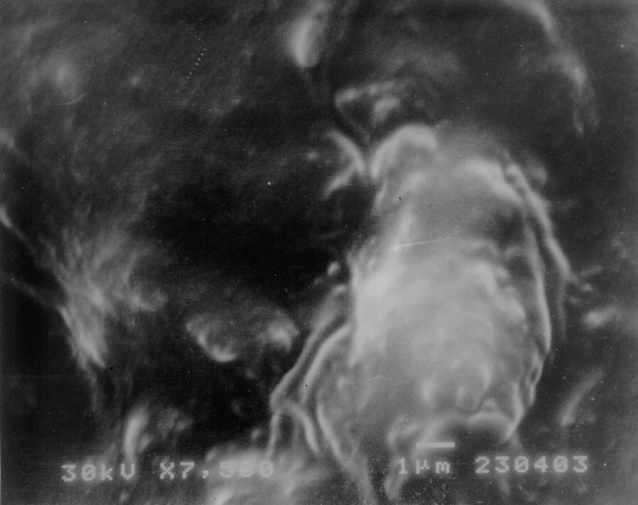
Figure 6. The SEM micrograph of NR/CSM composites filled with 20 phr waste rubber powder at 7500X magnification.

CONCLUSION

The purpose of this work was to investigate the vulcanization behavior and gamma irradiation ageing of elastomers based on two network precursors, nonpolar natural rubber and polar CSM and different content of waste rubber powder. The characteristics t_{s2}, t_{c90} and curing rate index of rubber blend compounds increase with increasing WRP content. The incorporation of WRP reduces the flow of rubber blend compounds, which resulted in an increase of minimum torque. The improvement attained in mechanical properties has been certified by assessment of physical properties of the prepared rubber blend composites. The magnitude of improvement is a function of the gamma irradiation dose as well as the content of WRP in rubber blend. It was estimated that the tensile strenght for all prepared elastomeric materials increased with increasing gamma irradiation dose reaching its maximum value at 200 kGy as a consequence that the crosslinking process was the dominating one up to 200 kGy whereas the degradation process has apparently prevailed for higher doses. The improvement in mechanical properties of prepared composites is in correlation with homogenous WRP distribution which has been assigned by scanning electron microscopy.

ACKNOWLEDGEMENT

Financial support for this study was granted by the Ministry of Science and Technological Development of the Republic of Serbia (Project Numbers 45022 and 45020).

LITERATURE

- Ismail H., Nordin, R., Mohd Noor A., The Effects of Recycle Rubber Powder (RRP) Content and Various Vulcanization Systems on Curing Characteristics and Mechanical Properties of Natural Rubber/ RRP Blends, Iranian Polym J, 12 (5), 2003, 373-380
- Ismail H., Yusof A., Blend of waste poly(vinylchloride) (PVCw)/acrylonitrile butadiene-rubber (NBR): the effect of maleic anhydride (MAH). Polym Test 23(6): 2004; 675–683.
- Sombatsompop, N., Kumnuantip C., Rheology, cure characteristics, physical and mechanical properties of tire tread reclaimed rubber/natural rubber compounds, J Appl Polym Sci, 87 (2003) 1723–1731.
- Marković G., Dević S., Marinovic-Cincovic M., Budinski-Simendić J, Influence of carbon black on reinforcement and gamma–radiation resistance of EPDM/CSM CR/CSM rubber blends. Kautsch Gummi Kunstst 6 (2009) 299–305.
- Salleh S., Ahmad, M., Ismail H., Rubber waste Properties of Natural Rubber/Recycled Chloroprene Rubber Blend: Effects of Blend Ratio and Matrix, Procedia Chemistry 19 (2016) 346-350
- Alex R., Mathew N.M., De S.K. Effects of gamma-radiation on natural rubber vulcanizates under tension International Journal of radiation application and instrumentation, Radiat Phys Chem 33 (2) (1989) 91–95.
- Zhang P., Huang G., Qu L., Nie Y., Weng G., Study on the self-crosslinking behavior based on polychloroprene rubber and epoxidized natural rubber. J App Polym Sci, 125 (2012) 1084–1090
- Toki S., Fujimaki T., Okuzama M., Strain induced crystallization of natural rubber as detected real time by wide-angle X ray diffraction technique, Polymer 41 (14) (2000) 5423-5429.
- Bandyopadhyay S., De P., Tripathy D., De S. Dynamic mechanical spectroscopic studies on the miscibility of polychloroprene-epoxidized natural rubber blend in presence of carbon black filler, Polymer, 36 (1995) 1979–1984
- Marković G., Marinović-Cincović M., Jovanović V., Samaržija-Jovanović S, Budinski-Simendić J., The effect on gamma irradiation on the aging of sulfur cured NR/CSM and NBR/CSM rubber blends reinforced by carbon black. Chem Ind Chem Eng Quart 15(4) (2009) 291–298.
- Dubey K, Bhardwaj Y., Chaudhari C, Sabharwa S. Radiation-processed styrene–butadiene-co-ethylene–propylene diene rubber blends: compatibility and swelling studies. J Appl Polym Sci 99(6) (2006) 3638–3649.
- Marković G., Marinović-Cincović M., Radovanović B., Budinski-Simendić J. Rheological and mechanical properties of wood flour filled polyisoprene/ chlorosulphonated polyethylene rubber blends. Chem Ind Chem Eng Quart 13(4) (2007) 186–191.

