LOGO WILL BE HERE
computer program for calculating distribution of water-flow in heat exchangers which are used in graphic industry
Kire Popovski, Aleksandar Trajkovski, Blagoj Ristovski, Igor Popovski
Summary: This paper represents, an analysis of the influence of the input elements on the distribution of water flow in cylindrical evaporators in the graphic industry. Based on a mathematical model a computer program has been developed, that determinates the degree of uneven distribution of water flow in the pipes of the pipe bundle at cylindrical evaporators. A numerical example of such propellants is made and an overview and recommendations for changing certain structural elements that contribute to optimal operation of evaporators or meeting the criteria for uneven distribution of water flow in the pipe bundle.
Keywords: water-flow, evaporator, heat exchanger.
1. Introduction
Using the mathematical model (Mijakovski Popovski, 1996),a computer program is developed to determine the extent of the uneven distribution of water flow in pipes in the pipe bundle in cylindrical ammonia evaporators.
The degree of uneven distribution of the flow is determined by the ratio of the total pressure drop and the dynamic pressure in the intake pipe, respectively,

(1)

Where is:
v_{max} - maximum flow rate in the pipes,
v_{sr} - average speed of flow in pipes.
The criteria for the uneven distribution of water flow in pipes in the pipe bundle is the requirement,

(2)

A correction of the hydraulic-fluid flow sizes ammonia vaporizers is required and as a result, we get the following:
a) increase of the total pressure drop so that it will be much larger than the dynamic pressure, is:

(3)

b) decrease of the dynamic pressure at the entrance of the collector or increase of the size of the collector.
In certain cases, after the inlet pipe it is necessary to set up a safety barrier, which is tasked to protect the pipes in the pipe bundle from the abrasive action of the liquid. This protective barrier is used when the product ρ⋅v² is:
Tabele 1 Value product ρ⋅v²
Waterflow | Value product ρ⋅v²
For single-phase flow of non-aggressive liquids: | Pa
For other fluids, including liquids near the boiling point, | Pa

In practice, the safety barrier is placed at a distance D_{VL}/4 of the lower end of the inlet pipe,
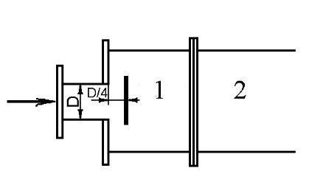
1 - entry chamber, 2 - pipe bundle
Fig.1. A safety barrier at the entrance to the water chamber

This certain placement of the barrier does not change the cross-section of flow. The fall in static pressure is calculated as the rectangular knee or equation,

Pa | (4)

The safety barrier carried dissipation of kinetic energy flow and provides uniform distribution of pressure in the chamber.
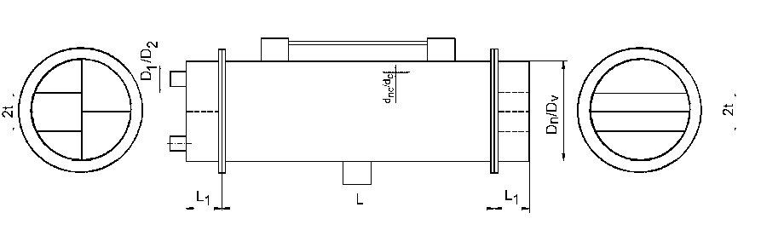
Fig. 2. Structural characteristics of evaporators cylindrical
2. Mathematical model and a computer program
According to the mathematical model and the computer program, the criteria for uneven distribution of water flow pipe bundle for ammonia evaporators is determined which is a product of AD "Frinko" - Bitola, where it can be stated as follows:
a) Cylindrical ammonia evaporators Di-80 (720/700) and Di-200 with its structural and linear features are composed in a good way. The criterion of imbalances of flow with and without a protective barrier is within the permitted limits.
b) Cylindrical ammonia evaporators Di-34 with the proposed design features listed in Table 1 and water flow of 7,65 m³/h does not meet the criteria for uneven distribution of flow through the pipe bundle (18,89 / 16,94). By increasing the size of the entry and exit slots D1 / D2 = 89/82 mm for the same flow rate of 7,65 m³/h got size criterion 7.056 / 6.735, which is also not satisfactory. By increasing the size of the entry and exit openings of following standard sizes D1 / D2 = 108/100 mm, the criteria for the uneven distribution of flow through the pipe bundle is satisfied (3.87 / 3.77).
c) For the entire production program of the cylindrical evaporators AD "Frinko" - Bitola (Table 1) gives an overview and recommendations for changing certain structural elements (Table 2) that contribute to the optimal performance of the vaporizers, thus meeting the criteria for uneven distribution of water flow in the pipe bundle.
Table 1 Characteristics of cylindrical evaporators, part I
Type | D_{n}/D_{v}  mm | L  mm | L₁  mm | D₁/D₂  mm | d_{nc}/d_{c}  mm
Di-22 | 632/614 | 2012 | 100 | 57/51 | 30/24,8
Di-34 | 632/614 | 2462 | 100 | 57/51 | 30/24,8
Di-60 | 632/614 | 4400 | 100 | 57/51 | 38/33
Di-80 | 720/700 | 4612 | 100 | 108/100 | 26,9/22,3
Di-80 | 800/776 | 3852 | 100 | 133/125 | 38/33
Di-100 | 1000/976 | 3600 | 100 | 133/125 | 38/33
Di-200 | 1120/1092 | 4150 | 100 | 216/200 | 30/24,8
Table 1 Characteristics of cylindrical evaporators, part II
Type | S  mm | No. of  knags | t  mm | Number of tubes  in the knag | Flow  m³/h
Di-22 | 40 | 8 | 112 | 13,13,17,17  17,17,15,15 | 3,0  4,37
Di-34 | 40 | 8 | 112 | 16,16,20,20  20,20,21,21 | 7,65  11,25
Di-60 | 50 | 8 | 112 | 16,16,20,20  20,20,21,21 | 9,3  13,7
Di-80 | 40 | 8 | 146 | 13,13,32,32  32,32,26,26 | 12,0  17,7
Di-80 | 50 | 8 | 136 | 22,22,22,22  22,22,22,22 | 12,0  17,7
Di-100 | 50 | 8 | 178 | 32,32,37,37  37,37,32,32 | 14,83  21,85
Di-200 | 40 | 8 | 180 | 69,69,65,65  62,62,66,66 | 29,67  43,65
Table 2 Review and recommendations for changes to certain structural elements, part I
Type | L  mm | D₁/D₂  mm | d_{nc}/d_{c}  mm | Flow  m³/h
Di-22  632/614 | 2012 | 57/51  89/82  89/82  108/100 | 30/24,8 | 3,0  3,0  4,37  4,37
Di-34  632/614 | 2462 | 57/51  89/82  108/100  108/100 | 30/24,8 | 7,65  7,65  7,65  11,25
Di-60  632/614 | 4400 | 57/51  89/82  133/125  133/125 | 38/33 | 9,3  9,3  9,3  9,3  13,7
Di-80  720/700 | 4612 | 108/100  108/100 | 26,9/22,3 | 12  17,7
Di-80  800/776 | 3852 | 133/125  159/150  159/150 | 38/33 | 12  12  17,7
Di-100  1000/976 | 3600 | 133/125  159/150  193,7/175  193,7/175 | 38/33 | 14,83  14,83  14,83  21,85
Di-200  1120/1092 | 4150 | 216/200  216/200 | 30/24,8 | 21,67  43,65
- unsatisfactory
+ satisfies
Table 2 Review and recommendations for changes to certain structural elements,
part II
Type | K_{am1}/K_{am2}  % / % | Δp  Pa | Remark
Di-22  632/614 | 16,176/14,727  5/4,2  5,2/5,034  4,451/4,321 | 285  143  297  256 | -  +  -  +
Di-34  632/614 | 18,89/16,94  7,036/6,735  3,87/3,77  4,451/4,321 | 1570  667  556  1044 | -  -  +  +
Di-60  632/614 | 23,901/20,855  13,56/12,48  8,63/8,153  4,62/4,456  4,785/4,612 | 1793  496  361  281  589 | -  -  -  +  +
Di-80  720/700 | 2,444/2,406  2,55/2,507 | 2184  4554 | +  +
Di-80  800/776 | 5,8/5,58  3,32/3,24  3,43/3,35 | 371  316  665 | -  +  +
Di-100  1000/976 | 10,56/9,9  6,55/6,28  4,138/4,02  4,227/4,144 | 304  241  208  438 | -  -  +  +
Di-200  1120/1092 | 2,447/2,405  2,639/2,591 | 834 | +  +
- unsatisfactory
+ satisfies
Nomenclature
d mm - diameter,
v m/s - flow in the pipes,
Δp Pa - pressure drop.
References
[1] Mijakovski I. Popovski K. (1996). Impact of distribution items on the distribution of the flow of fluid through the pipe bundle in horizontal cylindrical heat exchangers, Proceedings, p. 143-151, Faculty of Technical Sciences, Bitola, Macedonia.
[2] Mijakovski I., Popovski K., Mijakovski V. (1999). Impact of distribution items on the distribution of the flow of water through the pipe bundle in cylindrical evaporators. VII counseling DTRM 99, Mechanical Engineering - Skopje, Ohrid, Macedonia.
[3] Leaflet material "Frinko" -Bitola, Macedonia.

Professor Dr. Kire Popovski, Bitola, Macedonia, Faculty of Technical Sciences, University "St. Kliment Ohridski", e-mail:kire.popovski@uklo.edu.mk
Dr. Aleksandar Trajkvski, Bitola, Macedonia, SOU "Taki Daskalo", e-mail: acanbt@yahoo.com
Post-graduate Blagoj Ristovski, Bitola, Macedonia, Faculty of Information and Communications Technology, University "St. Kliment Ohridski", e-mail: Blagoj_Ristovski@yahoo.com
Post-graduate Igor Popovski, Bitola, Macedonia, Faculty of Technical Sciences, University "St. Kliment Ohridski", e-mail: igor.popovski92@gmail.com

