LOGO WILL BE HERE

Data recording systems with TELOC - 1500 for upgrading safety systems on locomotive series 441-521
Tihomir Latinovic , Mladen Todic , Cristian Barz , Pop Vadean Adina , Pop Paul Petrica
Summary: In recent years, railway traffic is being developed in the EU and in the neighboring countries of Bosnia and Herzegovina and the Republic of Srpska. In these countries rolling stock are used for cheap transport of passengers and goods, with a high reliability, high level of safety and low operating costs. In the Republic of Srpska, railway traffic is used to transport goods, primarily coal and iron ore. The fleet is quite old and not very safe for traffic. Installing systems such as TELOC 1500 provides exceptional measurement and acquisition system for additional safety train 441-521. This paper describes a data acquisition system for electric locomotive 441-521, with key parameters, speed, braking systems, the use of the system for alarm and memory of all the changes that occur during operation. The system further improves safety system in railway traffic. The work explains the practical operation of such a system with the analysis of the data obtained in this way, as well as opportunities offered by the introduction of such a system. The paper was written as part of a successful project commissioning test train series 441-521 after implantation TELOC 1500 device. Everything is supported by real measurement data from real-time analysis of railway traffic in Doboj, Republic of Srpska.
Keywords: Data acquisition system, safety systems, railway traffic
- INTRODUCTION
Electric locomotive 441 are four-axle, single-phase, with a diode and with the power supply voltage of 25 kV, 50 Hz. They have DC current traction motors with ordinal excitation.
The main transformer with step-switch on the high voltage side enabled 41-degree change in supply voltage traction motors. To reduce the ripple current traction motors there is a main silencer. Each traction motor has a special diode rectifier. Weakening initiatives traction motors are bridging carried out in three stages. Traction is controlled by the controller train drivers.
Measuring instruments and signal lamps for the control of locomotives are located on the control panel. Slip protection locomotive is based on measuring the difference electric traction motors.
Facts slip protection are blasting, power compensation relieve the front axle and lowering the power supply voltage of traction motors. Locomotives are registering velocity device, pulsed inductive device vigilance, and auto-stop device. Traction motors, diode rectifiers, reactors and the main transformer oil have forced air cooling. Locomotives are equipped with a lubricating wheel flange.
We have on a market more existent solutions of kilometer counting methods and distribution of these data [1]:
- Mechanical mileage counters - The first devices, built in trains, had mechanical mileage meters. It was in 1934 and made by Siemens Schuckertwerke. The first practical method is to measure a mileage wagon with a mechanical counter.
- Electromechanical counters are one way of calculating distances. The method is based on e.g. Hasler RT / A type, which is installed in the engine driver's cab [3]. This is a type of indirect measurements. With it, it is estimated mileage attached wagon based on the mileage of railway engine during its operation. There is no possibility of electronic data transfer "on-line" at the central data collection point, for example, a central database including information on mileage.
- Electronic tachometers are a method of counting mileage. It is based on electronic tachometers, where vaginal mileage measurement is indirectly calculated. TELOC 1500/2500 [3], is a modern solution based on recording of driving data with the ability to analyze collected data using a computer. Devices are installed on a railway engine. This mode of acquisition and driving registration meets all the latest safety requirements as well as the European Commission standards.
- GPS-based mileage measurement: Distance control methods using the GPS system depend on calculating the mileage of the wagon at the summits at the time intervals between the points pointing to the GPS. They use an indirect calculation system. They work on the location of railway vehicles on the map. These systems often oversee other parameters of railway vehicle works (e.g. Railroad and Rail wagons, engine driver logging and working time, and quick access to reports, statistics and data sheets). There is also a full function of track visualization and stopping history.

- TELOC 1500
TELOC® 1500 system [4] is part of new generation of equipment, which satisfied highest standards in the domain of safety and controlling of the train during driving. TELOC® 1500 are used for registering velocity, analog signals (motor current, the voltage for contact network, the pressure in braking system etc..). We have a digital signal, like alarm, brake signal, on-Road driving, automatic device for vigilance, protection from going downhill and monitoring of speeding.
Hasler® MultiRec-Sg software giving You the opportunity to diagnostic and configuring TELOC® 1500, and have a connection with the RS232 interface. All saved data are analyzed with TELOC® EVA Professional software. Data about sliding distance are saved in memory which is very impact resistant and fire resistant and can be accessed only through service units.
  - Requirements for the installation of devices for measuring speed and data registration
The device for measuring the speed and the registration information must include:
- Central unit TELOC1500 - 1. (place to accommodate the central unit will be subsequently agreed), with a full software package (application software, configuration software and boot software); connectors for connection with the installation of locomotives are delivered in part of the device;
- speed indicator with moving coil, with analog and digital speed (The digital display with three digits) - 2 units,
- an optical pulse generator, with the two sensors, and the coding disc with a perforation of hole 200 - 1pcs,
- a connecting box - 1 unit,
- a pressure sensor for the pressure in the main line and brake cylinder into the water - 2 units,
- electromechanical odometer - 1 unit,
- display - 2 units.
Dead-man function and wheel flange lubrication are provided through the device TELOC1500. Do bypass TELOC 1500 and dead man in case of failure, by switches or buttons. This exclusion should be evidencing and record with TELOC 1500.

- STRUCTURE AND FUNCTIONALITY OF SYSTEM
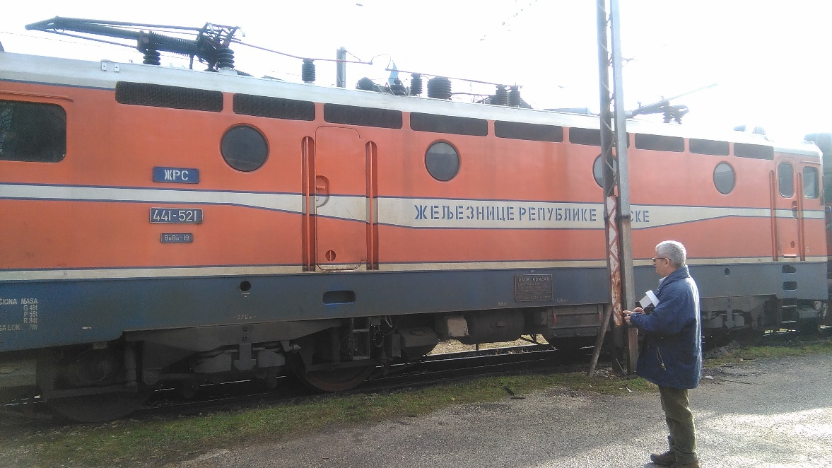
Fig. 1 (Train 441-521 with TELOC 1500)

TELOC 1500 [4] system is suitable for all railway applications and is the most flexible of all HaslerRail data recorders. The system is based on equipment embedded in train Fig. 1, service device like element for communications with equipment and equipment for evaluations which analysis data about sliding distance downloads from TELOC 1500 Fig.1. The diagram of the Fig. 2 gives us a structure for system TELOC 1500. We have equipment embedded in train, service unit for communication and equipment for evaluation for analyzing data about sliding distance taken from TELOC 1500.
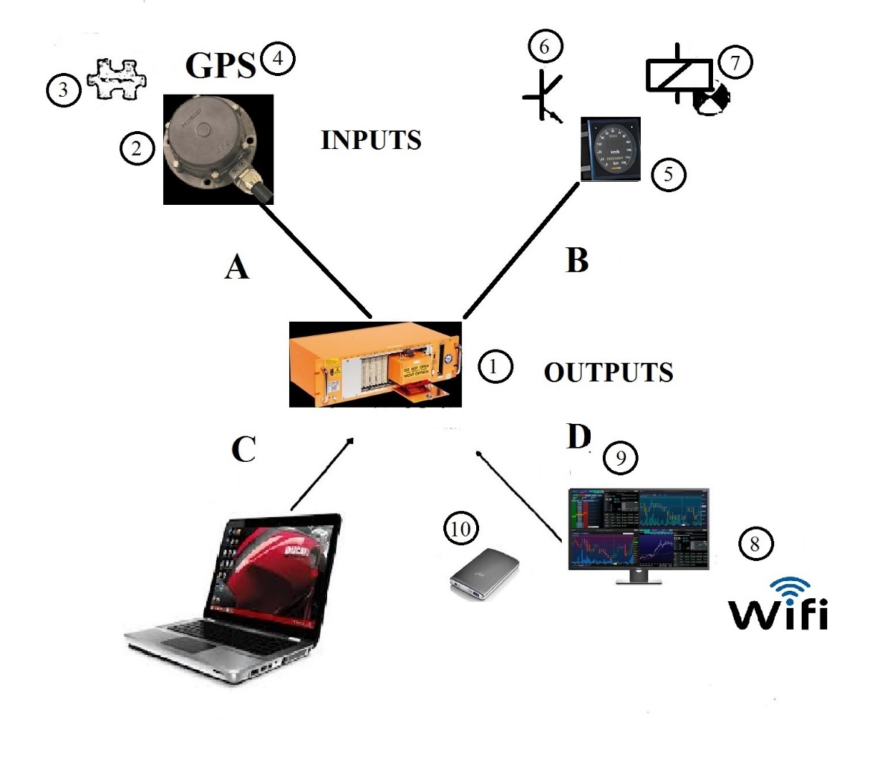
Fig. 2 (System TELOC 1500)

- A Built-in equipment (input)
- B Built-in equipment (output)
- C Notebook with software Hasler Multirec-SG and EVA TELOC
- D Options

- TELOC 1500
- Pulse generator
- Input digital / analog signals
- Weather information from the GPS device
- Speed indicator
- The output digital relay
- Pulse output
- WIFI
- Integrated or external display
- Memory impact resistant and fire CPM)

One of the key element for systems is Hasler optical pulse generator Fig. 3. Optical Pulse Generator resists most extreme mechanical and thermal stress. The technology is based on an optical system that operates in the infrared range. It is possible to have two different frequencies per revolution and up to six electrically isolated sensors.[6]
The pulse generator delivers the signals for measuring and recording the distance as well as the speed, for wheel slip and slide sensing, for various control and safety functions, train safety system, etc.
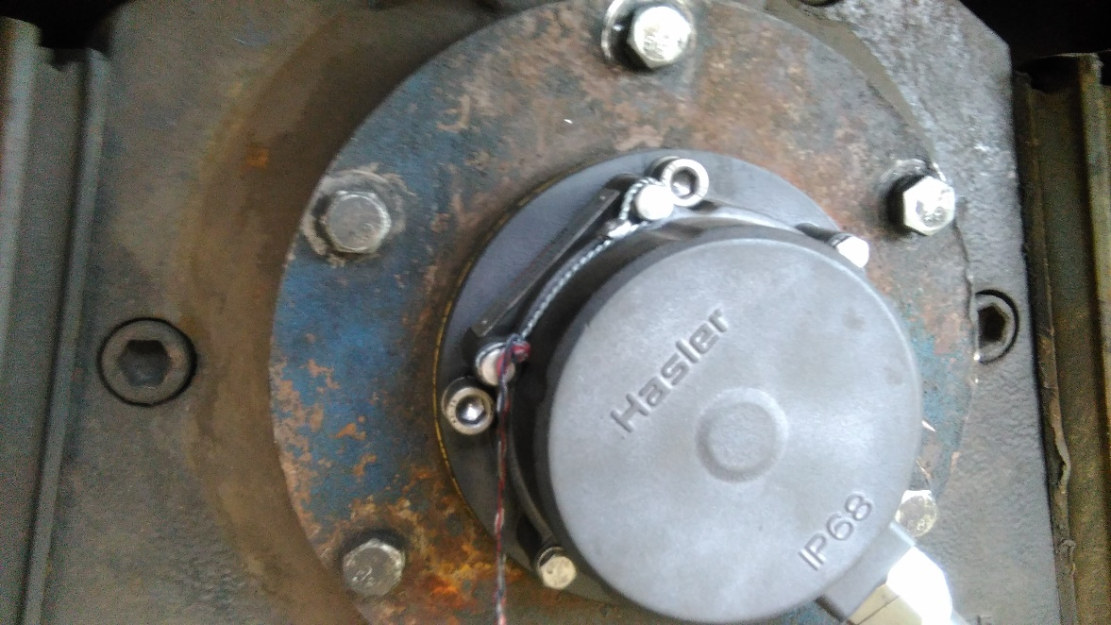
Fig. 3 (Hasler optical pulse generator)

On Fig. 4 will see a locomotive control panel with an indicator of velocity which is connected with the optical pulse generator. Registered signals are processed according to with configuration. We have some alternative:
- Registered in activated memory in TELOC 1500 in internal and external memory
- Broadcasting analog signal (for control of indicator of velocity)
- Broadcasting digital signals in dependence of velocity for control peripheral equipment
- Bus signals (RS485, MVB, CANopen, Profibus etc.)

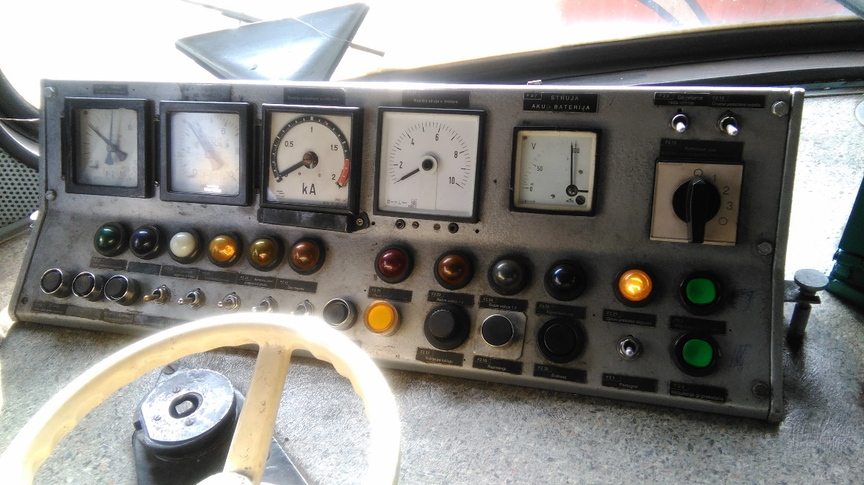
Fig. 4 (Locomotive 441 control panel with indicator of velocity)
On Fig. 5 we will see an all embedded equipment and connect peripheral devices on train 441. The TELOC 1500 can be connected to the whole variety of HaslerRail products, e.g. Hasler Optical Pulse Generators, Hasler Speed Indicators and accessory products such as Hasler Badge Reader Boxes, Hasler Voice Boxes, Hasler Front and Rear View Recording Systems, the Hasler Gateway System, Energy Metering solutions and different interface products such as service displays or driver interface terminals.

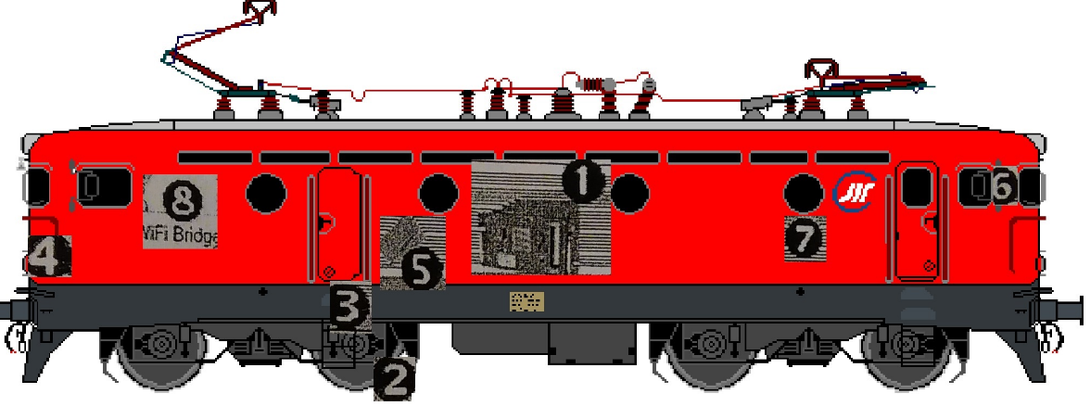
Fig. 5 (Appliance and connect peripheral devices in locomotive 441)

- TELOC 1500
- Pulse generator
- Terminal box
- Speed indicator
- External memory
- Terminal for train driver in the cabin
- Connection to the Train bus driver
- Wi-Fi Bridge

- EVA2 SOFTWARE FOR EVALUATION

Software for evaluation TELOC EVA [5] is used for analyzing date of driving. The software is very safety and only read a data without any write in protected memory. TELOC 1500 generated a lot of data about analog, digital or frequency signal. These data are used for evaluation of the performance of train for some time. These data we are using after some event. The signal that is memorized give needed data about the behavior of train and give us full statistic of driving.
We have:
- Operating data are internal data generating for internal use
- ETCS data are 24 hours’ data or 8-day data in specified format

These data are using for graphical presentations of train driving during 24 hours or 8 days or after some accident.

3.1 Procedure for measurement of train speed [6]
Measurement of train speed are basically forming with two criteriums:
In accordance with real velocity, the base for velocity calculation are two criteriums:
- “LOW SPEED” is low than 320 optical pulses per second (PPS)
- “HIGH SPEED” is more than 400 optical pulse per second (PPS)

In
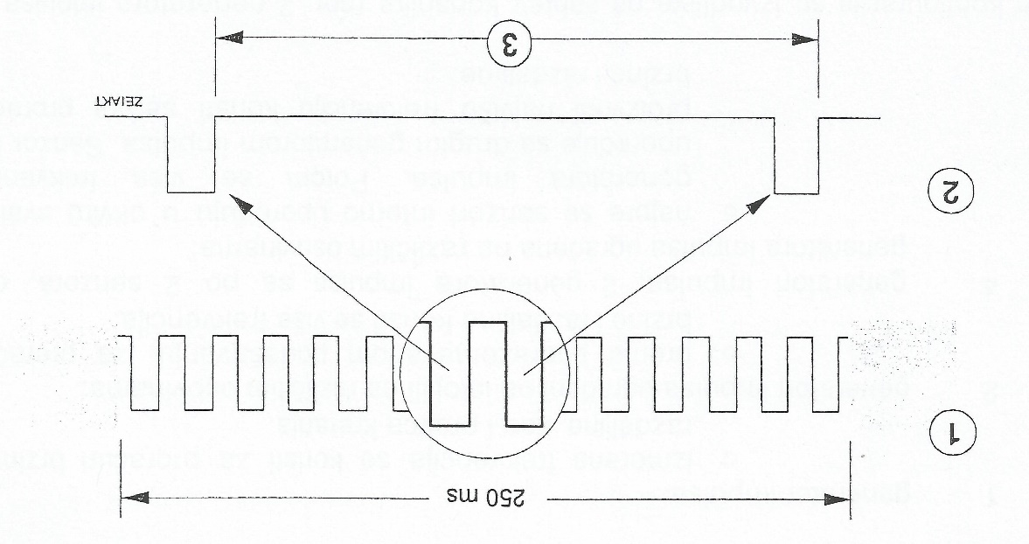
Fig. 6 (Measurement cycles “HIGH” and “LOW” speed)

- Criterium “HIGH Velocity”
- Criterium “SMALL Velocity”
- Time between two impulse

Maximal possible frequency is recalculated based on configured target speed.
$$Fmax=\frac{Vend*z}{3.6*π*d}[Hz]$$
Fmax: Maximal frequency
Vend: Shifting pins [km/h]
z: The number of pulses during a speed point
3.6: factor of conversion m/s -> km/h
d : wheel diameter [m]
  - Kind and type of data
Data about a train trip are:

- Date about driving (operating data)
- ETCS data

- Data about driving are used during driving and these are analog, digital and frequency signals, memorized in a different type of memory (short-term, long-term memory and events memory). These data are used for detail dataset about behaviors of the train during driving. We use data for the statistical report and for a report after some accident like on Fig, 7.
- ETCS data are recognized with the name of fileName.Xnn, where is:
Name = Name of file
Xnn = X00 – X14
There are two types of ETCS files. Files that contain 24-hour data and files that contain 8-day data. ETCS data, as well as TELOC data recorder data, are in a special format and therefore must first be linked with EVA2.

Registration velocity is proportional to measured velocity.
In the picture Fig, 7. we see a number of data in the real time that passed through locomotive 441-521. In the figure, we can see all the parameters of driving the locomotives, including: braking, driving, siren use and other parameters depending on the built-in sensors. Everything is remembered in shock-resistant and fire-resistant memory. Everything can be read and stored on a usb or wifi transferred to a remote computer. All this depends on the installed equipment on the TELOC 1500. Data is obtained in real time and graphically as Fig. 7.
The difference between "normal" raw data and raw data ETCS:
Normal raw data is files from the TELOC recording device. They are out in raw data records. They can also be selected to be exported as a whole or as individual files using the EVA Data Browser.
The ETCS file can be a single file or part of a normal raw data file. All ETCS files can also be exported to an XCL or XML file.

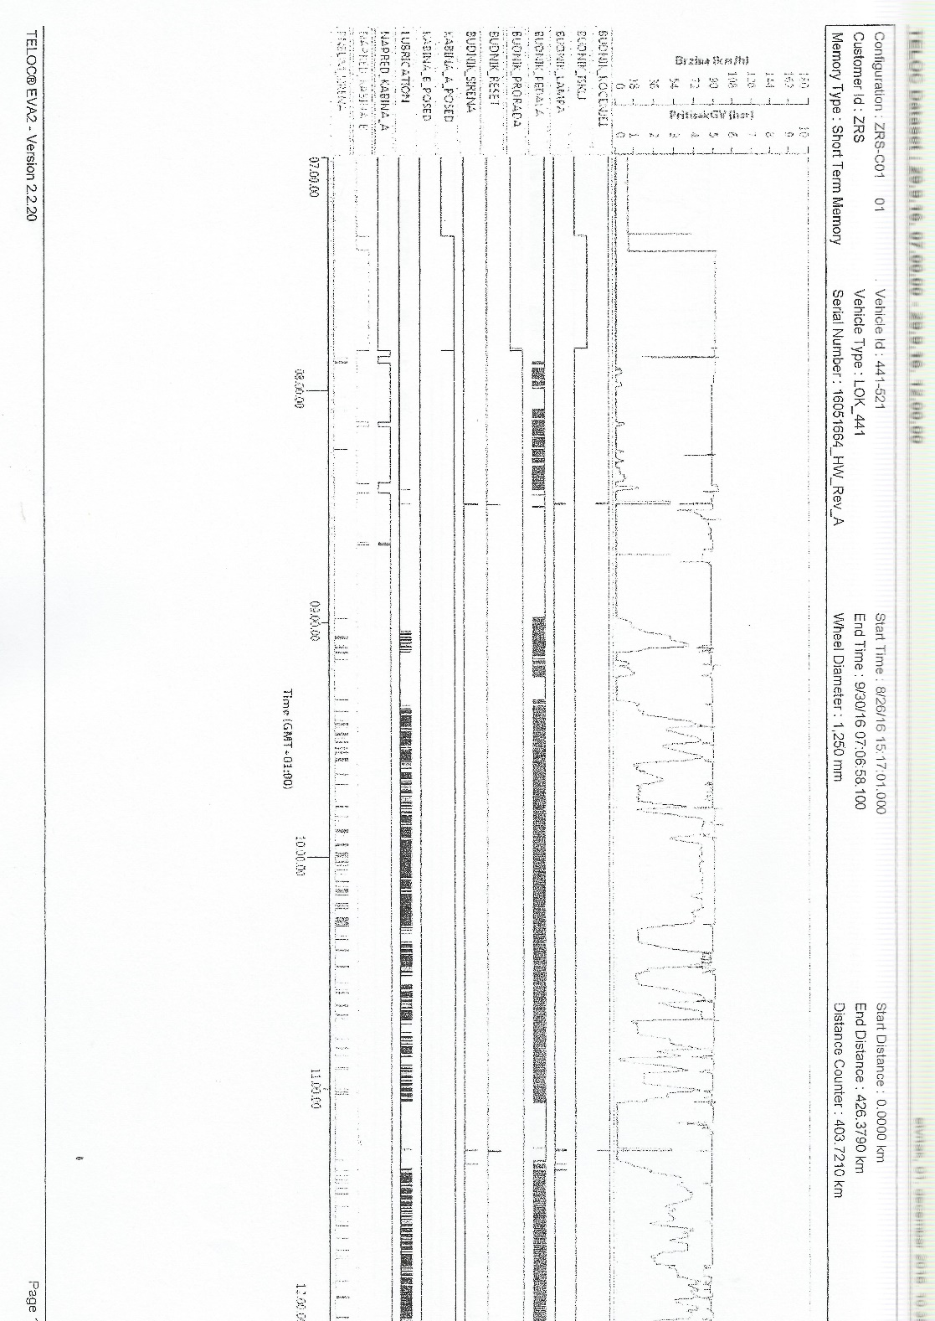
Fig. 7 (TELOC Dataset after train traveled 426.379 km)

- CONCLUSION
At the end, we can look back on a railway carriage. All the neighboring countries, especially those that are most developed are used to this kind of transport. France, Germany, Japan, America and many other countries a wider network of this kind of transport, while Bosnia and Herzegovina, Serbia and other ex-Yugoslavian countries are rigid for railway transport.
BiH almost finished the transport of people and only remains on the transport of goods, mostly rude. On the other hand, the real highway network, combined with a network of railways is better decision. In the former Yugoslavia, the trains were transporting people from Belgrade to Bar and from Sarajevo to Belgrade and for smaller places such as Bihac, Prijedor and many others.
The rise in oil prices make those highways become a more expensive mode of transport, a combined railway passenger and cargo transport became the only affordable mode of transport. In this paper, we look at one such mode of transport and tried to improve it with new technology and safer for people and cargo.
An integrated, sustainable system-wide approach to the transporting of goods in the urban area presented in this paper, shown a strong current tendency to develop innovative ways to make the logistics and transport in BiH more environmentally friendly.
The working solutions are the response to the growing problems of congestion, goods movements, the inefficiency of the goods distribution processes, the space deficit and the environmental and social nuisances in many cities. Enhancing levels of urbanization, globalization and the consumption of goods are reflected in the growing demands on of logistics and transport activities. Therefore, further research and improvements in the integrated sustainable transport systems in urban areas are required to provide the expected benefits from businesses, public authorities and the local community.
REFERENCES (BOLD)
Journal Papers:
- Zadnik, Ž., Karakašič, M., Kljajin, M., Duhovnik, J. (2009). Function and Functionality in the Conceptual Design Process. Strojniški Vestnik - Journal of Mechanical Engineering, vol. 55, no. 7-8, p. 455-471.
- Alessandrini, A., (2012). Using rail to make urban freight distribution more sustainable, European Transport, Issue 50 paper nr 5,p. 30-32
- Allen J., Browne M., Woodburn A., Leonardi J. (2012)., The Role of Urban Consolidation Centres in Sustainable Freight Transport, Transport Reviews, vol. 32, no. 4,p. 110-115
Books:
- Luthi M., (2009). TELOC 1500 Instruction Manual first edition. HaslerRail AG, Bern, Swicherland
- HaslerRail AG, (2014), EVA2 Software manual. HaslerRail AG, Bern, Swicherland
- HaslerRail AG, (2014), Pulse Generator installation manual. HaslerRail AG, Bern, Swicherland

PhD,Tihomir Latinovic, Banja Luka, Republic of Srpska, BiH, University of Banja Luka, Faculty of Mechanical Engineering, (tihomirlatinovic@live.com)
PhD, Mladen Todic, Republic of Srpska, BiH, University of Banja Luka, Faculty of Mechanical Engineering, (mladentodic@unibl.rs)
PhD, Cristian Barz, Romania, Technical University of Cluj Napoca, Center University of North from Baia-Mare, Department of Electrical Engineering Electronics and Computers, (cristian.barz@cunbm.utcluj.ro)
PhD Student, Pop Vadean Adina Technical University of Cluj Napoca, Center University of North from Baia-Mare, (adinaluciapopvadean@yahoo.com)
PhD Student, Pop Paul Petrica, Technical University of Cluj Napoca, Center University of North from Baia-Mare, (poppaulpetrica@yahoo.com)

