THE IMPACT OF PARTIAL REFURBISHMENT ON THE HEATING ENERGY CONSUMPTION OF A RESIDENTIAL BUILDING SECTOR
Andreja Stefanović
Summary: The energy used in buildings represents a large share of national energy use in most countries, so one of the conditions for the reduction of total energy consumption has become improvement of the energy efficiency in the building sector. Understanding of the buildings energy performance at the city level is necessary in order to form a city energy planning policy and make a strategic decision on which buildings should be thermally improved. In this paper, the impact of new windows installation on the heating energy consumption of a multi-family residential building sector, built before 2012 in the city of Kragujevac, Serbia, was investigated. Heating energy consumptions and reductions were estimated by engineering bottom-up method which uses representative building types and building energy simulation program. After the simulation of the new windows with U=2.2 W/Km² and U=1.4 W/Km² installation, the reductions of the total annual heating energy consumption of a multi-family residential building sector were 15.97% and 19.26% respectively.
Keywords: energy consumption, building sector, refurbishment, energy reduction
1. INTRODUCTION
The buildings sector accounts for more than 30% of the total global final energy consumption, with residential buildings accounting for 74% and non-residential buildings for 26% of the global building energy use [1].
Understanding of the buildings energy performance at the city level is necessary in order to form a city energy planning policy and make a strategic decision on which buildings should be thermally improved. Some of the biggest problems in the energy savings process in buildings and often energy efficiency measures implementation failure causes are a lack of information about the building's characteristics and measures which need to be applied to the buildings fund and the complexity related to the implementation of energy efficiency measures. The knowledge of building stock characteristics and energy consumption estimation are essential in understanding how the energy performance of buildings can be improved and energy consumption reduced.
One way of solving the problem with the lack of building characteristics information is the development of models and methods for predicting energy consumption in buildings stock. Energy modeling of the building sector is the methodology that estimates energy consumption in buildings and simulates the effects of energy efficiency improvements of building envelopes and building systems. Two general energy modeling methods of the residential sector are top-down and bottom-up, where bottom-up models can be divided into statistical models and engineering models or statistical based and building physics based models [2,3]. The engineering bottom-up method involves a description of a building stock by means of representative building types and it usually uses building energy simulation program for estimation of energy consumption of the building stock. When engineering bottom-up method is used for energy modeling, building stock is represented by building types that can be real buildings or archetypes [2].
In this paper engineering bottom-up method was used for modeling the heating energy consumption of a multi-family residential building sector built before 2012 in the city of Kragujevac in Serbia. In October 2012 two ordinances on the energy efficiency of buildings came into effect in Serbia and imposed a legal obligation for the construction of new energy efficient buildings, so from today’s point of view, all multi-family residential buildings constructed before 2012 are practically energy inefficient. The methodology was already verified [4] and in this paper was used to estimate heating energy consumption reductions after simulation of the new windows with U = 2.2 W/Km² and U = 1.4 W/Km² installation.
2. METHODOLOGY
Fig 1 shows a methodology for modeling the heating energy consumption of a multi-family residential building sector of the city.
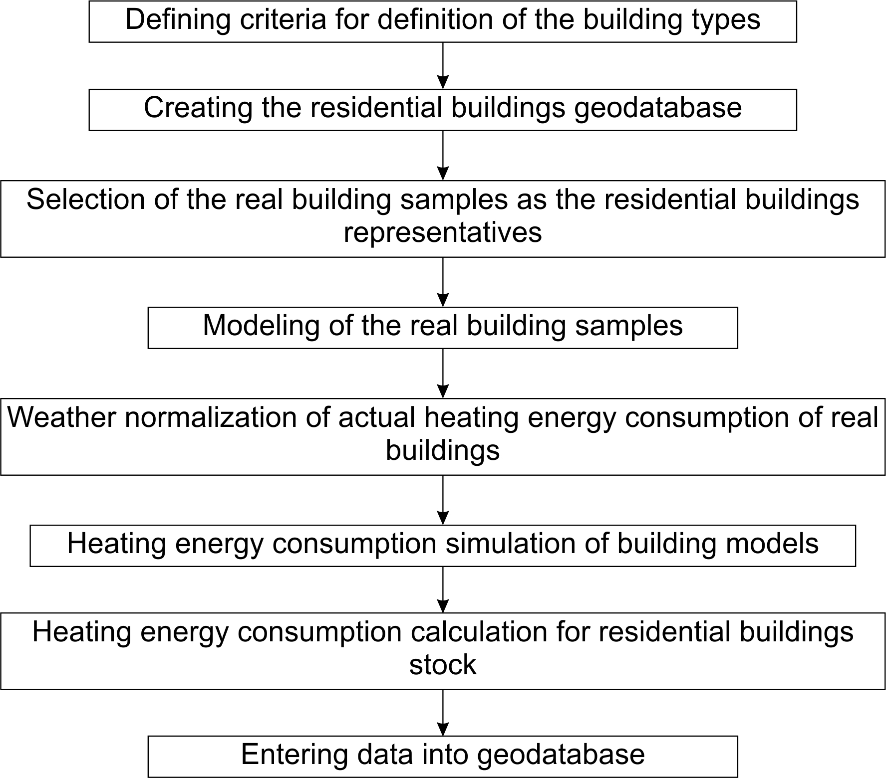
Fig 1 Methodology scheme
2.1. Defining criteria for definition of the buildings types
Criteria, based on which building types were defined and multi-family residential building stock was described, have been selected in such a way as to describe buildings as accurately aspossible.
There are 5 criteria based on which buildings types were defined:
1. Architectural-urban criterion,
2. Construction period criterion,
3. Building heating system criterion,
4. Criterion based on type of area in contact with lower horizontal construction of heated building area,
5. Criterion based on type of upper horizontal construction of heated building area.
2.2. Creating the residential buildings geodatabase
Geodatabase of multi-family residential buildings in the city of Kragujevac was created in the GIS program. Graphic part of the geodatabase consists of polygons representing the foundation of the buildings. Analytical part of the geodatabase includes information determined by criteria for defining the buildings types, the address of the building, number of floors, orientation and heated area of the building.
2.3. Selection of the real building samples as the residential buildings representatives
General rule for the selection of building samples was: The buildings that have been chosen for samples belong to the types of buildings that are most representative of the architectural-urban type and the construction period.
Using the general and additional selection rules, 43 real buildings were chosen to represent all of the multi-family residential buildings in the city of Kragujevac.
2.4. Modeling of the real building samples
Real building samples were modeled in Google Sketchup and EnergyPlus software.
In Google Sketchup the geometry of the buildings has been drawn, each surface of the buildings has been given corresponding construction and contact conditions have been defined for each surface of the thermal envelope. Also, the buildings have been positioned on their real world coordinates, surrounded by neighboring buildings that cast a shadow over the model building.
Other parameters necessary for simulation of the heating energy consumption in buildings were defined in EnergyPlus software. They included material layer structures, schedules for heating, occupancy, lighting, electrical equipment,activity level, infiltration, ventilation, etc.
2.5. Weather normalization of actual heating energy consumption of real buildings
Weather normalization of energy consumption enables a comparison of energy consumptions from different periods with different weather conditions and commonly uses degree days as a simplification of historical weather data related to the outside air temperature.
Weather normalization was used in calculation of targeted heating energy consumption of the simulated building model which is calibrated with heating energy consumption of real buildings.
2.6. Heating energy consumption simulation of building models
Modification coefficients have been introduced in order to reduce the number of simulated building models in relation to the number of building types which represent a multi-family residential building stock. These coefficients relate models of the simulated buildings with buildings of similar types.
Orientation coefficients were defined in order to identify the difference between buildings of the same type that have different orientations.
By varying the number of ventilation air changes per hour simulated heating energy consumption approached the targeted heating energy consumption. After the heating energy consumption simulation of the original, rotated and modified building models and calculation of orientation and modification coefficients, all the required data for multi-family residential buildings were completed.
2.7. Heating energy consumption calculation for residential buildings stock
Due to high functionality and automation of operations, calculations were performed in an Excel spreadsheet in which data from geodatabase were imported. After calculation of heating energy consumption, data from the Excel spreadsheet were exported back to the geodatabase.
The data entered into the spreadsheet for building models included: orientation coefficient, modification coefficient and simulated annual heating energy consumption of building models. The annual heating energy consumption per square meter of the heated area was calculated by dividing the simulated annual heating energy consumption and the heated area of the building model.
The data entered into geodatabase for other buildings included: orientation coefficient and modification coefficient. The annual heating energy consumption per square meter of heated area for every building was calculated by multiplying orientation coefficient, modification coefficient and annual heating energy consumption per square meter of heated area of the corresponding building model. The annual heating energy consumption for every building was calculated by multiplying the annual heating energy consumption per square meter of heated area by the heated area of the building.
2.8. Entering data into geodatabase
After calculation of heating energy consumption, data from the Excel spreadsheet were exported back to the geodatabase, in a format that could be used for energy mapping of the city.
3. SIMULATION OF NEW WINDOWS INSTALLATION ON ALL MULTI-FAMILY RESIDENTIAL BUILDINGS
Partial thermal improvement of building envelopes was investigated with the simulation of new windows installation, with U = 2.2 W/Km² and U = 1.4 W/Km² overall heat transfer coefficient. Types of windows, U and g-values were adopted from windows library of software Knaufterm2S (Table 1).
Table 1 Types of windows, U and g-values
Window type | U-value (W/K⋅m²) | g-value (-)
Aluminum frame with improved thermal break, double-layer low-E glass package 4 + 12 + 4 | 2.2 | 0.45
Aluminum frame with improved thermal break, double-layer low-E glass package with krypton 4 + 12 + 4 | 1.4 | 0.40
When installation of the new windows was simulated, in addition to the change of U-value and g-value of glass, for buildings built between 1946-1990 infiltration was also changed to the value of 0.5 h⁻¹[5], since the change of the windows would lead to the change of the buildings air-tightness.
When installation of the new windows with U = 2.2 W/Km² was simulated, buildings built between 1991-2012 were not taken into account, because windows in that period have overall heat transfer coefficient U = 2.79 W/Km² and air infiltration have already been adopted at 0.5 h⁻¹, so that improvement would not lead to a significant reduction in heating energy consumption.
Summarizing of the estimated annual heating energy consumptions of all buildings from the investigating stock resulted in the total heating energy consumption of 147,975 MWh.
After the simulation of the new windows with U = 2.2 W/Km² and U = 1.4 W/Km² installation, the reductions of the total annual heating energy consumption were 23,636 MWh and 28,502 MWh or 15.97% and 19.26% respectively.
It was possible to calculate the potential heating energy consumption reduction for each of the architectural-urban building types. The percentage distribution of potential reductions is shown in Table 2.
Table 2 The percentage distribution of potential reductions
Architectural-urban type | U = 2.2 W/Km² |  | U = 1.4 W/Km²
Architectural-urban type | MWh | % | MWh | %
Free standing building | 3,369 | 14.26 | 4,231 | 14.84
High rise building | 3,976 | 16.82 | 4,371 | 15.34
Apartment block | 6,421 | 27.17 | 7,495 | 26.30
Building in a row | 1,468 | 6.21 | 2,208 | 7.75
Building in a staggered block | 7,400 | 31.31 | 8,857 | 31.08
Building in an apartment block row | 1,002 | 4.24 | 1,340 | 4.70
It was also possible to calculate the potential heating energy consumption reduction for each of the architectural-urban building types in each of the construction periods. The largest percentage reductions of 34.06% for windows with U = 2.2 W/Km² and 37.61% for windows with U = 1.4 W/Km² can be expected in the high-rise buildings, constructed in the period 1961-1970 and 1971-1980 respectively.
4. CONCLUSION
In order to achieve significant heating energy consumption reductions of the multi-family residential building sector, thermal improvements must be carried out at least on the city level. This would probably be impossible without defining city energy policy which would apply to the whole multi-family residential building sector.
The modeling method, presented in this paper, was performed on multi-family residential building sector built before 2012 in the city of Kragujevac in Serbia. After the simulation of the new windows with U = 2.2 W/Km² and U = 1.4 W/Km² installation, the reductions of the total annual heating energy consumption were 23,636 MWh and 28,502 MWh or 15.97% and 19.26% respectively. In presented methodology it was also possible to calculate the potential heating energy consumption reduction for each of the architectural-urban building types in each of the construction periods. High-rise buildings, constructed in the period 1961-1980, have the greatest heating energy reduction potential in refurbishment process which would consist of new windows installation.
Energy modeling methodology and data presented in this paper could be the basis for the city energy policy but also can be used in decision-making process which buildings have the greatest heating energy reduction potential and should be primary candidates for refurbishment.
REFERENCES
- Energy efficiency market report 2015, (2015). International Energy Agency, OECD/IEA.
- Swan L.G., Ugursal V.I. (2009). Modeling of end-use energy consumption in the residential sector: a review of modeling techniques, Renewable & Sustainable Energy Reviews, vol 13, p. 1819–1835.
- Kavgic M., Mavrogianni A., Mumovic D., Summerfield A., Stevanovic Z., Djurovic-Petrovic M. (2010). A review of bottom-up building stock models for energy consumption in the residential sector, Building and Environment, vol. 45, p. 1683–1697.
- Stefanovic A., Gordic D. (2016) Modeling methodology of the heating energy consumption and the potential reductions due to thermal improvements of staggered block buildings, Energy and Buildings, vol.125, p. 244-253.
- EN ISO 13789, (2007). Thermal Performance of buildings. Transmission and ventilation heat transfer coefficients. Calculation method. International Organization for Standardization. Geneva.

dr Andreja Stefanović, Kragujevac, PE Urban Planning – Kragujevac, andreja2202@gmail.com

