LOGO WILL BE HERE
Significance of hydraulic system working fluid maintenance with integrated logic and built-in components
M.Jocanović, V.Karanović, D.Knežević , M.Orošnjak , S.Laloš
Summary: Based on the need to make small and compact aggregates, modern hydraulic systems are usually designed using built-in hydraulic components. Built-in components require low space and provide the possibility to drastically reduce the number of hydraulic fluid ducts, without the use of pipelines. In contrast to classical components, logic components provide the possibility of operation of hydraulic systems with high flows, as well as low space requirements and compactness. The disadvantage of built-in and logic components however, is that they require a specific level of fluid quality, which additionally imposes preventive and regular working fluid maintenance within prescribed ranges of cleanliness. This paper presents, through an example from practice, the significance of working fluid quality for the performance of a shear machine hydraulic system with logic and built-in components.

Key words: maintenance processes; tribology; hydraulic systems; working fluid cleanliness.
- INTRODUCTION
Modern hydraulic systems are often designed to have, in addition to their classical components, also logic and built-in components. Advantages of these types of components are:
- Possibility of higher flow of working fluid comparing to the classical components,
- Smaller overall dimensions,
- Possibility to be built-in into monolith block constructions without using the pipeline
- Simple design and control [1-3, 6-7].
However, they have certain disadvantages: they require clean oil that has to be maintained at the required level. Problems related to operation of hydraulic systems with contaminated working fluid, have been known before. With the development of new designs of valves and aspirations of designers to require tight tolerances in assemblies of some groups of valves, i.e. small clearances between working elements, the problem of working fluid cleanliness becomes very important. For instance, if we take the catalogue data for certain groups of components from major international manufacturers of hydraulic equipment [1-5], we will see that the impact of the contaminants present in the working fluid, on the operation and functioning of all the components, is very serious and that certain groups of components require very high level of working fluid cleanliness, which has been presented by the authors in their papers [8-10]. The continuous topicality of this issue is based on the requirement that each technical system and therefore, a hydraulic system as well, has, among other, the highest possible reliability and energy efficiency. Logic and built-in components take an important place in modern hydraulic systems, for which reason we took, as an example to be considered, the existing shear machine hydraulic system where the working fluid contamination caused disorder in functioning and the decrease in total machine efficiency coefficient. With proper selection of corresponding oil, bringing the oil to the required level of cleanliness and adjustment of the hydraulic system components, the increase of the machine efficiency was obtained, as presented in this paper.
- CONSTRUCTIONS OF LOGIC AND BUILT-IN VALVES
The purpose of logic valves in hydraulic systems is to provide the distribution of large quantities of working fluid along with reliable operation of hydraulic systems using low/high pressure values depending on the type of the system (figure 1).
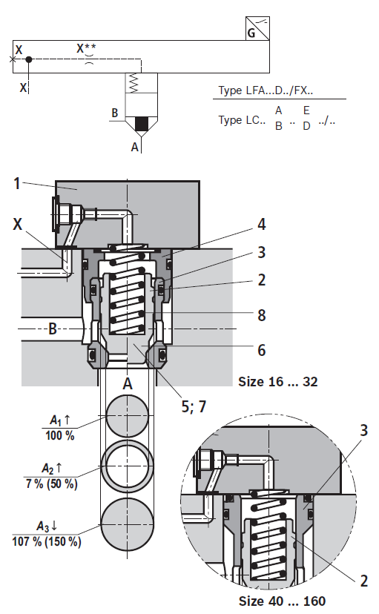
Fig. 1. Logic 2-way cartridge valves
Built-in valves offer a wide range of operational possibilities (pressure valves, flow valves, check valves, control valves 2/2, 2/3, 3/4 etc.), which makes it possible for a large number of different valves to be built in into small blocks without the need of huge piping installation. The valve control is also different, mostly of the solenoid type, and in contrast to classical construction, it is performed with a single solenoid magnet – figure 2. As shown in figures 1 and 2, both components are of the built-in type, which makes their building in, and later maintenance, easier, because the maintenance procedures consist of simple replacement of worn sealing elements (O-rings and Teflon rings) and the maintenance of the working fluid cleanliness in the hydraulic system.
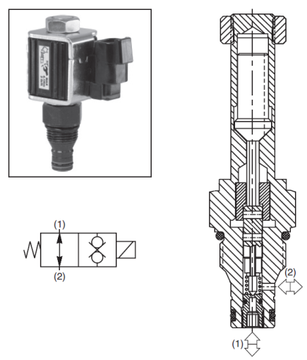
Fig 2. Example two way Poppet Valves – normally open Poppet
2.1 WORKING FLUID CLEANLINESS LEVEL FOR BUILT-IN AND LOGIC VALVES
Working fluid cleanliness in a hydraulic system has to satisfy the most critical component in a hydraulic system [6][8-9][10]. If working fluid cleanliness is not taken care of, in most cases problems will firstly occur in relation to the control and preciseness of operation of hydraulic components, and later, if the contaminated oil is further used, the hydraulic system breakdown may occur together with abrasive erosion wear of the most critical components (pumps, proportional and servo hydraulics – valves, built-in and logic valves group). To avoid this problem, filters and even filter groups are installed in hydraulic systems, to maintain the working fluid – oil at the required level of cleanliness.
However, in real practice, completely different situations will occur, i.e. the maintenance staff, either due to their unskillfulness, or for some other reasons, do not take care of this problem, so the operators on these machines usually have problems with the operation of some hydraulic systems. Additionally, in some cases, design engineers do not pay sufficient attention to built-in components in hydraulic systems, and during the designing, they build in the filters of improper fineness and filtration level, as well as the insufficient capacity, for which reason they make a big mistake.
To avoid such mistakes, it will be necessary to look at the hydraulic system as a whole and identify the most sensitive component in the system. The required working fluid cleanliness level is defined according to: construction of the components and the system, clearance size in the hydraulic components, year of manufacturing, the importance of the machine in the production process, hydraulic components manufacturer’s recommendation, working environment conditions of the machine with the hydraulic system, etc. As we can see, the defining of the required working fluid cleanliness level involves many criteria, which means that definition of the required working fluid cleanliness level for a specific system cannot be predetermined. Consequently, we must have in mind that different manufacturers of hydraulic components and authors dealing with this problem, have different approaches to evaluation of the required working fluid cleanliness level. The analysis of professional literature and recommendations by hydraulic components manufacturers shows that the required working fluid cleanliness level can be defined on the basis of criteria related to the following requirements:
- Construction of hydraulic system and / or construction of the machine with the built-in component;
- Constructions of hydraulic components regardless of the working pressure value;
- Constructions of hydraulic components and the working pressure;
- Working environment conditions of the hydraulic system and the type of hydraulic fluid.
Table 1 shows examples of certain components with required working fluid cleanliness level within certain working pressure range.
Table 1 Oil cleanliness class for specific construction components [1-6][8-10].
Hydraulic | Pressure
components | to 150 bar | 150 ÷ 220 bar |  | across 220 bar
PUMP
Gear | 20/18/15 | 19/17/15 |  | 18/16/13
Vane | 20/18/15 | 19/17/14 |  | 18/16/13
Piston | 19/17/15 | 18/16/14 |  | 17/15/13
Vane - variable capacity | 19/17/15 | 18/16/14 |  | 17/15/13
Piston - variable capacity | 18/16/14 | 17/15/13 |  | 16/14/12
VALVES
Solenoid valve | 20/18/15 | 20/18/15 | 19/17/14
Pressure valve | 19/17/14 | 19/17/14 | 19/17/14
Flow valve | 19/17/14 | 19/17/14 | 19/17/14
Check valve | 20/18/15 | 20/18/15 | 20/18/15
Built-in valve 2/2 | 20/18/15 | 20/18/15 | 19/17/14
Ball valve | 18/16/13 | 18/16/13 | 17/15/12
LS valve regulation | 20/18/15 | 20/18/15 | 19/17/14
Hydraulic controlled solenoid valve | 18/16/14 | 18/16/14 | 17/15/13
Direct proportional solenoid valve | 18/16/13 | 18/16/13 | 17/15/12
Pressure proportional valve | 18/16/13 | 18/16/13 | 17/15/12
Built - in proportional valve | 18/16/13 | 18/16/13 | 17/15/12
Servo valve | 16/14/11 | 16/14/11 | 15/13/10
AKTUATORS
Cylinders | 20/18/15 | 20/18/15 | 20/18/15
Vane motors | 20/18/15 | 19/17/14 | 18/16/13
Axial piston motors | 19/17/14 | 18/16/13 | 17/15/12
Gear motors | 21/19/17 | 20/18/15 | 19/17/14
Radial Piston motors | 20/18/14 | 19/17/14 | 18/16/13
According to this table, it is enough to take over specific defined working fluid cleanliness levels for specific components from the manufacturer, design a table for the specific hydraulic system and, based on the critical component in the system, define the maximum required oil cleanliness to make the hydraulic system operate most efficiently.
2.2 THE MAINTENANCE OF SHEAR MACHINE HYDRAULIC SYSTEM
The example of hydraulic shear machine DURMA 3013, with hydraulic system containing mostly built-in and logic components, shows the method of defining the required working fluid cleanliness level. The hydraulic shear machine system was found in very bad condition because the maintenance was at minimum required level (cleaning of the workplace and check-up of oil level in the tank). After the breakdown of the hydraulic system, resulting in slow operation of the shear and impossibility of cutting semi-finished products, along with overheating of the working fluid (the oil was overheating up to 70°C), it was more than evident that the system had been insufficiently maintained and neglected.
With a systematic approach, using data provided by the manufacturer of the equipment, taking into account working pressures (up to 210 bars) and the shear operation intervals (they were operating during the whole production process lasting 8 working hours), the authors created Table 2 with accompanying components and their requirements regarding the oil cleanliness, based on the hydraulic shear scheme, shown in figure 3.
Table 2. Components of the hydraulic shears DURMA 3013 with the appropriate oil cleanliness degree according to the manufacturer's recommendations
Mark | Hydraulic components | Pressure
 |  | to 150 bar | 150 ÷ 210 bar
 | PUMP
 | Gear pump | 20/18/15 | 19/17/15
 | VALVES
7.02 | Electromagnetic solenoid valve | 20/18/15 | 20/18/15
7.03 | Cartridge pressure valve NG20 | 19/17/14 | 19/17/14
7.04 | Cartridge pressure valve | 19/17/14 | 19/17/14
7.06 | Cartridge pressure valve NG10 | 19/17/14 | 19/17/14
7.07 | Cartridge pressure valve NG10 | 19/17/14 | 19/17/14
7.08 | Cartridge pressure valve NG6 | 19/17/14 | 18/16/13
7.11 | Logic 2-way cartridge valves | 20/18/15 | 20/18/15
7.05 | Two way Poppet Valves 2/2 | 19/17/14 | 18/16/13
AKTUATORS
9, 10 | Cylinders | 20/18/15 | 20/18/15
11, 12 | Cylinders | 20/18/15 | 20/18/15

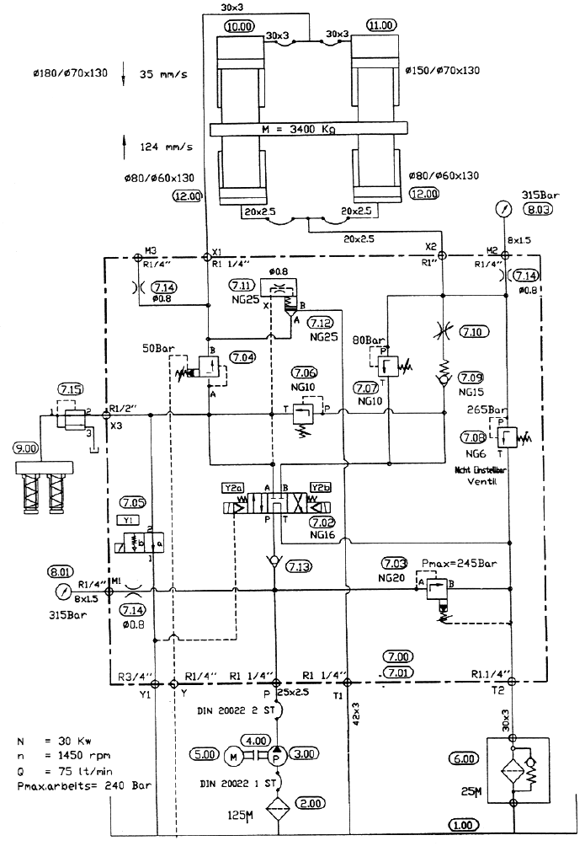
Fig 3. Hydraulic Shears scheme type DURMA 3013
Figure 4 shows the hydraulic shear block with all built-in valves from the hydraulic shear scheme shown in Figure 3. Table 2 shows that all components, except for the distribution valve in position 7.02 are of built-in type, requiring oil of higher cleanliness level compared to classical components. The main pressure limiting valve 7.03 was set to 210 bar pressure. This is important to emphasize due to the difference in the scheme. The valve in position 7.05 was, during the system operation, in semi-open position, which was causing the oil overheating.
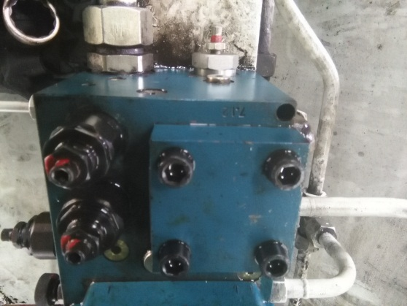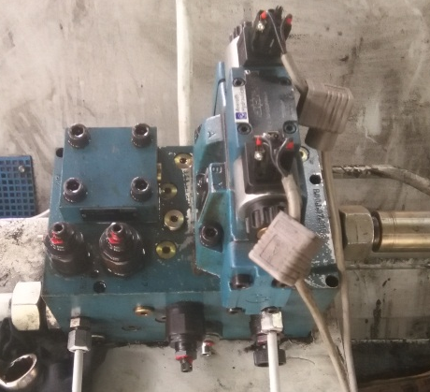

Fig 4. Hydraulic block with built-in components
Table 2 shows that the required oil cleanliness level for the most critical components was at level 18/16/13 according to ISO 4406/99 or class 4 according to SAE AS4059 [11,12]. It was a signal that the oil received from the manufacturer packed in drums had to be filtered prior to pouring it into the hydraulic system tank. Also, the project anticipated 25 µm filtration degree filter. However, the most abrasive particles in a hydraulic system were 10 – 15 µm particles, i.e. ≥6 i ≥14 µm(c) according to 4406/99 standard. This project mistake was corrected by installing β₁₀≥200 factor filter for absolute filtration of 10µm and larger particles. In this way, we chose a corresponding filter to provide the required and sufficient filtration level of hydraulic oil. Later, it was proved during the exploitation of the machine. However, by installing a higher filtration degree filter (5 µm filter) a dangerous situation could occur in which the resistance to the fluid flow in the return pipe could increase (the return flows were massive and fluid flow rates fast) and the filtration medium of the filter could break, which, however, should have been taken into consideration at the time of selection of the filter, because the machine was operating in various temperature environments – there was no heating during the winter.
We would like to note that the shear machine hydraulic system, during the 6-month operation, did not have any breakdown, the oil temperature was at 50ºC, i.e. within the normal range, whereas the filter inserts were regularly replaced. This method of maintaining the oil at the required and sufficient cleanliness level has resolved previous problems that existed with DURMA 3013 shear machine hydraulic system.
- CONCLUSION
Through the example of shear machine hydraulic system, we have presented the problems of the maintenance of working fluid – oil at the allowed contamination level. Also, with corresponding methodology of observation of certain working parameters in the system and the allowed contamination of working fluid, we have created tables with critical components regarding the required oil cleanliness level. We should also mention that we have examined the catalog requirements regarding required component cleanliness for each component of the hydraulic system, which has been presented by the authors in table 2. Additionally, we have classified the components according to the work pressure levels at which they operate, and based on these results, each component has been classified in corresponding group.
This simple, and at the same time, systematic approach, provides an adequate maintenance of a hydraulic system that contains built-in and logic components. Normally, more demanding systems with built-in components of proportional and servo type, require a higher level of maintenance with corresponding filtration level. The methodology of defining critical components and selection of filters, which has been presented in this paper through an example from practice, can be applied and is applied also to other hydraulic systems.
REFERENCES
- Bosch Rexroth, Product Catalog Industrial Hydraulics, from https://www.boschrexroth.com/ics/cat/?language=en&id=&cat=Industrial-Hydraulics-Catalog&m=DE&u=si&o=Desktop&p=g253780
- Parker Hanifin, Product Catalog Industrial Hydraulics, from http://ph.parker.com/us/en/hydraulic-valves;
- Hawe Hydraulik, Product Catalog Industrial Hydraulics, https://www.hawe.com/en-us/products/product-search-by-category/hydraulic-valves/pressure-control-valves/load-holding-valves/
- Hydac, Product Catalog Industrial Hydraulics, from https://www.hydac.com/de-en/products/high-pressure hydraulics/valves/show/Download/index.html
- Eaton, Product Catalog Industrial Hydraulics, from http://www.eaton.com/ecm/groups/public/@pub/@eaton/@hyd/documents/content/ct_198975.pdf
- Savić V. (2003), Uljna hidraulika 3, Ikos, Novi Sad, COBISS.SR-ID 185722119;
- Jocanović M. (2015). Automatizacija procesa rada – Osnove hidrauličnog upravljanja, Univerzitet u Novom Sadu, FTN, Novi Sad, 2015, ISBN 978-86-7892-662-4;
- Knežević D. (2007). “The influence of geometry gap in hydraulic components automatic control the efficiency of hydraulic systems”, Doctoral Thesis, University of Novi Sad, Faculty of Technical Sciences, Novi Sad;
- Jocanović M. (2010). „ Determination and Researching of Calculation Model for Solid Particle Flow with Oil mass through Gaps, Depending on Constructional and Working parameters of Hydraulic components”, Doctoral Thesis, University of Novi Sad, Faculty of Technical Sciences, Novi Sad;
- Karanović V. (2015). Development of a solid particle influence model on performance of piston-cylinder contacting pairs for hydraulic components, Doctoral Thesis, University of Novi Sad, Faculty of Technical Sciences, Novi Sad;
- ISO 4406/99 Cleanliness Level Standards, Method for coding the level of contamination by solid particles, http://www.ns-aria.com/wp-content/uploads/2015/09/ISO-4406-Particles-in-fluid.pdf
- SAE AS4059 Aerospace Fluid Power - Cleanliness Classification for Hydraulic Fluids, from http://standards.sae.org/as4059/

PhD. Mitar Jocanović, University of Novi Sad, Faculty of Technical Sciences, mitarj@uns.ac.rs
PhD. Velibor Karanović, University of Novi Sad, Faculty of Technical Sciences, velja_82@uns.ac.rs
PhD. Darko Knežević, University of Banja Luka, Faculty of Mechanical Engineering, darko.knezevic@unibl.rs
MSc. Marko Orošnjak, University of Novi Sad, Faculty of Technical Sciences, orosnjak@uns.ac.rs
MSc. Saša Laloš, University of Banja Luka, Faculty of Mechanical Engineering, sasalalos@yahoo.com

