LOGO WILL BE HERE
DETERMINATION OF LOSSES RELATED TO FRICTION WITHIN THE RECIPROCATING COMPRESSORS - INFLUENCES OF TRIBOLOGICAL OPTIMIZATION OF PISTON AND CYLINDER

Saša Milojević, Radivoje Pešić, Dragan Taranović
Summary: Measures to reducing friction inside the reciprocating machine make a decisive contribution to further improvements of machines efficiency. A number of influencing parameters have already been tested on diesel and gasoline engines. The friction between piston and cylinder liner is a major contributor to overall engine friction. Reducing friction in reciprocating machines can be achieved by using appropriate materials and optimizing the structure of the piston and piston group. Tribological materials and coatings are one of the options for increasing strength of the aluminum parts of reciprocating engines and compressors. This initial manuscript describes the influences of the piston skirt and cylinder liner design. The differences in frictional losses are determinate for the entire compressor operating map for base aluminum construction, as well as coated aluminum construction.
Key words: Reciprocating Machines; Aluminum; Coating; Friction
- INTRODUCTION
Heavy−duty vehicles (HDVs), trucks and buses are responsible for about a quarter of carbon dioxide (CO₂) emissions from road transport in the EU and for some 6% of total EU emissions. Transport is the only major sector in the EU where greenhouse gas emissions are still rising.
In city buses and trucks a lot of fuel energy is engaging for power of auxiliary units. Specifically, the fuel energy is engaged for drive of periphery units on engine, as example, for the air compressor, the alternator, the steering pump, the oil pump, the coolant pump, the fuel high pressure pump and the fuel delivery pump, as well as for (A/C) compressor. The share of auxiliaries on the total power consumption is especially high for city buses due to the air conditioning (A/C) system and additional consumers of electricity and pressurized air, Fig. 1 [1,2].
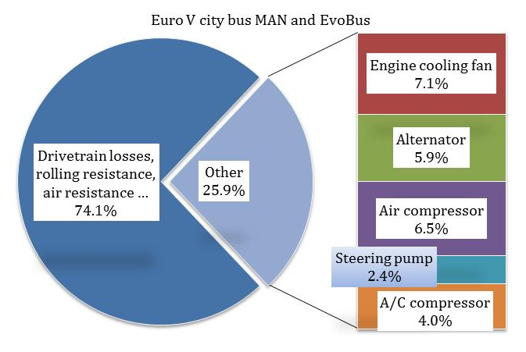
Fig. 1 Percentage of driving resistances and auxiliary power demand on the fuel consumption of the city bus
Reasons for this are the higher air demand of the wheel brakes, fewer headwinds for the engine cooling or more steering in curves. i.e. the main influence factors on fuel consumption are the engine off heat or the wheel brakes air demand.
Generally, city bus 18 t (rigid bus, 12 m) classes are associated with 4.4% of (CO₂) emissions [1]. City buses are frequently purchased by public institutions and thus they are in the public eye, yet may be the focus of cost-cutting measures [2,3,4].
Vehicles equipped with a conventional combustion engine can be still further improved by minimizing the internal friction of the mechanical parts in order to reduce (CO₂) emissions [5].
Potential actions to reduce friction in vehicles include the use of advanced coatings and surface texturing technology on engine and transmission components, new low-viscosity and low-shear lubricants and additives, and tire designs that reduce rolling friction [6,7,8,9].
Aluminum also continues to gain in importance as a material for lightweight engine design. One of the applications is replacing of material for engine blocks, which has been traditionally produced of gray cast iron.
In accordance with the above mentioned facts, we have realized the research in the field of optimal design of reciprocating aluminum engines and compressors. Consequently, we investigated new option for increasing strength and tribological characteristics of the tribosystem piston-cylinder liner [8,9,10,11,12,13,14].
The result of researches is patented prototype of aluminum piston and cylinder whose contact surfaces are coated or modified with inserts based on the tribo-materials [8].
- NEW CONCEPT OF ALUMINUM CYLINDER WITH REINFORCEMENTS
Running surfaces of cylinder inside conventional reciprocating machines usually are made from gray cast iron or AlSi alloy. For the adequate lubrication, honing of surface was used as the standard technology. When the piston ring now comes into contact with honed cylinder surface, the oil can be drained from the contact point through the interconnected grooves potentially leading to boundary lubrication states with higher friction and wear.
Generally, according to real machining conditions, the full contact between piston rings and cylinder wall is not possible. One way to reduce consumption of oil and thus friction and wear is the application of the sliding surfaces in the form of spirals. This fact leads us to the idea that by casting tribological inserts in the cylinder wall, we can determine in forward, contact area between piston rings and cylinder wall.
With the aim to achieving strength as well as tribological characteristics similarly as in case of the application grey cast iron, we patented the cylinder of composite material for reciprocating air compressor with the reinforcements consisting of tribological materials, Fig. 2 [8].
The internal surface of the aluminum cylinder as base material-matrix, (alloy EN AlSi10Mg), was modified by putting tribological inserts of cast iron that are arranged in the form of continuous pads, the plates (Fig. 2.a) or like discrete tribological plugs in the form of spheres (nodule), or particles spherical shape, as reinforcements (Fig. 2.b) [8].
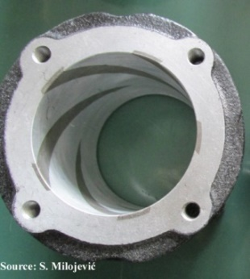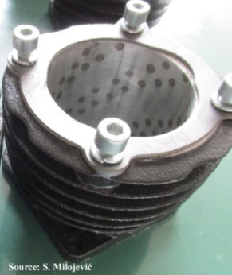
a) b)
Fig. 2 Photography of patented aluminum cylinder with tribological pads (a-continual and b-nodular discrete pads)
By transferring the contact between the piston rings and cylinder made of aluminum metal matrix composites on the reinforcements, we reduce the wear. This technology extends the service life of cylinder and piston rings.
This optimization can lead to reduce machine weight as well as reduced friction and wear. A reduction of friction between piston rings and the cylinder running surface is particularly effective, because the majority of frictional losses in the reciprocating machines are generated in this tribological system [13].
- EXPERIMENTAL RESEARCHES
Wear is progressive loss of material caused by friction resistance between contact surfaces. The present work wants to investigate and evaluate the effect of tribological plugs on tribological behavior of patented aluminum cylinder.
We have started also the laboratory testing of a patented small experimental reciprocating air compressor, which is made of aluminum alloy, the ratio of bore/stroke is (74/35 mm∙mm⁻¹). The base compressor, before reconstruction it was constructed of grey cast iron. For purposes of testing the performance of the reciprocating compressors, we projected the installation for measuring (Fig. 3.a) in the Laboratory for IC Engines at the University of Kragujevac, Faculty of Engineering (FINKG) [4,12,17].
Tribological tests were carried out at (FINKG) on CSM nanotribometer (Fig. 3.b) with ball-on-plate contact pair for different normal loads, sliding speeds and distances without lubrications.
The first step of the research work consists in the measurement of the friction coefficient under different conditions (see Fig. 4). Generally, tribological tests are based on variation of three different normal loads (0.3, 0.6 and 0.9) N and three different speeds (3, 9 and 15) mm∙s⁻¹. Duration of each test was 500 cycles (distance of 1 m), whereat one cycle is represented by full amplitude sliding distance (half amplitude is 0.5 mm). The friction coefficient was automatically recorded during the testing, using data acquisition software. Simultaneously, the friction coefficient curve was recorded and plotted.
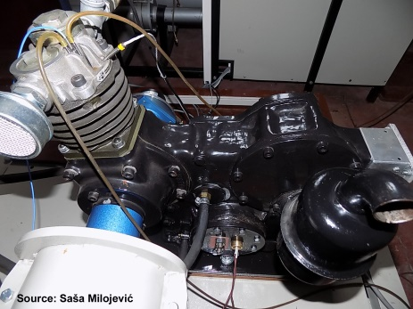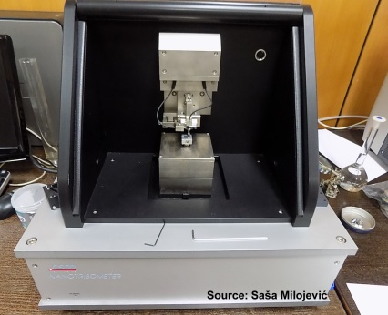
a) b)
Fig. 3 Photography of the experimental installation (a-test rig for reciprocating compressors and b-CSM nanotribometer)
3.1 Experimental results
Diagrams of friction coefficient (COF) and penetration depth during reciprocating sliding are shown in (Fig. 4.a) for base material (aluminum) and in (Fig. 4.b) for tribological inserts of cast iron as reinforcements.
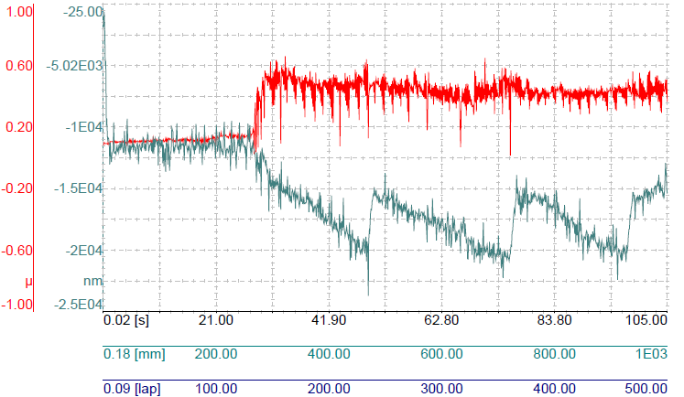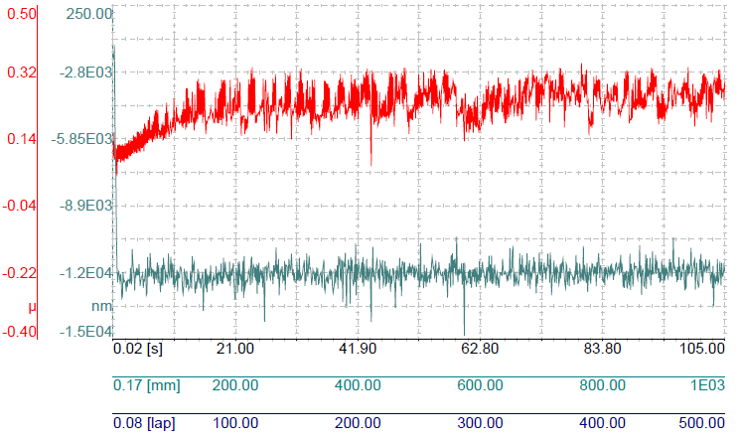
a) b)
Fig. 4 Coefficient of friction and penetration depth under ($F_{N}=0.3 N; V=15 mm∙s^{-1})$ for (a-base metal-matrix and b-reinforcements)
The values of the (COF) for reinforcements were ranging from (0.041 up to 0.344), and these maximal values are lower to the results of base material (0.016 up to 0.662). This decrease was specifically lower for higher values of sliding speed and higher regimes of load. A steady-state value for the friction coefficient was reached shortly after the beginning of the test. Penetration depth of reinforcements has relatively stable and constant values compared to base material.
After the tribological tests, plan is to continue testing of the optimized cylinder construction on the test rig for compressors. The friction power test rig can be used to examine parameters for the compressor components and frictional pairs (piston-cylinder) and to define friction mapping using the indication method. Friction mean effective pressure (FMEP) can be determinated as the difference between the brake and indicated mean effective pressure (BMEP and IMEP). This method depends on the use of high-precision torque measurements combined with high-quality compressor indication.
Based on the results of tribological investigations (Fig. 4) and the results of wear which are obtained by testing of the engine [13,14], it is expected to be significantly reduced the losses related to friction, by applying new concept of the cylinder.
- CONCLUSION
In city buses and trucks a lot of fuel energy is engaging for power of auxiliary units.
Potential actions to reduce friction include the use of advanced coatings and surface texturing technology on engine and transmission components, new low-viscosity and low-shear lubricants and additives, and tire designs that reduce rolling friction.
Aluminum continues to gain in importance as a material for lightweight engine design. One of the applications is replacing of material for engine blocks, which has been traditionally produced of gray cast iron.
Wear is progressive loss of material caused by friction resistance between contact surfaces. Inside manuscript, are investigated the effects of tribological plugs as reinforcements, on the tribological behavior of the patented cylinder whose base is made of aluminum.
ACKNOWLEDGEMENT

The paper is a result of the research within the project TR 35041 financed by the Ministry of Science and Techno-logical Development of the Republic of Serbia.
REFERENCES
- European Comission. Climate Action, from http://ec.europa.eu/clima/policies/transport/vehicles/index_en.htm, accessed on 2017-03-02.
- Milojević, S., Pešić, R. (2011). CNG Buses for Clean and Economical City Transport. Journal Mobility & Vehicle Mechanics (MVM), vol. 37, no. 4, p. 57-71.
- Milojević, S. (2016). Reconstruction of Existing City Buses on Diesel Fuel for Drive on Hydrogen. Journal Applied Engineering Letters, vol. 1, no. 1, p. 16-23.
- Milojević, S., Gročić, D., Dragojlović, D. (2016). CNG Propulsion System for Reducing Noise of Existing City Buses. Journal of Applied Engineering Science, vol. 14, no. 3, p. 377-382.
- Kennedy, M., Hoppe, S., Esser, J. (2012). Piston Ring Coating Reduces Gasoline Engine Friction. MTZ Motortechnische Zeitschrift, vol. 73, no. 5, p. 40-43.
- Mitrović, S., Babić, M., Stojanović, B., Miloradović, N., Pantić, M., Džunić, D. (2012). Tribological Potential of Hybrid Composites Based on Zinc and Aluminium Alloys Reinforced with SiC and Graphite Particles. Journal Tribology in Industry, vol. 34, no. 4, p. 177-185.
- Stojanović, B., Glišović, J. (2016). Automotive Engine Materials. Saleem Hashmi (Editor), Reference Module in Materials Science and Materials Engineering. Oxford, Elsevier, p. 1-9.
- Pešić, R. (2004). ASMATA–Automobile Steel Material Parts Substitution with Aluminum. Journal Mobility & Vehicle Mechanics (MVM), Special Edition, vol. 30.
- Vencl, A. (2012). Optimization of the Deposition Parameters of Thick Atmospheric Plasma Spray Coatings. Journal Balkan Tribological Association, vol. 18, no. 3, p. 405-414.
- Vencl, A., Rac, A., Bobic, I. (2005). Tribological Behaviour of Al-Based MMCs and their Application in Automotive Industry, Journal Tribology in Industry, vol. 26, no.3-4, p. 31-38.
- Vencl, A., Rac, A. (2004). New Wear Resistant Al Based Materials and their Application in Automotive Industry. Journal Mobility & Vehicle Mechanics (MVM), Special Edition, vol. 30, p. 115-139.
- Pesic, R., Milojevic, S. Efficiency and Ecological Characteristics of a VCR Diesel Engine. Journal Automotive Technology, vol. 14, no. 5, p. 675-681.
- Milojević, S., Pešić, R., Taranović, D. (2015). Tribological Principles of Constructing the Reciprocating Machines. Journal Tribology in Industry, vol. 37, no. 1, p. 13-19.
- Milojevic, S., Pesic, R., Taranovic, D. (2015). Tribological Optimization of Reciprocating Machines According to Improving Performance. Journal Balkan Tribological Association, vol. 21, no. 3, p. 690-699.
- Gand, B. (2011). Coating for Cylinder Surfaces in Aluminium Engine Blocks. MTZ Motortechnische Zeitschrift, vol. 72, no. 1, p. 34-39.
- Solzak, T.A., Polycarpou, A.A. (2006). Tribology of Protective Hard Coatings for use in Oil-Less Piston-Type Compressor. Purdue University, International Compressor Engineering Conference Proceedings, paper 1790, p. 1-8.
- Taranović, D. (2013). The test bench for non-standard testing of reciprocating compressors for motor vehicles. PhD. Dissertation, University of Kragujevac, Faculty of Engineering, Kragujevac, Serbia.

Mr Saša Milojević, assistant R&D. University of Kragujevac, Faculty of Engineering, Republic of Serbia, sasa.milojevic@kg.ac.rs
Dr Radivoje Pešić, prof. University of Kragujevac, Faculty of Engineering, Serbia, pesicr@kg.ac.rs
Dr Dragan Taranović, prof. assist. University of Kragujevac, Faculty of Engineering, Serbia, tara@kg.ac.rs

