LOGO WILL BE HERE
MODELLING AND FINITE ELEMENT ANALYSIS
OF ELEVATOR BUCKETS
Nenad Miloradović, Slobodan Garić, Rodoljub Vujanac
Summary: The bucket elevator with centrifugal discharge designed for transport of grains is analysed in the paper. Operation, main characteristics and major elements of bucket elevator are described in the paper. Essential elements of calculation of the drive mechanism are presented, bucket discharge type is adopted and main elements of transport device are selected. A rubber belt is selected as traction device. Available transport capacity ranged from 15 t/h to 45 t/h, while lifting height was 18 m. Based on initial data and calculations, a spatial 3D model of the elevator is formed. Static finite element analysis (FEA) of the elevator bucket was conducted based on previously formed model. A modified version of the bucket was made in order to show the influence of design change on mass, deformation and the stress states of the elevator buckets. Modelling of the elevator bucket was conducted using 3D Autodesk Inventor software.
Key words: bucket elevator, bulk materials, buckets, FEA
- INTRODUCTION
Bucket elevators belong to a group of vertical or inclined transport equipment that efficiently moves goods between floors, vessels or other structures.
These are the simplest and the most dependable units for performing vertical lifting. They are available in a wide range of capacities and may operate entirely in the open or be totally enclosed. The trend is toward highly standardized units, but for special materials and high capacities, it is wise to use specially engineered equipment. Main design variations are found in: casing thickness, bucket thickness, belt or chain quality and drive equipment [1].
Major elements of a bucket elevator are:
- buckets that contain the material;
- belt that carry the buckets and transmit the pull;
- devices that drive the belt and
- accessories for loading the buckets or picking up the material, for receiving the discharged material, for maintaining the belt tension and for enclosing and protecting the elevator [2].
A bucket elevator can elevate a variety of bulk materials, from light to heavy and from fine to large lumps. There are three common bucket elevator designs in bulk material handling facilities worldwide: centrifugal, continuous and positive discharge elevators. A centrifugal discharge elevator may be vertical or inclined. Vertical elevators depend entirely on the action of centrifugal force to get the material into the discharge chute and must be run at relatively high speeds. Inclined elevators with buckets spaced apart or set close together may have the discharge chute set partly under the head pulley. Since they do not depend entirely on the centrifugal force to put the material into the chute, the speed may be relatively lower [3].
Most of the centrifugal discharge elevators have spaced buckets with rounded bottoms. They pick up their load from a boot, a pit, or a pile of material at the foot pulley. The buckets can have triangular cross sections and may be set close on the belt with little or no clearance between them [4]. Early bucket elevators used a flat chain with small, steel buckets attached at every few inches. Current designs use a rubber belt with plastic buckets.
- MODELLING OF BUCKET ELEVATOR
Based on given material - grain, which determines the speed of the elevator of v=1.5 m/s and on elevator type - high speed elevator for centrifugal discharge, the type of the bucket can be selected. For selected material and type of elevator, the deep bucket is assessed as the most adequate [1]. Volume of the bucket, i₀, can be calculated using the following equation:

$\frac{i_{0}}{t_{k}}=\frac{Q_{m}}{3.6v}$ | (1)

where values for bucket pitch, t_{k}, elevator speed, v, material density, ρ, average coefficient of bucket filling, ψ, and capacity, $Q_{m}$, are given in advance.
Figure 1 presents the CAD model of the elevator bucket, and figure 2 shows a drive unit.

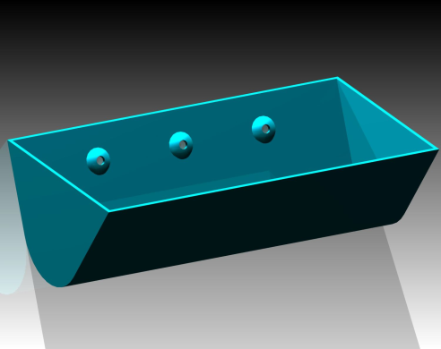 | 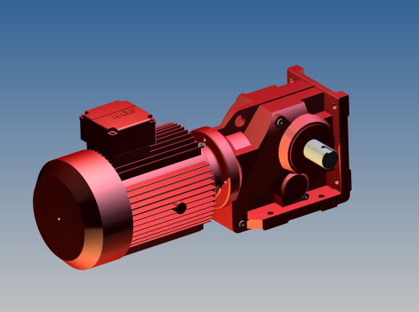
Fig. 1 CAD model of chosen  elevator bucket | Fig. 2 Model of electromotor – reducer unit

From the above, the parameters of the bucket may be adopted: bucket volume i₀=6,3 l, bucket width B_{k}=400 mm, mass of the bucket m_{k}=9 kg and width of the bucket wall b_{k}=4mm. Adequate electromotor and reducer were chosen and geometry of the elements was defined.
Figure 3 presents the CAD model of a drive head of the elevator located at the top of the elevator. Selected elements are: 1) the upper subassembly, 2) lower subassembly, 3) electric motor with reduction gearbox, 4) carrier of electric motor and gearbox, 5) slide bearings. The lower return casing is located at the bottom head of the elevator and is shown in figure 4.

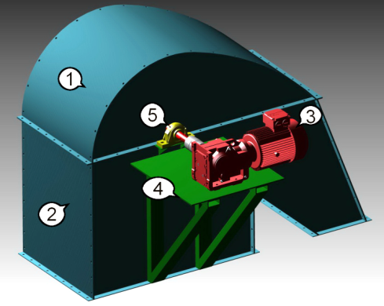 | 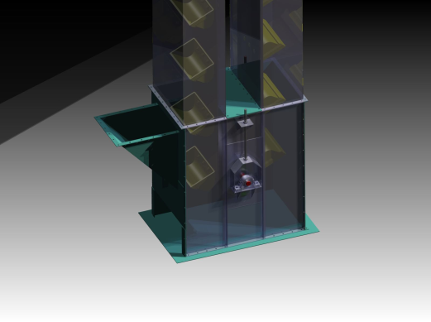
Fig. 3 Drive head of the elevator | Fig. 4 The lower return casing of the elevator

Figure 5 presents the complete model of elevator with all its parts and assemblies.
- FEA ANALYSIS
Since the bucket is the part of elevator which are used to transport grain, this part carry the most load and impact sow bucket must be construct with boundaries of that influence on them. They must carry the load and to have a long life of exploiting. In this paper has been analyzed bucket elevator who carries output capacity of 15 t/h to 45 t/h, where 45 t/h is a required capacity of elevator.
The following material (steel) properties have been used in analysis of a bucket under static conditions [5]: Young’s modulus 200 GPa, Poisson’s ratio 0.3, density 7850 kg/m³ , yield strength 250 MPa.
The 3D model was analysed using Autodesk Inventor software stress analyses module. Fixed conditions were imposed at the screw connectors of the bucket structure and the belt connection with the bucket throw screw. Figure 6 shows the load pressure of material, gravity influence and the meshed view of the bucket body. The total tonnage is divided between the buckets and the obtained value is distributed on the surface of the bucket.
The results obtained by simulation are shown in figures 7 and 8. Figure 7 shows the deformation of the bucket, which is found to be 1.313 mm, maximally. Figure 8 shows the stress distribution and the maximum stress of 61.47 MPa. As the buckets are made of mild steel, the developed static stress is within the permissible limits.

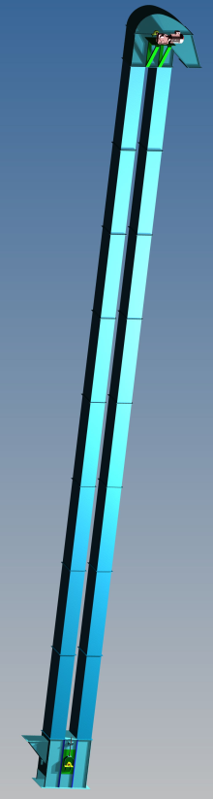 | Similarly, the static analysis was carried out for outputs of 15 t/h and 30 t/h to show the influence of lower output levels on stresses of the bucket. Respective results are included in Table 1.  Maximal levels of stress and deformation for all designs of buckets are situated at the same spot.  The results show that all maximal stresses are within the maximal limits for the given material. The high values are obtained for factors of safety, but when the values of deformation are observed, there can be possible small changes in buckets in order for deformation and tension to stay within the limits.
 | 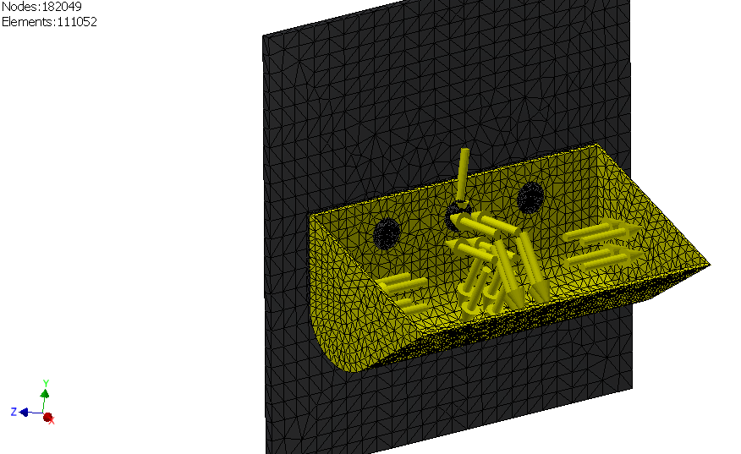
Fig. 5 Model of the elevator | Fig. 6 Meshed view of the bucket

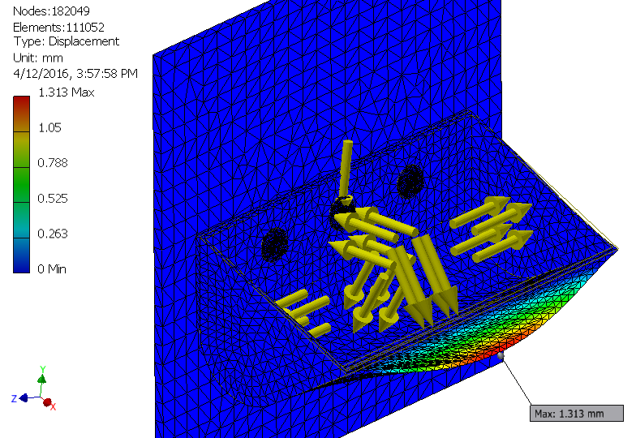 | 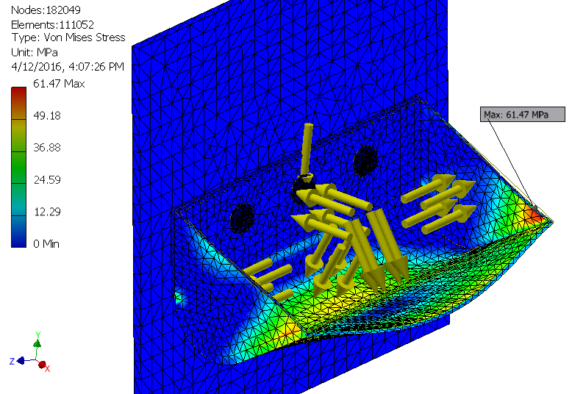
Fig. 7 Deformation of the bucket | Fig. 8 Von Mises stresses of the bucket

Table 1 Results obtained for different output levels
No. | Output, t/h | Max. def., mm | Max. stress, MPa
Casing-1 | 15 | 0.4448 | 20.79
Casing-2 | 30 | 0.8789 | 41.12
Casing-3 | 45 | 1.313 | 61.47

3.1 Modification of the bucket
In order to obtain a lighter bucket while stress and deformations stay within allowed boundary values, some changes were proposed and simulated: thickness of the bucket have been decreased from 4 mm to 3 mm, reinforcements of the upper edges of the buckets were added in places where the highest stress values appear and more rounded edges were applied.
Table 2 Results obtained for reinforced bucket
No. | Output, t/h | Max. def., mm | Max. stress, MPa
Casing-1 | 15 | 0.345 | 19.76
Casing-1 | 30 | 0.6812 | 39.04
Casing-1 | 45 | 1.017 | 58.31

This results show that all stresses are within the maximal limits for given material. It is obvious that the stresses obtained on reinforced buckets are smaller than stresses obtained on original bucket.
- RESULTS AND DISCUSSION
Results of simulation of the reinforced bucket show that the mass of the bucket was reduced. The original mass was 5.5 kg and the mass of the new bucket was 4.7 kg. Comparison of Von Mises stresses obtained for original and modified bucket is shown in figure 9 for different outputs.

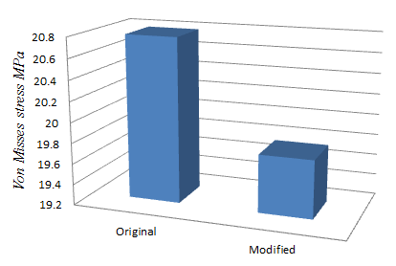 | 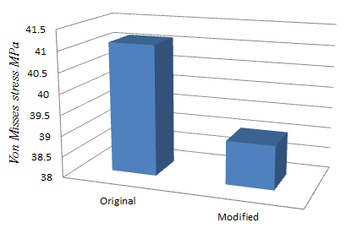 | 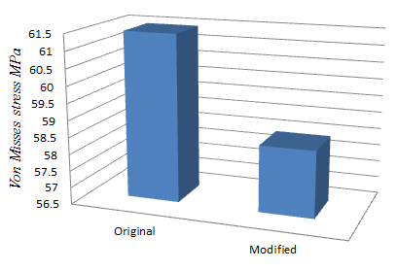
a) | b) | c)
Fig. 9 Maximal stresses of original and modified bucket under load of
a) 15 t/h, b) 30 t/h, c) 45 t/h,

Comparison of deformations obtained for original and modified bucket is shown in figure 10 for different outputs.

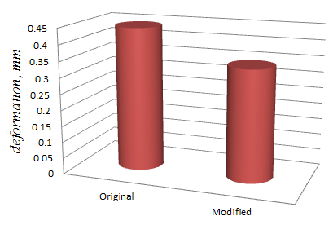 | 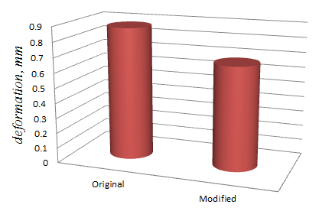 | 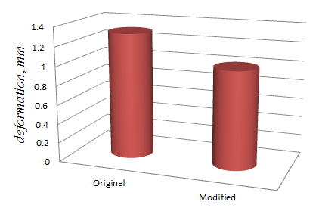
a) | b) | c)
Fig. 10 Maximal deformations of original and modified bucket under load of
a) 15 t/h, b) 30 t/h, c) 45 t/h,
- CONCLUSION
In this paper, simulation studies of the original bucket and modified bucket of the belt bucket elevator were performed. Static structural analysis for different components of the bucket elevator has been performed with FEA tools under standard operating conditions. The original and modified buckets were observed for outputs ranging from 15 t/h to 45 t/h.
The analysis have shown that both the original and the modified bucket meet the requirement of mass, stress and deformation, but that the modified bucket has 5% less stress results and 22,5% less deformation results. In addition, the modified bucket is 15% lighter than original bucket.
After the analysis, it may be concluded that the new modified bucket meets given load conditions and operates within the allowed zones of stress and deformation states.
Considering the previous simulation results, it may be concluded that the modified bucket has been improved in all aspects. This improvement can contribute to better performance of the bucket elevator and significantly decrease the weight of the elevator in cases when they operate on higher altitudes.
More detailed inspection of the bucket elevator elements may be performed using diagnostic tools and methods.
REFERENCES
- Garić, S. (2015). Elevators with buckets for grain transport, Master thesis, Faculty of Engineering, University of Kragujevac, Serbia.
- Yashaswini, N., Raju, B., Purushottham A. (2014). Design and optimisation of bucket elevator throught finite element analysis. IPASJ International Journal of Mechanical Engineering, vol. 2, no. 9, p. 73-78.
- Patel, S., Patel, St., Patel, J. (2012). A review of design and analysis of bucket elevator, International Journal of Engineering Research and Applications (IJERA). vol. 2, no. 5, p. 18-22.
- Patel, S., Patel, J. (2013). Productivity improvement of bucket elevator by modified design, International Journal of Emerging Technology and Advanced Engineering. Vol. 3, no. 1, p. 128-133.
- Göksenli, A., Eryürek, I. B. (2009). Failure analysis of an elevator drive shaft, Engineering Failure Analysis,vol. 16, no. 4, p. 1011-1019.

Ph. D., Nenad Miloradović, assist. prof., Kragujevac, University of Kragujevac, Faculty of Engineering, mnenad@kg.ac.rs
MSc, Slobodan Garić, Ph. D. student, Kragujevac, University of Kragujevac, Faculty of Engineering, sgaric@kg.ac.rs
Ph.D., Rodoljub Vujanac, assist. prof., Kragujevac, University of Kragujevac, Faculty of Engineering, vujanac@kg.ac.rs

