LOGO WILL BE HERE
SIZING OPTIMIZATION OF PARAMETRICALLY DESIGNED TRUSSES
Nenad Petrović, Nenad Marjanović, Nenad Kostić, Mirko Blagojević, Miloš Matejić
Summary: In this paper parametric modeling of sizing optimization truss models is developed. Sizing optimization of trusses views element cross-sections as variables with the goal of minimizing overall mass while maintaining equivalent stresses within acceptable ranges, as well as limiting displacement. In order to conduct such a process, models needs to be created with parameters, and outputs which can be used to create an objective function. Furthermore the models in each iteration of the optimization are subjected to finite element analyses to determine stress. Parametric models of standard 10 bar, 17 bar, and 25 bar trusses are created to facilitate optimization. The heuristic optimization method used is genetic algorithm. Optimization results obtained from these models are compared to those from literature and the initial model.
Key words: truss, sizing optimization, parametric model, genetic algorithm
- INTRODUCTION
Structural truss optimization is an interesting topic of research in the fields of mechanical, civil, and structural engineering. The structural optimization problem determines the best design for a specified problem subjected to certain restrictions. This complex process is very beneficial, as it can lead to lighter and more inexpensive structures, while maintaining structural integrity, through optimizing various construction parameters. The most frequently used optimization types are sizing, shape, topography, topometry, and topology. Sizing optimization views cross section geometries as variables. Most papers published in recent years on the subject of truss sizing optimization use new methods or their variations and use standard test examples of 10, 15, 17, 25, 47, 52, 72, 117, etc. bar trusses. The most commonly used are heuristic optimization methods for their favorable characteristics.
Hasancebi and Azad [1] created and tested a new meta-heuristic method called adaptive dimensional search which updates search dimensional parameters in every iteration. They investigated the capabilities and potentials of ADS in structural optimization, and tested their method on various standard test examples of trusses. Cheng et al. [2] tested their new hybrid harmony search algorithm on six test problems achieving very competitive results. Degertekin et al. [3] applied TLBO algorithm to optimize truss structure sizing and compared their results to other meta-heuristic method results. Kaveh et al. [4] used a combination of swarm intelligence and chaos theory to find optimal truss structure cross sections. Kazemzadeh et al. [5] approached the discrete sizing optimization of steel trusses problem using guided stochastic search (GSS) as a design-driven heuristic approach and tested it on 10, 117, 130, 392, and 354 member truss structures. Sizing optimization done by Mortazavi and Toğan [6] showed the method of hyperspheres and showed promising results in using this method for truss optimization. Farshi and Alinia-ziazi [7] included an analysis step in the optimization cycle excluding the need for separate structural analyses and showed the improvement on 10, 22, 25, 72, 60, 132 and 200 bar trusses. Asl et al. [8] gave a detailed description of the sizing optimization problem and an extensive comparison to various other results from literature for the same test problems. Soek et al. [9] showed the importance of the selection of starting values for sizing optimization using harmony search method.
In this paper sizing optimization of standard 10 bar, 17 bar, and 25 bar trusses is conducted on parametric models created for these purpouses. Genetic algorithm optimization results are compared to those from literature. The parametric models can be adapted for any truss design sizing optimization due to their parametric nature. The goal is to have a single parametric model which can be used for any design and loading case by simple parametric input changes.
- PROBLEM FORMULATION
Sizing optimization views cross section parameters as variables and requires an initial model of the truss. These parameters can be cross section geometry (shape) and/or dimensions. Standard test examples optimized in this paper all have circular cross section profiles, and only vary the diameters of each truss element cross section. As cross section diameters are variables the models need to be created with this in mind. The parametric models and optimization in this research are all done in Rhinoceros 5.0 using Grasshopper, Galapagos optimization, and Karamba plugins.
2.1 OPTIMIZATION
For the purposes of this research the heuristic optimization method, genetic algorithm was used due to its favorable characteristics. Genetic algorithm (GA) is a heuristic method for optimizing whose operation is based on mimicking natural/evolutionary processes [10].The algorithm contains three basic operators: selection, crossover, and mutation. The process of transferring genetic information through generations is called selection. Crossover represents the process/operations between two parents, where an exchange of genetic information and new generations are made. A random change in the genetic structure of some individuals for overcoming early convergence is created by the mutation operator. Algorithm operation is based on survival of the fittest individuals through evolution which exchange genetic material. Selection ranks individuals in the population using values from the fitness function, which defines the ability/quality of the individual.
Genetic algorithm, due to its convergence characteristics has a widespread application. Researchers are inspired to use this algorithm for scientific purposes, industrial application, business applications and to further increase its use.
In order to properly constrain the complex mathematical model, so that the result of the optimization gives a realistic model, many design factors need to be considered. As the examples tested in this paper are of standard examples taken from literature which have been determined to give applicable resulting models by only considering node displacement and/or stress depending on the example.
In the case of sizing optimization the minimum weight design problem for the truss structures can be defined as:
$\left\{\begin{matrix}\begin{matrix}minW\left(A\right)=\sum_{i=1}^{i=n}{ρ_{i} A_{i}l_{i} with A=\left(A_{1},…,A_{n}\right)} \\ \end{matrix} \\ subjected to \left\{\begin{matrix}A_{min}≤A_{i}≤A_{max} for i=1,…,n \\ σ_{min}≤σ_{i}≤σ_{max} for i=1,…,n \\ u_{min}≤u_{j}≤u_{max} for j=1,…,k\end{matrix}\right.\end{matrix}\right.$ (1)
where n is the number of truss elements, k is the number of nodes, l_{i} is the length of the i^{th} element, A_{i} is the area of the i^{th} element cross section, σ_{i} is the stress of the i^{th} element, u_{j} is displacement of the j^{th} node.
As cross section area is a variable parameter in the optimization of the trusses, adequate parametric models need to be created to accommodate the optimization method needs. Galapagos optimization for Grasshopper does not have a penalty function input. This has been overcome by having the constraints set to multiply all separate masses of elements with a large number in each generation where any or all of the constraints are not met to ensure that such a result does not end up being a local minimum. The optimization parameters for Galapagos are a maximum stagnant of 50, population of 50, initial boost of 2x, maintaining 5% and +75% inbreeding for the evolutionary solver.
2.2 PARAMETRIC MODELS
For each of the three test examples parametric models were created in Rhinoceros 5. The only variable parameters connected to the optimization operator are the cross sections of elements. The initial model beams are created by parametric input of points and the selection of which points connect to each other. Circular cross sections for all models are initially set to 200mm diameter. Forces and supports are then tied to created points and set as needed by inputting values.
For the 10 bar truss the initial model bar and node layout is given in figure 1. This cantilever truss has 10 independent variables. The material of the truss elements is Aluminum 6063-T5 whose characteristics are: Young modulus 6894.7kN/cm² and specific weight 27.1447kN/cm³. Point loads P₁ are 444.82kN, P₂=0kN in the first load case, and P₁ are 667.233kN, P₂=222.411kN in the second load case as shown in figure 1. The model is limited to a maximal displacement of ±0.0508m of all nodes in all directions, axial stress of ±172.3689MPa for all bars, and minimum cross-sectional area of all members is limited to 9.045mm diameter.
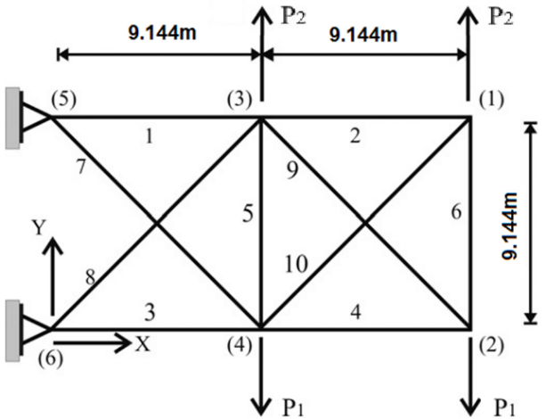
Fig. 1 Initial 10 bar truss model
For the 17 bar truss the initial model bar and node layout is given in figure 2. For this example the material characteristics are: Young modulus 20684.2719kN/cm², shear modulus 8076kN/cm², and specific weight 72.6985kN/cm³. A single point load of 444.82kN is applied in node 9, as shown in figure 2. Each bar cross section is an independent variable limited to a minimal cross-sectional area of all members is limited to 64.516mm² (9.045mm diameter) as a lower limit to all boundaries. The only constraint is a displacement limitation for all nodes of ±0.0508m of all nodes in both x and y directions.
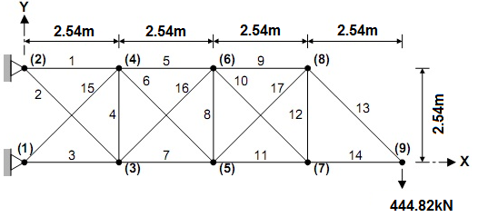
Fig. 2 Initial 17 bar truss model
For the 25 bar truss the initial model bar and node layout is given in figure 3. The material of the truss elements is Aluminum 6063-T5, the same as for the 10 bar truss. This example has two load cases which are given in table 1. This space truss has members cross sections grouped as follows: 1 (A₁), 2 (A₂ – A₅), 3 (A₆ – A₉), 4 (A₁₀ – A₁₁), 5 (A₁₂ – A₁₃), 6 (A₁₄ – A₁₇), 7 (A₁₈ – A₂₁), 8 (A₂₂ – A₂₅). The model is limited to a maximal displacement of ±0.00889m of all nodes in all directions, member stress limitations for bar groups are given in table 2, and minimum cross-sectional area of all members is limited to 64.516mm² (9.045mm diameter).
Table 1 25 bar truss example load conditions
Node | Load condition 1 components  P_{x}, P_{y}, P_{z} [kN] | Load condition 2 components  P_{x}, P_{y}, P_{z} [kN]
1 | 0, 20, -5 | 1, 10, -5
2 | 0, -20, -5 | 0, 10, -5
3 | 0, 0, 0 | 0.5, 0, 0
6 | 0, 0, 0 | 0.5, 0, 0
Table 2 Member stress limitation for the 25 bar truss
Member groups | Compressive stress limitation [kN] | Tensile stress limit [kN]
1 (A₁) | 241.951 | 40
2 (A₂ – A₅) | 79.9102 | 40
3 (A₆ – A₉) | 119.314 | 40
4 (A₁₀ – A₁₁) | 241.951 | 40
5 (A₁₂ – A₁₃) | 241.951 | 40
6 (A₁₄ – A₁₇) | 46.6017 | 40
7 (A₁₈ – A₂₁) | 47.9806 | 40
8 (A₂₂ – A₂₅) | 76.4077 | 40
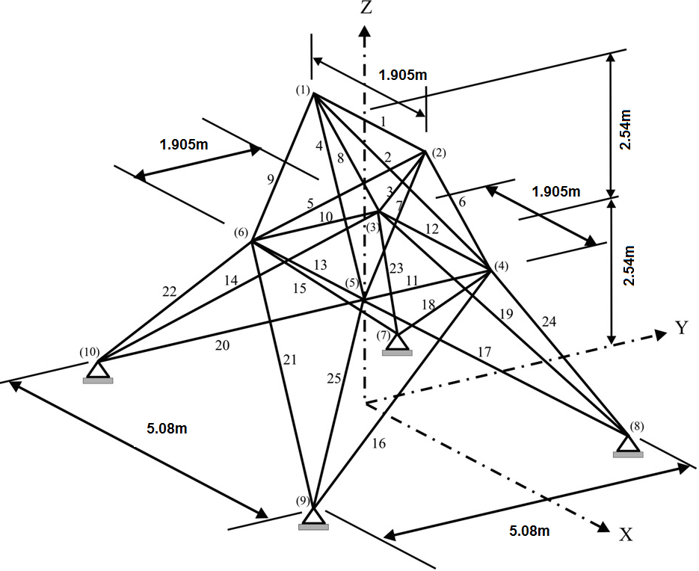
Fig. 3 Initial 25 bar truss model
Models are created in Rhino initially as curves which are collected in Grasshopper and converted to beam elements. Ass these elements to not vary in length the only variable input in their assembly is the cross section diameter for each element individually. Individual weights of elements are calculated from individual cross section areas and multiplied by their length, and specific weight. Once the model is analysed using first order theory of small deflections the model deformation resulting bar compressive and tensile forces are calculated via further operators. Stress is calculated for each of the elements for all load case and compared to stress limits giving either a true or false readout discarding any combination without all elements meeting required constraints. At the same time displacement is also compared to the limit value. If either of the two conditions are not met each elements weight is multiplied by a large number to ensure that such a combination is not considered a global or local minimum before entering the objective function.
- RESULTS
The initial weight of the 10 bar truss when all elements have 20mm thick elements is 9089.765kg with a maximum displacement of 21.239mm. Table 3 compares element diameters and total weight of trusses according to loading case. Figure 4 shows the resulting deformed models for both load cases.
Table 3 10 bar truss optimal design comparison by load case
Element  number: | GA |  | [7] |  | [8]
Element  number: | LC1 Φ[mm] | LC2 Φ[mm] | LC1 Φ[mm] | LC2 Φ[mm] | LC1 Φ[mm] | LC2 Φ[mm]
1 | 163.23 | 143.23 | 158.014 | 138.731 | 157.9815 | 138.1159
2 | 9.04 | 9.05 | 9.045 | 9.045 | 9.04465 | 9.04465
3 | 149.96 | 142.64 | 137.764 | 143.847 | 137.7651 | 144.655
4 | 119.28 | 122.485 | 111.594 | 108.445 | 111.4828 | 109.5262
5 | 9.045 | 9.05 | 9.045 | 9.045 | 9.04465 | 9.04465
6 | 9.045 | 40.432 | 21.239 | 40.142 | 21.32505 | 40.13928
7 | 76.28 | 103.063 | 78.1051 | 100.734 | 78.12607 | 100.1688
8 | 126.83 | 106.554 | 131.183 | 102.426 | 131.292 | 101.7163
9 | 130.3 | 126.247 | 132.708 | 128.963 | 132.5376 | 129.0003
10 | 09.045 | 9.05 | 9.045 | 9.045 | 2.86017 | 9.04465
Weight: | 2314.1636kg | 2171.615kg | 2295.81kg | 2121.81kg | 2294.568 | 2120.738
The initial weight of the 17 bar truss when all elements have 20mm thick elements is 10044.4355kg with a maximum displacement of 8.887mm. Table 4 compares element diameters and total weight of trusses. Figure 5 shows the resulting deformed model with compressed elements shown in red, and stretched elements in blue.
Table 4 17 bar truss optimal design comparison
Element number: | GA Φ[mm] | [9] Φ[mm] | [8] Φ[mm]
1 | 109.419 | 113.765 | 113.757
2 | 43.878 | 9.399 | 9.272
3 | 102.403 | 99.063 | 99.181
4 | 9.045 | 9.045 | 9.045
5 | 94.131 | 81.653 | 81.468
6 | 57.046 | 67.120 | 67.271
7 | 83.253 | 98.371 | 98.429
8 | 13.546 | 9.045 | 9.045
9 | 68.956 | 80.563 | 80.675
10 | 9.047 | 9.045 | 9.045
11 | 65.848 | 57.865 | 57.710
12 | 34.799 | 09.045 | 9.045
13 | 68.977 | 68.046 | 68.190
14 | 57.794 | 57.638 | 57.266
15 | 61.124 | 68.022 | 67.593
16 | 49.697 | 09.045 | 9.045
17 | 61.903 | 67.575 | 67.565
Weight: | 1207.407kg | 1170.63477kg | 1169.705kg
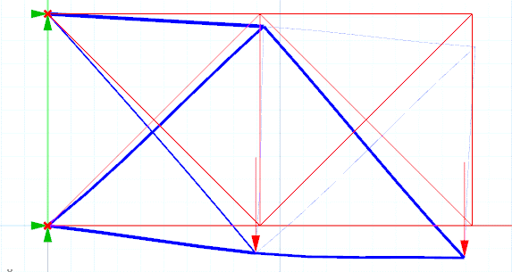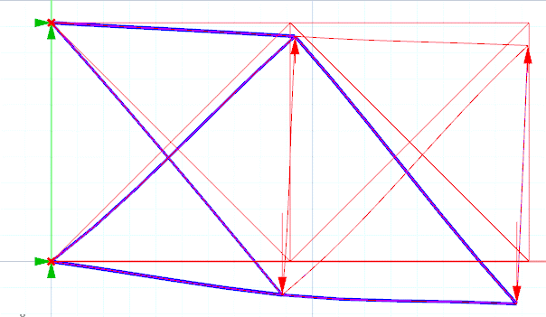
Fig. 4 Deformed optimal model of 10 bar trusses for LC1 (left) and LC2 (right)
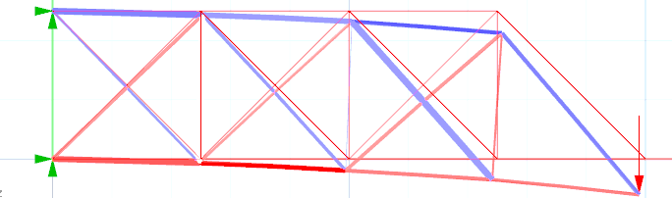
Fig. 5 Deformed optimal model of 10 bar truss
The initial weight of the 25 bar truss when all elements have 20mm thick elements is 7389.295kg with a maximum displacement of 0.402mm. Table 5 compares element diameters and total weight of trusses. Figure 6 shows the resulting deformed model with compressed elements shown in red, and stretched elements in blue.
Table 5 25 bar truss optimal design comparison
Element group: | GA Φ[mm] | [7] Φ[mm] | [8] Φ[mm]
1 (A₁) | 2.86 | 40.4297 | 2.860
2 (A₂ – A₅) | 32.02 | 49.397 | 40.311
3 (A₆ – A₉) | 56.36 | 2.860 | 49.519
4 (A₁₀ – A₁₁) | 2.86 | 2.860 | 2.860
5 (A₁₂ – A₁₃) | 2.86 | 23.650 | 2.860
6 (A₁₄ – A₁₇) | 25.97 | 37.017 | 23.596
7 (A₁₈ – A₂₁) | 43.3 | 46.708 | 36.999
8 (A₂₂ – A₂₅) | 41.85 | 40.430 | 46.681
Weight: | 261.296kg | 247.375kg | 247.1532kg
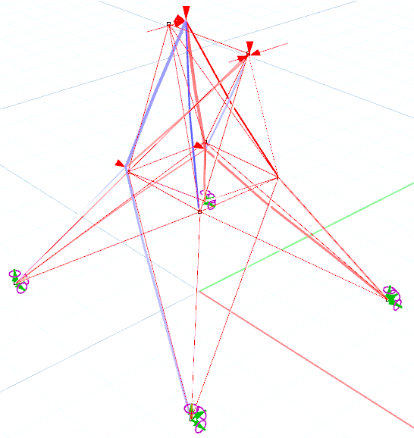
Fig. 6 Deformed optimal model of 25 bar truss
- CONCLUSION
As most heuristic optimization methods show drastic decreases in weight of standard test models, the benefits of their use in designing practically applicable trusses is obvious. The quickest way to create truss models is through parametric input. By combining parametric modeling with optimization the time needed to achieve a minimal weight design concept is decreased. In this paper through the use of Rhino, a program with integrated modeling, parameterization, finite element analyses, and optimization this process is further integrated to not require additional steps. The parametric models optimization capabilities are proven in this paper by testing the created model on 10, 17, and 25 bar truss models showing a 74.25% (76.11% for Load case 2), 86.72%, and 96.46% decrease in weight respectively. While the weight results vary from those in literature, due to the model using basic genetic algorithm without penalty functions, they are still competitive. The next step in this research will be creating a parametric model with dynamic input of nodes and their connections to optimize shape and topology as well.
REFERENCES
- Hasançebi, O., Kazemzadeh Azad, A. (2015). Adaptive dimensional search: A new metaheuristic algorithm for discrete truss sizing optimization - Computers & Structures, vol. 154, 1 July 2015, p. 1-16.
- Cheng, M. C., Prayogo, D., Wu, Y. W., Lukito, M. M., (2016). A Hybrid Harmony Search algorithm for discrete sizing optimization of truss structure - Automation in Construction, vol. 69, September 2016, p. 21-33.
- Degertekin, S.O., Hayalioglu, M.S. (2013). Sizing truss structures using teaching-learning-based optimization - Computers & Structures, vol. 119, 1 April 2013, p. 177-188.
- Kaveh, A., Sheikholeslami, R., Talatahari, S., Keshvari-Ilkhichi, M. (2014). Chaotic swarming of particles: A new method for size optimization of truss structures - Advances in Engineering Software, vol. 67, January 2014, p. 136-147.
- S. Kazemzadeh Azad, O. Hasançebi, M.P. Saka (2014). Guided stochastic search technique for discrete sizing optimization of steel trusses: A design-driven heuristic approach - Computers & Structures, vol. 134, 1 April 2014, p. 62-74.
- Mortazavi, A., Toğan, V. (2017). Sizing and layout design of truss structures under dynamic and static constraints with an integrated particle swarm optimization algorithm - Applied Soft Computing, vol. 51, February 2017, p. 239-252.
- Farshi, B., Alinia-ziazi, A. (2010). Sizing optimization of truss structures by method of centers and force formulation - International Journal of Solids and Structures, vol. 47, no. 18–19, September 2010, p. 2508-2524.
- Asl, R. N., MAslani, M., Panahi, M.S. (2013). Sizing Optimization of Truss Structures using a Hybridized Genetic Algorithm, Cornell University Library - Optimization and Control, vol. 1, Jun 2013, p. 1-20.
- Lee, K. S., Geem, Z. W. (2004). A new structural optimization method based on the harmony search algorithm - Computers & Structures, vol. 82, no. 9–10, April 2004, p. 781-798.
- Shopova, E. G., Vaklieva-Bancheva, N. G. (2006). BASIC—A genetic algorithm for engineering problems solution - Computers & Chemical Engineering, vol. 30, no. 8, 15 June 2006, p. 1293-1309.

Nenad Petrović, Kragujevac, Serbia, University of Kragujevac, Faculty of Engineering, (npetrovic@kg.ac.rs)
Nenad Marjanović PhD, Kragujevac, Serbia, University of Kragujevac, Faculty of Engineering, (nesam@kg.ac.rs)
Nenad Kostić, Kragujevac, Serbia, University of Kragujevac, Faculty of Engineering, (nkostic@kg.ac.rs)
Mirko Blagojević PhD, Kragujevac, Serbia, University of Kragujevac, Faculty of Engineering, (mirkob@kg.ac.rs)
Miloš Matejić, Kragujevac, Serbia, University of Kragujevac, Faculty of Engineering, (mmatejic@kg.ac.rs)

