Two-phase flow analysis in spiral evaporator tube of steam generator
Ivana Kecman¹, Mirko Dobrnjac², Vladimir Stevanović³, Milan Lečić⁴
Summary: Objective of this paper is analysis of one-dimensional, uniform two-phase flow of liquid and steam phase. In first part of the calculation, parameters of water, steam and two-phase mixture were obtained by numerical solving of mass, momentum and energy balance equations for one-dimensional one-phase or two-phase compressible fluid. By applying the „two-fluid“ model, solving balance equations for each phase and using corresponding constitutive correlation, parameters of water and steam were obtained as well as volume fraction of water and steam. Balance equations were solved using Runge-Kutta method after they were transformed from partial differential equations to ordinary differential equations. In calculation were took into account change in density due warming along evaporator canal with the assumption that the water heats with uniform heat flux over the entire length. The results of conducted calculation were presented graphically.
Key words: Two-phase flow, Numerical simulation, Runge-Kutta method, parameters of water and steam, evaporator tube
1. INTRODUCTION
A medium that flows through the evaporator tube is a mixture of water and steam. A part of the volume is filled with steam, and the rest is filled with water. The mixture of water and steam is unbalanced except when the both phases are on boiling temperature. The first bubbles appear in bumps on the surface of the tube walls when the temperature of the tube wall is slightly higher than the boiling temperature. After that, with further heating in the vertical evaporator tube the next flow regimes are occurring in order: bubble flow, plug flow, pennum flow, annular flow after which the convective overheating of the steam begins.
The calculation of flow and thermic parameters of water and steam was conducted by numerical solving of mass, momentum and energy balance equations for one-dimensional one-phase or two-phase compressible fluid. One-phase fluid includes subcooled water or overheated steam at pressures lower than the critical as well as the water on above critical pressures. The two phase flow occurs at pressures lower than the critical. The calculations were conducted by applying the „two-fluid“ model, within which balance equations for each of the phases were solved, whereat the exchange of the balance value on the dividing surfaces of the phases and between certain phases and the wall of the flow canal were determined by using corresponding constitutive correlations. The solving of the balance equations enables determining changes of pressure, velocity and enthalpy (temperature) of water and steam in under critical area as well as the water at pressures higher than critical. Concerning the flow of the two-phase mixture the velocity of each phase is determined, volume content of water and steam in two phase mixture, pressure and enthalpy (temperature) of two phase mixture. The calculation starts with a developed form of partial differential equations.
Mass balance for fluid phase:
$$\frac{∂α_{1}ρ_{1}}{∂t}+\frac{∂α_{1}ρ_{1}u_{1}}{∂z}=Γ_{21}-Γ_{12} (1)$$
Mass balance for steam:
$$\frac{∂α_{2}ρ_{2}}{∂t}+\frac{∂α_{2}ρ_{2}u_{2}}{∂z}=Γ_{12}-Γ_{21} (2)$$
Momentum balance for fluid phase:
$$\frac{∂α_{1}ρ_{1}u_{1}}{∂t}+\frac{∂α_{1}ρ_{1}u_{1}^{2}}{∂z}+α_{1}\frac{dp}{dz}=α_{12}τ_{12}-α_{1z}τ_{1z}-α_{1}ρ_{1}g\sin{θ} (3)$$
Momentum balance for steam phase:
$$\frac{∂α_{2}ρ_{2}u_{2}}{∂t}+\frac{∂α_{2}ρ_{2}u_{2}^{2}}{∂z}+α_{2}\frac{dp}{dz}=α_{12}τ_{12}-α_{2z}τ_{2z}-α_{2}ρ_{2}g\sin{θ} (4)$$
Energy balance for fluid phase:
$$\frac{∂α_{1}ρ_{1}h_{1}}{∂t}+\frac{∂α_{1}ρ_{1}h_{1}u_{1}}{∂z}=\left(Γ_{21}-Γ_{12}\right)h^{"}+{\dot{q}}_{v1} (5)$$
Energy balance for steam phase:
$$\frac{∂α_{2}ρ_{2}h_{2}}{∂t}+\frac{∂α_{2}ρ_{2}h_{2}u_{2}}{∂z}=\left(Γ_{12}-Γ_{21}\right)h^{"}+{\dot{q}}_{v2} (6)$$
Where are: $α$- volume content, $ρ$- density, $u$- velocity, $h$- enthalpy, $τ$- friction, subscripts: $1$-fluid phase, $2$- steam phase, $z$- wall;$Γ_{21}={\left(h-h^{'}\right)}/{\left(h^{"}-h^{'}\right)}∙{\left(ρ_{1}α_{1}\right)}/τ\left[{kg}/{m^{3}s}\right]$- evaporation speed, $Γ_{12}=0$- condensation speed.
After introducing presumptions, system of partial differential equations was turned into a system of the ordinary differential equations, which are afterwards solved by the Runge-Kutta method. Thermohydraulic calculation of the flow was carried out for three different regimes of flow, with the assumption that the water heats with uniform heat flux over the entire length. The results of conducted calculation were presented graphically.
2. SYSTEM OF ORDINARY DIFFERENTIAL EQUATIONS
Presumptions in the calculations are: the flow is stationary $∂/{∂t}=0$; The steam enthalpy, in evaporator canal, is equal to saturation enthalpy $h_{2}=h^{"}$, from what follows that the energy balance for steam is not necessary. After introducing presumptions, we get a system of ordinary differential equations which are used to describe the flow. For shorter inscription following labels were introduced:
$$M_{1}=α_{12}τ_{12}-α_{1z}τ_{1z}-α_{1}ρ_{1}g\sin{θ}, M_{2}=α_{12}τ_{12}-α_{2z}τ_{2z}-α_{2}ρ_{2}g\sin{θ}.$$
$$\frac{dp}{dz}=\frac{\frac{M_{1}+2Γ_{12}u_{1}+α_{1}u_{1}^{2}\frac{dρ_{1}}{dh_{1}}\frac{dh_{1}}{dz}}{ρ_{1}u_{1}^{2}}+\frac{M_{2}-2Γ_{12}u_{2}}{ρ_{2}u_{2}^{2}}}{α_{1}\frac{1-u_{1}^{2}\frac{dρ_{1}}{dp}}{ρ_{1}u_{1}^{2}}+α_{2}\frac{1-u_{2}^{2}\frac{dρ_{2}}{dp}}{ρ_{2}u_{2}^{2}}} (7)$$
$$\frac{du_{1}}{dz}=\frac{{-Γ}_{12}-ρ_{1}u_{1}\frac{dα_{1}}{dz}-α_{1}u_{1}\frac{dρ_{1}}{dp}\frac{dp}{dz}-α_{1}u_{1}\frac{dρ_{1}}{dh_{1}}\frac{dh_{1}}{dz}}{α_{1}ρ_{1}} (8)$$
$$\frac{du_{2}}{dz}=\frac{Γ_{12}-ρ_{2}u_{2}\frac{dα_{2}}{dz}-α_{2}u_{2}\frac{dρ_{2}}{dp}\frac{dp}{dz}}{α_{2}ρ_{2}} (9)$$
$$\frac{dh_{1}}{dz}=\frac{{\dot{q}}_{v}-Γ_{12}h^{"}+h_{1}Γ_{12}}{α_{1}ρ_{1}u_{1}} (10)$$
In the equations (7-10) dependent variables are: pressure, velocity of water and steam, volume content and enthalpy of water. The independent variable is space coordinate z.
3. RUNGE-KUTTA METHOD
Solving the system of balance equations (7-10) was done by using the Runge-Kutta method. It is a numerical method for solving first order differential equation systems with given initial conditions.
$$\frac{dy_{1}x}{dx}=f_{1} \left(x,y_{1},…,y_{n}\right),…, \frac{dy_{n}x}{dx}=f_{n} \left(x,y_{1},…,y_{n}\right) (11)$$
With this procedure, the average solution is calculated in designated points by using exclusively arithmetical operations and calculating the function value. Runge-Kutta method is developed on the basis of development in Taylors order. The most frequent is a fourth order method. In this method the values on the right side of the equations (11) are calculated four times in one step: once at the beginning, two times in the middle and once at the end of the interval$i=1,2,…,n$.
$\left\{\begin{aligned}\begin{aligned}f_{i}^{1}=f_{i} x,y_{1},…,y_{n} \\ f_{i}^{2}=f_{i}\left(x+\frac{∆x}{2},y_{1}+\frac{f_{1}^{1}}{2}∆x,…,y_{n}+\frac{f_{n}^{1}}{2}∆x\right) \\ f_{i}^{3}=f_{i}\left(x+\frac{∆x}{2},y_{1}+\frac{f_{1}^{2}}{2}∆x,…,y_{n}+\frac{f_{n}^{2}}{2}∆x\right) \end{aligned} \\ f_{i}^{4}=f_{i}\left(x+\frac{∆x}{2},y_{1}+\frac{f_{1}^{3}}{2}∆x,…,y_{n}+\frac{f_{n}^{3}}{2}∆x\right) \end{aligned}\right.$(12)
Where are:$f_{i}^{1}$-value of the derivative of a function on the beginning of the interval,$f_{i}^{2},f_{i}^{3}$- values of derivatives in the middle,$f_{i}^{4}$- value of the derivative at the end. On the basis of values of derivatives (12) the values $y_{i}$are calculated at the end.
$$y_{i}\left(x+∆x\right)=y_{i}\left(x\right)+\frac{Δx}{2}\left(f_{i}^{1}+f_{i}^{2}+f_{i}^{3}+f_{i}^{4}\right)+error (13)$$
Where are: $y_{i}\left(x\right)$-function value at the beginning, $y_{i}\left(x+∆x\right)$-function value at the end, $∆x$-step value.
4. TERMOHYDRAULIC CALCULATION OF A FLOW
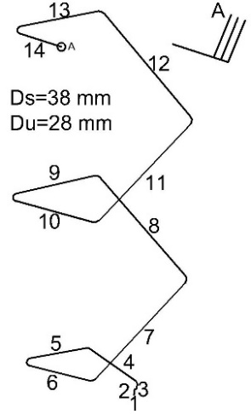
Spiral evaporator tubes (pic. 1) on which the calculation was made are divided into 14 sections which are linked by joints. They are set at the angle of $17°26'$ in relation to the horizontal. They are climbing up in the shape of a spiral, on the walls around the firebox of the boiler until height $72,210 m$. There every tube is branching on 3 tubes (Fig. 1, detail „A“), so that from 400 spiral tubes 1200 tubes are generated, and they are now spread vertically. Overall length of the pipes is $203,627\left[m\right]$, and the overall local resistance is $7,02\left[-\right]$.
Figure 1 Appearance of spiral evaporator tube
The temperature of the tube wall is always higher than the temperature of the heat recipient. The difference between the outside surface of the metal and the heat recipient depends on heat load$\left(q\right)$, tube wall thickness$\left(δ\right)$, limescale thickness$\left(δ_{k}\right)$, coefficient of thermal conductivity of the tube$\left(λ_{m}\right)$ and of limescale$\left(λ_{k}\right)$ and the heat transfer coefficient from internal wall surface to the recipient$\left(α_{2}\right)$. Heat conduction resistance ${δ_{m}}/{λ_{m}}$ in equation (14) can be ignored because of the small wall thickness and big thermal conductivity of metal from which made tubes.
$$∆t=q\left(\frac{δ_{m}}{λ_{m}}+\frac{δ_{k}}{λ_{k}}+\frac{1}{α_{2}}\right)℃ (14)$$
Thermohydraulic calculation of the flow was made for three different work regimes. The first regime had next parameters: steam production $1711t/h$, inlet pressure $223,7 bar$, absolute roughness of the tube $0,025 mm$. The second regime had the same parameters, as the first, except the absolute roughness of the tube which was $0,5 mm$. The third regime had the same parameters, as the first, except the inlet pressure which was $210 bar$.
Towards carrying out thermohydraulic calculation, it is necessary to define tube geometry, the number of spiral evaporator tubes and thermophysical properties on tube inlet. On basis of pressure and temperature at tube inlet, enthalpy and density of fluid phase can be determined. That liquid phase enthalpy is the radix of enthalpy upon calculating the changes of liquid phase enthalpy along evaporator tube. The surface heat flux and the volume heat flux can be determined from longitudinal heat flux.
Mass flow through one tube can be determined from overall mass flow through all tubes, and the number of tubes. Mass flux (mass velocity) of liquid phase can be determined from mass flow through one tube and cross-section surface. Mass flux is used to calculate velocity of the liquid phase on an inlet of the tube, by using the density of liquid phase on an inlet of the tube.
At the initial point, only fluid phase flows through evaporator tubes, but because we use two fluid model, for solving one-phase and two-phase flow, we must assign fictive initial values for steam velocity (a little higher velocity than the fluid phase is adopted) and volume content of liquid phase (the value $0,9999$ is adopted). Based on pressure of fluid that flows through evaporator tube, the area in which fluid belongs is determined (above the critical or under the critical area). Then, if the flow is in under critical area, based on the fluids enthalpy, is determined if the flow is one-phase or two-phase. If the enthalpy of the fluid, which flows through evaporator tube, is smaller than the saturation enthalpy of water, or higher than the saturation enthalpy of steam, the flow is one-phase. Otherwise, we have the two-phase flow. Above critical fluids are observed as a one-phase. Thermophysical properties of fluid are calculated for fluid that flow through evaporator tube.
5. DISPLAY AND DISCUSSION OF THE RESULTS
Based on the charts (Fig. 2), on which the results of the calculations are displayed, we see that the velocities of phases are increasing along the evaporator tube, considering that the velocity of steam phase is higher because it has smaller density. The value of liquid phase velocity $\left(u_{1}\right)$ on the evaporator tube inlet of first and the second regime is $2,8 m/s$, while the third regime has a little higher velocity, the cause for that is a smaller value of pressure on the evaporator tube inlet which leads to smaller density of the liquid phase. The velocities of liquid and steam $\left(u_{2}\right)$ phase are quickly increasing from the height of tube where evaporation began, until the end of the tube. The density of the two-phase mixture is decreasing along the evaporator tube, because of the increase of volume content of steam, and of the liquid phase is decreasing because of heating and rising of its temperature. Volume content, as well as mass circulating content of the steam, are increasing along the evaporator tube because the evaporation process is starting and the steam content in evaporator tube is increasing. Evaporation process, in which the steam phase appears, for every regime starts at different height of the evaporator tube. The highest value of volume content of steam is in third regime because of the longest line of evaporation. The enthalpy of fluid phase quickly increases along the evaporator tube due the heating. The liquid phase is heated until the state of saturation when the evaporation process begins and the two-phase mixture appears. The pressure is decreasing along the evaporator tube. The smallest pressure drop is in first regime, in third regime is a little higher because of the smaller value of pressure on the evaporator tube inlet, and the highest is in the second regime because of the bigger absolute roughness of the tube. Overall pressure drop consists of pressure drop due to gravity, pressure drop due to local resistance and pressure drop due to friction (most influential).
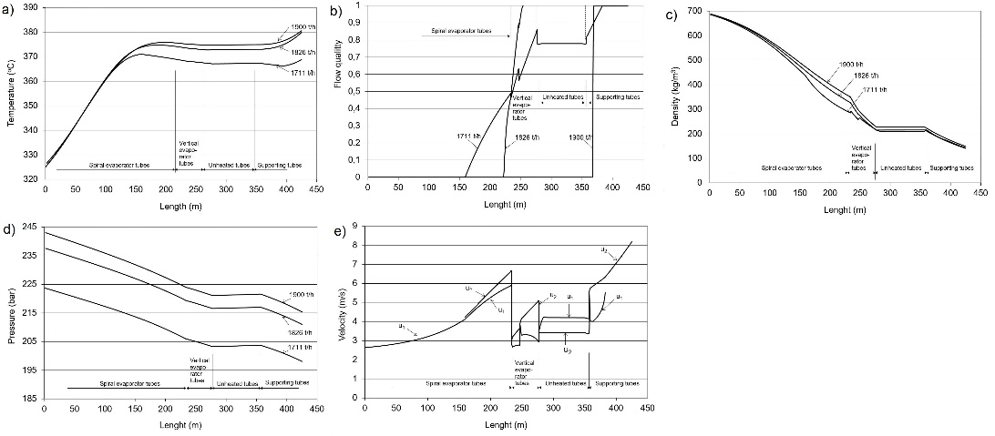
Figure 2 Diagrams for the three regimes of the work along the evaporator tubes a) distribution of temperature, b) distribution of flow quality, c) the distribution of density, d) the distribution of pressure, e) the distribution of velocity
6. CONCLUSION
Flow and thermal parameters of water and steam are determined over analyses of steam boilers as well as over their designing towards ensuring their safe and reliable work. The calculations were made for three different work regimes the only difference between the first and second work regime is that the second regime has a bigger pressure drop, then the first, because of the bigger roughness of the tube. The changes of flow and thermal parameters of water and steam are same for all three work regimes, but the individual values of flow and thermal parameters of phases are different in all three work regimes. In third work regime the velocity of the liquid phase is higher than in the rest two regimes, because of the smaller pressure at the inlet of the tube which has led to a smaller density of liquid phase at the inlet of the tube.
REFERENCES
- Brkić Lj., Živanović T. (2007.). Parni kotlovi. Univerzitet u Beogradu, Mašinski fakultet, Beograd
- Šašić, M. (1990.). Transport fluida i čvrstih materijala cevima. Naučna knjiga, Beograd
- Bugarinović S. (2015.). Termohidraulički proračun isparivačke cijevi u generatoru pare. Diplomski rad, Univerzitet u Beogradu, Mašinski fakultet, Beograd
- Kuznecov, Yu. N. (1989.). Heat Transfer in Problems of the Nuclear Reactors Safety. Energoatomizdat, Moscow
- Whalley, P.B. (1996). Two-Phase Flow and Heat Transfer. Oxford University Press, New York
- Chisholm, D. (1983). Two-phase flow in pipelines and heat exchangers. George Goldwin, London
- Kandlikar, S.G. (1990). A General Correlation for Saturated Two-Phase Flow Boiling Heat Transfer Inside Horizontal and Vertical tubes. Journal of Heat Transfer, Vol.112, p. 219-228
- Loilier, P., Ombga-Essama, C., Thompson C. (2005). Numerical experiments of two-phase flow in pipelines with a two-fluid compressible model. 12th International Conference on Multiphase Technology 2005 in Barcelona

