LOGO WILL BE HERE
APPLICATION OF POLYURETHANE WASTE IN VIRGIN RUBBER BLENDS
Petar Djekić, Biljana Milutinović, Mladen Tomić
Summary: With the wide application of polyurethane foam, large amounts of polyurethane wastes are generated. Polyurethane waste from vehicles, waste of electrical and electronic equipment and many other sources attracted great attention worldwide as a result of rapidly rising amounts and increasingly tight legislation on its treatment and disposal. Polyurethane waste is recycled in two primary ways. Mechanical recycling, called powdering or recycling of regrind, involves grinding of waste containing polyurethane, and one of the fractions obtained is polyurethane powder. Thus obtained powder is mixed with virgin polymer materials and it can be used for new products. Chemical recycling takes the material back to its various chemical constituents. In this article polyurethane waste from electrical and electronic equipment is used as filers in virgin rubber. Different amount of polyurethane powder was added to rubber blend and their influence on mechanical properties and structure of rubber blends were examined. This study determined the optimal share of powder, in which there is no significant decrease in the properties of rubber compounds..
Key words: polyurethane waste,recycling, rubber blends.
- INTRODUCTION
Waste electrical and electronic equipment (WEEE) is one of the fastest growing types of waste in the world. In the US, it amounts from 1% to 3% of the total waste generated in the municipalities. In the EU, the WEEE is growing for 16-28% every 5 years, which is 3 times faster than the average waste generated in a year [1].
WEEE contains more than 1000 different substances among them are considerable quantities of valuable materials such as precious metals. Early generation PCs used to contain up to 4 g of gold each; however, this has decreased to about 1 g today. The value of metals contained is also very high (for example 1 ton of WEEE contains up to 0.2 tons of copper). Therefore, recycling WEEE has the potential of becoming an attractive business for companies [2].
According to the European Topic Centre on Resource and Waste Management, iron and steel are the most common materials found in electrical and electronic equipment and they account for almost half of the total weight of WEEE. Plastics are the second largest component by weight representing approximately 15% of WEEE. The percentage share of material and mass balance of a refrigerator with the average weight of 54 kg is given in Table 1.
Table 1 Mass Balance of a Refrigerator
Material | Share (%) | Weight (kg)
Iron | 63.33 | 34.20
Aluminum | 4.17 | 2.25
Copper | 0.58 | 0.31
Stainless steel | 0.02 | 0.01
Plastic | 12.65 | 6.83
Rubber | 0.77 | 0.41
Freon | 0.54 | 0.29
Wood | 0.76 | 0.41
Polyurethane foam | 15.71 | 8.48
Mineral wool | 0.51 | 0.27
Oil | 0.01 | 0.01
Other | 0.95 | 0.51
Total | 100 | 54.00

The table shows that the highest content of material in the refrigerator is iron (63.33%) and plastics (12.65%), which are successfully returned to the production process. In addition, there is a huge amount of polyurethane foam, almost 16%, for which there is currently no acceptable way of reusing it.
During WEEE recycling that contains polyurethane foam (refrigerators, freezers, cooling equipment, etc.), the waste polyurethane powder (WPU powder) has been generated as one of recycling product. Such WPU powder cannot be re-processed, expanded and used as an insulator. So far, WPU powder is used in two primary ways. Mechanical recycling, called powdering or recycling of regrind. Thus obtained powder is mixed with virgin polymer materials and it can be used for new products. Chemical recycling takes the material back to its various chemical constituents. Also, WPU powder has a high heating value (27 MJ/kg), and it can be used in incineration process as a fuel.
In this article WPU powder obtained from WEEE recycling is used as filers in virgin rubber. Different amount of polyurethane powder was added to rubber blend and their influence on mechanical properties and structure of rubber blends were examined.
- EXPERIMENTAL RESEARCH
2.1 Rubber blends
WPU powder was produced only from waste refrigerated and waste freezer, where the present impurities were less than 0.05% and the particle size was less than 250μm. The characteristics of rubber blend with 0% of WPU powder (virgin rubber blend) was compared with the characteristics of two blends in witch were added 5% and 20% of WPU powder, respectively. Composition of NR/SBR blend is shown in Table 2.
Table 2 Composition of rubber blends
Ingredients | Virgin rubber blend (g) | Rubber blend with 5% of WPU powder (g) | Rubber blend with 20% of WPU powder (g)
SMR-10 | 225 | 225 | 225
SKS-30 | 870 | 870 | 870
ZnO | 48 | 48 | 48
Stearin | 15 | 15 | 15
4010 Na | 11 | 11 | 11
TMQ | 11 | 11 | 11
SOLAR-3 | 70 | 70 | 70
N-220 | 580 | 550 | 350
CBS | 14,6 | 14,6 | 14,6
MS | 1,0 | 1 | 1,0
S | 24,2 | 24,2 | 24,2
PVi | 1,8 | 1,8 | 1,8
WPU powder | 0 | 54.75 | 219

The blends were mixed in a 2kg laboratory size two-roll mill at temperature of 80 °C and the mixing time of 15 min. The time and length of the curing process was determined by the Monsanto Rheometer 100S according to ASTM D 2240-93, with the vulcanization time of 15 min, and the vulcanization temperature of 155 °C.
2.2 Mechanical testing
All measurements were performed before and after aging. The aging process was conducted in the aging oven for the period of 7 days at a temperature of 100 °C.
Hardness measurements were performed in accordance with ISO 7619-1 [3], using a manual durometer type Shore A. The measurements were carried out 5 times for each sample.
The testing of wear resistance was performed in accordance with ISO 4649 [4] using a Shopper cylindrical device with 5 measurements per sample.
The determination of tensile strength was carried out in accordance with ISO 37 [5] at the Instron testing machines, on dumbbell specimen type "2" of 2 mm in thickness, strained to break. The clamp separation speed was 100 mm/min.
Tear resistance was analyzed in accordance with ISO 34 [6]. Three angular type “A” tubes of 3 mm in thickness were strained to break in the measuring point, where the speed of clamp separation was constant at 500 mm/min.
Scanning electronic microscope was peroformed at JFC-1100E (JEOL, Japan).
- RESULTS AND DISCUSSION
Hardness of all samples is illustrated in Fig. 1. Hardness increases with the increase in the amount of WPU powder. Hardness increases more significantly when the amount of WPU powder reaches 20%, resulting in around 9% of the initial hardness. This appears to happen due to the decrease in cross-link density when WPU powder filler is used. Large deviations in hardness occur after aging, where hardness increases significantly with the increasing percentage of WPU powder.
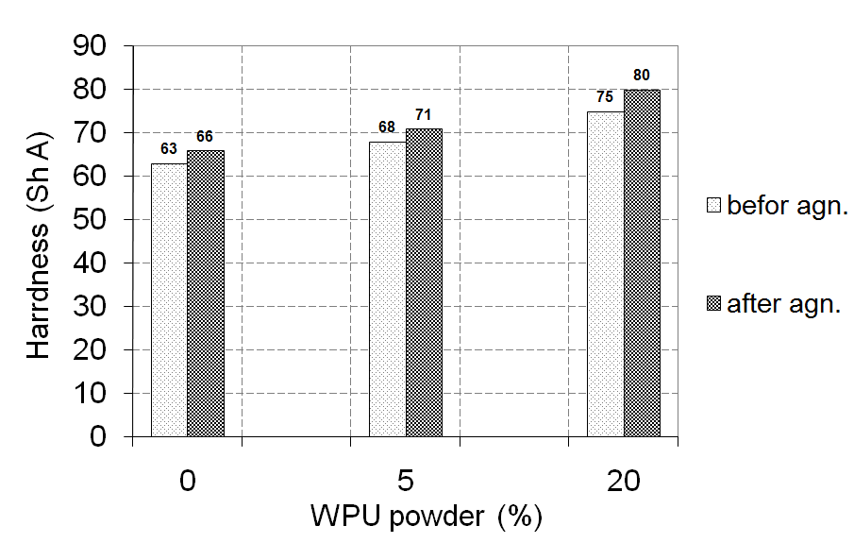
Fig. 1 Results of hardness testing
Tensile properties fall into one of the most important properties of rubber compounds (tensile strength and modulus of elasticity). Tensile strength is shown in Fig. 2.
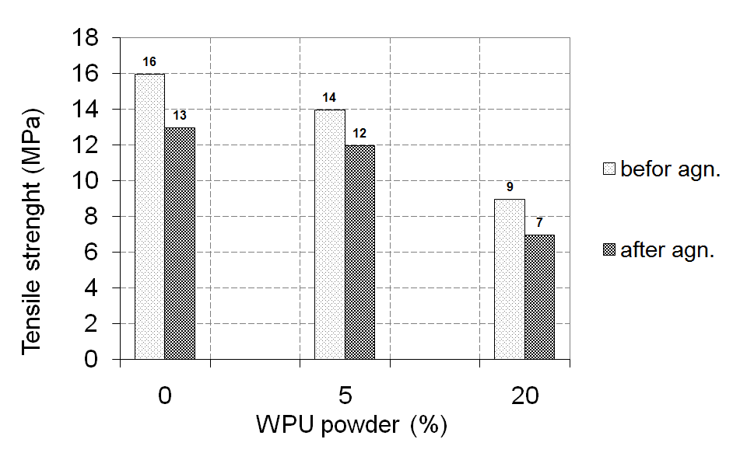
Fig. 2 Results of tensile strength of rubber blends
It decreases slightly with the increase in the amount of WPU powder, where the small difference in tensile strength for 5% of WPU powder. Tensile strength decreases significantly when the amount of filler reaches 20%. This can be explained by weak bonds between particles and polymer chains, as well as irregular networking, which lead to a decrease in tensile strength. With the increase in the amount of WPU powder, the possibility of improper particle dispersion also increases, causing the more frequent occurrence of errors in the material. On the basis of the aforementioned, it can be concluded that the WPU powder behaves like a rigid filler since it has a higher modulus of elasticity than the natural rubber matrix.
Test results for wear resistance are shown in Fig. 3. It can be concluded, from the diagram, that WPU powder particles have small effect on this property either before or after aging.

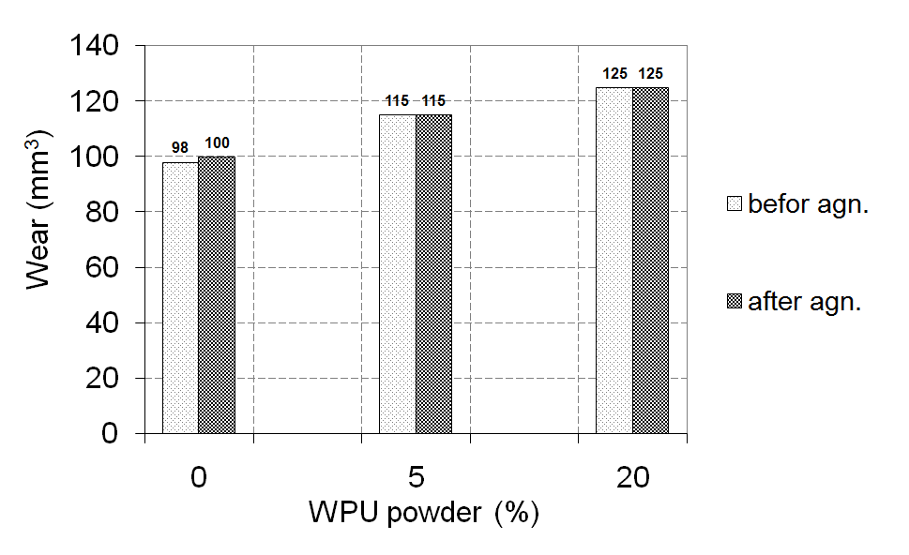
Fig. 3 Results of wear resistance test.
Residual elongation after unloading increases with the increase in WPU powder percentage, as well as breaking elongation. This is explained by the poor cross-linking between WPU powder particles and NR / SBR compounds which leads to weakened bonds, as well as the decrease in the ability to of rubber compounds to absorb the stresses.
Test results of tear resistance are shown in Fig. 4. A significant decrease in tearing force was recorded after adding 5% of WPU powder, which is followed by a slight decrease with the increasing percentage of WPU powder, which can be explained by poor distribution of particles in the cross-linked chains of WPU powder, particles being grouped by themselves, and the varying particle size, which negatively affects the resistance to fragmentation.

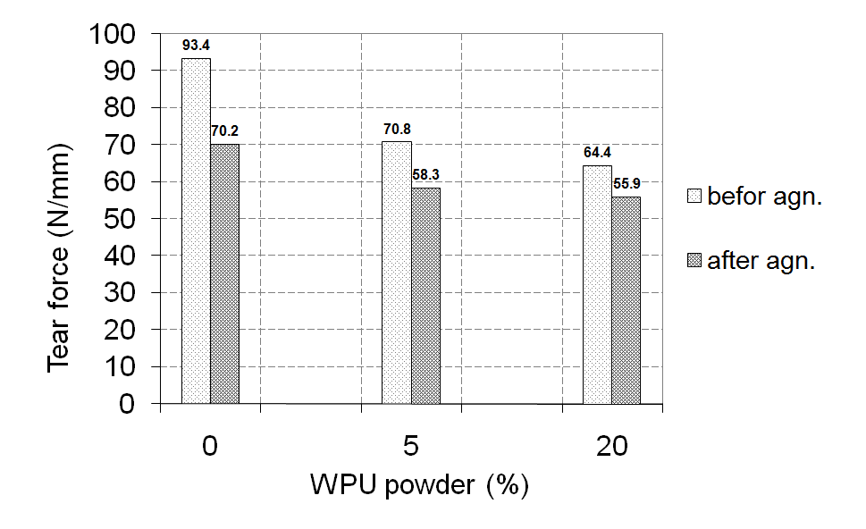
Fig. 4. Results of tear resistance testing
The recycling process of PU foams considerably affects on its microstructure. As can be seen in the SEM pictures before and after recycling, shown in Fig. 5 where the honeycomb structure of the PU completely is destroyed.

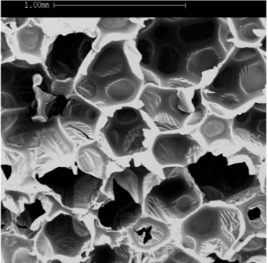 | 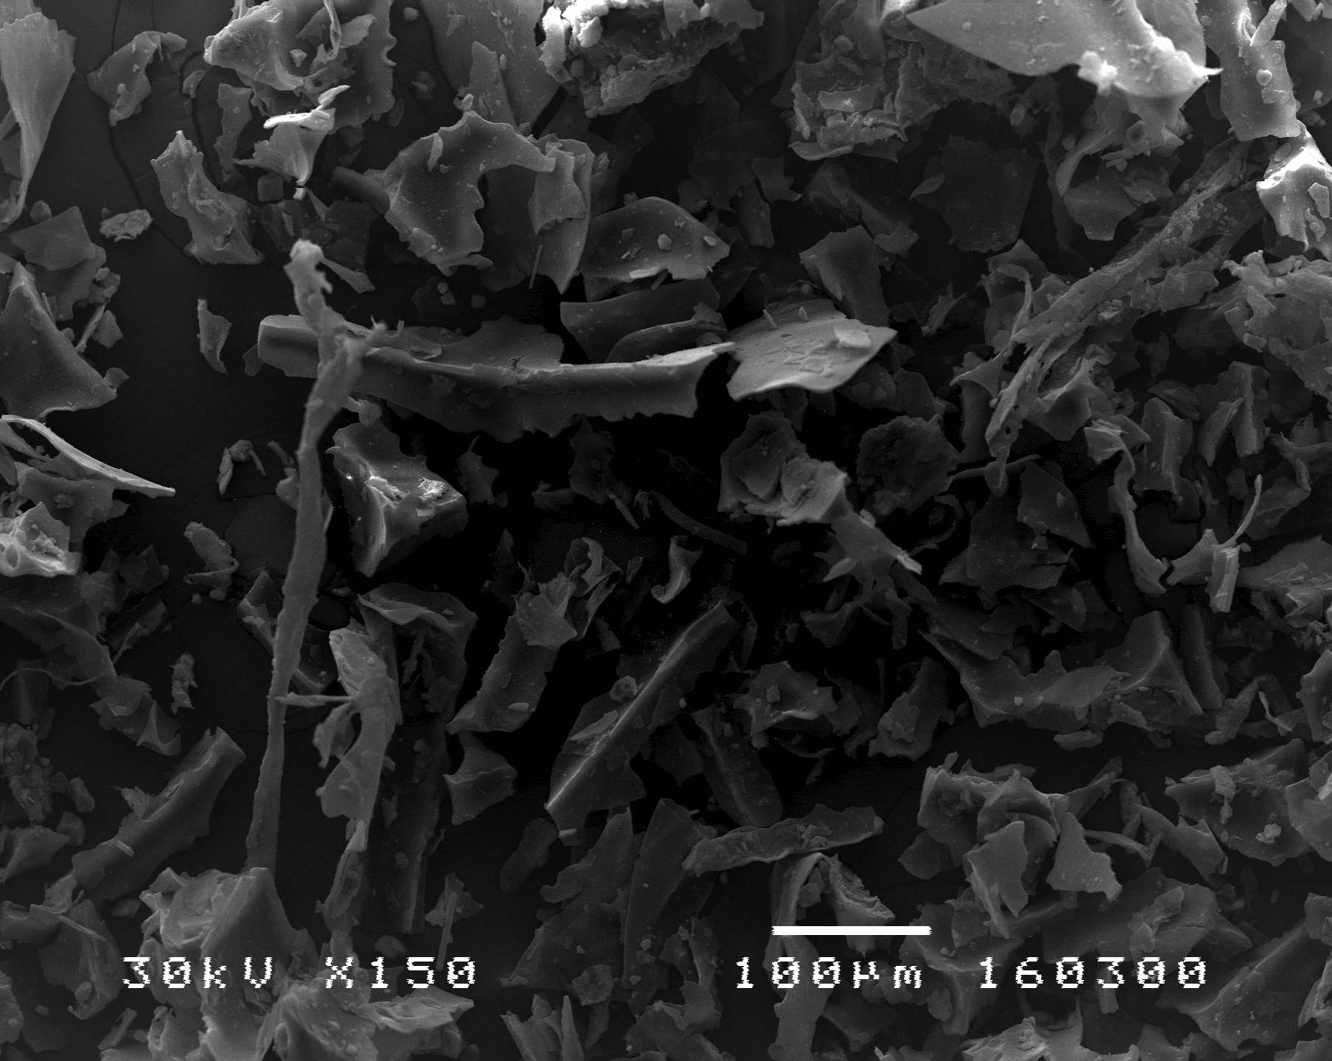
Fig. 5. Appirance of PU befor and after recycling
Because of its sharp edges (glassy structure) particles of WPU powder threads to bind to the rubber polymer chains and behave like inclusions in the chains. These damaging the structure of the rubber and adversely affect the elastic properties. A set of rubber structure with or without WPU powder, done on SEM, is shown in Fig. 6.

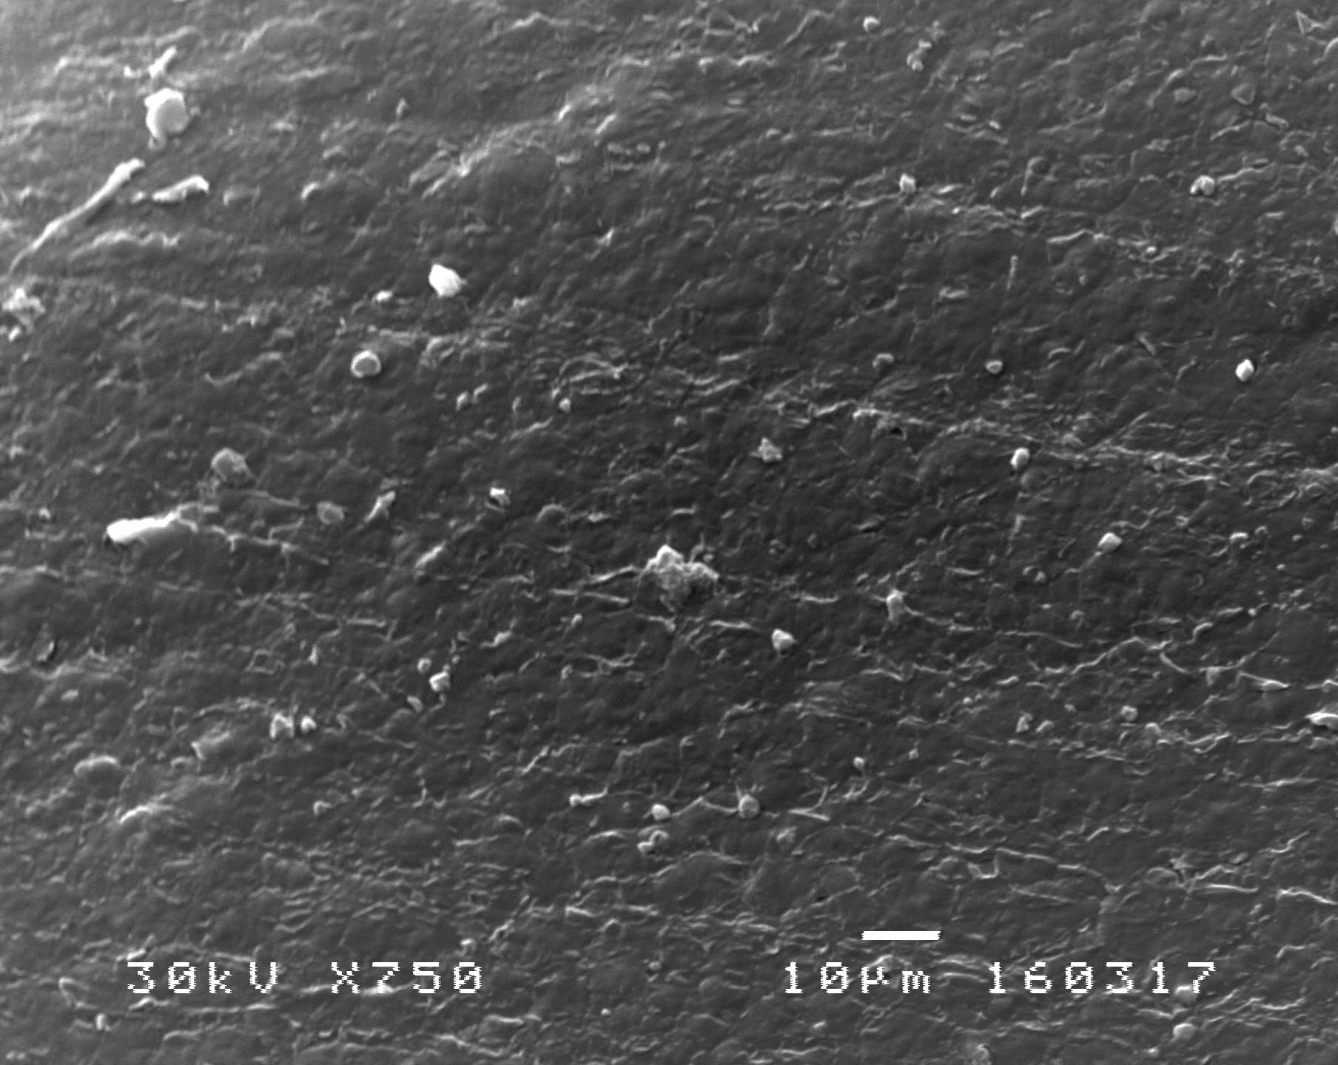 | 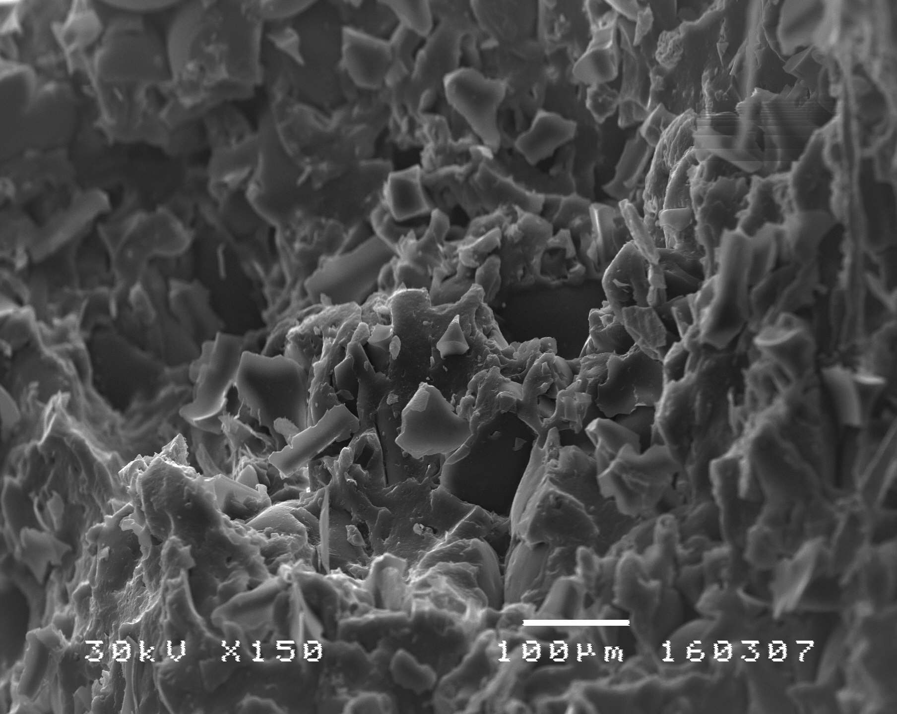
Fig 6. Structure of rubber with 0% and 20% of WPU powder
- CONCLUSION
The results presented analyses suggest that the possible use of WPU powder in NR/SBR compound depends on the required characteristics of rubber products. Hardness, which is one of the most important properties, can be achieved by maximal amount of 5% of WPU powder. As far as tensile properties (tensile strength and permanent elongation) are concerned even a small amounts of WPU powder lead to a significant drop of properties. Wear resistance shows small sensitivity to application of WPU powder.
In the aforementioned properties, the best properties are achieved by applying less than 5% of WPU powder, yet the optimal ratio from the standpoint of economic and technical analysis is 5 %.
However, for products where a prominent feature are tensile properties and tear resistance, the use of WPU powder is not recommended since it leads to significant reduction of thease properties.
REFERENCES
- Balkan e-Waste Management Advocacy Network, Upravljanje e-otpadom u Srbiji, 2010.
- Widmera R., Oswald-Krapf H., Sinha-Khetriwal D., Schnellmann M., Bonia H. (2005). Global perspectives on e-waste, Environmental Impact Assessment, vol. 25, p. 436– 458.
- ISO 7619-1:2010. Rubber, vulcanized or thermoplastic -- Determination of indentation hardness -- Part 1: Durometer method (Shore hardness).
- ISO 4649:2010. Rubber, vulcanized or thermoplastic -- Determination of abrasion resistance using a rotating cylindrical drum device.
- ISO 37:2011. Rubber, vulcanized or thermoplastic — Determination of tensile stress-strain properties.
- ISO 34-1:2015. Rubber, vulcanized or thermoplastic -- Determination of tear strength -- Part 1: Trouser, angle and crescent test pieces.

MSc Petar Djekić, Niš, College of Applied Technical Sciences Niš, djekicpetar@yahoo.c om
Dr Biljana Milutinović, Niš, College of Applied Technical Sciences Niš, bimilutinovic@gmail.com
Dr Mladen Tomić, Niš, College of Applied Technical Sciences Niš, tomicmladen@yahoo.com

