The impact of input temperature at panel heating system to heat the sports hall

Dragan Cvetković*, Aleksandar Nešović, Ljubiša Bojić,
Fakultet inženjerskih nauka, Univerzitet u Kragujevcu, Sestre Janjić 6, 34 000 Kragujevac

* Dragan Cvetković, e-mail:dragan_cw8202@yahoo.com, tel. 064 124 62 33

Abstract: Low temperature heating panel systems offer distinctive advantages in terms of thermal comfort and energy consumption, allowing work with low energy sources. The low temperature panel systems, by their nature work at a low temperature sources. However, this method of application panel system is not suitable for work in large spaces such as the sports hall. The aim of this study was to investigate the effect of inlet temperature of the panel systems in order to facilitate their application in sport halls. Simulation models are developed in the EnergyPlus software package developed by Lawrence Berkeley Laboratory in the United States.

Key words: energy, radiant panel heating, temperature, Energy Plus

- Introduction

Low temperature heating panel systems have been increasingly used in Europe today for purpose of heating and cooling of residential buildings and houses. According to some studies, spread of these systems go over 50% [1,2]. It is possible to save even 30% of energy when using this system [3, 4]. On the other hand, application of low temperature heating panel systems is questioned in case of big spaces and volumes.

Radiation systems are very complex because they involve different heat transfer mechanisms, transfer through wall, convection between space and air in these interiors, radiation between panels and surrounding areas and transfer between floor and ground.

Many studies are dedicated to lab research of panel systems in terms of heat transfer and development of new ways to manage them [5-10]. When looked through the prism of modeling, there are few analytical studies about thermal characteristics of panel systems. In the first model, Kollmar and Lises [11] show that heat is mainly lost on the upper side of panel. Leal and Miler [12] have been using analytical numeric methods to determine temperature in installation used to heat pedestrian roads. Zhang and Pate developed two dimensional method of final elements for ceiling heating, that was used for modeling of NTS heating [13,14]. Kilkis [15] developed stationary composite model for modeling of radiation systems for heating and cooling. After that, Kilkis and Sapci [16] together with Kilkis and Coley [17] used this model to develop software for design of floor heating and cooling systems.

Maloney [18] developed model of radiation heating panels for BLAST program. Strand and Pederson [19, 20] used conduction transfer method to develop radiation model for heating and cooling within the EnergyPlus software. Miriel [21] used TRNSYS software for modeling of ceiling panels for heating and cooling.

Aim of this paper is to explore the possibility to apply panel heating systems to big spaces and volumes. Because of balanced acting, the system with wall panels is connected to natural gas boiler. Inlet temperatures were changed from 40°C to 90°C.

- Description of the building

Analyzed building shown on figure 3 is a standard sports hall. Building consists of main room and annex space that is used for fitting room, showers space and toilets. Surface area of sports hall is around 1130 m². Walls of the hall consist of hollow bricks of 190mm, Styrofoam insulation layer of 50mm and lime mortar of 20mm. Coefficient of heat passage is 0.57 W/(m²K). Windows are two layered with coefficient of heat passage of 2.72 W/(m²K).
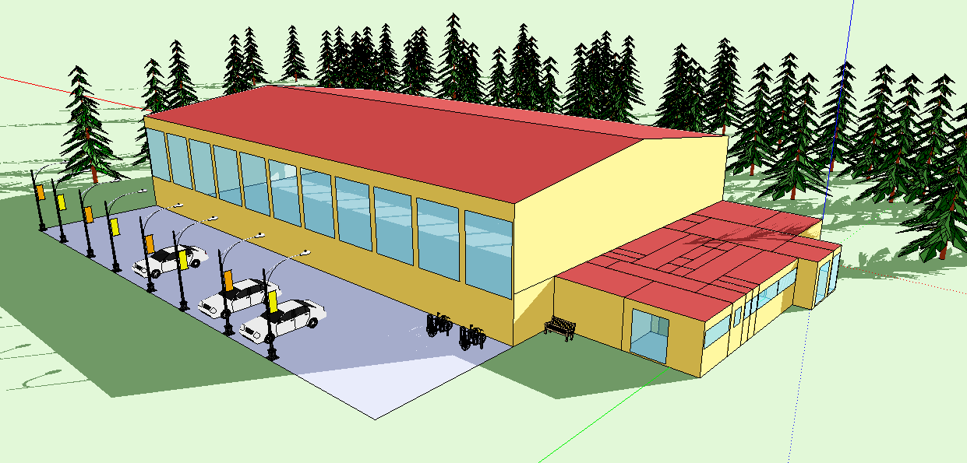
Figure 3. Analyzed sports hall

- Location and climate conditions of the building
Analyzed building is located in Kragujevac, Serbia. Altitude above sea level of Kragujevac city is 209m. The sports hall is located on 44º1N and 20º55E. Climate is moderately continental with different seasons such as summer, autumn, winter and spring. Weather file generated inside Metenorm software was used for EnergyPlus calculations [23]. Heating season in the city of Kragujevac lasts from 15th October to 15th April [24].
Table 1.Climate parameters for Kragujevac, Serbia [25]
Month | Average temperature °C |  | Average falls (mm) | Number of rain days
Month | Daily minimum | Daily maximum | Average falls (mm) | Number of rain days
Jan | -3.8 | 3.8 | 4.1 | 11.6
Feb | -1.7 | 6.7 | 3.87 | 10.4
Mar | 1.4 | 11.8 | 4.44 | 10.6
Apr | 5.5 | 17.3 | 4.94 | 12.2
May | 10.1 | 22.0 | 7.38 | 13.1
Jun | 13.0 | 25.0 | 8.47 | 12.9
Jul | 14.2 | 25.0 | 6.8 | 9.3
Aug | 13.7 | 27.2 | 5.33 | 9.3
Sep | 10.7 | 23.9 | 4.48 | 8.1
Oct | 6.3 | 18.2 | 3.82 | 8.6
Nov | 2.4 | 11.5 | 4.82 | 10.3
Dec | -1.6 | 5.6 | 4.76 | 12.3

- Mathematical model

  - Panel systems description

In case of panel heating, panels are integrated within construction elements - walls. These elements are heated to the temperature higher than the temperature of the surrounding air, so that they transfer heat by convection and radiation.
Wall panels are applied increasingly because limits in floor and ceiling temperatures. They are installed on cold outside walls thus stopping heat transfer through them. Differently from the ceiling panels, floor panels provide the most of heat by radiation, therefore being better for functioning on higher temperatures of fluids, which outcomes with higher heat flux.
The way heat pipes are positioned increases complexity to determine heat transfer. Usually two types of heat pipe layouts are used; spiral and serpentine (figures 1 and 2). In case of the serpentine, heat flux moves across the surface of the pipe, while in case of spiral layout, it is radial.

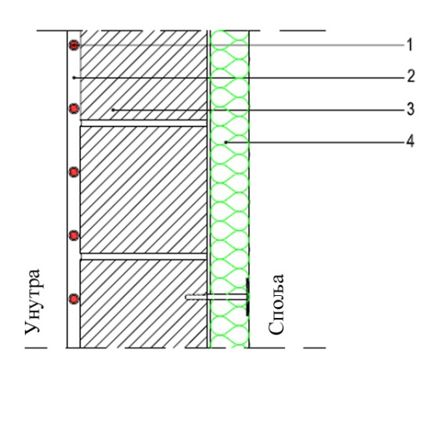 | 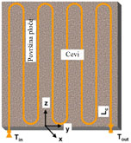
Figure 1.Wall panel  1 – heating pipe, 2 – mortar, 3 – hollow brick, 4 – Styrofoam | Figure 2. Wall panel

  - Amount of spent energy of the heating system
Amount of spent primary energy per heating period of the analyzed building was calculated by using the following formula:
$E_{sys}=E_{ng}+E_{el}∙R$ (1)
$E_{ng}$ is natural gas consumption per heating period, $E_{el}$ is power consumption per heating period to empower heating system and R coefficient of primary energy transformation. This coefficient is defined as relationship between total input energy from different energy sources (hydro energy, coal, oil and natural gas) and final production of electric energy. This value for produced electric energy for Serbia is R = 3.61 [26].

- Results and discussion

This research inquiry simulates heating panel system connected to gas boiler with an aim to heat sports hall. Wall heating was chosen for this purpose. It was placed on the outside surface which contains thermo insulation. Non-condensation boiler was used to generate heat based on natural gas with continuous flow circulation pump.
Low temperature panel systems are not convenient to be used in big inside spaces. Because of that, impact of input temperature on panels was considered, with an aim to adjust certain temperature inside the heated space. Panel inlet temperatures are changed from 40 to 90°C. Wall panels that work with input temperatures until 50°C can be considered low temperature panels, while wall panels with inlet temperatures of 60 and more degrees can be considered high temperature panels.

  - Results

Results of the simulation for every of the analyzed cases were first shown through energy consumption of fluids.

Energy consumption that involves consumption of natural gas and electric energy to keep the pump working was shown on figure 4. First case resembles wall panel with inlet temperature of 40°C and, as such, it represents classical low temperature wall panel. Its consumption of final energy is around 244.8 kWh/m2a. Heating system consumption with inlet temperature of 50°C is 7.6% higher and it is around 263.4 kWh/m2a. Heating system consumption with inlet temperature of 60°C is around 9.7% higher than in the case when inlet temperature is 40°C and it is around 268.5 kWh/m2a.
Heating system with inlet temperature of 70°C consumes more than 11% than if the inlet temperature is 40°C and it is around 271.6 kWh/m2a. If the panel inlet temperature is 80°C then the consumption is around 12.6% higher than the case when inlet temperature is 40°C which in that case is 275.7 kWh/m2a. Consumption of the heating system in case of inlet temperature of 90°C is around 14.1% higher than the case in which the inlet temperature is 40°C and it accounts to around 279.2 kWh/m2a.

Figure 4.Final energy consumption for heating with different inlet temperatures to wall panel

Mean air temperature, Mean radiant temperature, Operative temperature in heated spaces and Design temperature are shown on figure 5. Operative temperature was regulated with thermostat and its value was 18°C. It can be noticed that goal value is reached only for panels working with inlet temperature of 60°C and higher. On the other hand, mean air temperature was too low for cases in which inlet temperatures are 40°C or 50°C. Mean radiant temperature was below given values only in case when inlet temperature was 40°C.

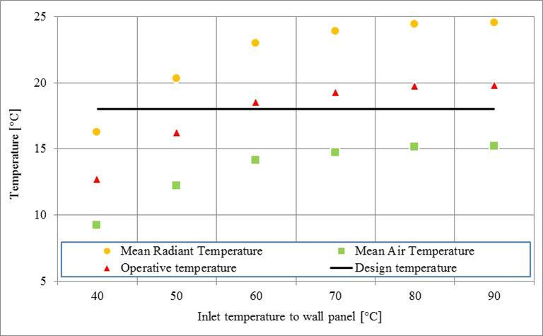
Figure 5. Temperature inside sports hall with different inlet temperatures to wall panel

Mean radiant temperature with different inlet temperatures was shown on figure 6. Heating system was not working in period from 24 to 09h. In this case, temperature had a tendency to drop, depending from the accumulative features of the sports hall and amount of radiated heat during the previous day. Time needed to achieve aimed temperature differs because of different inlet temperatures. For example, in order to achieve 18.3°C, with inlet temperature of 40°, there was 2h late, while for inlet temperatures from 50 to 90°C aimed temperature was achieved very quickly.

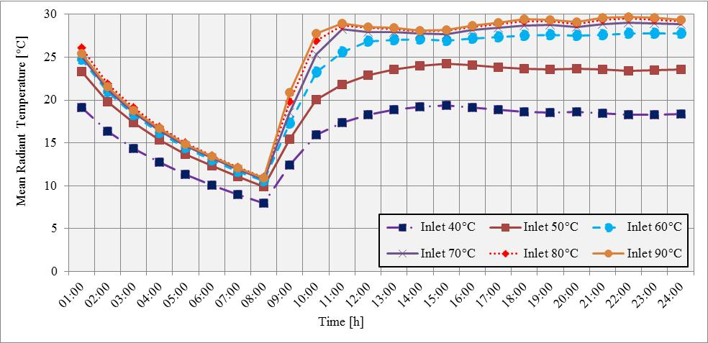
Figure 6. Dependence of mean radiant temperature from the inlet temperature to the wall panel

Mean air temperatures for different values of inlet temperatures to the wall panel are shown on figure 7. There was no heating from 24 to 09h as indicated from the graph. In this period, temperature was dropping as dependent from accumulative feature of the space and amount of radiated heat during the previous day. Time needed to achieve aimed temperature differs depending from the inlet temperature to the wall panel. For example, aimed temperature could not be achieved if inlet temperature is from 40°C to 50°C. For inlet temperatures of 60, 70, 80 and 90°C there is a delay of 4h, 3h, 2h, 2h i 2h, respectively.

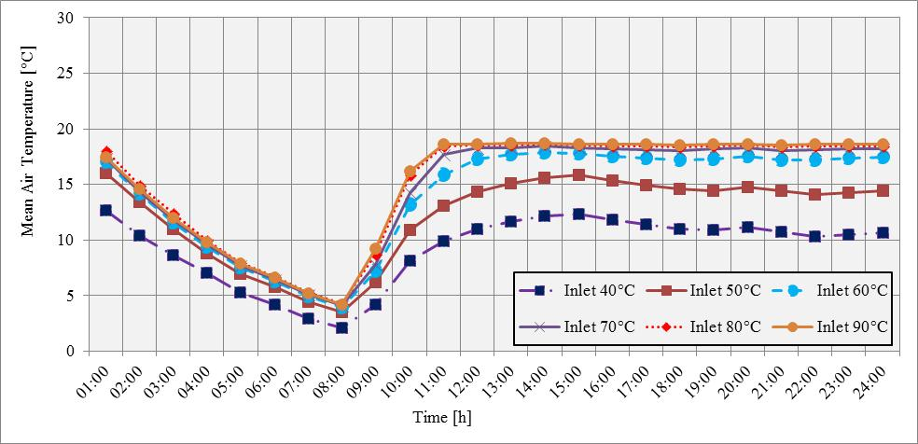
Figure 7.Dependence of mean air temperature from inlet temperature to panel

Values of operative temperature depending from different inlet temperatures to the wall panel are shown on figure 8. As written before, there was no heating in the period from 24 to 09h. Temperature has a tendency to drop in this period depending from accumulative feature of the space and radiated heat during the previous day. Time needed to achieve aimed temperature differs from the inlet temperature to the wall panel. Aimed temperature has not been achieved for inlet temperature of 40°. Aimed temperature was achieved for inlet temperatures of 50, 60, 70, 80 i 90°C with delay of 2h, 1h, 1h, 1h, 1h and 1h, respectively.

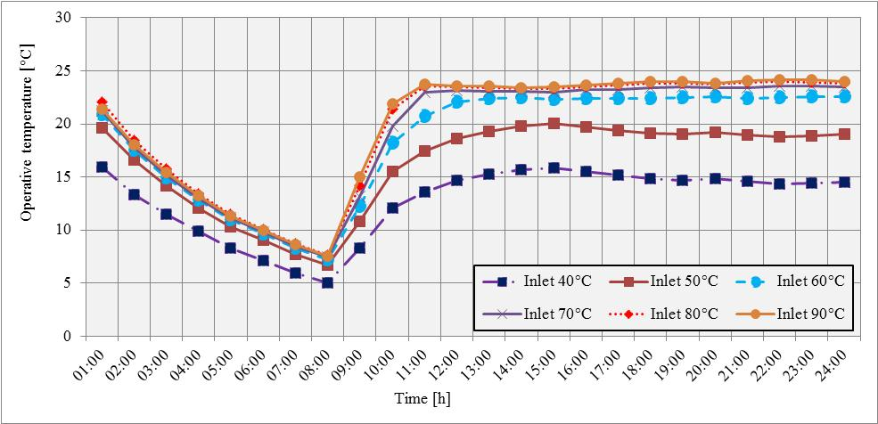
Figure 8. Dependence of operative temperature from inlet temperature to the wall panel

Figure 9 shows dependence of outlet temperature from the panel in relation to given values of inlet temperature to wall panel. It is possible to conclude that more values of inlet temperature have greater variation and less stable workflow. Thus, temperature difference is greatest if inlet temperature is 90°C and it goes to 37°C, while the lowest inlet temperature is from 40°C to 5°C

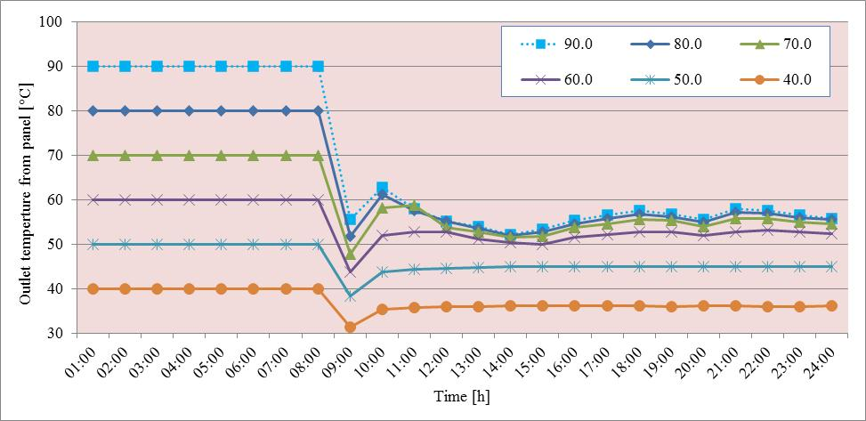
Figure 9. Dependence of outlet temperature from outlet temperature from the wall panel

- Conclusion

This research inquiry analyzes impact of inlet temperatures for the heating systems, with wall panels to the energy consumption and temperature inside heated space. As source of heat, classical non-condensation boiler was used, based on natural gas, connected to circulation pump, with constant flow. Analyzed sports hall is located in Kragujevac city area. Its architecture represents typical way of construction for this kind of buildings in Serbia.
Heating system with inlet temperature of 40°C has lower consumption of energy, while system with inlet temperature of 90°C has highest consumption of energy. Panel systems of heating with inlet temperature cannot achieve aimed values and thus its use is unacceptable for this sports hall. Its use may be acceptable if different architectural concept is in question, with fewer transparent surfaces and better heat insulation. Heating system with inlet temperature of 50°C is not satisfactory in terms of aimed temperatures, but it is near that point. Heating system with inlet temperature of 60°C is the first system that achieves aimed values of temperature. Its energy consumption is around 9.7% higher than if the inlet temperature 60°C.
Also, higher inlet temperature outcomes with greater temperature difference and thus greater exergy unbalance. Low inlet temperatures are of no use for this kind of building because of huge volume of space to heat and bad heat insulation. Its eventual application can be achieved by changing the architecture of the building.

Acknowledgment

This paper is a result of two investigations: (1) project TR33015 of Technological Development of Republic of Serbia, and (2) project III 42006 of Integral and Interdisciplinary investigations of Republic of Serbia. The first project is titled “Investigation and development of Serbian zero-net energy house”, and the second project is titled “Investigation and development of energy and ecological highly effective systems of poly-generation based on renewable energy sources. We would like to thank to the Ministry of Education and Science of Republic of Serbia for their financial support during these investigations.

References

[1] Kilkis BI, Sager SS, Uludag M. A simpliIed model for radiant heating and cooling panels. Simulation Practice and Theory 1994;2:61–76;
[2]Lisa LM. Radiant heating provides energy-e-cientversatility.Professional builder and remodeler. 1992.
[3] Stetiu C. Energy and peak power potential of radiant cooling systems in US commercial buildings. Energy and Buildings 1999;30: 127–38.
[4] Yost PA, Barbour CE, Watson R. An evaluation of thermal comfort and energy consumption for a surface mounted ceiling radiant panel heating system. ASHRAE Transactions 1995;101(1):1221–35.
[5] Simmonds P. Practical applications of radiant heating and cooling to maintain comfort conditions. ASHRAE Transactions 1996;102(1):659–65.
[6] Simmonds P. Control strategies for combined heating and cooling radiant systems. ASHRAE Transactions 1994;100(1):1031–9.
[7] Olesen BW. Comparative experimental study of performance of radiant floor heating systems and a wall panel heating system under dynamic conditions. ASHRAE Transactions 1994;100(1): 1011–23.
[8] Gibbs DR. Control of multi-zone hydronic radiant floor heating systems. ASHRAE Transactions 1993;99(1):1003–10.
[9] Leigh SB, MacCluer CR. A comparative study of proportional flux-modulation and various types of temperature-modulation approaches for radiant floor heating system control. ASHRAE Transactions 1994;100(1):1040–52.
[10] MacCluer CR. The response radiant heating systems controlled by outdoor reset with feedback. ASHRAE Transactions 1991;97(2): 795–9.
[11] Kollmar A, Liese W. Die strahlungsheizung, 4th ed. Munchen: R. Oldenbourg; 1957.
[12] Leal RLV, Miller PL. An analysis of the transient temperature distribution in pavement heating installations. ASHRAE Transactions 1972;78(2):71–8.
[13] Zhang Z, Pate MB.A numerical study of heat transfer in a hydronic radiant ceiling panel. In: Chen JLS, Vafai K, editors. Numerical methods in heat transfer, vol. 62. New York: ASME-HTD: 1986.
[14] Zhang Z, Pate MB.A semi-analytical formulation of heat transfer from structures with embedded tubes. In: Kuehn TH, editor. Heat transfer in buildings and structures, vol. 78. New York: ASME-HTD: 1987. p. 17–25.
[15] Kilkis BI, Eltez M, Sager S. A simpliIed model for the design of radiant in-slab heating panels. ASHRAE Transactions 1995;99(2):210–6.
[16] Kilkis BI, Sapci M. Computer-aided design of radiant sub-floor heating systems. ASHRAE Transactions 1995;99(2):1214–20.
[17] Kilkis BI, Coley M. Development of a complete software for hydronicfloor heating of buildings. ASHRAE Transactions 1995;99(2):1201–13.
[18] Maloney DM, Pederson CO, Witte MJ. Development of a radiant heating system model for BLAST. ASHRAE Transactions 1988;94(1):1795–808.
[19] Strand RK, Pederson CO. Implementation of a radiant heating and cooling model into an integrated building energy analysis program. ASHRAE Transactions 1997;103(1):949–58.
[20] Strand RK, Pederson CO. Modeling radiant systems in an integrated heat balance based energy simulation program. ASHRAE Transactions 2002;108(2):1–9.
[21] Miriel J, Fermanel F, Mare T. Modeling of water ceiling radiant panel heating and cooling system—interaction between air velocity and temperature fields. Computational technologies for fluid/thermal/structural/chemical systems with industrial applications. ASME;vol.1.1999. p. 285–91.
[22] AbdelazizLaouadi. Development of a radiant heating and cooling model for buildingenergy simulation software Building and Environment 39 (2004) 421 – 431
[23] Meteonorm,Global Meteorological Database for Engineers, Planners and Education:http://www.meteonorm.com, Retrieved May 2011
[24]M.Bogner, M. (2002). Technical regulations about heating, cooling and air conditioning (in Serbian). Belgrade: SMEITS.
[25] World Meteorogical Organization: http://worldweather.wmo.int/101/c00198.htm Retrieved May 5, 2011,
[26]http://www.ssllink.com/mre/cms/mestoZaUploadFajlove/ENERGETSKI_BILANS_PLAN_ZA_2008,Retrieved May 5, 2011.
[27] M. Virtanen, M. Ala-Juusela, Increased energy efficiency and improved comfort, Paper No. 1494, 9th REHVA World Congress- Clima 2007, 10–14 June, Helsinki, Finland.
[28] M. Ala-Juusela, Heating and Cooling with Focus on Increased Energy Efficiency and Improved Comfort, Guidebook to IEA ECBCS, Annex 37, Low Exergy Systems for Heating and Cooling of Buildings, VTT Technical Research Centre of Finland, 2003
[29] Interklima: http://www.interklima.rs/03_01cena_pg.html, Retrieved May 5, 2011
[30] Interklima: http://www.interklima.rs/01_14nacin_obracuna.html, Retrieved May 5, 2011

