EXPLORATION OF UNDERGROUND STRUCTURES WITH GEOPHYSICAL - SEISMIC METHODS

Blagica Doneva¹, Todor Delipetrov¹, Marjan Delipetrev¹, Krsto Blazev¹, Gorgi Dimov¹

University of Goce Delchev, Faculty of natural and technical sciences – Stip, Republic of Macedonia

Summary
Seismic explorations are based on registration of seismic refraction and reflection of the elastic waves. In the processed geophysical data, obtained during the investigations of the archaeological site "Skupi", seismic explorations were conducted in combination of refraction and reflection. But, this paper presents the results only from refraction method.
During the research, the application of seismic methods is performed using measurement technique slalom by placing more geophones along the investigated area.
Slalom technique is based on registration of the generated elastic waves which spread through the researched area in the setted geophones. Using the moment of registration of elastic waves in a geophone, by adjusting the time it can be assumed as a source of new elastic wave, which with further registration modeling the characteristics of the investigated terrain where it is placed. Through this technique with one generation of elastic waves are produced seismic models for each geophone, and for each subsequent decreases the depth of examination, because it cuts the measuring length of recording of the elastic waves.

Key words: refraction, underground structures, archaeological site

1. Introduction

The subject of research in the paper is the fence wall the archaeological locality "Skupi". According to the existing data, the wall has a pentagonal shape with a total length of about 3000 m. It is built of stone with basement width of 3 m and height of 4 to 7 m. The aim of the investigations is indication of the shifting of the real spatial position of the wall from initial spatial position and planning uncovering the fence wall and entire archaeological site [1].
Coverage and relatively large length for the detection of the wall by direct digging, justifies the preliminary application of geophysical investigations to locate the wall.
The geophysical approach is based on the initial geomagnetic prospecting of the investigative space, the results of which are standards for investigative geophysical explorations. Combined seismic and geoelectric investigations have been adopted as investigative methods by which, through a complex interpretation of the registered anomalies, potential excavation sites are determined in order to determine the position of the archaeological site.
Seismic tests are carried out through two seismic methods: standard profile refractive researches and reflective seismic studies combined with detailed refraction investigations (only forwards).

2. Refraction seismic method

The refractive seismic method studies the propagation of the elastic waves that refract at the boundary surfaces. [2] The refractive method is performed by placing the geophones from the source of the elastic waves along the measured profile line at a certain distance. Geophones through cables are connected to the seismic apparatus. In the moment when the seismic waves encounter a boundary surface that separates two different elastic environments, they refracted and as such the feedback signals are registered. On the surface of the ground, the installed geophones turn mechanical oscillations into electrical impulses that are transmitted to the seismic apparatus. The seismographs register the time of arrival of the elastic wave as well as the moment of excitation of the ground. Based on seismographs, diagrams are constructed that determine the dependence between the distance of the geophon from the point of excitation and the time of arrival of the seismic oscillations to each geophon. Such diagrams are called hodochrons.

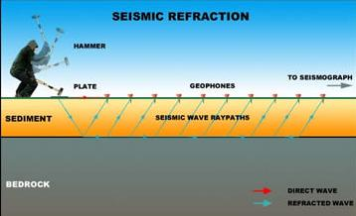
Figure 1. Seismic refraction method

With the refractive seismic method, horizontal, vertical and steep boundary surfaces are successfully determined, but with the condition that in each deeper layer the propagation velocity of the elastic waves is greater than the speed in the previous.

3. Geological composition of the exploration terrain

From the previous geological researches performed on the investigative area, the image of the basic geological structure of the same is generalized. Figure 2 presents the basic geological structure of the investigative space with the represented lithological members. [3]

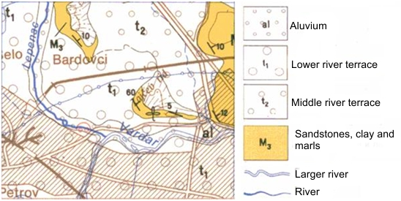

Figure 2. Geological map of the investigated area

Sandstones, clays and marls (M₃). Upper Miocene sediments lye above the basal conglomerates and have large spreading in the northern edge of Skopska valley. Also, determined are along the valley of Lepenec. They are composed of sandstones, clays and marls, and, also, present are marly clays and clayey marls. Marls, marly clays and marly sandstones are directly above the Cretaceous sediments.
Marl series occur in the lower parts of the Miocene basin. Due to its uniform composition shows long time unchanged sinking medium and continuity of the basin. Upper parts which are composed of coarse granular sediments pointed to rapid changes, stagnation of the basin level and filling of the basin, which is associated with the termination of the sinking of the basin and calming of the tectonic processes. This is supported by the fact that immediately over the terrigenous sediments lies a thick complex of Pliocene layers of coarse composition (poorly bound gravels and sands).
Middle river terraces (t₂) are determined on 20 to 30 meters of the alluvium on the rivers Vardar and Lepenec. констатирани се на околу 20 – 30 метри од алувионот на Вардар и лепенец. Slightly inclined towards the riverbeds. Along the valley of the river Lepenec, similar terraces were developed at 30 - 40 meters from the modern aluvion on both sides of the river near Kacanik.
Lower river terraces (t₁) are found along the river Vardar, and along the valley of the river Lepenec on height of 10 – 20 meters from the modern alluvium. Lower terraces occupy very large area around the mouth of Lepenc in Vardar and upstream to the entrance to the Kachanicka gorge. In the valley of Lepenec, these terraces are found upstream from Kachanik, in the form of interspersed narrow terraced landscapes that, unlike the higher terraces, are horizontally developed around the river beds.
Alluvium (al). The largest areas under the alluvial and recent riverbeds are found around the larger rivers Vardar and Lepenec. They are mostly made of gravel - sand material. Around the river Lepenec and its tributaries this material is coarse granular and composed mainly of rounded blocks whose size ranges up to 2m3. This material is, in fact, redeposited moraine sediments, or fluvial - glacial material where modern river flows on their route eroded and redeposited it.

4. Results from the refraction seismic explorations

On the investigated object were conducted several variants of refractive seismic explorations:
- Standard refractive investigations – with excitation of seismic waves, forward and back
- Detailed refractive investigations parallel to the reflective seismic explorations with excitation of seismic waves only forward – “slalom” technique.
A part of the seismic studies were performed just ahead with the slalom technique as well as the refractive explorations performed with forward - back technique are interpreted individually, and some of the overlapping tests are interpreted through data from both refractive methods. [4]

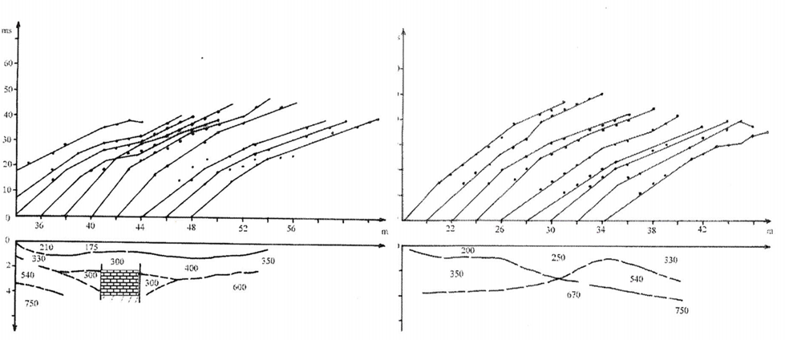
Figure 3. Profile line – 2, Refractive seismic investigations – slalom
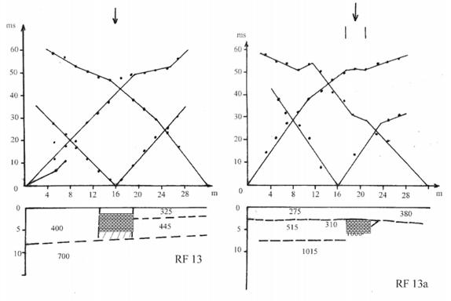
Figure 4. Profile line – 13, Refractive seismic investigations, Forward – Back

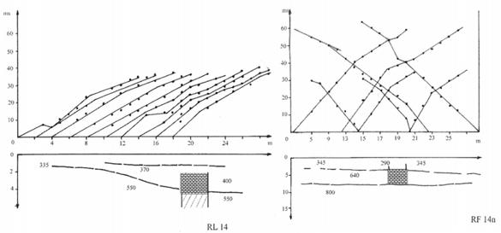
Figure 5. Profile line – 14, Refractive seismic investigations, slalom and Forward – Back

5. Conclusion

In the paper, refractive seismic research has been applied as the main investigative method in defining the fence wall of Skupi archeological site.
The complementary use of seismic researches performed through refractive and reflexive methods in determining the fence wall of the archaeological site "Skupi" was applied on the basis of the various elastic characteristics of the building stone on the wall and the sedimentary material surrounding it. The main disadvantages in the application of these researches is that the subject under study is on a relatively shallow depth (2.5 - 5 m) with a small width (from 1.5 to 2.5 m), which drastically reduces the efficiency of the used methodology.
Geophysical methods give a complete preview of the entire research area and serve to define exploitational drilling in the extremities of the geophysical model. Geological exploration drilling with core mapping gives precise data on rock masses for the place where they are took, but not for the wider area. From this aspect, the combination of geophysical investigations with exploratory drilling at the extremes of the geophysical model is the path for the development of a real geological model.

References

[1] Delipetrov T., (2000) Report – Geophysical explorations on the wall of archeological locality “Skupi”, University of Cyril and Methodius – Skopje, Faculty of mining and geology, Department for geology and geophysics - Stip

[2] Delipetrov T., (2003) Basics of geophysics, Faculty of mining and geology, Stip

[3] Jancevski J., Popvasilev V., (1978) Map and Interpreter for Basic geological map, Sheet Skopje

[4] Manevski V., (2016) Complex interpretation of geophysical methods, Doctoral thesis, Faculty of natural and technical sciences, Stip

