LOGO WILL BE HERE
ANALYSIS OF CARBON FOOTPRINT METHOD-AN REVIEW
Mirjana Laković, Milica Jović, Predrag Živković , Dragana Dimitrijević
Rezime: Kako se ugljen dioksid smatra jednim od najvećih uzročnika pojave efekta staklene bašte, praćenje emisije ovog gasa је od vitalne važnosti za očuvanje životne sredine. U ovom radu, prikazana je analiza gasova koji utiču na pojavu efekta staklene bašte sa posebnim osvrtom na ugljen-dioksid. Otisak ugljen-dioksida je takođe analiziran u ovom radu. Termin otisak ugljen-dioksida se koristi za emisiju gasova staklene bašte i generalno se izražava kao CO₂ ekvivalent (CO₂e), koji se sastoji od emisije CO₂, CH₄ i N₂O. Ovi gasovi se prevode u količinu CO₂ (što se naziva ekvivalentnom količinom CO₂). Za svaki sektor, moguće je izračunati određeni iznos otiska ugljen-dioksida. Od svih sektora, sektor energetike ima najveću vrednost otiska ugljen-dioksida, pre svega zbog sagorevanja fosilnih goriva u termoelektranama.
Ključne reči: ugljen-dioksid, otisak ugljen-dioksida, globalnog zagrevanja, ekološki otisak

Summary: As the carbon dioxide is considered one of the major causes of the greenhouse effect, tracking emissions of this gas is of vital importance to the preservation of the environment. In this paper, an analysis of gasses that affect on global warming, with special emphasis on carbon dioxide emissions, is presented. Carbon footprint is also analyzed in this paper. The term carbon footprint is used for greenhouse gas emissions and is generally expressed as CO₂ equivalents (CO₂e), which consists of emissions of CO₂, CH₄ and N₂O. These gasses are translated into the amount of CO₂ (this is called the equivalent amount of CO₂). For each sector, it is possible to calculate a specific amount of carbon footprint. Of all sectors, the energy sector has the highest value of the carbon footprint, primarily due to the combustion of fossil fuels in power plants.
Keywords: carbon footprint, carbon dioxide, global warming, greenhouse gasses
INTRODUCTION

The term environment means the entire system of natural and anthropogenic objects and appearance in which people work, live and relax. Negative impacts on the environment have led to the appearance of climate change. Climate change has become one of the most popular topics among scientists who study this field and engineers around the world. A recent report of the Intergovernmental Panel on Climate Change (IPPC) [1] predicts, according to the worst-case scenario, an increase in the average air temperature ranging from 1.1 to 6.4 °C in this century which has the potential to cause irreversible impact on ecosystems, biodiversity, water supply, food and energy industries, economic development and global stability. All Europe, excluding Scandinavia and parts of northern Germany, Belgium, Scotland and Northern Polish, will record a significant decline in the annual flow of water to 2050 [2]. This will have the most impact on the Danube that flows through Serbia and Bulgaria, on the river Seine in France and several rivers on the Iberian Peninsula.
The tendency of increasing emissions of greenhouse gasses leads to the long-term goal of establishing control of environmental impacts caused by climate change. It is believed that the most consequence on global warming has emissions of SO₂, NOx, CO₂, particulate matter and other pollutants originating from thermal power plants (using lignite or other not-quality coal) and from industrial plants. Carbon dioxide (CO₂) is considered to participate with about 50 - 55% of global warming. The main reason for the increased concentration of this gas in the atmosphere is increasing use of fossil fuels (coal, oil, gas) and cutting of forests. Figure 1 shows the production of CO₂ by sectors.
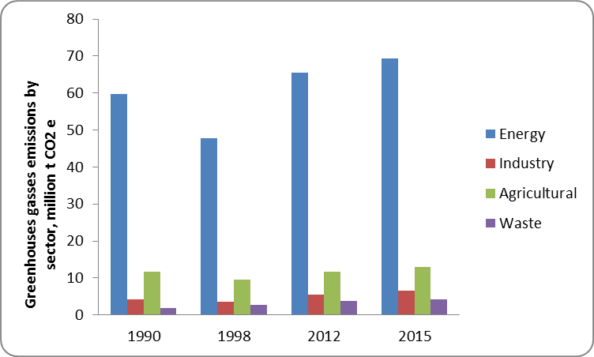
Figure 1. Greenhouses gasses emissions by sector[3]

The energy sector is before other sectors at Figure 1. The reason is primarily that the energy is still largely dependent on fossil fuels. Using or burning fossil fuels leads to high emissions. This shows us that we need to strive for the implementation of renewable energy sources. When it comes to thermal power plants, which are one of the main representatives of the energy sector should be tackled their modernization and problems relating to gas purification. Thermal power plants are the biggest polluters of the environment that surround us. This diagram indicates to us that the years of emissions is constantly growing, both in the energy sector and in other sectors. Therefore, in parallel with the energy sector should be taken into account and the other sectors. People must respect the rules, respect the environment and as soon as possible people must start with the reduction of carbon dioxide and other harmful gasses and not only that, their emissions is growing. One methodology that indicates the amount of carbon dioxide and other harmful gasses in the atmosphere is concepts Carbon footprint.
It is necessary to strive to reduce CO₂ emissions from all sectors but with special emphasis on the reduction of CO₂ emissions from the power plant sector. Approximate values of CO₂ emissions along with few major greenhouse gasses are referred as Carbon Footprint. Carbon Footprint is a concept which is yet in developing stage. Carbon footprint as an indicator of the environment is used. Carbon footprint quantifies the main sources of emissions and represents an effective tool for environmental protection and energy management.
CARBON FOOTPRINT
The carbon footprint has become a widely used concept in carbon dioxide emissions assessments. It is a measure of the total amount of carbon dioxide in the atmosphere in a given time frame which is directly or indirectly transmitted. Carbon footprint helps us to determine the amount of emissions from various sectors, which is useful for quantifying the impact of human activities on the environment and global warming. In the postindustrial era, the concentration of carbon dioxide in the atmosphere is increasing alarmingly.
Carbon Footprint concept stems from the concept of the ecological footprint, which started Wackernagel and Rees 1996 [4]. However, with the increase in global warming, this concept has evolved into an independent concept with extended terms. The term carbon footprint is used for greenhouse gas emissions and is generally expressed as CO₂ equivalents (CO₂e), which consists of emissions of CO₂, CH₄ and N₂O. These gasses are translated into the amount of CO₂ (this is called the equivalent amount of CO₂). Carbon footprint has the potential to reduce the impact on climate change through increased consumer awareness and stimulate discussion about the impact on the environment. This concept offers useful information for environmental protection and awareness of citizens when managing the local government.
Calculating carbon footprint
Carbon footprint uses the concept of ‘scope’ in an attempt to delineate between different types of carbon emission sources and to aid accounting and reporting. The terms scope 1, scope 2 and scope 3 have become widely accepted and utilized in a number programs and standards [5].
- Scope 1 is for direct greenhouse gasses emissions (GHG) occur from sources that are owned or controlled by the company, for example, emissions from combustion in owned or controlled boilers, furnaces, vehicles, etc.; emissions from chemical production in owned or controlled process equipment. Direct CO₂ emissions from the combustion of biomass shall not be included in scope 1 but reported separately.
- Scope 2 accounts for GHG emissions from the generation of purchased electricity consumed by the company. Scope 2 is electricity indirect GHG emissions
- Scope 3 is an optional reporting category that allows for the treatment of all other indirect emissions.

Direct stationary combustion emissions (CO₂, CH₄, and N₂O) are calculated using the emission factors. The equation for product carbon footprint calculation is the sum of all materials, energy and waste across all activities in a product’s life cycle multiplied by their emission factors [6].
CONCLUSION
Annually in the world is emitted into the atmosphere large amount of CO₂ and because of that CO₂ is the biggest problem when speaking about environment protection. Mostly CO₂ is emitted from power plant operation, from traffic and households. In this paper, special attention was paid to the definition of the carbon footprint. Using carbon footprint it can be determined and define which are the major emitters of GHG, and in which areas it is necessary to apply new technologies for reducing these emissions. Carbon footprint is developed from the ecological footprint and represents a model for the analysis of air quality in the environment that surrounds us.Both within the energy sector and in the context of the economic criteria, it should be noted that the ecology and environmental consequences of different actions and technologies has an important economic category that has to rehabilitated the consequences, as well as to invest in technologies that do not have harm influence on the environment.
REFERENCES
- Stefanović, P. Lj., et al. “Evaluation of Kolubara Lignite Carbon Emission Characteristics”, Thermal Science, Year 2012, Vol. 16, No. 3, pp. 805-816
- Lakovic et al.“ Coal-fired power plants energy efficiency and climate change-current state and future trends”, Facta Universitatis, Series: Working and Living Environmental Protection, Vol. 12, No 2, 2015, pp 217-227
- Environmental Performance reviews Serbia Third review, United Nations Economic Commission For Europe, Chapter 6, New York and Geneva, 2015
- Wackernagel M, Rees WE., „ Our ecological footprint: Reducing human impact on Earth“, New Society Publishers, Gabriola Island, BC, 1996
- Lucian-Ionel, Cioca, Maria-Viorela, Codoi, The Impact Of Carbon Footprinting In Romania, The 6th Balkan Region Conference on Engineering and Business Education, Sibiu, Romania, October, 18 – 21, 2012
- D. Boksai, É. Erdélyi, “Carbon footprint focused on organic products”, Eman- Eu Conference accounting for climate change – what and how to measure, proceedings, pp. 80-87, 2011

PhD, Mirjana Laković, Niš, Serbia, University of Niš, Faculty of Mechanical Engineering, (lmirjana@masfak.ni.ac.rs)
MSc, Milica Jović, Niš, Serbia, University of Niš, Faculty of Mechanical Engineering, (milica.jovic@masfak.ni.ac.rs)
PhD, Predrag Živković, Niš, Serbia, University of Niš, Faculty of Mechanical Engineering, (pzivkovic@masfak.ni.ac.rs)
MSc, Dragana Dimitrijević, Niš, Serbia, University of Niš, Faculty of Mechanical Engineering, (dragana.dimitrijevic@masfak.ni.ac.rs)

