TYPES OF SILICA RAW MATERIALS ON THE TERRITORY OF THE REPUBLIC OF MACEDONIA

Krsto Blazev¹, Blagica Doneva¹, Gorgi Dimov1, Marjan Delipetrev¹, Todor Delipetrov¹

University of Goce Delchev, Faculty of natural and technical sciences – Stip, Republic of Macedonia

Summary
The Republic of Macedonia, in which structure participate different lithological complexes and various formations of different ages, in terms of minerageny, is rich with different genetic types of silica raw materials. Quartz, quartzite, quartz sandstones and secondary igneous quartzite are treated as a special group of raw materials due to their specificity, application area and the manner and conditions of their formation and the types of deposits in which they appear.
The quality of silica raw materials depends on presence of harmful matters (feldspars, mica, pyrite, limonite etc.).
Studying of silica resources on the territory of Macedonia suggests a promising development of these raw materials, primarily because of their applications in many industries, such as telecommunications, optics, medicine etc.

Key words: silica raw materials, classification, types

1. Introduction

Evolution of the geological structure on the territory of the Republic of Macedonia allowed formation of different types of silica raw materials. In the literature, there is no single classification of silica raw materials. It can be performed according to: [1]
- Mineralogical – petrographic characteristics
- The conditions of formation (genesis)
- Morphological characteristics and
- Economic significance.

2. Mineralogical – petrographic classification

According to mineral - petrographic characteristics, the following types can be distinguished:
1. Pegmatite quartz - represents well-differentiated concentrations of pure quartz within the pegmatite bodies. They have almost uniform monomernal composition of quartz crystals. Low contents of mica and feldspars are found locally (almost in all deposits in Pelagon). Locally appear pigmentations in the quartz mass with limonite in the small cracks.
2. Wired quartz - monomineral quartz masses deposited from hot or cold aqueous solutions. The presence of secondary minerals in the composition of quartz wires is complex and is in a certain relationship with the chemical and mineralogical composition of the surrounding rocks. Deposits of wire quartz in Macedonia mainly appear in gneiss - mikaschist formations or granite intrusions. In their composition, it is often possible to find smaller contents of plagioclases, potassium feldspars, tourmaline, rutile, sericite, biotite and kaolin (for example, Umlenna, Preseka, Prevedena, Ribnica, Babuna, etc.).
3. Quartzite - Quartzites are metamorphic rocks in which quartz as the main mineral is represented by more than 80% in the entire rock mass, and some deposits represent mono-mineral rocks made only by quartz. As subsidiary ingredients in quartzite there are: mica, pyrite, chlorite, sericite, dysten, graphite, sillimanite, epidote and organic matter. The pure quartzites are white, but from the impurities can be colored gray - greenish, dark or completely black. Quartzites often have a granoblastic structure, but they can sometimes have the structure of quartz sandstones, i.e. blastopsamitic. The texture is massive, but there are also schistose quartzites. The quartz grains in these rocks are usually rolled together and this gives great hardness on the rock masses. The most important deposits are in Western Macedonia, Skopska Crna Gora and the Veles series. [2]
4. Secondary quartzites - Secondary quartzites (a term adopted by the Soviet terminology) also known as silexes are hydrothermal - metasomatic creations formed from acid and medium acid volcanic rocks. [3] They have a quartz-calcedon mineral composition. Unlike other quartzites, they are characterized by an amorphous structure and high hardness. In Macedonia, such deposits are only in Kratovo - Zletovo Volcanic area and they are Crn Vrv, Plavica and Pester (fig. 1).

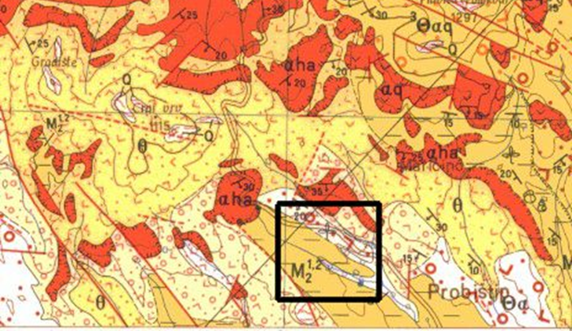
Figure 1. Area of deposits of secondary quartzites [4]

5. Quartz gravel, pebbles and grains - These are actually loosed clastic creations froms of semi-rounded or rounded pieces of monomineral quartz rocks. Depending on their transportation, they can be of different size and degree of curvature. By their composition, apart from quartz, they may contain Calcedone or opal concentrations (for example, deposit Lakvica). Besides quartz, as additional minerals appear mica, feldspar and limonite matter. Deposits of quartz gravles, pebbles and grains are found in several places, almost all over Macedonia (the alluvions of Pchinja, Treska, Babuna, Bregalnica, Kriva Reka, as well as in the Pliocene sediments in Kumanovo, Berovo, Radovish, Veles, Vinica, Kocani, etc.).

3. Genetic types of deposits

According to the conditions of formation (genesis), the following genetic types of deposits can be separated: [5]
- Magmatogenic deposits
- Sedimentogenic deposits
- Metamorphogenic deposits.

1. Within the magmatogenic or primary deposits are separated pegmatitic and hydrothermal.
- Pegmatitic deposits include pegmatiteic - quartz wires and lenses. In these deposits, the zonality is clearly expressed in the layout of individual minerals, so quartz is most often found in the central parts of the pegmatite bodies. Among the pegmatitic deposits can be divided two subgroups of deposits: endocontact and exocontact deposits.
Endocontact deposits are spatially located in granites near contact with surrounding rocks. In these deposits, there is often an increase in the content of potassium feldspars (eg, deposits in Mariovo, Berovo, etc.).
Exocontact pegmatite deposits are located outside the granite massifs, ie in their immediate surroundings within the gneiss - micaschist formation (for example, the deposits in Pelagonia and Veles). Unlike endocontacts, these deposits are much less prevalent and of less economic significance.
- Hydrothermal deposits on the territory of Macedonia are found as hydrothermal quartz wires and lenses and hydrothermal - metasomatic quartzites. Hydrothermal quartz wires and lenses are formed in conditions of medium temperatures. Hydrothermal solutions rich in silica components moving through the surrounding rocks repeatedly leached additional silicon and again deposited from the hot solutions in the form of quartz deposits. Spatially, these concentrations were placed along the crack systems forming deposits in the form of wires, lenses or irregular bodies (eg. Preseka, Prevedena, etc.). This group is associated with the appearance of quartz crystals. Such deposits are formed along the cracks in the granite intrusions where the quartz crystals are formed in the central parts of the wires, where the crystals "grow" on the walls of the cracks in the free or in the favorable environments filled with clay material (eg. the phenomena near the villages Budinarci and Mitrashinci).
Hydrothermal – metasomatic quartzites, mentioned as secondary quartzites, genetically are connected to igneous rocks and are product of hydrothermal metasomatosis on volcanic formations.
2. Of sedimentogenic deposits the most present are alluvial deposits and those deposited in Pliocene shallow lake basins.
Alluvial deposits formed in the areas of water currents and their terraces, as well as on the slopes and platforms near the autochthonous deposits of silica raw materials. They occur in the form of pebbles or grains with different granulometric composition, deposited in alluvial - deluvial sediments or fluvial - glacial sediments. Quartz originates from surrounding rocks rich in quartz wires or other silica raw materials.
Especially important are the sedimentary deposits formed in the Pliocene basins, where the quartz masses were deposited from the quartz-rich rocks or overdeposited from the already formed sediments (for example, deposits Oslomej, Lakavica, Slavishko Pole, etc.).

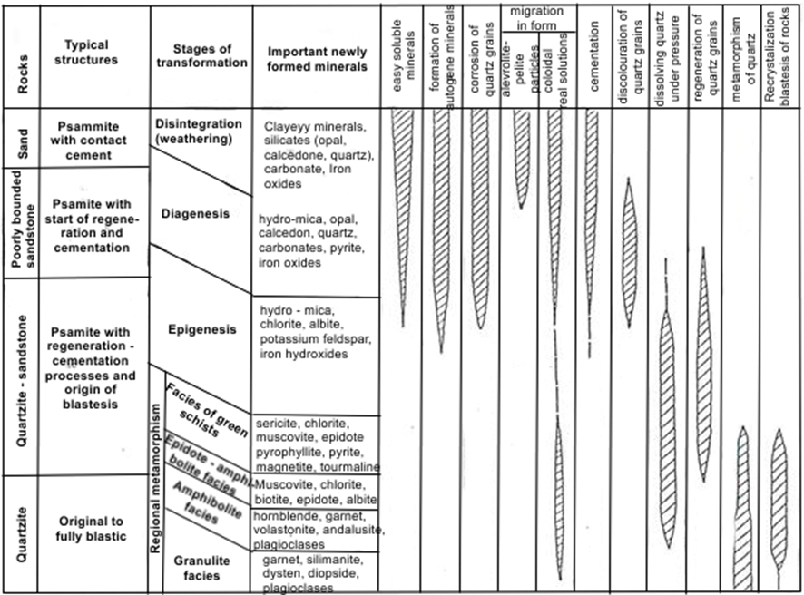
Figure 2. Stages of development of quartz sands and transformation in quartzite
(after K. Blazev, 1991) [1]
3. Metamorphogenic deposits formed with the process of regional metamorphism by transforming the quartz sands and sandstones primarily formed in marine environments during tectonically stable phases (quartzite deposits in Vardar zone and Western - Macedonian mass). Their final genetic physionomy was formed by tectonic-metamorphic processes that made significant changes in the structural-textural features in the primary silica sediments. The base mass is composed of quartz grains that are cemented with silicone matter. In the process of quartz formation, four stages are identified (Figure 2): disintegration and weathering, diagenesis, epigenesis and regional metamorphism.

4. Classification according to the morphology of the ore bodies

According to the morphology of the ore bodies, quartz deposits can be separated in the following types: [1]
1. Wire ore bodies occur in magmatogenic, pegmatitic and hydrothermal deposits in granite intrusions or old Precambrian formations. They are formed along the crack systems. Their powerthickness is from 30 cm to 10 m, and up to 200 m in length.
2. Lensed ore bodies are found in all types of deposits. In magmagenic, pegmatitic and hydrothermal deposits this type is represented by quartz concentrations along cracked systems or disintegrated zones in the form of lenses with dimensions of 50 - 100 m (deposit Umlena). In metamorphogenic deposits quartzites form lensed ore bodies, but with much larger dimensions compared to quartz lenses.
Sedimentary lensed bodies are formed in alluvial deposits where quartz pebbles are concentrated in the form of lenses (eg. Lakavitsa deposit).
3. Layered ore bodies are most commonly formed in sedimentogenic and metamorphogenic deposits. In sedimentary deposits are layers that are rich in quartz grains. Layers can be at different levels of sediment basins and can be shifted in cycles with layers of sand, clay, etc. They have a different thickness ranging from 50 cm to 5 m, and can be tracked from 200 to 300 m in length (characteristic example is the deposit Lakavica near Shtip). In metamorphogenic deposits layered ore bodies form quartzite in the form of elongated stripes and thin layers with a length of several hundred meters.
4. Irregular ore bodies occur exclusively in hydrothermal and pegmatite deposits. They represent quartz concentrations embedded in the fault zones or where they cross with undefined and irregular shapes of different dimensions. They are most commonly present in granite intrusions and gneiss - micaschist formations (eg. hydrothermal deposits Budinarci - Mitrashinci).

4. Classification according to economic significance

In separation of the deposits according to their economic significance should be taken into consideration several elements: the belonging of the deposit to a certain ore bearing formation or genetic group, the contribution of the reserves of the given type of deposit in the total reserves of the raw materials and their quality, mining factors in exploitation and market conditions.
Knowing all upper mentioned deposits of silica raw materials, in Macedonia, according the economic significance, can be classified in several groups:
1. Metamorphogenic deposits of quartzites – these deposits are the most present on the territory of the Republic of Macedonia. They are characterized by a very high degree of research, reserves ranging from several hundred thousand tons to several million tons. They are characterized by medium to extremely high quality and very favorable conditions for massive exploitation.
2. Sedimentogenic deposits of quartz are the most important deposits in Macedonia. The most significant are deposits formed in shallow lake basisns (Oslomej and Lakavica), and, also, alluvial deposits of quartz pebbles which appear all over the country.
3. Magmatogenic deposits within which are distinguished pegmatitic and hydrothermal deposits.
Pegmatitic deposits include pegmatite - quartz wires and lenses that are widespread in the domain of the Serbian - Macedonian massif, the Pelagonia and the Vardar zone. They are characterized by the best quality of the raw material, but are least researched because they are in difficult access areas.
Hydrothermal deposits include hydrothermal quartz wires and lenses and deposits of secondary quartzites. They are characterized by quite high quality, but the deposists of secondary quartzites are quite rare. They are only known in the Kratovo-Zletovo volcanic area (Crni Vrv, Pleshenci and Plavica, Fig.1). They are characterized by variable quality of the raw material, from extremely high to very weak and it is necessary to select them during exploitation. Reserves have a high degree of research from several hundreds to several million tonnes. The exploitation conditions are quite favorable.

5. Conclusion

The Republic of Macedonia is rich with different genetic types of silica raw materials. In the literature, there is no single classification of silica raw materials. It can be performed according to mineralogical – petrographic characteristics, the conditions of formation (genesis), morphological characteristics and economic significance.
According to mineral - petrographic characteristics can be distinguished deposits of: pegmatite quartz, wired quartz, quartzite, secondary quartzites and quartz gravel, pebbles and grains.
According to the conditions of formation (genesis) can be separated: magmatogenic (pegmatitic and hydrothermal) deposits, sedimentogenic and metamorphogenic deposits.
Based on the morphology of the ore bodies, quartz deposits can be separated in: wire ore bodies, lensed ore bodies, layered ore bodies and irregular ore bodies.
According the economic significance, can be separated three groups of deposits: metamorphogenic deposits of quartzites, sedimentogenic deposits of quartz and magmatogenic deposits. The most important deposits in Macedonia are sedimentogenic deposits of quartz formed in shallow lake basins.

References

[1] Blazev K., (1991) Minerageny of silica raw material in Macedonia and their economic importance, Doctoral thesis, Faculty of mining and geology, Stip,

[2] Adjigogov L. (1971) Final report for regional investigation of quartzite in Vardar zone.

[3] Blazev, K. et al. (2009). Mining project for exploitation of Quartzite from the deposit Pester, Probishtip

[4] Paskalev P. (1990) Quartz and quartzite in SRM

[5] Hristov S. et al. (1968 - 1969). Basic geological map of the Republic of Macedonia and Interpreter - sheet Kratovo 1 : 100 000

