LOGO WILL BE HERE
Calculation of LBKz factor for Carbon fiber REINFORCED POLYMER UNDER compression and their comparison with other lightweight materials
Aleksija Đurić, Biljana Marković
Summary: The aim of this paper is to show which material, based on the LBKz factor, is more applicable in lightweight constructions. The LBKz factor has been calculated for three different groups of material (CFRP, hybrid laminates and materials applicable in additive technologies), and the calculation was based on the results obtained from our own experimental testing, as well as from the research results shown in available papers of other authors. The experimental compression testing was performed on the CFRP material.
Key words: Lightweight design, LBKz factor, CFRP, compression
- INTRODUCTION
In the process of new products development, a lightweight design has an important role. Different definitions of the term lightweight design can be found in literature [1-3], but the mass i.e. material construction, has a crucial role in all definitions.
New materials have been developed, which should enhance the possibilities of weight reduction [4]. Various methods for selecting material are also developed due to the difficulties to select proper material with the most potential for application in lightweight constructions from a large group of materials available [5]. The properties of a material will determine the quality and performance of the product; therefore material selection is positioned as crucial phase in product design [6].
One of the methods to determine a material potential for application in lightweight constructions is through the use of a LBKz factor (German-Leichtbaukennzahl) [2,7,8]. Mechanical properties of the material, density, geometry and type of load shall be taken into consideration when calculating a LBKz factor [9]. This paper will show calculation of the LBKz factor for carbon fiber reinforced polymer (CFRP). The LBKz factor shall be calculated based on the data obtained from the experimental compression testing of the said material.
Composite laminates are materials made of two or more different layers in order to achieve larger load capacity, stiffness and lower mass due to which composite laminates are largely applied in lightweight construction. Hybrid composite laminates were manufactured varying ratio of glass-woven fabric and carbon woven fabric in an epoxy matrix. The LBKz factor for various types of hybrid composite laminates, shown in [10] together with the experimental compression test results, shall be calculated in this paper as well.
For the purpose of a fast, cheep and simple manufacture of a complex geometry, a large number of procedures for additive production have been developed and successfully applied in the last thirty years. Nowadays, the three most used polymers in the additive production are: Polylactic Acid – PLA, Acrylonitrile butadiene styrene – ABS, and improved version of ABS+ [11]. Based on the results obtained from the experimental compression testing of the polymers mentioned in [11], the LBKz factor shall be calculated for these materials. Finally, all the LBKz factors shall be compared in order to determine which of the materials has the most potential for application in lightweight constructions.
- EXPERIMENTAL TESTING
2.1 MATERIAL AND METHODS
Fiber reinforced polymer (FRP) composites are attractive for use in a wide range of engineering fields because of their high strength-to-weight and stiffness-to-weight ratios, corrosion resistance, and potentially high durability characteristics [12]. The use of carbon fiber reinforced polymer (CFRP) composites could yield a 40–60% weight reduction [10]. CFRP is a mixture of carbon fiber and matrix material, an epoxy resin being the most commonly used matrix material. For the needs of the experimental testing, CFRP of the following dimensions was used:
- Rod of a circular cross section 𝛷8 and length l=1 [m]
- Rod of a circular cross section 𝛷5 and length l =0,5 [m]
- Tube 𝛷7𝑋4,6 and length l=1 [m]
- Tube 𝛷8𝑋5,8 and length l=1 [m]
Preparation of the test specimen, i.e. cutting the test specimen out of the rod (tube), was performed on the test specimen cutting device in the company “Orao” a.d. Bijeljina. The lenght, i.e. the test specimen height, was determined as per l_{s}=3d, where d is a test specimen diameter, and the test specimen prepared for testing are shown in Figure 1.
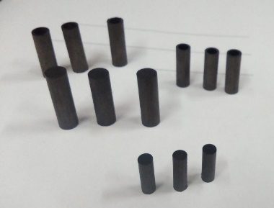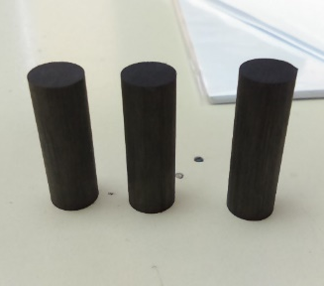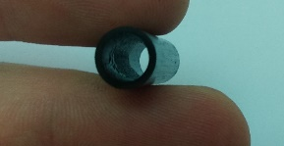
Fig. 1 Test specimen prepared for compression testing
The testing was performed on 12 test specimen, marked as follows:
- Test specimen of a full-circle cross section, marked as: P–test specimen diameter– CFK – test specimen number;
- Test specimen of ring cross section, marked as: P–test specimen outer diameter /inner diameter – CFK – test specimen number.
The material density is not required for compression testing of CFRP, but it is necessary for the LBKz factor calculation. The material density was determined by measuring material weight on an electronic scale (Laboratory of Applied Mechanics and Design of the Faculty for Mechanical Engineering in East Sarajevo). The calculated value of density for CFRP is ρ=1520 kg/m³.
The compression testing was realized on the testing machine with the max applied load 200 kN (Figure 2) in the Laboratory for Material Testing in “Orao” a.d Bijeljina.
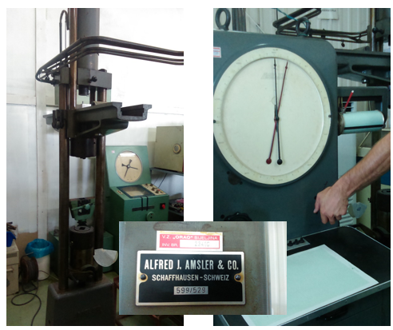
Fig. 2 Testing machine in the Laboratory for Material Testing, “Orao” a.d. Bijeljina
2.1 RESULTS AND DISCUSSION
Traverse speed of the testing machine was manually adjusted based on the operator's experience. All 12 test specimen were tested in the same manner. Upon completion of the testing, dispersion of the test results was determined for two test specimens and the values for those test specimen were not taken into further consideration. The expected crack in case of successful tested specimens is longitudinal, i.e. in direction of a fiber, as shown in Figure 3a, in case of test results dispersion the crack shape is irregular, as shown in Figure 3b.
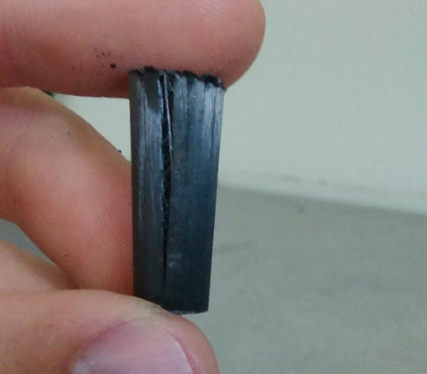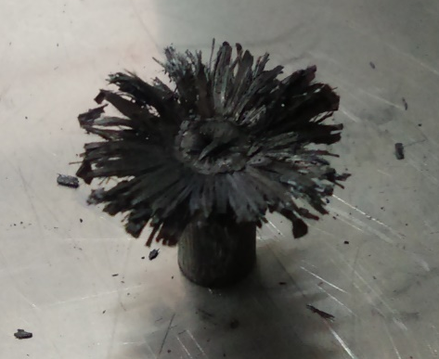
Fig. 3 a) The expected crack in case of successful tested specimens under compression; b) The specimen crack tested under compression in case of test results dispersion
The test results dispersion occurred in case of the testing specimen P-5-CFK-3 and P-8/5,8-CFK-1. A root cause of results dispersion can be found in many factors, such as: uneven cutting surface, defects in material, testing error, which are not the object of this research paper. The accurate value of the maximum force was read on the machine, indicated by the machine needle (Figure 2) and expressed in [daN]. Since a very brittle material is in question, the maximum force value can be considered to be approximately the same as the force value at the yield strenght. The geometry of the test specimen is known, so the yield stress is easily to calculated. The results are shown in Table 1.
Based on the values shown in the table 1, it can be concluded that for the compression testing, yield stress for CFRP is within limits 500-700 [N/mm²]. The mean value from Table 1 shall be used for calculation of the LBKz factor, therefore, the yield stress for CFRP is 616,5 [N/mm²].
Table 1 Values of the calculated yield stress of CFRP for compression testing
No. | The mark of specimen | Maximum force  [daN] | Test specimen cross section area [mm²] | Yield Stress  (R_{eH}≈R_{m}) [N/mm²]
1. | P-5-CFK-1 | 1340 | 19,625 | 669,8293
2. | P-5-CFK-2 | 1350 | 19,625 | 674,828
3. | P-5-CFK-3 | (645) | - | -
4. | P-8-CFK-1 | 2292 | 50,24 | 447,5422
5. | P-8-CFK-2 | 2835 | 50,24 | 553,5699
6. | P-8-CFK-3 | 3015 | 50,24 | 588,7172
7. | P-8/5,8-CFK-1 | (490) | - | -
8. | P-8/5,8-CFK-2 | 1440 | 23,8326 | 592,7343
9. | P-8/5,8-CFK-3 | 1730 | 23,8326 | 712,1044
10. | P-7/4,6-CFK-1 | 1370 | 21,8544 | 614,9654
11. | P-7/4,6-CFK-2 | 1450 | 21,8544 | 650,8758
12. | P-7/4,6-CFK-3 | 1470 | 21,8544 | 659,8534

- CALCULATION AND COMPARISON OF LBKz FACTORS
The LKBz factor in case of tension (compression) does not depend on the cross section area, but on the yield stress, density, gravity and length of the test specimen, i.e. on the part, and it is calculated as per (1) [9]:
(1)
Where:
- yield stress in
- material density in
- gravity ()
- length in

The higher value of the LBKz factor means the material most potential for application in lightweight constructions.
The data needed for calculation of the LBKz factor for hybrid laminate with five different lay-up schemes: [C]₈, [C₂G₂]_{s}, [CG₃]_{s}, [CGCG]_{s} and [G]₈, where C (Sigmatex™ carbon 2/2 ) and G (Colan™ E-glass) denote carbon fiber and glass fiber respectively, shown in [10], are given in Table 2. The same table shows the values of the LBKz factor for the mentioned laminates assuming that the length is =1m, which will be used for the LBKz factor calculation for other materials. It is obvious from the data from table 1 that the laminate [C]₈ has the most potential for application in lightweight constructions compared to other laminates, followed by the laminate [CGCG]_{s}.
Table 2 Calculation of LBKz factor for different hybrid laminates
No. | The Mark | Density [kg/m³] | Yield stress  (R_{eH}≈R_{m}) [N/mm²] | LBKz
1 | [C]₈ | 1237 | 260 | 21425,68
2 | [C₂G₂]_{s} | 1327 | 171 | 13135,79
3 | [CG₃]_{s} | 1460 | 189 | 13195,93
4 | [CGCG]_{s} | 1316 | 217 | 16808,73
5 | [G]₈ | 1508 | 171 | 11559,15

If ABS, ABS plus and PLA polymers are treated in the same manner (compression testing results are given in [11] ),and the density was obtained based on the data from the polymer manufacturer's web page [13], hence, it can be concluded based on the results from table 3 that the PLA polymer has the most potential for application in lightweight constructions compared to the ABS and ABS plus polymers.

Table 3 Calculation of LBKz factor for different polymers aplicable in additive technologies
No. | Designation | Density [kg/m³] | Yield stress  (R_{eH}) [N/mm²] | LBKz
1 | ABS | 1010 | 50,74 | 5121,063
2 | ABS plus | 1100 | 54,76 | 5074,599
3 | PLA | 1250 | 86,54 | 7057,288

Considering the results of the research given in tables 2 and 3, it can be concluded that the laminate [G]₈ from the group of laminates has the least potential for application in LW constructions, but it has the higher value of the LBKz factor in relation to the PLA polymer, meaning that, in general, the laminates have better potential for application in LW constructions than polymers applied in additive technologies.
Based on the results of the experimental testing of CFRP presented in the previous chapter of this paper, the LBKz factor for CFRP can be easily determined. Since the material density is ρ=1520 kg/m³, yield stress R_{eH}=616,5 N/mm², and l=1 m, the calculated LBKz factor for CFRP is LBKz=41344,76. The LBKz factor values for all materials analyzed in this paper are presented in Figure 4.

Fig. 4 Comparison of LBKz factor values for different materials
It can be easily recognized from the diagram shown in Figure 4 that CFRP material has the most potential for application in lightweight constructions. Such result was expected; even though CFRP has a slightly higher density compared to other materials, CFRP has significantly better mechanical properties. It can also be concluded that a lesser material density is not crucial for selection of material for lightweight constructions. The LBKz factor does not consider a material price, which also has an important role in material selection. This factor is used only as a recommendation on which material with better potential for application in LW constructions shall be selected, meaning, a final decision on the best or optimum material for application in lightweight constructions cannot be made only based on the LBKz factor. Specifically, the laminates have greater application in LW constructions than CFRP, mostly due to the price.
- CONCLUSION
Development of new products in global market pressure environment and struggle of worldwide companies to ensure their position on the list of the most successful companies is an important process enabling achievement of world domination, at least for a short period of time. One of important design concepts, as a phase of a product development process, is a lightweight design, which is especially present in automotive and aviation industry. The most important phase of the lightweight construction design is selection of an optimum material, i.e. the most convenient material, and one of the ways to adequately select the material is through the usage of the LBKz factor, which demonstrates potential of the material for application in lightweight constructions. This paper shows the method for calculation of this factor for three different groups of materials used in lightweight constructions. The results used for calculation were obtained from our own experimental research- compression testing of CFRP test specimen, as well as from the research results shown in available papers of other authors. Conclusions which clearly indicate the differences in potentials for application in lightweight constructions were drawn based on the comparison of the given results. Although this factor is a very useful indicator, it is not a crucial factor which fully determines selection of materials used in lightweight constructions. Very important factor is a cost price as well, and material availability on the market, which was not the subject of this paper.

REFERENCES
- Đurić, A., Marković, B., Pelkić, S. (2014). Osnovni principi I pravila primjene lakog dizajna u mašinstvu. II Conference on Mechanical Engineering Technologies and Applications - COMETa 2014 Conference Proceedings, p. 579-588.
- Klein, B. (2009). Leichtbau-Konstruktion, Berechnungsgrundlagen und Gestaltung, Vieweg+Teubner.
- Albers, A., Burkardt, N. (2011). Systemleichtbau – ganzheitliche Gewichtsreduzierung. Henning, F., Moeller, E., Handbuch Leichtbau. Hanser Verlag, p. 115–132.
- Merklein, M., Geiger, M. (2002). New materials and production technologies for innovative lightweight constructions. Journal of Materials Processing Technology, vol. 125-126, p. 532-536.
- Vučetić, N. (2017). Quantitative methods for material selection –material properties chart. ACTA TECHNICA CORVINIENSIS–Bulletin of Engineering, Tome X, Fascicule 1, p. 43-46.
- Sakundarini, N., Taha, Z., Abdul-Rashid, H. S., Ghazila, R. A. R. (2013). Optimal multi-material selection for lightweight design of automotive body assembly incorporating recyclability. Materials and Design, vol. 50, p. 846-857.
- Maier, M., Niehbur, N., Hamm, C., Thoben, D. K. (2015). Eine Konstruktionsmethodik des bionischen Leichtbaus. Lightweight Design, vol. 8, no. 3, p. 34-39.
- Friedrichs, L., Maier, M., Hamm, C. (2012). A new method for exact three-dimensional reconstructions of diatom frustules. Journal of Microscopy, vol. 248, pt 2, p. 208–217.
- Đurić, A., Marković, B., Vučetić, N., Pelkić, S. (2016). Calculation of factors LBKz and its significance for the development of Lightweight construction. Тhird International Conference Mechanical Engineering in XXI century – MASING 2016 Conference Proceedings, p. 153-156.
- Zhang, Y., Lai, X., Zhu, P., Wang, W. (2006). Lightweight design of automobile component using high strength steel based on dent resistance. Materials and Design, vol. 27, p. 64-68.
- Kraišnik, M., Šljivić, M., Anić, J., Ilić, J. (2016). Compressive properties of commonly used polymers in additive manufacturing processes. III Conference on Mechanical Engineering Technologies and Applications - COMETa 2014 Conference Proceedings, p. 285-292.
- Cao, S., Wu, Z., Wang, X. (2009). Tensile Properties of CFRP and Hybrid FRP Composites at Elevated Temperatures. Journal of COMPOSITE MATERIALS, vol. 43, no. 04, p. 315-330.
- MikroPrinc. Plastika za 3D printere, from http://www. mikroprinc.com/proizvodi/ index.php, accessed on 2017-03-04.

M.Sc., Aleksija Đurić, East Sarajevo, Faculty of Mechanical Engineering, University of East Sarajevo, (aleksijadjuric@gmail.com) (CA).
PhD, Associate Professor, Biljana Marković, East Sarajevo, Faculty of Mechanical Engineering, University of East Sarajevo, (biljana46m@gmail.com).

