SOLAR RADIATION ATLAS FOR GRADIŠKA AND VIŠEGRAD (REPUBLIC OF SRPSKA)
M. Preradović
Faculty for Mechanical Engineering, University of Banja Luka

Abstract
This paper presents an atlas of solar radiation for two locations in Republic of Srpska, Gradiška and Višegrad. Data obtained in this work are from Photovoltaic Geographical Information System (PVGIS) database. This paper summaries calculations of global and direct solar radiation falling on the horizontal surface and global solar radiation falling on the optimally placed surface at two named locations; calculated are also global, direct and diffuse irradiances on fixed and dual-axis tracking solar power plants in Gradiška and Višegrad. At the end, calculated are the amounts of produced electricity from PV solar power plants (1 MWp) at both locations and solar power systems are compared with each other and between the two locations. Although there are differences in the calculated values for global and direct solar radiation falling on the horizontal surface and global solar radiation falling on the optimally placed surface and differences in amount of produced electricity by fixed, one-axis and dual-axis tracking PV solar power plants between Gradiška and Višegrad, they are not found statistically significant by application of Mann-Whitney Test.
Key words: solar radiation, solar energy, solar power plants, PVGIS system, PV.

- INTRODUCTION
The amount of solar radiation intake on the Earth’s surface is affected by many factors: geographical latitude, time of the year, part of the day, atmosphere state, cloudiness, surface inclination and orientation, etc. Such data can be decisive when it comes to installing of solar power plants [1]. In this work, calculated are global and direct solar radiation falling on the horizontal surface and global solar radiation falling on the optimally set surface. Besides that, calculated are quantities of energy produced by three different systems (fixed plant, one-axis and dual-axis tracking PV solar power plant) in Gradiška and Višegrad. Both locations are compared with each other in the amounts of produced energy (electricity).

- GOALS, MATERIALS, METHODS AND HYPOTHESES OF THE WORK
Goals of this paper are to present differences:
- in the energy of direct solar radiation falling on the horizontal surface and on the optimally placed surface, the energy of global solar radiation falling on the optimally placed surface in Gradiška and Višegrad;
- in global, direct and diffuse irradiances on fixed and dual-axis tracking PV solar power plants in Gradiška and Višegrad;
- between monthly electricity production by fixed, one-axis and dual-axis tracking PV solar power plants (power of 1 MWp) in Gradiška and Višegrad and
- between monthly produced electricity by fixed and one-axis tracking PV solar power plants, between monthly produced electricity by fixed solar power plant and dual-axis tracking PV solar power plants and between monthly produced electricity by one-axis and dual-axis tracking PV solar power plants.
Data are obtained from PVGIS data base [2], which contains satellite data from four meteorological sources: PVGIS-CMSAF, PVGIS-SARAH, PVGIS-ERA5 and PVGIS-COSMO. In this work, used data are from PVGIS-CMSAF (Satellite Application Facility on Climate Monitoring), which is a part of the European Organisation for the Exploitation of Meteorological Satellites (EUMETSAT) ground segment and of EUMETSAT network of Satellite Application Facilities. The main task of SMSAF is the generation of climate data record – time series of sufficient length, constancy and quality to discover climate variability and changes. Data are available from 2007 to 2016 [3].
Data and results are presented in tables and graphs using analytical-statistical tool SPSS (version 24). Statistically significant differences were obtained by using of Mann-Whitney Test [4,5]. There are four hypotheses on which this work is built:
H₀₁: There is no statistically significant difference in: the energy of direct solar radiation falling on the horizontal surface, the energy of global solar radiation falling on the horizontal surface and the energy of global solar radiation falling on the optimally placed surface in Gradiška and Višegrad.
H₀₂: There is no statistically significant difference in: global irradiance on a fixed solar power plant, direct irradiance on a fixed solar power plant, diffuse irradiance on a fixed solar power plant, global irradiance on a dual-axis tracking PV solar power plant in Gradiška and Višegrad.
H03: There is no statistically significant difference in: monthly electricity production by a fixed solar power plant, one-axis and the dual-axis tracking PV solar power plant.
H₀₄: There is no statistically significant difference between monthly electricity production by: a fixed solar power plant and one-axis tracking PV solar power plant; a fixed solar power plant and dual-axis tracking PV solar power plant and a one-axis and dual-axis tracking PV solar power plant in Gradiška and Višgrad and solar power systems at both locations regarding amount of produced electricity.

3. THE GEOGRAPHICAL POSITION AND BASIC INFORMATION ON GRADIŠKA AND VIŠEGRAD
Gradiška is the city in the north part of Repbulic of Srpska, about 50 km from Banja Luka, capital of the Republic [6], whereas Višegrad [7] is municipality located in the far east of the Republic of Srpska, on the border with Serbia. Geographical locations of Gradiška and Višegrad can be seen in the Figure 1. And, Table 1. contains basic information about selected locations.
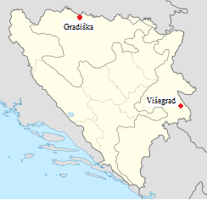
Figure 1. The geographical location of Gradiška and Višegrad

Table 1. Basic information on Gradiška and Višegrad
 | City/Municipality
 | Gradiška | Višegrad
Coordinates | 45.145, 17.254 | 43.784, 19.293
Optimal angle | 33 [2] | 31 [2]
Time zone | UTC | UTC
Elevation (m) | 92 [8] | 324 [9]
Area (km²) | 762 [10] | 448 [9]
Population | 49196 [10] | 10118 [11]
Number of households | 16939 [11] | 3966 [11]

4. RESULTS
This chapter contains the results of the calculations for global radiation falling on the horizontal surface and direct radiation falling on the horizontal surface and surface under the optimal angle in Gradiška and Višegrad (4.1).
4.1 Global and direct solar radiation
Minimum measured value of the energy of direct solar radiation falling on the horizontal surface in Gradiška is 9.71 and 11.91 kWh/m² in Višegrad. Maximum measured value of the energy of direct solar radiation falling on the horizontal surface in Gradiška is 243.79 and 228.81 kWh/m² in Višegrad. Mean measured value of the energy of direct solar radiation falling on the horizontal surface in Gradiška is 105.557 and 93.494 kWh/m² in Višegrad.
Maximum measured value of the energy of global solar radiation falling on the horizontal surface in Gradiška is 215.56 and it is in Višegrad 223.06 kWh/m², while minimum measured energy of global solar radiation falling on the horizontal surface in Gradiška is 26.16 and 18.21 kWh/m² in Višegrad. Mean measured value of the energy of global solar radiation falling on the horizontal surface in Gradiška is 109.227 and in Višegrad 107.874 kWh/m².

Minimum measured energy of direct solar radiation falling on an optimally placed surface in Gradiška is 22.31 and it is in Višegrad 30.88 kWh/m², and maximum measured value of the energy of direct solar radiation falling on an optimally placed in Gradiška is 225.82 and it is in Višegrad 220.75 kWh/m². Mean measured value of the energy of direct solar radiation falling on a surface set at an optimal angle in Gradiška is 123.363 and in Višegrad it is 119.371 kWh/m² (Table 2).

Table. 2: The energy of direct solar radiation falling on the horizontal surface, the energy of global solar radiation falling on the horizontal surface and the energy of global solar radiation falling on a surface set an optimal angle in Gradiška and Višegrad
Location | Radiation | N | Minimum | Maximum | Median | Mean | Std. Dev.
Višegrad | direct | 120 | 11.91 | 228.81 | 83.1750 | 93.4936 | 58.24563
Višegrad | horizontal | 120 | 26.16 | 223.06 | 99.6900 | 107.8743 | 59.87384
Višegrad | optimal | 120 | 30.88 | 220.75 | 117.4900 | 119.3705 | 55.87436
Gradiška | direct | 120 | 9.71 | 243.79 | 97.5750 | 105.5574 | 62.39502
Gradiška | horizontal | 120 | 18.21 | 215.56 | 102.8000 | 109.2270 | 63.29428
Gradiška | optimal | 120 | 22.31 | 225.82 | 129.3650 | 123.3627 | 58.29240

Following illustrations (Figure 2,3 and 4) show the energy of global solar radiation falling on the horizontal surface in Gradiška and Višegrad – Figure 2, the energy of direct solar radiation falling on the horizontal surface in Gradiška and Višegrad – Figure 3. and the energy of global solar radiation falling on a surface set at the optimal angle in Gradiška and Višegrad – Figure 4. All the graphs illustrate values for measured period of time (2007-2016).
There is no statistically significant difference in the energy of global solar radiation falling on the horizontal surface (z = -1.545, p = .122) in Gradiška and Višegrad. There is also no statistically significant difference in energy of direct solar radiation on horizontal surface (z = -.073, p = .942) as well as in the energy of global solar radiation falling on the on the surface under the optimal angle (z = -.589, p = .556) at two named locations.

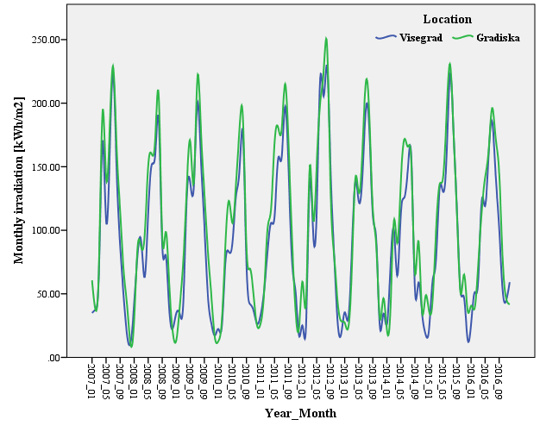
Figure 2. The energy of global solar radiation falling on the horizontal surface
in Gradiška and Višegrad

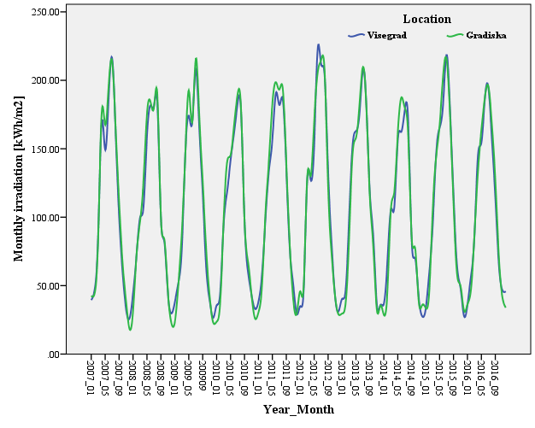
Figure 3. The energy of direct solar radiation falling on the horizontal surface
in Gradiška and Višegrad

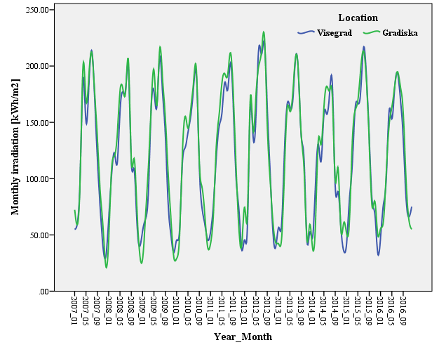
Figure 4. The energy of global solar radiation falling on a surface set at an optimal angle in Gradiška and Višegrad

4.2 Global, direct and diffuse solar radiation
In this part of work, global, direct and diffuse solar radiation in regard to fixed plane and dual-axis tracking solar plant are shown. Figure 5. is related to calculations for Gradiška, while Figure 6. presents results for Višegrad.
- Gradiška
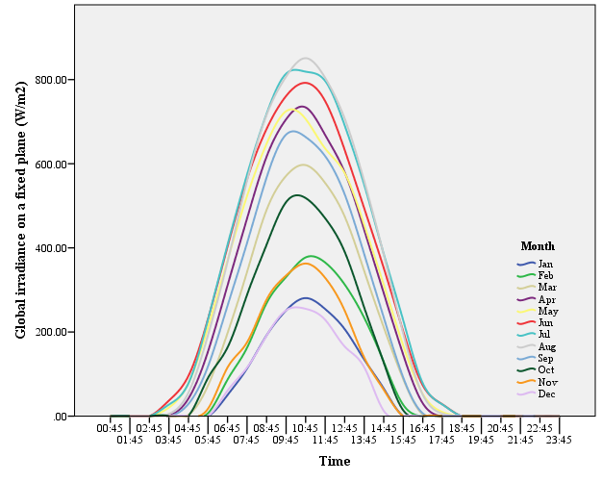 | 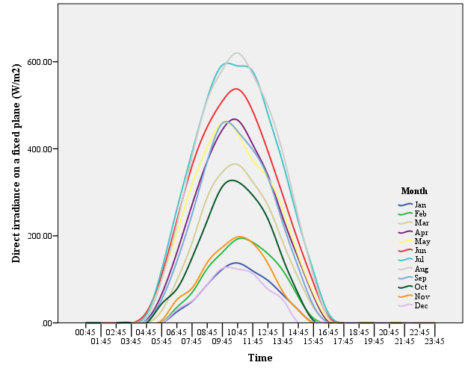
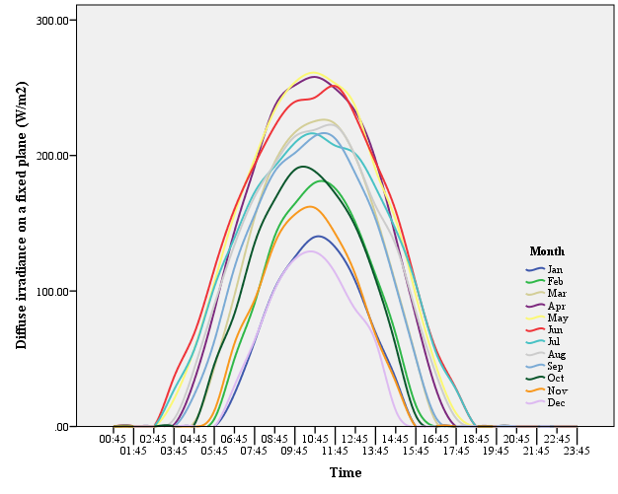 | 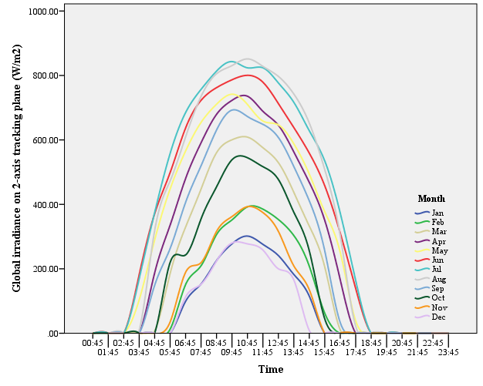
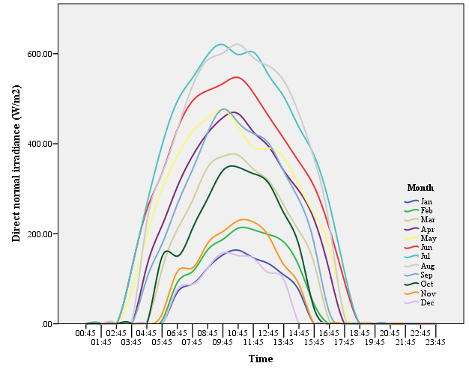 | 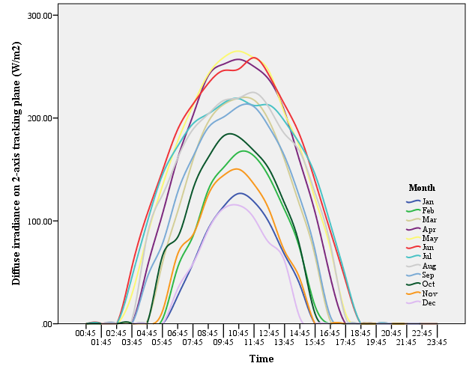
Figure 5: Global, direct and diffuse irradiation on a fixed and dual-axis tracking plane (W/m²) in Gradiška

- Višegrad
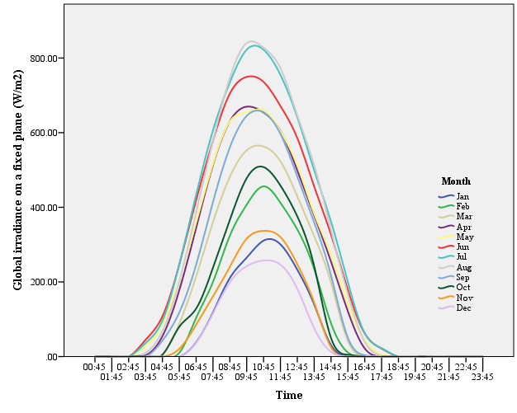 | 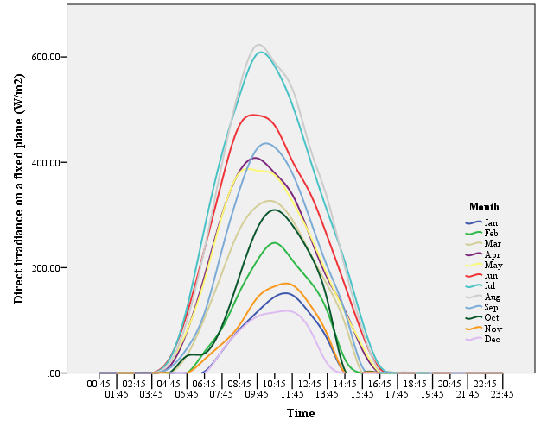
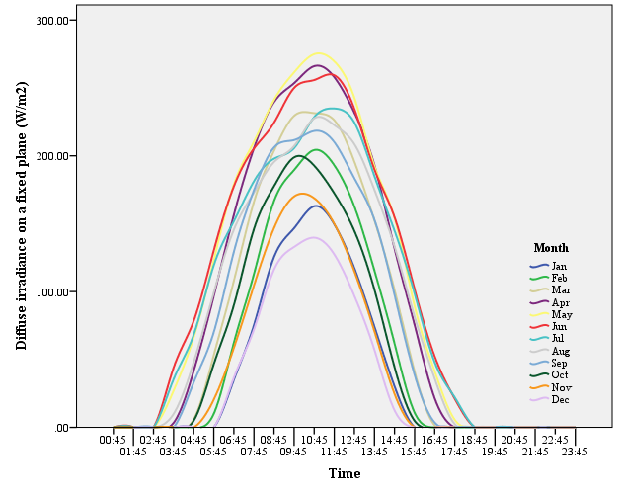 | 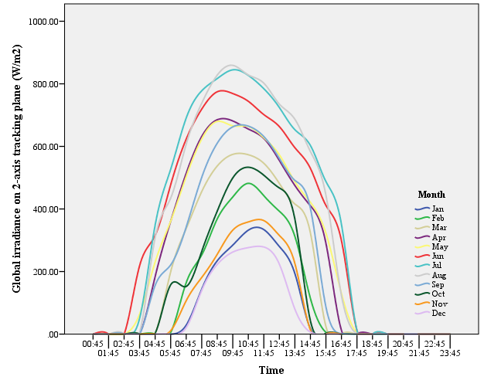
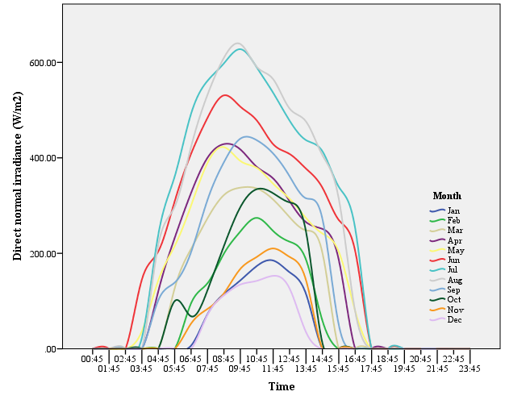 | 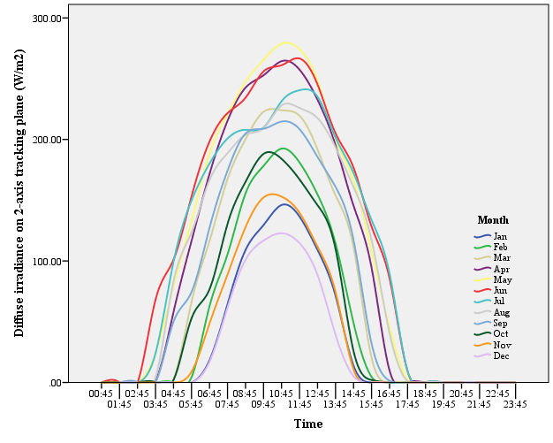
Figure 6: Global, direct and diffuse irradiation on a fixed and dual-axis tracking plane (W/m²) in Višegrad

No statistically significant differences were obtained by application of Mann-Whitney Test, in global irradiance (W/m²) (z = -.136, p = .892), in direct irradiance on a fixed plane (W/m²) (z = -.872, p = .383), in diffuse irradiance on a fixed plane (W/m²) (z = -.262, p = .793), in global irradiance on dual-axis tracking PV solar power plant (W/m²) (z = -.423, p = .672), in direct normal irradiance (W/m²) (z = -1.325, p = .185), in diffuse irradiance on 2-axis tracking plane (W/m²) (z = -.021, p = .983) in Gradiška and Višegrad.

4.3 Solar power plants
Table 3. shows minimum, maximum, median, mean and standard deviation of measured values for fixed, one-axis and dual-axis tracking PV solar power plants in Gradiška and Višegrad. The PV solar power plants are made of monocrystalline silicon solar modules of 1 MWp total power. Power plant losses are 14%. Azimuth angle for fixed solar plant is 0˚ for both locations [2]. Annual electricity production (kWh) from fixed solar plant for Gradiška is 1011239.4, and for Višegrad it is 2002667.68. The one-axis tracking PV solar power plant produces electricity of 1481568.96 in Gradiška and 1366208.35 kWh in Višegrad. In Gradiška the yearly electricity production from dual-axis tracking PV solar power plant is 1514494.92 and in Višegrad it is 1392317.88 kWh.

Table 3. Monthly electricity production by a fixed solar power plant, by the one-axis and the dual-axis tracking PV solar power plant with monocrystalline silicon solar modules total power of 1 MWp in Gradiška and Višegrad
Location | Angle | N | Minimum | Maximum | Median | Mean | Std. Dev.
Višegrad | fixed | 12 | 24.20 | 148.96 | 82.4684 | 83.5556 | 45.80917
Višegrad | inclined | 12 | 36.90 | 193.71 | 117.5478 | 113.8507 | 56.56871
Višegrad | two-axis | 12 | 39.15 | 197.73 | 118.3443 | 116.0265 | 56.83389
Gradiška | fixed | 12 | 21.56 | 150.22 | 83.5427 | 84.2699 | 48.71976
Gradiška | inclined | 12 | 40.63 | 205.33 | 128.3544 | 123.4641 | 60.81320
Gradiška | two-axis | 12 | 44.18 | 210.23 | 129.3347 | 126.2079 | 60.90222

The next table (Table 4) presents how much more energy is produced in Gradiška in comparison to Višegrad, while the Table 5. shows the comparison between three types of solar power plants at both locations. For Višegrad it can be seen, that one-axis tracking PV solar power plant produces 36.26% more energy than fixed solar plant and that dual-axis tracking PV solar power plant produces about 39% more energy than fixed and only 1.91% more than one-axis tracking PV solar power plant. On the other side, in Gradiška the situation is similar, the one-axis tracking PV solar power plant produces 46.51% more energy than fixed system, 49.77% more energy is produced by dual-axis tracking PV solar power plant than from the fixed system and only 2.2% more energy is produced from dual-axis tracking PV solar power plant than from the one-axis tracking PV solar power plant.
The main disadvantage of fixed solar power plant is that there is no tracking of solar radiation, which further affects the low energy (electricity) production. The one-axis tracking PV solar power plants are installed under the optimal angle and they change their position vertically during the day (from east to west side), but their efficiency is 20-25% higher than efficiency of fixed PV systems. Dual-axis tracking PV solar power plant changes its position through the day (horizontally and vertically), according to the position of the Sun. This system is 25-30% more efficient than fixed system [12]. The results of this calculations are in accordance to literature values mentioned before.
Table 4: Difference in produced energy in Gradiška compared to Višegrad
 | Difference in produced energy (Gradiška vs. Višegrad)
 | kWh | %
Fixed solar plant | 8571.72 | 0.85
One-axis tracking PV solar power plant | 115360.61 | 8.44
Dual-axis tracking PV solar power plant | 122177.04 | 8.78

Table 5: Comparison between solar systems (kWh and %) in Gradiška and Višegrad
 | Višegrad |  | Gradiška
 | kWh | % | kWh | %
One-axis – fixed | 363540.67 | 36.26 | 470329.56 | 46.51
Dual-axis - fixed | 389650.20 | 38.86 | 503255.52 | 49.77
Dual-axis - one-axis | 26109.53 | 1.91 | 32925.96 | 2.22

The next three graphs (Figure 7,8,9) show the amounts of produced energy in fixed plant, one-axis and dual-axis tracking PV solar power plants.

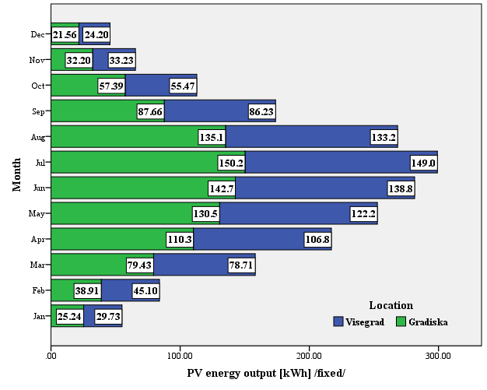
Figure 7. Monthly electricity production of the fixed solar power plant with monocrystalline silicon solar modules total power of 1 MWp in Gradiška and Višegrad

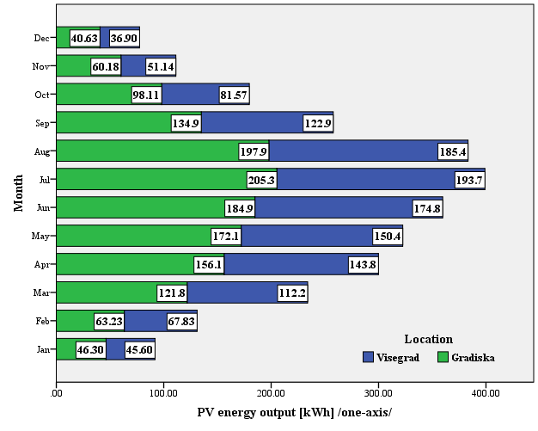
Figure 8. Monthly electricity production by the one-axis tracking PV solar power plant with monocrystalline silicon solar modules total power of 1 MWp in Gradiška and Višegrad

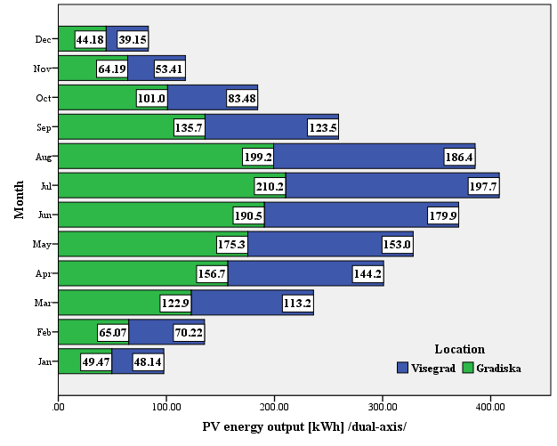
Figure 9. Monthly electricity production by the dual-axis tracking PV solar power plant with monocrystalline silicon solar modules total power of 1 MWp in Gradiška and Višegrad

The next graph shows the differences in percentage of the monthly electricity production. Shown are the comparisons of fixed plant, one-axis and dual-axis tracking PV solar power plant in Gradiška and Višegrad.

Figure 10. Differences (%) of the monthly electricity production of three plants in Gradiška and Višegrad

No statistically significant differences were obtained (by application Mann-Whitney Test) in the monthly electricity production by a fixed solar power plant (z = -.115, p = .908), in the monthly electricity production by the one-axis tracking PV solar power plant (z = -.404, p = .686) and in the monthly electricity production by the dual-axis tracking PV solar power plant (z = .462, p = .644) in Gradiška and Višegrad. Also, there were no statistically significant differences found between: the monthly electricity production by a fixed solar power plant and one-axis tracking PV solar power plant in Višegrad (z = - 1.501, p = .133) and Gradiška (z = -1.732, p = .083), the monthly electricity production by fixed solar power plant and dual-axis tracking PV solar power plant in Višegrad (z = -1.501, p = .133) and Gradiška (z = -1.790, p = .073) or the monthly electricity production by one-axis and dual-axis tracking PV solar power plant in Višegrad (z = -.346, p = .729) and Gradiška (z = -.404, p = .686).

5. CONCLUSION
This paper brought the comparison of solar radiation at two locations (Gradiška and Višegrad) in Republic of Srpska. Global and direct solar radiation are calculated in relation to the horizontal surface and global radiation in relation to the optimal angle. Optimal angle for Gradiška is 33˚ and for Višegrad 31˚. Although, there are no statistically significant differences in the energy of global solar radiation on the horizontal surface or optimal angled surface or in the energy of direct solar radiation falling on the horizontal surface in Gradiška and Višegrad, there are some differences in mentioned radiations, but they are not found statistically significant.
There are three types of solar power plants studied in this paper (fixed, one-axis and dual-axis tracking PV solar power plants at both locations). It can be concluded, that solar power plants in Gradiška produces more energy (electricity) than those in Višegrad. Gradiška produced 0.85% more energy by the fixed solar plant, 8.44% more energy by the one-axis tracking PV solar power plant and 8.78% more energy by the dual-axis tracking PV solar power plant than the same systems in Višegrad. Compared were also the solar power plants with each other in regard to produced electricity (kWh and %), and it has been showed, that all three types of systems have produced more electricity in Gradiška than in Višegrad. Nevertheless, according to literature the one-axis and dual-axis tracking PV solar power systems are more efficient in electricity production than fixed plants, which has been proven in the calculations.
Only in January, February, November and December the electricity production by fixed solar power plant in Višegrad surpasses the electricity production by the same plant in Gradiška. When it comes to the electricity production by the one-axis tracking PV solar power plant in Višegrad, only in February and November the calculated values excel the values from Gradiška. And, in February Višegrad outstrips the production of electricity of dual-axis tracking PV solar power plant in Gradiška. Although, in every other month, except in those mentioned, Gradiška surpasses Višegrad in electricity production, statistical tests did not show any significant differences between those two locations and solar systems in regard to amounts of radiation or amounts of produced energy.

6. LITERATURE
[1] – D. Lj. Mirjanić, et al., Solar radiation atlas in Banja Luka in the Republic of Srpska, Contemporary Materials, Vol. XII-1 (2021), 39-49.
[2] - https://re.jrc.ec.europa.eu/pvg_tools/en/#PVP, access May 7. 2021.
[3] – K. Cieslak, P. Dragan, Comparison of the existing photovoltaic power plant performance simulation in terms of different sources of meteorological data. E3S Web of Conferences, 49, 00015, (2018). https://doi.org/10.1051/e3sconf/20184900015
[4] - S. Jakšić, S. Maksimović, Verovatnoća i statistika: teorijske osnove i rešeni primeri, Arhitektonsko-građevinsko-geodetski fakultet, Banja Luka 2020, 228-231
[5] - W. Navidi, Statistics for engineers, Mc Graw Hill International Edition 2011, New York, 454-456.
[6] - http://investingradiska.com/gdje-se-nalazimo/?lang=sr, access May, 13. 2021.
[7] - https://visegradturizam.com/en/geografija/, access May, 13. 2021.
[8] - http://gin.ba/upoznajte-gradisku/istorija, access May, 13. 2021.
[9] - https://opstinavisegrad.com/polozaj/, access May, 7. 2021.
[10] - http://gradgradiska.com/o_gradisci/, access May, 7. 2021.
[11] – Republički zavod za statistiku Republika Srpska, Popis stanovništva, domaćinstava i stanova u Republici Srpskoj 2013. godine, Rezultati popisa, pages 14 and198. https://www.rzs.rs.ba/static/uploads/bilteni/popis/gradovi_opstine_naseljena_mjesta/Rezultati_Popisa_2013_Gradovi_Opstine_Naseljena_Mjesta_WEB.pdf, access May, 11. 2021
[12] – T. M. Pavlović, D. D. Milosavljević, D. Lj. Mirjanić, Obnovljivi izvori energije, Akademija nauka i umjetnosti Republike Srpske, Banja Luka 2013, 96-99.

