Title: Diabetes management: Let’s us make it to the finish line
Background: Diabetes is chronic and progressive disease which can cause serious complications. Prevalence of end-stage kidney disease is ten times higher in people with diabetes^{1,2}. Diabetic retinopathy is leading cause of vision loss in the working-age adults³. People with diabetes are two to three times more likely to have cardiovascular disease than people without diabetes⁴. The complications deprive patient of desired quality of life and cut life expectancy short.
Case presentation: A patient, 54 years old female, who was diagnosed diabetes 13 years ago, had many treatment changes over years (Figure 1). She came to our office with good glycemic control 4 years ago. Patient’s HbA1C was 6,3%, had four to six daytime and up to four nighttime hypoglycemia a month. Patient’s family physician and endocrinologist were pleased with glycemic control. Patient’s good glycemic control was result of patient’s great effort. But, patient was dissatisfied with body weight and had left an impression of hard-working person rather than happy person. Patient’s current therapy was basal insulin plus three boluses, oral metformin three times daily and was self-checking blood glucose at least 4 time a day. We proposed a therapy that we deemed would maintain glycemic control, simplify application of therapy and self-glucose monitoring, reduce body weight and offer cardiovascular protection^{5,6}.
Two months after the initiation of new therapeutic regime, patient maintained good glycemic control, glycemic variability was reduced as well as body weight and need for frequent glucose monitoring and patient felt content (Table 1). After introduction, the dose of liraglutide was not increased to 1,2 mg once daily after the first week because of health insurance issue (patient had to pay full price of liraglutide) and good glycemic control was achieved with the minimum liraglutide dose (0,6mg once daily). After six months, liraglutide dose was increased to 1,2mg once daily to achieve additional reduction of body weight and dose of basal insulin. A year ago, patient raised concern over increased appetite, not linked to hypoglycemia and prospect of gaining weight. At that time, once-weekly GLP-1 RA became available thru patient’s health insurance at no extra cost, so patient was switched from liraglutide daily to dulaglutide weekly (1,5mg). Since the introduction of GLP-1RA in therapy until now, more than 4 years, patient’s diabetes management goals have been maintained. At the last regular checkup, 4 months ago, patient’s HbA1C was 6,6% and BMI 29,1kg/m², current therapy dulaglutide 1,5mg once weekly, basal insulin 28i.u. once daily and metformin tablets 1000mg twice daily.
Conclusion: This case report is intended as a reminder that we should always keep in mind holistic and individualized management of diabetic patient. Main goals of diabetes management are prevention of complications and optimization of quality of life. These goals can be achieved by good glycemic control, reduction and maintaining healthy body weight, reducing cardiovascular risk and tailoring therapy that fits patients’ needs and wishes. We have many effective agents to choose from and we should try to achieve all the set goals. We shouldn’t stop at the halfway. Let’s us make it to the finish line.

Figure 1. Patient’s therapy changes over time
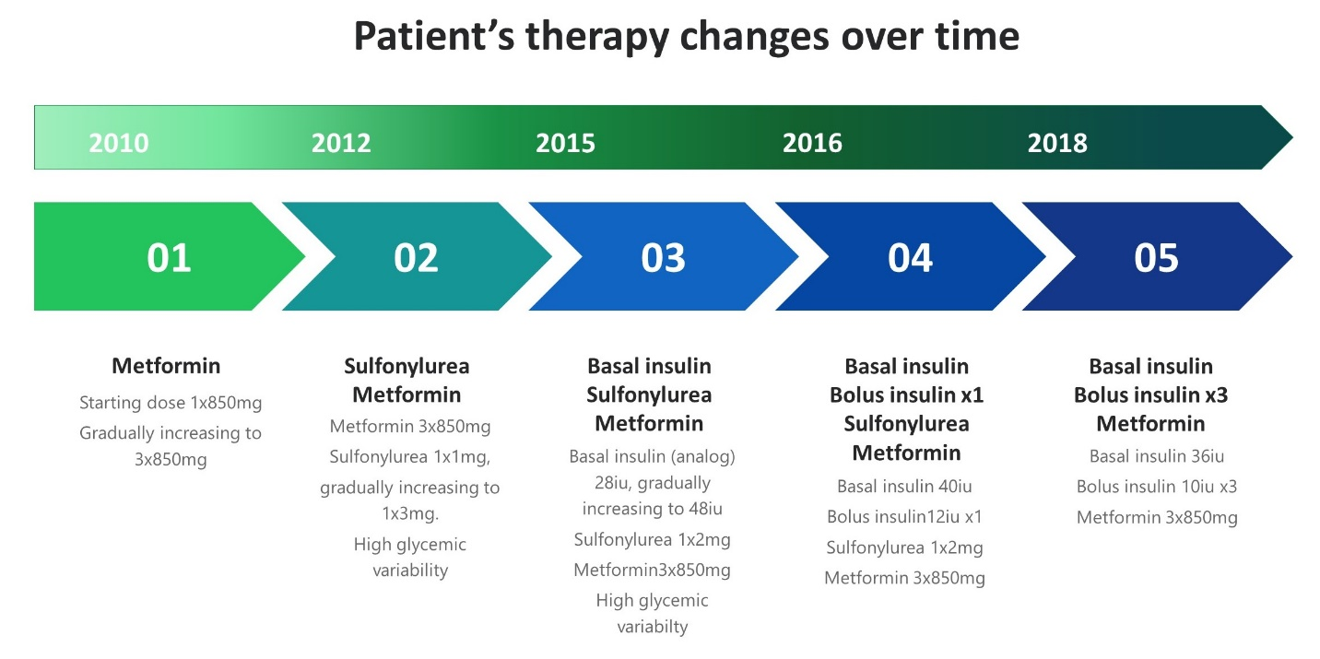

Table 1. Review of body mass, BMI, blood glucose, HbA1C and insulin doses before and after the introduction of liraglutide in dose of 0,6mg/daily
 |  | Breakfast |  | Lunch |  | Dinner
Body weight (kg) | BMI  kg/m² | FPG mmol/L | PPG mmol/L | FPG mmol/L | PPG mmol/L | FPG mmol/L | PPG mmol/L | HbA1C  % | Basal  /bolus dose iu
Before introduction of liraglutide
94 | 33,7 | 6,0-7,8 | 6,8-8,5 | 6,4-10,1 | 5,2-7,8 | 6,1-7,9 | 4,2-9,7 | 6,0 | 36/30
14 days after introduction of liraglutide
91 | 32,6 | 5,2-5,9 | 5,2-7,4 | 4,2-6,9 | ~6,0 | 4,6-5,8 | 5,2-6,5 | - | 30/0
2,5 months after introduction of liraglutide
86 | 31,7 | 4,6-6,8 | 5,7-6,9 | 5,0-7,7 | ~7,3 | 5,3-8,3 | 5,7-8,7 | 5,9 | 30/0

FPG=fasting plasma glucose; PPG=prandial plasma glucose;

References:
1. Komenda, P.; Ferguson, T.W.; Macdonald, K.; Rigatto, C.; Koolage, C.; Sood, M.M.; Tangri, N. Cost-effectiveness of primary screening for CKD: A systematic review. Am. J. Kidney Dis. 2014, 63, 789–797
2. Steinke, J.M. The natural progression of kidney injury in young type 1 diabetic patients. Curr. Diab. Rep. 2009, 9, 473–479.
3. Bourne RRA, Jonas JB, Bron AM, Cicinelli MV, Das A, Flaxman SR, et al. Prevalence and causes of vision loss in high-income countries and in Eastern and Central Europe in 2015: magnitude, temporal trends and projections. Br J Ophthalmol. 2018;102:575–585. doi: 10.1136/bjophthalmol-2017-311258.
4. IDF DIABETES ATLAS. Ninth edition, 2019. www. https://www.diabetesatlas.org/upload/resources/2019/IDF_Atlas_9th_Edition_2019.pdf. [Accessed: 2020-09-15]
5. S.P. Marso, G.H. Daniels, K. Brown-Frandsen, et al. Liraglutide and cardiovascular outcomes in type 2 diabetesNew Engl. J. Med., 375 (4) (2016), pp. 311-322, 10.1056/NEJMoa1603827
6. G Ferrannini, H.C Gerstein, H.M Colhoun, G.R Dagenais, R Diaz, L Dyal, M Lakshmanan, L Mellbin, J Probstfield, M.C Riddle, J.E Shaw, L Ryden, REWIND Investigators , Dulaglutide is cardioprotective with or without background metformin in patients with diabetes and established or high risk for coronary vascular disease. A subgroup analysis of the REWIND Trial, European Heart Journal, Volume 41, Issue Supplement_2, November 2020, ehaa946.3353, https://doi.org/10.1093/ehjci/ehaa946.3353

