MEASUREMENT AND ANALYSIS OF THE SPECTRAL EMISSION OF DIFFERENT TYPES OF DOMESTIC LAMPS IN THE BLUE LIGHT HAZARD WAVELENGTH RANGE

Plamen Tsankov¹, Veselina Stefanova¹, Milko Yovchev¹, Ivaylo Stoyanov¹
¹ Technical University of Gabrovo, Faculty of Electrical Engineering and Electronics,
Hadji Dimitar 4, 5300 Gabrovo, Bulgaria

Summary: In recent years, research on the photobiological impact of light on humans has been expanding and deepening. A significant part of this research is aimed at harmful effects such as the blue light hazard (BLH) on the retina of the human eye, for which there are standardized indicators in international normative documents. The current research presents laboratory measurements and results for the spectral emission in blue light hazard wavelength range for several domestic lamps: conventional tungsten filament lamps, halogen and metal halide lamps, compact fluorescent lamps, and state-of-the-art LED lamps. The measurements are conducted in a specialised laboratory in the Technological Park of the Technical University - Gabrovo using a photometer with a spectroradiometer in an integrating sphere and are processed with specialised software. Graphical comparisons of the spectral distributions of lamps in the visible part of the electromagnetic spectrum with the dangerous blue light wavelength range are shown. Data on the main photometric and colour characteristics - luminous flux, light efficacy, chromaticity coordinates, colour temperature, colour rendering index, and indicators for assessing the presence of dangerous blue light - blue light (weighted power) and blue light hazard factor (weighted power/ lux), for the different types of lamps, are shown in tables. Conclusions and recommendations regarding the choice of the type of domestic lamp and its colour characteristics to limit the level of dangerous blue light are made.
Keywords: blue light hazard, domestic lamp, light-emitting diode, spectral distribution of lamp, spectroradiometer measurement.

- INTRODUCTION

In recent years, the widespread adoption of artificial lighting in domestic settings has revolutionized our lives, enhancing productivity, safety, and comfort during nighttime hours. However, with the rapid proliferation of energy-efficient light sources, particularly light-emitting diodes (LEDs), concerns have arisen regarding their potential adverse effects on human health. Of particular interest is the blue light emitted by these lamps, which has been identified as a potential hazard due to its impact on the circadian rhythm and ocular health.
One of the significant direct potentially harmful effects of radiation from light sources is the Blue Light Hazard (BLH), which has a relatively strong photochemical effect in retinal tissues. [1,2] Specific measurement methods and BLH level control indicators are systematized and defined in international normative documents. [3,4] The relevance of the BLH problem is confirmed by modern scientific books and publications by authoritative scientists. [1,5,6,7]
Fig. 1 shows a comparison of photopic eye sensitivity, actinic UV, blue light and thermal hazard spectrums according to IEC 62471 Photobiological Safety of Lamps and Lamp Systems. [2]
The human eye is sensitive to light across a broad spectrum, ranging from ultraviolet (UV) to visible and infrared light. Blue light, with wavelengths between approximately 400 to 500 nanometers, lies at the higher-energy end of the visible spectrum and plays a crucial role in regulating our sleep-wake cycle. In natural settings, exposure to blue light during the day is essential for maintaining proper circadian rhythms, alertness, and mood. However, excessive or untimely exposure to blue light, especially during evening hours, can disrupt the natural sleep-wake cycle, leading to various health issues. [8]
Domestic lamps, including LEDs, compact fluorescent lamps (CFLs), and traditional incandescent bulbs, have replaced conventional lighting sources in households due to their energy efficiency and longer lifespan. LEDs, in particular, have gained popularity due to their low energy consumption and versatile applications. Nonetheless, their high blue light content has raised concerns regarding their potential impact on human health.

Fig. 1. Photopic eye sensitivity, actinic UV, blue light and thermal hazards spectrums. [2]

In contemporary indoor lighting lamps, light-emitting diodes (LED) based on a Blue LED + Yellow phosphor are mainly used. In both cases, the presence of a blue LED emitting in a narrow wavelength range with a maximum close to that of the blue light hazard wavelength range of (400÷500) nm, makes it highly likely that the eye-safe levels of blue light will be exceeded. Fig. 1 shows a typical spectrum of Blue LED + Yellow phosphor technology LED. Blue light is directly emitted by the GaN-based LED luminescence (peak at about 465 nm) and the more broadband Stokes-shifted light emitted by the Ce3+:YAG (Yttrium aluminium garnet—Y3Al5O12) phosphorescence, which emits at roughly 500–700 nm. [2,9]

Fig. 2. Spectrum formation of Blue LED + Yellow phosphor technology LEDs

Studies have shown that prolonged exposure to blue light, especially during the evening, can suppress the production of melatonin, a hormone responsible for regulating sleep. This disruption can lead to sleep disturbances, insomnia, and even contribute to the development of chronic health conditions, including obesity, diabetes, and cardiovascular diseases. Moreover, blue light exposure can cause eye strain, visual discomfort, and in extreme cases, retinal damage, leading to an increased risk of age-related macular degeneration (AMD).
One of the quantitative indicators giving information about the potential danger of the spectrum of a given light source is the blue light hazard efficacy of luminous radiation K_{B,V} [10,11,12], expressed in (W/lm), with a mathematical definition:
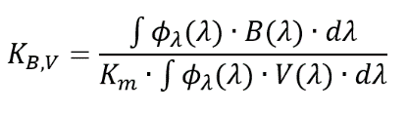 | (1)
where: Ф_{λ}(λ) is the radiometric spectral power distribution of the white light source (W/nm); λ is the wavelength variable (nm); B(λ) is the blue light hazard weighting function defined in IEC 62471; K_{m} is the photopic luminous efficacy of radiation for a monochromatic source with a 555 nm wavelength (683 lm/W); V(λ) is the luminous efficiency function of the human eye.
The watts in the dimension W/lm, calculated using formula (1), are the blue light hazard weighted optical watts of the source, designated as W_{B}. Another possibility for the analytical representation of K_{B,V} in IEC 62471 is through illuminance or luminance of the light sources - formula (2):

(2)

where E_{B} (W_{B}/m²) and L_{B} (W_{B}/(sr.m²)) values are used for calculation of K_{B,V} value [1,11,13]. In the present study, according to the definition proposed by EN 62471 for for K_{B,V} via illuminance, a (µW/cm²/lux) dimension is used.

2. LABORATORY SETUP FOR MEASUREMENTS

The measurements of the spectral power distribution (SPD) in range (380÷780) nm, electrical, photometric and colourimetric parameters and efficacy of the lamps studied are performed using a CCD spectroradiometer system Lisun LMS-9000B with an integrating sphere in Gabrovo Tech Park (Fig. 3). [14] The power supply with pure sinewave rated voltage and measurement of the electrical, photometric and colourimetric parameters and efficacy of the domestic lamps studied are realized by the specialized software product LMS-9000 Lisun CCD Spectroradiometer, shown in Fig. 4.

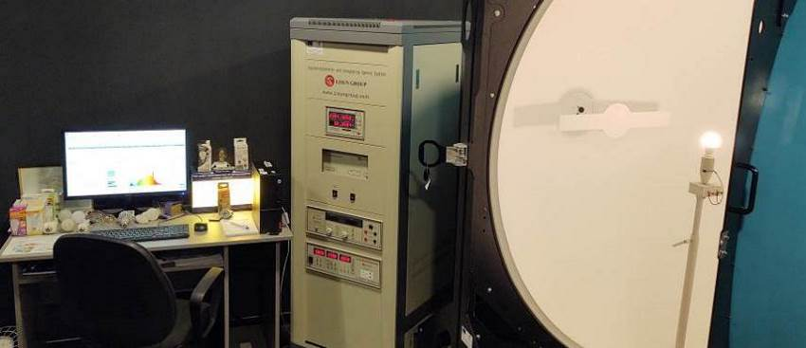

Fig. 3. Measurement of the spectral emission of the studied domestic lamps with a CCD spectroradiometer system

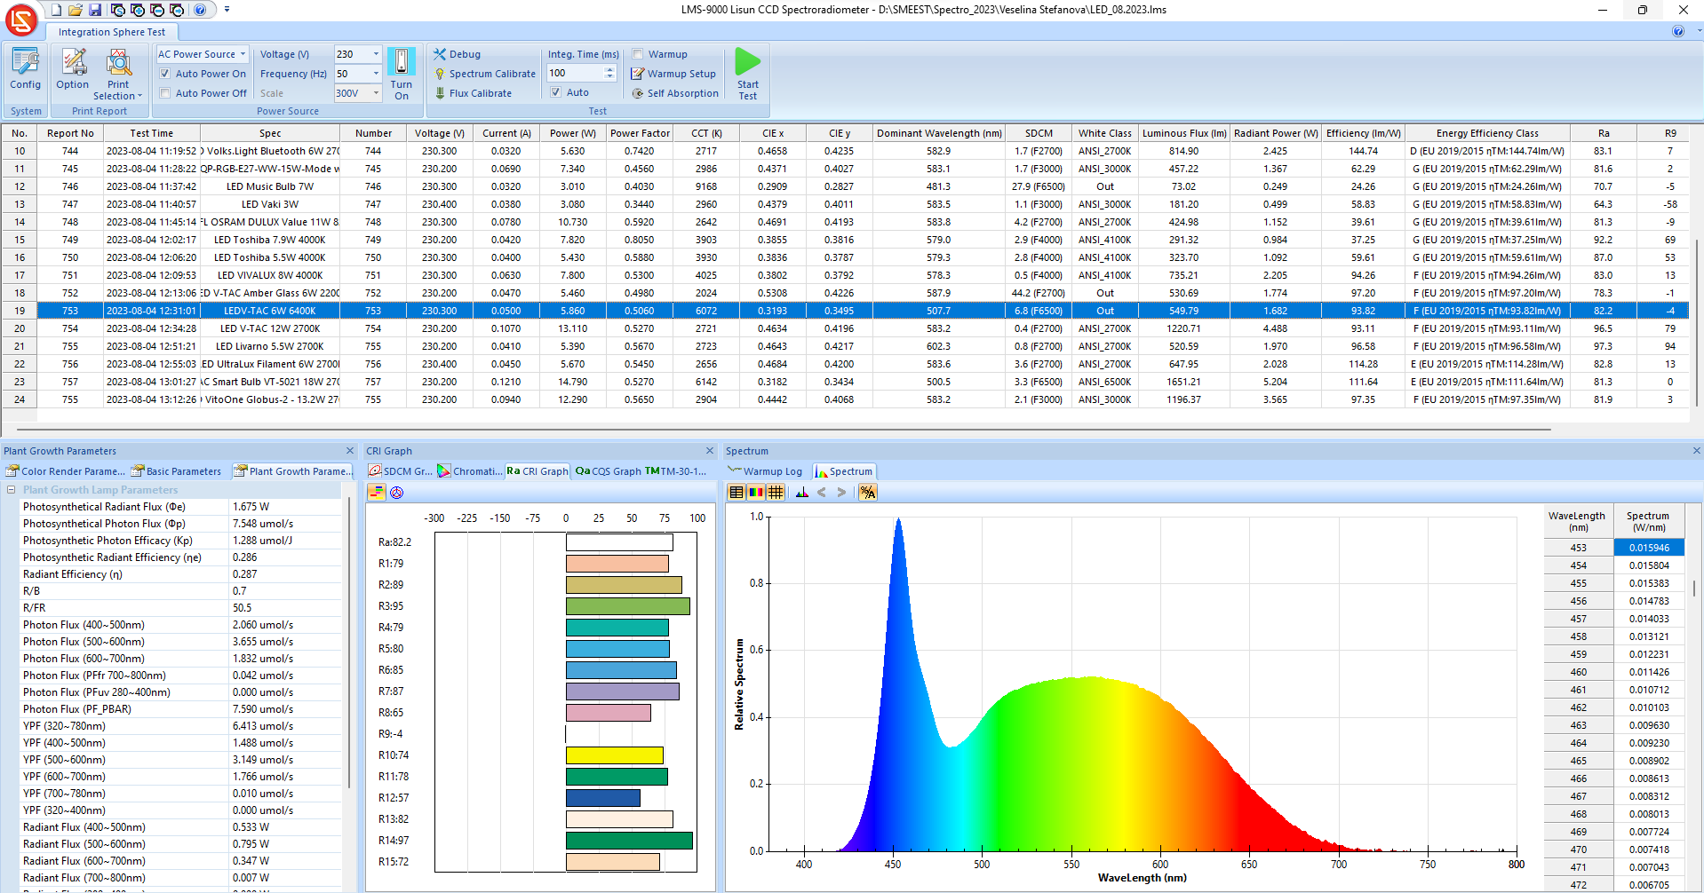

Fig. 4. LMS-9000 Lisun CCD Spectroradiometer software used to control the measurement process
In LMS-9000 Lisun CCD Spectroradiometer software, the spectral power distribution data (W/nm) in the wavelength range (380÷780) nm of the domestic lamps studied are exported and recorded in CSV file format, shown in Fig. 5. Then spectral power distribution data are processed in f.luxometer™ online application and service, shown in Fig. 6. [15]

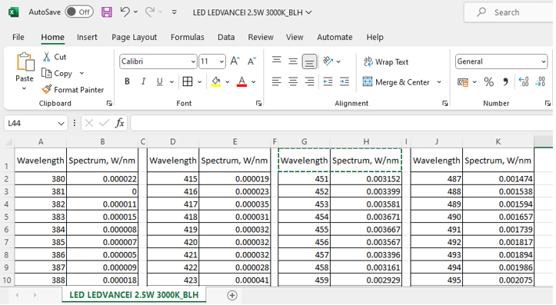

Fig. 5. Recording spectral power distribution data in CSV file format

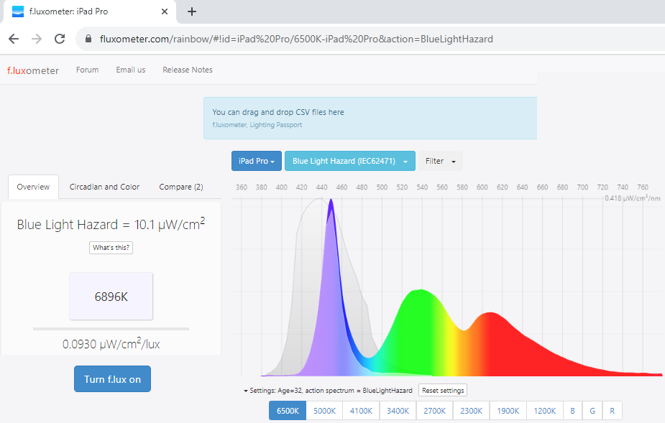

Fig. 6. Online application and service f.luxometer™ used to process the spectral power distribution data in CSV format

Eighteen domestic lamps with different power and correlated colour temperature: two incandescent lamps, three halogen lamps, six compact fluorescent lamps (CFL), two metal halide lamps (MHL), two xenon lamps, and three LED lamps, are studied. Fig. 7 shows part of the domestic lamps studied.

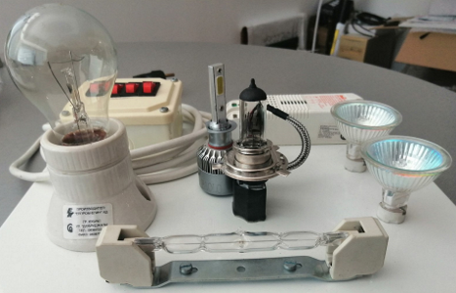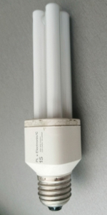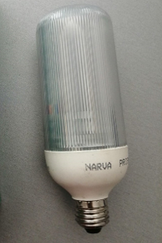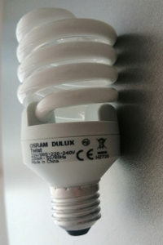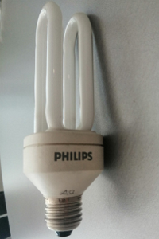
a. Tungsten incandescent and halogen lamps b. Compact fluorescent lamps

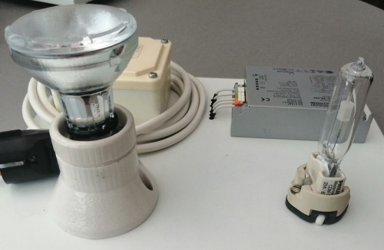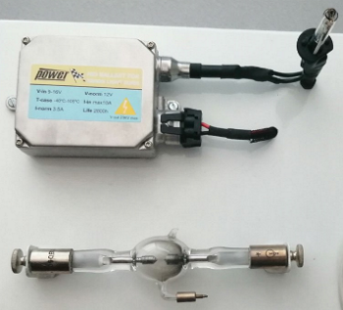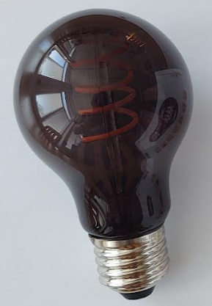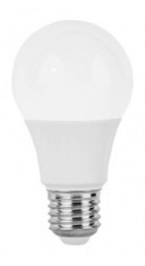
c. Metal halide lamps d. Xenon lamps e. LED lamps

Fig. 7. Appearance of the domestic lamps studied

Before the measurements of the colour characteristics each tested lamp is warmed up to a steady state mode according to established international lighting standards. [16,17]

3. MEASUREMENT RESULTS AND ANALYSIS.

In the CCD spectroradiometer system Lisun LMS-9000B, the photometric, colourimetric parameters, and efficacy of the domestic lamps, are measured. Table 1 shows the results of measured correlated colour temperature CCT, chromaticity coordinates CIE x and CIE y, dominant wavelength, luminous flux, radiant power, colour rendering index Ra and strong red colour sample R9, colour fidelity index Rf, and colour gamut Rg, and efficacy of tested domestic lamps.

Table 1. Measured photometric and colourimetric parameters and efficacy of tested domestic lamps
Lamp | CCT  (K) | CIE x | CIE y | Dominant wavelength (nm) | Luminous flux  (lm) | Radiant power (W) | Efficacy (lm/W) | Ra | R9 | Rf | Rg
Tungsten incandescent-100W | 2634 | 0.4662 | 0.4131 | 584.4 | 1028.08 | 7.98 | 10.53 | 99.7 | 99 | 100 | 100
Tungsten incandescent-150W | 2773 | 0.4544 | 0.4100 | 583.8 | 1787.23 | 13.173 | 11.67 | 99.8 | 99 | 100 | 100
Dichroic halogen-14.7W | 2460 | 0.4873 | 0.4248 | 584.5 | 88.43 | 0.681 | 6.00 | 97.1 | 90 | 95 | 95
Dichroic halogen-15W | 2500 | 0.4795 | 0.4178 | 584.9 | 97.98 | 0.778 | 6.50 | 99.0 | 96 | 98 | 98
Halogen-53W | 2765 | 0.456 | 0.4120 | 583.6 | 267.00 | 1.937 | 5.03 | 99.6 | 99 | 99 | 99
CFL-11W | 2642 | 0.4691 | 0.4193 | 583.8 | 424.98 | 1.152 | 39.61 | 81.3 | -9 | 72 | 104
CFL SL-15W | 5916 | 0.3227 | 0.3512 | 528.6 | 765.01 | 2.377 | 61.55 | 73.3 | 16 | 74 | 95
CFL PL-15W | 2720 | 0.4639 | 0.4205 | 583.1 | 563.65 | 1.618 | 37.70 | 82.3 | -6 | 74 | 103
CFL-21W | 6336 | 0.3133 | 0.3517 | 504.1 | 507.55 | 1.574 | 33.61 | 77.8 | 24 | 80 | 97
CFL-23W | 7146 | 0.3021 | 0.3256 | 488.5 | 1413.99 | 4.694 | 67.62 | 80.8 | 41 | 81 | 99
CFL-55W | 3929 | 0.3864 | 0.3884 | 577.3 | 2603.44 | 7.516 | 46.26 | 78.5 | 16 | 76 | 100
MHL SDM-R-35W | 2985 | 0.436 | 0.4003 | 583.4 | 2308.18 | 7.801 | 53.94 | 83.6 | -29 | 81 | 100
MHL-35W | 3094 | 0.4307 | 0.4023 | 582.4 | 3114.51 | 10.24 | 72.33 | 79.8 | -53 | 77 | 99
Xenon lamp-60W | 6798 | 0.3046 | 0.345 | 507.7 | 1978.36 | 7.833 | 33.48 | 56.9 | -117 | 62 | 85
Xenon lamp-75W | 6578 | 0.3091 | 0.3441 | 497.5 | 2655.72 | 10.74 | 35.56 | 63.8 | -88 | 68 | 88
LED lamp-6W | 6072 | 0.3193 | 0.3495 | 507.7 | 549.79 | 1.682 | 93.82 | 82.2 | -4 | 83 | 91
LED lamp-7W | 4472 | 0.3623 | 0.3673 | 576.1 | 389.64 | 1.179 | 62.74 | 82.1 | 4 | 83 | 97
LED filament lamp-4W | 1585 | 0.5764 | 0.3998 | 593.4 | 60.59 | 0.321 | 14.82 | 90.8 | 60 | 86 | 89

The spectral power distribution data (W/nm) of the studied lamps, measured in a spectroradiometer LMS-9000B and exported in CSV format, are processed using the f.luxometer™ application and service to calculate the results about the blue light hazard wavelength range. Spectral power distributions of the domestic lamps and blue light hazard wavelength range are compared graphically in Fig. 8.

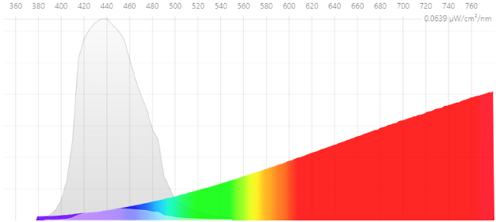 | 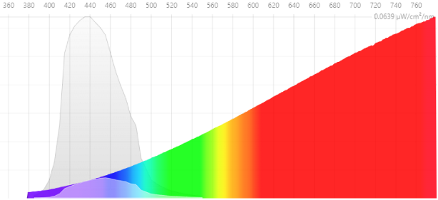
a) Tungsten incandescent lamp-100W | b) Tungsten incandescent lamp-150W
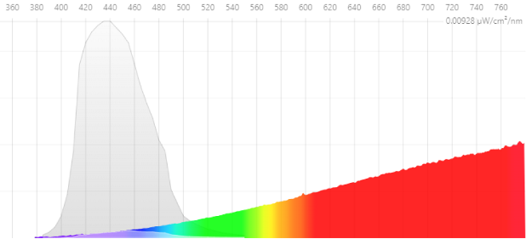 | 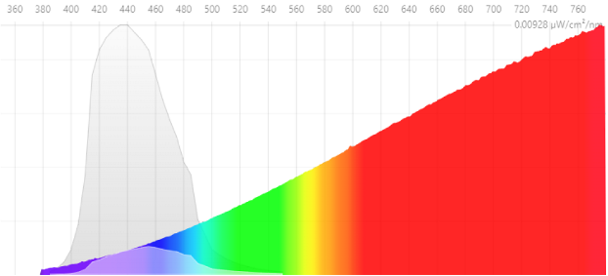
c) Dichroic halogen lamp-15W | d) Halogen lamp-53W
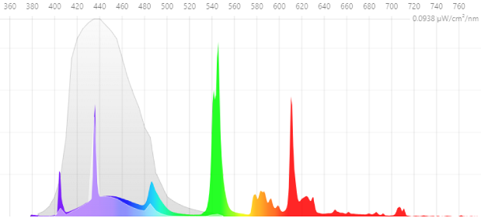 | 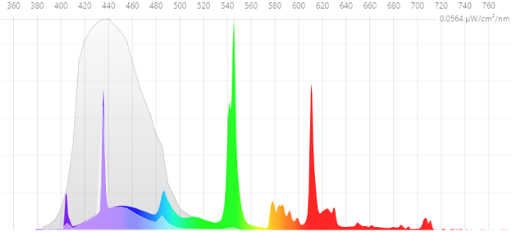
e) CFL SL-15W | f) CFL-21W
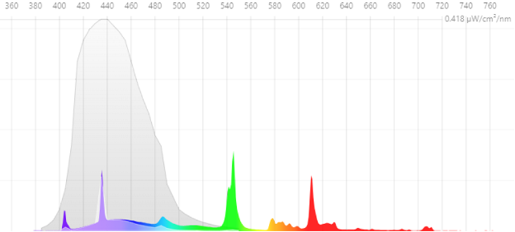 | 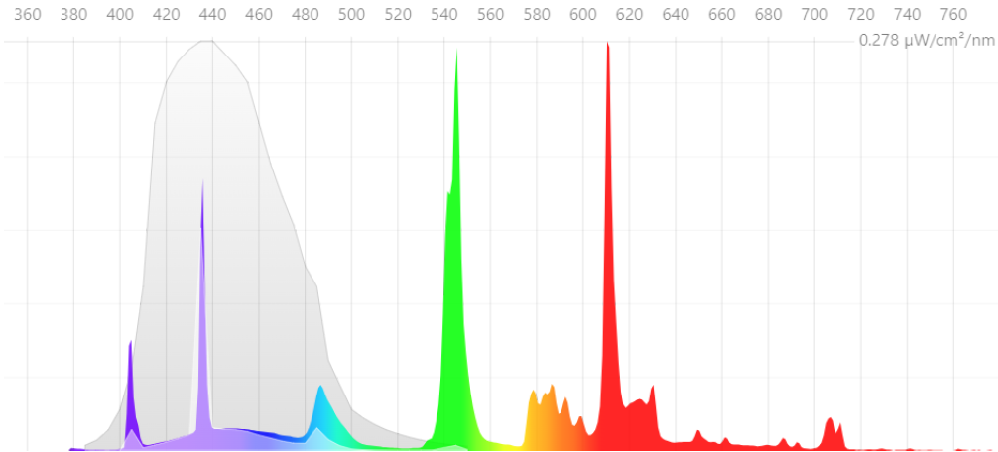
g) CFL-23W | h) CFL-55W
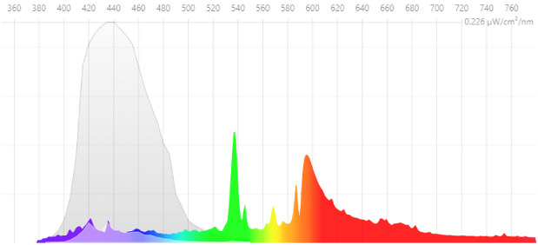 | 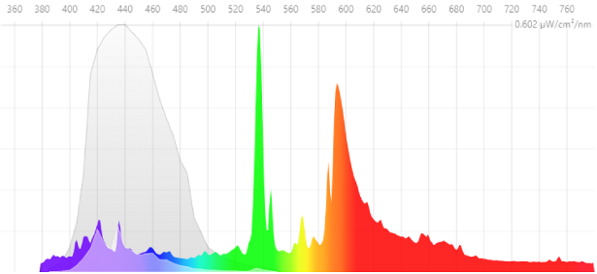
i) MHL SDM-R-35W | j) MHL-35W
Fig. 8. Comparison between SPD of the domestic lamps studied and the BLH wavelength range

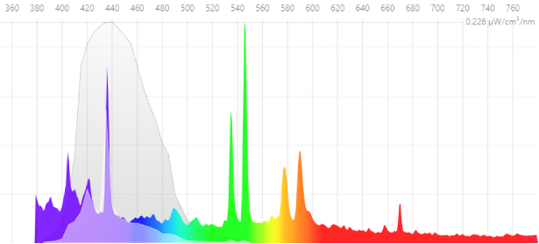 | 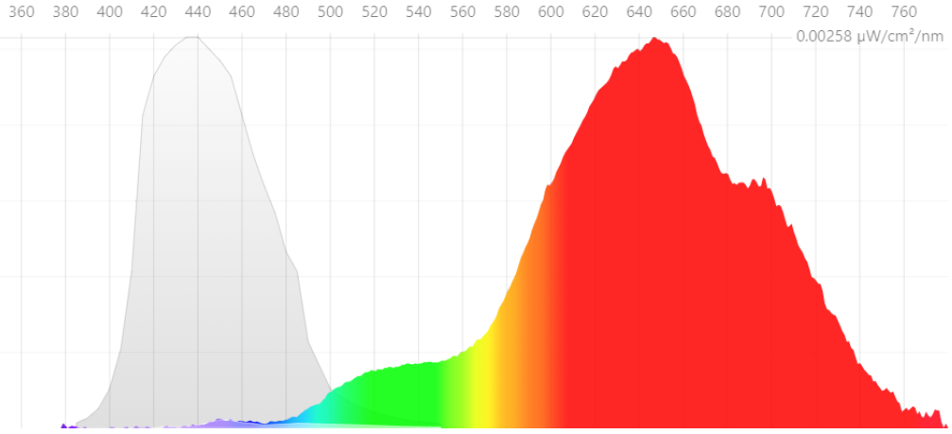
k) Xenon lamp-75W | l) LED filament lamp-4W
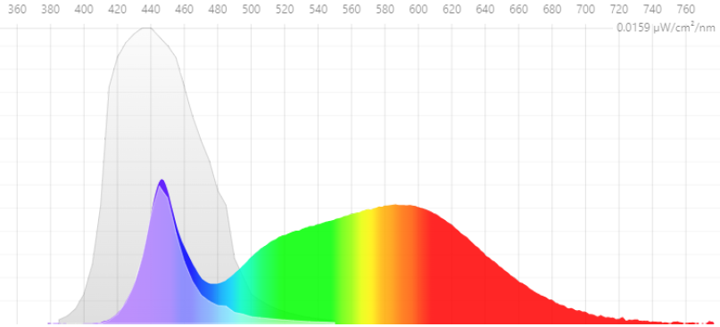 | 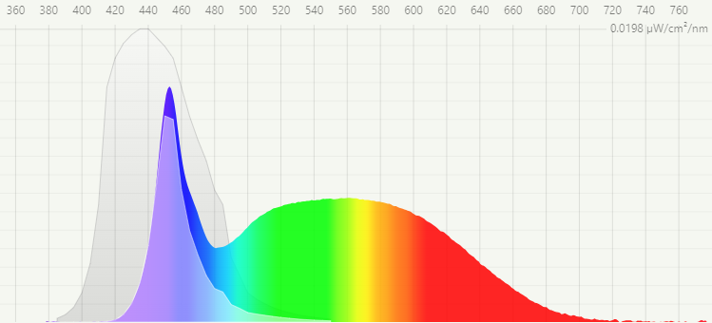
m) LED lamp-7W | n) LED lamp-6W
Fig. 8. Comparison between SPD of the domestic lamps studied and the BLH wavelength range

In Table 2, results for the measured correlated colour temperature and calculated blue light (weighted power) in µW/cm², blue light hazard factor (weighted power/lux) K_{B,V} in µW/cm²/lux, and dominant wavelength of the tested indoor LED lamps, are systematized.

Table 2. Measured correlated colour temperature and calculated blue light (weighted power), blue light hazard factor (weighted power/lux), and dominant wavelength of the tested domestic lamps
Lamp | Correlated colour temperature,  K | Blue light  (weighted power),  µW/cm² | Blue light hazard factor  (weighted power/lux),  µW/cm²/lux | Dominant wavelength,  nm
LED filament lamp-4W | 1582 | 0.003 | 0.0044 | 593.4
Dichroic halogen lamp-14.7W | 2460 | 0.015 | 0.0166 | 584.5
Dichroic halogen lamp-15W | 2500 | 0.020 | 0.0202 | 584.9
Tungsten incandescent-100W | 2634 | 0.253 | 0.0246 | 584.4
CFL-11W | 2642 | 0.105 | 0.0247 | 583.8
CFL PL-15W | 2720 | 0.143 | 0.0254 | 583.1
Halogen-53W | 2765 | 0.072 | 0.0269 | 583.6
Tungsten incandescent-150W | 2773 | 0.499 | 0.0279 | 583.8
MHL SDM-R-35W | 2985 | 0.921 | 0.0399 | 583.4
MHL-35W | 3094 | 4.200 | 0.0420 | 582.4
CFL-55W | 3929 | 1.340 | 0.0517 | 577.3
LED lamp-7W | 4472 | 0.229 | 0.0587 | 576.1
CFL SL-15W | 5916 | 0.622 | 0.0814 | 528.6
LED lamp-6W | 6072 | 0.396 | 0.0720 | 507.7
CFL-21W | 6336 | 0.414 | 0.0816 | 504.1
Xenon lamp-75W | 6578 | 2.700 | 0.1020 | 497.5
Xenon lamp-60W | 6798 | 2.050 | 0.1040 | 507.7
CFL-23W | 7146 | 1.390 | 0.0984 | 488.5

The analysis of the results in Table 2 shows an approximately linear relationship between CCT and blue light hazard factor (weighted power/lux) K_{B,V} in µW/cm²/lux for the 18 domestic lamps tested. In Fig. 9, graphical and defined linear analytical dependence of blue light hazard efficacy of luminous radiation K_{B,v} on the correlated colour temperature CCT of the measured domestic lamps.

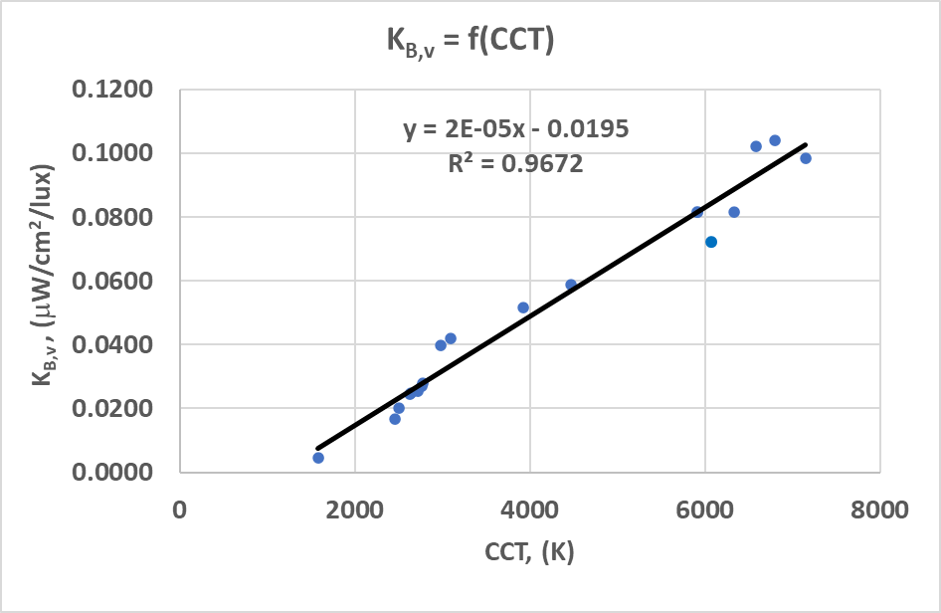

Fig. 9. Graphical and defined linear analytical dependence of blue light hazard efficacy of luminous radiation K_{B,v} on the correlated colour temperature CCT of the measured domestic lamps

4. CONCLUSIONS

The analysis of the results shows a linear increase trend in the blue light hazard factor K_{B,V} with an increase in the correlated colour temperature CCT of the measured light sources not only for LED lamps, which has been a frequently researched issue in recent years, but also for the older technology domestic lamps they replace, even for tungsten incandescent and incandescent halogen lamps, which, as heat emitter technology, have a lower emission intensity in the blue of the spectrum – Table 2 and Fig. 9. It is even found that at similar levels of colour temperature, CFLs and Xenon lamps have higher K_{B,V} values than LED lamps. For a more precise assessment of the real danger of falling into a risk group for blue light hazard, according to the standard IEC 62471, at the next stage, it is necessary to examine the luminance of the light source or luminaire to the eye for the specific light distribution of their optical system.
From research, it can be concluded that LED lamps, at the same light temperature and other conditions, have the same or lower light emissions in the blue light hazard wavelength range than other domestic light sources. The most important conclusion is that regardless of the technology of light sources, to provide safer household lighting with reduced blue light hazard emissions, it is advisable to use lamps with "warm" or "soft white" light, or with as much as possible -low colour temperature.
The obtained results confirm the expediency of the research and the accuracy of work of the laboratory setup created at the Technical University - Gabrovo for researching the problems with dangerous blue light, which can also be used for other research on direct or indirect photobiological effects of light.

5. ACKNOWLEDGEMENT

This work was supported by the European Regional Development Fund within the OP “Science and Education for Smart Growth 2014 - 2020”, Project CoC “Smart Mechatronic, Eco- And Energy Saving Systems And Technologies“, № BG05M2OP001-1.002-0023.

6. REFERENCES

[1] Bommel, W. Interior lighting - Fundamentals, Technology And Application. Springer, 2019, pp. 137-257.
[2] Tsankov, P.T. (2020). Lighting Technologies. In: Pavlovic, T. (eds) The Sun and Photovoltaic Technologies. Green Energy and Technology. Springer, Cham, 2020, pp. 213-270.
[3] Xue, C. et al. High Performance Non-Doped Blue-Hazard-Free Hybrid White Organic Light-Emitting Diodes with Stable High Color Rendering Index and Low Efficiency Roll-Off. Opt. Mater., vol. 106, 2020.
[4] Bauer, S. Blue-Light Hazard of Light-Emitting Diodes Assessed with Gaussian Functions. International Journal of Environmental Research and Public Health, 2021, pp. 4-8. doi.org/10.3390/ijerph18020680.
[5] Nikolova, K., I. Petrinska, D. Ivanov, D. Pavlov. Investigation of the Photobiological Risk from Blue Light of a Human-Centric Lighting System - Case Study. 2019 11th Electrical Engineering Faculty Conference (BulEF), 2019.
[6] Brainard, G. et al. Sensitivity of the Human Circadian System to Short-Wavelength (420-nm) Light. Journal of Biological Rhythms, vol. 23, Issue 5, 2008.
[7] Pawlak, A. Evaluation of the Hazard Caused by Blue Light Emitted by LED Sources. Lighting Conference of the Visegrad Countries (Lumen V4), 2018.
[8] Dai, Q. et al. Circadian-Effect Engineering of Solid-State Lighting Spectra for Beneficial and Tunable Lighting. Opt. Exp., vol. 24, pp. 20049–20059, 2016.
[9] Ye, L. et al. Phosphor-Converted Laser-Based Illuminant with High Color Rendering Index and Low Blue. IEEE Photonics Journal, Vol. 14, 2022.
[10] Standard IEC 62471:2006/CIE S 009:2002 Photobiological Safety of Lamps and Lamp Systems.
[11] IEC TR 62778 Application of IEC 62471 for the Assessment of Blue Light Hazard to Light Sources and Luminaires.
[12] Sims, P. Safety - Understanding IEC 62778 and Using KV,B to Calculate White Light Eye Safety Risk Groups. LUMINUS, 2022.
[13] https://luminusdevices.zendesk.com/hc/en-us/articles/10087466808589-Safety-Understanding-IEC-62778-and-Using-KV-B-to-Calculate-White-Light-Eye-Safety-Risk-Groups
[14] High Precision CCD Spectroradiometer LMS-9000B with Integrating Sphere – User’s Manual, LISUN GROUP.
[15] https://fluxometer.com/rainbow/
[16] CIE 84:1989 - Measurement of Luminous Flux.
[17] CIE 177:2007 - Colour Rendering of White LED Light Sources.

