МАПА СУНЧЕВОГ ЗРАЧЕЊА ЗА ПЕТ ОПШТИНА СМЈЕШТЕНИХ У ЈУГОИСТОЧНОМ И ИСТОЧНОМ ДИЈЕЛУ РЕПУБЛИКЕ СРПСКЕ

THE MAP OF SOLAR RADIATION FOR FIVE MUNICIPALITIES LOCATED IN THE SOUTHEASTERN AND EASTERN PART OF THE REPUBLIC OF SRPSKA
Душанка Марчетић¹, Драгољуб Мирјанић², Бојан Ковачевић¹, Дијaна Ђукић³, Светлана Пелемиш⁴, Дарко Дивнић²
¹Универзитет у Бањој Луци, Природно-математички факултет, Младена Стојановића 2, 78000 Бања Лука, Босна и Херцеговина, e-mails: dusanka.marcetic@pmf.unibl.org, bojan.kovacevic@pmf.unibl.org
²Академија наука и умјетности Републике Српске, Бана Лазаревића 1, 78000 Бања Лука, Босна и Херцеговина, e-mails: mirjanicd@gmail.com, divnic@gmail.com
³Универзитет у Бањој Луци, Машински факултет, Војводе Степе Степановића 71, 78000 Бања Лука, Босна и Херцеговина, e-mail: dijana.djeordjic@mf.unibl.org
⁴Универзитет у Источном Сарајаеву, Технолошки факултет Зворник, Каракај 34А, 75400 Зворник, Босна и Херцеговина, e-mail: svetlana.pelemis@tfzv.ues.rs.ba

Сажетак: Процес преласка на обновљиве изворе енергије услиједио је као ријешеност човјечанства да ограничи ефекте глобалног загријавања, узрокованог првенствено емисијом гасова стаклене баште. Соларна енергија је покретач већине процеса који се догађају на планети, и може се директно претварати у електричну струју кориштењем фотонапонских технологија. Такав начин производње електричне енергије се показао једним од најперспективнијих у циљу смањења емисије. Од свих обновљивих извора енергије, Босна и Херцеговина највише користи хидро енергију, док је соларни потенцијал готово нетакнут. У овом раду, направили смо мапу сунчевог зрачења за пет општина смјештених у југоисточном и источном дијелу Републике Српске. Мапа је добијена кориштењем PVGIS (фотонапонски географски информациони систем) базе података. За одабранa мјеста, презентовали смо средњу дневну ирадијацију, средњу мјесечну и годишњу ирадијацију, директну нормалну ирадијацију, глобалну ирадијацију под оптималним углом као и омјер дифузне и глобалне ирадијације те средњу температуру. Поред тога, дата је процјена електричне енергије која би се могла добити из соларних електрана номиналне снаге 5kWp, инсталираних на крововима кућа или зграда. Ове процјене би могле бити од помоћи становницима при доношењу одлуке да експлоатишу соларну енергију као самостални произвођачи.
Abstract: The world’s transition process to renewable energy sources emerged as its commitment to limit global warming, mainly caused by the greenhouse gas emissions. Solar energy drives most of the processes on the planet, and it can be directly converted into electricity by using photovoltaic technologies. This way of electricity generation proves to be one of the most promising in the achieving the aforementioned goal. Among all renewables, Bosnia and Herzegovina mostly exploits hydropower, whereas its solar potential is almost untouched. In this paper, we produce the map of solar radiation for five municipalities located in the southeastern and eastern part of the Republic of Srpska. The map is obtained by using the Photovoltaic Geographical Information System (PVGIS) database. For selected towns, we present average daily irradiation, average monthly and yearly global horizontal irradiation, direct normal irradiation, global irradiation at optimum angle as well as diffuse to global ratio and average temperature. Besides, we give estimates of electricity that could be generated by solar power plants of 5kWp nominal power, installed on the rooftops of households or buildings. These estimates may guide householders in their decisions to harvest solar energy as independent energy producers.
Кључне ријечи: обновљиви извори енергије, сунчево зрачење, фотонапонске технологије, соларне електране
Keywords: renewable energy sources, solar radiation, photovoltaic technologies, solar power plants

- INTRODUCTION

Over about two centuries of rapid industrialization and massive exploitations of exhaustible natural resources, we have so immensely contaminated our planet that the life has become endangered. One of the steps taken by humanity to resolve this situation is the transition to renewable energy sources. Solar energy is considered as one of the most prosperous among all renewables. It is practically inexhaustible, as the Sun is expected to shine for the next five billion years. Every second, from its surface, the Sun emits a vast amount of energy in the form of electromagnetic radiation. Only about 5x10⁻⁸ % of this, which approximates to 170 petawatts of energy per second, reaches the outer layer of the Earth’s atmosphere. Some of this energy is immediately reflected out into space. Transmitted energy, in its way to the ground, is absorbed, scattered and reflected by various atmospheric components, mostly by the clouds. Depending on the geographical coordinates, altitude, local landscape, part of the year and the day, etc., in average, approximately 150-300 W/m² of solar energy per second hits one square meter of the ground in an inhabited place [1]. In just an hour and a half, the Earth's surface receives enough energy to cover the annual demands of humanity [1,2]. Solar energy can be collected in a number of ways, but the most common are solar thermal, where the solar energy is accumulated as heat, which can further be used to produce electricity, and photovoltaic (PV) solar, where the solar energy is directly converted into electricity [3]. These technologies are safe, environmentally friendly and ultimate in order to achieve the world goal of net zero emissions. They are still not competitive to fossil fuel based energy or to other renewables, but it is expected that with the accelerated development of PV technologies and infrastructure, as well as policy supports, they will be the most abundant and cheapest way of electricity production in the next decades. This is the part of the world energy transition strategy made to fulfill the Paris Climate Agreement’s 1.5°-degree goal by 2050 [4].
The world’s leading countries trend toward renewable energy utilization is certainly reflected on small and undeveloped countries such as Bosnia and Herzegovina (B&H), which slowly, but evidently is preparing for this route. B&H is electricity exporter, however, more than 60% of generated electricity in 2022 is produced by coal-fired power stations [5], while the rest is based on renewables, mostly hydropower and a small percentage of wind power. Installed photovoltaic capacity is around 100-150 MW currently, but these numbers are increasing fast, since many solar power plants are under construction or are planned to be built.
Republic of Srpska (RS), one of the entities of B&H, has amended its law of 2013 regarding renewables, and the new Law on Renewable Energy Sources of RS came into force in 2022 [6]. A year later, this law was complemented by the Rulebook on Prosumers, which additionally specified prosumer’s status, rights and obligations. These are the most recent steps made by the RS Government in order to instigate residents on installation of solar panels on their households.
In this paper we estimate solar potential of five towns: Bileća, Ljubinje, Berkovići, Kalinovik and Rudo, located in the southeastern and eastern part of the Republic of Srpska. We apply Photovoltaic Geographical Information System (PVGIS) utility [7]. PVGIS is free online application developed in 2001 by the European Comission Joint Research Centre to assess solar resources of Europe and near Mediterranean region. Since then, it has continuosly been improving [8,9]. Current version is PVGIS 5.2 and its data are collected by METEOSAT satellite observations. By using PVGIS we obtain average daily, monthly and yearly irradiation on horizontal and normal plane as well as the plane tilted at optimum angle. Diffuse to global ratio and average temperature are also presented. Finnaly, we give PVGIS estimates for the electricity that could be generated by crystalline silicon 5 kWp solar modules installed at fixed optimum angle on the roofs of households and buildings. The present study is the part of Solar Atlas of Republic of Srpska - a larger study regarding solar potential assessment of the Republic of Srpska, and adds up to some previous research on the topic [10-16]. With the changes in policies and subventions offered by the Government of RS, we hope that the massive installations of solar panels (modules) on existing rooftops would mark the upcoming period. Thus, clean energy could be produced with no additional degradation of land, whereas reliance on thermal power plants could weaken.

- MAP OF SOLAR RADIATION FOR THE SELECTED REGION

Bosnia and Herzegovina is a country located in the southeastern part of Europe. Its climate varies from moderate continental in the northern Peri-Pannonian region, through transitional Mediterranean climate towards the south, to Modified Mediterranean (Adriatic) at the furthest south. Mountainous and Alpine climate prevails on altitudes higher than 1000 m. Bosnia and Herzegovina has, on average, about 1900 sun hours annually. In Herzegovina, annual sunshine duration reaches up to 2300 hours [17], which makes it very favorable for PV utilization. The selected region of the Republic of Srpska for PV resource’s estimation is
located in the southeastern and eastern part of the RS. Capitals of the municipalities of the same name are
presented in Figure 1. In Figure 2, for considered region, we present the map of global solar irradiation (GHI)
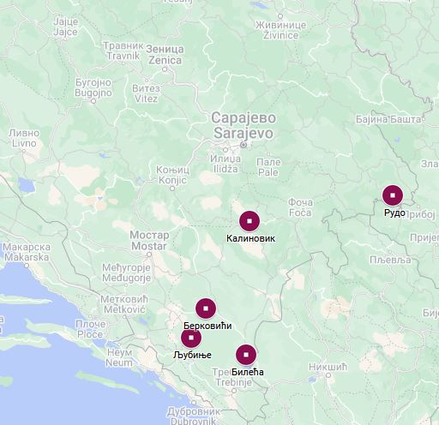

Figure 1. Geographical position of selected towns in the Republic of Srpska for which we estimate solar radiation.
obtained by using Global Solar Atlas [18]- free online application. GHI is solar energy that falls on one
square meter of a horizontal flat surface during a period of time. As we see in Figure 2, daily average GHI varies over the interval 3.2-4.4 kWh/m², while the annual average is in the interval 1100-1600 kWh/m². It is also noticeable that irradiation increases towards the south.

2.1 Daily average irradiation profile

Bileća is the southernmost town of the considered region. It is located in the karst field at an altitude of around 470 m, and has about 2200 sun hours per year. Geographical coordinates of Bileća are taken to be 42.874° (42° 52’ 26.4’’) north latitude and 18.429° (18° 25’ 44.4’’) east longitude. For these coordinates, in Figure 3(a)-(d), we present average hourly values of irradiance in January, April, July and October, obtained from PVGIS data collected over the period 2005-2020 with the resolution of one hour. Irradiance is the amount of energy that, in one second, hits one square meter of a plane, i.e. it is a power per unit area. Average global G(i), direct (beam) Gb(i) and diffuse Gd(i) irradiances on a fixed horizontal plane are presented. Direct irradiance strikes the plane directly from the Sun’s disk, whereas diffuse irradiance strikes the plane from all other directions, after being scattered by the atmosphere, mainly by the clouds.

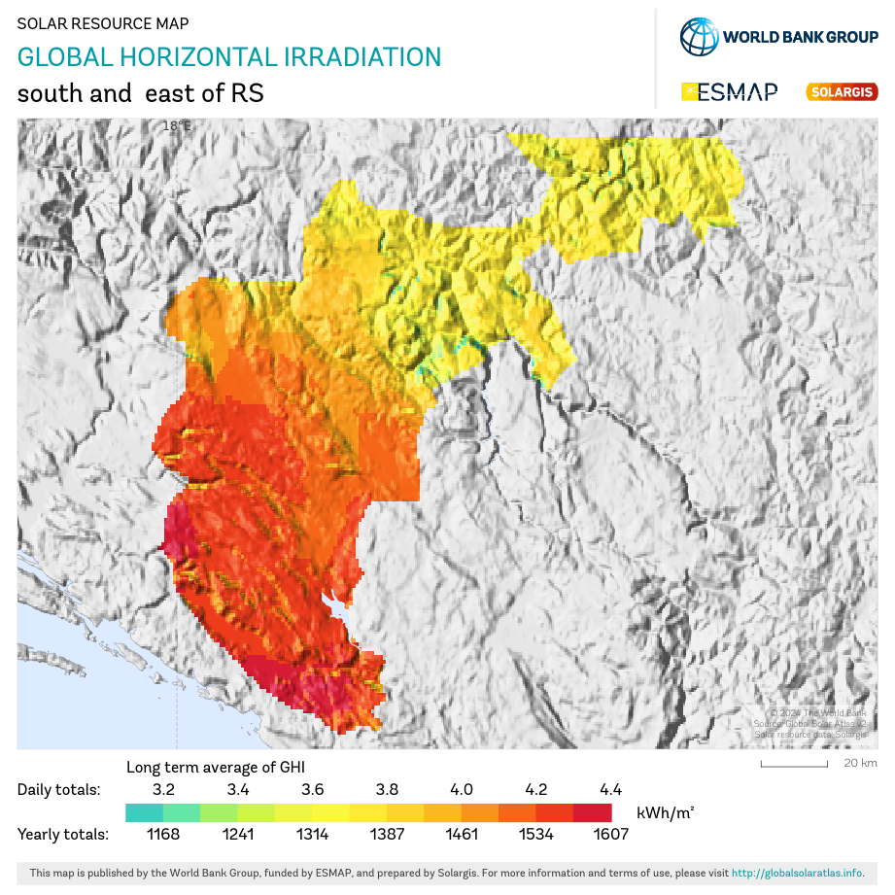
Figure 2. The map of GHI for selected region.

Figure 3. Hourly average global, direct and diffuse solar irradiance distribution over a day in January (a), April (b), July (c) and October (d) for Bileća.
They are the components of global irradiance, which represents total irradiance o the horizontal plane. It is noticeable in Figure 3(a)-(d) that irradiances reach the peak around the solar noon, and that the largest sunshine duration and irradiances occur in July. Also, values of diffuse irradiance in comparison to direct are smallest in July, indicating that weaker attenuation is present in July, due to mostly clear sky conditions. From average hourly irradiances for each day in a given month, for the period 2005-2020, we estimate average daily irradiations by months, i.e. average energy which falls on one square meter during a typical day in a given month. Geographical coordinates of all five considered locations for which calculations are done, are given in Table 1. For each town, in Figure 4(a)-(d), we present average daily irradiations on a horizontal plane in January, April, July and October, i.e. for a month in each season. Daily average value of GHI is the lowest for January in Kalinovik (1.29 kWh/m² ), whereas the highest value is for July in Bileća (7.13 kWh/m² ). Furthermore, as can be seen in Figure 4, Bileća, Ljubinje and Berkovići have higher and similar values of corresponding daily irradiations, whereas Kalinovik and Rudo have lower, mutually similar irradiations.

2.2 Average monthly irradiation, diffuse to global ratio and temperature

PVGIS provides the data of GHI for each month over the period 2005-2020. Also, data of global irradiation on a plane tilted at optimum angle (GOI) are available. For a fixed inclined plane, global

Town | Bileća | Ljubinje | Berkovići | Kalinovik | Rudo
Latitude | 42.874° | 42.952° | 43.117° | 43.504° | 43.618°
Longitude | 18.429° | 18.090° | 18.067° | 18.447° | 19.366°
Altitude | 473m | 408m | 870m | 1069m | 399m
Tilt angle | 36° | 34° | 36° | 33° | 34°
Table 1. Geographical coordinates (north lattitude and east longitude), altitude and optimum tilt angle for considered locations.

Figure 4. Average daily global (GHI), beam (BHI) and diffuse (DHI) irradiation on a horizontal plane for January (a), April (b), July (c) and October (d).

irradiation is maximal at optimum angle, and this option should be considered while planning installation of PV modules. Optimum tilt angle is given in Table 1 for each considered town. Another quantity of interest
is direct normal irradiation (DNI). DNI is direct irradiation on a plane always facing normally to the Sun rays, which can be accomplished by tracking systems. In Figure 5, which presents average monthly GHI calculated for each month, one can see that the lowest value of GHI, below 50kWh/m², is for December in Kalinovik, whereas the highest monthly values are over 220kWh/m² for July in Bileća, Ljubinje and Berkovići. Average global irradiation at optimum angle by months is presented in Figure 6, together with numerical values given tabularly. GOI is the most relevant parameter concerning our PV output estimates, and we will refer to these values in the next section. One can see that, compared to horizontal plane, optimum angle significantly increases global irradiation in non-summer months, almost up to 100% in winter.
High values of DNI and higher than GHI in non-summer months, are displayed in Figure 7. In Figure 8, average monthly diffuse to global ratio is shown, where we see how the ratio decreases towards summer months, when direct irradiation dominates. The ratio is the largest for Kalinovik and Rudo in all months. It is especially large in winter when it reaches 67% for December in Kalinovik, for example.

Figure 5. Average monthly GHI (by months) for five considered towns.

Figure 6. Average monthly GOI (by months) for five considered towns.
Finally, average monthly temperature for all five towns is presented in Figure 9. We see that among all considered towns, Kalinovik has the lowest average temperature for each month during the year. It is below zero degrees Celsius in December, January and February, which is expected since Kalinovik is settled at mountainous region at an altitude over 1000 m (Table 1). Rudo has similar average temperature to Kalinovik, but somewhat higher. Ljubinje has the highest average temperature among all considered locations, slightly higher than Bileća and Berkovići, with milder winters.
As an overall review, in Figure 10, we present average yearly GHI, GOI and DNI. We see that Bileća is in a slight advantage, e.g. GHI is 1508 kWh/m² per year, while GOI is 1767 kWh/m². For Kalinovik GHI is 1320 kWh/m², while GOI is 1487 kWh/m². Average yearly values of GOI for each location are also presented in Table 2.

Figure 7. Average monthly (by months) DNI for five considered towns.

Figure 8. Average monthly diffuse to global Figure 9. Average monthly temperature for all five irradiation ratio for all five towns. towns

Figure 10. Average annually GHI, GOI and DNI for five considered towns.

Figure 11. Average monthly energy production from PV crystalline silicon modul of 5kWp nominal power, installed at fixed, optimum angle.

- ESTIMATES OF PV OUTPUT

In this section we present estimates of electrical energy that could be generated by grid connected PV modules installed at rooftops of households and buildings. We assume that the solar module is crystalline silicon (c-SI) with the nominal (peak) power of 5kWp, and that it is fixed at optimum angle. Effects of terrain shadowing are accounted for through the built in option ‘calculated horizon’. Besides automatically accounted losses due to cell’s efficiency, we add up an additional loss of recommended 14% for the overall system loss (cables, inverters…). Results for average PV output by months (average electrical energy in kWh generated by the module in each month) are given in Figure 11. We see that the largest PV outputs over most of the months are for Bileća and Berkovići, then Ljubinje. Among all months, the largest outputs are in July, and they vary from about 668 kWh for Rudo to 754 kWh for Berkovići. The smallest outputs for all towns are in December, and they vary from 233 kWh for Kalinovik to 373kWh for Bileća. From tabular values in Figure 11, it follows that, except for winter months, the amount of generated electrical energy may meet demands of four-membered family, with extra production in July and August. The corresponding values of energy that is received by one square meter of the module are given in Figure 6, where Global irradiation at optimum angle is shown graphically and tabularly. One should bear in mind that the overall surface of 5kWp module is about 30 square meters, so that the total energy it receives (incident energy) is 30 times larger than GOI. From values given in Figure 11 and the corresponding values given in Figure 6 multiplied by surface, it is obtained that 10-13% of solar energy is converted into electricity, depending on town and month. Although Bileća receives the largest amount of energy, the largest percentage i.e. the best conversion is obtained for Kalinovik and then Berkovići. They are at higher altitudes where temperature, wind and other meteorological conditions might give better working conditions for PV modules.
As an overall view, in Table 2, for each considered town, we present average daily and monthly values throughout the whole year and average yearly, for the period 2005-2020. The average values are given
for GOI – total energy received by one square meter of the modules at optimum angle and for energy generated by the whole module.

Table 2. Average daily, monthly and yearly values of solar energy received by one square meter of 5kWp module set at the fixed optimum slope and zero azimuth. Corresponding outputs of the module (the whole PV array ) are also given.
Town | Geographical coordinates | Optimum tilt angle | Daily GOI kWh/m² | Monthly GOI  kWh/m² | Yearly GOI  kWh/m² | Daily output  kWh | Monthly output  kWh | Yearly output  kWh
Bileća | 42.874 N 18.429 E | 36° | 4.84 | 147.23 | 1766.78 | 18.02 | 548.20 | 6578.38
Ljubinje | 42.952 N 18.090 E | 34° | 4.66 | 141.64 | 1699.65 | 17.04 | 529.14 | 6349.68
Berkovići | 43.117 N 18.067 E | 36° | 4.74 | 144.16 | 1729.91 | 18.03 | 548.35 | 6580.17
Kalinovik | 43.504 N 18.447 E | 33° | 4.07 | 123.89 | 1486.73 | 15.96 | 485.35 | 5824.25
Rudo | 43.618 N 19.366 E | 34° | 4.11 | 124.88 | 1498.52 | 15.32 | 466.13 | 5593.54

- SUMMARY AND CONCLUSIONS

In this paper we have estimated and analyzed solar energy potential of five towns, capitals of the same-named municipalities, located in the southeastern part of the Republic of Srpska. Average daily GHI, BHI and DHI are presented for a month in each season in Figure 4 (a)-(d), whereas average daily value of GOI over a whole year is given in Table 2. Average monthly GHI, GOI, and DNI for each month are given in Figures 5-7, whereas average monthly GOI over a whole year is given in Table 2. Average yearly GOI is given in Table 2. From the values of these parameters, it is evident that Bileća, Ljubinje and Berkovići, with average annual GOI of about 1700 kWh/m², are municipalities with exquisite conditions for solar energy harnessing. Regarding solar potential they are almost comparable with the southern coastal part of Croatia, and more favorable than Serbia in average [19]. Kalinovik and Rudo have average annual GOI of about 1500 kWh/m², which is still significant, and is comparable with Pannonian part of Serbia and Croatia [20], for example.
We have also estimated the amount of electrical energy that could be produced by solar modules with a nominal power of 5kWp, possibly installed on the rooftops at fixed optimum angle and oriented south. Average monthly PV output for each month and each town is presented in Figure 11, whereas average daily and monthly values over a year and average annual values are presented in Table 2. Berkovići and Bileća have the largest annual outputs, about 6600kWh of electricity generated per year, which is more than energy demand of an average household. For all considered locations, the amount of generated electricity can cover the household’s needs in average. In winter, grid supplement might be necessary, whereas in summer, an excess energy could be exported to the utility grid.
One should remark that the values of irradiations obtained and presented in this paper are just the estimates made on the basis of satellite provided data for the given coordinates. Temporal resolution of the data are one hour, while spatial resolution is 5 km. Besides, landscape near the chosen locations can produce additional shadowing effects, which were not taken into account in calculations. For these reasons, more precise assessment would require finer resolution and all the estimates should be validated with the data produced by ground station measurements.
Also, we would like to mention that, since most rooftops are already inclined, the panels could be mounted at roof angle, without additional tilt frames. Then, estimates can be made for any given angle. This would result in smaller outputs than presented here, depending on the deviation of roof angle from optimum tilt angle. In most cases, for small power plants, it might not be financially profitable to make adjustments for optimum angle.
Finally, as we found that the considered area is very favorable for solar harnessing, we would like to mention that this study can easily be extended on estimates of PV output for large solar power plants with tracking systems, which would be the subject of our future work.

- ACKNOWLEDGEMENT

This research is financially supported by the Ministry of Scientific and Technological Development and Higher Education of the Republic of Srpska through the project No. 19.032/961-26/23 approved on 29.12.2023.

- REFERENCES

[1] T. M. Letcher, V. M. Fthenakis (eds.) A comprehensive Guide to Solar Energy Systems, Academic Press Elsevier, London, 2018.
[2] M. E. Mackay, Solar energy- An Introduction, Oxford University Press, Oxford UK, 2015.
[3] R. Foster, M. Ghassemi, A. Cota, Solar Energy: Renewable Energy and Environment, CRC Press, Boca
Raton, 2010. [4] IRENA, World Energy Transitions Outlook 2023, https://www.irena.org/Publications/2023/Jun/World-Energy-Transitions-Outlook-2023
[5] F. Sher, N. Smječanin, H. Hrnjić, E. Bakunić, J. Sulejmanović, Prospects of renewable energy potentials and development in Bosnia and Herzegovina – A review, Renew. Sustain. Energy Rev., 189 (2024) 113929.
[6] Law on renewable energy sources, Official Gazette of the Republic of Srpska, no.16/22, Banja Luka, 2022.
https://www.derk.ba/DocumentsPDFs/Zakon-o-obnovljivim-izvorima-energije-RS-16-2022-h.pdf
[7] EU Science Hub, https://joint-research-centre.ec.europa.eu/photovoltaic-geographical-information-system-pvgis_en
[8] M. Šúri, T. A. Huld, E. D. Dunlop, PV-GIS: a web-based solar radiation database for the calculation of PV potential in Europe, Int. J. Sustain. Energy, 24 (2005) 55-67.
[9] M. Šúri,T. A. Huld, T. Cebecauer, E. D. Dunlop, Geographic Aspects of Photovoltaics in Europe:Contribution of the PVGIS Website, IEE Journal of selected topics in applied Earth observations and remote sensing, 1 (2008) 1939-1404.
[10] I. Radonjić Mitić, T. Pavlović, D. Mirjanić, D. Divnić, L. Pantić, Reviewing the photovoltaic potential of Bijeljina in the Republic of Srpska, Facta Universitatis, Series: Electronics and Energetics 36 (2023), 465-483.
[11] D. LJ. Mirjanić, T. M. Pavlović, I. S. Radonjić, L. S. Pantić, G. I. Sazhko, Solar radiation atlas in Banja Luka in the Republic of Srpska, Contemporary Materials, XII˗1, (2021), 29-49.
[12] D. Lj. Mirjanić, T. M. Pavlović, I. S. Radonjić, L. S. Pantić, A. V. Marić, G. I. Sazhko, Solar radiation atlas in Trebinje in the Republic of Srpska, Proceedings from International Scientific Conference “UNITECH 2020” – Gabrovo, 20-21 November 2020, pp. I-33 – I-38
[13] D. D. Milosavljević, T. M. Pavlović, D. Lj. Mirjanić, D. Divnić, Photovoltaic solar plants in the Republic of Srpska - current state and perspectives, Renew. Sustain. Energy Rev., 62 (2016) 546-560.
[14] T. M. Pavlović, D. D. Milosavljević, D. Mirjanić, L. S. Pantić, I. S. Radonjić, D. Piršl, Assessment and perspectives of PV solar power engineering in the Republic of Srpska (Bosnia and Herzegovina), Renew. Sustain. Energy Rev., 18 (2013) 119-133.
[15] T. M. Pavlović, , D. D. Milosavljević, D. Lj. Mirjanić, I. S. Radonjić, L. S. Pantić, D. Piršl, Analyses of PV systems of 1 kW electricity generation in Bosnia and Herzegovina, Contemporary Materials (Renewable energy sources) II-2 (2011) 123–138.
[16] D. Mirjanić, S. Maksimović, D. Divnić, T. Pavlović L. Pantić, D. Milosavljević, Investigation of energy efficiency of polycrystalline silicon solar modules in relation to their geographical orientation and tilt angle, Contemporary Materials (Renewable energy sources) VI-2 (2015) 87–94.
[17] UNFCC Bosnia and Herzegovina, https://www.unfccc.ba/en/analize-en/klimatskekarakteristikebih-en
[18] SOLARGIS, Global Solar Atlas, https://globalsolaratlas.info/map
[19] T. Pavlović, D. Milosavljević, I. Radonjić, L. Pantić, A. Radivojević, M. Pavlović, Possibility of electricity
generation using PV solar plants in Serbia, Renew. Sustain. Energy Rev., 20 (2013) 201-218.
[20] B. N. Smaragdakis, D. Šljivac, V. Katić, T. Stajić, Z. Čepić, D. Topić, M. Vukobratović, Solar energy potential in
Pannonian part of Serbia and Croatia, International Journal of Electrical and Computer Engineering Systems, 3-1 (2012),
31-39.

Daily average over a whole year could be calculated as a weighted average of daily averages for each month, and these values would vary in the same range as those given in the map in Figure 2.
For a module with peak efficiency $e_{ff}=0.15$, the surface of the module would be $A=\frac{5kWp}{1\frac{kWp}{m^{2}}*0.15}≈33m^{2}$.

