MECHANICAL DEFORMATION OF CARBON NANOTUBES FOLLOWED BY LOCAL ELECTRON TRANSFER

Zoran P. Popović¹, Milan Damnjanović^{1,2}, Ivanka Milošević¹
¹ NanoLab- Faculty of Physics, University of Belgrade, Belgrade, Serbia;
²Serbian Academy of Sciences and Arts, Kneza Mihaila Street 35, Belgrade, Serbia;
*Corresponding Author E-mail: zokapop@ff.bg.ac.rs

Abstract: Structure and geometry, modelling of carbon nanotubes enable to generate whole system from a single representative atom, by symmetry transformation. Hence, symmetry can be used to reduce calculations and prediction of electronics and wide range other relevant physical properties. Homogeneous mechanical deformation, that preserves symmetry, causes Hamiltonian reparameterization that influences change of energy bands change. For semiconducting carbon nanotubes, the most significant changes occur around Fermi level, where the process involves conducting and valence bands with the same angular quantum number. Deformations can be varied until bands come close to each other. Inside Brillouin zone bands approach always in two points symmetrical with respect to gamma point during homogeneous deformation of carbon nanotube. In accordance with the non-crossing rule, valence and conducted states never intersect if they have all quantum numbers the same, even in the moment they take cone-like shape when it comes to the change of Berry phase. This is interpreted as the change of average positions of two electrons simultaneously by tunneling from the onsite position toward the intermediate position between two neighbor sites or vice versa, despite that nanotube is semiconductor.

Keywords: carbon nanotube; symmetry; Berry phase; deformations.

INTRODUCTION IN CARBON NANOTUBES

Carbon nanotubes (CNTs), when discovered and produced by arc-discharged evaporation method [1] in 1991. were described as needle-like finite carbon structures. Using electron microscopy, it was found that each needle grown at the negative end of the electrode used for the arc discharged, contains coaxial tubes of graphitic sheets. The single wall carbon nanotubes (SWCNTs) are found as one of the carbon allotropes just like early predicted stable structure of fullerene [2, 3] and graphene, single layer of carbon atoms directly observed by electron microscopy [4]. Later, after the discovery of CNTs and the understanding of their atomic structure, they were modeled in a various manner to calculate and predict their physical properties as efficiently as possible. The simplest model is conceived as the bending of graphene into a cylinder along a vector that forms a chiral angle relative to the basis vector of the unit cell, having characteristic atomic structure that forms regularly arranged hexagons on the surface of the cylinder, characterized by the chiral angle and the cylinder's diameter. All the line groups given by [5] for all SWCNTs were identified, they allowe for the simple generation of models only from a single atom. This is followed by efficient calculation of phonon and electronic bands, and consequently, the derivation of physical phenomena and properties of nanotubes.
Carbon nanotubes exhibit remarkable physical properties, including mechanical, thermal, electrical and optical, that make them attractive for intensive theoretical and experimental investigation continuously since their discovery [6]. For example, given in [7], tensile strength of individual multi wall carbon nanotubes measured in tensile load experiment, ranged from 11 to 63 GPa, while Young’s modulus of outermost layer varied from 270 to 950 GPa. Besides, in accordance with specific elastic properties, very high thermal conductivity of SWCNT and MWCNT as well as in graphene was measured and found to be one of their most interesting properties. The observed thermal conductivity is temperature dependent with the peak at 320 K [8], and theoretically is predicted to be very sensitive to atomic carbon structure [9, 10]. Optical activity of SWCNTs was studied within the framework of symmetry application, and classification of possible optical devices explained by [11], as well as optical conductivity tensor along with electron energy loss function, allowed and peak position transition which are predicted in relation with quantum numbers are predicted and given in [12]. One of the first theoretical estimations of charge transport properties of CNT confirmed by [13], based on first- principles and self-consistent calculations, show their similarity with metals or zero band gap at room temperature and predict that their transport properties are most like quantum wires [14]. Electronic band structures of CNTs are found to tube dependent, often degenerated, but all these predicted with a help of applying their symmetry group. Relative to charge transport phenomena prediction, there is the need for full assignment of electronic bands. Complete set of quantum numbers consists of the angular and linear quasi-momentum and parities with respect to the specific symmetry element like U axis or mirror planes, they are used to classify physical tensors, enabling their application through selection rules applications, discussed by [15, 16].
Charge fractionalization occurs as the most interesting manifestation in condensed matter physics, of which the earliest theoretical prediction was in the contents of relativistic theory given by [17]. An equivalent phenomenon in solid state was predicted in the Su Schriefer and Heeger (SSH) model [18], where the structure of polyacetylene was considered as 1D dimerized chain of electrons. In this model soliton with fractionalized quantum numbers occurs between the two dimerization states. Carbon nanotubes could be driven through a topological phase transition using either strain or a magnetic field, that lead to fractionalized charges with spatially inhomogeneous strain axial field [19]. These two types of fractional states occur between regions with different strains.
Homogeneous deformations that preserve symmetry will be applied to localize charge periodically along the tube at different positions from monomer the middle or ends. Berry phase is one of the most important quantities in topological band theory, related to smoothly modifying phase of electrons Bloch states with slow adiabatic evolution of parameters of the system.

f
2. MODEL OF SWCNTs AND THEIR ELECTRON BAND STRUCTURE

Graphene possesses such a crystal structure that electrons through it can travel along sub-micrometer distances without common scattering events. The electron structure of graphene is such that electron charge carriers behave like massless relativistic particles shown in [20, 21]. Electronic spectra of graphene sheet are useful for understanding the important properties of electronic spectra of SWCNTs, since they are very sensitive to tube diameter and wrapping angle [22].

2.1. Symmetry generated model of SWCNT and their deformation modeling

Carbon nanotube models could imagine as graphene layer folded along chiral or wrapping vector $c$. This is the origin of one commonly used assignment of SWCNTs with pairs of integers $\left(n_{1},n_{2}\right), n_{1}>n_{2}$, that relate with chiral vectors $c=n_{1}a_{1}+n_{2}a_{2},$ where $a_{1},a_{2}$ are layer lattice basis vectors. Chiral vector defines relevant geometrical parameters, diameter $D=c/π$ of nanotube and inclination angle $θ∈\left[0,30°\right],$ which strongly correlates with electronic properties. According to the atom arrangement, they possess nontrivial symmetry, depending on chirality described with the line group. Model of any SWCNT can be generated only from single carbon atom, called orbit representative with coordinates $r_{000}=\left(\frac{D}{2},ϕ_{0},z_{0}\right),$ by affecting line group generators
$$l_{tsu(v)}={\left(C_{q} | f\right)}^{t}C_{n}^{s}U^{u}\left(σ_{V}^{v}\right).$$
They are element $\left(l_{tsuv}\right)$ of thirteenth family $L^{\left(13\right)}=T_{2n}D_{nh}$, and generate CNTs classified as achiral zig-zag $\left(n,0\right)$ or armchair $\left(n,n\right)$ nanotubes, or $l_{tsu}$ from the fifth family $L^{\left(5\right)}=T_{Q}D_{n}$, that generate chiral nanotube$.$ Rotation for $\frac{2π}{Q}$ followed by fractional translation is labeled with $\left(C_{Q} | f\right),$ $C_{n}$ is pure rotation around main axis of the tube ($z-$axis) for $\frac{2π}{n}$ with $n=GCD\left(n_{1},n_{2}\right)$, $U$ is rotation around $x-$axis (which passes through center of hexagon that contains orbit representative) for $π$. Exponents of generators, often written as set $\left(t,s, u,\left(v\right)\right)$, which elements take values $t=0,±1,±2,…; s=0,1,…,n-1;u=0,1;v=0,1,$ where is orbit representative labeled with $C_{000}$ ($\left(t,s,u\right)=(0,0,0)$)$.$ Parameters of line groups $Q,n,f$ are function of geometrical parameters and $n_{1}$ and $n_{2}.$ Line groups are composition of screw axis $T_{Q}$ and point subgroup $D_{n}$ for 5th family generated from $\{U,C_{n}\}$ shown in Fig.1, or $D_{nh}$ for 13th family which additionally possesses mirror planes $σ_{V/H}$.
Mimics realistic homogeneous deformation, generated model of SWCNT is deformed by experimentally realized deformation [23], with the goal of varied electronic properties. Experiments with twisting or strained force applied to individual CNT [24] showed effects on band gap. Electrons near Fermi level have an especially strong response to the deformations. So, symmetry breaking in metallic NT by torsion is followed by band gap oscillation. Coupling between deformations applied on various SWCNTs and their impact on electro-optical properties is theoretically investigated [25]. Homogeneous deformation is realized by changing all atoms from the tube in the same manner. It is achieved by changing line group parameters $Q, f$ or NT diameter. Radial deformation $D'=D(1+ϵ)$, which looks like radial breathing mode, is realized by changing the radius of all carbon atoms in the same way while symmetry is preserved.
Deformations are directly related with group parameters. Continuous torsion for angle $τ$ per unit length is modelled as action of screw axis elements by changing
$$\frac{1}{Q^{'}}=\frac{1}{Q}\left(1+τ\frac{Qf}{2π}\right).$$

Axial stretching $ε_{z}$ corresponds to change of fractional translation
$$f^{'}=f\left(1+ε_{z}\right),$$
where applied intensities are very small, only a few percent. When deformation is fixed, all rest coordinates are relaxed until minimum energy is reached, so continual deformations cause smooth continual change of geometrical parameters. Deformations intensities along with cylindrical coordinates of representative carbon atom $C_{000}$ making continual changeable parameter space. For such a configuration electron band calculation is calculated.

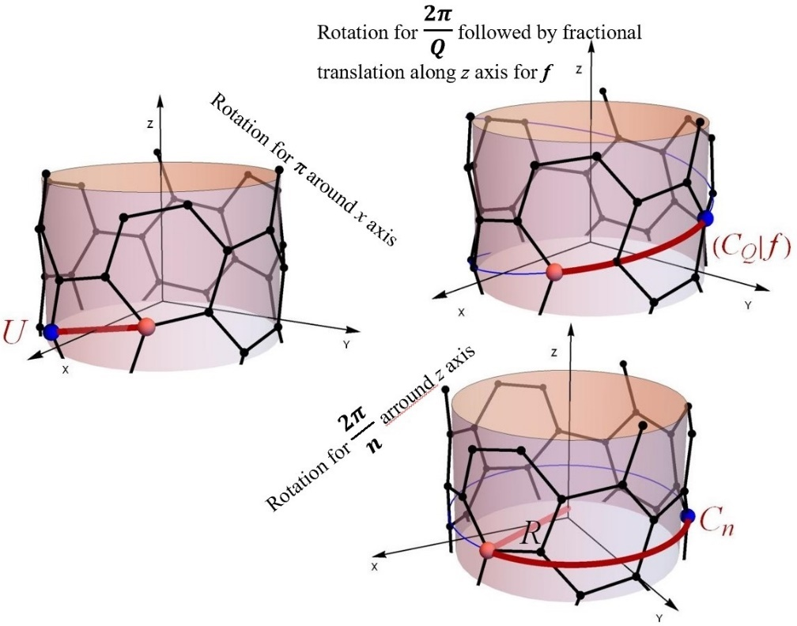
Figure 1. Action of line group generators from the 5th family for chiral (6,3) SWCNT, where the blue atom is created from orbit representative (red).

2.2. Electron bands SWCNTs in relaxed and deformed configurations

Electronic properties of CNTs correlate with their atomic structure. According to the conducting characteristics based on electronic band structure they are divided into metallic armchair, quasi-metallic if $n_{1}-n_{2}$ is divisible by 3 and $n_{1}≠n_{2}$ with a small narrow band gap mainly conducting at room temperature. Otherwise, they are semiconducting with an energy gap of the order of 0.5 eV, strongly dependent on tube diameter discussed in [26, 27].

Simplest framework of tight-binding spin-independent model is implemented to obtain electronic band structure. Quantum state space of electron is built from $\left.{|p}_{z}\right\rangle = \left.|tsu\right\rangle$ orbitals, each one localized at carbon atom $C_{tsu}$ perpendicular to the tube surface, could be imagine as generated from $C_{000}$ by action of line group. Used only $p_{z}$ orbitals are obtained Hamiltonian and metric matrix elements, further used to construct their pulled down operators $H_{μ}^{↓}, M_{μ}^{↓}$ on symcell auxiliary space [28]. Considering this approximation is quite relevant for examined topology characteristics, due to used orbitals create states around Fermi level, conductive for metallic as well as highest occupied (HOMO) in valence and lowest unoccupied (LUMO) in semiconducting NT. These relevant electron state spaces around Fermi level do not change significantly if rest orbitals are taken (into $sp^{3}$ bounds) and larger electron state space is constructed. With this reduction of state space acceleration of calculations is achieved, without losing the quality of information.
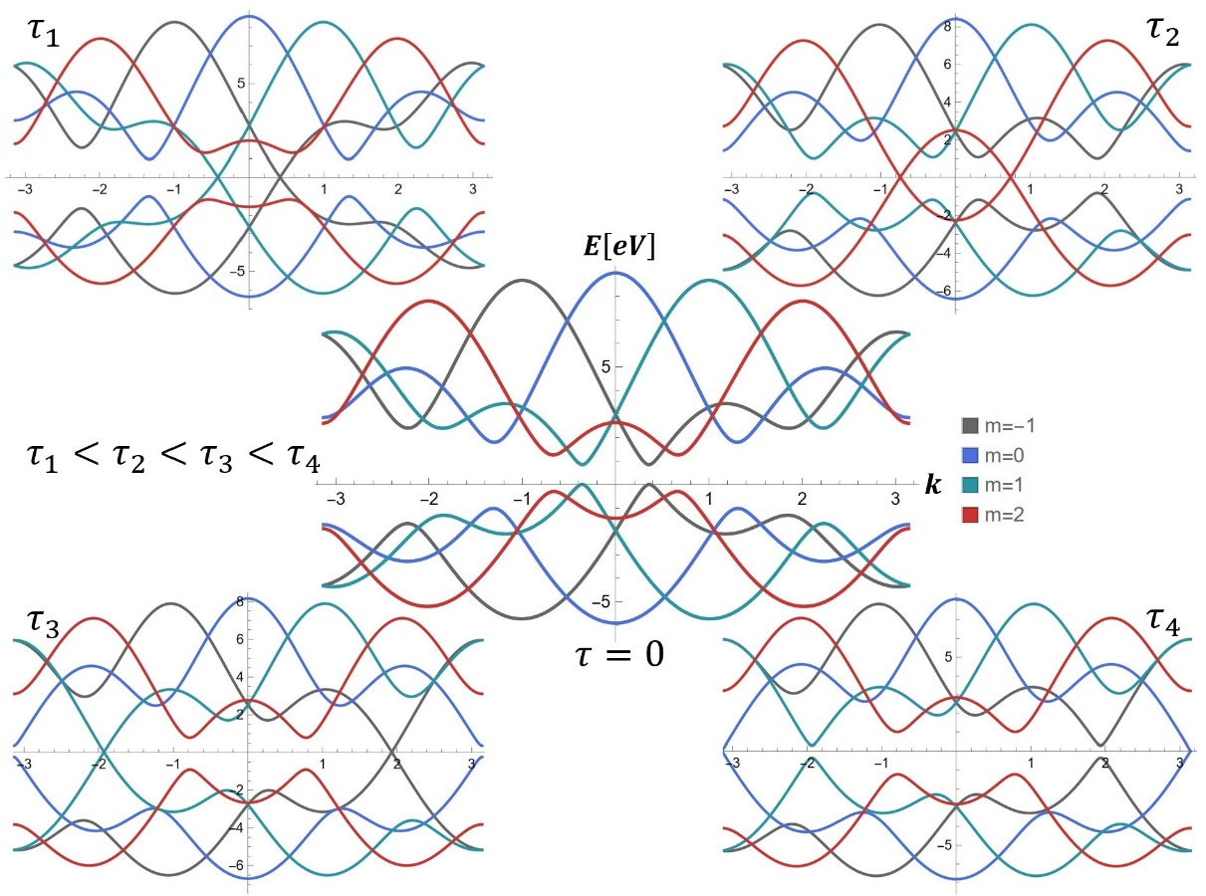
Figure 2. Electronic band structure, in the middle of non-deform, up and down for twisted (8,4) SWCNT up to degree that valence and conduction bands are touching.
Deformation is followed by changing the mutual distance of carbon atoms, that causes change overlap and Hamiltonian matrix elements. Related to the degree of deformation, the shape of electron bands is changing. Those with different $\tilde{m}$ could mix, since counterparts with same angular quantum number, filled below and unfilled above Fermi level, approach to each other forming direct disappearance gap like it is illustrated in Fig. 2. This cone-like shape of electron bads never touch and has important role in the occurrence of phase transition.

3. TOPOLOGY

Extend calculations of electron band structure is performed in approximation of single $p_{z}$ orbital per carbon atom, allowing reduction of calculation for very large number of different CNTs deformed configuration. For certain type and various intensity of deformation using POLSym code [5] are obtained electron bands with eigenvectors of each appropriate point from Brillouin zone applying the next algorithm. To the vectors of electron state are assigned helical quantum numbers $μ=\left(\tilde{k},\tilde{m}\right)$ where $\tilde{k}∈\left[0,π/f\right]$is helical quasi-momenta and $\tilde{m}∈\left[0,n/2\right]$is angular quantum number. Orthonormalized states are obtained by next relations firstly is found energy spectrum $ε_{μt_{μ}}$ from BZ and vector form reduced BZ at reference atom $C_{000}$ by solving next eigen problem

$$W=M_{μ}^{↓}H_{μ}^{↓}, W{|\left.ε_{μt_{μ}}\right\rangle }^{0}=ε_{μt_{μ}}{|\left.ε_{μt_{μ}}\right\rangle }^{0}$$
then, parts of vectors for each calculated state are partitioned on segments correspond to appropriate part from BZ.

$${|\left.ε_{μt_{μ}m}\right\rangle }^{0}={\left\langle μm\right.|\left.ε_{μt_{μ}}\right\rangle }^{0}, {|\left.ε_{μt_{μ}m}\right\rangle }^{tsu}=\sum_{m'}{D_{mm^{'}}^{\left(μ\right)*}(l_{tsu})} {|\left.ε_{μt_{μ}m'}\right\rangle }^{000}$$
Further, vectors determined up to phase correspond to all numerically obtained states, filled as well as unfiled are unpacked up to electron vectors, extended to columns whose components correspond to the atoms from the initial monomer $|\left.\tilde{k},\tilde{m}\right\rangle$. Applying deformation of SWCNT, the system is changed along with its geometrical parameters that is the relative position of the atoms, but also Hamiltonian and its spectrum with conducting characteristics including gap like shown on Fig.3, as well as eigenvectors too.

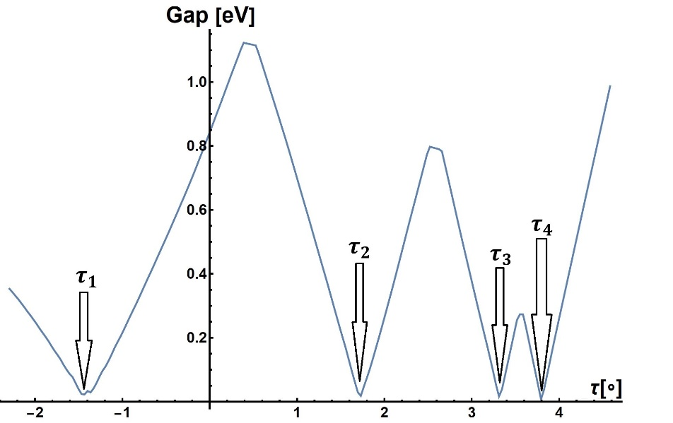
Figure 3. Gap dependance on torsion angle for (8,4) CNT prominent when gap tends to zero.
These changes can be considered as slow time evolution followed by phase evolution of the vector state, seen as change of two terms recognized as dynamical and Berry phase [29]. Given procedure of searching spectrum and vectors is preparation for calculation and analysis of Berry phase, for filled bands with $\tilde{m}$ of semiconducting SWCNT
$$ϑ_{\tilde{m}}=i\int_{-π}^{π}{TrA(\tilde{k})d\tilde{k}} mod 2π,$$

where $A(\tilde{k})$ is Berry connection calculated as
$$A\left(\tilde{k}\right)=\left\langle \tilde{k},\tilde{m}\right.|∂_{\tilde{k}}|\left.\tilde{k},\tilde{m}\right\rangle$$
For the 1D system Berry phase is related to the position of the centers of Wannier orbitals within a unit cell. In geometric-phase theory Berry phase is identified as an average position of charge. Regardless of initial phases of electronic state, they are functionally dependent on adiabatically changed parameters and change smoothly with them. There is simple physical interpretation of this quantity, by which it is claimed that it is possible to map electron density coincide with classical point charge as
$$\frac{ϑ}{2π}=\frac{ϑ}{2π} +R, R∈Z$$
where $R$ labels unit cell, in this case monomer, where the electron is localized [30]. Due to the presence symmetry of $U$ axis values of Berry phase take quantized values $ϑ∈\left\{0,π\right\}.$ Using relation between $ϑ$ and centers of Wannier function $\overline{z}$ within a unit cell
$$\frac{\overline{z}}{f}=\frac{ϑ}{2π} mod 1.$$

From previous observations can be concluded that electron in SWCNT or homogeneously deformed sitting at site when $ϑ=0$ then $\overline{z}=0$, or between two neighbor sites where for $ϑ=π$ Wannier orbital is located at $\overline{z}=f/2.$
Continual deformation causes smooth change in parametric space of Hamiltonian matrix elements, and energies too, along with the components of electronic eigenvectors. These changes occur slow enough to characterize the process as adiabatic.

Change of Berry phase occurs when valence and conduction bands with the same angular quantum number, during Hamiltonian reparameterization caused by deformations, come close to each other. Due to the non-crossing rule, they never cross or touch each other, that is the direct gap during these processes never closes. Conducted states from bands with opposite angular quantum numbers $\tilde{m}$ and $-\tilde{m}$ simultaneously approaches their filled valence counterpart near Fermi levels, causing two electrons shift.
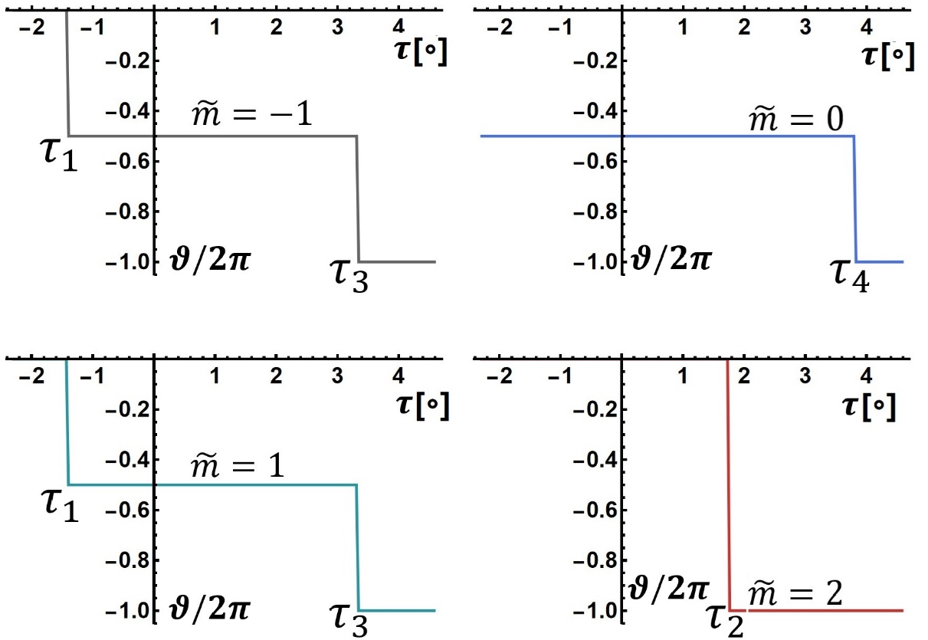
Figure 4. Quantized change of Berry phase achieving prominent torsion angles for bands with different $\tilde{m}$.
For illustration, in equilibrium state (8,4) SWCNT is semiconductor with direct gap between HOMO and LUMO electron states, belong bands with $\tilde{m}=1$ and $\tilde{m}=-1$ Fig. 2 (center). Small selected distortion of the system while its symmetry is preserved can lead to a narrowing of the band gap for both counterparts simultaneously Fig. 3. For example, twisting up to small torsion angles $τ_{1}$ and $τ_{3}$ these bands become close enough Fig. 2 that phase transition takes place. If this occurs in succession, that is system cross $τ_{1}$ and afterwards $τ_{3}$. In these distortions states of CNT each pair of bads touches in different $\tilde{k}$ point Fig.2 (left up and down), and Berry phase of electrons with $\tilde{m}=±1$ at first undergoes change for $-π$, since each pair touches in one point, and then again additionally for $-π$, i.e. totally for $-2π$ Fig. 4 (left up and down). In the meantime, since the deformation is continuum and system pass through $τ_{2}$, bands with $\tilde{m}=2$ approach to Fermi level by closing gap Fig. 2 (right up), with two cone-like peaks symmetrically positioned related to $Γ$ point ($\tilde{k}=0$), causing change of Berry phase for $-2π$ Fig. 4 (right down). By continuing twisting up to $τ_{3}$, band with $\tilde{m}=0$ closed gap in $Π$ point (edge of BZ) Fig. 2 (right down), what makes Berry phase change for $-π$ with.
4. CONCLUSION

During the closed path in parametric space Berry phase is unchanged, in which the system is returned to the original states preserving symmetry cycling along the path. Thanks to symmetrical deformations of the single wall carbon nanotube, Berry phase takes characteristic values, which correspond to the position of the electron at middle or at the ends of the CNT monomer. Given example of Berry phase change of deformed chiral CNT show that, based on physical interpretation of applying continual homogeneous deformation it is possible to achieve reversible but controllable shift of electron with appropriate quantum numbers along the tube for the length of the monomer.

ACKNOWLEDGEMENT

This work is funded by Ministry of Science, Technological Development and Innovation, Projects 451-03-
47/2023-01 and SANU-F93.

4. REFERENCES

[1] Sumio Iijima, Helical microtubules of graphitic carbon, Nature Vol. 354, (1991), 56-58.
[2] E. Ōsawa et al., The Evolution of the Football Structure for the C₆₀ Molecule: A Retrospective [and Discussion], A Postbuckminsterfullerene View of the Chemistry, Physics and Astrophysics of Carbon ,Vol. 343, No. 1667, (1993), pp. 1-8.
[3] Z. Yoshida, E. Osawa, Aromaticity; Chemical Monograph Series 22; Kagaku-Dojin: Kyoto, Japan, (1971), pp. 174–178.
[4] J. C. Meyer et al., The structure of suspended graphene sheets, Nature Vol. 446, 2007, 60-63.
[5] M. Damnjanović, I. Milošević, Line Groups in Physics, Lect. Notes Phys. 801, Springer,
Berlin Heidelberg (2010).
[6] J. Chen et al., A Brief Introduction of Carbon Nanotubes: History, Synthesis, and Properties, Journal of Physics: Conference Series, 1984, (2021), 012184(9).
[7] Min-FengYu, O. Lourie et al., Strength and Breaking Mechanism of Multiwalled Carbon Nanotubes Under Tensile Load, Science, Vol. 287, (2000), 637-640.
[8] P. Kim et al., Thermal Transport Measurements of Individual Multiwalled Nanotubes, Phys. Rev. Lett. Vol. 87, 215502, (2001), 21-19.
[9] Z. P. Popović et al., Phonon transport in helically coiled carbon nanotubes, Carbon, Vol. 77, (2014), 281-288.
[10] Z. Popović et al. THERMAL CONDUCTANCE OF HELICALLY COILED CARBON NANOTUBES, Contemporary Materials V-1, Vol 5, No.1, (2014), 37-41.
[11] M. Damnjanović et al., Full symmetry, optical activity, and potentials of single-wall and multiwall nanotubes, Phys. Rev. B, Vol. 60, (1999), 2728-2739.
[12] I. I. Milošević et al., Electro-optical properties of single-walled carbon nanotubes, Physica E: Low-dimensional Systems and Nanostructures, Vol. 12, (2002), 745-748.
[13] J. W. Mintmire et al., Are fullerene tubules metallic?, Phys. Rev. Lett. Vol 68, (1992), 631.
[14] S. J. Tans et al., Individual single-wall carbon nanotubes as quantum wires, Nature, Vol. 386, (1997), 474-477.
[15] T. Vuković et al., Carbon nanotubes band assignation, topology, Bloch states, and selection rules, Phys. Rev. B, Vol. 65, (2002),45418-45429.
[16] Z. P. Popović et al., Transport in helically coiled carbon nanotubes: semiclassical approach, Contemporary Materials, VI−1, (2015), 15-19.
[17] R. Jackiw and C. Rebbi, Solitons with fermion number 1=2, Phys. Rev. D. Vol. 13, (1976), 3398-3409.
[18] W. P. Su, J. R. Schrieffer, and A. J. Heeger, Solitons in Polyacetylene, Phys. Rev. Lett., Vol 42, (1979), 1698-1701.
[19] Y. Efroni et al., Topological Transitions and Fractional Charges Induced by Strain and a
Magnetic Field in Carbon Nanotubes, Phys. Rev. Lett., Vol. 119, (2017),147704(6).
[20] K. S. Novoselov, et al. Two-dimensional gas of massless Dirac fermions in graphene. Nature Vol. 438, (2005), 197–200.
[21] Y. Zhang, et al., Experimental observation of the quantum Hall effect and Berry's phase in graphene. Nature 438, (2005), 201–204.
[22] Jeroen W. G. Wildoer et al., Electronic structure of atomically resolved carbon nanotubes, Nature, Vol. 391, (1998), 59-62.
[23] L. Forro et al., Electronic and Mechanical Properties of Carbon Nanotubes. In: Thorpe, M.F., Tománek, D., Enbody, R.J. (eds) Science and Application of Nanotubes. Fundamental Materials Research. Springer, Boston, (2002),297-320.
[24] A. R. Hall et al., Torsional electromechanical systems based on carbon nanotubes, Rep. Prog. Phys., Vol. 75, (2012),116501(22).
[25] S. Dmitrović et al., Mechanical coupling in homogeneously deformed single-wall carbon nanotubes, J. Phys.: Condens. Matter, Vol. 25, (2013), 145301(6).
[26] N.T. Hung et al., Diameter dependence of thermoelectric power of semiconducting carbon nanotubes, Phys. Rev. B, Vol. 92, (2015) 165426-.
[27] N. Hamada et al., New One-Dimensional Conductor: Graphitic Microtubules, Phys. Rev. Lett., Vol. 68, (1992),1579-1581.
[28] M. Damnjanović and I. Milošević, Full symmetry implementation in condensed matter and molecular physics—Modified group projector technique, Volume 581, (2015), 1-43.
[29] Andrei B. Bernevig, Topological insulators and topological superconductors, Published by Princeton University Press, 41 William Street, Princeton, New Jersey 08540, (2013).
[30] A. Alexandradinata et al., Wilson-loop characterization of inversion-symmetric topological insulators, Phys. Rev. B, Vol. 89, (2014), 155114(18).

МЕХАНИЧКЕ ДЕФОРМАЦИЈЕ УГЉЕНИЧНИХ НАНОТУБА ПРАЋЕНЕ ЛОКАЛНИМ ПОМЕРАЈЕМ ЕЛЕКТРОНА

Сажетак:
Због своје атомске структуре и геометрије, моделирање угљеничних нанотуба могуће је коришћењем једног репрезентативног атома применом симетријских трансформација. Такође, симетрија се може искористити за редуковање времена прорачуна како електронских бендова тако и широког спектра релевантних физичких својстава. Хомогена механичка деформација, која одржава симетрију, узрокује репараметризацију Хамилтонијана, што даље утиче на промену енергетских бендова. За полупроводне угљеничне нанотубе, током деформације најзначајније промене се дешавају око Фермијевог нивоа, где су у процес укључени проводни и валентни појасеви са истим ангуларним квантним бројем. Деформације се могу варирати све док се зоне не приближе један другом. Унутар Брилуенове зоне при хомогеној деформацији електронске зоне се увек приближавају у две симетричне тачке у односу на гама тачку, уколико је симетрија угљеничне наноцеви очувана. У складу са правилом искључења, валентна и проводна стања се никада не секу ако имају све квантне бројеве исте, чак и у тренутку када попримају облик конуса приликом промене Беријеве фазе, што се интерпретира као промена позиције два електрона. При скоку Беријеве фазе електрони истовремено тунелују из тренутне у суседну позицију унутар мономера, са једног атома на место између атома или обратно, упркос томе што је нанотуба полупроводна.
Кључне речи: угљеничне нанобуте, симетрија, Бери фаза, деформације.

