APPLICATION OF CORDIERITE CERAMICS IN CASTING TECHNOLOGY

Ljiljana Trumbulović¹, Snežana Aksentijević¹, Ivana Čeković¹, Branko Drndarević²

Western Serbia Academy of Applied Studies, Užice Department – College of Applied Sciences, St. Sava's Square 34, 31000 Užice, Serbia
² Rad Raso d.o.o., Vukole Dabića 13, 31000 Užice, Serbia

Abstract: Standard raw materials, kaolin and talc, were used in the synthesis of cordierite ceramics. The cordierite composition corresponded to 2 MgO - 2 Al₂O₃ - 5 SiO₂. Sintered cordierite was used as a refractory filler in the ceramic coating for evaporative polystyrene patterns in the new casting technology known as the Lost Foam process. Cordierite characterization was carried out by means of X-ray structure analysis. The characteristic temperatures for carrying out solid-state reactions in the three-component system of 2 MgO - 2 Al₂O₃ - 5 SiO₂ were determined differentially by thermal analysis in the range from ambient temperature to 1200°C. The obtained ceramic coatings were applied using the “full mold” casting method. For realistic evaluation of possible cordierite application in the production of evaporative pattern ceramic coatings, concurrent analyses with talc-based coatings were carried out. While cordierite has wide applications in the electrothermic, electronics, and engineering industries, it has not yet been used in casting.

Key words: cordierite ceramics, Lost Foam process, ceramic coating

1. INTRODUCTION

The research into new ceramic coatings has a significant influence on the improvement and development of new casting methods, particularly casting with meltable and evaporable patterns. The selection of ceramic materials to be used as refractory fillers, materials for the binding system, and additives for maintaining suspension stability will be carried out in accordance with the casting method selected for the actual alloys and types of castings. The importance of these issues is reflected in the fact that the application of quality coatings increases production efficiency by producing high-quality castings, increasing metal yield, and eliminating expensive casting operations such as cleaning and machining.
Modern ceramic coatings include a large number of components, the most important being the refractory filler, liquid agent or solvent, binding agent, and suspension stability agent. For application in the Lost Foam process, ceramic coatings should meet a number of requirements, such as:
- Corresponding refractoriness,
- Appropriate coating permeability for the decomposition and evaporation products The samples were tested in the range of 4⁰ to 65⁰ degrees of the polymer pattern, generated in contact with liquid metal during pouring into the “full mold”,
- Easy application to the pattern, good adhesion to the surface, and fast drying,
- Ability to check and adjust coating thickness,
- Appropriate coating hardness and resistance to abrasion, so that the coatings do not break or crack during storage or mold production,
- Prevention of liquid metal penetration into the mold during the pouring stage (1-3).

Cordierite ceramics have a low thermal expansion coefficient, high resistance to thermal shock, good mechanical properties (resistance to bending and pressure), and relatively high refractoriness. Considering these characteristics of cordierite and the requirements for quality coatings in the Lost Foam casting process, the idea arose to investigate its possible application as a refractory filler in this process. Since the technological properties of cordierite ceramics are a direct function of the polycrystalline material structure, special attention was paid to studying the process of cordierite phase formation in order to establish parameters for producing a coating with preset properties.
The main problem in the production of cordierite ceramics is the narrow sintering range. The cordierite mass based on talc and kaolin used in this paper has a sintering range of 10-20°C. This narrow range creates problems during sintering, leading to deformation and deteriorated properties of the products. When sintering below the optimal temperature, a sufficient quantity of cordierite is not achieved. When sintering above the optimal temperature, part of the produced cordierite decomposes into mullite and magnesium metasilicate. To widen the sintering range, up to 4% feldspar is added to the cordierite mass. Feldspar is used as a flux in the ceramic mass to provide the formation of a liquid phase in which some components, which are difficult to melt (quartz, alumina), are dissolved (4).

2. EXPERIMENT

The cordierite for ceramic coating production was obtained by high-temperature reaction in the solid state, wherein kaolin, talc, and Al₂O₃ were used for synthesis, Table 1. In Table 2, the composition of the mixture starting components for cordierite production is shown.

Table 1 – Cordierite mass composition

Designation | Component type
Designation | Kaolin | Talc | Al₂O₃
C | 29 | 36 | 35

Table 2 – Composition of the mixture starting components for cordierite production

Component | Ign. loss  (LOI) | Fe₂O₃  [%] | Al₂O₃  [%] | SiO₂  [%] | CaO  [%] | MgO  [%] | Color
Kaolin | 8.14 | 1.34 | 28.83 | 53.0 | 0.50 | 0.00 | Beige
Talc | 5.3 | 0.28 | 1.18 | 60.15 | 1.50 | 31.40 | White
Al₂O₃ | 3,15 | 0,09 | 95,96 | 0,14 | 0,16 | 0,00 | Pink

The starting materials for cordierite mass, except for kaolin, were ground to a 0.1 mm grain size, then mixed in the ratio: 2 MgO : 2 Al₂O₃ : 5 SiO₂. After homogenization, the powder mixture was pressed on a Lais type press under 1 MPa pressure, then sintered at 1300°C for 8 hours in a laboratory oven in an oxidation atmosphere. The cordierite samples were tested by the following methods:
- Roentgen diffraction analysis was used for the determination and monitoring of phase composition. It was performed on a Philips PW 1710 roentgen diffractometer with a curved graphite monochromator and scintillometer, operating at a tube voltage of 40 kV and a power of 30 mA.
- Differential thermal analysis was performed using a Netzsch STA-408 EP device in the temperature range of 20 – 1200°C, at a heating rate of 10°C/min, to test the characteristic temperatures at which solid-state reactions in the three-component system of MgO – Al₂O₃ – SiO₂ were carried out.
- Quality mineral analysis of the samples was carried out using a JENA POL-U polarizing microscope for reflected and transmitted light (Carl Zeiss, Jena). The immersion method was used for qualitative identification of present minerals, with a magnification range of 10 – 50x. The analysis of shape and grain size was performed using the software package OZARIA 2.5 (0 – 1 range), where a shape factor of 0 corresponds to a needle shape and 1 corresponds to a circle. Grain size was given in microns (µm).

Composition of the cordierite- based coating:
- Refractory powder: cordierite of 40 µm grain size, 91%,
- Binder: bentonite, 1 – 2%; Bindal H, 0.5 – 1%; clay from cordierite composition,
- Suspension stability agent: Na₃P₃O₃, 1 – 3%; carboxymethyl cellulose, 0.5 – 1%,
- Solvent: water.

The process parameters of suspension preparation, coating and drying of patterns:
- Suspension density: 2 g/cm³,
- Temperature: 22°C,
- Slow mixing of suspension during application of the coating to the pattern at a rate of 1 circumference per minute,
- Coating technique: immersion, pouring down, brush application,
- Drying: first coat: 1.5 hours; finishing coat: 24 hours, in the air,
- Coating thickness after drying: 0.2 mm.

During the application of the coating suspension, adhesion to the pattern surface was evaluated and the dried coating was tested for bubbles, peeling, cracking, resistance to abrasion, and wiping off. After drying, the coated patterns were placed into steel molds and covered with dry, free quartz sand of 0.26 mm grain size. Casting was carried out after molding (castings designation: cordierite (C)).
The parameters of the Lost Foam casting process:
- Alloy: Al Si10 Mg,
- Preparation of the liquid melt: Refining by salts based on Na and K chloride, 0.1% of the melt mass; degasification with briquetted C₂Cl₆ in the amount of 0.3%; and modification with 0.04% sodium,
- Casting temperature: 720°C,
- Evaporative pattern of polystyrene: 20 kg/m³ density, 1.5 mm grain size,
- Assembling casting patterns: "Cluster" with four patterns, 20 x 50 x 200 mm size,
- Pouring system: Central runner gate (40 x 40 x 400 mm), ingates (20 x 20 x 10 cm).

For concurrent analyses aimed at evaluating the efficiency of cordierite-based coating, the castings produced by the Lost Foam process with talc-based ceramic coatings were used (castings designation: talc (T)).
Composition of talc-based coating:
- Refractory filler: talc, 40 µm grain size, 89%,
- Binder: bentonite, 3 – 5%; Bindal H, 8%,
- Suspension stability agent: dextrin, 0 – 1%; Lucel, 0.5 – 1%,
- Solvent: water, up to the required density of 2 g/cm³.

3. RESULTS AND DISCUSSION

In Table 3, the composition of cordierite and talc used for ceramic coating production by the Lost Foam process is shown.

Table 3: Composition of cordierite and talc as refractory filler

Designation | Composition [%]
Designation | SiO₂ | Al₂O₃ | Fe₂O₃ | CaO | MgO
Cordierite (C) | 45.52 | 28.10 | 1.23 | 3.70 | 15.9
Talc (T) | 62.20 | 3.11 | 1.25 | 1.07 | 4.10

In Figures 1 and 2, roentgenograms of samples C and T are given.

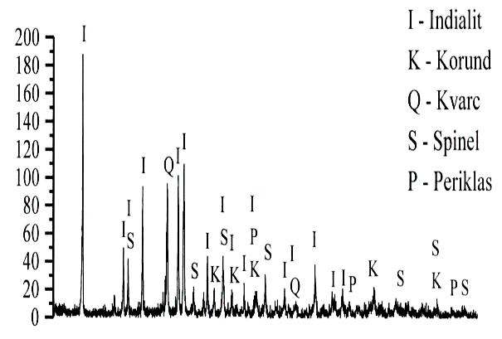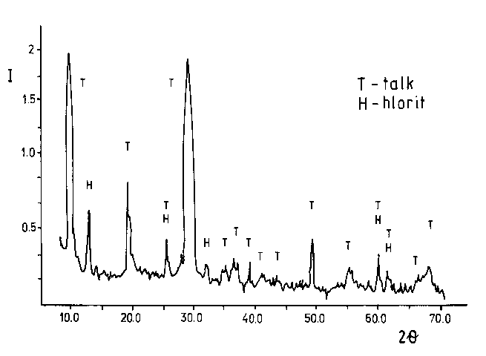
Figure 1 – Roentgenogram of coating C Figure 2 – Roentgenogram of coating T
suspension suspension

In Figure 1, the dominant presence of cordierite, as well as quartz and spinel, can be seen. In Figure 2, the dominant presence of talc can be identified.
In Figure 3, the DTA curve of sample C is shown with distinct characteristic temperatures. The endothermic effect corresponds with the phase transformation of tridymite to quartz (at 517.370°C), while the exothermic effect corresponds with the reaction between MgO and SiO₂, resulting in the formation of magnesium metasilicate (at 1155.440°C).
Figure 3: DTA curve of sample C

In Figures 4 and 5, microphotographs of samples C and T are shown. The microphotographs show the presence of tiny, irregular flakes of cordierite or talc, rather uniformly distributed in the solvent. The distribution homogeneity of the refractory filler in the coating suspension depends on the suspension preparation and coating procedure. Steady, slow mixing, maintaining the set density (2 g/cm³) and temperature (22°C), are necessary.

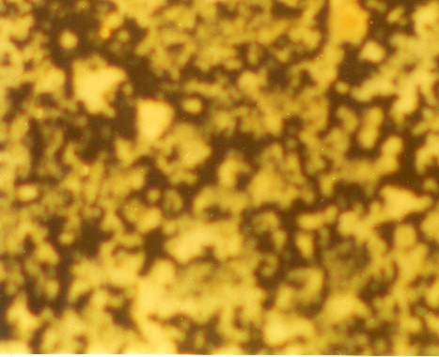 |  | 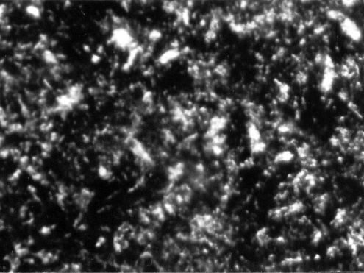
Figure 4 – Microphotograph of sample C |  | Figure 5 – Microphotograph of sample T
The applied and dried coating layers, C and T, on the patterns did not crack, peel, or wipe off. After casting and shaking out the castings from the patterns, the coating was easily removed from the surface of the castings. The produced castings had smooth and bright surfaces, and they were exact replicas of the used patterns. This indicates that the selected casting temperature (720°C), coating thickness (0.2 mm), and gating of molds produced equilibrium in the system: evaporative pattern – refractory coating – liquid metal – sand, ensuring that the casting process was carried out uniformly, without stoppage zones, and without breaking through the coating or metal penetration into the sand. The surface of the castings was bright and clean, making machining unnecessary. Testing the mechanical and structural properties of the castings, series C and T, showed no substantial differences in the results, and they corresponded to the values that are standard for this type of alloy (2, 4).

4. CONCLUSION

The application of cordierite as a refractory filler in the manufacture of refractory lining for the EPC casting process showed positive effects. Cordierite can be easily synthesized, and the raw materials for its synthesis are available and inexpensive. It has excellent thermal properties and high resistance to thermal impacts. Its low coefficient of thermal expansion makes it interesting for study and important for application in linings because it decreases the risk of coat fracture during expansion. The application of refractory lining based on cordierite enables the production of castings with high-quality surfaces. Linings based on cordierite exhibit good properties during casting. All these features recommend it for further investigation, which would provide a detailed appraisal of its properties. In this way, its application will be significant for linings used in casting at high temperatures, considering the high cost of coatings and linings currently used for these purposes.

REFERENCES

[1] Ljiljana Trumbulovič: Effects of the application cordierite ceramics in foundry, doctoral dissertation, Tehnološko metalurški fakultet, Beograd, Univerzitet u Beogradu
[2] ] Ljiljana Trumbulovič, Zagorka Aćimović Pavlović: Kordijeritna keramika u livarstvu, monografija, Savez inženjera metalurgije Srbije (2010),s.110, ISBN 978-86-87183-11-7, COBISS.SR-ID 172019212, Beograd 2010.god.
[3] Ljiljana Trumbulović, Z.Aćimović, Z.Gulišija: "Correlation of technological parameters and quality of castings obtained by the EPC method", ELSEVIER , Materials Letters 58 Issue 11, (2004) , Netherlands, pp.1726-1731. ISSN 0167-577X, (IF=1,186, 60/177)
[4] Ljiljana Trumbulović, Marko Pavlović, Nada Jovičić, Zagorka Aćimović Pavlović: Cordierite ceramics in foundry, 10st International Conference ″Science and higher reducation in function of sustainable development″ SED 2017 High business technical school of Uzice, 6-7 October 2017., Užice. ISBN 978-86-83573-90-5. COBISS.SR.ID.2493800364

