Evaluation of the use of EU regional development funds by Hungary - with special regard to economy/business-development interventions
by Valér Jobbágy (PhD student)

Abstract
The author evaluates the use of EU regional development funds (Structural Funds and Cohesion Fund) by Hungary, with particular consideration to the implementation in sectoral vs. regional (i.e. territorial) programmes, and to the “location” of specific interventions (with special regard to those of economy/business-development) in sectoral or regional programmes.
Problem Statement:
In Hungary from its accession it was a serious dilemma to implement EU regional development funds in regional or sectoral (so-called “operational”) programmes. This was especially true for economy/business-development interventions.
In the first period (2004-06) in addition to sector-wide programmes there was only one “country-wide” Regional Operational Programme, which included “regional” (territorial) measures, and which had one central decision-making body (so-called Managing Authority). For the period from 2007 besides a number of sectoral programmes seven Regional Operational Programmes were adopted for the seven statistical-developmental regions of Hungary, also with one single central decision-making body, but the so-called Regional Development Councils obtained a stronger involvement in decision-making.
Those arguing for regional programmes say that decisions should be taken at the lowest possible (but still efficient) level, by those who are affected by the interventions (principle of “subsidiarity"), and that complex problems with territorial dimension are more effectively tackled in multi-faceted territorial programmes. Whilst those arguing for sectoral programmes reason with the efficiency of implementation, taken into consideration the relatively small extent of the country.
Purpose of the Study:
The author examines the above-mentioned problem through the results of the two periods roughly similar in length (2004-06; 2007-10), i.e. whether there is a “raison d’etre” for regional programs in Hungary, and if so, what types of interventions should they cover, what functions, competencies should the implementation-system bear and how it should be structured.
Methods: The author applies the following methodologies of evaluation: desk research, meta-evaluation, interview, secondary analysis of aggregated monitoring data, benchmarking.
Findings and Results:
The author concludes that in fact the question is not: regional or sectoral programme but rather under what type of programmes certain types of interventions should be implemented. The author also emphasizes the importance of the conformity of the implementation-structure and the location of tasks with the interventions to be implemented. In addition, the qualitative and quantitative characteristics of the existing implementation-system, EU’s regulatory framework and the government's current policy on territorial policy play also key roles.
Conclusions and Recommendations:
The author outlines the frameworks of a hypothetic regional-sectoral programme and implementation-system setup for the next EU “programming cycle” from 2014.

Key words: EU-funds; European Regional Policy; Implementation and Evaluation

In Hungary from its accession it was a serious dilemma to implement EU regional development funds in regional or sectoral (so-called “operational”) programmes. This was especially true for economy/business-development interventions.
Those arguing for regional programmes say that decisions should be taken at the lowest possible (but still efficient) level, by those who are affected by the interventions (principle of “subsidiarity"), and that complex problems with territorial dimension are more effectively tackled in multi-faceted territorial programmes. Whilst those arguing for sectoral programmes reason with the efficiency of implementation, taken into consideration the relatively small extent of the country.
In the framework of the research we examine the above-mentioned problem through the results of the two periods roughly similar in length (2004-06; 2007-10), i.e. whether there is a “raison d’etre” for regional programs in Hungary, and if so, what types of interventions should they cover, what functions, competencies should the implementation-system bear and how it should be structured.

Period of the I. National Development Plan (NDP), 2004-06

In the first period (2004-06) in addition to the four sector-wide programmes there was only one “country-wide” Regional Operational Programme, which included “regional” (territorial) measures.

The structure of the Operational Programmes and their linkage to the national strategy (I. National Development Plan – „Community Support Framework” (CSF) after adoption by the EU Commission) is reflected in the table below.

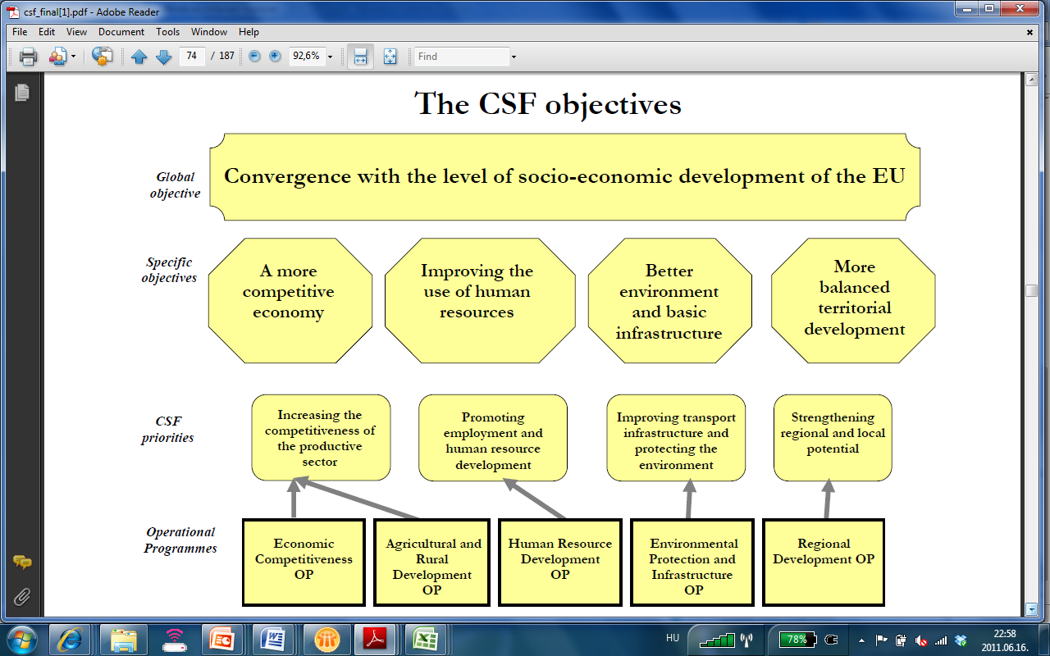
Figure 1: Structure of OPs (2004-06)
Source: Community Support Framework 2004-2006for Hungary

The relative financial weight of the OPs was rather balanced. The OP for Regional Development counted for 18% of the total amount – what was obviously unacceptably low for the regions (regional stakeholders).

Table 1: Weight of OPs (2004-06)
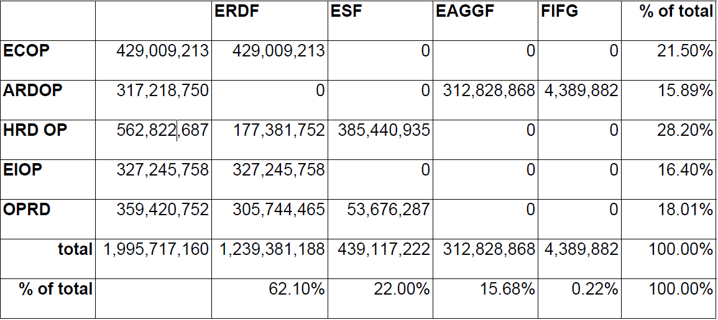
Source: Community Support Framework 2004-2006 for Hungary

However this participation could be esteemed even high, taking into consideration of the extremely weak and heterogeneous scope of the Regional Development OP, especially compared to the sectoral ones. The repartition of the intervention fields among the OPs can be summarized as follows:

The Economic Competitiveness Operational Programme (ECOP) intends to improve the general competitiveness of the economy by supporting investments aimed at modernisation in the manufacturing sector, and will increase social cohesion and employment through technical modernisation of small and medium-sized enterprises and support to their innovation networking activities, as well as passing on up-to-date management skills. It will promote economic innovation by supporting competitive research in the Hungarian R+D sector financed publicly and privately, as well as strengthening relations between the R+D sector and the economy. Another objective of the Operational Programme is to support the development of an electronic economy concerning infrastructure and digital content, as well as electronic administration.

The objective of the Human Resource Development Operational Programme (HRDOP) is to increase the rate of employment and improve the competitiveness of the workforce by providing qualifications in line with the demand of the labour market and promoting social integration. The priorities of the OP include support to active labour market policies, development of training and education in the framework of the life-long learning policy, improvement of adjusting capabilities and entrepreneurial skills, as well as development of health, educational and social infrastructure related to human resource development.

In line with the development financed from the Cohesion Fund, the Environmental Protection and Infrastructure Operational Programme (EPIOP) has set an objective to improve the environmental conditions of the country by establishing environmental infrastructure, increasing environmental safety, and investing into nature conservation. It also aims at investing into the improvement of transport infrastructure by building motorways and bypasses around large cities.

As its title also indicates, the Agricultural and Rural Development Operational Programme (ARDOP) has identified the objectives of modernisation of, and more efficient, agricultural production by developing production technologies and processing of products (especially food processing). The other aspect of the programme includes realignment of rural areas and finding alternative sources of income for the rural population, development of rural infrastructure and services, protection of rural cultural heritage. Part of the rural development measures will be financed from the national budget.

The Regional Development Operational Programme (RDOP) aims at the development of economically and socially underdeveloped areas and parts of settlements within regions. The Operational Programme intends to promote this development by improving the economic environment, supporting educational infrastructure that assist tourism and economic development, developing regional infrastructure, rehabilitating settlements and improving their environment management activities, increasing human resources and the knowledge base of regions and modernising public administration.

The single Regional OP had one central decision-making body (so-called Managing Authority), similarly to the sectoral OPs, which at that time were located in the competent line-ministries. The Managing Authority was seconded by a two-layer system of Intermediary Bodies, comprising the Váti Kht., a central institution specialised in the implementation of EU-funds on the upper level and the Regional Development Agencies on the bottom of the system.

Period of the II. National Development Plan („New Hungary Development Plan” (NHDP) or „National Strategic Reference Framework” (NSRF))

For the period from 2007 besides a number of sectoral programmes seven Regional Operational Programmes were adopted for the seven statistical-developmental regions of Hungary.

The structure of the Operational Programmes, their linkage to the national strategy’s (II. National Development Plan or NHDP, NSRF) priorities and their financial weight is reflected in the table below.

Table 2: Structure and weight of OPs (2007-13)
NSRF Priorities | Operational programmes | Total,  million EUR | % of total
1. Economic development | Economic Development OP | 2 603,8 | 10,0%
2. Transport development | Transport OP | 6 427,2 | 24,8%
3. Social renewal | Social Renewal OP | 3 645,3 | 14,1%
3. Social renewal | Social Infrastructure OP | 2 033,6 | 7,8%
4. Environment and energy developments | Environment and Energy OP | 4 301,9 | 16,6%
5. Regional development | West Pannon OP | 484,2 | 1,9%
5. Regional development | Central Transdanubia OP | 530,2 | 2,0%
5. Regional development | South Transdanubia OP | 735,8 | 2,8%
5. Regional development | South Great Plain OP | 781,5 | 3,0%
5. Regional development | North Great Plain OP | 1 017,4 | 3,9%
5. Regional development | North Hungary OP | 943,0 | 3,6%
5. Regional development | Central Hungary OP | 1 581,1 | 6,1%
6. State reform | State Reform OP | 154,3 | 0,6%
6. State reform | Electronic Public Administration OP | 376,6 | 1,5%
Co-ordination and communication of the New Hungary Development Plan | Implementation OP | 329,1 | 1,3%
The New Hungary Development Plan in total |  | 25 944,9 | 100,0%
Source: own preparation on the basis of the II. NDP and the OPs

The relative financial weight of the OPs was much less balanced than in the previous period, however we consider that it reflects much better the real needs of the different fields than during the first period. Regional OPs altogether counted for 23,4% of the total amount. At that time it was considered very low once again by the regions. Considering the rather broad scope of intervention of the regional OPs on the one hand, and the multiplication of funds per year by more than 3 in absolute terms, on the basis of our assessment we esteem that the amount of funds allocated to the regional OPs are more or less in equilibrium with regard to the tasks covered the OPs.

Table 3: Content of sectoral OPs (2007-13)
Economic Development OP | Transport OP | Social Renewal OP | Social Infrastructure OP | Environment and Energy OP | State Reform OP | Electronic Public Administration OP
R&D and innovation for competitiveness | Improving the international road accessibility of the country and the regional centres (TEN-T Road) | Improving employability, promoting entry to the labour market | Development of the infrastructure of education | Healthy, clean settlements | Renewal of processes and organizational development | Renewal of the internal procedures and the services of public administration
Complex development of enterprises (focusing on SMEs) | Improving the international railway and waterway accessibility of the country and the regional centres (TENT-T Rail) | Improving adaptability | Development of the infrastructure of the health care system | Proper treatment of our living waters | Improvement of the quality of human resources | Developments aimed at improving access to public services (delivering the services to the clients)
Improvement of modern business environment | Improving regional accessibility | Providing quality education and ensuring access for all | Development of the infrastructure supporting labour market participation and social inclusion | Wise management of natural assets
Financial instruments | Linking up the modes of transport and improving the intermodality and the transport infrastructure of economic centres | Developing the content and organisation of higher education to create a knowledge- based economy
 | Improving urban and suburban public transport | Strengthening social inclusion and participation
 |  | Health preservation and human resource development in health care system
Source: own preparation on the basis of the OPs

Finally, Regional Operational Programmes are special in that sense that unlike the sectoral operational programmes they include several development areas and sectors as well. Regional Operational Programmes can be grouped into 9 large topics: regional economic development, development of tourist attractions and capacities, transport investments, development of environmental infrastructure, development of health care infrastructure, development of social infrastructure, development of public educational institutions, elimination of barriers to access at public institutes, urban regeneration.

The 7 Regional OPs have one single central decision-making body (Managing Authority), but from 2007 on each Managing Authority was located in the National Development Agency contrarily to the former period when they were in line ministries. The Regional OP Managing Authority was seconded by Intermediary Bodies which were the Regional Development Agencies and the Váti Kht., similarly to the previous period. However, a considerable step forward was taken compared to the former period, that the regional stakeholders through the so-called Regional Development Councils obtained a stronger involvement in decision-making.

Main findings

Efficiency and effectiveness of implementation
- No significant differences can be recognised between the sectoral and regional implementation systems. The advantage in efficiency of the centralised sectoral implementation was offset by the surplus in effectiveness caused by the local knowledge. Problems related to efficiency and effectiveness are rather owe to the over-burocratic regulations of procedure which concentrated much more on administrative, technical, procedural elements rather then on success of the developments themselves. This has very graphically appeared between the two periods, when the regulation was considerably simplified - the same is expected to be observed after 2010. If there were problems of efficiency and effectiveness linked to regional and sectoral implementation they were caused in most of the cases by the content-institutional "mismatch", so that sectoral programmes covered non-sectoral, regional programs non-territorial interventions.

The structure of OPs
- In the first period the one single regional OP was mostly the consequence of the rather rigid approach of the EU Commission on the one hand, and the totally unclear position of the Hungarian Government on the topic, on the other.
- In the second period the issue arose just at the moment of the formation of a new government (of the same colour) after the general elections and the new owner of the topic was very determined and consistent on the necessity of seven regional OPs. By this time the EU-Commission has also proved to be more permissive, given the relatively good performance of the earlier period.

Repartition of thematic fields between sectoral and regional OPs
- When defining the content of the OPRD for the first period only very vague considerations existed on what could be implemented in an efficient way (tourism, municipal environmental infrastructure, infrastructure of elementary education), but the rest was determined rather on a „residual basis”. The result of this approach was a considerably heterogeneous „bunch of interventions”, concentrating on a quite narrow scope, which could hardly be called: programme.
- For the second period interventions with territorial impact and necessitating local knowledge were selected with much more aware. As a result, the ROPs constitute coherent territorial programmes themselves. At the same time there were still left in it "inappropriate elements", which either outreach regional and local territories due to their size or importance (e.g. motorway N4, health infrastructures of big size) or the optimization and the selection would have been more appropriate to be done at national level (e.g.: minor roads, ...)

Institutional setup
- In the period 2004-06 the single central decision-making body (Managing Authority) was a legitimate solution. Problems rather arose in field of co-operation with other OPs and MAs. Although there was a “CSF Managing Authority” located in the National Development Office, responsible for the co-ordination of all of the OPs, but it was quite weak vis-a-vis the MAs in the line ministries. Another problem was the multitude of Intermediary Bodies. As regards OPRD, the distribution of tasks along the different stages of the same procedures proved to be an extremely bad decision from the point of view of efficiency.
- In the second period the institutional setup of MAs took the other extremity: all MAs were concentrated in the National Development Agency with the pupose of: increasing efficiency of co-ordination of the implementation of operational programmes, improvement of transparency, promotion of exchange of experiences and accountability, as well as the rationalisation of task organisation. However, by now it can be stated that most of these purposes did not come true, since the MAs took and extreme independence from the central co-ordination and from each other, which hampered considerably the necessary co-operation between them. Moreover, the „extraction” of the MAs from the line ministries had the consequence of the deterioration of sectoral professional quality of the functionning. As for the OPRD the single central MA was compensated by the much stronger involvement relatively to the former period of regional stakeholders through the Regional Development Councils in decision-making
- At the level of IBs a sever audit/accreditation process was realised which ended in the considerable reduction of the number of IBs. This measure and the simplification of procedures and the regulation necessarily improved efficiency of the implementation. As regards OPRD, the repartition of tasks between the two kinds of IBs (Váti and RDAs) was done much reasonably than in the former period: measures were distributed to only one of the two kinds of institutions.

Conclusions and recommendation

As a result of the evaluation we came to the conclusion that in fact the question is not: regional or sectoral programme but rather under what type of programmes certain types of interventions should be implemented. The author also emphasizes the importance of the conformity of the implementation-structure and the allocation of tasks with the interventions to be implemented. In addition, the qualitative and quantitative characteristics of the existing implementation-system, EU’s regulatory framework and the government's current policy on territorial policy play also key roles.
Finally, we outlined the frameworks of a hypothetic regional-sectoral programme and implementation-system setup for the next EU “programming cycle” from 2014, which can be summarised as follows:
- For the new programming period (2014-21) we suggest that the ROPs would be the place of project packages based on regional coordination and regional planning (spatially integrated programs), what would result in not a system of calls for applications similar to the current one, but in financing of mutually reinforcing projects which can be of different fields but are strongly linked to one another.
- The sectoral OPs’ role in this system is twofold: a) financing of large-scale projects of national importance as priority projects b) operating systems of call for application where strong competition at national level can be expected and which can be assessed relatively objectively (e.g. calls fro SMEs; calls generating a multitude of public projects, e.g. urban road development)
- The spatially integrated programs would be planned/programmed by a multi-stage procedure could:
- 1. stage: preparation of a regional plan, which defines some complex topics/fields, determines the financial possibilities per topic/field and the frame and the principles of selection and allocation. Such complex topics could be such as:
- development of human public services at micro-regional level
- complex touristic development of a given area (attraction, transport, accommodation)
- wastewater, water conservation handled territorially
- regional transport systems (public transport, road development, road cycling network development)
- complex urban rehabilitation
- development of industrial sites along with network infrastructure
- R&D&I poles
- 2. stage: those competent actors of the area who will be supposedly responsible for the future operation of the output of the projects (e.g. micro-regions, touristic destination management organizations, clusters, transport associations, municipalities) formulate their project-ideas/nucleuses and arrange them into complex project-packages.
- 3. stage: the Regional Development Agencies with the broad network of experts support the project-package owners with expertise in project development, and if necessary, project-generation.
- 4. stage: the project package is submitted to the Intermediary Body (the IB should be national organization having devolved units which is independent from the RDA, but works in close co-operation with it, for example Váti Kht.). The decision is taken by the Managing Authority.
- 5. stage: the owner institution of the projects (who will operate the project-outputs) is responsible for the implementation of the project. The Intermediary Body monitors the implementation.
- 6. stage: further specific projects arising during 2014-2020 should be fit into the project-packages using the "negotiated programming procedure" developed by the South-Transdanubian Development Agency (a quasi two-round procedure with project development and fitting).
For the proper functioning of this system a number of preconditions must be met: development of programming principles and methodologies - based on the 2007-2010 experience of ROPs; enforcement of planning capacities, start of the planning process, strengthening of local partnerships, … . For the time being very little information is available on the system of EU-funds post-2013, but o the basis of the Barca report (strategic document laying the outlines of the future system) it is a highly probable that this logic outlined above will be not opposed to the EU-regulations.

Sources:

- Budapest Institute – IFUA Horváth&Partners: Mid-term evaluation of Competitiveness Operational Programme, 2010.

- Commission of the European Union, DG Regio: Working Document No 1: Indicative Guidelines on Evaluation Methods: Ex-Ante Evaluation, 2007.

- Commission of the European Union, DG Regio: Working Document No 5: Indicative Guidelines on Evaluation Methods : Evaluation during the Programming Period, 2007.

- Commission of the European Union, DG Regio – Fabrizio Barca: An Agenda for a Reformed Cohesion Policy, 2010. (“Barca Report”)

- Commission of the European Union, DG Regio: Fifth Report on Economic, Social and Territorial Cohesion, 2010.

- Commission of the European Union, DG Regio: EVALSED: The resource for the evaluation of Socio-Economic Development, 2010.

- Commission of the European Union, DG Regio – the Government of Hungary: Community Support Framework and its Operational Programmes, 2004.

- KPMG – IFUA Horváth&Partners: Mid-term evaluation of Economic Competitiveness Operational Programme, 2006.

- Metropolitan Research Institute – IFUA Horváth&Partners: Mid-term evaluation of Regional Operational Programmes, 2010.

- National Development Agency: Mid-term evaluation of the 1. National Development Plan, 2006.

- National Development Agency: National Strategic Report on the basis of 1083/2006/EK 29. (Hungary), 2009.

- The Government of Hungary: I. National Development Plan and its Operational Programmes, 2003.

- The Government of Hungary: II. National Development Plan („New Hungary Development Plan” (NHDP) or „National Strategic Reference Framework” (NSRF)) and its Operational Programmes, 2005.

University of Pécs, Doctoral School of Regional Economics and Policy (7625 Pécs, Rákóczi u. 80, mail: valer.jobbagy@ifua.hu); Consultant: Prof. Dr. Gyula Horváth

