Kinetics of solid state reactions: software approach and application
Dijana Jelić¹, Dragoljub Mirjanic², Branko Škundrić² and Slavko Mentus^{3,4}
¹University of Banjaluka, Faculty of Natural Sciences and Mathematics, Chemistry Department, Banja Luka, Bosnia and Herzegovina
²Academy of Sciences and Arts of the Republic of Srpska, Bana dr. T. Lazarevića 1, Banja Luka, Bosnia and Herzegovina
³University of Belgrade, Faculty of Physical Chemistry, Studentski trg 12, 11000 Belgrade, Serbia ⁴Serbian Academy of Sciences and Arts, Knez Mihajlova 35, 11000 Belgrade, Serbia

ABSTRACT:
Countless inorganic, organic and polymeric materials are in the form of solids. Understanding and controlling the mechanism of the solid-state degradation or solid/gas reactions is crucial for designing reactions for new contemporary materials. For such systems kinetics of solid state reactions is very applicable since it explains the mechanism of the thermally stimulated processes and gives information on thermal decomposition, phase transformations, crystallization etc., important for the optimization of the chemical processes. Using useful tool called kinetic triplet (KT): activation energy (Ea), pre-exponential factor (A) and reaction model (f (α)), obtained by Kinetics2015 software package, we get valuable insight into physico-chemical significance of results. The Kinetics2015 software program supports thermal analysis methods (TGA, DTA and DSC) and works in non-isothermal conditions. The presentation will cover wide range of different materials starting from metallic nanocomposites, through polymers and pharmaceuticals for which by using software approach we get information regarding thermal stability and their decomposition. A special case study of thermal degradation of catalyst copper oxide yielding to copper will be discussed in paper in details.
Key words: kinetics, solid state, Kinetics2015 software, drugs, nanocomposite, copper oxide reduction

INTRODUCTION:
Thermal decomposition of solids is mostly studied by thermal analysis methods since they are involved with thermally stimulated processes. On the other hand, the kinetics of solid state reaction, as a tool, provides insight in mechanism of such processes. Combining the thermal analysis and kinetics of solid state reaction valuable physico-chemical data could be obtained for solids. Information regarding thermal stability, phase transformations or crystallization proved to be very important for the optimization of the chemical processes. Kinetic analysis focus on motions and forces in systems under investigation. The ultimate goal of each kinetic analysis is in obtaining the so called kinetic triplet: activation energy (Ea), pre-exponential factor (A) and reaction model (f(α)). The kinetic analysis of solid state can be divided into: experimental and software modelling. Both categories can be carried out in isothermal or non-isothermal regime. Software uses model-free and model-fitting approach. Model-free approach gives us insight into variation of activation energy with conversion degree of reaction, while model-fitting fits obtained experimental results into suitable theoretical kinetic models. Mechanistically, kinetic models involving chemical reactions can be classified as: diffusion, nucleation, geometrical contraction, and reaction order models. The kinetic analysis provide us with physico-chemical significance of results and mechanistic behavior of system under investigation.With this tool we can do analysis faster, reduce potential errors, improve reliability and we can visualize the motions of the system through graphs and diagrams and far more important we can design and optimize the mechanism of the process under investigation. Even thought some disadvantages such as complexity and high cost can emerge. There are various kinetics software available on the market: Advanced Kinetic and Technology Solution program, AKTS, NETZSCH Kinetics Neo, Kinetics2015 by GeoIsoChem Comp. etc. Here, we will have Kinetics2015 software in focus. One of the kinetics software advantage is applicability in different areas of materials science. There are numerous examples how Kinetics2015 and thermal analysis can help in development of new materials and how it communicates well with the stoichiometry, particle size, crystal defects and strain. Examples for kinetics of nanocomposite such as: CuWO₄, CuMO₄, or some Ag, Co and Cu- based materials, can be find in literature. In pharmacy field kinetic software proved to be very valuable especially for thermal stability of active pharmaceutical ingredients (API), which is very important issue in the development of water poorly soluble drugs. Also, kinetic analysis can give insight in stability of pharmaceutical carriers which is important feature for drug delivery systems,.Evaluation of shelf-life of drugs is additional favorable software feature. Application of software Kinetics2015 will be demonstrated on cooper oxide reduction by hydrogen, yielding copper powder. The cooper oxide is well known for its catalytical properties, and coper powder, being its reduction product, is important in powder metallurgy. The reduction reaction was monitored in Ar+25% H₂ atmosphere, under non-isothermal conditions.

A case study: The reduction of CuO by hydrogen: the effect of particle size on the reduction kinetics

The reduction of oxides of transition metals by hydrogen is long ago the subject of scientific interest. However, recently this particular method of metal production gets great practical importance, since classical procedure with coal as the reduction agent, for instance iron production, is criticized as an significant pollutant of Earths atmosphere by carbon dioxide. This assumes that almost complete metal production based on oxide reduction should in future be directed to the use hydrogen as a reduction agent.
Many studies of the reduction of copper oxide by hydrogen have been reported in the literature. Concerning this subject, it was concluded that reaction CuO_{(s)} + H_{2(g)}=Cu_{(s)} +H₂O_{(g)} consists of an induction stage, an acceleration or autocatalytic stage terminating at about 35%reduction of the oxide, and a decreasing rate stage,,,,.Temperature-programmed reduction (TPR) studies of the reduction of bulk CuO have typically shown a direct transformation to Cu, without the formation of possible intermediate phases such as Cu₂O or Cu₄O₃¹⁸However, in several cases,in bulk CuO reduction, the appearance of Cu₂O as an intermediate phase was observed under conditions of decreased temperature and/or decreased oxygen partial pressure¹⁹,²⁰,.
Copper(II) oxide is widely used as a catalyst because of its high activity and selectivity in oxidation and reduction reactions,,.CuOwas found to be an alternative to precious metal catalysts such as platinum, palladium and rhodium for the oxidation of hydrocarbons, and the reduction of nitrogen oxides (NOx) in automobile exhaust systems²³. Copper oxide is, also, used in the synthesis of methanol from CO and H₂, and in the water-gas shift reaction (CO + H₂O = CO₂ + H₂)²⁴. It was found that catalytic activity might depend on the reductive pre-treatment temperature. Also, crystallite size, intermediate compound formation and many other physical and chemical properties are often related with temperature and time of reduction. Kinetics study of the hydrogen-copper oxide reaction, can be very important for the design of a commercial scale process of both catalyst and powdery metal production.
This paper is a continuation of our previously work in which the reduction of copper oxide synthesized by citrate-nitrate combustion method was examined thermogravimetrically under non-isothermal conditions using H₂ as reducing agent¹⁴. In our former study, the reduction process was observed from the kinetics point of view and it was concluded that transformation from copper oxide to metallic copper may be optimally described by means of two-parameter nucelation and growth model with the parameters n and m 0,873 and 0,653, respectively,a nd an activation energy of 64.41 kJ mol⁻¹. Obtained activation energy value was in good agreement with the values published by Kim et al of 60.68 kJ mol⁻¹, and by Bond et alof 56,50 kJ mol⁻¹. Goldstein et al used carbon monoxide as reduction agent and found for the reduction of Cu(II) oxide to copper of 83.71 kJ mol⁻¹, and for the reduction of copper(I) oxide to metallic copper 104.64 kJ mol⁻¹.
The present work is aimed to the investigation of the reduction of CuO by hydrogen, where the CuO samples, obtained by citrate-nitrate combustion method, were thermally pretreated at 400, 600 and 800 C.This pretreatment incited the mean particle size to increase progressively, and the influence of the particle size on the reduction kinetics was investigated.

Materials and sample preparation:

The powder of CuO was synthesized by citrate-gel combustion method, using Merck p.a. Cu(NO₃)₂ · 3H₂O and citric acid, C₆H₈O₇ For the synthesis, a solution of Cu-nitrate and citric acid were prepared, mixed in a ratio of 3.6 mol of nitrate groups against 1 mol of citric acid, The solution was heated on in an open glass beaker under permanent magnetic stirring until homogeneous viscous gel was obtained. The heating was then continued without stirring in an oven up to the temperature of self-ignition, as formerly described. In order to remove carbon residues, and to modify the mean particle size, the samples were heated in free air at a constant temperature of 400, 600 and 800 °C for 1 hour each.

Thermal analysis:

Simultaneous thermogravimetric and differential thermal analysis was performed by TA SDT 2060 device. Reduction of CuO samples was observed under flow of 25% H₂ + Ar mixture (Messer, Belgrade branch office)the purity of which was 99.995vol. %, at a flow rate of80 mL/min.Non-isothermal regime at several heating rates was employed according to the ICTAC recommendations. The heating rates amounted to 5, 10,20 and 30°Cmin⁻¹.
.

Electron microscopy:

The particle size and morphology of the thermally treated oxide powders were analzsed by scanninig electron microscope ( SEM ) JEOL JSM-639.

Kinetic analysis:

The kinetic analysis ofthe TG data obtained experimentally was performed by means of the software KINETICS2015. This software provides application of different kinetics models selected from the two model groups: model free (isoconversional) and model fitting (phase boundary and nucleation and growth) ones. In order to choose the best model, we followed the agreement between experimental and calculated data, searching for a minimum of statical sums RSS₁ and RSS₂ (RSS₁-sum of squares of weighted normalized rate residuals and RSS₂- sum of squares of weighted normalized cumulative residuals). The best fit of the calculated to the experimental data was achieved by means of expanded Friedman isoconversional kinetic model and modified Prout-Tomkins model simulating a nucleation and growth model.
Expended Friedman method belongs to the isoconversional methods, which were demonstrated to be very helpful in non-isothermal solid state kinetics,. Isoconversional methods provide the information on the variation of activation energy Ea and preexponential factor A, with the variation in conversion degree.

(1)

Where t_{α}, T_{α}, E_{α} and A_{α} are the time, temperature, apparent activation energy and pre-exponetnial factor, respectively at various conversion degres labeled by α. What labeled by -E_{α}/R and ln{A_{α}f(α)} are the slope and the intercept with vertical axis of the plot of ln(dα/dt_{α}) vs. 1/T_{α}.To enable calculation of parameter A, the reaction order is assumed to be equal t one.
For the comparison, an another isoconversional method, namely the Kissinger one was used,. Its use is based on the plot of ln(β/T_{p}²) vs. 1/T_{p}, where T_{p} is the temperature of maximum (peak) reaction rate, and β is the heating rate.

(2)

The slope of such plot determines the value –Ea/R. The Kissinger method is a form of isoconversional methods, since Tmax usually corresponds to the conversion degree of 0.5. Since this method is relatively robust, the activation energies obtained in that way are usualy used as criterion and initial values in other kinetical analysis procedures.

The third analysis method used in this study is based on the Prout-Tompkins reaction model. Burnham et al expanded original Prout-Tomkins model (in which m = n = 1), allowing the exponents m and n to be adjstable, not obligatory equal to unity:

(3)
Parameters m and n, and the preexponential factor and energy of activation are adjustable and tend to a fixed values during iterations performed in order to achieve the best fit between experimental and calculated data. The coefficient q is a fixed parameter with the value 0.99. This model is applicable to a wide range of solid-state processes involving the nucleation and growth. If n=0 and m=1, equation 3 has the limit of linear chain-branching model. If n=1 and m=0 it has the limit of a first-order reaction. For m=n=1 this equation presents standard Prout-Tompkins model³⁴. The pre-exponnential factor and the activation energy are hidden inside the rate constant (k, which has a form of Arrhenius equation), and present the additional two parameters which participate in the iterration procedure leading to the minimum sum of squared differences between experimental and calculated points..

RESULTS AND DISCUSSIONS:

Fig 1 presents the SEM pictures of CuO samples after their treatment at specified temperatures during the same time of one hour, indicating the morphology and particle size.The morphology of the sample treated at 400 °C, indicating strong particle agglomeration building long thread-like chains, is preferably due to melting of reaction mixture and release of gaseous products during the citate-gel combustion process. Heating at higher temperatures led to particle coarsening, with a hint of deaglomeration at 600 ºC, and complete deaglomeration at 800 ºC.One can estimate that the mean particle dimensions increase from submicron ones for sample heated at 400 °C, to ~1 micron for sample heated at 600 °C, and to several microns for sample heated at 800 °C.

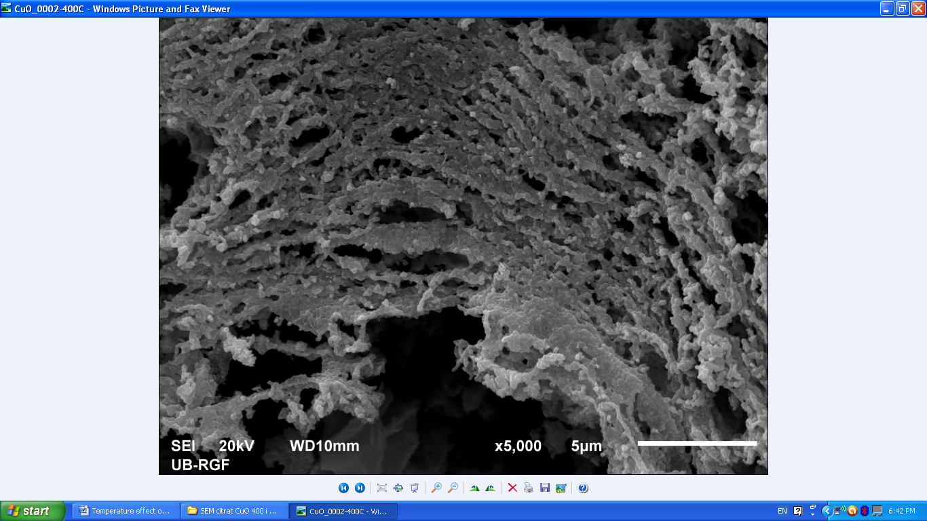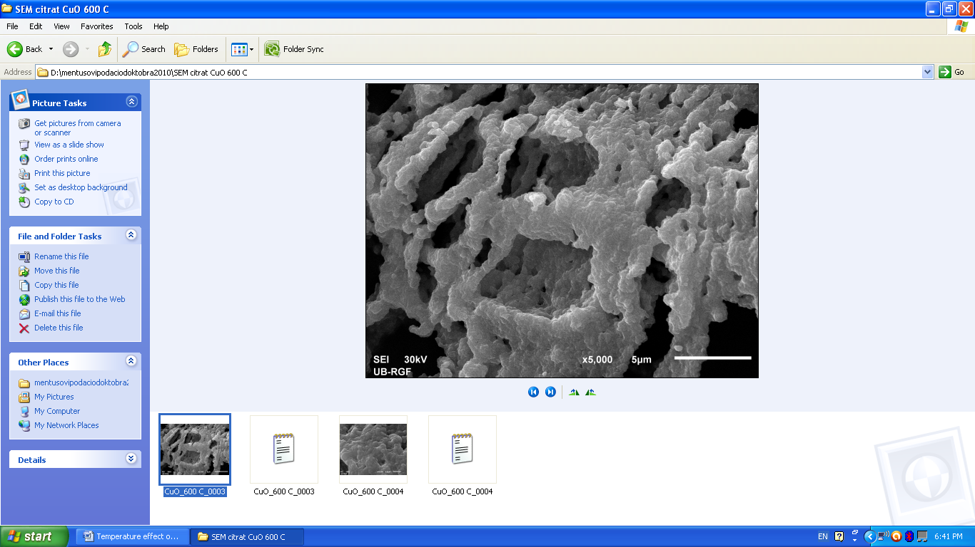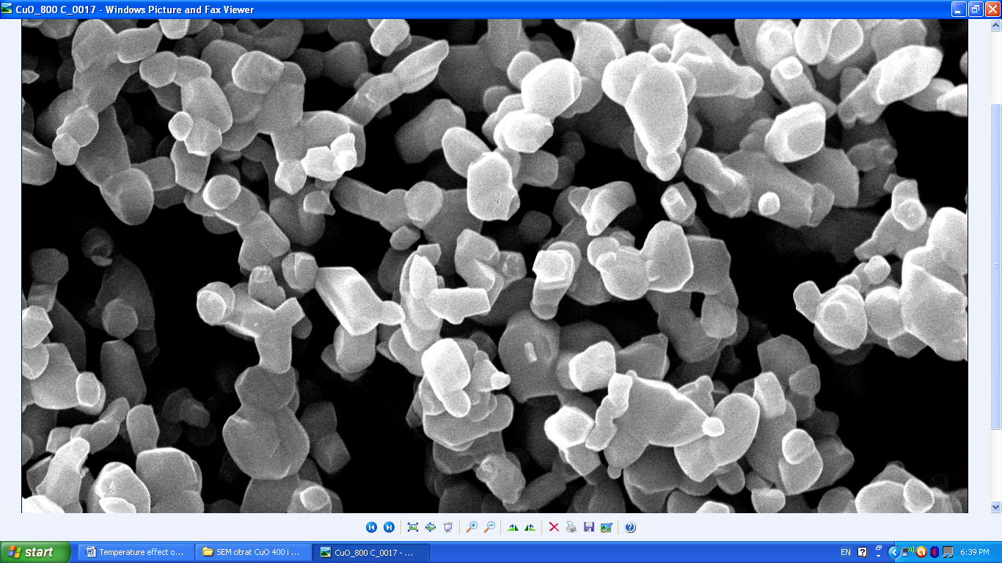
Figure 1. SEM micrographs of CuO samples thermally treated at 400 (left), 600 (midddle) and 800 (right) °C. The length of white bar in middle picture is common for other two pictures, since the magnification (of 5000X) is common for all three pictures.

Such treated samples were placed into thermogravimetric analyser under hydrogen and

Figures 2. left to right present the TG curves of reduction of CuO sample pretreated at 400°C, 600 °C and 800 C°, measured at the heating rates 5, 10, 15, 20 and 30 °C/min. For each pretreatment temperature, with the increase of heating rate, one may see a regularly expected shift of TG curves toward higher temperatures, as an indication of kinetic limitations of the reduction reaction. Samples exposed to different pretreatments, followed the same reduction reaction path, in the sense that Cu was final and direct product with no indication of appearance of intermediate species. Mass loss in each TG series was between 19.8 – 20.1%, compared to the stoichiometrically expected value being 20.1%for a very pure CuO.
Fig 2. TG curves of reduction of CuO sample pretreated at 400°C (left), 600°C (middle) and 800 C° (right) measured at the heating rates 5, 10, 15, 20 and 30°C/min.
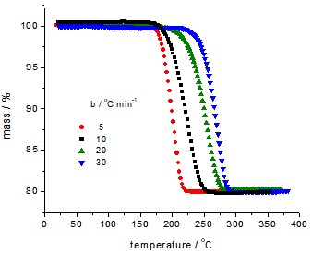
In the Table 1 we sumarized the data characterizing each of experimentally obtained TG curve, such as final mass, m_{f}, the temperatures of the onset and finishing of reduction process (T initial and T final), and difference between them, ΔT. The table also includes the inflection points (point of greatest reduction rate, T_{m}) which overlaps with the maximum of differential form of TG curve.

Table 1. The characteristic data for TGcurve of CuO reduction by H₂

Heat treatment temperature | β,  °C/min | Final mass,  m_{f} | Initial T, °C | Final T,  °C | ΔT,  °C | Inflection point (T_{m}),  °C
400 °C | 5 | 80.1 | 170 | 218 | 48 | 199
400 °C | 10 | 79.9 | 172 | 232 | 60 | 210
400 °C | 15 | 80.1 | 210 | 252 | 32 | 230
400 °C | 30 | 80.3 | 212 | 280 | 68 | 250
600 °C | 5 | 79.8 | 232 | 275 | 43 | 253
600 °C | 10 | 79.8 | 238 | 280 | 42 | 271
600 °C | 20 | 80.2 | 260 | 305 | 45 | 295
600 °C | 30 | 80.2 | 266 | 333 | 67 | 312
800 °C | 5 | 79.9 | 242 | 275 | 33 | 258
800 °C | 10 | 80.1 | 270 | 300 | 30 | 285
800 °C | 20 | 79.9 | 285 | 320 | 35 | 304
800 °C | 30 | 79.9 | 290 | 350 | 60 | 322

The data from the two shadowed columns were used to made the Kissinger plots for the CuO samples treated at various temperatures, which are presented in Fig 3.From the slope of these lines we calculated the activation energies of reduction, which are presented in Fig 3.
Detailed thermokinetic study of CuO treated at 400°C, 600°C and 800°C by model-free and model-fitting method was used, as presented in the next subsections.
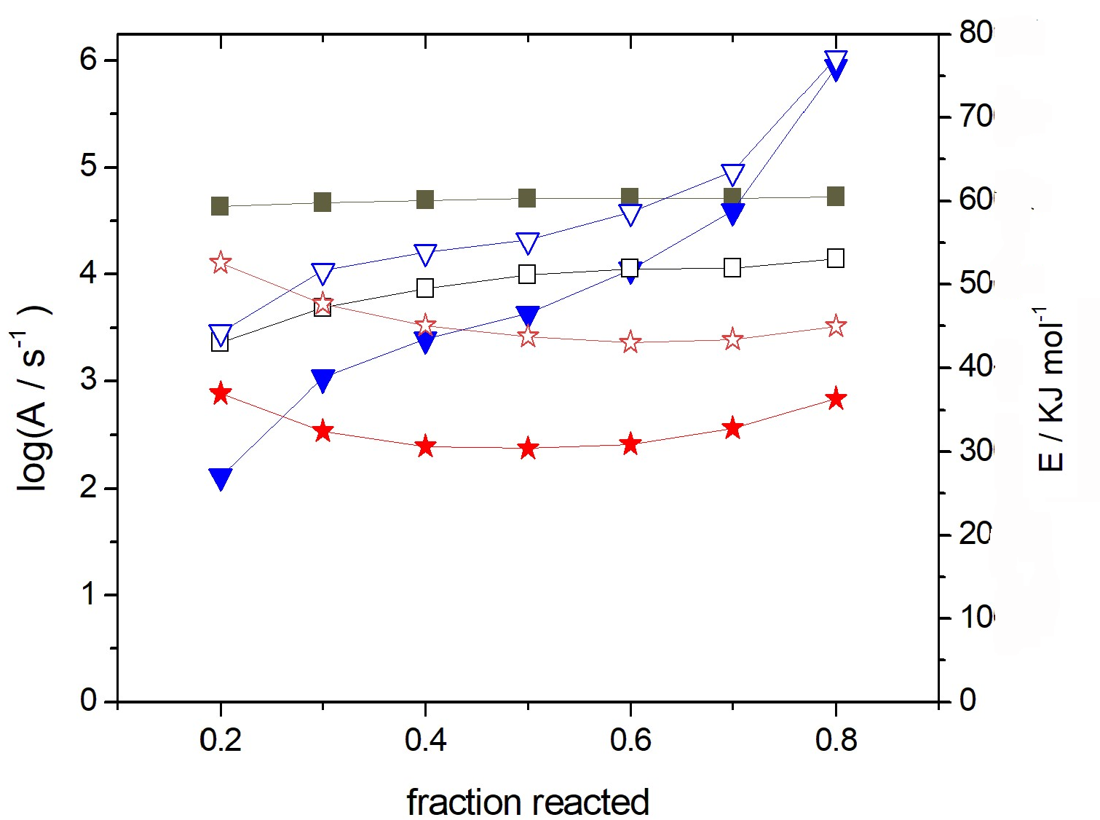
Fig. 4. log (preexponential factor, A) (full symbols) and energy of activation (E) (empty symbols) for CuO reduction analysed by isoconverional Friedman method: Squares -sample heted at: 400 C triangles - 600 C and stars - 800 C
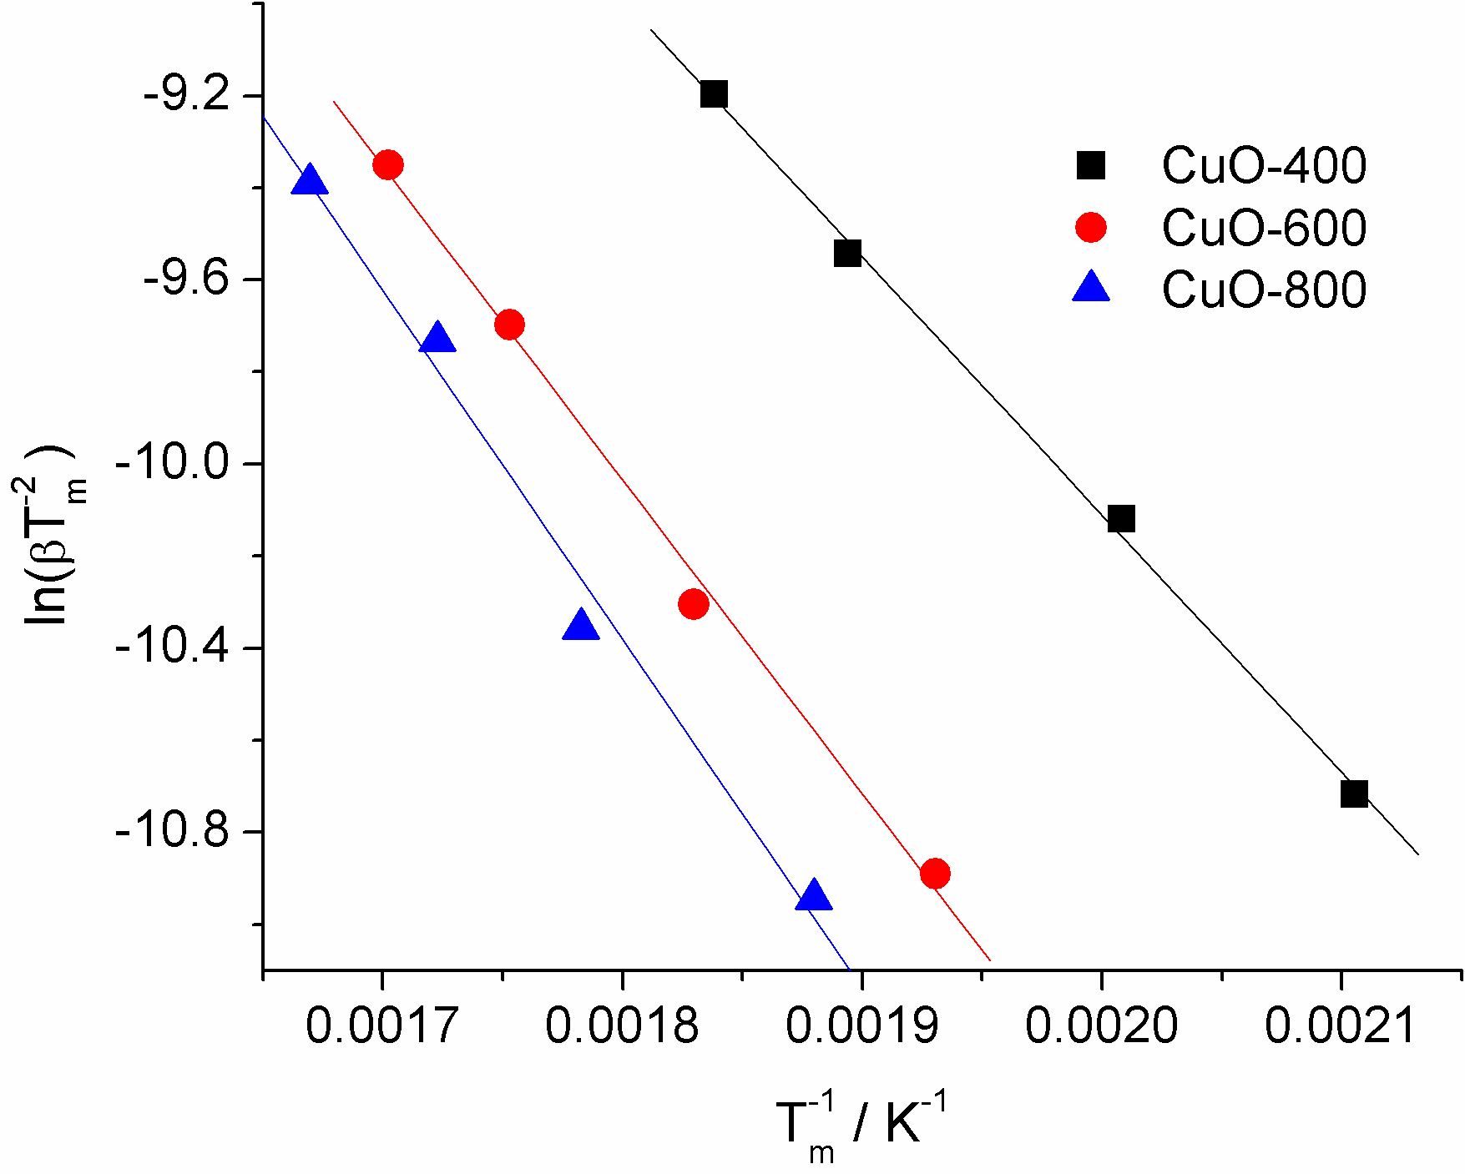
Fig 3. Kissinger plot for the reduction of CuO
Samples preheated at 400, 600 and 800 C

Kinetic analysis by isoconversional Friedman method

Upon introduction of experimental data presented in Fig 2 into software KINETICS2015 setted to perform kinetics analysis according to Friedman formula, a series of data was obtained which were presented in Figs 4 and 5, and Table 2. The data presented in Fig 4are the dependence of preexponential factor (left ordinate) and activation energy (right ordinate)as functions of fraction reacted. The data for fractions reacted between 0.2 and 0.8 are emphasized, since out of this range, the accuracy of parameter determination is usually uncertain and unacceptable. This method of data processsing treats the A and E parametersat different fractions reactedas variables and adapt them in order to enable calculated TG curve to follow optimally the experimental one. In principle, if the reaction order is equal to one, these plots are constants, i.e. paralell to fraction reacted axis. This is almost true for the sample pretreated at 400 °C, and partially true for samples treated at 800 °C, but is far from being true for sample treated at 600 °C,which display permanent increase for increasing fraction reacted.
These parameters for fraction reacted 0.5 are presented in Table 2. Parallell to them, activation energies obtained by Kissinger plot were presented. As we can see, while activation energy obtained by Kissinger plot shows systematic slow increase with the increase in treatment temperature, activation energies obtained by isoconversional Friedman method show irregular dependence. As also reported in many previous studies, logA and E show mutually dependent changes with the change in reacted fraction, what is know as compensation effect. According to Vyazovkin³⁶ if the values of Ea vary with α in a way that they are decreasing and have convex shape, that is an indication that there is a change in rate determing step,and in a case of concave shape, there is a possibility of of a reversibile step in the reaction system. Hovewer, as we found a non-systematic behaviour for differently treated samples, we can conclude that the parameters obtained by fitting are only calculatory facts, which probably do not speak about real processes in the samples.

Table 2. The kinetic parameters of CuO reduction by hydrogens obtained by Friedman and by Kissinger method
Pretreatment temp. | 400°C |  | 600°C |  | 800°C
Parameter | Log(A / s⁻¹) | E kJ mol⁻¹ | Log(A / s⁻) | E kJ mol⁻¹ | Log(A / s⁻¹) | E kJ mol⁻¹
Friedman method | 4.709 | 51.14 | 3.632 | 55.29 | 2.378 | 43.77
Kissinger method |  | 46.48 |  | 56.52 |  | 62.67
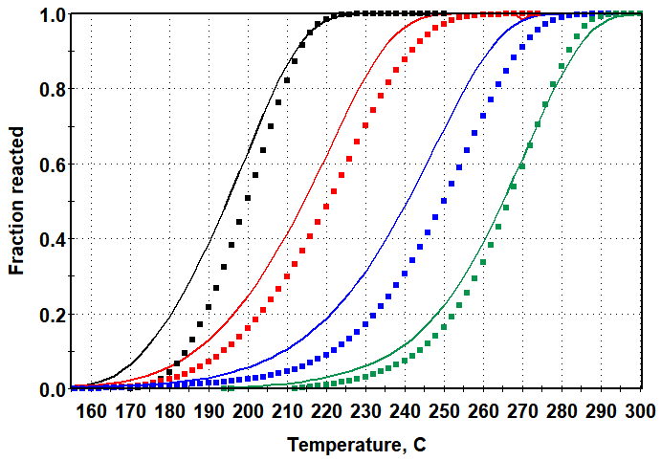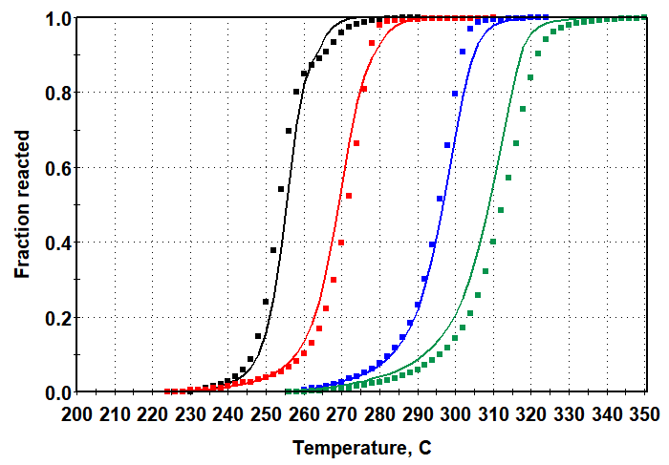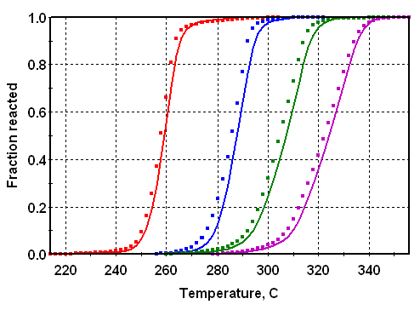
Figure 5. Fraction reacted versus temperature for CuO samples treated at (left) 400 , (middle) 600 and (right) 800°C. Dots-experimental curves, ful lines – curves calculated on the basis of expanded Friedman method. Expansion of Temperature axis is roughly the same for all three diagrams

To visualize the quality of the fit of the calculated to the experimental data achieved with the parameters shown in Fig 4, we present in Fig 5 the fraction reacted as a function of temperature,where the experimental points were obtained by conversion of original experimental TG curves, and lines are calculated by Friedman method.The error sums for fitted curves are RSS₁= 4.285 and RSS₂ =1.426 for samples treated at 400 °C, RSS₁ =2.323 and RSS₂ = 0.4754 for samples treated at 600 °C and RSS₁ = 2.262 and RSS₂ = 0.6757 for samples treated at 800 °C.In principle, Friedman method enables the fitting of theoretical curves to experimental data, with some limitations. Namely sums of squared differences for the samples treated at 400 °C areabout twice higher than for other two cases, what clarifies pronounced difference between experimental and calculated curves visible in Fig 5a. The fitting procedure for other two cases seems well.

Kinetic analysis by nucleation and growth model basedfitting method

The other method we used to analyse TG data from the Fig 1 is a nucleation -growth model (NGM) given by Equation (3). Choosing this modelin software Kinetics2015 the iteration starts which processes four parametersA, E, m and n, in order to minimize the sum of squared differences between calculated and experimental points in dependences of fraction reacted on temperature. The comparison of fitted curves and experimental points converted to fraction reacted vs temperature plot is shown in Fig 6.
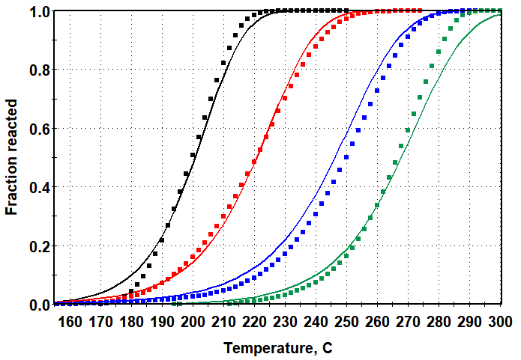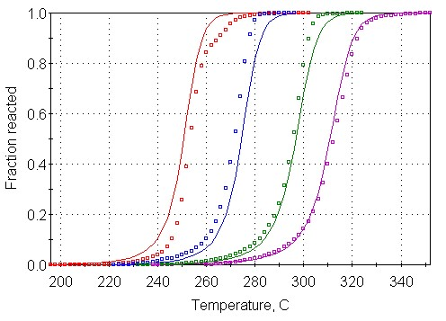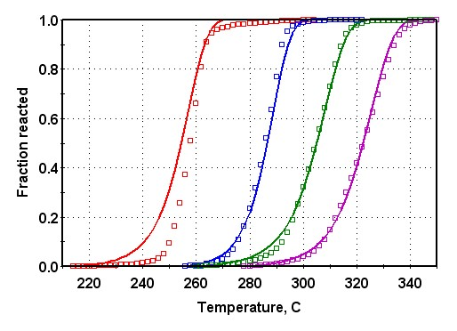
Fig 6. Fraction reacted versus temperature for CuO samples treated at 400 (left) , 600 (middle) and 800°C (right). Dots present the experimental points, snd ful lines present curves calculated on the basis of nucleation-growth model. Expansion of Temperature axis is roughly the same for all three diagrams

The parameters obtained after iteration, corresponding to the Fig 6 are presented in Table 3.
Table 3. Kinetic parameters for CuO reduction by hydrogen obtained by fitting procedure based on
nucleation and growth model dα/dt = kα^{n}(1-0.99x)^{m}

Pretreating temperature | 400 °C | 600 °C | 800 °C
log(A /s⁻¹) | 3.140 | 4.987 | 4.309
E kJ mol⁻¹ | 47.73 | 65.80 | 62.70
m | 0.7550 | 1.272 | 0.918
n | 0.8545 | 1.094 | 0.732
RSS₁ | 1.695 | 1.498 | 1.220
RSS₂ | 0.2484 | 0.6044 | 0.39
As one can see in Fig. 6, the agreement between calculated and experimental values are quite good in this case for all three samples pretreated at different temperatures. This is expected, since one deals here with sigmoidal curves, which are suitable for processing with nucleation-growth reaction models. Both sum of squares of weighted normalized rate residuals (RSS₁) and sum of squares of weighted normalized cumulative residuals (RSS₂) are remarkably lover than in the case of the use of isoconversional analysis.
For m and n equal to 1, the reaction model would correspond to a standard Prout-Tompkins equation, however, here is not that case. Compared to the activation energies obtained by isoconversional metod, one can see that the activation energies obtained from the nucleation-growth model follow better the values obtained by Kissinger method. However, all kinetic parameters in either cases do not show an systematic order, indicating its statistic nature, which makes discussion about any real mechanism of reduction process rather speculative unless some more direct methods of observation are used.
One can notice that the treatment of CuO samples at different temperatures incited considerable increase in mean particle diameters, and consequently considerable reduction of specific surface areas. However that produced only slight and rather nonsystematic course of kinetic parameters of reduction by hydrogen. That may mean that hydrogen penetrates easily in CuO particles, and the reduction reaction occurs within the whole particle depth, independently on its diameter.
The fact that the reduction may be finished at relatively low temperatures close to 250 ºC, which does not support rapid sintering of copper particles, offers this type of reduction as a suitable method for synthesis of copper powder of controlled particle size, adjustable by mediation of oxide temperature pretreatment.

CONCLUSIONS:

The paper presents software approach for evaluation of the kinetics of solid state reaction. As a case study we examined the kinetics of CuO reduction in hydrogen atmosphere by thermogravimetric measurements using Kinetics2015 software. By previous thermal treatment at 400, 600 and 800°C considerable differences in mean particle diameters, and consequently in specific surface areas was achieved. The raw data were analyzed by two procedures of kinetic analysis: isoconversional Friedman method and nucleation-growth method. Unexpectedly, the samples pretreated at different temperatures, displayed similar kinetic parameters of reduction. That led us to the conclusion that the reduction reaction occurs within the whole particle volume, what indicates fast penetration of hydrogen into particle depth.
The mass change during reduction reaction evidences that the final state of the reaction is always pure Cu powder, independently on the initial CuO state.Since the temperature of reduction finishing may be rather low, for low heating rates, reduction by hydrogen may be recommended as a suitable method of production of Cu powders of controllable particle size, for metallurgical purposes.

Acknowledgement
S.M. is indebted to the Ministry of Science, Technological Development and Innovation of Republic Serbia, for supporting the study through the project contract 451-03-65/2024-03/200146 and to the SerbianAcademy of Sciences and Arts for funding the study through the project: “Electrocatalysis in the contemporary processes of energy conversion” no F-190. D.J. is also thankful to Ministry of Scientific and Technological Development and Higher Education of Republic of Srpska, Grant Number 19.032/961-96/23.

REFERENCES:

D. Jelić. Thermal stability of amorphous solid dispersions. Molecules. 26 (2021) 238.
D. Jelić, S. Mentus, J. Penavin-Škundrić, D. Bodroža and V. Antunović, A thermogravimetric study of reduction of silver oxide under non-isothermal conditions, Contemporary materials Vol. I-2 (2010) 143-149.
Akts-thermokinetics version 5.11. In: Advanced kinetics and technologysolutions. 2019, URL ttp://www.akts.com.
Kinetic analysis of chemical reactions.2019, URL https://kinetics.netzsch.com/.
https://geoisochem.com/kinetics2015/
D. Jelić, S.Zeljković, B. Škundrić,S. Mentus. Thermogravimetric study of the reduction of CuO–WO₃ oxide mixtures in the entire range of molar ratios. J Therm Anal Calorim 132 (2018) 77–90.
D. Jelić, S. Zeljković, D. Jugović, S. Mentus.Thermogravimetric insight in the reduction of xCuO – (1-x)MoO₃ oxide system (0.1 ≤ x ≤ 0.9) by hydrogen, International Journal of Refractory Metals and Hard Materials, Volume 96 (2021) 105480.
D. Jelić, J. Penavin-Škundrić, D. Majstorović, S. Mentus. The thermogravimetric study of silver(I) oxide reduction by hydrogen.Thermochimica Acta. 526 (1–2) (2011) 252-256.
B. Tomić-Tucaković, D. Majstorović, D. Jelić, S. Mentus.Thermogravimetric study of the kinetics of Co₃O₄ reduction by hydrogen.Thermochimica Acta. 541 (2012)15-24.
D. Jelić, T. Liavitskaya, S. Vyazovkin. Thermal stability of indomethacin increases with the amount of polyvinylpyrrolidone in solid dispersion.Thermochimica Acta. 676 (2019)172-176.
D. Jelić, M. Đermanović, A. Marković et al. Novel insight in thermo-oxidative kinetics of vitamin D-based supplement formulation using TG–DTG–DTA, ATR-FTIR and MALDI-MS techniques. J Therm Anal Calorim 148 (2023) 4281–4305.
D. Jelić, M. Araki, K. Kawakami. Isoconversional kinetic analysis of thermal decomposition of Bidirectionally stabilized amorphous formulation loading Vitamin D₃ (Cholecalciferol) and Calcium Carbonate. Thermochimica Acta. 736 (2024)179740.
D. Jelić, S. Papović, M. Vraneš, S. Gadžurić, S. Berto, E. Alladio, D. Gajić, B. Janković. Thermo-Analytical and Compatibility Study with Mechanistic Explanation of Degradation Kinetics of Ambroxol Hydrochloride Tablets under Non-Isothermal Conditions. Pharmaceutics. 13(11) (2021)1910.
D. Jelić, B. Tomić-Tucaković, S. Mentus. A kinetic study of copper(II) oxide powder reduction with hydrogen, based on thermogravimetry. Thermochimica Acta. 521 (1–2) (2011) 211-217.
L. Holappa. A General Vision for Reduction of Energy Consumption and CO2 Emissions from the Steel Industry. Metals. 10 (2020)1117.
M. Ardestani, H.R. Rezaie, H. Arabi, H. Razavizadeh. The effect of sintering temperature on densification of nanoscale dispersed W–20–40 wt% Cu composite powders. Int. J. Refract. met. 27 (2009) 862-867.
D.G. Kim, K.H. Min, S.Y. Chang, S.T. Oh, C.H. Lee, Y.D. Kim. Effect of prereduced Cu particles on hydrogen-reduction of W-oxide in WO₃–CuO powder mixtures. Mat. Sci. Eng. A399(2005)326-331.
J. Li, J.W. Mayer, K.N. Tu. Nucleation and growth of Cu₂O in the reduction of CuO thin films. Phys. Rev. B. 45(1992) 5683-5686.
W.P. Dow, Y.P. Wang and T.J. Huang.Yttria-stabilized zirconia supported copper oxide catalyst I. Effect of oxygen vacancy of support on copper oxide reduction. J. Catal. 160(1996)155-170.
J. Cheng, C.Lei, E. Xiong, Y. Jiang, Y. Xia. Preparation and characterization of W–Cu nanopowders by a homogeneous precipitation process. J. Alloys Comp. 421(2006)146-150.
H.H. Kung, Transition metal Oxides: Surface Chemistry and Catalysis; Elsevier; New York 1989.
T.L. Reitz, P.L.Lee, K.F. Czaplewski, J.C. Lang, K.E. Popp, H.J. Kung. Time-resolved XANES investigation of Cuo/ZnO in the oxidative methanol reforming reaction. J. Catal 199(2001)193-201.
W.P.Dow, T.J. Huang. Effect of chlorine on TPR and TPO behavior of an YSZ/Al2O3 supported copper oxide catalyst, Appl. Catal.A141(1996)17-29.
Y.F.Yu Yao. The oxidation of CO and C₂H₄ over metal oxides: V. SO₂ effects. J. Catal. 39 (1975) 104-114.
J.Y.Kim, J.A.Rodriguez, J.C.Hanson, A.I.Frenkel, P.L.Lee. Reduction of CuO and Cu₂O with H₂: H Embedding and Kinetic Effects in the Formation of Suboxides. J.Am.Chem.Soc. 125(2003) 10684-10692.
W. D. Bond and W. E. Clark, "Reduction of Cupric Oxide by Hydrogen. I. Fundamental kinetics, Oak Ridge National Laboratory 1960.
E.A. Goldstein, E.R. Mitchell. Chemical kinetics of copper oxide reduction with carbon monoxide, Proceedings of the Combustion Institute. 33 (2011) 2803-2810.
S. Mentus, Dijana Jelić,Veselinka Grudić. Lanthanum nitrate decomposition by both gel combustion Lanthanum nitrate decomposition by both temperature programmed heating and citrate gel combustion. Journal of Thermal Analysis and Calorimetry. 90(2007)393-397.
S. Vyazovkin, A. Burnham, J. Criado, L. Perez-Maqueda, C. Popescu, N. Sbirrazzuoli N. ICTAC kinetics committee recommendations for performing kinetic computations on thermal analysis data. Thermochim Acta. 520:1 (2011)1–19.
H.L. Friedman. Kinetics of thermal degradation of char-forming plastics from thermogravimetry. Application to a phenolic plastic. J. Polym. Sci. C 6 (1964)183–195.
A.K. Burnham, L.N. Dinh. A comparison of isoconversional and model-fitting approaches to kinetic parameter estimation and application predictions. J. Therm. Anal. Calorim. 89 (2007) 479–490.
H.E. Kissinger. Reaction kinetics in differential thermal analysis. Anal. Chem., 29 (1957) 1702–1706.
C.-R. Li, T.B. Tang. Dynamic thermal analysis of solid-state reactions. The ultimate method for data analysis?, J. Therm. Anal. Calorim. 49 (1997) 1243–1248.
E.G. Prout, F.C. Tompkins. The thermal decomposition of potassium permanganate. Trans. Faraday Soc. 40 (1944) 488–498.
A.K. Burnham, R.L. Braun. An appropriate kinetic model for well-preserved algal kerogens. Energy Fuels. 10 (1996) 49–59.
S.Vyazovkin, Chapter 13, Isoconversional kinetics, in M.E. Brown and P. K. Gallagher, Eds, Handbook of Thermal Analysis and Calorimetry, Elsevier (2008). p. 503-538, ISSN: 1573-4374
J. Opfermann. Kinetic analysis using multivariate non-linear regression. Journal of Therm. Anal. Calorim. 60(2000)641-658.

