DETERMINATION OF ACETALDEHYDE ADSORPTION ON SYNTHETIC ZEOLITES AND CHARACTERIZATION OF SAMPLES BY FTIR METHOD

Dragana Kešelj¹, Kika Stevanović¹, Milenko Aćimović¹, Ljubica Vasiljević¹, Marko Ivanović¹
¹University of East Sarajevo, Faculty of Technology Zvornik, Karakaj 34a, 75400 Zvornik, Republika Srpska, Bosnia and Herzegovina, e-mail: dragana.keselj@tfzv.ues.rs.ba; kikastevanovic90@gmail.com; milenko.acimovic@tfzv.ues.rs.ba; ljubica.vasiljevic@tfzv.ues.rs.ba; marko88ivanovic@gmail.com
Abstract: Acetaldehyde is one of the most common carcinogenic organic compounds (pollutants) that can be found in the air in urban and industrial areas, as well as in indoor spaces. Generally, the most efficient method for removing pollutants from the air is adsorption with suitable adsorbents. To choose a suitable adsorbent, it is necessary to know its characteristics, the most significant of which is the adsorption capacity, i.e., the maximum amount of adsorbed substance per gram of adsorbent under given conditions. Nowadays, there is still a search for an adequate method that would provide an answer to how much and which organic substances are adsorbed on adsorbents. This paper presents the possibility of applying the FTIR analysis method for the identification and detection of adsorbed acetaldehyde on different types of zeolites. Adsorption of acetaldehyde from the gaseous phase was performed on ZSM zeolite (ZEOflair 100, ZEOflair 110), NaA zeolite (ZEOflair 1000), and the Na-form of mordenite (ZEOflair 800). Initial concentrations of acetaldehyde in the air ranged from 0.071 mol/m³ to 1.239 mol/m³, and the adsorption was carried out at atmospheric pressure, T=25 °C, and relative humidity (rH) 65%. On the FTIR spectra of the examined samples after adsorption, peaks were observed at a wavelength of 1700 cm⁻¹, which are characteristic of the carbonyl group of acetaldehyde. It was observed that the peak areas were proportional to the amounts of adsorbed acetaldehyde, which were very small and ranged from 0.107 mmol/g to 2.98 mmol/g of zeolite. Based on the obtained results, it can be concluded that FTIR spectroscopy, as a rapid and non-destructive method, can be used to determine the adsorption of acetaldehyde on different types of zeolites at very low concentrations.
Keywords: zeolites, acetaldehyde, adsorption, FTIR

1. INTRODUCTION
The reduction of volatile organic compounds (VOC) emission is an issue of common concern. Indeed, these compounds are toxic to the human health and some of them, such as acetaldehyde or benzene, are confirmed carcinogens [1]. Benzene and acetaldehyde are among the most common, easily volatile organic compounds in urban and industrially developed areas [2-4]. Aldehydes mainly originate from various industrial processes as well as from internal combustion in car engines. Incomplete fuel combustion and atmospheric oxidation of organic compounds are the main sources of most carbonyl compounds. The analysis of aldehydes is very important in the fields of atmospheric chemistry and medicine since several of these compounds, including formaldehyde, acetaldehyde, acrolein, and benzaldehyde, are classified as carcinogenic compounds [5]. Low level exposure of aldehyde would cause respiratory issues, such as throat irritation, shortness of breath, eye irritation, and chest tightness [6]. High concentration or long term exposure would increase the risk of acute poisoning or chronic toxicity as well as nasal tumors [7,8]. To reduce the content of volatile organic compounds, various materials and adsorbents can be used, which have a strong affinity for these compounds. The selection of the most suitable adsorbent is influenced by many factors, such as temperature, pressure, adsorbate content, affinity for the adsorbate, etc. [9-10].
Zeolites are very successfully applied as adsorbents for various organic compounds. The advantages of zeolites include high stability, regeneration at low temperatures, their hydrophobic or hydrophilic character, ease of operation, etc. [11-12]. Zeolites are natural or synthetic crystalline microporous aluminosilicates with a well-defined crystalline structure built between the corners of tetrahedra formed by SiO₄ and AlO₄. Zeolites are characterized by a large specific surface area, and their highly regular spatial structure contributes to significant thermal stability. They have the ability to adsorb hydrocarbons and incorporate foreign ions, such as active metals, into their lattice, making them extremely important for many industrial processes [9]. Zeolite A (LTA type) is a synthetic zeolite with very small pores. Zeolite NaA has a pore diameter of 4 Å, which can be modified either to 5 or 3 Å by ion exchange with aqueous solutions of calcium or potassium salts [13]. Zeolite A is normally synthesized in the Na⁺ form, Na₁₂Al₁₂Si₁₂O₄₈ ∙ 27H₂O, and it has a three-dimensional pore structure. Its structure is composed of sodalite cages, which are similar to faujasite ones, but connected through double four-membered rings (D4R) of [SiO₄]⁴⁻ and [AlO₄]⁵⁻. By this connection, three cages are present: D4R, sodalite cage, and α-cage. The pore diameter is defined by an eight-member oxygen ring with diameters between 0.23 and 0.42 nm [14]. Due to its low cost and high thermal stability, A-type zeolite has potential applications in separation processes and shape-selective catalysis [13]. Some properties such as high ion exchange potential, high surface area distributed throughout pores with several diameters, high thermal stability, and high acidity allow zeolites to be materials with great potential for many important applications. Furthermore, they have shown prominence as adsorbents in gas purification, as ions exchangers in detergents, in petroleum refinement catalysis, and in petrochemistry [15]. ZSM-5 is a medium pore (5.1-5.6 Å) zeolite with threedimentional channels defined by 10-membered rings [16]. Due to its unique shape selectivity, solid acidity, ion exchangeability, pore size, thermal stability and structural network, ZSM-5 has been widely used as catalysts and sorbents in petroleum and petrochemical industry [17]. The catalytic and sorption properties of the zeolite are often influenced by their crystal size. The acidity of ZSM-5 zeolite used as a catalyst has significant effect on reaction path and product distribution in reaction. Modernite is characterized by the main canal of elliptical shape made up from a twelve-membered ring whose dimensions are of 6.5x7.0 Å, and the socalled “side pockets” in the form of eight-membered rings whose dimensions are 2.6x5.7 Å [18,19].
Infrared radiation belongs to the realm of electromagnetic radiation with wavenumbers from 13000 to 10 cm⁻¹, or wavelengths from 0.78 to 1000 µm. Infrared spectroscopy (IR spectroscopy) is widely used in the qualitative and quantitative analysis of various chemical substances, the identification of unknown compounds, and the determination of molecular bond relationships. IR spectroscopy of the mid-IR spectrum is most commonly used for the analysis of organic, inorganic, and organometallic compounds, including heavy atoms (mass number above 19), and provides useful information for studying structures such as conformation and lattice dynamics of the sample [20,21]. The advantages of infrared spectroscopy is that it is almost universal, measuring infrared spectra is relatively fast and easy. Another important advantage of infrared spectroscopy is sensitivity. It is a measure of the minimum amount of material that gives a usable spectrum. For the average FTIR, milligram (10⁻³ gram) samples are ideal, and micrograms (10⁻⁶ gram) of material can be detected routinely. If a gas chromatograph is hooked up to an FTIR, nanograms (10⁻⁹ gram) of material can be routinely detected [22].
Analytical IR spectroscopy is based on the absorption (or reflection) of radiation in the range of ~1 to 1000 µm, and for the examination of zeolites, the mid-IR region of wavelengths λ= 2.5 to 50 µm is mostly used. Absorption spectra in the IR region correlate with specific structural groups in the zeolite, including oscillations within tetrahedra and oscillations of external bonds. Oscillations within tetrahedra can be: Asymmetric stretching oscillations ν = 1250 cm⁻¹ to 950 cm⁻¹ Symmetric stretching oscillations ν = 720 cm⁻¹ to 620 cm⁻¹ Deformation oscillations T-O ν = 500 cm⁻¹ to 420 cm⁻¹ Oscillations of external bonds can be: Double ring ν = 650 cm⁻¹ to 500 cm⁻¹ Entrance to the cavity ν = 420 cm⁻¹ to 300 cm⁻¹ Symmetric stretching oscillations ν = 820 cm⁻¹ to 720 cm⁻¹ Asymmetric stretching oscillations ν = 1150 cm⁻¹ to 1050 cm⁻¹.

2. MATERIALS AND METHODS
For the purposes of this experiment, zeolites ZSM (ZEOflair 100, ZEOflair 110), NaA (ZEOflair 1000) and Na-form modernite (ZEOflair 800) were used as adsorbents. Before and after adsorption of acetaldehyde, FTIR spectra of different zeolites were recorded using a Cary 630 FTIR spectrometer. Adsorption of acetaldehyde was conducted in adsorption chambers with a volume of 2.5 dm³, on tested samples of zeolites with a mass of about 0.5 g. Experiments were carried out at atmospheric pressure, at a constant temperature of 25°C, and with a relative humidity (rH) of 65% in the chambers at the beginning of adsorption. The concentration of acetaldehyde at the beginning of adsorption (C₀) and equilibrium concentration of acetaldehyde (C_{e}) were determined by the total organic carbon analyzer, using the method presented in the paper [23]. The amount of adsorbed acetaldehyde is calculated using the following equation (1):

$q_{e}=\frac{\left(C_{0}-C_{e}\right)V}{m_{1}}$ (1)
Where is:
q_{e} – the amount of the adsorbed acetaldehyde per gram of adsorbent (mmol/g)
C₀ –concentration of acetaldehyde at the beginning of adsorption (mol/m³)
C_{e}– equilibrium concentration of acetaldehyde (mol/m³)
V- adsorption chamber volume (m³)
m₁ – mass of the adsorbent- zeolite (g)

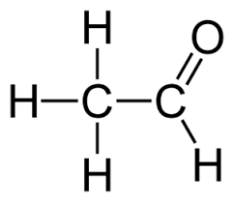
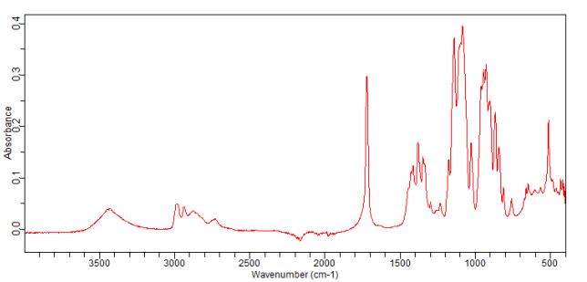
Figure 1. FTIR spectrum of acetaldehyde
The absorption bands of acetaldehyde (Figure 1) can be interpretated as follows: Around 2900 cm⁻¹: This region usually indicates C-H stretching vibrations. For acetaldehyde, you might see peaks due to the -CH₃ group. Around 2750 cm⁻¹: This peak is often characteristic of aldehyde C-H stretch, a distinctive feature for aldehydes. Near 1700 cm⁻¹: This is the carbonyl (C=O) stretching region, which is a strong and sharp peak, characteristic of aldehydes. In the region of 1400-1300 cm⁻¹: These peaks are generally associated with C-H bending vibrations. Between 1250 and 1000 cm⁻¹: This region shows C-O stretching vibrations and could have multiple peaks due to different molecular interactions. The region of 1000-400 cm⁻¹: Fingerprint region, which includes a complex set of peaks that are unique to the specific structure of acetaldehyde.
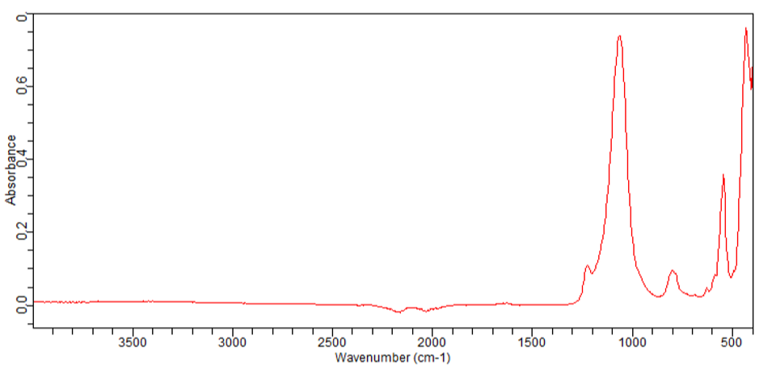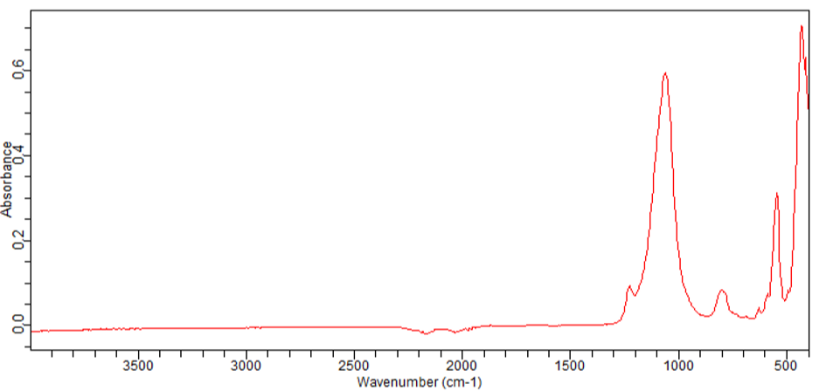
- b)
Figure 2. FTIR spectra of: a) ZEOflair 100 and b) ZEOflair 110 before adsorption of acetaldehyde
The absorption bands on FTIR spectra (Figure 2, Figure 3) near 788, 1084 and 1218 cm⁻¹ are characteristic of SiO₄ tetrahedron units [24]. The strong absorption band in the region 1200-1000 cm⁻¹ has been assigned to the internal vibration of SiO₄, AlO₄ tetrahedra for ZSM-5 [25]. The band near 788 cm⁻¹ is assigned to the symmetric stretching of the external linkages. The strong band near 543 cm⁻¹ is attributed to the double five-ring lattice vibration of the external linkages [26]. The absorbance at around 450 cm⁻¹ is due to the T-O bending vibrations of the SiO₄ and AlO₄ internal tetrahedral.
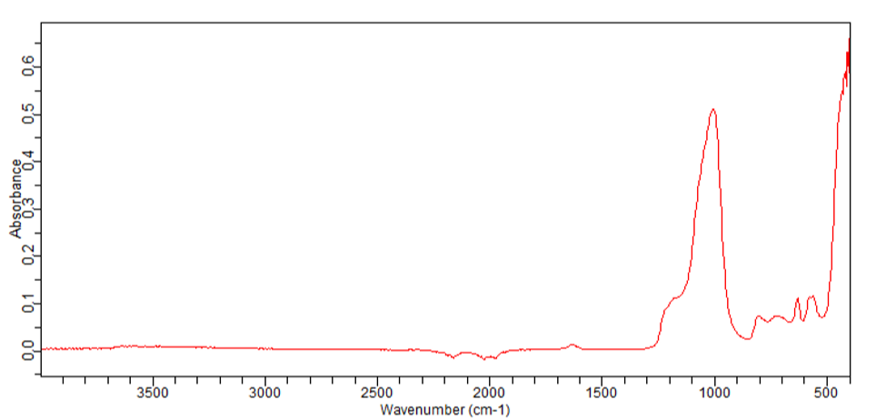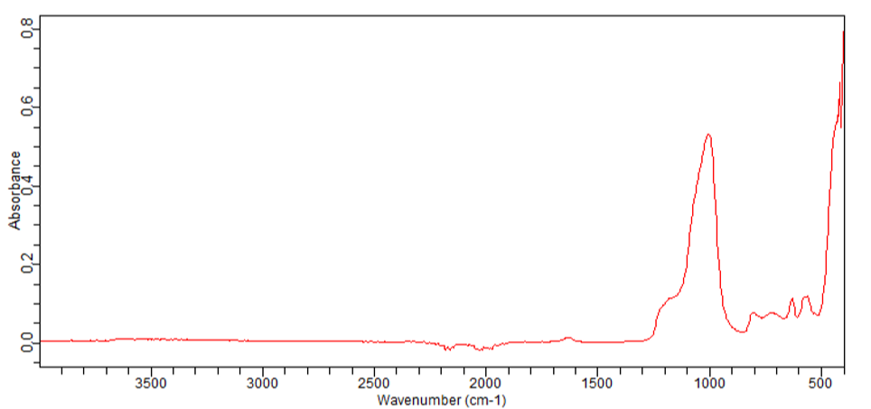
- b)
Figure 3. FTIR spectra of: a) ZEOflair 800 and b) ZEOflair 1000 before adsorption of acetaldehyde
Vibration band found at 1200cm⁻¹ is due to asymmetric elongation Si-O-Al, Si-O-Si internal vibration. The absorbance at around 450 cm⁻¹ is due to the T-O bending vibrations of the SiO₄ and AlO₄ internal tetrahedral. Band near 680cm⁻¹ is due to internal vibrations (Si,Al-O) symmetric stretching. 550cm⁻¹ is due to external vibrations of double four rings. Band near 800 cm⁻¹ is symmetric elongation Si-O-Al, Si-O-Si external vibrations. The absorbance at 1010 cm⁻¹ is due to assymetric elongation Si-O-Al external vibrations [27].
In the FTIR spectrum of the zeolite NaA (Figure 3b), the characteristic bands for zeolite framework at 557 cm⁻¹ due to the external vibration of double four-rings. The absorption band near 1001 cm⁻¹ is due the internal vibration of (Si, Al)–O asymmetric stretching. The band near 671 cm⁻¹ for the internal vibration of (Si, Al)–O symmetric stretching, and 467 cm⁻¹ for the internal vibration of (Si, Al)–O bending were observed. The band related to O-H bending also appeared at about 1650 cm⁻¹ [28–31].
3. RESULTS AND DISCUSION
Adsorption of acetaldehyde on zeolites ZEOflair 100, ZEOflair 110, ZEOflair 1000 and ZEOflair 800 was performed in an experimental chamber under specific conditions: T=25 °C, rH=65%, P=1058-1060 mbar. The obtained results are shown in Tables 1. 2. 3. and 4.
Table 1. Adsorption of acetaldehyde on ZEOflair 100 at T=25 °C, rH=65%
 | 1. | 2. | 3. | 4. | 5. | 6.
C₀  (mol/m³) | 0,146 | 0,206 | 0,359 | 0,405 | 0,457 | 0,899
C_{e}  (mol/m³) | 0,057 | 0,089 | 0,107 | 0,111 | 0,136 | 0,343
q_{e}  (mmol/g) | 0,349 | 0,845 | 1,456 | 1,468 | 1,583 | 2,619

Table 2. Adsorption of acetaldehyde on ZEOflair 110 at T=25 ºC i rH =65%
 | 1. | 2. | 3. | 4. | 5. | 6.
C₀  (mol/m³) | 0,071 | 0,123 | 0,222 | 0,311 | 0,371 | 0,441
C_{e}  (mol/m³) | 0,049 | 0,068 | 0,089 | 0,102 | 0,185 | 0,017
q_{e}  (mmol/g) | 0,107 | 0,276 | 0,683 | 0,974 | 1,495 | 2,654

Table 3. Adsorption of acetaldehyde on ZEOflair 800 at T=25 ºC i rH =65%
 | 1. | 2. | 3. | 4. | 5. | 6.
C₀  (mol/m³) | 0,145 | 0,482 | 0,551 | 0,442 | 0,820 | 1,067
C_{e}  (mol/m³) | 0,072 | 0,121 | 0,216 | 0,442 | 0,559 | 0,723
q_{e}  (mmol/g) | 0,332 | 0,9643 | 0,907 | 1,069 | 1,291 | 1,68

Table 4. Adsorption of acetaldehyde on ZEOflair 1000 at T=25 ºC i rH =65%
 | 1. | 2. | 3. | 4. | 5. | 6.
C₀  (mol/m³) | 0,281 | 0,419 | 0,709 | 0,845 | 1,061 | 1,239
C_{e}  (mol/m³) | 0,05 | 0,107 | 0,299 | 0,346 | 0,472 | 0,663
q_{e}  (mmol/g) | 1,155 | 1,513 | 2,047 | 2,47 | 2,98 | 2,808

Based on the obtained results (Tables 1-4), we can conclude that adsorption of acetaldehyde occurred on all zeolite samples. For all samples, it is evident that with an increase in the initial concentration of acetaldehyde, there is an increase in adsorption capacity, i.e., the amount of adsorbed acetaldehyde per gram of zeolite increases. When using ZEOflair 100 as an adsorbent, the highest obtained value of adsorbed acetaldehyde was 1.583 mmol/g, at an initial acetaldehyde concentration of 0.457 mol/m³. For the ZEOflair 110 sample, the highest obtained value of adsorbed acetaldehyde was 2,654 mmol/g, at an initial acetaldehyde concentration of 0.441 mol/m³. When using ZEOflair 800 as an adsorbent the highest obtained value of adsorbed acetaldehyde was 1.68 mmol/g, at an initial acetaldehyde concentration of 1,067 mol/m³. For ZEOflair 1000 samples, the highest obtained value of adsorbed acetaldehyde was 2,808 mmol/g for the initial concentration of 1,239 mol/m³.
Based on the initial FTIR spectra of zeolites and acetaldehyde (Figures 1-3), it can be seen that the region 1200-400 cm⁻¹ (fingerprint region) cannot be used for the detection of acetaldehyde. The absorption bands characteristic for the structure of acetaldehyde overlap with the absorption bands characteristic of zeolites. It can also be observed that in the FTIR spectra of zeolites in the region 4000-1250 cm⁻¹, there are no distinct absorption bands at 3600 cm⁻¹ and 1650 cm⁻¹, which are attributed to O-H stretching and O-H bending in zeolites respectively. Absorption bands at 3600 cm⁻¹ and 1650 cm⁻¹ are distinct when the zeolite has adsorbed water. Unlike the FTIR spectra of zeolites, the FTIR spectrum of acetaldehyde in the region 4000-1250 cm⁻¹ has several absorption bands: around 2900 cm⁻¹ (C-H stretching vibrations), around 2750 cm⁻¹ (aldehyde C-H stretch - characteristic of aldehydes), near 1700 cm⁻¹ (the carbonyl (C=O) stretching region), and the region of 1400-1300 cm⁻¹ (associated with C-H bending vibrations). Of all the peaks that appear in this region, the peak near 1700 cm⁻¹ is the most intense. The peak near 1700 cm⁻¹ corresponds to the peak characteristic of the carbonyl group, by which aldehydes are recognizable.
After adsorption of acetaldehyde on zeolites (ZEOflair 100, ZEOflair 110, ZEOflair 1000, and ZEOflair 800), FTIR spectra were recorded (Figures 4-7)
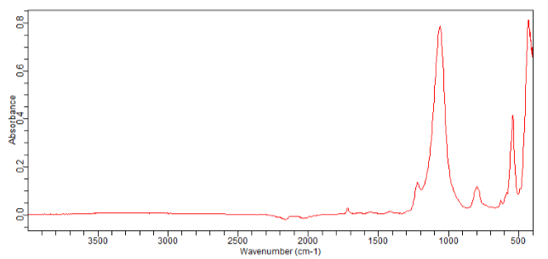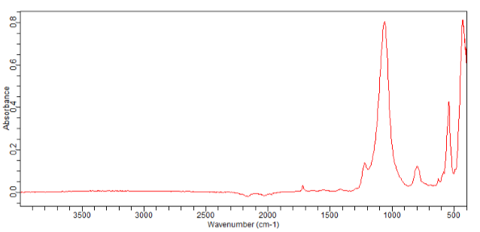
q_{e} = 0,845 mmol/g
q_{e} = 0,349 mmol/g
- b)
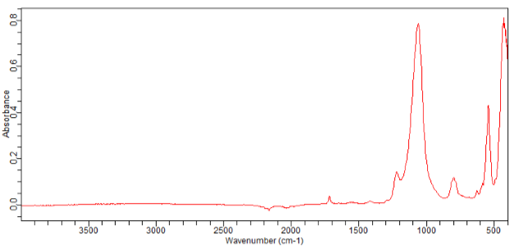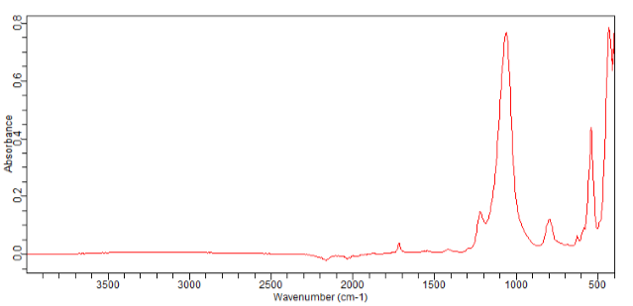
q_{e} = 1,468 mmol/g
q_{e} = 1,456 mmol/g
c) d)
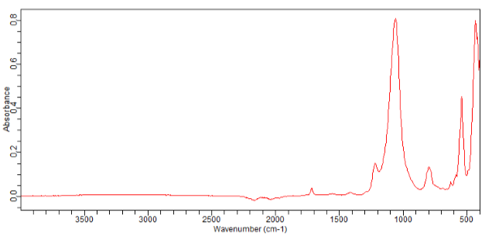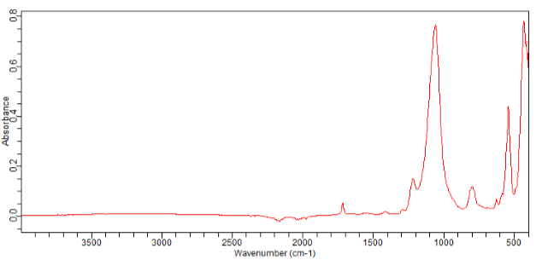
q_{e} = 2,619 mmol/g
q_{e} = 1,583 mmol/g
e) f)
Figure 4. FTIR spectra of ZEOflair 100 after adsorption of acetaldehyde for different amounts of the adsorbed acetaldehyde per gram of adsorbent:a) q_{e} = 0,349 mmol/g; b) q_{e} = 0,845 mmol/g; c) q_{e} = 1,456 mmol/g; d) q_{e} = 1,468 mmol/g; e) q_{e} = 1,583 mmol/g; f) q_{e} = 2,619 mmol/g

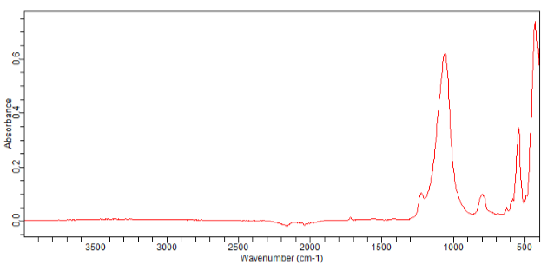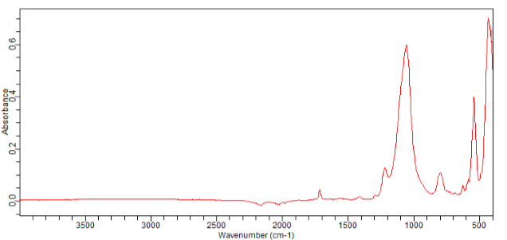
q_{e} = 0,276 mmol/g
q_{e} = 0,107mmol/g
- b)
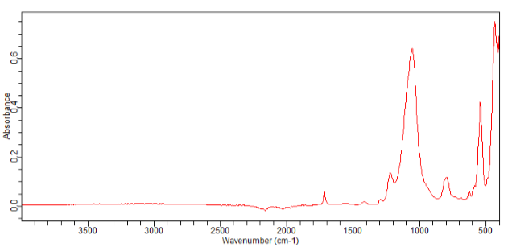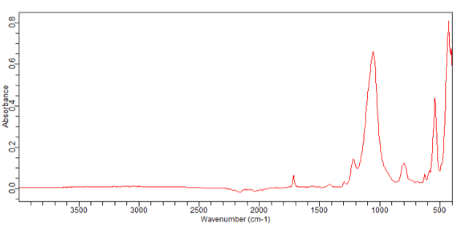
q_{e} = 0,974 mmol/g
q_{e} = 0,683mmol/g
c) d)
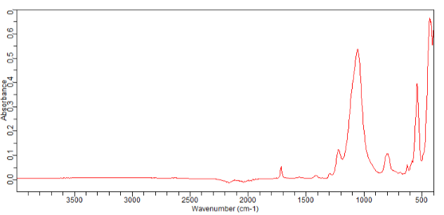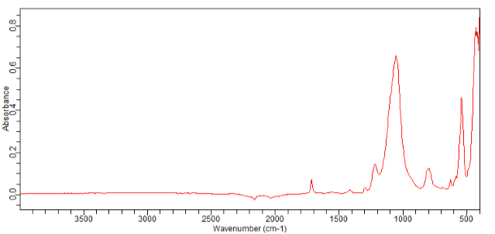
q_{e} = 1,495 mmol/g
q_{e} = 2,654 mmol/g
e) f)
Figure 5. FTIR spectras of ZEOflair 110 after adsorption of acetaldehyde for different amounts of the adsorbed acetaldehyde per gram of adsorbent: a) q_{e} = 0,107 mmol/g; b) q_{e} = 0,276 mmol/g; c) q_{e} = 0,683 mmol/g; d) q_{e} = 0,974 mmol/g; e) q_{e} = 1,495 mmol/g; f) q_{e} = 2,654 mmol/g
After adsorption of acetaldehyde, on all FTIR spectra (Figures 6-9), we can notice smaller and larger peaks near 1700 cm⁻¹ which is characteristic for carbonyl group of acetaldehyde.
The peaks detected at 1700 cm⁻¹ on zeolites ZEOflair 100 and ZEOflair 110 (Figure 4, Figure 5) are sharp, intense, and can be described as ideally symmetric. In contrast to these peaks, the peaks occurring at the same wavelength on zeolites ZEOflair 800 and ZEOflair 1000 (Figure 6, Figure 7) are not intense and sharp. On the same FTIR spectra (Figure 6, Figure 7), peaks are observed at 1650 cm⁻¹. These peaks are not sharp but are more intense than the peaks at 1700 cm⁻¹. The peaks at 1650 cm⁻¹ are due to O-H bending, the appearance of which is associated with water adsorption. It can also be noted that in the region 3600-3400 cm⁻¹ there are very low-intensity absorption bands, associated with O-H stretching. Based on all the aforementioned, it can be concluded that on the ZEOflair 1000 and ZEOflair 800 zeolites, in addition to acetaldehyde adsorption, water adsorption also occurred simultaneously. This is consistent with the nature of these zeolites, as they are hydrophilic zeolites. Unlike them, ZSM zeolites are hydrophobic, and their FTIR spectra do not show absorption bands at wavelengths of 3600-3400 cm⁻¹ and 1650 cm⁻¹. The appearance of absorption bands at 1650 cm⁻¹, which is a consequence of water adsorption, reduced the intensity of peaks at 1700 cm⁻¹, i.e., peak overlap occurred. This directly affected the lower detection limit of adsorbed acetaldehyde by the FTIR method on zeolites. Namely, in the obtained FTIR spectra after acetaldehyde adsorption on ZEOflair 100 and ZEOflair 110 zeolites, much smaller acetaldehyde contents were detected (0.349 mmol/g and 0.107 mmol/g, respectively), unlike the FTIR spectra obtained after acetaldehyde adsorption on ZEOflair 1000 and ZEOflair 800 (2.047 mmol/g and 0.9643 mmol/g, respectively). It can be concluded that the FTIR method is more sensitive in the case of acetaldehyde adsorption on different types of zeolites if water adsorption did not simultaneously occur on the examined zeolites.

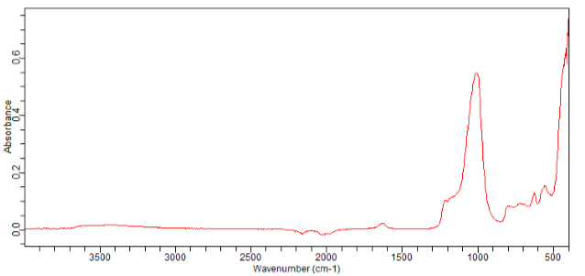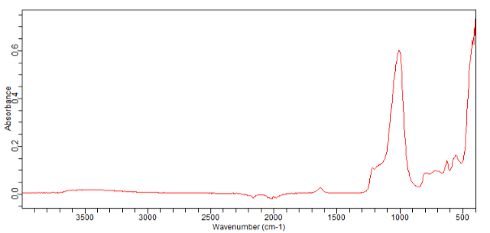
q_{e} = 0,9643 mmol/g
q_{e} = 0,332 mmol/g
- b)
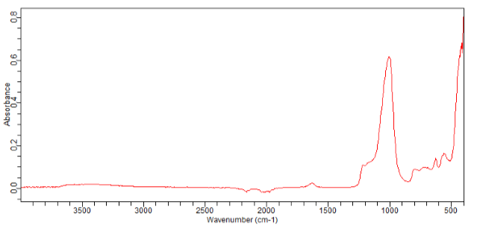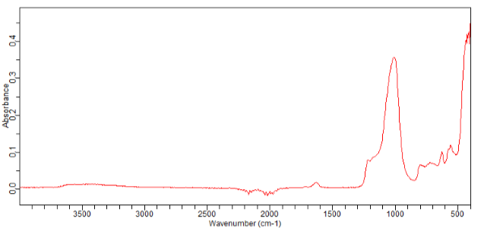
q_{e} = 1,069 mmol/g
q_{e} = 0,907 mmol/g
c) d)
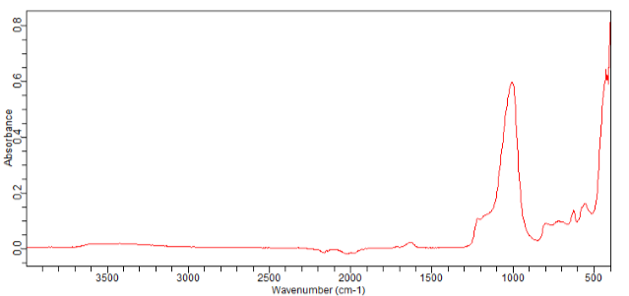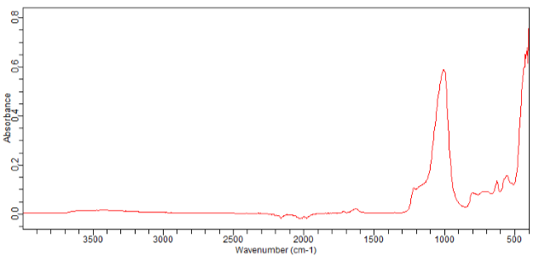
q_{e} = 1,68 mmol/g
q_{e} = 1,291 mmol/g
e) f)
Figure 6. FTIR Spectra of ZEOflair 800 after adsorption of acetaldehyde for different amounts of the adsorbed acetaldehyde per gram of adsorbent: a) q_{e} = 0,332 mmol/g; b) q_{e} = 0,9643 mmol/g; c) q_{e} = 0,907 mmol/g; d) q_{e} = 1,069 mmol/g; e) q_{e} = 1,291 mmol/g; f) q_{e} = 1,68 mmol/g

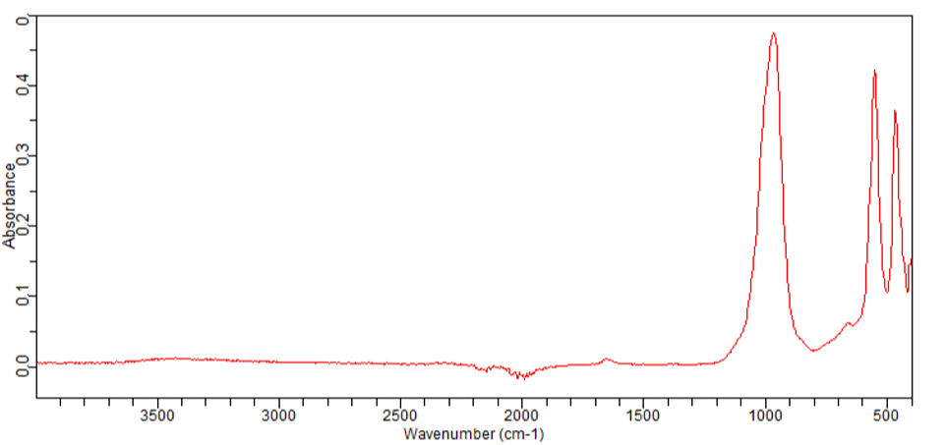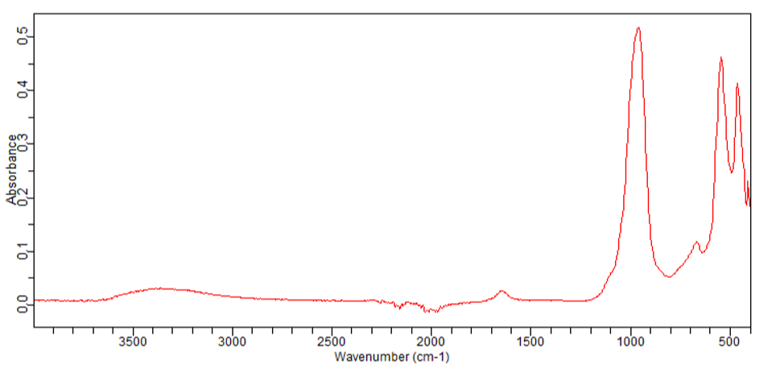
q_{e} = 1,513 mmol/g
q_{e} = 1,155 mmol/g
a) b)
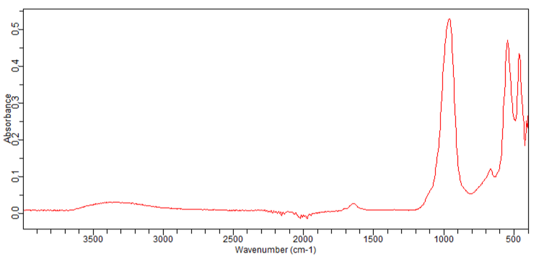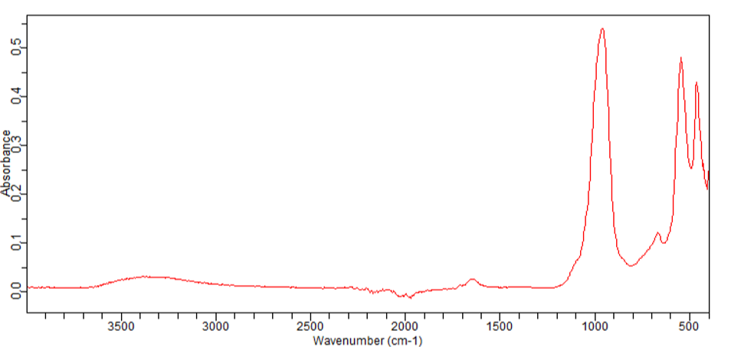
q_{e} = 2,47 mmol/g
q_{e} = 2,047 mmol/g
c) d)
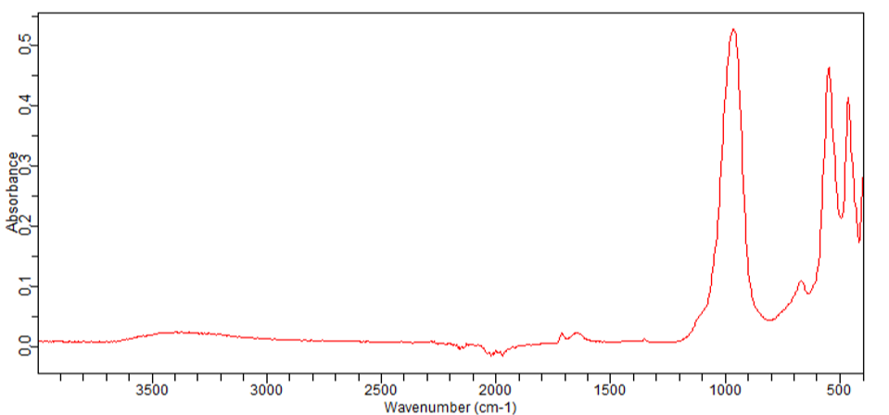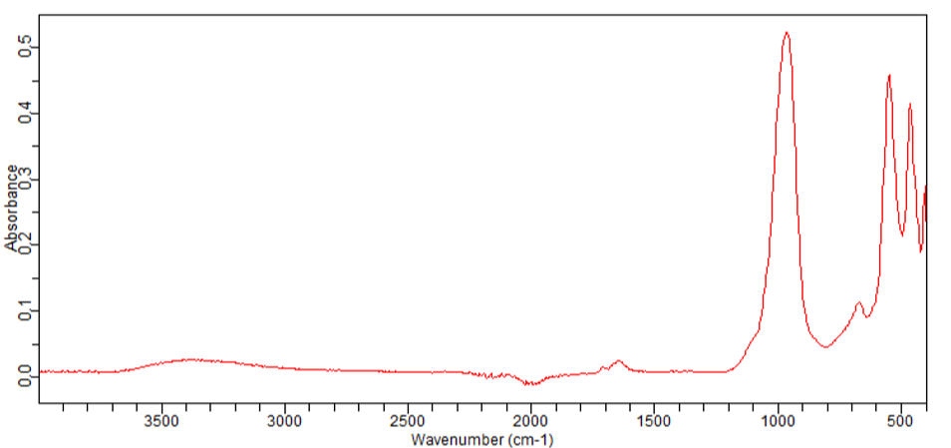
q_{e} = 2,808 mmol/g
q_{e} = 2,98 mmol/g
e) f)
Figure 7. FTIR spectras of ZEOflair 1000 after adsorption of acetaldehyde for different amounts of the adsorbed acetaldehyde per gram of adsorbent: a) q_{e} = 1,155 mmol/g; b) q_{e} = 1,513 mmol/g; c) q_{e} = 2,047 mmol/g; d) q_{e} = 2,47 mmol/g; e) q_{e} = 2,98 mmol/g; f) q_{e} = 2,808 mmol/g

4. CONCLUSION
From the conducted research, it can be seen that the amount of acetaldehyde adsorbed on the zeolites (ZEOflair 100, ZEOflair 110, ZEOflair 800, ZEOflair 1000) is relatively low, ranging from 0.107 to 2.98 mmol of acetaldehyde per gram of zeolite. Although the amount of adsorbed acetaldehyde on the examined zeolites was small, changes were observed in the FTIR spectra of the tested samples at the wavelength of 1700 cm⁻¹, which are characteristic of the carbonyl group of acetaldehyde. The research results showed that the intensity of the peaks at the wavelength of 1700 cm⁻¹ is proportional to the adsorbed amount of acetaldehyde. With an increase in the adsorbed amount of acetaldehyde on the examined zeolite, the intensity of the absorption band at the wavelength of 1700 cm⁻¹ also increases, which is comparable to determining the concentration of adsorbed acetaldehyde using the TOC (Total Organic Carbon) method. Water adsorption on the zeolite causes partial overlapping of the peak at 1700 cm⁻¹ (characteristic of the carbonyl group) with the peak occurring at 1650 cm⁻¹ (due to O-H bending, which is associated with water absorption). It can be concluded that the FTIR method is more sensitive in the case of acetaldehyde adsorption on different types of zeolites if water adsorption did not simultaneously occur on the examined zeolites. Generally, it can be concluded that the FTIR method is suitable for the rapid confirmation of acetaldehyde adsorption on zeolites. The advantage of this method is that it is non-destructive, requires a small amount of sample for analysis, and is selective, as it can detect peaks characteristic of different groups of organic compounds that are adsorbed. Therefore, the FTIR method can be used for the qualitative and quantitative determination of the adsorption of organic compounds on different types of zeolites.
Based on the obtained results, we can conclude that further research is desirable in the direction of investigating the adsorption of other organic compounds, with a tendency to focus on a narrower wavenumber range, characteristic for the targeted functional groups.

5. ACKNOWLEDGMENTS
We are very grateful to the “Zeochem” doo, Zvornik for the excellent cooperation and the provided zeolite samples.

6. REFERENCES
[1] Tran, V.V. Park, D., &Lee, Y.C. (2020). Indoor Air Pollution, Related human Diseases, and Recent Trends in the Control and Improvement of Indoor Air Quality, Int J Environ Res Public Health, 17(8): 2927.
[2] Belarbi H. Gonzales P., Basta A., Trens P. (2019). Comparison of the benzene sorption properties of metal organic frameworks: influence of the textural properties, Environ. Sci. Processes Impacts, 21, 407-412.
[3] Rubahamya, B. Reddy, K.S.K., Prabhu, A., Shoaibi, A.A., Skrinivasakannan, C. (2018). Porous carbon screening for benzene sorption Special Issue: Special Issue on Sorption Technologies,38, (1) s93-s99. doi: https://doi.org/10.1002/ep.12925
[4] ATSDR, (2007), Toxicological Profile for Benzene. U.S. Department of Health and Human Services, Pubil Health Service Agency for Toxic substances and Disease Registry
[5] Worch E. (2012). Adsorption Technology in Water Treatment: Fundamentals, Processes, and Modeling. Dresden: Walter de Gruyte.
[6] D.M. Main, T.J. Hogan, Health effects of low-level exposure to formaldehyde, J. Occup. Environ. Med. 25 (1983) 896–900.
[7] M.S. Kamal, S.A. Razzak, M.M. Hossain, Catalytic oxidation of volatile organic compounds (vocs) – a review, Atmos. Environ. 140 (2016) 117–134
[8] C. Yu, D. Crump, A review of the emission of vocs from polymeric materials used in buildings, Build. Environ. 33 (1998) 357–374.
[9] Pui W.K. Yusoff R. Aroua M.K. (2018). A review on activated carbon adsorption for volatile organic compounds (VOCs), Reviews in Chemical Engineering, 35(5): 649-668. doi: https://doi.org/10.1515/revce/2017/0057
[10] Ligotski, R. Sager, U., Schneiderwind, U., Asbach, C., Schmidt, F. (2019). Prediction of VOC adsorption performance for estimation of service life of activated carbon based filter media for indoor ait purification, Build. Environ. 149:146-156. doi: 10.1016/j.buildenv. 2018.12.001.
[11] Hussein M.S. Ahmed M.J. (2016). Fixed bed and batch adsorption of benzene and toluene from aromatic hydrocarbons on 5A molecular sieve zeolite, Materials Chemistry and Physics, Volume 181, pp, 512-517. doi: https://doi.org/10.1016/j.matchemphys.2016.06.088
[12] Zhao Y.T. , Yu L.Q. , Xia X. , Yang, X.Y. , Hu W. , Lv Y.K. (2018). Evaluation of the adsorption and desorption properties of zeolitic imidazolate framework-7 for volatile organic compounds through thermal desorption – gas chromatography, Anal. Methods, 10, 4894-4901. doi: https://doi.org/10.1039/C8AY01856A
[13] H. Yang et al., Microporous Mesoporous Mater. 117 (2009) 33–40
[14] T.M. Salama et al., Mater. Chem. Phys. 113 (2009) 159–165.
[15] D.W. Breck, Zeolites: Molecular Sieves, first ed., Wiley, New York, 1974
[16] Sh. Sang, F. Chang, Zh. Liu, Ch. He, Y. He, and L. Xu, Catal. Today 93-95, 729 (2004)
[17] C. Falamaki, M. Edrissi, and M. Sohrabi, Zeolites, 19, 2 (1997).
[18] M. Andreas, Zeolite Catalysis, Catalysts, vol. 6, no. 8, 2016. [Online] https://www.mdpi.com/2073-4344/6/8/118 [Accessed Sep. 17, 2021].
[19] P. Wright, and M. Lozinska, “Chapter 1: Structural Chemistry and Properties of Zeolites,” Zeolites and Ordered Porous Solids: Fundamentals and Applications, 5th International FEZA Conference 2011, Valencia, Spain, July 3-7, 2011. [Online]
[20] B. H. Stuart, Infrared Spectroscopy: Fundamentals and Applications, Wiley & Sons, Chichester (2004).
[21] H. Gunzler, H.U. Gremlich, IR Spectroscopy:An Introduction, Wiley & Sons, Chichester (2002).
[22] Brian C. Smith Fundamentals of Fourier transform infrared spectroscopy CRC Press, Taylor & Francis Group (2011).
[23] D. Kešelj, D. Lazić, Z. Petrović (2022). Use of Total Organic Carbon Analyzer in Isotherm Measurements of Co-Adsorption of VOCs and Water Vapor from the Air, Acta Chimica Slovenica, 69, 803-810
[24] D. Trong, S. Kaliaguine, and L. Benneviot, J. Catal. 157, 235 (1995).
[25] V. P. Shiralkar and A. Clearfield, Zeolites 9, 363 (1989).
[26] W. Fan, R. Li, J. Ma, B. Fan, and J. Cao, Micropor. Mat. 4, 301 (1995)
[27] S. A. Boussaa, D.Nibou, K. Benfadel, L. Talbi, A. Boukezzata , Y. Ouadah, D. Allam, S. Kaci (2023) Hydrothermal Synthesis of Mordenite Type Zeolite, International Journal of Computational and Experimental Science and ENgineering (IJCESEN), Vol.9-No.2 (2023) pp. 86-90
[28] R.W. Stevens, R.V. Siriwardane, J. Logan, Energy Fuels 22 (2008) 3070–3079
[29] H. Yamada et al., Sci. Technol. Adv. Mater. 6 (2005) 394–398.
[30] Y. Huang, Z. Jiang, Microporous Mater. 12 (1997) 341–345.
[31] K.A. Iyer, S.J. Singer, Phys. Chem. 98 (1994) 12679–12686.

ОДРЕЂИВАЊЕ АДСОРПЦИЈЕ АЦЕТАЛДЕХИДА НА СИНТЕТИЧКИМ ЗЕОЛИТИМА И КАРАКТЕРИЗАЦИЈА УЗОРАКА ФТИР МЕТОДОМ

Сажетак: Ацеталдехид је једно од најчешћих канцерогених органских једињењаи полутаната, који се може наћи у ваздуху у урбаним и индустријским подручјима, као и у затвореним просторијама. Генерално најефикаснија метода за уклањање полутаната из ваздуха је адсорпција са погодним адсорбенсом. Да би се изабрао погодан адсорбенс, неопходно је познавати његове карактеристике од којих је најзначајнији капацитет адсорпције, то јест колика је максимална количина адсорбоване супстанце по граму адсорбенса могућа при датим условима. Данас се још увијек трага за адекватним методама које би дале одговор колико и које органске супстанце су адсорбоване на адсорбенсима. У овом раду је приказана могућност примјене ФТИР методе анализе за идентификацију и детекцију адсорбованих органских једињења. Вршена је адсорпција ацеталдехида из гасовите фазе (гдје се почетна концентрација ацеталдехида кретала од 0,071 mol/m³ до 1,239 mol/m³) на различитим адсорбенсима тј. зеолитима ZSM (ZEOflair 100 и 110), NaA (ZEOflair 1000), NaA форма морденита (ZEOflair 800). На свим узорцима зеолита детектовани су пикови на 1700 cm⁻¹, који су карактеристични за карбонилну групу ацеталдехида. Уочава се да су површине пика биле сразмјерне одређеним количинама адсорбованог ацеталдехида, које су изразито мале и кретале су се од 0.107 mmol/g до 2.98 mmol/g зеолита. На основу овога се може закључити да ФТИР спектроскопија, као брза и недеструктивна метода може послужити за одређивање адсорпције ацеталдехида на различитим типовима зеолита.
Кључне ријечи: зеолити, ацеталдехид, адсорпција, ФТИР

